IAEA GUIDELINES ON THE PREPARATION,
PRESENTATION AND SUBMISSION
OF VIRTUAL POSTERS

International Conference on the Safe and Secure Transport of Nuclear and Radioactive Materials
(CN-280)
(In-person event with the possibility of remote connection)

The poster should be a visual presentation of your submitted abstract. Posters should meet the following criteria:

Size and Design
Posters can be designed in either portrait or landscape orientation. You should design your poster in Microsoft PowerPoint as one or two slides, the final poster will include a pre-recorded presentation made using the ‘Record Slide Show’ function in PowerPoint and must be submitted to the IAEA as a MPEG-4 Video (*.mp4) File.

Logos and Poster ID Number
Insert the INDICO paper ID (IAEA-CN-280) on the upper right side of the virtual poster.
Logos of the major institutions can be inserted anywhere on the virtual poster.

Title
The title should be the same as in the submitted abstract and full paper and should start with INDICO ID #.
The Title of the Paper, Name(s) of the Author(s), Affiliation(s) and Email of the main contact author should be displayed at the top of the poster.

Headings
It is recommended to use capital letters for headings.

Lettering
Use UPPER and lower case for general content, as all-capital text is difficult to read. Avoid using mixtures of type/font styles. The text and presentation should be in English only.

Content
The text should be concise and easy to read. Avoid using full sentences, but rather use short text in bullet point format. The message that your poster contains should be clear and understandable without the requirement of oral explanation. If relevant, methods should be presented simply and concisely.

After the title, the two most important sections are the Introduction and the Conclusions. On the basis of these two sections, a reader will decide whether to consider the poster details and perhaps talk to the presenter. These sections need to be very simple, concise and visually attractive.

Results should be presented graphically if possible. Avoid large tables of data. Results should be in line with those originally submitted in your abstract. If using tables, they should have a short heading.

Use pictures, graphs and colour. “A picture is worth a thousand words…”. Figure legends are essential and should be short but informative.

Use the space on the poster to attract your audience for discussion, not to present complex details of methods and results.

Please ensure any logos, graphics or images inserted are of a high resolution to avoid them pixelating.

Video
Authors who have been selected for a virtual poster should record a short video presentation using Microsoft PowerPoint. The duration of the presentation must not exceed 5 minutes.

Please leave a blank space on the bottom right side of your poster for your MPEG-4 Video (*.mp4) to be inserted.

For more guidance on recording and inserting your video see Annex 1 & 2.

Additional Mandatory Requirements for Virtual Posters

· Your submitted file must include only a maximum of two slides
· The video presentation must not exceed 5 minutes duration
· The final file size must not exceed 500mb

Any posters that do not meet these requirements will be returned.

Submission

Virtual posters must be uploaded to a file sharing platform such as OneDrive or Dropbox. The link to the file must be sent by email to I.Ostrouska@iaea.org and A.Dervoz@iaea.org by 15 October 2021. This will allow sufficient time for the Secretariat to check the compatibility of the video presentations with the technical specifications and to ensure suitability before the start of the conference.

Posters attached to e-mails will not be processed.

PRESENTATION DURING THE VIRTUAL CONFERENCE

Your poster will be made available on the IAEA Conference and Meetings App (available for free download from the App Store and Google Play), prior to the start of the conference. There will be a commenting box placed under each poster for authors to interact with participants, answer any questions they have and initiate further discussions.

TECHNICAL SPECIFICATIONS —PRE-RECORDED VIDEO (VIRTUAL) POSTERS

1. Video Quality:
· Pre-recorded presentation must be made using Microsoft PowerPoint 2016 or a later. version (see further instructions for Microsoft PowerPoint in Annex 2).
· Format: MPEG-4 Video (*.mp4).
· Format: Slide Ratio 16:9.
· Full HD 1080 x 1920 Pixels (if for any reason it is not possible to save the file at 1080p the file must at the very least be saved at 720p to avoid issues with video quality and with playback).

2. Suitable location / background /preparation:
· Record with as much natural light as possible. If it is too dark or the light is unbalanced, turn on the room light and position a desk lamp or other light source. The speaker should be evenly lit and brighter than the background.
· Find a quiet location. Eliminate any background noise (e.g., switch off air conditioning and close windows to block traffic noise).
· Dress appropriately as if present at the conference.
· Practice the presentation before recording the final version.

3. Audio:
· If using a clip-on microphone fasten it at chest height.
· If possible, use Bluetooth headphones with a built-in microphone or a headset to improve sound quality.

4. Frame the video shot:
· If using a laptop with a built-in camera rest the device on a stable surface; make sure the camera is straight with the lens just below eye level.
· If using a webcam, camera or phone mount the device on a tripod if you have one; film horizontally (landscape) and not vertically (portrait mode); make sure the camera is straight with the lens just below eye level.

5. Record the video:
· The speaker should look directly into the camera lens to maintain eye contact with the viewers.
· After pressing the ‘Record’ button, there should be a time gap of at least 3 seconds before the speaker starts to speak. Stop the recording at least 3 seconds after the speaker has finished.

6. Playback to check the video recording:
· For sound quality purposes, headphones should be used to check if the recorded sound is clear and understandable.
· Check if the speaker is in focus and her/his exposure looks even.
· Consider re-recording if the video and/or sound quality are not good.

USING MICROSOFT POWERPOINT – PRE-RECORDED VIDEO (VIRTUAL) POSTERS

- Prepare your poster:
Use Microsoft PowerPoint to prepare your poster as per the guidelines above. Please prepare the poster in the following format: widescreen, ratio 16:9 in either landscape of portrait orientation.

You should leave a blank space on the bottom right side of the poster where your video will be inserted once recorded.

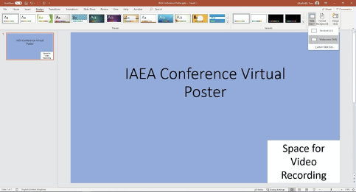

2. Changing your slide to portrait orientation:
Should you wish to change your slide to a Portrait Orientation:
· Go to the Design tab
· Select Slide Size
· Select Custom Slide Size
· On the sub menu under Orientation select Portrait

3. Record your 5-minute presentation using the Slide Show Function:
· Follow the guide in Annex 1 for preparing and setting up your computer and camera
· Open your poster
· Select Slide Show
· Select Record Slide Show
· Select Record from Beginning
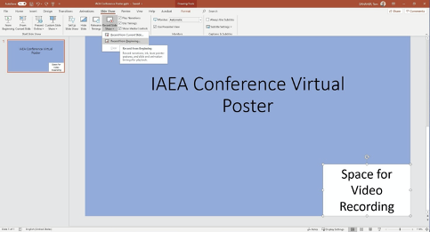

- Recording your video presentation:
· After following the above steps, you will be taken to a presenter screen
· You will see the video projected on the bottom right corner of the slide
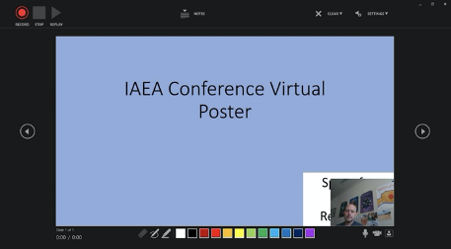

Navigating the presenter screen

· Along the top of screen, you will see from left to right:
- Record button – press to start the recording
- Stop button – press to stop the recording
- Replay button – press to replay the recording
- Notes dropdown – you can view your presenter notes here
- Clear recording button – you can clear the recording here should you not be satisfied
- Settings button – Here you can access your microphone and camera settings

· Along the bottom of the slides, you will see from left to right:
- Eraser – To remove anything drawn in real time on the slides
- Pen and Highlighter - You can use the two pens as a pointer or to draw on the slides in real time
- Colour Selection - You can use the colour pad to select the colour of the pen
- Microphone Button – You can mute your microphone by pressing this button
- Camera Button – You can switch off your camera at any time by pressing this button
- Camera Preview Button – You can switch of the camera preview at any time by pressing this button

Recording your presentation:
· To begin recording your presentation press the record button on the top left corner
· The presenter screen will countdown from 3 seconds and then begin to record
· Record your presentation discussing the various sections of your poster
· Once you have finished press the stop button on the top left corner
· You can preview your presentation by pressing the replay button on the top left corner
· Once you are satisfied with the recording close the presenter screen, you will return to the main PowerPoint screen and the recording will be automatically inserted into the poster

- Exporting your virtual poster an MPEG-4 Video (*.mp4) file:
· Go to the File tab
· On the left side of the screen select Export
· Then select Create a Video
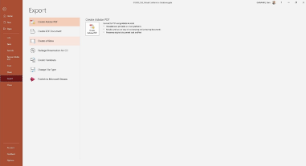

· The file should be saved as Full HD 1080x1920 Pixels or at the least 720p / maximum 1080p
· Keep selected Use Recorded Timings and Narrations
· Press Create Video

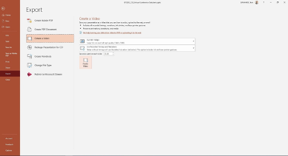
· A Save As dialogue box will appear
· Choose the location where you would like to save the recording
· Ensure the Save as type is MPEG-4 Video (*.mp4)
· Press the Save button to save the file (it will take a few minutes to export the video)
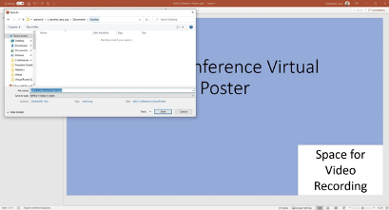
· The file is ready to be previewed and then forwarded to the IAEA via OneDrive or Dropbox

