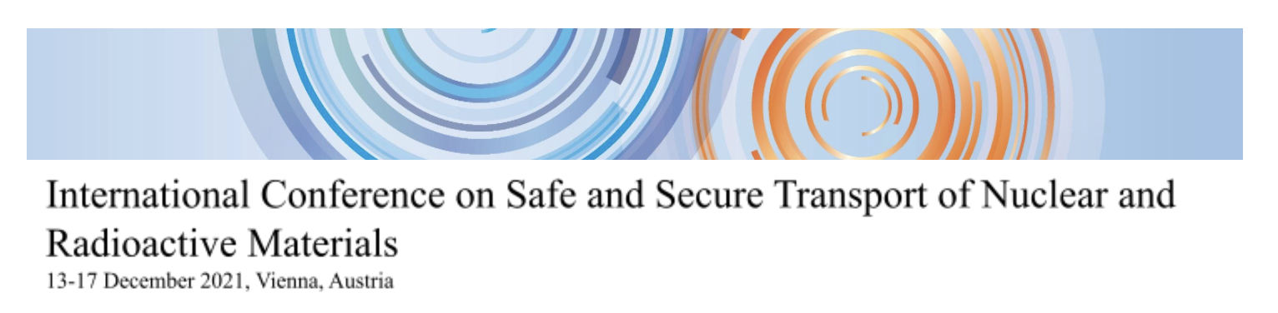
Release of Virtual Poster
I agree that my poster, presented at the International Conference on the Safe and Secure Transport of Nuclear and Radioactive Materials (CN280), 13 – 17 December 2021, Vienna may be made available on the IAEA Conference and Meetings App as a MPEG-4 Video (*.mp4) File.

INDICO ID:
Country/Invited Organization:
Family Name:
First Name:

YES | NO

Signature:

Please complete and return this form by email to:
I.Ostrouska@iaea.org and A.Dervoz@iaea.org
Subject: CN-280 Release Form

