Verification of multiphysics coupling techniques for modeling of molten salt reactors

J. Groth-Jensen¹, A.V. Pedersen¹, A. Nalbandyan², E.B. Klinkby², B. Lauritzen², P. Sabbagh³,

¹Seaborg Technologies, Copenhagen, Denmark
²DTU Physics, Roskilde, Denmark
³DAES SA, Petit Lancy, Switzerland

Email contact of corresponding author: jgj01@seaborg.com

The Molten Salt Reactor (MSR) [1] is a promising design concept for the next generation of nuclear power plants, with potential to meet the safety, economy and sustainability objectives of Generation IV reactors. The MSR employs a high-temperature circulating fuel which adds a series of inherent safety features. The MSRs require substantially different modeling approaches and codes compared to the solid fueled reactor concepts, partially due to the transport of the delayed neutron precursors with the fuel flow, which affects the effective delayed neutron fraction in the core. The verification and validation of such codes are not a trivial task, in particular for fast reactor designs, where no experimental data are available. In absence of experimental data, a benchmark was developed by LPSC/CNRS-Grenoble [2] [3] for multiphysics codes dedicated to MSR studies.
In this study we present two independent and novel multiphysics approaches and apply them to this benchmark. The first approach utilizes the SEALION framework [4]. The SEALION framework employs a specialized thermal hydraulics solver based on the finite volume CFD code OpenFOAM [5] that is coupled with a modified Point Kinetics neutronics solver. The main advantage of this approach is that it allows for a pre-determination of the reactivity response to temperature perturbations using Monte-Carlo codes like Serpent2 [6], leading to a significant reduction in computational requirements while retaining the quality expected from a Monte Carlo simulation. The second approach [7] employs the Serpent2 multiphysics interface, allowing for high fidelity coupling of OpenFOAM and Serpent2. In this approach, Serpent2 serves as the main neutronics solver and is coupled to an OpenFOAM based thermal-hydraulics solver and a delayed neutron transport solver implemented in OpenFOAM as well. The main advantage of this coupling approach is the possibility to use a high accuracy Monte-Carlo approach for solving the neutron transport equations.
Both approaches are validated against the benchmark [3]. An overall agreement between the results demonstrates the validity of both approaches.

Benchmark geometry and stages
One of the traditional benchmark cases used to validate thermal-hydraulics solvers for incompressible flow is the lid driven cavity model. The geometry is fairly simple, it captures the main characteristics of the flow and provides a clear identification of relevant parameters for the simulation. The benchmark geometry has been adapted in [2][3] as well as this work for validation of the neutronics-thermal hydraulics coupling techniques for MSRs; the cavity model also represents a simplified Molten Salt Fast Reactor design, with the fuel circulating inside a cylindrical cavity. In Figure 1 the lid driven cavity model geometry is shown.

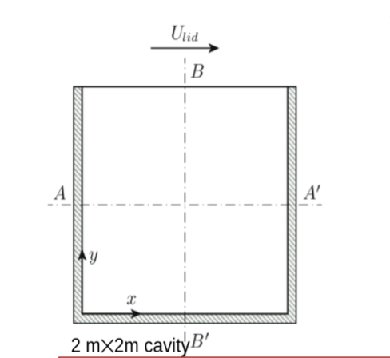
Figure 1: Benchmark geometry: a simple 2m times 2m cavity treated as a 2D
The multiphysics benchmark is performed in three main stages: first the individual software for the neutronics and the thermal-hydraulics are tested, then a fully coupled steady state analysis of the model is carried out, and finally the coupling is tested for a forced convection transient scenario. The coupling in the second phase of the benchmark is introduced gradually: initially the impact of the fuel velocity field on the neutronics is investigated with a fixed temperature and power input, then the power distribution impact on the fuel temperature field is modeled and finally the buoyancy effects are encountered for.

Benchmark results
A standalone thermal hydraulics test is performed to obtain the velocity field of the fuel with a fixed lid velocity u=0.5m/s. In Figure 2 the horizontal velocity component along the cavity vertical centerline is shown, providing a good agreement between the results of this work and the benchmark participants. The second standalone physics test is the test of the neutronics module, in terms of the fission rate density shown Figure 3. A very good agreement with the benchmark isobserved both for the point-kinetics results (SEALION) and for the Serpent results (DTU)
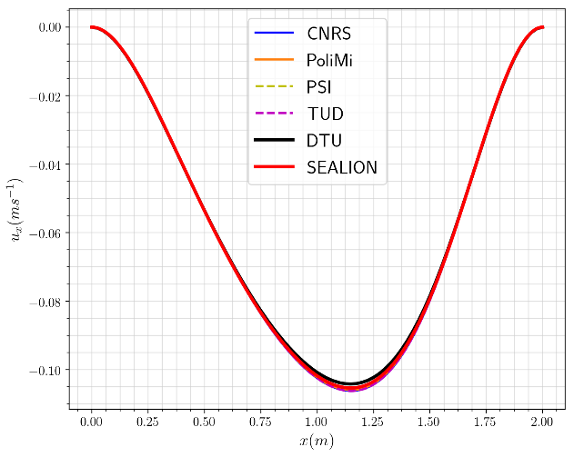  Figure 2 : Horizontal velocity component along AA' | 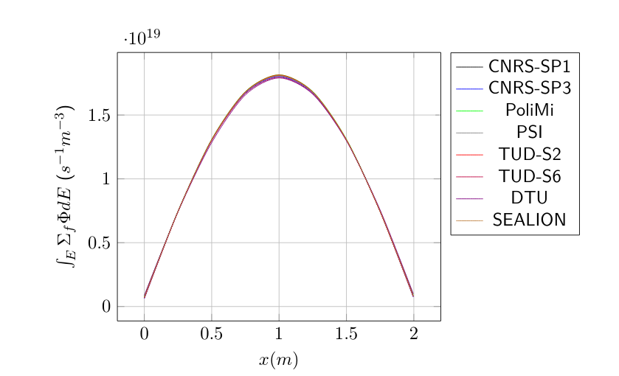  Figure 3: Fission rate density along AA'
In the latter phases of the benchmark the impact of a non-uniform temperature on the flux and in turn the effect of the flux deformation on the temperature is evaluated. A sinusoidal perturbation to the heat transfer coefficient is considered with various frequencies and a constant amplitude. The effect of non-homogeneous salt cooling on the power is observed and reported as a function of the power gain. Figure 4 shows the power gain as a function of frequency for all the participants of the benchmark. The SEALION results agrees fairly well with the benchmarks participants but undershoots the power gain at higher frequencies.

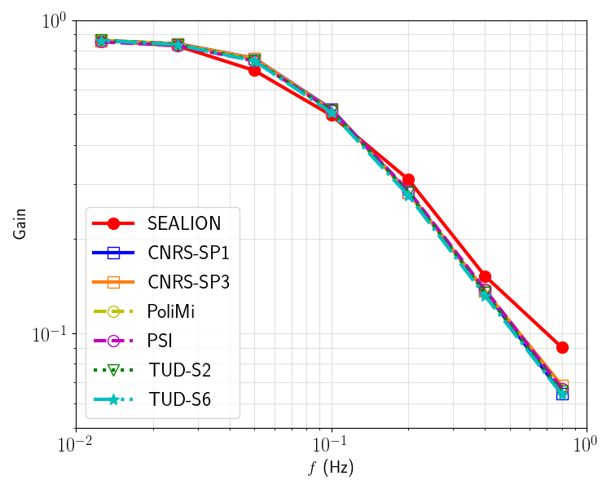
Figure 4: Bode diagrams of power gain as a function of the frequency

Conclusion and some remarks on the importance of the open-source approach.
At all stages of the benchmark reasonable agreement is demonstrated with the benchmark participants. The standalone physics modules yield almost identical results with the bench-mark participants. Gradual introduction of coupling terms shows good reflection of neutronics feedback mechanisms as well as the implementation of the thermal-hydraulics solver.

The availability of benchmark like the one presented here is crucial to the development of multiphysics simulations codes in the absence of experimental data. They provide state-of-the-art knowledge and examples of best practice implementation using an open-source approach. They also help to set standards for testing requirement management and can potentially be a powerful tool in a licensing process.

References
[1] |  | H. Boussier. et al., "The molten salt reactor in generation iv: Overview and perspectives," in Generation4 International Forum Symposium,, San Diego, USA, 2012.
[2] |  | M. Aufiero et al., "Testing and verification of multiphysics tools for fastspectrum msrs: The cnrs benchmark," in ANS Annual Meeting, 2018.
[3] |  | M. Tiberga et.al., " Results from a multiphysics numerical benchmark for codes," Annals of Nuclear Energy, vol. 142, 2020.
[4] |  | J. Groth-Jensen. et al., "Verification of multiphysics coupling techniques for modeling of molten salt reactors," Annals of Nuclear Energy, vol. 164, 2021.
[5] |  | H. Weller. et al., "A tensorial approach to computational continuum mechanics using object-oriented techniques," Computers in Physics, vol. 12, pp. 620-631, 1998.
[6] |  | J. Leppänen et al., "The serpent monte carlo code: Status, development and applications in 2013," Annals of Nuclear Energy, vol. 82, p. 142–150.
[7] |  | A. Nalbandyan et al., "Coupled neutronics thermal hydraulics assessment of graphite molten salt reactors," in Proceedings of the NURETH18 conference, 2019.

