Open source tools in support of multiphysics simulation for fusion

A. DAVIS¹, A.J. DUBAS¹, H. BROOKS¹, A. BLAIR¹, S. DIXON¹

¹United Kingdom Atomic Energy Authority, Culham, Abingdon, United Kingdom

Email contact of corresponding author: andrew.davis@ukaea.uk

Several organisations around the world are progressing their own technological paths to fusion energy, but all fall into two categories: Magnetic Confinement Fusion (MCF) and Inertially Confined Fusion (ICF). In either case most near term (40 year timescales) use cases focus around the confinement of deuterium-tritium (D-T) fuel for sufficient triple product (temperature-time) that results in the release of significant quantities of energy. Using this energy in a useful way is of course the goal of all fusion power plants, but trapping this energy and using it productively comes with challenges.
We will deal with issues of modelling for MCF in this paper, but the tools developed can also be used for ICF and indeed other domains. First we must consider what it is we need to aim to model. Near term fusion devices, those targeting operations before 2040, face a challenging regulatory environment. If we consider the number and range of experiments that will produce directly relevant material qualification data, then we have a very limited set of materials that will be investigated in a timely manner. Similarly, each fusion concept focuses on a slightly different blanket coolant which again has qualification questions around boiling regimes and multiphase or Magneto-HydroDynamic (MHD) impacted flow. Comparably, there will be a limited number of magnetic test facilities, which will mimic the operational schedule and thus fatigue life of fusion components. It is clear therefore that the vast majority of accreditation of near term fusion devices will be almost entirely in silico, and the new and existing experiments will feed model data to those to lower uncertainty.
What is clear is that given the complexities of the fusion load case, we must embrace a more tightly coupled way of performing Whole Component Analysis (WCA) and Whole Device Analysis (WDA). The traditional mechanistic method of passing simulation results between a series of static calculations or by passing results between domain experts, can’t scale to WCA or WDA where the mesh Degrees Of Freedom (DOF) we can expect from the solid parts of the mesh are expected to be more than 1x10⁹, and from the congruent fluid in excess of 1x10¹². A DOF count in this region implies highly scaling iterative solvers for all PDEs. In terms of physics, there is a nominal set that we must consider; at the minimum radiation transport (both thermal and nuclear), structural mechanics (elastic, plastic, viscoplastic), thermal conductivity (Fourier and hyperbolic), fluid dynamics (turbulence and heat transport through both free and forced convection), electromagnetics (in both high and low frequency regimes) and radiation damage modelling (embrittlement and transmutation). There is of course other physics that may be needed, for example certain liquid metal blankets will need magneto-hydrodyamics (MHD), and there are multiple length scales that must be considered.
Fusion use cases naturally span several of these kinds of physics concurrently combining tight physical coupling, uncertain model parameters, large and complex geometry with implicitly multiscale physics. Thus in order for fusion engineering analysis to scale to the WCA scale and eventually to WDA, a framework must be chosen that balances several features including; HPC scalability, open source, usability, community, documentation, and software quality. Such a field of requirements lead to a comparison of some 37 FEA packages, a detailed comparison of 8, and final set of 3 codes [1]. From this comparison, MOOSE [2] was taken forward as the basis of a multiphysics framework for fusion relevant engineering analysis. Over and above other frameworks, it has a plethora of existing physics which means that if your use case is covered by that physics, then in fairly short order - several hours - one can be up and running with the first relevant problems. One of the key requirements, the open source nature, means that a whole field of possibilities is opened up beyond what was previously possible. This includes a comprehensive wrapping of tools by Uncertainty Quantification (UQ) frameworks such as DAKOTA [3] or EasyVVUQ [4]. Such enabling technology, with embedded UQ, highly scalable solvers, free from the limitations of commercial solvers is a powerful tool that will allow a much more complete analysis to be performed than is traditionally performed.

Radiation Transport
Ionising radiation from the DT reactions in the fusion core are the source of several impacts upon the tokamak, including; radiation damage and other radiation induced phenomena, nuclear heat, and transmutation. It is the nuclear heat that is a large driver for the shielding of toroidal field magnets, central solenoids and divertor steering coils, this nuclear heat is also a significant source of thermal stresses upon components. Traditionally in fusion systems, MCNP [5] is used to calculate nuclear responses, however there are a number of complications which preclude integration of MCNP into a full multiphysics framework; lack of dedicated API to update temperatures and densities, licencing issues on arbitrary HPC systems, and legacy development practices. Therefore, OpenMC [6] which is open source, highly scalable and has easily modified APIs for simple coupling.

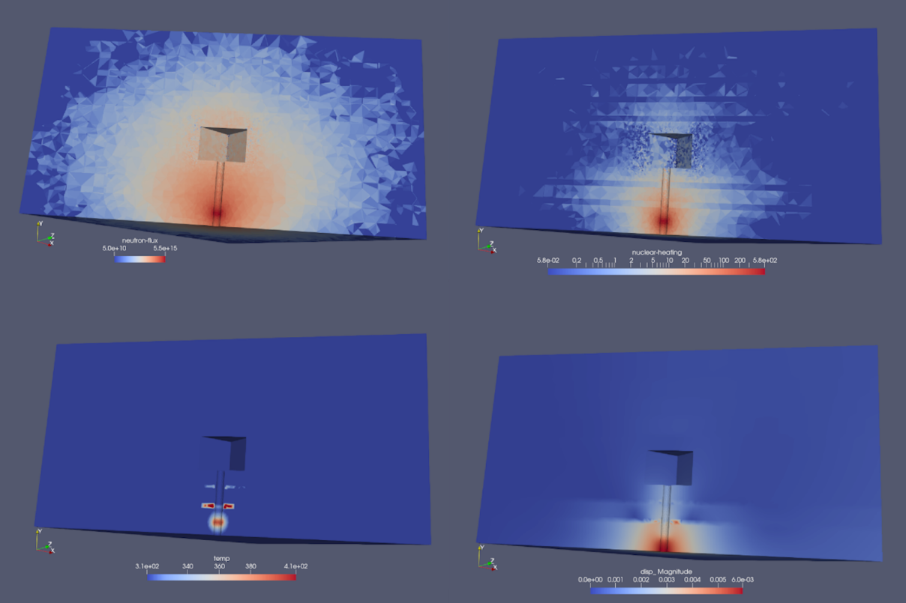
FIG 1: Example Aurora calculations on the FNG neutron source assembly, (top left) neutron flux, (top right) nuclear heat, (bottom left) temperature and (bottom right) displacement magnitude

One of the major use cases for AURORA - https://github.com/aurora-multiphysics/aurora a framework for the multiphysics analysis of fusion devices, is the evaluation of the radiation field of a device on the rise to operational temperature. Most radiation analysis does not model this impact, because systems have not existed to allow the calculation. CAD models as developed or supplied necessarily reflect the need to define the geometry at room temperature, the temperature at which the device is constructed. One can idealise the rise to operational temperature as that starting at T₀ and increasing until some thermal equilibrium is reached during operations. During the rise to temperature, radiation induced thermal expansion occurs, driving spatial displacements - and therefore changing densities and the closure of streaming channels. This feedback mechanism, radiation-thermal-expansion-density, will change during the initial ramp up as the geometry changes, which impacts radiation streaming, which impacts the nuclear heat source, which must necessarily be addressed in an iterative manner. A full paper on the technical implementation can be found at this meeting [Brooks - “Scalable tightly coupled multi-physics for fusion reactors with Aurora].

Electromagnetics
Electromagnetic (EM) analysis is at the heart of the reactor design process. It is needed in various formulations and approximations for the generation of plasma equilibria, calculations of radio-frequency heating for plasma current drive and heating applications, and for the design of the coils required to generate the magnetic fields used to confine the plasma. A crucial task during the magnetic coil design process is the design of the magnet geometry and support structure, which must resist the large internal Lorentz forces generated by the magnet. This analysis is often performed using common tool chains like ANSYS [5], which will typically involve running an explicit EM calculation with approximations made on the form of the forces applied to the magnet structure. It is rare that a fully coupled transient simulation is done, with explicit coupling between the Lorentz forces and the magnetic field, as this is usually not a major use case or is limited by technology.

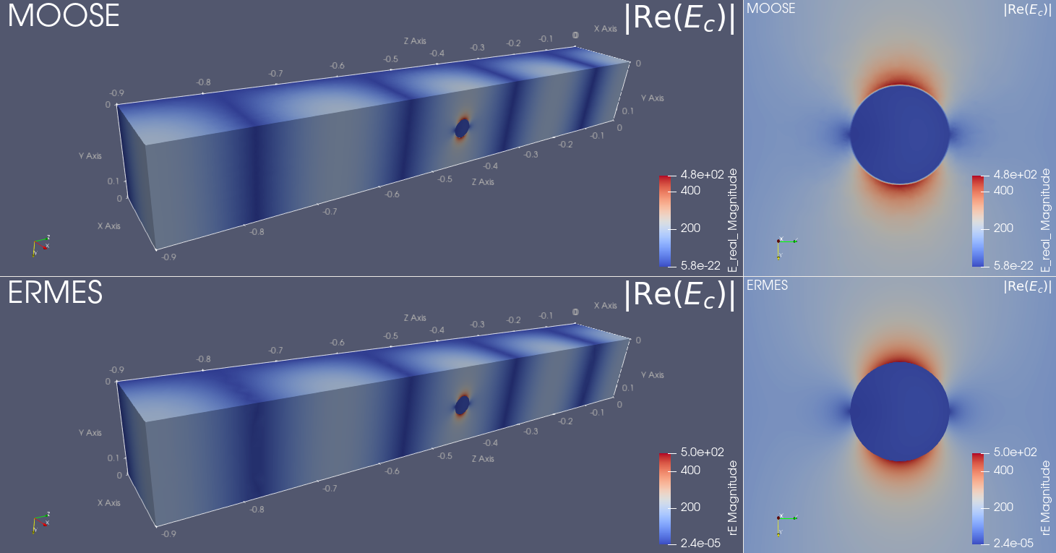
FIG 2: Example results from Apollo full wave Maxwell solver (top) and reference results from ERMES (bottom) for the electric field distribution around an ellipsoidal phantom in a rectangular waveguide.

With the example capability shown in the Radiation Transport section, it is now possible to fully couple not only the electromagnetics capability here with the already present functionality in MOOSE (e.g. thermal, structural, fluids) but linked with the AURORA (OpenMC-MOOSE application) fully coupled transient nuclear-thermal-structural-fluid calculations would be possible. This enables hithertofore absent capabilities; such as studies of the impact on operational temperatures from changes to magnets arising due to nuclear heating, or even enable simulations investigating magnet quench behaviour, where there is a numerically tight coupling between electromagnetics, thermal, and fluids simulation, and where traditional Fourier heat models may break down.

Tritium Transport
Tritium transport (sometimes listed as diffusion) is a fairly complex set of material dependent phenomena where tritium (but also including other light gases like protium, deuterium or helium) get absorbed into materials and trapped (depending upon the material structure). The tritium atoms can then get released (desorped) at different rates depending on the material (chemical structure), density, and temperature. This is of particular relevance for tritium inventory of components exposed to the unburned tritium flux from the plasma, this tritium can then get absorbed (trapped) in the component, fairly near the surface (within several microns). An example of this is shown in FIG 3, the MOOSE based application (Achlys) for tritium transport, which can take tritium concentrations as input and derive the effective desorption rates as a function of temperature. In this example, the Achlys application is run with coefficients that describe this problem, compared against the experimental data from [8]
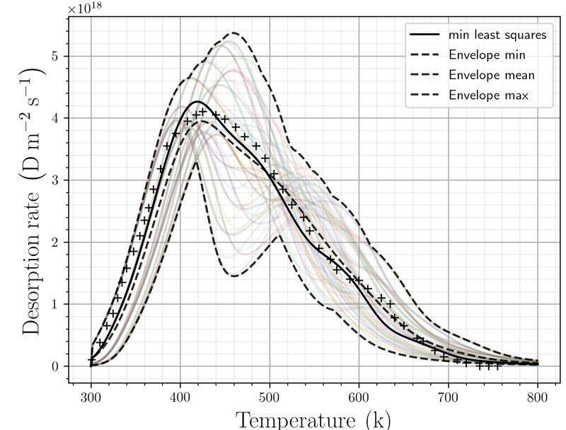
FIG 3: Deuterium concentration as a function of temperature (including model uncertainty)

An extension of the above, would utilise the AURORA MOOSE application to determine the neutron fields and nuclear heat sources, and therefore the (n,t) tritium reaction rates as source terms in a tritium transport calculation. Extension of this to a full detailed breeding blanket will be very straightforward given the highly scalable nature of MOOSE and its toolchain, enabling the first demonstration of a fully coupled nuclear-fluid-structural-thermal-tritium problem needed to form complete digital models of fusion blankets.

Conclusions
We have developed the first of a kind set of tools, https://github.com/aurora-multiphysics, to perform a range of loosely and closely coupled physics problems for fusion with the highly scalable backend, MOOSE, as the basis for this work. By integrating a set of tools for fusion into the MOOSE framework, we can gain a set of benefits;
- Allows the use of the existing suite of multiscale physics present in the framework
- Massively parallel implementation
- A community of users and developers
- A set of QA documentation, and an extensive set of unit tests
We have demonstrated that in quite short order, less than 6 months or so, how it is possible to couple an external code into the MOOSE framework, integration of new physics in the form of Maxwell’s equations for a number of use cases and setup of new FE based discretisations of hydrogen transport problems and wrap those with UQ tools.
As we gain more experience with this toolchain a new set of problems will arise, how to pre-condition large coupled problems with little a priori knowledge, what limits the scalability of the simulations for large coupled systems and so on. It is already clear that if Monte Carlo (MC) is to be used in these large coupled systems then a GPU port or version is implicitly going to be needed.
References
- DUBAS, A., “Evaluating Exascale FEA Backends for Fusion Digital Twins”, 1st Spanish HPC Fusion Workshop, Barcelona, November 2020.
- PERMANN, C. J., “MOOSE: Enabling massively parallel multiphysics simulation”, Journal of SoftwareX, 11, 2020, https://doi.org/10.1016/j.softx.2020.100430
- ELDRED, M. S. et al, “Investigation of reliability method formulations in DAKOTA/UQ”, Structure and Infrastructure Engineering, 3, 3, 2007 - https://doi.org/10.1080/15732470500254618
- RICHARDSON, R. A. et al, “EasyVVUQ: A Library for Verification, Validation and Uncertainty Quantification in High Performance Computing”, Journal of Open Research Software, 8(1), p 11 - http://doi.org/10.5334/jors.303
- WERNER C. J. et al, “MCNP6.2 Release Notes”, LA-UR-18-20808, 2018
- ROMANO P. K. et al, "OpenMC: A State-of-the-Art Monte Carlo Code for Research and Development," Annals of Nuclear Energy, 82, pp 90-97 (2015) - https://doi.org/10.1016/j.anucene.2014.07.048
- DE SALVO G. J. et al, “ANSYS Engineering Analysis System User’s Manual”, Swanson Analysis Systems, 1985
- Ogorodnikova, O. V., “Fundamental Aspects of deuterium retention in tungsten at high flux plasma exposure”, Journal of Applied Physics, 118, 2015, https://doi.org/10.1063/1.4928407

