ONIX: AN OPEN-SOURCE DEPLETION CODE FOR REACTOR ANALYSIS AND NUCLEAR SECURITY

J. DE TROULLIOUD DE LANVERSIN
Harvard University
Cambridge, United States
Email: j.detroullioud@gmail.com

M. KÜTT
Institute for Peace Research and Security Policy
Hamburg, Germany
Email: kuett@ifsh.de

A. GLASER
Princeton University
Princeton, United States
Email: alx@princeton.edu

Email contact of corresponding author: j.detroullioud@gmail.com

Several depletion codes for nuclear reactor analysis have been developed overtime and successfully validated, with many in use today. Unfortunately, their often proprietary nature and various export control regulations restrict the distribution of these codes. Community-based software development and open user groups, which have shown to be drivers of innovation in many other areas, are being forestalled by these restrictions. They also reduce the degree of transparency for science and engineering projects and complicate the collaboration between groups from different countries. This can be particularly problematic in the field of nuclear security which relies on software that can model the depletion of nuclear systems to assess nuclear risks and verify non-proliferation and arms control processes. The success of these collaborative efforts depend enormously on trust between the different parties involved and the transparency of the technologies used [1].

ONIX (for OpeN IsotopiX) overcomes these limitations by offering a fully open-source depletion module with neutronic coupling to the open-source Monte Carlo transport code OpenMC [2]. The code uses state-of-the-art algorithms and nuclear data sets. ONIX has also been specifically designed to be a practical tool for nuclear security research such as nuclear archaeology. ONIX has been validated and verified through comparison with multiple numerical and experimental benchmarks [3]. The software can be used today as an efficient numerical tool to model nuclear reactors and to support technical research on nuclear security issues. The objective of this work is to give a description of the capabilities of ONIX, review applications of the software and finally, discuss various aspects related to the development and open-source nature of ONIX such as export control regulations, international collaboration, and documentation.

ONIX has been designed as a Python module with an object-oriented approach. Python allows efficient data processing and computations, as well as options to easily read and extend the code.

ONIX offers various useful and original functionalities:

Nuclear data libraries:
- The nuclide depletion networks simulated by ONIX are not limited by size. By default, ONIX can build a burnup matrix from all nuclides included in a nuclear data library;
- A module within ONIX can also automatically create optimized data libraries by removing isolated isotopes which are those isotopes that are not connected to any other isotopes via neutron-induced or decay reactions. This module has been used to create reduced libraries, which are used in ONIX by default and greatly improve the computation speed of the depletion solver. Fig. 1 shows a chart of the nuclide to illustrate the size of the original ENDF/B-VIII.0 library as read by ONIX and the resulting reduced library;
- ONIX also allows the user to manually define nuclear data objects which the code will use instead of nuclear data libraries. This feature can be used to model a custom, small nuclide network with few decays and neutron-induced reactions.
Isomeric branching: ONIX has been developed to update isomeric branching ratios with the evolution of the neutron spectrum of a problem after each OpenMC simulation.
Coupled and stand-alone modes:
- The coupled mode offers neutronics coupling with OpenMC. OpenMC is used to compute one-group neutron flux and reaction rates which the depletion module of ONIX uses to deplete the materials. ONIX then feeds the new isotopic densities to OpenMC for a new transport simulation. This process continues iteratively until the desired burnup is reached;
- The stand-alone mode of ONIX can be used to model the irradiation of a simple set of materials without the need for coupling to OpenMC. The one-group cross sections and the neutron flux for the whole system need to be provided by the user.
One-group cross section computation: ONIX will calculate, by default, the cross sections for all the isotopes that have data in a cross section library used by OpenMC. The user can also ask ONIX to calculate the one-group cross sections of a more limited set of nuclides. This can be a list of isotopes provided by the user or several pre-compiled lists provided with ONIX.
Burnup solver: Salamèche is the module that builds the burnup matrix and solves the depletion equation in ONIX. The depletion solver used by Salamèche is a 16th order CRAM method [4].
Nuclides’ production/destruction path visualization: ONIX can plot graphical representations of the production and destruction terms of a specific nuclide at any step of the simulation and for any burnup region. This is very useful to better understand the density evolution of certain nuclides. Fig. 2 is an example of such a plot, showing destruction and production terms of plutonium-239 in light water reactor (LWR) fuel.
Online change during operation: ONIX offers the option to programmatically change simulation parameters such as temperature, isotopic composition and densities over time. This is useful to model certain parameters that are usually adjusted by the reactor operators such as boron concentration in the cooling water or physical quantities that are not modelled in the neutronics such as change in the temperature of the materials.
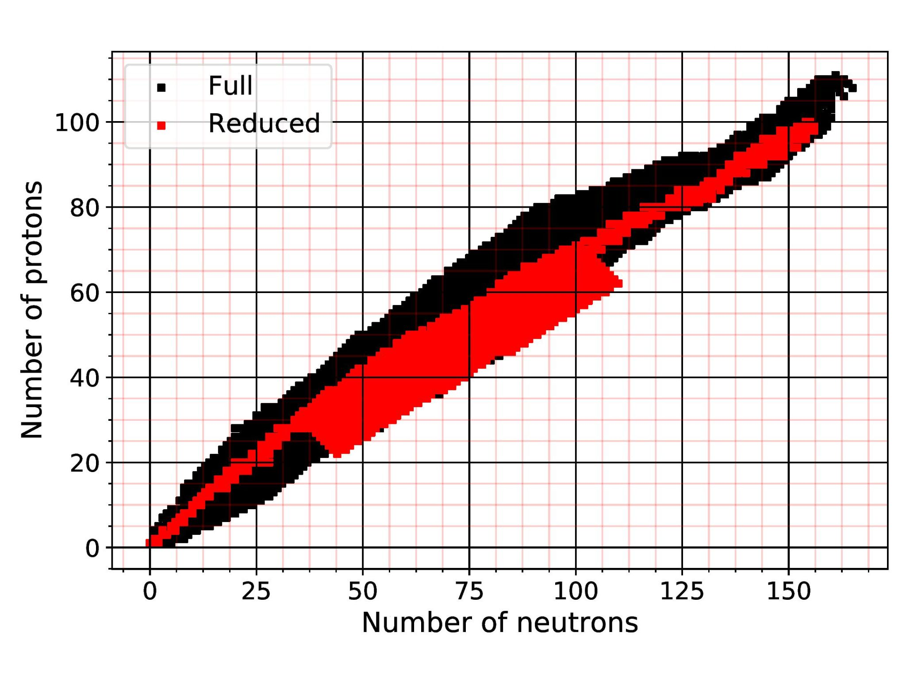
FIG. 1. Full and reduced ENDF/B-VIII.0 libraries. The reduced library has been obtained by removing all isolated isotopes (isotopes not connected to other isotopes via decay or neutron-induced reactions) from the full library. The colored squares (black and red) indicate isotopes for which nuclear data are taken.
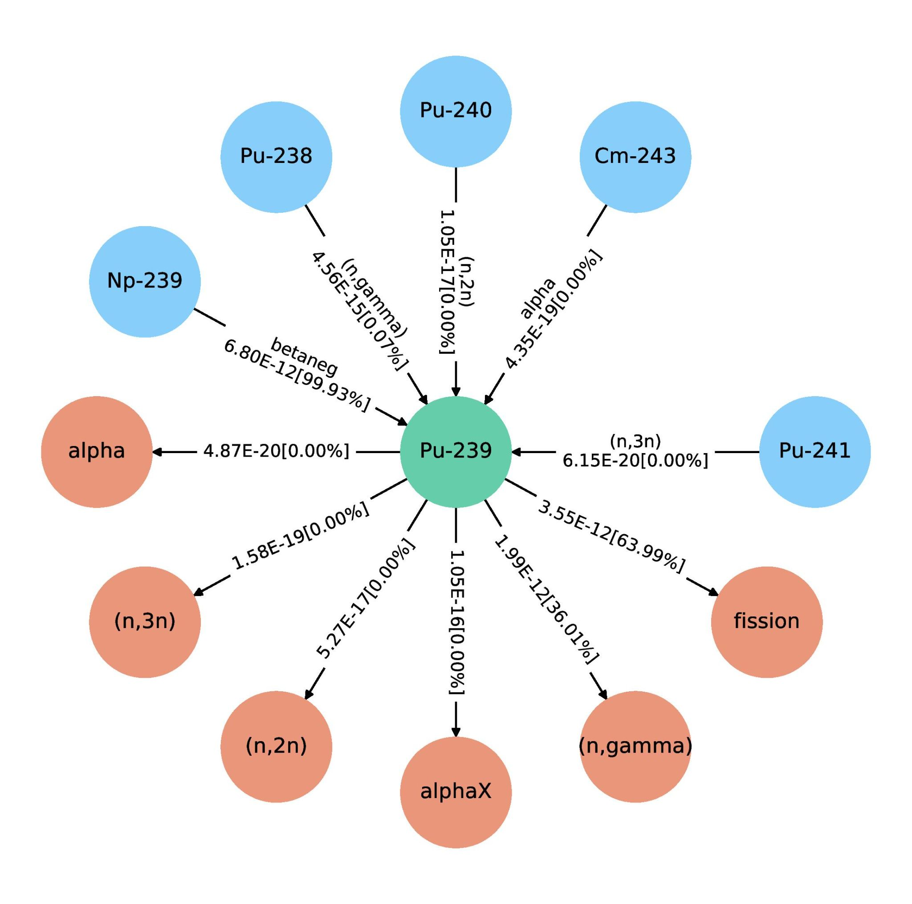
FIG. 2. Graphical representation of the production and destruction terms of plutonium-239. This plot has been generated with an ONIX function. The blue circles are the parents of the nuclide while the red circles represent the reactions by which the nuclide is being depleted. Numbers for each channel are reaction rates in 1/(barn∙cm∙s) with corresponding percent fraction of the total reaction rate in brackets.
In addition to these features, ONIX has been developed to support applications on issues related to nuclear security such as nuclear archaeology [5]. Nuclear archaeology aims to reconstruct past operation of nuclear reactors by analysing measured isotope ratios in structural materials. These ratios act as a fingerprint of past operation history. The depletion module in ONIX is able to deplete not only standard nuclear fuel materials, but also tracks production and depletion of arbitrary trace isotopes in non-nuclear structural materials exposed to neutron irradiation.
Estimating past plutonium production is one major application of nuclear archaeology. Based on isotope ratios in structural materials, one can estimate deposited fluence, from which the plutonium production can be derived. The nuclear archaeology module of ONIX allows users to automate three tasks that are fundamental for this application:
- Identifying isotope chains in the structural materials that are sensitive enough to fluence and can potentially be used as fluence indicators;
- Depleting these chains according to an operation history defined by the user; and
- Selecting the isotope ratios from these chains that would yield the lowest relative error on fluence.
Through these three steps, users can use ONIX to select the best fluence indicators to estimate total plutonium production for a given reactor design and any operation history.
The various functionalities of ONIX, from the burnup solver to the nuclear archaeology module have been applied and compared to established benchmarks. An example of such a benchmark is shown on Fig. 3. This graph presents the relative errors obtained by comparing numerically computed sets of isotopic densities with measured densities for the same isotopes from the spent fuel of a German nuclear reactor (the Gemein-schaftskernkraftwerk Unit II). Other results on the benchmarking process for ONIX have been published in the Annals of Nuclear Energy [6].
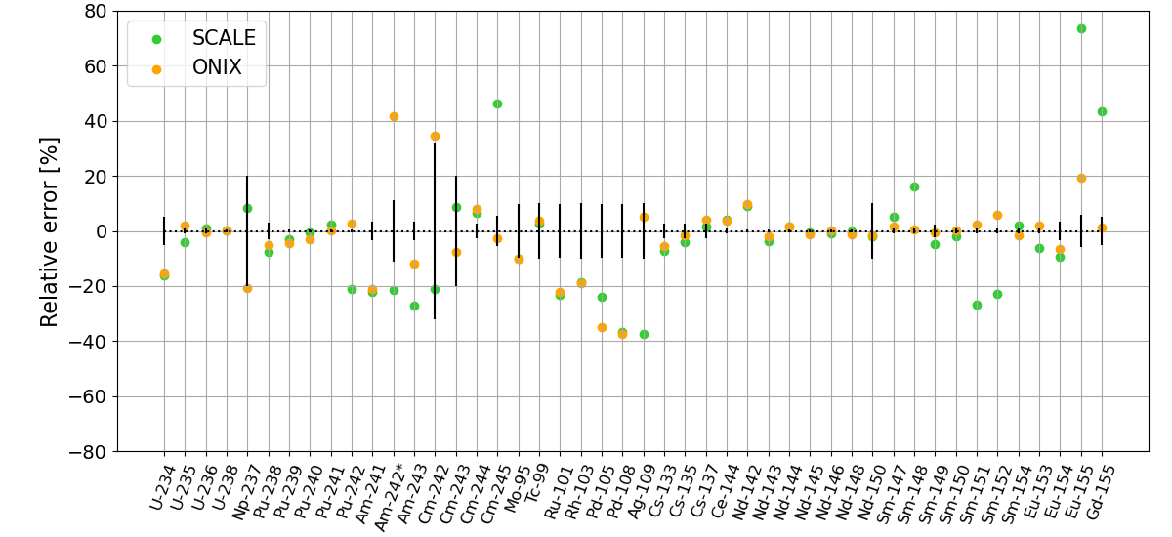
FIG. 3. Relative difference in percent between numerical results from SCALE and ONIX and experimental measurements. The measurement uncertainties for each nuclide are represented with black error bars.

ONIX is currently used by several researchers in various institutions. The software has been applied for various projects including:
- Estimating past nuclear material production in military reactors such as in North Korea and other states [7];
- Selecting best fluence estimators for nuclear archaeology in the North Korea reactor [8];
- Analysing fallout radioactivity from French nuclear tests in polynesia [9];
- Analyzing reactor performances for alternative naval reactor designs [10];
- Verifying that explosive tests carried out for nuclear weapon development respect CTBT terms and do not involve nuclear fission yields [11].

All of these projects focus on basic research, some could not have been carried out with other, export-controlled depletion software.

It is a key goal for the future development of ONIX to ensure that the code remains accessible to all, and that it is accompanied with documentation that will encourage new users and developers to familiarize themselves with the software and contribute to its improvement.

In order to ensure that ONIX can be published as open-source software, an export control expert from Princeton University was consulted at the very beginning of the development process. It was concluded that ONIX, as a product of fundamental research, was not subject to export control control regulations in the United States and could remain open-source after its release.

Developing ONIX has also been an unique opportunity to learn about ways to better encourage other individuals to participate in the development of the software and to use the software. Probably the most important aspect is the development of a clear, comprehensive, and accessible documentation. Our experience recommends producing such documentation as soon as possible and making it accessible online. A very important element of a good documentation is the inclusion of as many examples as possible. Other ways that have been adopted to make ONIX better known to other researchers include workshops, invited talks, and publications.

More generally, open-source software has great potential to provide transparency for scientific results, supports the transfer and long-term retention of knowledge, allows for easily accessible teaching tools, and contributes to capacity building both among developers and users. All these benefits apply to the specific fields of nuclear reactor modelling and nuclear security alike. However, there are particularities: simulation tools for nuclear applications, including reactors, often fall under export controls that aim at preventing proliferation of military nuclear technologies. Even if no military applications are intended, the limitations can create difficulties in the licensing and sharing process of open-source software to which unlimited distribution is a key component. To support researchers and experts in their work, the IAEA could in the future provide guidelines on how to avoid the above mentioned conflicts. This would be in line with the Agency’s mission of assisting Member States “in planning for and using nuclear science and technology for various peaceful purposes” and also be beneficial for the open-source software community at-large.

ONIX is avaiable from https://github.com/jlanversin/ONIX, its documentation at https://onix-documentation.readthedocs.io/en/latest/.

References
- KÜTT, M., Simulation of Neutron Multiplicity Measurements Using Geant4, Ph.D. Thesis, Technische Universität Darmstadt, 2016.
- ROMANO, P.K., HORELIK, N.E., NELSON, A.G., FORGET, B., SMITH, K. C., OpenMC: a state-of-the-art Monte Carlo code for research and development, Ann. Nucl. Energy 82 (2015) 90–97.
- J. DE TROULLIOUD DE LANVERSIN, M. KÜTT, A. GLASER, ONIX: An open-source depletion code, Ann. Nucl. Energy 151 (2021).
- M. PUSA, Rational approximations to the matrix exponential in burnup calculations, Nucl. Sci. Eng. 169 (2011) 155–167.
- S. FETTER, Nuclear archaeology: verifying declaration of fissile-material production, Sci. Global Secur. 3 (1993) 237–259.
- DE TROULLIOUD DE LANVERSIN, op. cit.
- J. DE TROULLIOUD DE LANVERSIN, M. KÜTT, Verifying North Korea’s plutonium production with nuclear archaeology, Sci. Global Secur. (accepted).
- Ibid.
- S. PHILIPPE, T. STATIUS, Toxique: Enquête sur les Essais Nucléaires Français en Polynésie, PUF (2021).
- E. MANÉ, Impact of fuel enrichment on key naval reactor characteristics and non-proliferation concerns, Sci. Global Secur. 28 (2020).
- J. DE TROULLIOUD DE LANVERSIN, F.N. VON HIPPEL, Onsite verification of the comprehensive nuclear test ban at very low yields, in preparation for the INMM & ESARDA Joint Annual Meeting 2021.

