HIGH PERFORMENCE CALCULATION ENHANCEMENT USING MASSIVE PARALLELIZATION WITH TRUST AND TRIOCFD

R. NOP, A. BRUNETON, J. DARONA, E. SAIKALI, U. BIEDER, P. LEDAC, A. KHIZAR, N. DORVILLE, E. ADAM

Université Paris-Saclay, CEA, Service de Thermo-hydraulique et de Mécanique des Fluides, 91191, Gif-sur-Yvette, France.

Email contact of corresponding author: raksmy.nop@cea.fr

- Overview of TRUST/TrioCFD Platform
TRUST/TrioCFD [1] is an open-source platform of fluid mechanics and thermohydraulics developed at CEA. The latter is made up of 2 codes:
- TRUST in which are implemented the general architecture and all the basic IT tools namely the classes and methods necessary to solve basic problems (operators, standard Navier-Stokes, solvers,...). Several advanced codes specialized to treat specific industrial applications are developed at CEA based on TRUST (e.g. steam generator, reactor core, chemical reactions). In each of them, specific advanced models are implemented from the TRUST toolbox and benefit from its massive parallel capabilities;
- TrioCFD is one of the advanced codes developed at CEA based on TRUST. It includes specific and advanced models, particularly in fluid mechanics and heat transfer modelling. TrioCFD is therefore able to solve more complex problems than laminar flows such as turbulent flow models, fluid-structure interactions, multiphase flows or flows in porous media.
This allows the resolution of the incompressible Navier-Stokes equations to which can be added more complex models, according to a specific problem to be investigated (through TrioCFD), and offers massive parallel computing capabilities (through TRUST). Initially, designed for nuclear industry, it can also be used for a wide range of applications. Meanwhile the platform is flexible: its object-oriented architecture developed in C++ allows for the development of target-oriented applications as fast-neutron reactor simulation, nuclear propulsion, but also now fuel cells simulations or chemistry.
The rigorous V&V process of the platform allows continuous integration of developments/corrections. The interested readers may refer to [2].
In 2015, TRUST/TrioCFD was able to handle cases with more than 650 million cells and 1.3 billion degrees of freedom. The computation was performed on 10,000 processor cores [3]. Recently, the needs in terms of modelling precision have greatly increased and TRUST/TrioCFD has been able to adapt: a computation was realized with a mesh of 1 billion elements in 2020, and more recently 2 billion elements in 2021. Technical limitations had to be pushed back and significant improvements were made to the platform to achieve these performances. These improvements will be presented in the next section. Applications with 1 and 2 billion cells will then be presented.
- Parallel computation enhancement
Recently the platform has benefited from several enhancements allowing it to reach new HPC capabilities.
First of all, several I/O processes have been improved: the code used to write some of its output data on an MPI-processor basis, meaning that we had as many files as MPI processors in the computation. While acceptable for small simulation (up to 500-1000 MPI nodes) This becomes un-tractable when reaching 10,000 MPI-nodes or more. This has now been rationalized thanks to the support of the HDF5 format [6]. The data structure remains similar (one piece of data per processor), but a given physical file is now replaced by a corresponding dataset in a single HDF5 file. This strategy has successfully been put in place for the checkpoint/restart files and for the domain splitting information storage, allowing a drastic reduction in the number of i-nodes used on the cluster file system.
Second, the porting of the code to 64-bit long identifiers has been conducted since the 32-bit format was proven too limiting for the mesh sizes at hand in a massive simulation. Indeed the various entities (vertices, faces, volumes) of a 2 billion-element mesh can not be indexed using only 4 bytes (32 bits). The core of the C++ code has been ported as well as various tools coming along with the platform (notably the visualization plugins for the VisIt software).
Finally memory optimisations have been conducted, allowing to reduce significantly the memory footprint of a typical CFD simulation. TRUST/TrioCFD relies heavily on the PETSc sparse linear algebra library [7], and some of the matrices of the computation were not optimally filled (notably the Jacobian matrix used in the implicit numerical schemes).
Thanks to these improvements on the parallelization and performances, TRUST/TrioCFD is now able to handle massive numerical simulations rarely reached by other open-source computational codes. On the following, we present two simulations with mesh sizes above the billion elements, which investigate two industrial cases involving different physical phenomena.
- Example of a 1 billion-element computation in 2020
In 2020, hydraulic forces on fuel assemblies with different sizes of water gaps were computed using TrioCFD [4]. The objectives of this study was to quantify the forces acting on the mixing grids as well as the behaviour of the fuel assemblies in case one of them is not axially aligned. In order to catch the interaction between fuel assemblies, several of them should be simulated, needing a large number of cells. In this work, meshes with up to 1 billion tetrahedrons were used to investigate configurations up to a group of 3 fuel assemblies of 17 x 17 rods with different tilts.
The typical fuel assembly considered is presented in Fig.1 (left) as well as the corresponding mixing grid (Fig.1 center). In order to investigate the forced on the mixing grid as well the flow structure around the the rods, we have considered the calculation domain around the mixing grid as presented in Fig.1 (right).
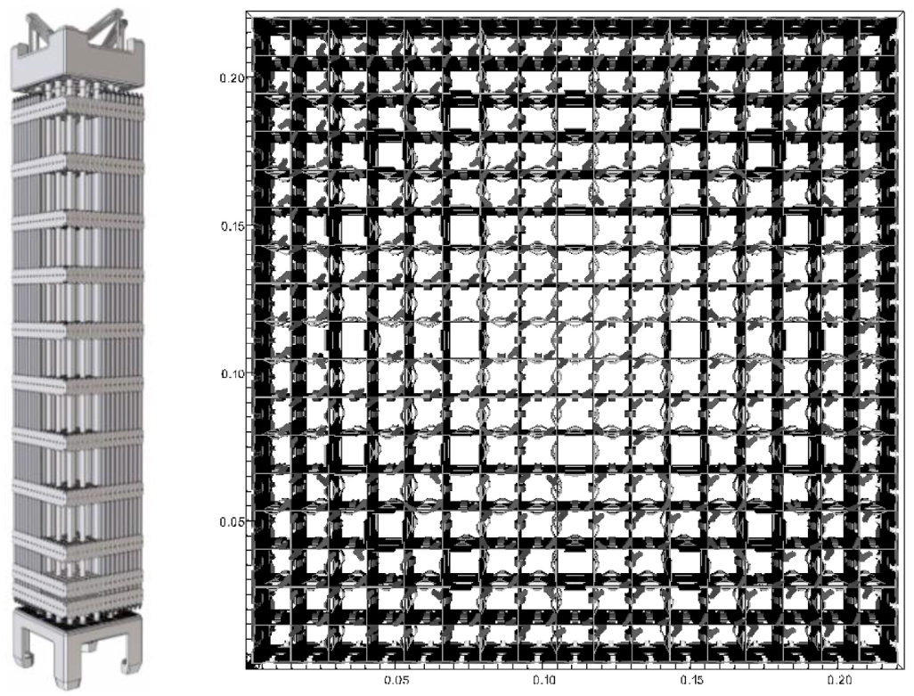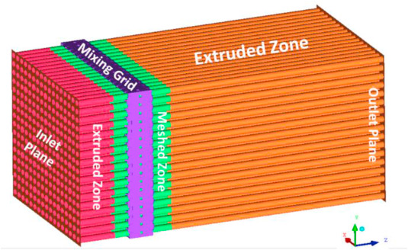
Fig. 1 Geometry overview. Typical fuel assembly (left). Mixing grid of the generic fuel assembly (center). Calculation domain (right) [4]
The problem consists in a forced flow coming from the inlet part with a Reynolds number about 500,000. As only isothermal flow is treated, buoyancy effects are not taken into account. Turbulence is modelled by unsteady Reynolds averaged Navier-Stokes approach (U-RANS) using a k-ε model to compute the eddy viscosity. Besides, the numerical details are summarized in Table 1 and been realized on about 17,000 processor cores.
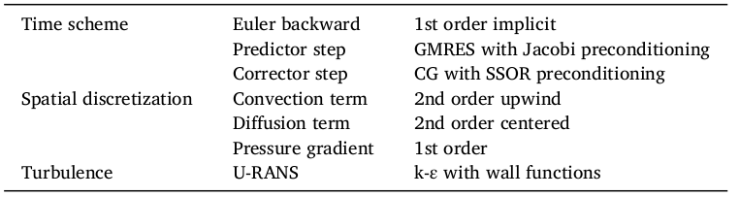
Table 1 Summary of the numerical scheme [4]
From the velocity and pressure fields obtained by the simulation (e.g. Fig.2), we can quantify the forces on the mixing grids and the fuel assemblies. Particularly, the analysis permitted to conclude that the horizontally acting pressure force (Venturi force) affects the fuel assemblies in the reactor core in a way that the force tries to adjust automatically the width of water gaps to similar values (self-stabilizing effect).

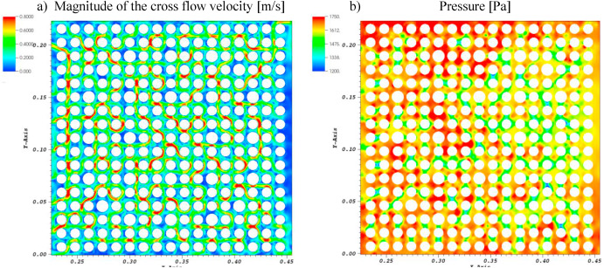
Fig 2. Cross flow velocity (a) and pressure (b) in the inclined assembly at z = 0,35 m [4]

- Example of a 2 billion-element computation in 2021
In 2021, simulations with TRUST using meshes up to 2 billion cells were realized to investigate a hydrogen leakage in a typical two-vented fuel cell configuration. The latter aims to understand the physical behaviour of the plume in such a configuration and to estimate the non-constant entrainment coefficient which is of key importance for industrial models employed for the safety of parking garages containing hydrogen cars. This work realized by Saikali et al. is soon to be published.
The plume resulted from a hydrogen leakage and its entrainment by ventilation is turbulent. Unfortunately, the comparisons with experiments have shown that this turbulent flow and the maximal concentration cannot be properly caught using RANS or LES (Large Eddy Simulation) simulations. It was then necessary to simulate this phenomenon using DNS (Direct Numerical Simulation) where the equations governing the flow are directly simulated. However, the latter approach needs a very fine space resolution and consequently, a large quantity of cells.
This work simulates an experiment in a two-vent cell of one cubic meter presented in [6] and illustrated in Fig.3. At the middle of the bottom square is placed an injector releasing hydrogen with a volumetric flow rate relevant with the application and corresponding to a typical accidental scenario. Two vents located are considered to enhance the passive ventilation. At the injection, the characteristic non-dimensional quantities are given by a Richardson number of about 10 and a Reynolds number of about 160. By the nature of the phenomena involved, various coupled mechanism has to be included in the DNS simulation: forced convection, natural convection and buoyancy which are included in TRUST.
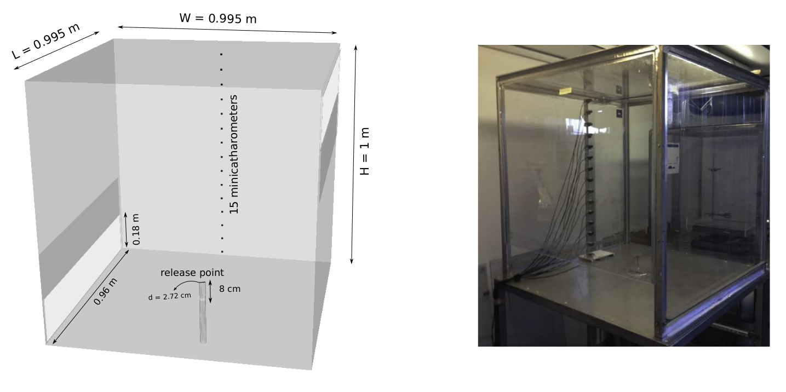
Fig.3 Schematics (left) and photography (right) of the two-vent cell experimental facility
In order to optimize the computational cost, two meshes are used. The computational domain (Fig.4 left) is first discretized as Mesh 1 gathers 250 million cubes (Fig.4 right) distributed over about 5,400 processors for the calculation. It is used to compute the transient from an initial state where the cavity is filled with pure air at rest to reach a quasi steady-state for the velocity field and the hydrogen volume fraction. The problem is computed during a physical time of 175 seconds to ensure to reach the quasi steady-state regime. The results of this computation are then used as the initial condition of the second computation. Mesh 2 gathers 2 billion cubes distributed over more that 50,000 processors. Mesh 2 is generated based on Mesh 1 by dividing each cube into 8 sub-cubes. The given cubes being under the predicted Kolmogorov and Batchlor length scales, the computation using Mesh 2 is then the reference DNS solution.

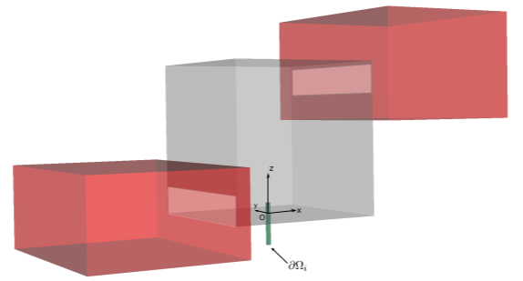
Fig. 4 Schematics of the DNS computational domain with the exterior region in red and the injection pipe in green (left). 2D visualization of Mesh 1 cross-section (right)
The DNS computation enables then to extract various quantities relevant to have a better understanding of the phenomena (turbulent statistics,...) which are not caught by lower resolution simulations such as by using RANS or LES approaches. We can for example observe in Fig.5 that some turbulent structures are only caught by the fine mesh allowed by the parallel computation offered by TRUST. As these results are in really good agreement with the experimental data, they may thus be used as reference data for future work in the community. Moreover, they also permits to compute quantities of interest for industrial applications such as the non-constant entrainment coefficient, which would increase the safety of such facilities and open the door to new analytic approach.
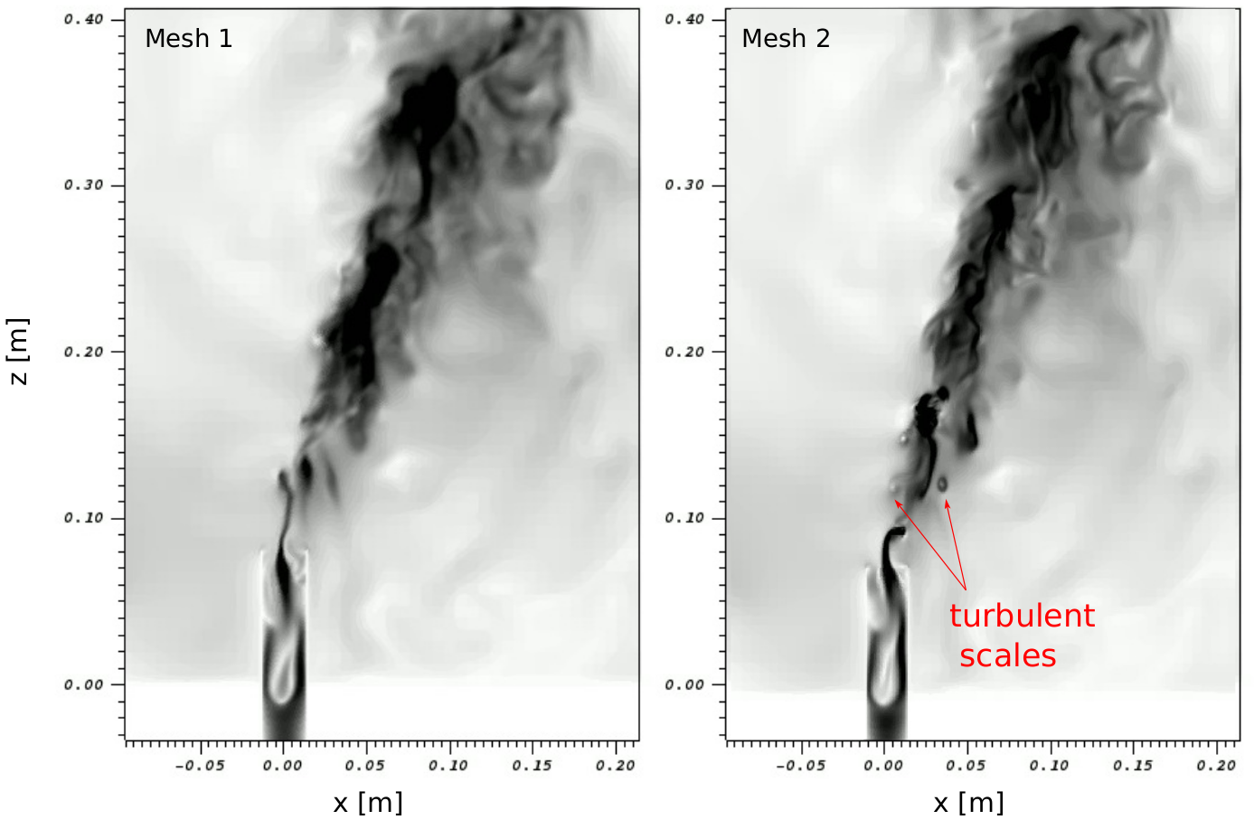
Fig.5 Iso-contour of the norm of the velocity at the vicinity of the release position illustrating the small turbulent scales observed with the mesh 2 (right) but not the mesh 1 (left)

Thanks to the various improvements conducted in the recent years on the architecture of the code and its optimization, the TRUST/TrioCFD platform is now able to perform simulations of more than 2 billion cells on clusters of up to 50,000 processors. This work also proved beneficial to smaller calculations, as the platform also gained in performance for more “common” size simulations on 10, 100, or 1000 processors.

References
- ANGELI P.-E., BIEDER U., FAUCHET G., “Overview of the TrioCFD code: Main features, V&V procedures and typical applications to engineering”, NURETH-16, Chicago, IL, August 30-September 4, 2015
- BRUNETON A., DARONA J., NOP R., P. LEDAC P., SAIKALI E., KHIZAR A., BIEDER U., DORVILLE N., ADAM E., “Verification & Validation process in the open-source TRUST/TrioCFD platform, Technical Meeting on the Development and Application of Open-Source Modelling and Simulation Tools for Nuclear Reactors, Vienna, AUSTRIA, October 27-29, 2021
- BIEDER U., FAUCHET G., C. CALVIN C., “High performance Large Eddy Simulation of turbulent flows around PWR mixing grids”, Proceedings of 16th IEEE International Conference on High Performance Computing and Communications (HPCC 2014) - First International Workshop on HPC-CFD in Energy/Transport Domains, Paris, FRANCE, August, 2014.
- BIEDER U., GENRAULT C., LEDAC P., Hydraulic forces acting on full cross section fuel assemblies with 17×17 fuel rods, Progress in Nuclear Energy, Volume 130, 2020.
- BERNARD-MICHEL G., HOUSSIN-AGBOMSON D., Comparison of helium and hydrogen releases in 1 m3 and 2 m3 two vents enclosures: Concentration measurements at different flow rates and for two diameters of injection nozzle, International Journal of Hydrogen Energy 42, 7542 (2017), ISSN 0360-3199.
- HDF5 file format - https://www.hdfgroup.org
- PETSc numerical library - https://www.mcs.anl.gov/petsc

