DEVELOPMENT OF POST PROCESSOR FOR VSOP’94 OUTPUT

ANIK PURWANINGSIH
National Nuclear Energy Agency
South Tangerang, Indonesia
Email: aniq@batan.go.id

NURSINTA ADI WAHANANI
National Nuclear Energy Agency
South Tangerang, Indonesia

VSOP’94 is one of the reliable software for reactor core design simulation which includes neutronic aspects, thermal-hydraulic aspects and economic aspects[1,2]. The VSOP output data is still displayed in text-based form which of course takes time to read the data and analyze the results[2]. Therefore a post processor was built in the form of a GUI to display important output data such as neutronic output data and thermal-hydraulic output data. This post processor is built based on open source using python language. Python is a freeware, multiplatform and reliable programming language[3]. The features of the post processor that have been built include features for displaying output data in the form of tables, 2D graphics and 3D contours.
Neutronic output display (example):
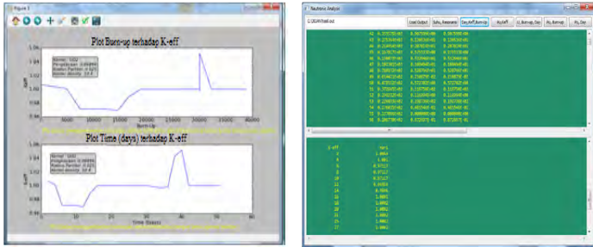

Fig. 1. Plot burn-up vs K-eff

Thermal-hydraulic output display (examples):
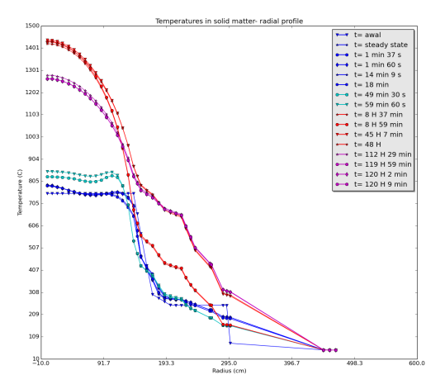

FIG. 2. Temperature profile radially based on time

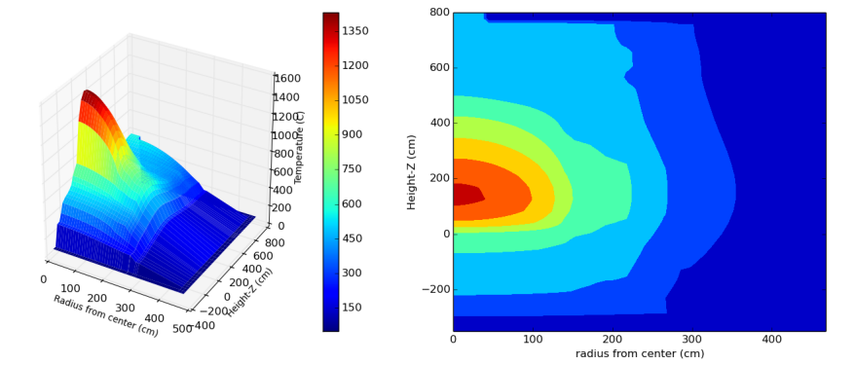

FIG.3. Contour of temperatures in solid matter after simulated for 120 hours 9 minutes 59.7 seconds

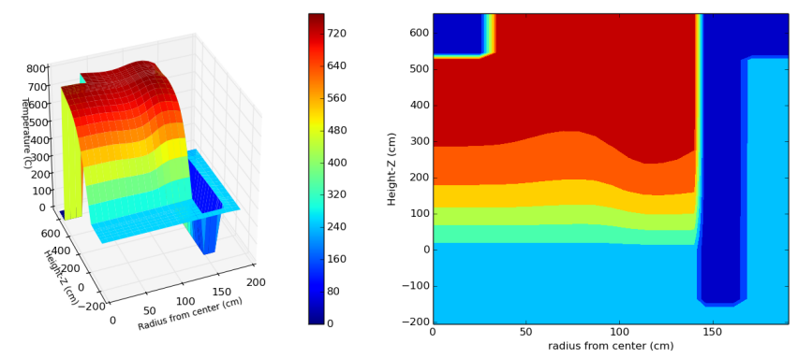
FIG.4. Contour of Fluid temperature

This post processor is expected to be useful for simplifying the interpretation of the VSOP'94 output, so that the output display is more informative and for further analysis it can be easier. Currently, the output displayed is limited to our needs, and it is possible to be developed further according to other needs. Anyone can improvements or add features to the code that we have built. This post processor is still wide open for further development such as coupling with other relevant software.
References
- CHEN F., et al., “Benchmark calculation for steady state temperatures distribution of the HTR-10 under full-power operation”, Journal of nuclear science and technology, vol.46, No.6, (2009) 572-580.
- RUTTEN H.J., et al, “VSOP'(94) Computer code System for Reactor Physics and Fuel Cycle Simulation-input manual and comments”, Berichte des Forschungszentrums Julich, April (1994).
- TOSI S., “Matplotlib for python developers “Packt Publishing Ltd., Birmingham (2009).

