Investigating efficient coupling of Finite Element Analysis with Machine Learning to optimise a laboratory experiment.

R. Lewis^{1,2}, Ll.M. Evans^{1,2}, R. Otin², K. Leng³, A. Davis²,

A.D.L. Hancock², J. Thiyagalingam³, P. Nithiarasu¹

¹ College of Engineering, Swansea University, Swansea, United Kingdom.
² United Kingdom Atomic Energy Authority, Culham, United Kingdom
³ Science and Technology Facilities Council, Didcot, United Kingdom

Corresponding author: llion.evans@swansea.ac.uk

Abstract
The Heating by Induction to Verify Extremes (HIVE) testing facility at the UK Atomic Energy Authority is a high heat flux experiment to research and develop plasma-facing components for fusion devices. Induction heating delivers the extreme thermal loads to a component while high-pressure coolant passes through it.
Performing these experiments is expensive, therefore it is imperative that the experimental parameters are correctly chosen to deliver the desired behaviour. Currently this inverse problem is solved using memories, experience, and gut-feeling of an experienced operator. A fully automated open-source framework, VirtualLab, has been developed which couples simulation with machine learning to solve the inverse problem posed by HIVE, giving the operator a selection of input parameters which deliver the desired condition.
Using the HIVE simulation created in VirtualLab, results at discrete points across the parameter space are evaluated. This data is used to train a Gaussian process regression model, creating a continuous mapping of inputs to outputs across the entire parameter space. This enables regions of interest, such as optima, in the parameter space to be quickly and easily identified for further investigation using the HIVE facility.
The framework developed utilises high performance computing clusters to dramatically reduce the time taken to generate and analyse the data, enabling rapid iterations of the engineering design cycle.
This is an example of human-machine collaboration guiding, but not making, decisions which is becoming an increasingly important and useful tool in a wide variety of fields.

1. Introduction
Fusion energy has the potential to supply the ever-growing energy requirements of the human race with a clean, sustainable energy source, however there are several challenges to overcome before this potential is realised [1]. One of these is the construction of a commercially viable machine which can routinely withstand the extreme environments fusion requires. The Heating by Induction to Verify Extremes (HIVE) testing facility at the UK Atomic Energy Authority (UKAEA) was established to research and develop the plasma-facing components (PFC) which experience the most severe thermal loads. Induction heating delivers up to 20 MW/m² of surface power to a component to replicate in-service loads, while components are actively cooled using high-pressure coolant.

HIVE’s main goal is to develop PFCs with improved component lifespan. This can be achieved by diffusing the surface thermal loads through the component, in a way which reduces thermal expansion related stresses particularly in regions of geometric features or bonding between dissimilar materials. Doing so increases the ratio of mean time between failure (MTTF) and mean time to repair (MTTR), a crucial metric for any commercially viable power plant.

Performing these experiments is expensive due to their high-power usage and the setup time required. Due to cost and limited opportunity it is crucial that the experimental parameters, such as induction coil design, coolant temperature and coil power, are correctly chosen to ensure that the desired behaviour is delivered. Currently, this inverse problem is solved by relying mostly on previous experiences of HIVE operators, however this knowledge takes years to build and is quickly lost through staff turnover, for example. In this work a more sustainable, robust, and accurate approach to solving inverse problems using machine learning (ML) is presented.

2. Methodology
While there are a plethora of experimental parameters in HIVE, the work presented here focuses on a subset of these relating to the design and orientation of the induction coil. The design of the induction coil significantly effects the heating profile imposed on the surface of the component [Fig. 1]. Moving the coil closer to the component increases the power delivered to the sample, however it also increases the unevenness of the heating profile. The thermal loads experienced by PFCs in a fusion device during normal operations are locally uniform with variations occurring over a larger length scale. Therefore, it is desirable to achieve as uniform a heat load as possible with HIVE to better replicate these conditions.
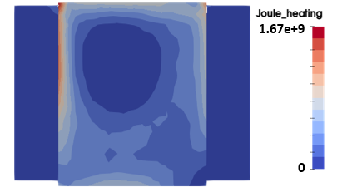
FIG. 1. Non-uniform heating profile generated due to coil design.

The configuration of the component with respect to the coil has 4 degrees of freedom (DoFs); displacement in x, y and z and rotation, Ω, along the y-axis, along which the coolant pipe sits [Fig. 2]. The inverse problem is then simply; which combination of these 4 DoFs results in a desired behaviour, such as maximum power or minimum variation of the heating profile?
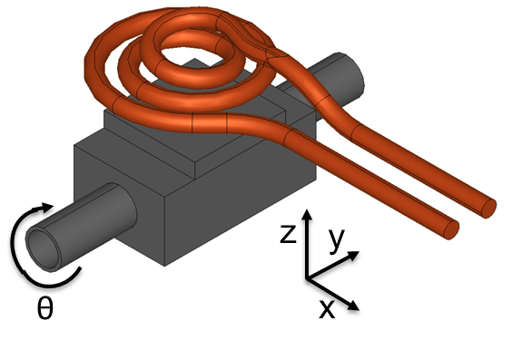
FIG. 2. Sample orientation with respect to coil.

Over the past three decades ML has been successfully applied to several research fields in computational mechanics [2]. More recently, ML has been adopted to solve the inverse problems which arise in a variety of applications in science and engineering [3]. Neural networks (NN) and its variations are commonly chosen due to their success in extracting high level features from data [4], however they are an extremely ‘data hungry’ algorithm. Given that computationally expensive simulation data is generated to feed to a ML algorithm it is desirable to choose one which provides maximum insight for minimal data.

Gaussian process regression (GPR) takes a Bayesian approach to regression and has demonstrated excellent performance using small datasets [5]. Also, GPR requires choosing only a few hyper-parameters, with the kernel which describes the covariance of the random variables in the Gaussian process the most influential. The radial basis function (RBF) kernel was chosen for this work as it is continuously differentiable, an essential condition for this work. All hyper-parameters chosen for this work are shown in Table 1.
Table 1. GPR hyper-parameters

Likelihood | Gaussian likelihood (fixed noise)
Mean | Constant mean
Kernel | Radial basis function

This GPR model was implemented using the GPyTorch package [6], with a graphical representation of the model shown in Fig. 3. This model creates a continuous mapping of inputs to outputs from a set of discrete data points in the parameter space. Given this and the models differentiability, regions of interest (ROI) in the parameter space, such as maximum power, can be easily identified using an optimisation package, such as scipy.optimize.

Gaussian Process Regression
x
y
z
Ω
Power
Variation
FIG. 3. Graphical representation of GPR model.

A fully-automated and parameterizable simulation of the HIVE experiment has been developed using VirtualLab, an open-source package developed by the authors, which enables ‘virtual experiments’ to take place. It combines the open-source packages SALOME, CodeAster and ERMES to generate CAD geometries and perform FEA analysis. Due to VirtualLab’s modular nature, alternative FEA packages could be used to perform analyses. Utilising VirtualLab’s multi-node and high throughput computing (HTC) capabilities, a large number of simulations can be performed for a variety of experimental parameters in a very short space of time, allowing rapid iterations of the engineering design cycle.

Simulation data is collected and passed to the GPR model for training seamlessly within VirtualLab. Given the desire to run a minimal number of simulations, a variety of sampling techniques are investigated to see which provides the most insightful points in the parameter space for training the GPR model:

- Random - Sample points are chosen at random from the parameter space using a uniform distribution [Fig 4.a];
- Halton - Quasi-random sample points are chosen based on the Halton sequence [7] [Fig 4.b];
- Adaptive: New sample points are decided based on previously collected points [Fig 4.c]. In this example there is a peak at the origin, resulting in increased sampling there.

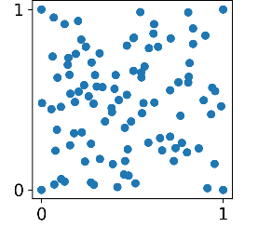 | 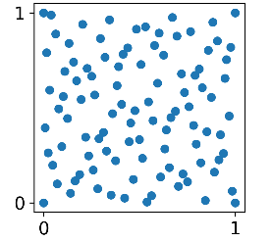 | 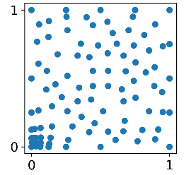
FIG. 4. Sampling techniques in 2D; a) Random (left), b) Halton, c) Adaptive.

The success of each sampling method is measured by looking at the mean squared error (MSE), between the model’s prediction and the exact value for a test dataset, Eq. (1), and the accuracy of the prediction for maximum power, the inverse problem demonstrated here.
MSE = $\frac{1}{n}\sum_{i=0}^{n}{{\left(x_{i,GPR}-x_{i,Exact}\right)}^{2}}$ | (1)

3. Results & Discussion
GPR models were trained for increasing number of data points for each sampling method to assess their performance and data requirements for convergence. The same 100 data points were used in the test dataset for consistency. The MSE on the test and train datasets for each sampling method is shown in Fig. 5. Initially, the MSE is small for the training data and high for the test data, which is caused by the model over-fitting to the small number of data points available. As the number of data points used for training increase, the MSE for the test data decreases rapidly, highlighting that the model generalises to unseen data much better and is no longer over-fitting. The small increase in MSE for the training data is also attributed to this.

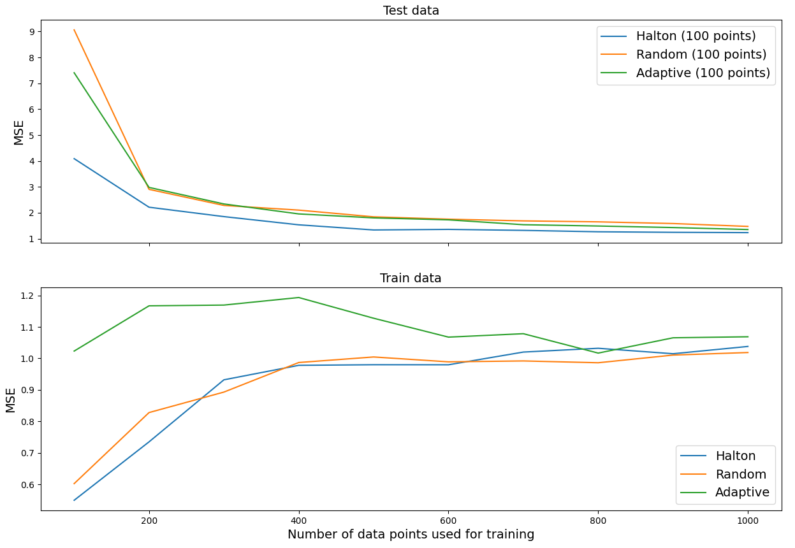
FIG. 5. MSE for test and train data for each sampling method.

For each sampling technique there is only very slight improvement in the test MSE as the training dataset size increases over 500, with the Halton sampling technique clearly outperforming the others.

While MSE infers the accuracy of the model across the entire parameter space, to ensure the optimal configuration is found it is essential that it is highly accurate in ROIs. The predicted and actual power at the configuration recommended by the GPR model for maximal power is shown in Fig. 6. The adaptive method performs the best in this regard, however this can be attributed to fact that this is the only method which places data points on the boundaries of the parameter space, where this optimum is located.
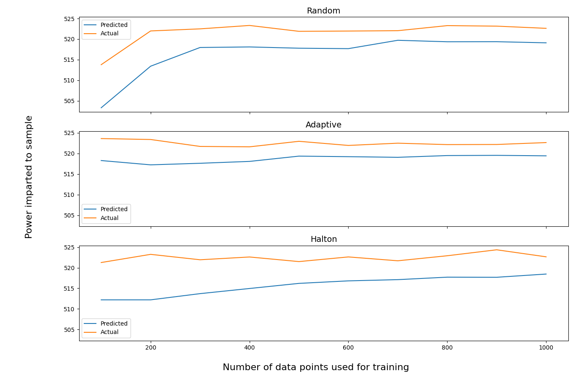
FIG. 6. Predicted and ground truth power for maximum power configuration.

To overcome this, a hybrid simulation-ML sampling technique is proposed. Using an aforementioned technique, an initial number of data points are collected to train a GPR model. ROIs in the parameter space are then identified using the model, with data points collected in this region to improve the model’s accuracy in its vicinity. Using the Halton technique, 400 data points are collected. There is a dramatic improvement in the model's accuracy in the ROI of maximal power by including only 5 additional points nearby [Fig. 7]. As a result, an improved maximum power configuration is identified with fewer than 450 data points using the hybrid method compared with 1000 points for the original methods.
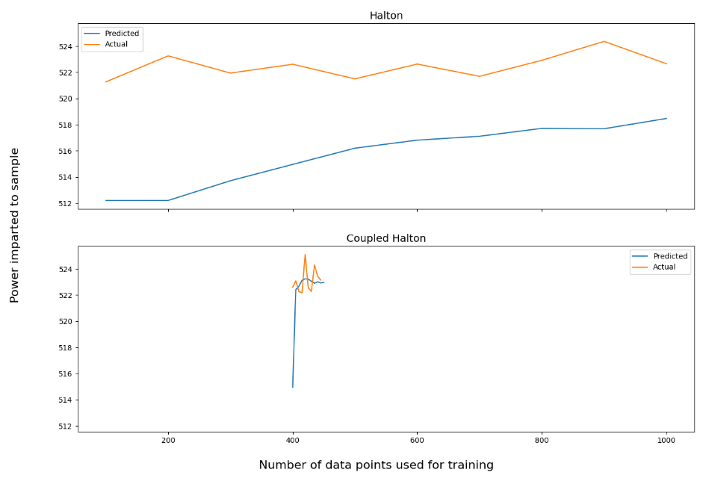
FIG. 7. Improvement in optimal configuration with hybrid approach.

The performance of the hybrid approach over the entire parameter space must also be considered [Fig. 8]. The sudden increase in training MSE can be attributed to the model's inability to fit to all the points in the densely sampled ROI. More importantly the test MSE remains largely constant, showing that the model still generalises well over the entire parameter space even with substantial improvement in the ROI, highlighting the success of this approach.

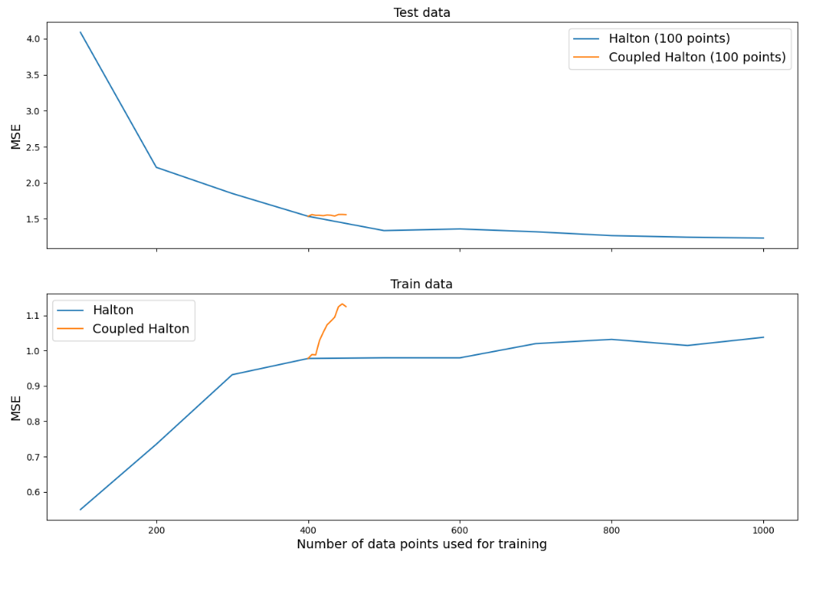
FIG. 8. Changes in MSE with coupled approach.

4. Conclusion
This work has presented how combining simulation data with ML can maximise the effect of experimental facilities. Using GPR models trained on simulation data, one of the many inverse problems posed by HIVE is solved. While standard sampling techniques showed good global performance, their accuracy in the ROI were often unsatisfactory. Using the hybrid approach to advise areas to densely sample resulted in a substantial improvement in performance in these regions without affecting the global performance.

Acknowledgements
This work has been carried out within the framework of the EUROfusion Consortium and has received funding from the Euratom research and training programme 2014-2018 and 2019-2020 under grant agreement No 633053 and from the RCUK Energy Programme [grant number EP/I501045] and EPSRC [grant number EP/R012091/1]. The views and opinions expressed herein do not necessarily reflect those of the European Commission.
We acknowledge the support of the Supercomputing Wales project, which is part-funded by the European Regional Development Fund (ERDF) via Welsh Government.

References
- Donné, A.J. H., The European roadmap towards fusion electricity, Phil. Trans. R. Soc. A.3772017043220170432 (2019)
- Kim, S.H., Boukavala, F., Machine learning-based surrogate modeling for data-driven optimization: a comparison of subset selection for regression techniques. Optimization Letters, Vol. 14, 989-1010, 2020
- Tamaddon-Jahromi, H.R., Chakshu, N.K., Sazonov, I., Evans, Ll.M., Thomas, H., Nithiarasu, P., Data-driven inverse modelling through neural network (deep learning) and computational heat transfer, Computer Methods in Applied Mechanics and Engineering, Volume 369, 2020,
- LeCun, Y., Boser, B., Backpropagation applied to handwritten zip code recognition, Neural computation, 1989.
- Sit, H., Quick start to Gaussian process regression, 2019, https://towardsdatascience.com/quick-start-to-gaussian-process-regression-36d838810319
- Gardner, J.R., Pleiss, G., Bindel, D., Weinberger, K.Q., Wilson, A.G., GPyTorch: Blackbox Matrix-Matrix Gaussian Process Inference with GPU Acceleration, 2019, arXiv: 1809.11165
- The Halton Sampler, http://www.pbr-book.org/3ed-2018/Sampling_and_Reconstruction/The_Halton_Sampler.html, 2021

