USE OF OPEN-SOURCE MODELICA-BASED LIBRARIES AS SYSTEM CODE FOR NUCLEAR POWER PLANT SIMULATION

S. LORENZI
Politecnico di Milano
Milano, Italy
Email: stefano.lorenzi@polimi.it

A. CAMMI
Politecnico di Milano
Milano, Italy

In the analysis of nuclear systems, a particular role is played by the system thermal-hydraulics codes. These simulation tools are aimed at analysing the thermal hydraulics behaviour of the different components located in the circuits of a nuclear power plant during operational, transients and accidental conditions [1]. The outcomes of the investigation are used for the evaluation of the performances during operational transients even if their main use is the assessment of accidental scenarios. For this reason, a large effort has been spent from the very beginning of the code development era in the nuclear industry to provide these codes with reliable simulation capabilities [2]. This led to the development of “legacy codes” in this field (RELAP, CATHARE, ATHLET, TRACE, …) that are based on conservation equations for mass, momentum and energy for the fluid of interest in a mono (axial) dimensional framework. This approach is then integrated with correlations for closure equations (typically for friction loss and for heat transfer) derived from and validate with separate effects or integral experiments [2]. Especially for two-phase flows, these correlations should cover different flow regimes and parameters, being a complex challenge both from numerical and validation point of view [3]. Given the resources spent in the validation of these tools and in the development of ad-hoc correlations, usually these codes are not open-source but subject to restrictions dictated by the developer institution and relative license.
It should be acknowledged that it is not realistic, at least in the short term, substituting these codes in the deterministic safety analysis of existing reactors because of the developed status in terms of validation. On the other hand, finding an open-source alternative for the modelling of thermal hydraulics components and circuits is still worthy in case the modelling of ex-core components is required (e.g., steam generators, primary and secondary circuits, balance of plant,…). An interesting option is represented by the Modelica language [4]. Modelica is a modern modelling language used for the simulation of physical and engineering systems [5]. It features different characteristic that make it suitable for being use as system thermal-hydraulics code also in the nuclear field, namely:
- It is object-oriented, granting a hierarchical structure, inheritance, abstraction and encapsulation that provide modularity, openness and efficiency to the modelling tool;
- It is declarative, focussing on what the models should describe rather than how the model is solved
- It is equation-based, solving Differential Algebraic Equation (DAE) systems rather than ODE for a better implementation of engineering first principles;
- It features acausal modelling, not specifying the classic input/output relationship but granting a more flexible and efficient data flow;
- It is component-oriented, allowing a description of single system components (or objects) in terms of physical equations and handling the connections among them through standardized interfaces (or connectors). In Fig. 1, an example of a pipe modelling is depicted with the connectors for fluid and thermal part where in Fig. 2 the declarative Modelica code for the mass, momentum and energy is reported.

The latter point – in addition to a more realistic representation of the plant – allows the creation of libraries of power plant components that can be reused not only in the same model but in other power plant configuration. Several already validated libraries are available from which the nuclear community can take advantage without the need to start from scratch (https://modelica.org/libraries.html).

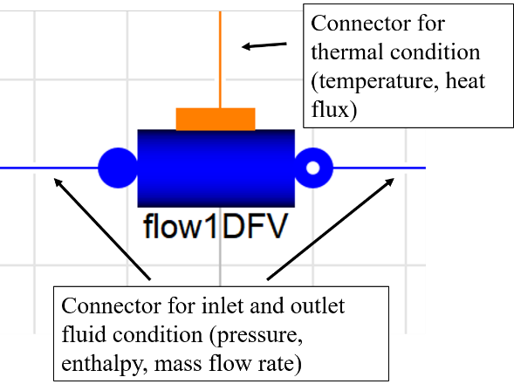
FIG. 1. Pipe component from the ThermoPower library.
FIG. 2. Modelica code for the mass, momentum and energy balance for the pipe component of Fig. 1.
Other advantages brought by the use of Modelica are:
- the presence of already validated components, especially the conventional ones;
- the possibility to develop ad-hoc components as extension of some base classes. In addition to that, ad-hoc correlations (e.g., for pressure drops and heat transfer coefficients) suitable for nuclear plant conditions can be easily adopted and implemented, especially for the different flow regimes. In the framework of open data paradigm – especially in terms of separate effect of integral experiments –, this can constitute a remarkable step for the thermal hydraulics community;
- open-source allows investigating the modelling approach used for each component, possibly improving or tuning the model approach to the specific use (e.g., avoiding the risk of over modelling). Open-source will help also for V&V process since errors will be more easy to detect;
- possibility to couple the Modelica-based model with other modelling approach through the Functional Mockup Interface [6].

Being Modelica a modelling language, it requires a simulation environment to be used. There are different proprietary options, even if open-source implementation can be considered through OpenModelica [7]. It is worth to mention the development of open-source Modelica-based libraries it is independent from the simulation environment meaning that the same library can be used both for proprietary and open-source software.
Modelica is currently used in different fields as automotive, robotics, thermo-hydraulic and mechatronic systems. Several applications involve also the nuclear simulation field. Different libraries have been developed at Politecnico di Milano for the development of power plant simulator for control purposes for ALFRED reactor [8], IRIS reactor [9] and MSFR reactor [10] and for the design and validation of phenomena related to the natural circulation [11]. The employed libraries are:
- ThermoPower is an open-source Modelica library for the dynamic modelling of thermal power plants and energy conversion systems [12]. It provides basic components for system-level modelling, in particular for the study of control systems in traditional and innovative power plants and energy conversion systems. The library has been also extended in order to consider distributed heat generation for the modelling of DYNASTY facility .
- NuKomp is a library of nuclear components for the modelling of nuclear power plants [9]. It provides modelling for pressurizer, reactor core (point kinetics neutronics, reactivity feedback, thermal model for fuel pins), steam generators.
- MSR is a library conceived for the modelling of molten salt systems [10]. In addition to the molten salt properties, the library allows for the modelling of the fuel circuit of a MSR taking into account the drift of delayed neutron precursors, both in the neutronics and the thermal-hydraulics and the decay heat distribution along the circuit.

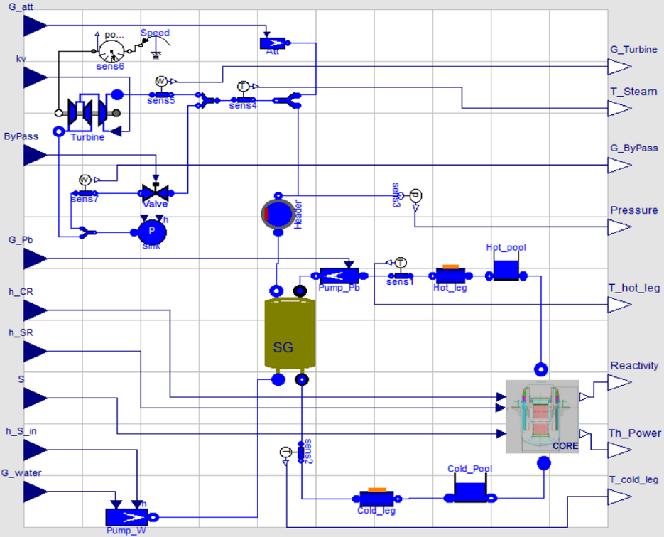
FIG. 3. Power plant simulator for the ALFRED reactor developed in Modelica.
Verification and validation facility have been performed in the past and are ongoing currently. As for verification, Modelica-based model have been compared with the outcome of RELAP [13] and TRACE [14] for IRIS and MSFR reactors, respectively . In terms of validation, a remarkable effort is ongoing through the first experimental campaign of the DYNASTY facility.

In conclusion, Modelica language represents a viable option for the open-source modelling of nuclear power plants components from a system point of view. Even if it cannot substitute the use of legacy system codes for safety analysis due to the lack of validation in accidental conditions, it turns out to work for control applications or operational transients. In this light, it may also provide a tool to be coupled with multiphysics code in order to provide the latter with a more realistic plant behavior.

References
[1] BESTION, D., “The structure of system thermal-hydraulic (SYS-TH) code for nuclear energy applications”, Thermal-Hydraulics of Water Cooled Nuclear Reactors, Elsevier (2017) 639–727.
[2] PETRUZZI, A., D’AURIA, F., Thermal-Hydraulic System Codes in Nulcear Reactor Safety and Qualification Procedures, Science and Technology of Nuclear Installations, Vol. 2008 (2008).
[3] SALOMON LEVI, Two-Phase Flow in Complex Systems | Wiley, WILEY, Ed, (199AD).
[4] THE MODELICA ASSOCIATION, Modelica 3.2.2 Language Specification, www.modelica.org.
[5] FRITZSON, P., Modelica A Cyber-Physical Modeling Language and the OpenModelica Environment, IWCMC 2011 - 7th International Wireless Communications and Mobile Computing Conference, (2011) 1648–1653.
[6] BLOCHWITZ, T. et al., The Functional Mockup Interface for Tool independent Exchange of Simulation Models, Proc. 8TH Int. Model. Conf. (2011).
[7] OpenModelica, https://www.openmodelica.org/.
[8] PONCIROLI, R., BIGONI, A., CAMMI, A., LORENZI, S., LUZZI, L., Object-oriented modelling and simulation for the ALFRED dynamics, Prog. Nucl. Energy 71 (2014) 15.
[9] CAMMI, A., CASELLA, F., RICOTTI, M.E., SCHIAVO, F., Object-Oriented Modeling, Simulation and Control of the IRIS Nuclear Power Plant with Modelica, Proceedings of the 4th International Modelica Conference, (2005) 423–432.
[10] TRIPODO, C., DI RONCO, A., LORENZI, S., CAMMI, A., Development of a control-oriented power plant simulator for the molten salt fast reactor, EPJ Nucl. Sci. Technol. 5 (2019).
[11] LUZZI, L. et al., Assessment of analytical and numerical models on experimental data for the study of single-phase natural circulation dynamics in a vertical loop, Chem. Eng. Sci. 162 (2017).
[12] CASELLA, F., LEVA, A., Modelling of thermo-hydraulic power generation processes using Modelica, Math. Comput. Model. Dyn. Syst. 12 1 (2006) 19.
[13] CAMMI, A., RICOTTI, M.E., CASELLA, F., SCHIAVO, F., New Modelling Strategy for IRIS Dynamic Response Simulation, 5th International Conference on Nuclear Option in Countries with Small and Medium Electricity Grids, (2004).
[14] A. CAMMI, S. LORENZI, C. TRIPODO, A. LAUREAU, E. MERLE, D. GERARDIN, D. HEUER, K. MIKITYUK, D.L.C., D1.4, Safety Issues of Normal Operation Conditions, SAMOFAR Project, (2019).

