A Framework for Multi-physics modeling, design optimization and uncertainty quantification of fast spectrum liquid fuel molten salt reactors

S. ¹, D. HOLLER¹, M. AVRAMOVA¹, K. IVANOV¹

¹North Carolina State University, Raleigh, USA

Email: sbhaska2@ncsu.edu

The majority of tools for modeling and simulation (M&S) of nuclear reactors have historically been focused towards simulating light water reactors (LWRs). This is due to the large operational experience of the current power reactor fleet which consists mainly of Generation II type systems. Only recently has there been appreciable development of tools for modeling Generations III, III+, IV (Gen-IV) type systems including Liquid Fuel Molten Salt Reactors (LFMSRs). The analysis of LFMSRs during steady state, operational transients and accident scenarios require addressing unique reactor multi-physics challenges with coupling between thermal hydraulics, neutronics, inventory control and species distribution phenomena. This strong coupling that exists between different physics makes the uncertainty analysis even more challenging. Dependencies and non-linear interactions between many inputs and outputs add to the complexity of the uncertainty study. To further the development of LFMSR concepts, a general framework for multiphysics modeling, design optimization, and uncertainty quantification is needed. This framework should also utilize advanced modelling approaches and an uncertainty quantification (UQ) technique that comprises of various statistical tools which propagate the input uncertainties through the entire modelling framework. The key is to identify the M&S and UQ codes that should be used as part of the framework to model the different multi-physics phenomena that impose the potential challenges to modeling and simulation of the reactors.
The M&S codes used in this work to analyze an LFMSR are the General Nuclear Field Operation and Manipulation (GeN-Foam) and System Analysis Module (SAM) codes. The GeN-Foam code is based on the OpenFOAM C++ library and capable of performing coupled fine/coarse mesh thermal-hydraulics calculations, multi-group neutrons diffusion calculation, and thermo-mechanics calculation using both structured and unstructured meshes [1]. The SAM code is an advanced Finite-Element Method (FEM) based system code that is currently being developed at Argonne National Laboratory [2]. The SAM code was built with the Multi-physics Object Oriented Simulation Environment (MOOSE) and uses open-source software packages such as the Portable Extensible Toolkit for Scientific computations (PETSc) and LibMesh to significantly reduce computational time and expense required to develop new applications.
The design adopted for this work is based on the results of the Evaluation and Viability Of Liquid fuel fast reactor system (EVOL) project in Europe [3]. Initially, a right circular design was chosen for its simpler modelling, but its flow paths caused recirculation zones [4]. These are not desired as they allow coolant to retain heat energy and may degrade the reactor vessel with thermal striping. A new core geometry based on an hourglass shape [5] was modelled that can avoid the presence of recirculation zones. Phenomena identification alone was not sufficient after the preliminary reactor design was chosen and must be followed with studies exploring the impact of phenomena on the reactor system during both steady state and transient scenarios. This can be accomplished through Computational Fluid Dynamics (CFD) and system level modeling. Detailed studies of the reactor geometry need to be performed by quantifying the uncertainties related to as many design parameters as possible.
FIG. 1. Layout of the Molten Salt Fast Reactor Circuit
The proposed framework to perform M&S, design optimization, UQ, and safety analysis under one umbrella and is presented in Figure 2. This framework also aims to establish a protocol for the study and analysis of LFMSRs which can later be expanded to other advanced reactors.
FIG. 2. General framework for Uncertainty Quantification
The statistical analysis tool Dakota was successfully coupled with GeN-Foam to perform high fidelity UQ studies. The coupling was verified by sampling thermophysical properties using Latin Hypercube Sampling (LHS) from a normal distribution of the property and studying the impact on two parameters, temperature (in Kelvin) and pressure difference ΔP (in Pa).
Previous work has shown the potential of the SAM code to model a molten salt system [6]. With the inclusion of point kinetics and the capability to solve for multi-physics in a coupled fashion, a SAM/Dakota coupling can serve as a reasonable checkpoint to compare the results with GeN-Foam/Dakota and identify the information loss that comes with using a system code. This comparison will also help to develop reduced-order or surrogate models more efficiently.
An important development step as part of the proposed framework is to define a safe operating zone for the LFMSR design under consideration by accounting for the thermal limits set by limiting safety systems settings (LSSS) [7]. The LSSS thermal limits for a LFMSR system are defined as follows:
- Fuel-coolant temperature should be higher than the melting point and lower than the boiling point with an error margin of 10%.
- To ensure the integrity of the pressure vessel, the average bulk outlet temperature of the reactor must remain below the structural material’s maximum allowable operational temperature.
The LFMSR design chosen for this study comprised of sixteen loops with every loop consisting of the core, a heat exchanger and pump. The parameterized cross-sections were generated using the infinite medium model in the Serpent 2 code and then a MATLAB script was used to prepare the cross-sections for GeN-Foam. The thermophysical properties used to set up the case are shown in Table 1 [5]. To save computational time, one-sixteenth of the core was modeled, and symmetry boundary condition was assigned to the lateral surface of the core component and wall-boundary conditions were used everywhere else to avoid crossflow. Vacuum boundary condition was used for the neutron flux at the walls.
TABLE 1. FUEL SALT DESIGN PARAMETERS FOR PRIMARY LOOP

Parameter | Value | Units
Density | 4200 | kg/m³
Specific Heat Capacity | 950 | J/kg-K
Dynamic Viscosity | 0.00217 | Pa-s
Thermal Expansion Coefficient | 0.000464 | 1/K
Thermal Conductivity | 0.7 | W/m-K
Power, mass flow rate and heat transfer coefficient (HTC) were varied, and particular attention was given to the maximum and minimum salt temperatures within the primary loop. Every case was tested against the thermal limit criteria given in Table 2 (which has adopted values from [8]) to determine a safe operating zone.
TABLE 2. THERMAL LIMITS CRITERIA

Parameter | Value | Units
Salt Melting Temperature | 739 | K
Salt Boiling Temperature | 1673 | K
Maximum Hastelloy N Operational Temperature | 990 | K
Maximum SS 316L Operational Temperature | 1658 | K
The analysis was performed for two different power levels (25 MW_{th}/loop and 50 MW_{th}/loop), three different HTC (1000 W/m²K, 2500 W/m²K, 5000 W/m²K) and three different pump momentum heads (5000 Pa/m, 10000 Pa/m, 20000 Pa/m). Figures 3 and 4 show that design indices 5 (25 MW_{th}, 2500 W/m²K, 10000 Pa/m) and 9 (25 MW_{th}, 5000 W/m²K, 20000 Pa/m) are the only designs that lie within the safe operating zone for the LFMSR.
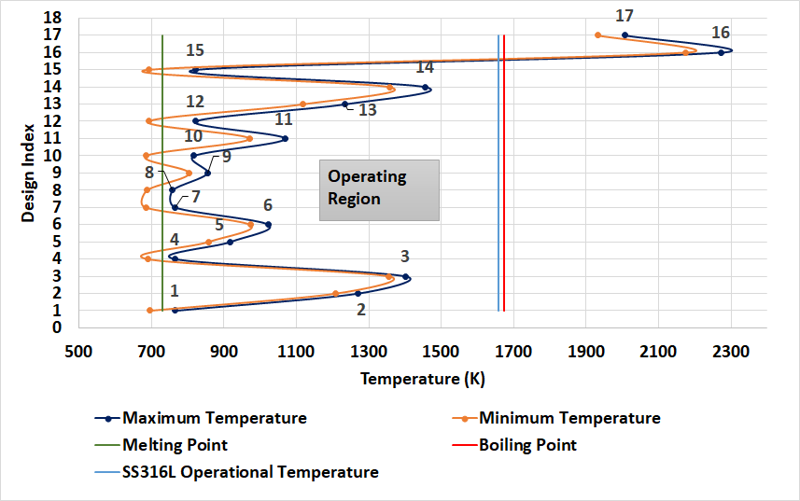
FIG. 3. LSSS diagram with operating region for SS 316L structural material
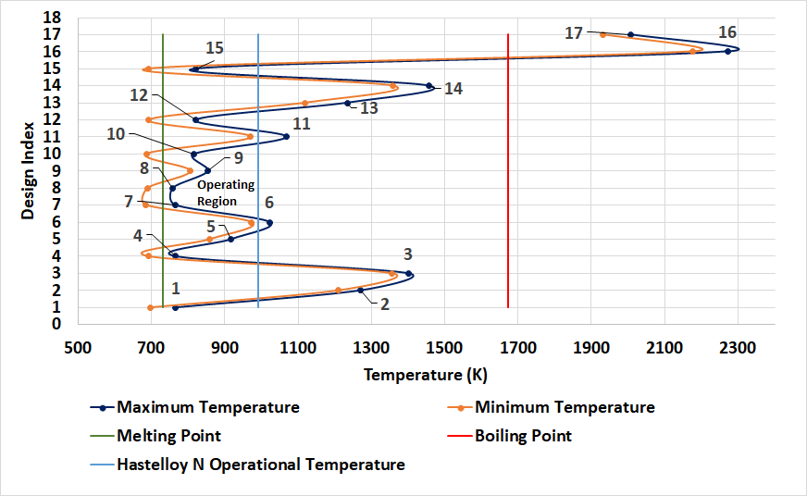
FIG. 4. LSSS diagram with operating region for Hastelloy N structural material
This work has identified reasonable design parameters for use in an LFMSR core and primary loop model. The future work will focus on testing this reactor design under transient scenarios and expanding the studies to perform high-fidelity multi-physics 2-D primary loop uncertainty and sensitivity analysis through the GeN-Foam/Dakota coupling that has been set up as part of the presented general framework.
References
[1] FIORINA, C., HURSIN, M., & PAUTZ, A., Extension of the GeN-Foam neutronic solver to SP3 analysis and application to the CROCUS experimental reactor, Annals of Nuclear Energy 1 (2017) 419-428.
[2] HU, R., FANNING, T. H., SUMNER, T., YU, Y., Status Report on NEAMS System Analysis Module Development. ANL/NE-15/4, Argonne National Laboratory, (2015).
[3] RUBIOLO, P. R., RETAMALES, M. T., GHETTA, V., GIRAUD, J., “High Temperature Thermal Hydraulics Modeling of a Molten Salt: Application To a Molten Salt Fast Reactor (MSFR)”, ESAIM: PROCEEDINGS AND SURVEYS (2017).
[4] BHASKAR, S., ALTAHAN, M., ZIYAD, D., BALESTRA, P., HOU, J., AVRAMOVA, M., SMITH, N, “Modelling and Simulation of a Liquid Fuel Molten Salt Reactor Core Using GeN-Foam”, PHYTRA4 - The Fourth International Conference on Physics and Technology of Reactors and Applications, Marrakech, Morocco (2018).
[5] ALTAHAN, M. R., BHASKAR, S., ZIYAD, D., BALESTRA, P., FIORINA, C., HOU, J., AVRAMOVA, M., Preliminary design and analysis of Liquid Fuel Molten Salt Reactor using multi-physics code GeN-Foam. Nuclear Engineering and Design 369 (2020).
[6] ABDALLA, A.J., SAMUEL A. W, BHASKAR, S., Ji W., Feasibility Assessment of a Natural-Circulation Salt Irradiation Loop in the Advanced Test Reactor, Nuclear Technology, DOI: 10.1080/00295450.2020.1843954 (2021).
[7] ROMATOSKI, R. R., HU, L. W., Fluoride-Salt-Cooled High-Temperature Test Reactor Thermal-Hydraulic Licensing and Uncertainty Propagation Analysis, Nuclear Technology, 205:11, 1495-1512, DOI: 10.1080/00295450.2019.1610686 (2019).
[8] LEEFE, S., JACKSON-LAVER, P., SCOTT, I.R., “Computation Fluid Dynamic Modeling of natural convection heat flow in Unpumped Molten Salt Fuel Tubes”, ThEC15-Thorium Energy Conference. Mumbai, India (2015).

