A concept of fluid dynamic code for molten salt reactor analysis with Open FOAM

Azizul Khakim
Nuclear Energy Regulatory Agency (BAPETEN)
Jl. Gajah Mada No. 8 Jakarta 10120 Indonesia
Email: a.khakim@bapeten.go.id
Recently Molten Salt Reactor (MSR) gains more interest among nuclear researchers due to its promising competitiveness and safety characteristics. ThorCon MSR (TMSR500) is this kind of reactor projected to be built in Indonesia. Due to a limited number of commercial codes available in the market, one may have to develop their own code. One of the main MSR features is the use of fluid fuel, which serves as both fuel and coolant. The heat is generated in the moving fluid fuel which makes it complicated in terms of thermodynamic modeling. The available lumped-parameter codes which are based on experimental correlation of convective heat transfer can not be applied, instead, CFD (computational fluid dynamics) has to be used. CFD is an expensive tool that may require the use of high-performance computing (HPC) for simulating 3-D multiphysics models. Unlike solid fuel reactor, where both prompt and delayed neutrons are born in the same spot of fission reaction, in the MSR the delayed neutrons emit somewhere else and could be escaping from the core due to fuel circulation.
Open FOAM is chosen as it is an open platform where the users can modify the source code for their simulation needs. Assuming the fluid fuel is completely incompressible, the following general transport equation is valid:
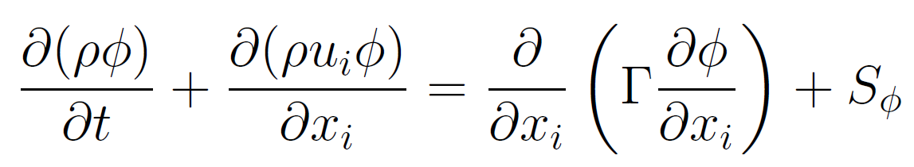 (1)
The first, second, third, and fourth terms of eq. (1) are time derivative, convective, diffusion, and source terms, respectively. The variables t, x, and u are time, space, and velocity, respectively. The ϕ is an arbitrary transport parameter, and ρ is the fluid density (kg/m3). The Γ is the diffusion coefficient of the fluid (kg/m.s). When ϕ=1, the eq. (1) becomes mass conservation equation:
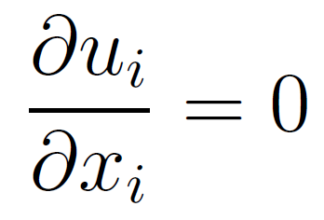 (2)
When ϕ=u, the eq. (1) becomes equation of momentum conservation:
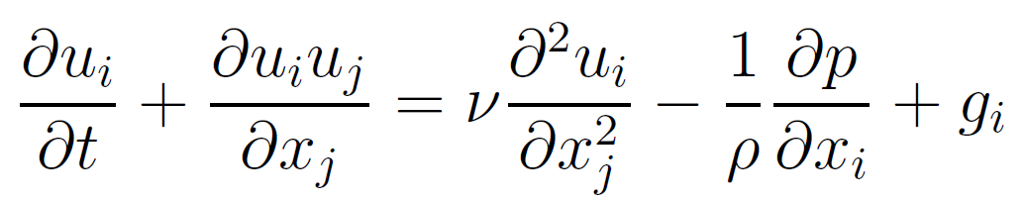 (3)
where g_{i} is the source term coming from gravity acceleration (m/s²). The fourth term of eq. (3) is the source term coming from pump pressure. The eq. (2) and (3) are more commonly known as Navier-Strokes equations which have become the basis of CFD.
When ϕ=C_{p}T, the eq. (1) becomes equation of energy conservation:
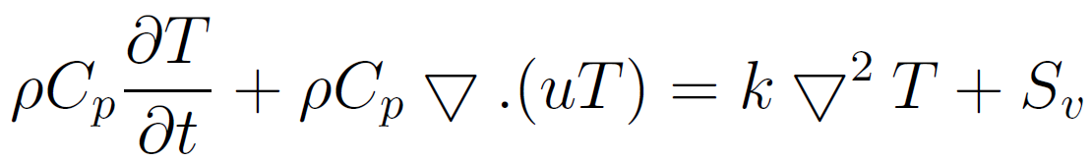 (4)
Where C_{p} and k are the fluid heat capacity (J/kg.K) and heat conductivity (w/m.K), respectively. The S_{v} is the source term of the energy equation (w/m³), in which for MSR, coming from fission reaction:
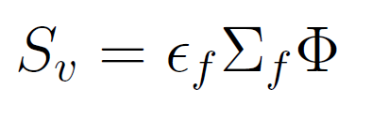 (5)
where ϵ_{f,} Σ_{f} and Ф are the energy generated per fission, fission macroscopic cross-section, and local neutron flux.
For fluid fuel reactors, such as MSR or Aqueous Homogeneous Reactor (AHR), the fission energy generation takes place in the fluid fuel, therefore Eq. (4) is applied. On the other hand, for graphite moderator of MSR, unless gamma heating is taken into account, the following equation applies:
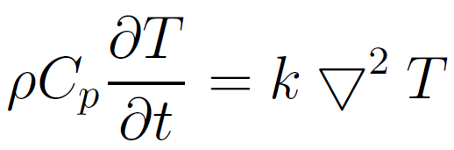 (6)
For an arbitrary passive scalar quantity, Y_{i}, which is transported by the fluid, the general equation can be derived from eq. (1) by ϕ=Y_{i}:
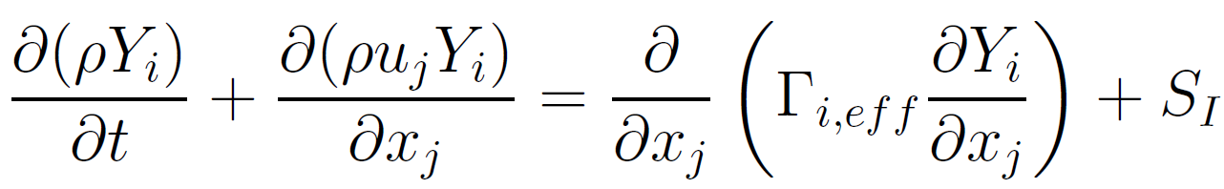 (7)
The passive scalar delayed neutron, C_{i}, then can be expressed as [1]:
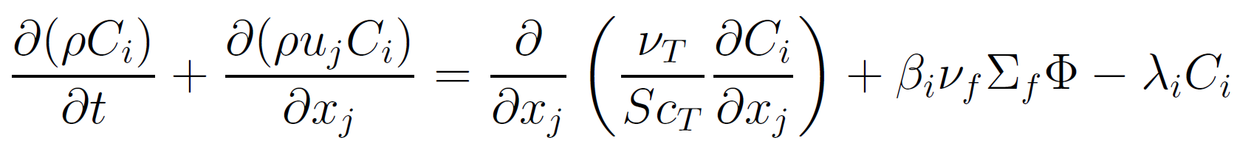 (8)
where Sc_{T} is turbulent Schmidt number, and ν_{T} is the turbulent viscosity. The β_{i} and λ_{i} are delayed neutron fraction and decay constant of group i, respectively. The parameter ν_{f} is the average number of neutrons produced per fission. Those three parameters β_{i}, λ_{i}, and ν_{f} can be calculated in advance using neutronic codes such as MCNP6. For laminar flow, the diffusion term can be eliminated to become [2]:
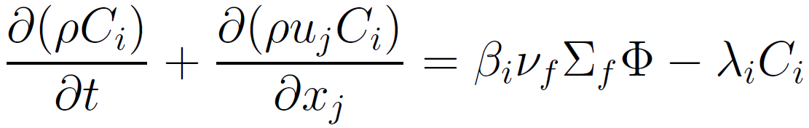 (9)
The solvers for all those terms in eq. (1) are available in Open FOAM. The users may need to modify as necessary. To reduce the number of cells, we need to simulate with a simple 2-D reactor using our 172-core HPC for the early steps.
References

[1] M. Aufiero et al., “Calculating the effective delayed neutron fraction in the Molten Salt Fast Reactor: Analytical, deterministic and Monte Carlo approaches,” Ann. Nucl. Energy, vol. 65, pp. 78–90, 2014.
[2] A. Lindsay, G. Ridley, A. Rykhlevskii, and K. Huff, “Introduction to Moltres: An application for simulation of Molten Salt Reactors,” Ann. Nucl. Energy, vol. 114, pp. 530–540, 2018.

