multi-scale computational analysis to predict the irradiation-induced change in engineering properties of fusion reactor materials.

S.MOHAMED^{1,2}, G.PO³, J.SHIMWELL⁴, R.LEWIS¹, LL.M. EVANS^{1,2},

¹Swansea University, Swansea SA1 8EN, United Kingdom
²Culham Centre for Fusion Energy, Culham Science Centre, Abingdon, Oxon, UK
³University of Miami, Coral Gables, FL 33146, USA
⁴First Light Fusion Ltd., Oxfordshire, UK

Email contact of corresponding author: s.mohamedkunju@swansea.ac.uk

INTRODUCTION
A critical challenge in the development and design of key in-vessel components for the DEMO fusion reactor, such as breeding blanket and divertor, is its ability to withstand prolonged exposure of the fusion plasma induced high energy (14MeV) neutron irradiation and larger thermal loads whilst maintaining structural integrity and thermal efficiency [1]. Due to the hostile radiation conditions inside the fusion power plant, in-vessel materials, such as W (armor), EUROFER97 (structural) and CuCrZr (heat sink), undergo degradation leading to several types of defects like transmutation products, impurities, dislocation loops, vacancy clusters, bubbles, and precipitates. Moreover, the material components in the fusion reactor undergo degradation at different stages during its lifecycle. As a consequence, these defects influence the mechanical and thermal behavior of materials inducing undesirable hardness, embrittlement and creep that leads to component failure. In addition, the change in the mechanical and thermal behavior is mainly due to change in engineering properties of the material during its operation and it consequently influences the overall operation of the fusion reactor. Currently, the experimental campaigns on in-vessel component materials are conducted by means of surrogate fusion radiation facilities which cannot actually reproduce the real fusion environment of the DEMO fusion power plant. In order to mimic the fusion instigated high energy neutron irradiation conditions and mitigate the risks associated with structural instability of the in-vessel materials, there is an urgent need within the fusion community to develop a reliable predictive capability to evaluate the material behavior [2].

In the present study, the authors employed a reliable predictive capability in the form of a mathematical model to analyse the influence of neutron irradiated induced defects in the overall behavior of fusion reactor material. In particular, the defects produced in the in-vessel components are usually in the range of micrometer/nanometer in size. Since there is a large difference between the size of the fusion reactor components and the size of the defects, multi-scale model is required to link the microstructural defects with the macrostructure. Therefore in the current work, the main objective is to employ multi-scale model to analyse the neutron irradiation induced defects on the temperature fields in the in-vessel component tungsten monoblock, that is the production of Transmutation Elements (TEs) precipitates. The presence of Rhenium (Re) and Osmium (Os) as TEs in Tungsten has been detected in experimental studies [3]. In addition, the thermal properties of the material at different stages of its degraded state are calculated by means of the multi-scale model employed in this study.

METHODOLOGY

During the nuclear fusion reaction, the neutrons produced by Deuterium-Tritium (DT) reactions collide and several types of reactions occur in fusion reactor materials such as divertor, first wall and blanket. In these fusion instigated reactions, charged particles, gamma rays and secondary neutrons are produced, which results in the Primary Knock-on Atoms (PKAs) of nuclides. The knocked nuclides and the charged particles travel through the material for a short range and the resultant kinetic energies are converted into thermal energy. However, the neutrons and the gamma rays move in the materials for a longer range to exchange its kinetic energy to thermal energy in the material. These thermal energies obtained from kinetic energy are called nuclear heat. In this study, the authors have obtained the nuclear heating values by means of Monte-Carlo method. For this, open-source software, OpenMC is employed which uses Monte- Carlo method to model the neutron transport and heating in fusion conditions (14MeV). In fact, for the current work, OpenMC software is implemented through another open-source software package paramak developed by UKAEA[4]. The nuclear heating values obtained from the paramak simulation are used as the thermal load for the multi-scale model simulation in a finite element framework.

In order to link the neutron induced microstructural defect information such as the precipitates, with the macrostructure of fusion reactor material, a multi-scale model in terms of multi-scale thermal homogenization technique is implemented in a finite element framework [5]. The advantage of using homogenization technique is that it is possible to obtain the effective mechanical/ thermal properties of a components containing defects since the components undergo degradation and different densities of neutron induced defects produced at various stages of its lifecycle.

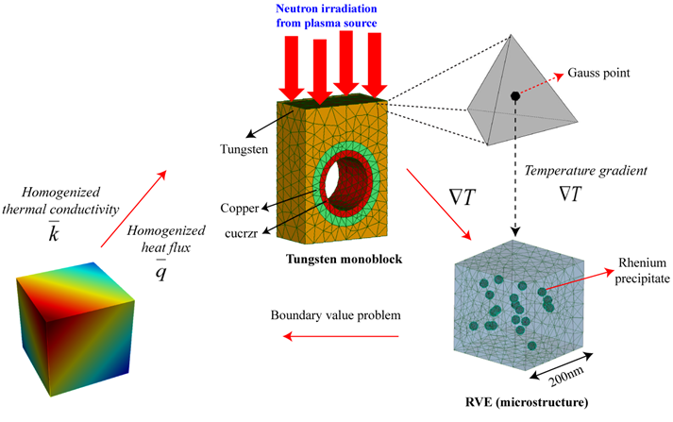
FIG. 1. Multi-scale thermal homogenization
The multi-scale thermal homogenization technique is developed and employed in the code-aster open source finite element software. Moreover, in the current study, VirtualLab open-source software developed by the co-authors in this paper, integrated with code-aster software, is used for the finite element simulation. In a multi-scale homogenization technique, Representative Volume Element(RVE) containing defects are assigned at the Gauss integration points of the mesh elements in the macrostructure. The temperature gradient at the Gauss integration point obtained from the macrostructure simulation is used as the temperature boundary condition on the surface of the microstructure/nanostructure containing defects as shown in Eq.(1). The problem at the microstructure is solved by means of finite element method and the resultant homogenized heat flux and thermal conductivity is transferred to the Gauss integration point of the macrostructure for the FEM simulation. The homogenized thermal conductivity is actually effective thermal conductivity due to the defects in the microstructure. The overall picture of multi-scale thermal homogenisation technique is depicted in Fig.1.

Temperature at the boundary of the microstructure:

(1)
Homogenized heat flux:

(2)

Effective thermal conductivity:
(3)

In the current study, tungsten monoblock is used as the macrostructure with dimensions 30 mm x 24 mm x 5mm. The tungsten monoblock consists of three different sections as shown in the Fig.1 the microstructure/nanostructure containing the Rhenium precipitate as defects are employed as RVE which are discussed in the following section. The thermal conductivity tungsten, copper, CuCrZr and Rhenium are reported in the table 1.

TABLE 1. Thermal conductivities of tungsten monoblock and rhenium.
Chemical element | Thermal conductivity (W/mºC)
Tungsten | 170.0
Copper | 400.0
CuCrZr | 348.0
Rhenium | 48.0

RESULTS
Monte-Carlo simulations are performed in OpenMC software integrated within the paramak software package. In order to reproduce the real fusion power condition, the source is modelled which emits neutrons at 14 MeV. In the current study, neutron heating values at the tungsten monoblock are obtained for sources at three different locations. In particular, the neutron heating values are analysed at monoblock for different source locations which are a) 5 cm (b) 10 cm c) 20 cm from the top surface of the monoblock.
Moreover, neutrons are discharged from the source in batches of 50 in which each batch emits 5000000 neutrons. Fig.2 depicts the neutron heating values for three different source locations as mentioned above. It is clear from the Fig. 2. that the neutron source located at 5 cm from the top surface of the block has higher nuclear heating values with a largest value of 3.9W with respect to the other two source locations.
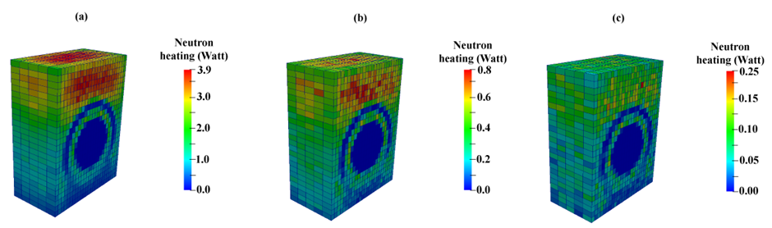
FIG. 2. Neutron heating values for neutron source (a) 5cm (b) 10cm (c) 20cm from the top surface of tungsten monoblock.
The heating values obtained from the Monte-Carlo simulations are imposed as heat source in code-aster simulations on which the multi-scale homogenization technique is implemented. At the inner surface of the CuCrZr pipe, convection boundary condition is used where the heat transfer coefficient is taken as 1000W/m² and fluid temperature of 20ºC.The study has employed three different RVEs which are seeded with the different densities of Rhenium precipitates as shown in fig.4. In a virgin material of tungsten monoblock, RVE is considered without any defects. In reality, after some period of fusion reactor operation, the tungsten monoblock undergoes degradation. Therefore, in order to mimic the degradation phenomena, RVEs are modelled with precipitates in which the last stage of the tungsten monoblock under operation contains a higher density of precipitates with respect to the previous stage (Fig.4.). Fig.3. shows the heat flux distribution of the RVE with Rhenium precipitates. Since the precipitate has lower thermal conductivity with respect to the parent material, tungsten, the heat flux is very low at the regions of precipitates. The effective thermal conductivity is calculated by means of homogenized heat flux calculated based on the Eq.3. The effective thermal conductivity obtained from the simulations for the different stages of the tungsten monoblock is reported in Table 2.

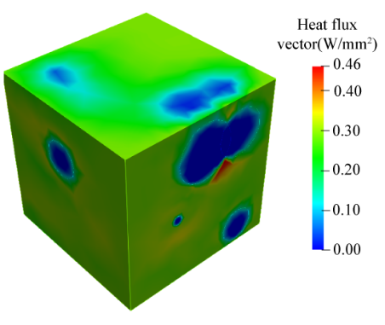
FIG. 3. Heat flux vector of the RVE with precipitates

TABLE 2. Effective thermal conductivity of different RVEs.
RVE | Thermal conductivity (W/mºC)
Virgin material | 170.0
Less dense defect | 137.7
High dense defect | 120.1
Fig. 4 shows the temperature evolution of the monoblock at different stages of its lifecyle, for the neutron source located at 5 cm. It is clear from the table 2 that the thermal conductivity varies based on the density of defects formed during the neutron irradiation. In particular, based on the Fig. 4 and Fig. 5 higher thermal gradients are observed for the monobock with a high density of defects with respect to the virgin material.
FIG. 4. Temperature contours of the tungsten monoblock assigned with different RVEs.
Fig.5 shows the temperature profiles plotted at various neutron source locations for different RVEs. The neutron source located at the 5 cm from the tungsten surface induce a maximum temperature of 2700ºC while the temperature is very low for the neutron source location at 20 cm. As mentioned above, based on the density of defects in the RVEs, the temperature profile changes for each of the neutron source location.
FIG. 5. Temperature profiles at the mid-section of the plane (depicted in dash lines) of the tungsten monoblock plotted for different neutron source locations at (a) 20 cm (b)10 cm (c) 5 cm
CONCLUSION
The present study is focussed to analyse the influence of neutron irradiation induced defects on the thermal properties of the fusion reactor material at different stages of its lifecycle and the consequent changes in the thermal fields of the component. For this, a numerical model based on multi-scale thermal homogenization is developed and simulations are performed. The thermal loads induced by the neutron transport across the tungsten monoblock for the finite element simulations are obtained from the Monte-Carlo method. The results show that the thermal conductivity of the tungsten monoblock changes due to the defects and significant changes in the temperature field is observed. Therefore, it is important to impose the correct thermal properties for modelling based on the defect densities to predict the accurate temperature fields and assess the overall performance of fusion reactor.
Acknowlegdement
This work has been carried out within the framework of the EUROfusion Consortium and has received funding from the Euratom research and training programme 2014-2018 and 2019-2020 under grant agreement No 633053 and from the RCUK Energy Programme [grant number EP/I501045] and EPSRC [grant number EP/R012091/1]. The views and opinions expressed herein do not necessarily reflect those of the European Commission. We acknowledge the support of the Supercomputing Wales project, which is part-funded by the European Regional Development Fund (ERDF) via Welsh Government.
References
- RIETH,M.,et al., Recent progress in research on tungsten materials for nuclear fusion applications in Europe, Journal of Nuclear Materials 432 (2013) 482–50
- KHAN,A.,ELLIMAN,R.,CORR, C.,LIM,J.J.H., FORREST,A.,MUMMERY,P.,EVANS,L.M., Effect of rhenium irradiations on the mechanical properties of tungsten for nuclear fusion applications,J.Nucl. Mate 477 15 (2016) 42-49
- SOZUDO,T., YAMAGUCHI,M.,HASEGAWA,A., Stability and mobility of rhenium and osmium in tungsten: first principles study, Modelling Simul. Mater. Sci. Eng. 22 (2014).
- SHIMWELL, J., DELAPORTE-MATHURIN, R., JABOULAY, J.C., et al., Multiphysics analysis with cad-based parametric breeding blanket creation for rapid design iteration, Nuclear Fusion 59 (2019).
- OZDEMIR,I, BREKELMANS,W.A.M, GEERS,M.G.D, Computational homogenization for heat conduction in heterogeneous solids,Int. J. Numer. Meth. Engng 73 (2008) 185–204.

