guidance ETHICS AS AN ENABLING INFRASTRUCTURE

Prof.dr.ir. Peter-Paul Verbeek
University of Twente
Enschede, The Netherlands
Email: p.p.c.c.verbeek@utwente.nl

Ethical discussions about technology typically have the character of a dilemma: should we or should we not accept this specific technology? In such dilemmas, ethics has the role of a border guard, assessing whether we should say ‘yes’ or ‘no’ to a technology. As a result, it is often hard to connect ethical reflection constructively to the development, implementation, and use of new technologies.

Moreover, this approach makes it hard to incorporate one of the most pressing challenges for the ethics of technology: the phenomenon of value dynamism, in which technologies have an influence on ethics itself, and help to redefine the values from which we evaluate technologies. One example of value dynamism concerns anaesthesia for surgery: this technology was highly contested when it was introduced, because it would go against human dignity to open someone’s body while she or he is unconscious, while by now it would be totally unacceptable it a doctor would operate on someone without anaesthesia. Also in relation to nuclear energy, this phenomenon plays a crucial role: ethical frameworks to assess this technology develop in interaction with the technology itself.

In this lecture, I will therefore elaborate a model of ethics as ‘accompaniment’ rather than ‘assessment’. The recently developed ‘Guidance Ethics Approach’ (see figure 1) will be the basis for this approach. In a three-step approach, Guidance Ethics aims to (1) analyse the technology in its concrete context of (potential) use; (2) anticipate the potential implications of this technology for all relevant stakeholders, in order to identify the values that are at stake in these implications; and (3) translate these values into concrete action perspectives regarding the technology itself (redesign), its environment (regulation, reconfiguration) and its users (education, communication, empowerment).

Guidance Ethics aims to be an ethics ‘from within’ rather than ‘from outside’: it does not seek to find a distant position for ‘technology assessment’ but rather a close connection to guide the technology in its trajectory through society. Also, it aims to do ethics ‘bottom-up’ rather than ‘top-down’: instead of letting ethical experts apply existing ethical approaches to a technology, it invites professionals and citizens to voice the ethical concerns they encounter in their everyday dealing with the technology. And third, Guidance Ethics is a form of ‘positive ethics’ rather than negative ethics. This does not imply that the approach always has a positive evaluation of new technologies, but rather that its primary focus is not on defining the boundaries of what we do not want, but on identifying the conditions for what we do want.
Along these lines, guidance ethics incorporates current philosophical insights in the relations between technologies, human beings, and ethics, and connects them to actual practices around technologies. By paying specific attention to the phenomenon of value dynamism in relation to nuclear energy, this lecture will elaborate how ethical reflection can be an enabling infrastructure for both technological and societal development.

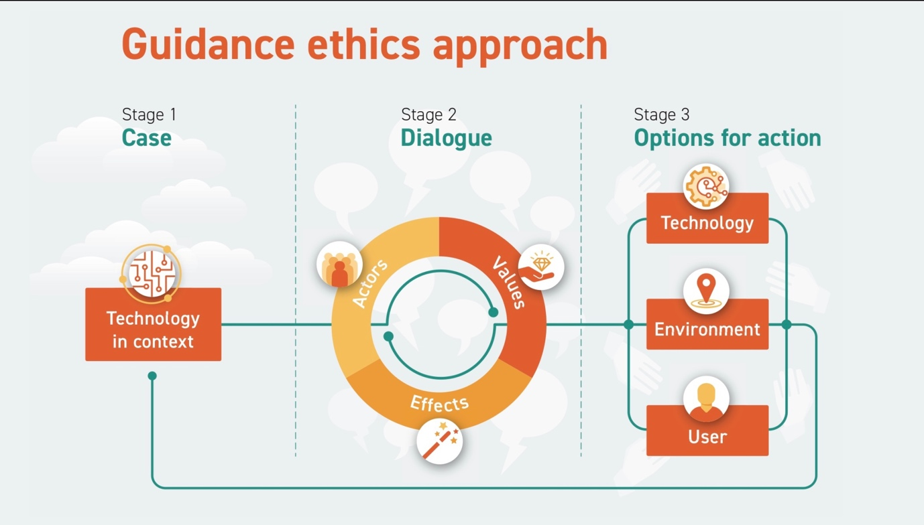

FIG. 1. The Guidance Ethics Approach.

