APPLICATION OF PCM MODEL validation for TREAT Experiments

D. HUANG and H.S. ABDEL-KHALIK
Purdue University
West Lafayette, United States
Email: huang714@purdue.edu

A.S. EPINEY
Idaho National Laboratory
Idaho Falls, United States
Model validation is required by the regulatory bodies to approve the use of computer models to simulate system conditions over the wide range of operational conditions, both during normal and off-normal conditions, i.e., transient and accident scenarios. The goal of model validation is to develop confidence in the model predictions for the target application of interest via a concerted use of analysis results and measurement from scaled-down experiments, designed to replicate the key physical phenomena that occur in the target application. The process used to combine analysis results and measurements together is intended to improve the predictions of the target application’s Figure of Merits (FOMs), implying a reduction in the FOM uncertainty, as compared to its prior value which is calculated from the simulation only. Previous work has developed a new methodology, denoted by Physics-guided Coverage Mapping (PCM) [1], which focused on the estimation of a given FOM’s Probability Density Function (PDF) by integrating the prior PDF calculated from multiple experiments along with their measurements. Past applications have focused on steady state problems relevant to criticality safety application [2]. This work demonstrates application of PCM to transient experiments that are conducted at the Idaho National Laboratory’s Transient REActor Test (TREAT) Facility [3]. Specifically, we compare the PCM to classical least-squares methodology, accounting for the uncertainties that originate from model parameters, such as the gap thermal conductivity, power coupling factor, fuel specific heat capacity, etc. The model analyzed is a RELAP5-3D [4] transient model to track the fuel temperatures over time in TREAT capsules, the Separate Effects Test Holder (SETH) [5] capsules, with SETH-C and SETH-D as experiment and application models respectively. Typical results are shown in Fig.1.
The PCM process is to find a relationship, namely mapping kernel, usually in the form of a joint PDF between the experimental and application FOMs. A pseudo response in terms of all available experiments, serving as predictors, which has the highest mutual information with the application FOM, is built as the representative of the experimental domain. The bias and uncertainties of the application FOMs can be predicted with the experiment measurements mapping through the mapping kernel. In this way, the uncertainty of application FOMs could be reduced with the validating information from the measurements and the mapping kernels of the simulations. For time-dependent FOMs, a mapping kernel is built between the application FOM at each step and the pseudo response of all predictors.
In the case study, PCM employs fuel temperatures of SETH-C at a few time steps as the experiments, and fuel temperatures of SETH-D over time as the application. The FOMs of interest here are the fuel cladding outer surface temperatures. 1000 samples of the RELAP5-3D models are generated and executed by RAVEN [6] to form the simulation clouds. Figure 1 shows an example of PCM performance on the left and least-squares performance on the right, using temperatures of SETH-C at 30, 35, 40, 45, 50, 55, and 60 [sec] as predictors, where the red dots are the predicted temperature of SETH-D with red band the associated prediction uncertainty (one standard deviation), and the prior information is shown in blue dots and band representing the mean values and standard deviations. The measurements of SETH-D temperatures over time are shown in yellow crosses with 2% uncertainty, serving as the reference/reality. The predicted SETH-D temperature is close to the measurement, within one standard deviation of predicted uncertainty, around the peak area from 5-10 [sec].

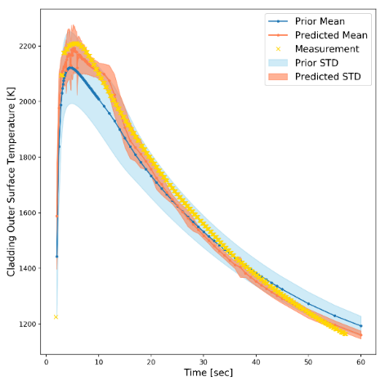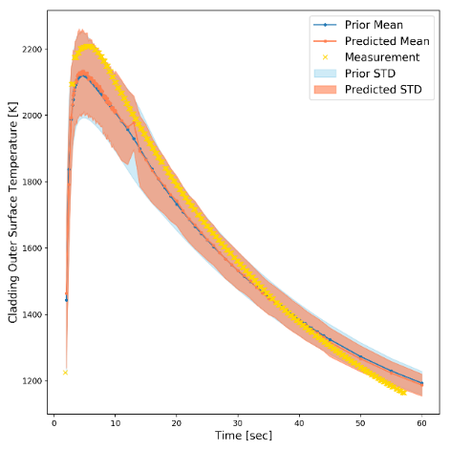
Fig. 1. PCM prediction over time.

Results show good performance of PCM in validation of this transient model, with predicted temperature within 2% difference from the real measurement around peak area, and about 30% uncertainty reduction from prior uncertainty around peak and 50% uncertainty reduction after the temperature peak. This indicates that the PCM can serve as a good model validation tool for the transient thermal conductance model. PCM will be further developed to optimize the experiment selection, address the issues in multi-physics validation problem such as RELAP5/BISON model, and finally contribute to the digital twin for the fuel system.
References
- H. ABDEL-KHALIK, A. I. HAWARI, and C. WANG, "Physics-guided covered mapping: a new approach for quantifying experimental coverage and bias scaling." Trans ANS 112 (2015).
- D. HUANG, and H. S. ABDEL-KHALIK, "Construction of optimized experimental responses in support of model validation via physics coverage mapping methodology." In Proceedings of PHYSOR,, vol. 2016, pp. 1-5. 2016.
- N. WOOLSTENHULME, C. BAKER, C. JENSEN, D. CHAPMAN, D. IMHOLTE, N. OLDHAM, C. HILL, and S. SNOW, "Development of irradiation test devices for transient testing." Nuclear Technology (2019).
- RELAP5-3D CODE DEVELOPMENT TEAM, 2012. RELAP5-3D Code Manual Volume I: Code Structure, System Models and Solution Methods. INL-EXT-98-00834-V1.
- N. WOOLSTENHULME, A. FLEMING, T. HOLSCHUH, C. JENSEN, D. KAMERMAN, and D. WACHS, "Core-to-specimen energy coupling results of the first modern fueled experiments in TREAT." Annals of Nuclear Energy 140 (2020): 107117.
- C. RABITI, A. ALFONSI, J. COGLIATI, D. MANDELLI, R. KINOSHITA, S. SEN, C. WANG, P. W. TALBOT, D. P. MALJOVEC, and J. CHEN, RAVEN user manual. No. INL/EXT-15-34123 (Revision 6). Idaho National Lab.(INL), Idaho Falls, ID (United States), 2017.

