State-Of-The-Art Turbulent Heat Flux Modelling for low-Prandtl flows

A. MATHUR, F. ROELOFS
NRG
Petten, the Netherlands
Email: mathur@nrg.eu

M. FIORE, L. KOLOSZAR
Von Karman Institute
Sint-Genesius-Rode, Belgium

Abstract

Turbulent heat transfer is a complex phenomenon, which has become the focus of turbulence modelling research in recent years. The closure of turbulent heat flux has conventionally been approached by the so-called eddy diffusivity approach and its most trivial version, the Reynolds analogy. While this approach provides a simple and efficient closure, it lacks accuracy when the similarity hypothesis between thermal and momentum fields are less justified, i.e. in presence of low Prandtl number fluids, such as liquid metals, for which reference data are scarce. The present paper discusses the recent advancements in heat flux modelling approaches, including the closures of local turbulent Prandtl number models and algebraic models with special attention to low-Prandtl cases.
Although these recently developed models provide a better alternative to the conventional approach, they also suffer from limitations of their own. The present paper provides a review of these shortcomings, including isotropic nature, lack of low-Reynolds number modelling, and the need for a priori knowledge of flow and heat transfer regimes, together with their applicability to industrial cases. Another major criteria to rank such models is their applicability to an ‘integral setting’ where multiple flow regimes exist in a single flow domain. Under the framework of the collaborative European PATRICIA project, it is planned to further develop and enhance the current heat flux modelling approaches to overcome these shortcomings. After rigorous testing and validation, the models are planned to be applied to prediction of heat transfer in an integral flow case over complex geometry.

INTRODUCTION
Nuclear energy plays an important role in power generation, especially with respect to environment protection, economic competitiveness and power supply security. With rapidly growing power demands and calls to scale down the use of fossil fuels, collaborative effort is under way towards development of fourth generation nuclear reactors [1]. Among these, liquid metal fast reactors (LMFR) present an attractive option due to the high thermal conductivity of the coolant fluid. In that context, Computational Fluid Dynamics (CFD) is regarded as a valuable tool to address the challenges in the development and improvement of the thermal-hydraulic design of LMFRs.
One of the biggest challenges within the Reynolds-Averaged Navier-Stokes (RANS) framework of CFD is turbulence closure. The momentum and energy transport equations are,
$$\frac{DU}{Dt}=-\frac{1}{ρ}\frac{∂p}{∂x_{i}}+\frac{∂}{∂x_{j}}\left(ν \frac{∂U_{i}}{∂x_{j}}-\overline{u_{i}u_{j}}\right)$$ | (1)
$$\frac{D(ρc_{p}T)}{Dt}=\frac{∂}{∂x_{j}}\left(λ \frac{∂T}{∂x_{j}}-ρc_{p}\overline{u_{i}θ}\right)$$ | (2)
where $\frac{D}{Dt}$ denotes the material derivative. Here, the unknown terms $\overline{u_{i}u_{j}}$ and $\overline{u_{i}θ}$ are turbulent momentum flux (TMF) and turbulent heat flux (THF) terms, respectively. Over the past decades, several different closures have been developed and validated for modelling of TMF. The most suitable model can be chosen based on the problem at hand, in order to reduce the uncertainties associated with modelling of turbulent velocity field. It is most commonly closed using the Reynolds analogy of the so-called eddy diffusivity approach, i.e. assumed to follow a linear constitutive relationship with mean rate of strain as,
$$-ρ\overline{u_{i}u_{j}}=2μ_{t}S_{ij}-\frac{2}{3}ρkδ_{ij}$$ | (3)
where $μ_{t}$ is the turbulent (or eddy) viscosity. This quantity, in turn, is evaluated as a function of other turbulent parameters, such as the turbulent kinetic energy ($k$) and its dissipation rate ($ε$ or $ω$). Although, closures for TMF have been paid vast attention, comparatively little has been done in development of closures for THF, especially for non-unity Prandtl number flows. An overview of the state-of-the-art of about 2012 is provided by Grötzbach [2] and a more recent overview can be found in the textbook edited by Roelofs [3].
Conventionally, a similar approach is taken for the closure of THF, as that for TMF. The eddy diffusivity approach is employed using a turbulent thermal diffusivity, $α_{t}$. And this unknown quantity is closed by the Reynolds analogy, introducing the turbulent Prandtl number, ${Pr}_{t}$, However, the application of the Reynolds analogy to close THF term involving non-unity Prandtl number fluids has well-known limitations. The Prandtl number has a strong impact on the similarity assumption between the turbulent momentum and heat transfer, as illustrated in Figure 1. Liquid metals are characterised by low Prandtl numbers, resulting in a much larger thermal boundary layer in comparison to momentum boundary layer. This outlying behaviour has sparked intense research in liquid metal thermal-hydraulics, and more specifically in low-Prandtl number turbulent heat flux modelling. Some of the most common closures for THF are presented in the following sections.

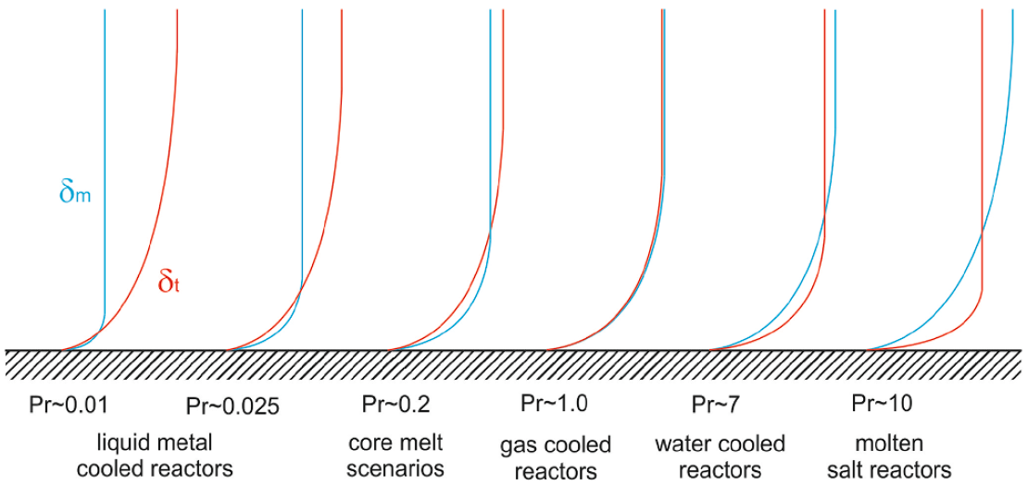
FIG. 1 Representative comparison of the momentum and thermal boundary layers with varying Prandtl numbers [4].

Standard Gradient Diffusion Hypothesis (SGDH)
As stated above, the conventional approach of SGDH assumed a linear relationship of THF with the mean temperature gradient,
$$\overline{u_{i}θ}=-α_{t}\frac{∂T}{∂x_{i}}$$ | (4)
The unknown quantity of turbulent thermal diffusivity, $α_{t}$, is closed using the Reynolds analogy. This introduces turbulent Prandtl number, ${Pr}_{t}$, as below,
$$α_{t}=\frac{ν_{t}}{{Pr}_{t}}$$ | (5)

Constant ${Pr}_{t}$
Commercial CFD solvers widely use a constant value for ${Pr}_{t}$ equal to 0.85 or 0.9. This approach is reported to work well for near-unity Prandtl number flows. However, in case of low-Prandtl number fluids such as liquid metals, this value is observed to fail leading to poor temperature predictions. This is illustrated below for planar channel flow. An alternative approach, for use with liquid metals, has been taking a different constant value for ${Pr}_{t}$, most commonly 2.0.
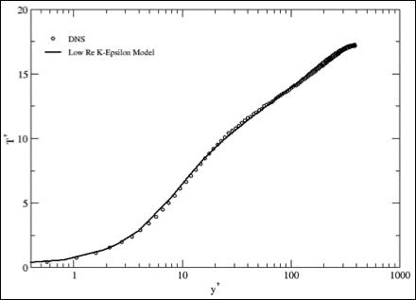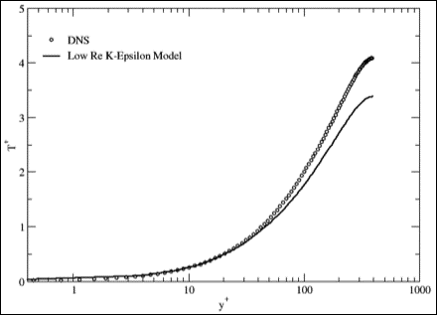
FIG. 2 RANS prediction of mean temperature profile for a planar channel flow at ${Re}_{τ}$ = 395 for (left) Pr = 1.0 and (right) Pr = 0.025, using a constant turbulent Prandtl number approach of ${Pr}_{t}$ = 0.85. (Kanawade [5]).

Figure 3 illustrates the distribution of ${Pr}_{t}$ calculated using DNS/LES data for planar channel flow at different Reynolds numbers. It can be seen that the values of ${Pr}_{t}$, in general, increase with decrease in molecular Prandtl numbers. The location of near-wall local maxima changes with the Reynolds number. The values of ${Pr}_{t}$ in the bulk of the flow, however, remains roughly the same for same molecular Prandtl number. It is clear that a single constant value of ${Pr}_{t}$ does not describe all low-Prandtl number flows. Moreover, the distribution of ${Pr}_{t}$ also varies with the distance from the wall.
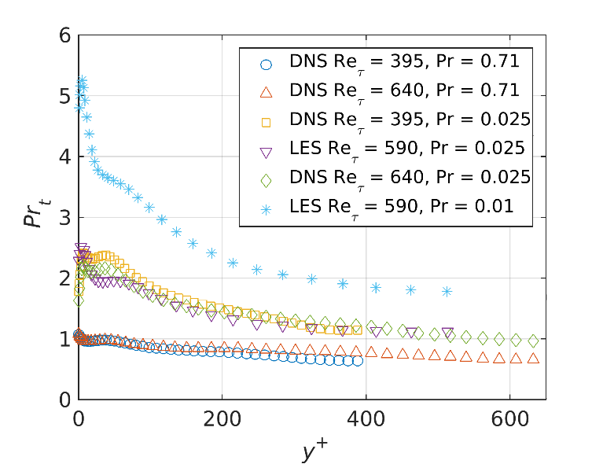
FIG. 3 Distribution of turbulent Prandtl number compared for DNS [6] and LES [7] in a planar channel flow at varying Reynolds and Prandtl numbers.

Flow dependant ${Pr}_{t}$
Reynolds [8] proposed implementing the following, varying value of ${Pr}_{t}$ in the SGDH approach to overcome the aforementioned drawbacks,
$${Pr}_{t}=\left(1+100 {Pe}^{-\frac{1}{2}}\right)\left(\frac{1}{1+120 {Re}^{-\frac{1}{2}}}-0.15\right)$$ | (6)
where $Re$ and $Pe$ are the bulk Reynolds number and Peclet number of the flow.
A space-varying model for ${Pr}_{t}$ was presented by Kays [9], using a turbulent Peclet number, defined as ${Pe}_{t}=ν_{t}/α$,
$${Pr}_{t}=0.85+\frac{0.7}{{Pe}_{t}}.$$ | (7)

Further development to this, Weigand [10] suggested dependence of ${Pr}_{t}$ on its value far away from the wall, ${Pr}_{t∞}$. This free-stream value is defined as,
$${Pr}_{t∞}=0.85+\frac{100}{Pr Re^{0.888}}.$$ | (8)
Thus, the local ${Pr}_{t}$ is derived from the correlation,
$$\frac{1}{{Pr}_{t}}=\frac{1}{2{Pr}_{t∞}}+C {Pe}_{t}\frac{1}{\sqrt{{Pr}_{t∞}}}-{\left(C {Pe}_{t}\right)}^{2}\left[1-\exp\left(-\frac{1}{C{Pe}_{t}\sqrt{{Pr}_{t∞}}}\right)\right]$$ | (9)
where $C$ = 0.3.
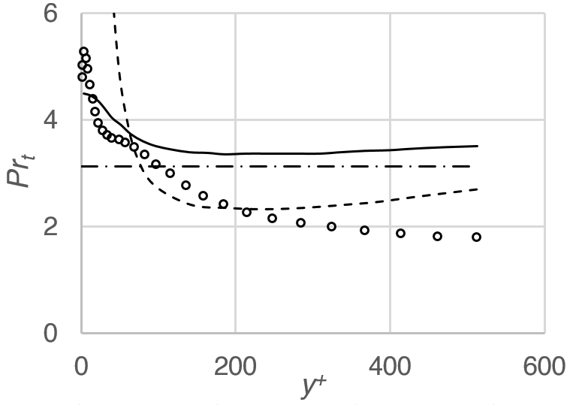
FIG. 4 Comparison of ${Pr}_{t}$ models for planar channel flow at $Re_{τ}$ = 590 – (o) LES [7], (dash-dot) Reynolds [8], (dash) Kays [9] and (solid) Weigand et al. [10].

Figure 4 presents the variation of ${Pr}_{t}$ with wall distance for planar channel flow at ${Re}_{τ}$ = 590. It is clear that none of the aforementioned ${Pr}_{t}$ models sufficiently capture the distribution as calculated for the reference numerical data. Furthermore, the models require a priori knowledge of the flow parameters such as Reynolds number. This elucidates the need for more elaborate closures which can represent turbulent heat transfer for a wider range of flow parameters.

Algebraic Closures

General Gradient Diffusion Hypothesis (GGDH)
In order to improve the accuracy of SGDH and directly include the effects of the turbulent momentum flux on the modelling of turbulent heat flux, Daly [11] proposed a model,
$$\overline{u_{i}θ}=-C_{θ}\frac{k}{ε} \left(\overline{u_{i}u_{j}}\frac{∂T}{∂x_{i}}\right)$$ | (10)
The inclusion of the TMF term is reported to greatly improve the accuracy in comparison to SGDH, as shown by Kenjeres et al. [12].

Implicit Algebraic Heat Flux Model (AHFM)
Kenjeres et al. [12] further reported the AHFM model based on the physical significant of the sources for turbulent heat fluxes. The closure of the THF term, here, is based on an implicit algebraic expression having the form,
$$\overline{u_{i}θ}=-C_{t0}\frac{k}{ε} \left(C_{t1}\overline{u_{i}u_{j}}\frac{∂T}{∂x_{i}}+C_{t2}\overline{u_{j}θ}\frac{∂U_{i}}{∂x_{i}}+C_{t3}βg_{i}\overline{θ^{2}}\right)+C_{t4}α_{ij}\overline{u_{j}θ}$$ | (11)
where $a_{ij}$ is the Reynolds stress anisotropy tensor, and $C_{t0}$,…,$C_{t4}$ are the model coefficients. The unknown temperature variance, $\overline{θ^{2}}$, is evaluated by solving a transport equation,
$$\frac{D\overline{θ^{2}}}{Dt}=2P_{θ}-2ρε_{θ}+\frac{∂}{∂x_{i}}\left[\left(\frac{λ}{c_{p}}+\frac{μ_{t}}{σ_{\overline{θ^{2}}}}\right)\frac{∂\overline{θ^{2}}}{∂x_{j}}\right]$$ | (12)
where $P_{θ}$ is the temperature variance production term. The additional term dissipation rate, $ε_{θ}$, is evaluated through the assumption of a constant thermal to mechanical time scale ratio, $R$, equal to 0.5.
Kenjeres et al. [12] proposed the model coefficients optimized for the natural and mixed convection regimes at unity Prandtl numbers. Shams et al. [13] extended this to the forced convection regime for low-Prandtl fluids via a calibration of the model coefficients. The model is further extended to natural and mixed convection regimes with the calibrated coefficients [14, 15]. It was reported that the performance of the model was greatly affected by the model coefficients, and a single set of coefficients does not satisfy all the different flow and heat transfer regimes. The calibrated coefficients can be calculated as below [4, 16],
$C_{t0}$ = 0.2, $C_{t2}$ = 0.6, $C_{t4}$ = 0.0 | (13)
$C_{t1}=0.053\ln{(Re Pr)}-0.27$ with $Re Pr$ > 180 | (14)
$C_{t3}=-4.5×{10}^{-9} {\left(log⁡(Ra Pr)\right)}^{7}$ with 1 > $Ra Pr$ > 10¹⁷ | (15)

Explicit AHFM (the $k$-$ε$-$k_{θ}$-$ε_{θ}$ model)
Manservisi and Menghini [17] proposed a model relying on the solution of the transport equations for the squared temperature fluctuations, $k_{θ}=\frac{1}{2}\overline{θ^{2}}$, and its dissipation rate, $ε_{θ}$. In combination with the employed two-equation $k$-$ε$ model for the closure of TMF term, this results in an explicit four-equation model, $k$-$ε$-$k_{θ}$-$ε_{θ}$. The transport equations for $k_{θ}$ and $ε_{θ}$ are,
$$\frac{Dk_{θ}}{Dt}=\frac{∂}{∂x_{i}}\left[\left(α+\frac{α}{σ_{k_{θ}}}\right)\frac{∂k_{θ}}{∂x_{i}}\right]+P_{θ}-ε_{θ}$$ | (16)
$$\frac{Dε_{θ}}{Dt}=\frac{∂}{∂x_{i}}\left[\left(α+\frac{α}{σ_{ε_{θ}}}\right)\frac{∂ε_{θ}}{∂x_{i}}\right]+\frac{ε_{θ}}{k_{θ}}\left(C_{p1}P_{θ}-C_{d1}ε_{θ}\right)+\frac{ε_{θ}}{k}(C_{p2}P_{k}-C_{d2}ε)$$ | (17)
In this model, the THF is calculated by the SGDH approach, with the turbulent thermal diffusivity defined by,
$$α_{t}=C_{θ}kτ_{lθ}$$ | (18)
where $C_{θ}$ is a model coefficient. Here, $τ_{lθ}$ is the local turbulent thermal timescale, which is calculated as a function of the four model parameters, $k$, $ε$, $k_{θ}$, and $ε_{θ}$.
One of the major drawbacks of the above algebraic models is the need for calibrated coefficients in the model which require a priori knowledge of flow parameters. Moreover, in an integral setting, a single set of flow parameters, and thereby a single set of coefficients, does not apply to the whole domain which may lead to failure of the above models in certain parts of the domain.

Second Moment Closures and other Advanced Models

Turbulent Model for Buoyant Flows (TMBF)
A second-order five-equation model to close the THF terms is proposed by Carteciano et al. [18]. The three components of THF are solved using three separate transport equations,
$$\frac{D\overline{u_{i}θ}}{Dt}=\frac{∂}{∂x_{j}}\left(\left[C_{TD}\frac{k^{2}}{ε}+\frac{α+ν}{2}\right]\frac{∂\overline{u_{i}θ}}{∂x_{j}}\right)-\left(\overline{u_{i}u_{j}}\frac{∂T}{∂x_{i}}+\overline{u_{j}θ}\frac{∂U_{i}}{∂x_{i}}\right)-G_{\overline{u_{i}θ}}+π_{i}+ε_{\overline{u_{i}θ}}$$ | (19)
where the term $π_{i}$ represents the pressure-temperature gradient correlation which is closed by,
$$π_{i}=-C_{T1}\frac{ε}{k}\overline{u_{i}θ}+C_{T2}\overline{u_{j}θ}\frac{∂U_{i}}{∂x_{j}}+C_{T3}βg_{i}\overline{θ^{2}}-C_{T4}\frac{ε}{k}\overline{u_{\left[n\right]}θ}δ_{i\left[n\right]}\frac{k^{\frac{3}{2}}}{x_{[n]}ε}$$ | (20)
where $δ_{i\left[n\right]}$ is the Kronecker delta and the index $n$ represent wall normal direction. The dissipation rate of the heat fluxes can be modelled as,
$$ε_{\overline{u_{i}θ}}=-\frac{1+Pr}{2\sqrt{Pr}\sqrt{R}}\left(\frac{ε}{k}\right)\exp\left(-C_{T5}({Re}_{t}+{Pe}_{t})\right)\overline{u_{i}θ}$$ | (21)
where $R$ is the turbulent time-scale ratio.
In order to close the model, additional transport equations are solved for the variance of the temperature fluctuations ($\overline{θ^{2}}$) and its dissipation $ε_{θ}$,
$$\frac{D\overline{θ^{2}}}{Dt}=\frac{∂}{∂x_{j}}\left[\left(C_{TT}\frac{k^{2}}{ε}+α\right)\frac{∂\overline{θ^{2}}}{∂x_{j}}\right]-2\overline{u_{j}θ}\frac{∂T}{∂x_{j}}-2ε_{θ}-2α{\left(\frac{∂\sqrt{\overline{θ^{2}}}}{∂x_{j}}\right)}^{2},$$ | (22)
$$\frac{Dε_{θ}}{Dt}=\frac{∂}{∂x_{j}}\left[\left(C_{DD}\frac{k^{2}}{ε}+α\right)\frac{∂ε_{θ}}{∂x_{j}}\right]-ε_{θ}\left(C_{D1}\frac{ε_{θ}}{\overline{θ^{2}}}+C_{D2}\frac{ε}{k}+C_{P1}\frac{\overline{u_{j}θ}}{\overline{θ^{2}}}\frac{∂T}{∂x_{j}}-C_{P2}\frac{P_{k}}{k}\right)+2ραα_{t}{\left(\frac{∂^{2}T}{∂x_{k}∂x_{j}}\right)}^{2}$$ | (23)
where $P_{k}$ is the production rate of the turbulent kinetic energy, $k$.

Elliptical Blending Differential Flux Model (EB-DFM)
An EB-DFM was initially introduced by Shin et al. [19] to account for the influence of wall blockage on turbulent heat flux. This model is further modified in order to reproduce full range of regimes from forced to natural convection, in association with the Elliptical Blending Reynolds Stress Model (EB-RSM) of Manceau [20].
A DFM consists of closing the THF term by solving a transport equation for each THF component as,
$$\frac{D\overline{u_{i}θ}}{Dt}=P_{iθ}+G_{iθ}+ϕ_{iθ}^{*}-ε_{iθ}+D_{iθ}^{v}+D_{iθ}^{t}$$ | (24)
The production terms, $P_{iθ}$ and $G_{iθ}$, do not require modelling, unlike the scrambling term ($ϕ_{iθ}^{*}$), the dissipation term ($ε_{iθ}$), and the turbulent and molecular diffusion terms, $D_{iθ}^{t}$ and $D_{iθ}^{v}$. Shin et al. [19], Choi and Kim [21] and Dehoux et al. [22] applied the elliptical blending strategies to the scrambling and dissipation vectors in order to account for the influence of the wall on turbulent heat flux,
$$ϕ_{iθ}^{*}=\left(1-α_{θ}\right)ϕ_{iθ}^{w}+α_{θ}ϕ_{iθ}^{h}$$ | (25)
$$ε_{iθ}=\left(1-α_{θ}\right)ε_{iθ}^{w}+α_{θ}ε_{iθ}^{h}$$ | (26)
where $ϕ_{iθ}^{h}$ and $ε_{iθ}^{h}$ represent the quasi-homogeneous model (i.e., a model not valid in the near-wall region and requiring the use of wall functions), while $ϕ_{iθ}^{w}$ and $ε_{iθ}^{w}$ represent the near-wall model. This approach is closed by solving an additional transport equation for the temperature variance.
An assessment of the aforementioned common approaches has recently been presented by Ortiz et al. [23], using three separate-effects tests. The error in prediction of temperature for planar channel flow for each of the assessed models is illustrated in Figure 5.

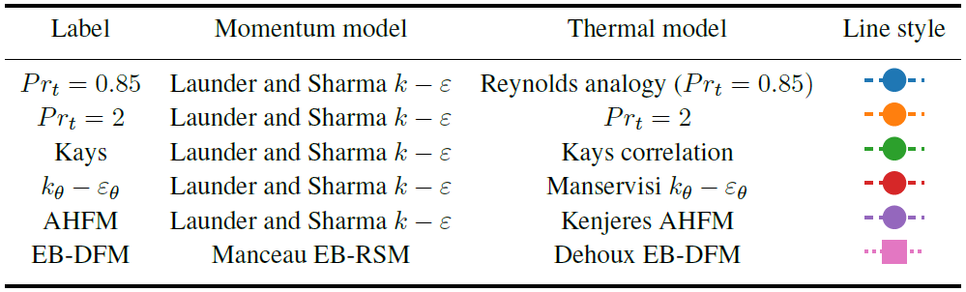
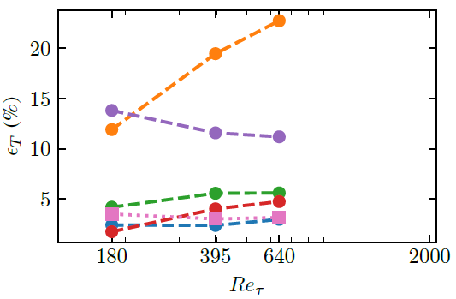 | 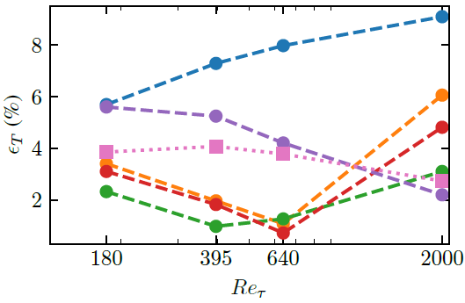
FIG. 5 (Top) Momentum and thermal turbulence models assessed by Ortiz et al. [23]. The error in temperature prediction for planar channel flow at different Reynolds numbers at (left) $Pr$ = 0.71 and (right) $Pr$ = 0.025.

FUTURE PERSPECTIVE
Several different closure approaches are highlighted in the sections above. Although each model may have some advantages and drawbacks, it is clear that no model has universal applicability. The performance of the models vary not just for fluid properties (such as Prandtl number), but also for flow parameters (such as Reynolds or Rayleigh numbers). With the currently available models, the best strategy to model low-Prandtl number flow is using ad hoc modelling approach based on the problem at hand. Algebraic closures, such as the implicit and explicit Algebraic Heat Flux Models (AHFM), show some promise in this context, albeit with calibrated coefficients.
Some flow domains may also exist where definition of the required flow parameters may not be clear or ill-defined. Furthermore, in an integral setting such as a reactor pool, several different heat transfer regimes (forced, natural or mixed convection) may co-exist in the same domain. A priori knowledge of flow parameters in different regions of the domain may not even be possible. This further elucidates the need for ongoing research on turbulent heat transport modelling. Various modelling strategies are being adopted in the international community, as highlighted below. As none of these yet provides a universal solution for modelling of low-Prandtl number flows, all of them require attention for future research and development activities.
In the USA, the focus is on improving the understanding of the heat transport behaviour by performance of high-resolution simulations and by comparing currently available models to the ever growing database of high-resolution data. In particular, new mixed convection regime data has been generated by Bhushan et al. [24] and existing turbulence models are being compared to these results and results of the already available international database [25].
Further development with respect to THF for liquid metal applications is planned, among others, within the framework of the collaborative European PATRICIA project. This development builds upon the advanced turbulent heat flux models, such as the Algebraic Heat Flux Models (AHFM), which might provide a reasonable compromise between robustness, computational efficiency, and accuracy. Further developments should overcome the deficits of the current state-of-the-art, i.e. mainly that the model should be robust but at the same time be able to deal with a variety of convection regimes without pre-determining the convection regime of the flow. In other words, the model should be able to identify the local convection regime and find a reasonably accurate solution for the heat transport locally. Other modelling strategies should also include consistently anisotropic modelling for both momentum and heat transport (see e.g. the recent work of Barbi et al. [26]). Development of wall functions for temperature is another area which require attention as most of the current modelling approaches rely on a wall resolved mesh.
In China, Su et al. [27] start from the explicit AHFM of Manservisi and Menghini [17] and try to improve this model by making the model more robust through the use of Taylor expansions and allowing the use of simple Dirichlet boundary conditions. First tests for forced convection flow in channel flow cases and a bare rod bundle provide promising results.
Recently, the use of machine learning in the assessment and development of new THF closures is also considered as shown by Fiore et al. [28, 29]. In these works, the increasing availability of high-resolution data from DNS and LES simulations is being exploited using a Machine Learning strategy. An algebraic mathematical structure is applied in conjunction with physical constraints which have to ensure attractive properties promoting applicability, robustness and stability. The closure coefficients of the model are subsequently determined by an Artificial Neural Network which is trained with DNS data at different Prandtl numbers. First validation of this approach using various liquid metal flow cases is promising.
ACKNOWLEDGEMENTS
The work presented in this paper has been performed by many colleagues worldwide in collaborative works which are too numerous to acknowledge here individually. It may be clear that development of turbulent heat flux models requires an international collaborative effort. The continuous support of the European Commission through the various framework programs and the numerous European collaborative projects (too many to be mentioned individually here) is gratefully acknowledged. Finally, collecting the information presented and writing of the paper was performed within the multi-year PIONEER R&D program sponsored by the Dutch ministry of Economic Affairs and Climate.
References
[1] GIF, Introduction to Generation IV Nuclear Energy System and the International Forum Https://Www.Gen-4.Org/Gif/, (2010).
[2] GRÖTZBACH, G., Challenges in low-Prandtl number heat transfer simulation and modelling, Nuclear Engineering and Design 264 (2013) 41.
[3] ROELOFS, F., Thermal Hydraulics Aspects of Liquid Metal Cooled Nuclear Reactors, Woodhead Publishing, Elsevier.
[4] SHAMS, A., DE SANTIS, A., KOLOSZAR, L.K., VILLA ORTIZ, A., NARAYANAN, C., Status and perspectives of turbulent heat transfer modelling in low-Prandtl number fluids, Nuclear Engineering and Design 353 (2019) 110220.
[5] KANAWADE, K., Algebraic Heat Flux Modelling for Numerical Prediction of Heat Transfer and FlowinNatural Convection, MSc, Delft University of Technology (2019).
[6] KAWAMURA, H., ABE, H., SHINAGI, K., DNS of Turbulence and Heat Transport in a Channel Flow with Different Reynolds and Prandtl Numbers and Boundary Conditions, Proc. of the 3rd International Symposium on Turbulence, Heat and Mass Transfer, (2000).
[7] BRICTEUX, L., DUPONCHEEL, M., WINCKELMANS, G., TISELJ, I., BARTOSIEWICZ, Y., Direct and large eddy simulation of turbulent heat transfer at very low Prandtl number: Application to lead–bismuth flows, Nuclear Engineering and Design 246 (2012) 91.
[8] REYNOLDS, A.J., The prediction of turbulent Prandtl and Schmidt numbers, International Journal of Heat and Mass Transfer 18 9 (1975) 1055.
[9] KAYS, W.M., Turbulent Prandtl Number—Where Are We?, Journal of Heat Transfer 116 2 (1994) 284.
[10] WEIGAND, B., FERGUSON, J.R., CRAWFORD, M.E., An extended Kays and Crawford turbulent Prandtl number model, International Journal of Heat and Mass Transfer 40 17 (1997) 4191.
[11] DALY, B.J., Transport Equations in Turbulence, Phys. Fluids 13 11 (1970) 2634.
[12] KENJEREŠ, S., GUNARJO, S.B., HANJALIĆ, K., Contribution to elliptic relaxation modelling of turbulent natural and mixed convection, International Journal of Heat and Fluid Flow 26 4 (2005) 569.
[13] SHAMS, A., ROELOFS, F., KOMEN, E.M.J., BAGLIETTO, E., Large eddy simulation of a randomly stacked nuclear pebble bed, Computers & Fluids 96 (2014) 302.
[14] SHAMS, A., Towards the accurate numerical prediction of thermal hydraulic phenomena in corium pools, Annals of Nuclear Energy 117 (2018) 234.
[15] DE SANTIS, D., DE SANTIS, A., SHAMS, A., KWIATKOWSKI, T., The influence of low Prandtl numbers on the turbulent mixed convection in an horizontal channel flow: DNS and assessment of RANS turbulence models, International Journal of Heat and Mass Transfer 127 (2018) 345.
[16] SHAMS, A., DE SANTIS, A., ROELOFS, F., An overview of the AHFM-NRG formulations for the accurate prediction of turbulent flow and heat transfer in low-Prandtl number flows, Nuclear Engineering and Design 355 (2019) 110342.
[17] MANSERVISI, S., MENGHINI, F., Triangular rod bundle simulations of a CFD κ-ϵ-κ-ϵ heat transfer turbulence model for heavy liquid metals, Nuclear Engineering and Design 273 (2014) 251.
[18] CARTECIANO, L.N., WEINBERF, D., MULLER, U., Development and Analysis of a Turbulent Model for Buoyant Flows, Brussels (1997).
[19] SHIN, J.K., AN, J.S., CHOI, Y.D., KIM, Y.C., KIM, M.S., Elliptic relaxation second moment closure for the turbulent heat fluxes, Journal of Turbulence 9 (2008) N3.
[20] MANCEAU, R., Recent progress in the development of the Elliptic Blending Reynolds-stress model, International Journal of Heat and Fluid Flow 51 (2015) 195.
[21] CHOI, S.-K., KIM, S.-O., Treatment of turbulent heat fluxes with the elliptic-blending second-moment closure for turbulent natural convection flows, International Journal of Heat and Mass Transfer 51 9–10 (2008) 2377.
[22] DEHOUX, F., BENHAMADOUCHE, S., MANCEAU, R., An elliptic blending differential flux model for natural, mixed and forced convection, International Journal of Heat and Fluid Flow 63 (2017) 190.
[23] ORTIZ, A.V., GARCIA, J.S., LOPEZ, P.S., KOLOSZAR, L.K., Quantitative Analysis of the Momentum-Thermal Turbulence Modeling at Low Prandtl Number Fluid Flows, Brussels (2022).
[24] BHUSHAN, S. et al., Analysis of turbulent flow and thermal structures in low-Prandtl number buoyant flows using direct numerical simulations, International Journal of Heat and Mass Transfer 189 (2022) 122733.
[25] BHUSHAN, S. et al., Assessment of low- and high-fidelity turbulence models for heat transfer predictions in low-prandlt number flows, Nuclear Engineering and Design 388 (2022) 111614.
[26] BARBI, G., GIOVACCHINI, V., MANSERVISI, S., A New Anisotropic Four-Parameter Turbulence Model for Low Prandtl Number Fluids, Fluids 7 1 (2021) 6.
[27] SU, X. et al., Development and Assessment of an Isotropic Four-Equation Model for Heat Transfer of Low Prandtl Number Fluids, Front. Energy Res. 10 (2022) 816560.
[28] FIORE, M., KOLOSZAR, L.K., MENDEZ, M.A., DUPONCHEEL, M., BARTOSIEWICZ, Y., Artificial Neural Networks for the Modelling of the Turbulent Heat Flux in Forced Convection Flows, The 19th International Topical Meeting on Nuclear Reactor Thermal Hydraulics (NURETH-19), Brussels (2022).
[29] FIORE, M. et al., Physics-constrained machine learning for thermal turbulence modelling at low Prandtl numbers, International Journal of Heat and Mass Transfer 194 (2022) 122998.

