REVIEW AND FUTURE PERSPECTIVES

OF THE COUPLED STH/CFD APPLICATIONS

PERFORMED AT THE UNIVERSITY OF PISA

A. PUCCIARELLI
Università di Pisa, Dipartimento di Ingegneria Civile e Industriale
Pisa, Italy
Email: andrea.pucciarelli@unipi.it

F. GALLENI
Università di Pisa, Dipartimento di Ingegneria Civile e Industriale
Pisa, Italy
Email: francescog.galleni@unipi.it

N. FORGIONE
Università di Pisa, Dipartimento di Ingegneria Civile e Industriale
Pisa, Italy
Email: nicola.forgione@unipi.it

Abstract

The capability to perform reliable numerical analyses of large thermal-hydraulics systems is one of the key features for the development of the new GEN IV of nuclear power plants. The analysis of such large and complicated systems often requires several simplifying assumptions which may help to cope with the required computational efforts: System Thermal Hydraulics (STH) codes were thus developed as a useful tool allowing to obtain sufficiently reliable predictions in reasonable calculation times. STH codes usually assume that the addressed thermal-hydraulics system may be simulated adopting 1D analyses: this reduces the computational cost of the calculations but introduces assumptions that may not be consistent with the addressed problem. In particular, the presence of large 3D environments, for which the one-dimensional approach is no more suitably applicable, represents one of the intrinsic limits of STH codes. In those cases, instead, the CFD approach should be preferred. Recently, the University of Pisa has been involved in several EU projects aiming at providing a better understanding of the thermal-hydraulics aspects of LMFRs. In the frame of these studies a coupled STH/CFD approach has been developed trying to overcome the observed limits of both the codes in stand-alone calculations. STH codes are adopted for the simulation of the thermal-hydraulic system, nevertheless CFD intervenes when a more detailed analysis of complicated 3D environments is required. This way the capabilities of both the codes are maintained, trying to avoid the drawbacks. The paper reports on the recent works performed at the University of Pisa trying to highlight both the advantages and limits of the adopted STH/CFD coupled applications. The performed works also helped in defining useful guidelines for a suitable use of the addressed approach providing a sound basis for a more extensive adoption of STH/CFD calculations in the frame of future works.

INTRODUCTION
In the frame of the innovative GEN IV nuclear power plants, Liquid Metals Fast Reactors (LMFRs) represent one of the most promising concepts for a more effective and widespread utilization of the available fissile resources. Liquid Metals, owing to their limited moderating capabilities, are in fact among the most suitable candidates as coolants for reactors working in the fast neutron spectrum, thus allowing for breeding reactions and fuel conversion. In addition, their thermo-physical properties show interesting capabilities regarding the safety features of the proposed designs, especially the pool type ones. In fact, owing to the large heat capacity of the liquid metal pool, the reactor should not undergo relevant temperature increases during the reference accidental conditions. In addition, thanks to the large thermal conductivity of liquid metals, very good heat transfer capabilities are reported. The very high boiling temperature exhibited by liquid metals also allows for nearly atmospheric pressures inside the vessel, thus increasing the safety of the whole plant. Lastly, in compliance with the requirements of GEN IV, liquid metals allow for passive cooling systems; natural circulation is in fact expected to occur inside the reactor pool during accidental scenarios in order to provide sufficient heat removal from the reactor core. As a consequence, the capability to obtain reliable predictions of thermal-hydraulics phenomena occurring in large 3D pools is one of the key elements in the design of GEN IV LMFRs.
Traditionally, safety analyses in large thermal-hydraulics systems are performed adopting STH codes. These codes are usually characterized by the adoption of a 1D approach; all the systems components are thus approximated through one or more one-dimensional counterparts, therefore implicitly assuming that the axial dimension of the component is the only relevant one. Such an approximation is of course suitable for piping and steam generators, nevertheless it provides only limited capabilities when adopted for addressing intrinsically 3-dimensional environments such as the foreseen large reactor pools. In such conditions, in fact, STH codes cannot predict possible recirculation and fluid mixing, thus failing in reproducing the observed phenomena. On the other hand, the STH approach only requires limited computational effort, thus representing a valuable tool for the simulation of long transients in relatively large and complicated thermal-hydraulics systems.
On the other side, the CFD approach allows for a refined analysis of complex geometries, also taking into account even the small details of the addressed facility; in this frame, the RANS techniques are usually adopted, owing to the relatively small computational cost required for each calculation. CFD is capable to predict local variable distributions and recirculation phenomena also allowing for a detailed setting of the operating and boundary conditions. As a consequence, it is one of the most suitable candidates for the analysis of the large 3-D environments foreseen for the reactor pools of GEN IV LMFRs. On the other hand, it must be stressed that CFD reported limited capabilities in the analysis of two-phase conditions, especially for boiling, thus turning to be not suitable for the analysis of the water side of steam generators. In addition, though the RANS approach is relatively cheap from a computational cost point of view, CFD is relevantly more time consuming than the STH approaches, thus implying that it is not suitable for the simulation of long transients in large thermal-hydraulic systems.
To summarise, STH and CFD codes offer interesting capabilities in addressing the thermal-hydraulics phenomena which are foreseen to occur in LMFRs; nevertheless, they also show relevant drawbacks which may considerably impair the obtained predictions. As a consequence, the use of coupled STH/CFD applications has been recently introduced, with the aim to exploit the advantages of both the applications, while avoiding their intrinsic drawbacks.
Concerning the LMFRs field, coupled STH/CFD applications were successfully applied to the analyses performed in support of the MYRRHA accelerator system [1] and for some selected experimental facility: see e.g. the works performed at SCK-CEN [2-3] for E-SCAPE [4], the ones for TALL 3-D [5] performed at KTH (see e.g. [6]) and the ones about CIRCE-HERO [7] performed at NRG (see e.g. [8]). The University of Pisa also joined the common effort in the frame of several EU funded projects (MYRTE, SESAME, and recently PATRICIA), developing a coupled STH/CFD approach involving the RELAP5 and ANSYS Fluent codes [9-13]. As a result of these common experiences in coupled code methods, Best Practice Guidelines for liquid metals applications were recently developed [14], proposing the most suitable numerical and spatial discretization approaches for some selected operating conditions. The present paper describes some of the activities performed at UniPi involving coupled STH/CFD calculations. Results are reported comparing the results provided by coupled STH/CFD applications against experimental data and both CFD and STH stand-alone calculations. Comments are provided concerning the expected reliability of coupled codes trying to highlight both the advantages and limits of the coupled STH/CFD approach, lessons drawn in the frame of previous experiences are here used to provide a solid basis for the future applications of the addressed method.

STH/CFD coupling fundamental aspects
When developing a coupled STH/CFD application, the user shall define several aspects of the coupling method straddling from the software architecture level to the adopted numerical discretizations. As a first step, the user must select which code is going to solve each region of the thermal-hydraulic system: as a general rule of thumb STH should always be preferred unless the advantages of adopting the CFD approach become relevant such as for the cited 3-D environments. In this sense, for the spatial discretization, either an overlapping or non-overlapping approach has to be adopted. Concerning the time advancing scheme, the user is usually required to select either between an explicit, implicit or semi-implicit coupling. As observed in [14], each choice brings advantages and drawbacks to be evaluated carefully for each application.
Thanks to the experience gained during the past years, the STH/CFD coupling approach developed at the University of Pisa has now achieved a sufficiently mature stage. As it will be shown in the next sections, the non-overlapping approach is always preferred, thus leading to separate STH and CFD domains which only communicate information through some selected interfaces. This of course simplifies the use of commercial codes in code coupling but, on the other hand, checks must be performed on the information transferred between one code and the other, in order to assure the fulfilment of momentum and energy balances at the codes interfaces. Concerning the time-discretization scheme, a semi-implicit approach is instead selected: being a relevant aspect of the adopted coupling strategy, Fig. 1 shows the fundamental steps of the adopted scheme. At each time step, the CFD boundary conditions (${{}_{}^{n}U}_{CFD}^{k})$are updated on the basis of the results provided by the STH code (${{}_{}^{n-1}Y}_{STH}^{})$ for the previous time step. Once the CFD calculation ends, the CFD results are considered as a first guess for the present time step and are adopted to provide the STH code with updated boundary conditions. At the end of the STH calculation the obtained results are checked: in case the considered convergence criteria are matched, the calculation moves to the following time step (n=n+1), if not, an additional iteration for the current time step (k=k+1) is performed. After applying a suitable under-relaxation factor, the STH results are adopted to update the CFD boundary conditions, and a new internal iteration starts until the convergence criteria are matched. The adopted scheme, though relatively simple, turned out to be suitable for a wide range of operating conditions, since it allows convergence of the coupled application disregarding the velocity of the involved phenomena. In fact, the use of a suitable under-relaxation factor and the continuous check of balance equations at the interfaces makes this technique both robust and reliable. Compared to other schemes proposed in the available literature, it usually turns out to be computationally less demanding, thus also allowing for a reduced calculation time.

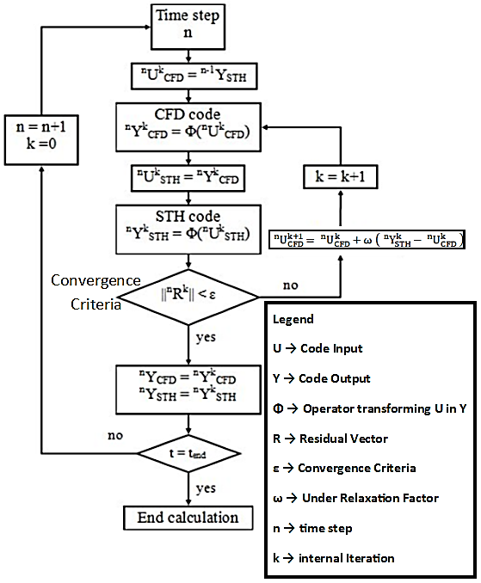

Fig. 1. Adopted time-advancing scheme (adapted from [14]).

past experiences review – the nacie-up facility
The NACIE-UP facility [15] is a rectangular loop designed to investigate thermal-hydraulics phenomena involving liquid metals, both in forced and natural circulation. The considered working fluid is Lead Bismuth Eutectic alloy (LBE), a sketch of the facility is reported in Fig. 2. Among the various components, the Fuel Pin Simulator (FPS) is probably the most relevant: here power is supplied to the system, in addition, the use of wire-wrapped spacers induces relevant cross-sectional flows making the 1-D discretization adopted by STH codes less effective. As a consequence, coupled STH/CFD calculations were performed for some PLOFA scenarios [12] investigated in the NACIE-UP facility: the system was simulated adopting the STH code RELAP5 except for the FPS which was simulated adopting the CFD code ANSYS Fluent. Fig. 3 reports the spatial coupling scheme adopted for the present application: as it can be observed, RELAP5 provides the CFD domain with updated inlet mass flow and temperature conditions; on the other side CFD provides instead RELAP5 with the FPS outlet temperature and the pressure drop across the component. In fact, since the LBE properties do not change to much with pressure, this setting allows the CFD domain working at an almost constant pressure facing only limited changes in the pressure distribution at each iteration, thus reducing the computational time. This way all the required information is transferred.
Fig. 4 shows the comparison between the mass flow rate measured during the addressed experiment and the one calculated by the coupled STH/CFD application and a RELAP5 stand-alone calculation. As it can be observed, both the modelling techniques managed to well reproduce the experimental trend, though the mass flow decrease was predicted to occur too dramatically. Figure 5 reports instead the calculated outlet temperature trends, showing again a good correspondence between the measured and calculated data.

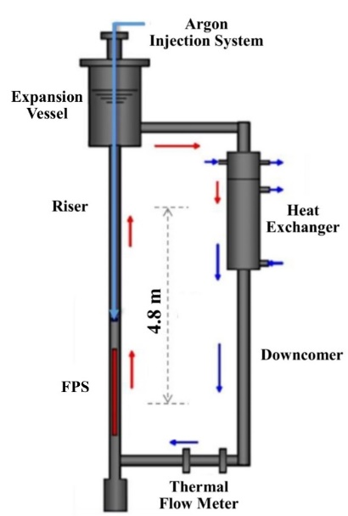  Fig. 2. Schematic layout of the NACIE-UP facility (adapted from [12]). | 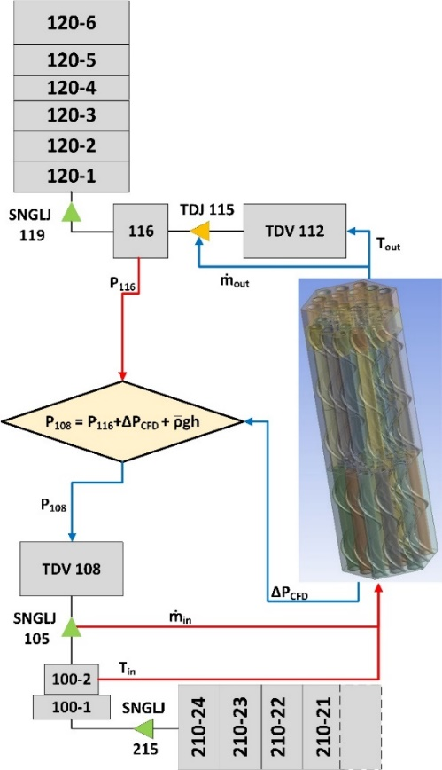  Fig. 3. Adopted coupled calculation nodalization, particular of the FPS region and data transfer scheme (adapted from [12]).
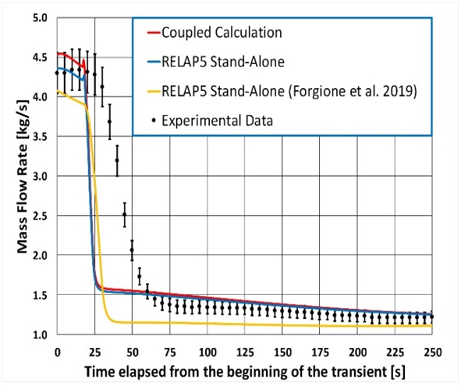  Fig. 4. Numerical and experimental mass flow rate (adapted from [12]). | 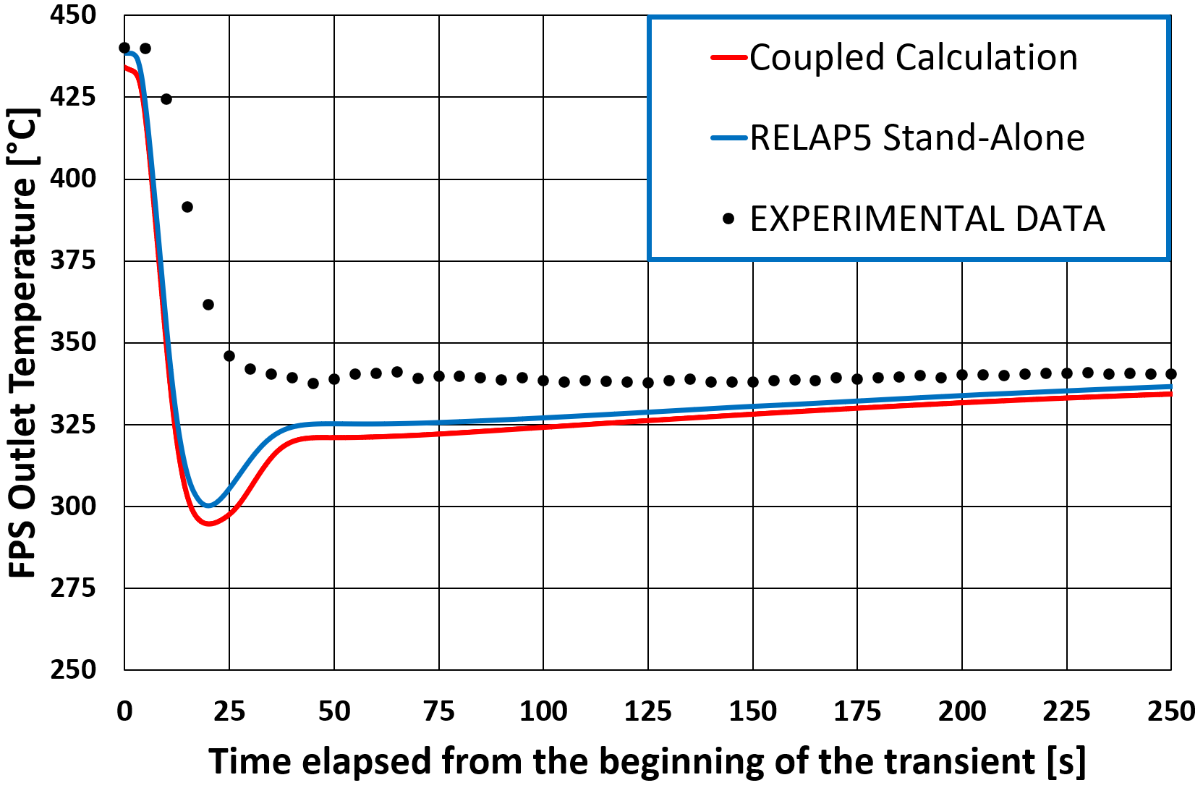  Fig. 5. Numerical and experimental FPS outlet temperature (adapted from [12]).

Though it could be argued that the advantages of using a coupled STH/CFD approach for this kind of application may thus be not so relevant from a global perspective point of view, the adopted approach allows to obtain very detailed results for the CFD domain: in fact, if the local perspective is taken into account, CFD can provide definitively more detailed information with respect to the STH stand-alone approach. Figures 6 and 7 show the predictions provided by the coupled STH/CFD application for the addressed PLOFA for some local temperature measurements inside the FPS. As it can be observed, a very good matching was obtained: such detailed information could not have been provided instead by a STH stand-alone application, which could not predict subchannel bulk temperatures but only cross-sectional averaged quantities. The detail for the wall temperature would be coarser too. The coupled STH/CFD application thus merges the good capability of the STH code in predicting the global system behaviour with the capability of CFD in predicting the local behaviour inside a component. Stand-alone CFD calculations could not achieve such a level of detail because of the limited capabilities of CFD in dealing with two-phase flow conditions of the steam generator; the very large computational cost would be a limiting factor, too. Since obtaining improved predictions of the wall temperature inside the FPS (here acting as Fuel Assembly) is of capital importance for the safety design of a Nuclear Power plant, coupled STH/CFD calculations may offer a significant contribution to this task, overcoming the limit of both the CFD and STH stand-alone applications.

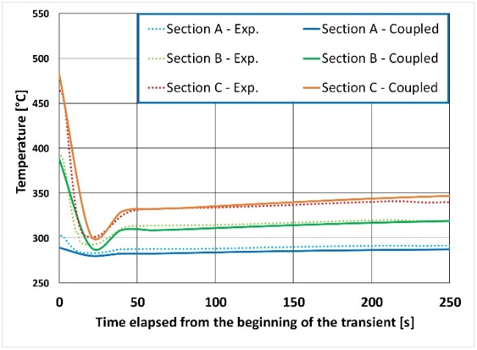  Fig. 6. Numerical and experimental subchannel 5 bulk temperature (adapted from [12]). | 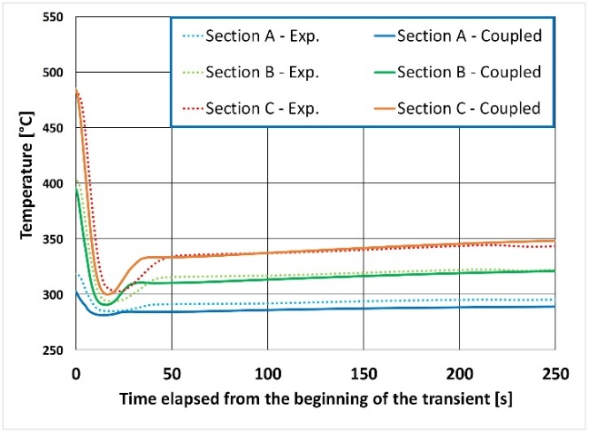  Fig. 7. Numerical and experimental Rod 3 wall temperature (adapted from [12]).

past experiences review – the CIRCE-HERO facility
The CIRCE-HERO facility [7] (see Figure 8) consists of a large vessel containing an internal loop and it is devoted to the investigation of forced and natural circulation phenomena in pool type LMFRs. Owing to the presence of the pool, the 1D STH approach can hardly be reliably applicable to this facility. In this sense, analyses adopting a RELAP5 stand-alone approach [16] reported several issues, especially concerning the unsuitability of the model in reproducing the relevant delays observed in the hot front propagation during the postulated experimental conditions related to recirculation phenomena inside the pool. As a consequence, together with CFD stand-alone calculations aiming at investigating the thermal stratification occurring inside the pool [17], coupled STH/CFD calculations were performed trying to provide a sufficiently reliable modelling of the addressed facility. Particularly, the CIRCE pool was modelled by adopting the CFD approach while the internal loop was discretized using RELAP5. In this case, both thermal hydraulics (at the FPS inlet and at the Steam Generator outlet) and thermal interfaces (on some of the internal loop walls) were included in order to assure a suitable information transfer between the CFD and STH codes. Figure 9 reports a sketch of the adopted spatial discretization, also highlighting the information transferred between the two codes. Unlike the NACIE-UP case, here the CFD domain must provide the RELAP5 domain with the actual pressure value, and not only the pressure drops. In fact, since the pool is not completely filled with LBE, and a gas plenum is present at the top, the pressure head at the FPS inlet and Steam generator outlet changes with the pool level. The pressure information in the pool strongly impacts on the natural circulation conditions and thus must be carefully transmitted to the STH domain. Figures 10 and 11 show the comparison between the measured and calculated mass flow rate and temperature trends inside the FPS component, respectively. As it can be observed, the obtained prediction is sufficiently close to the experimental data: nevertheless, the calculated trend is smoother and some of the fluctuations observed during the experiment and probably due to instantaneous variations in the supplied gas flow rate were not reproduced. In this case, the main advantage provided by the use of a coupled STH/CFD approach is the improved information obtained for the temperature and velocity fields inside the pool. Figures 12 and 13 report the pathlines predicted for the flow exiting the steam generator at the beginning and at the end of one of the simulated postulated transients: a large recirculation region can be observed especially in Figure 12. This information is relevant for the prediction of the time scales of the involved phenomena and of course it could not be obtained by adopting a STH 1D approach. Nevertheless, comparing to a STH stand-alone calculation, which requires computational times in the range of maximum a few hours, a coupled STH/CFD calculation requires computational times in the range of several weeks. Consequently, the obtained additional information comes to a significative cost, and the use of such an approach is thus justified only in front of relevant advantages in the foreseen predicting capabilities, such as in the cases reported in the present work.

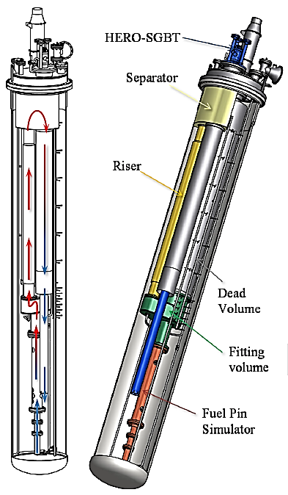  Fig. 8. CIRCE-HERO facility layout (adapted from [11]). | 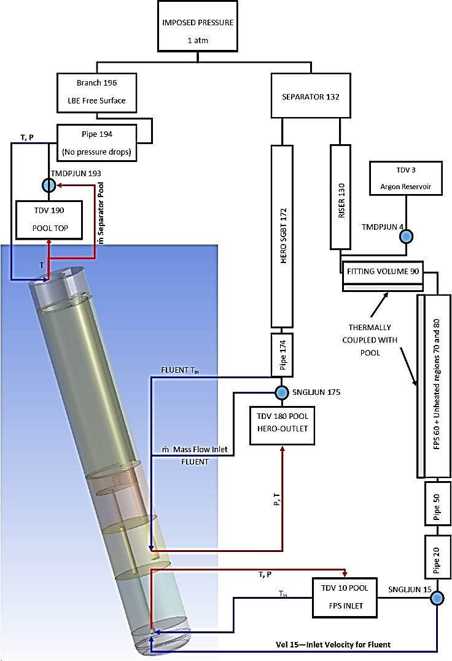 Fig. 9. Coupling scheme and spatial discretization (adapted from [11]).

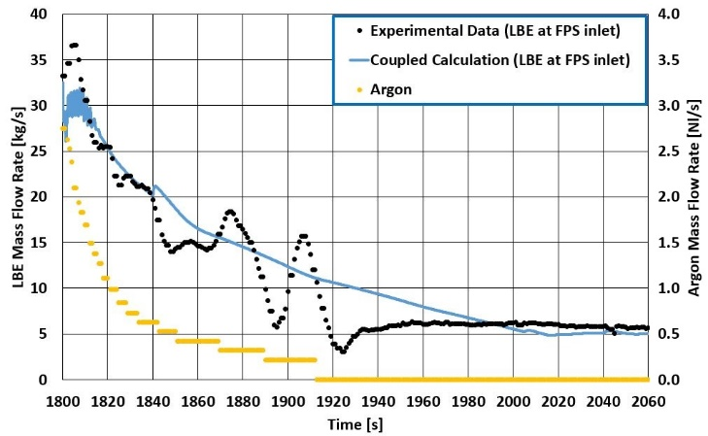
Fig. 10. Numerical and experimental LBE mass flow rate at the FPS inlet section (adapted from [11]).
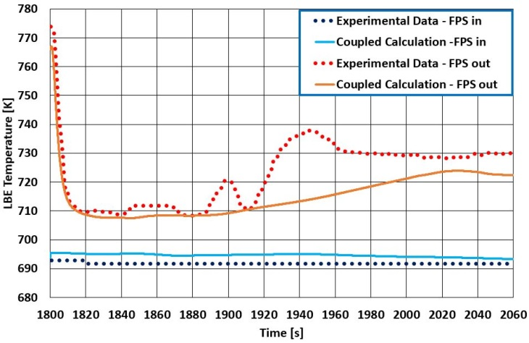
Fig. 11. Numerical and experimental FPS inlet and outlet temperatures (adapted from [11]).

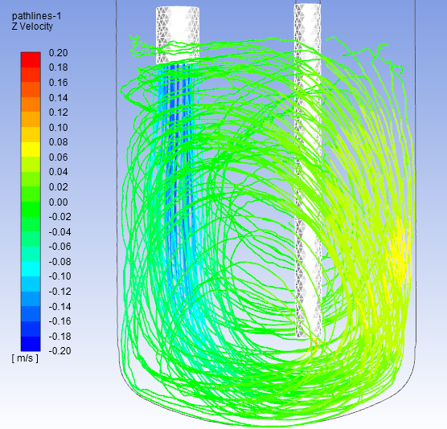  Fig. 12. Pathlines for the fluid exiting the HERO steam generator and entering the FPS for t = 1800 s. (adapted from [11]). | 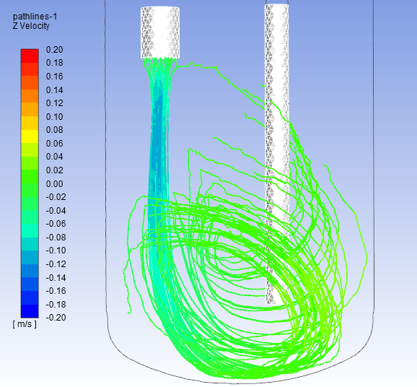  Fig. 13. Pathlines for the fluid exiting the HERO steam generator and entering the FPS for t = 2040 s. (adapted from [11]).

The coupling methodology between CFD code and system code already developed at the University of Pisa was improved accounting for its application to thermal boundary conditions. This allowed to carry out coupled simulations specifically focused on the performances of the HERO-HX steam generator [13]. The coupled methodology was applied to the entire HERO-HX section: the primary LBE side and the pipe structures were modelled with the CFD Fluent code whereas the water side was modelled with the STH code RELAP5, as shown in Figure 14. The variables exchanged between the boundaries of the two codes are: the bulk temperature and heat transfer coefficient of the ascending water (in two-phase flow) obtained from RELAP5 and transferred to Fluent code; the wall temperature at the water side surface of the pipes is calculated by Fluent and passed to RELAP5 code. The coupling procedure was tested against the experimental data provided by ENEA at the end of their experimental campaign. A total of eight different test cases were simulated and the predicted temperatures were compared with the experimental ones, both for the primary and the secondary side. The comparison found a general under-prediction of the temperature when compared with the experimental results; this discrepancy might be due to several reasons such as the simplified computational geometry or the incorrect estimation of the properties of the material composing the bayonet tubes.

However, the numerical results captured quite well the axial trend of the temperatures (Figure 15) and provided an overall good prediction also from a quantitative point of view; it is important to notice as well that this good performance remained consistent for all the cases, proving the general applicability of the methodology. Furthermore, the application of the coupling technique allowed the analysis of the temperature distribution in the cross section of the HX (see Figure 16); this feature can help highlight the flaws in the design of the heat exchanger and improve the evaluation of the overall efficiency with a considerably deeper insight than that provided by the STH codes alone.

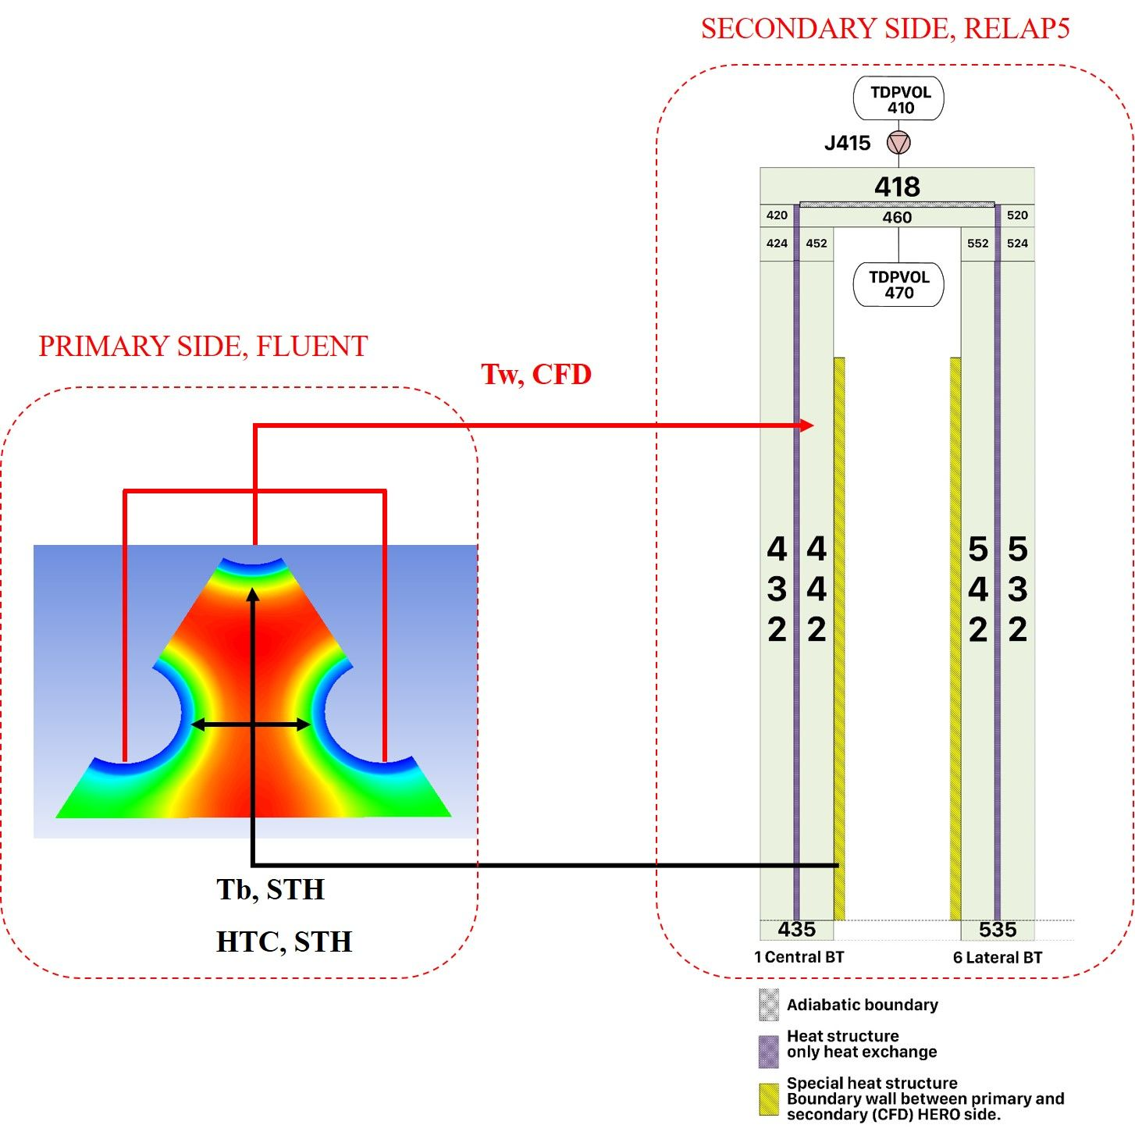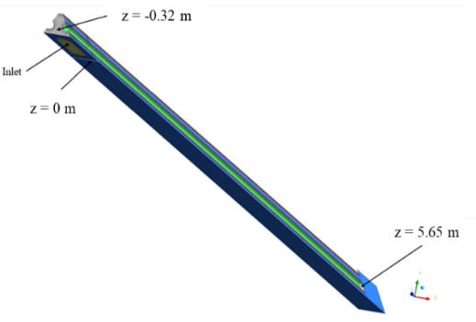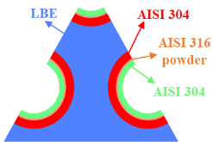
Fig. 14. HERO tubes RELAP5 nodalization and coupled variables (adapted from [13]).
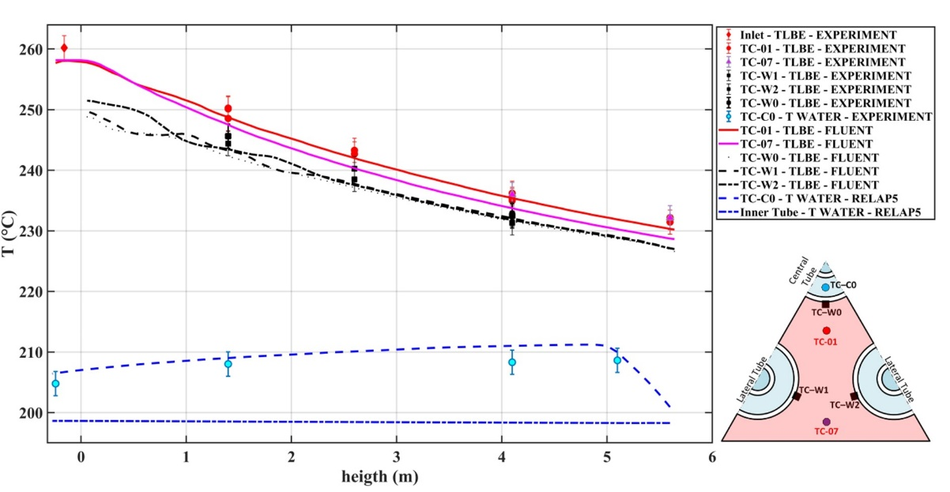

Fig. 15. Coupled simulations - Temperature axial evolution in Test 1 - Comparison with experimental data. (adapted from [11]).

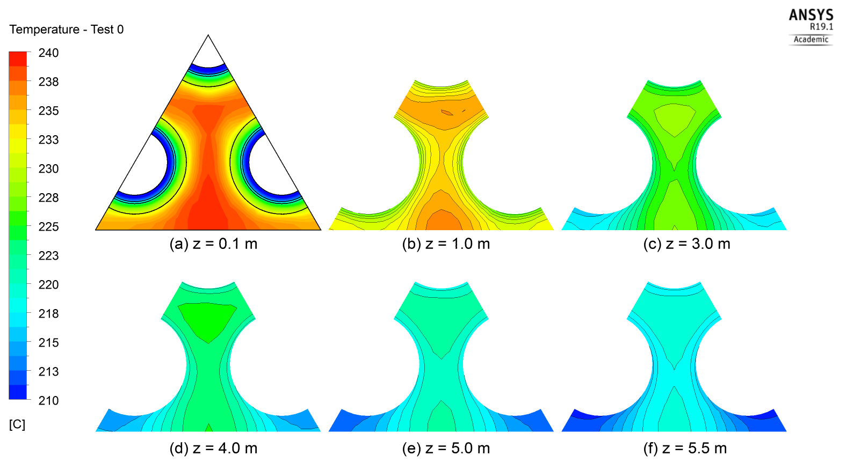
Fig. 16. Coupled simulations - Temperature distribution at different heights - Test 1. (adapted from [11]).

Conclusions and Future perspectives
The present paper resumed the results obtained in the frame of some of the latest coupled STH/CFD calculations performed at UniPi also reporting both advantages and drawbacks of the addressed approach. Coupled STH/CFD calculations are indeed a very interesting modelling tool for GEN IV LMFRs applications. Their improved capabilities in representing 3D phenomena with respect to the monodimensional approach of STH codes represent a valuable tool for the analysis of the thermal-hydraulics phenomena occurring in the reactor pools typical of several LMFRs concepts. The technique was also positively tested for the analysis of the heat transfer capabilities of steam generators, allowing for the chance to obtain improved predictions of the temperature and velocity fields inside the addressed component. On the other hand, they may require relevant computational efforts; their application should thus be limited to geometries and operating conditions that cannot be reliably modelled through simpler approaches. In this sense, also the spatial discretization of the domains and the numerical techniques to be adopted in the frame of the coupled STH/CFD calculation should be selected wisely in order to avoid undesired additional computational costs.
Concerning the ongoing and future works involving coupled STH/CFD calculation to be performed at UniPi, the recent EU funded PATRICIA project will provide relevant material for further assessment and development. In particular, in the frame of this project the CIRCE pool internal loop will be updated, with the inclusion of a new helicoidal tubes steam generator. This new component will represent an interesting benchmark for the considered applications. In fact, owing to its complicated geometry, STH codes cannot be considered suitable for the analysis of the shell side of the steam generator and a coupled STH/CFD calculation is thus recommended. In addition, being very compact, it will imply that the cold fluid exiting from its outlet section will be at a much higher position with respect to the presently considered CIRCE-HERO configuration, thus relevantly changing the velocity and temperature fields to be expected inside the pool. This, together with new postulated steady-state and transient scenarios will provide further material for the analysis of the thermal-hydraulics phenomena occurring inside the CIRCE pool.
The Best Practices Guidelines developed in the frame of recent works will be tested against the new applications, trying to assess the proposed recommendations and further investigate which are the best modelling options for each operating condition and geometry.
As a final comment, STH/CFD applications, despite their relevant computational cost, represent a valuable tool for the analysis of thermal-hydraulics phenomena occurring in large systems also including complicated components or large 3D environments. It is foreseen that, thanks to the continuous increase of computational capabilities, their applications will become more and more frequent with the final objective to have them recognized as a suitable tool for the licensing of Nuclear Power Plants.

ACKNOWLEDGEMENTS
This work was performed in the framework of the H2020 MYRTE project. This project has received funding from the Euratom research and training program 2014.2018 under grant agreement No 662186.
References
- DE BRUYN, D., ABDERRAHIM, H.A., BAETEN, P., LEYSEN, P., “The MYRRHA ADS Project in Belgium Enters the Front End Engineering Phase”, Physics Procedia 66 (2015) 75 – 84, 2015
- VAN TICHELEN, K., MIRELLI, F., GRECO, M., VIVIANI, G., “E-SCAPE: A scale facility for liquid-metal, pool-type reactor thermal hydraulic investigation”, Nuclear Engineering and Design 290, pp 65-77, 2015.
- TOTI, A., VIERENDEELS, J., BELLONI, F., “Improved numerical algorithm and experimental validation of a system thermal-hydraulic/CFD coupling method for multi-scale transient simulations of pool-type reactors”, Ann. Nucl. Energy, vol. 103, 36–48, 2017.
- TOTI, A., VIERENDEELS, J., BELLONI, F., “Coupled system thermal-hydraulic/CFD analysis of a protected loss of flow transient in the MYRRHA reactor”, Ann. Nucl. Energy. 118, 199-211, 2018.
- GRISHCHENKO, D., JELTSOV, M., KööP, K., KARBOJIAN, A., VILLANUEVA, W., KUDINOV, P., “The TALL-3D facility design and commissioning tests for validation of coupled STH and CFD codes”, Nuclear Engineering and Design 290, pp 144-153, 2015.
- PAPUKCHIEV, A., GEFFRAY, C., JELTSOV, M., KööP, K., KUDINOV, P., GRISHCHENKO, D., “Multiscale analysis of forced and natural convection including heat transfer phenomena in the tall-3D experimental facility”. In: NURETH 2015, Chicago, USA.
- PESETTI, A., FORGIONE, N., NARCISI V., LORUSSO, P., GIANNETTI, F., TARANTINO, M., DEL NEVO, A., “ENEA CIRCE-HERO Test Facility: Geometry and Instrumentation Description. Report ENEA CI-I-R-343”, 2018.
- ZWIJSEN, K., MARTELLI, D., BREIJDER, P.A., FORGIONE, N., ROELOFS, F., “Multi-scale modelling of the CIRCE-HERO facility”, Nucl. Eng. Des., 355, 2019.
- MARTELLI, D., FORGIONE, N., BARONE, G., DI PIAZZA, I., “Coupled simulations of the NACIE facility using RELAP5 and ANSYS FLUENT codes” Annals of Nuclear Energy 101, 408-418, 2017.
- MARTELLI, D., FORGIONE, N., BARONE, G., DEL NEVO, A., DI PIAZZA, I., “Coupled Simulations of Natural and Forced Circulation Tests in NACIE Facility Using RELAP5 and ANSYS Fluent Codes, ICONE22-30552, V004T10A020; 10 pages
- PUCCIARELLI, A., GALLENI, F., MOSCARDINI, M., MARTELLI, D., FORGIONE, N., “STH/CFD coupled simulation of the protected loss of flow accident in the CIRCE-HERO facility”. Appl. Sci. 10, 7032, 2020.
- PUCCIARELLI, A., GALLENI, F., MOSCARDINI, M., MARTELLI, D., FORGIONE, N., “STH/CFD coupled calculations of postulated transients from mixed to natural circulation conditions in the NACIE-UP facility”. Nucl. Eng. Des. 370, (15) 110913, 2020.
- GALLENI, F., BARONE, G., MARTELLI, D., PUCCIARELLI, A., LORUSSO, P., TARANTINO, M. and FORGIONE, N., “Simulation of operational conditions of HX-HERO in the CIRCE facility with CFD/STH coupled codes”. Nuclear Engineering and Design, 361, p.110552, 2020.
- PUCCIARELLI, A., TOTI, A., CASTELLITI, D., BELLONI, F., VAN TICHELEN, K., MOSCARDINI, M., GALLENI, F., FORGIONE, N., “Coupled System thermal hydraulics/CFD models: general guidelines and applications to heavy to liquid metals”, Nuclear Engineering and Design, 370, p.110913, 2020.
- DI PIAZZA, I., TARANTINO, M., AGOSTINO, P., GAGGINI, P., POLAZZI, G., FORGIONE, N., MARTELLI, D., “Nacie-UP: an heavy liquid metal loop for mixed convection experiments with instrumented pin bundle”, HLMC-2013, 2013.
- MOSCARDINI, M., GALLENI, F., PUCCIARELLI, A., MARTELLI, D., FORGIONE, N., “Numerical Analysis of the CIRCE-HERO PLOFA Scenarios”. Appl. Sci. 2020, 10, 7358.
- BUZZI, F., PUCCIARELLI, A., GALLENI, F., TARANTINO, M., FORGIONE, N., “Analysis of thermal stratification phenomena in the CIRCE-HERO facility”, Ann. Nucl. Energy, 131, Article 107320, 2020

