Thermal-hydraulic analysis of HLM cooled fuel pin bundle

Cioli Puviani Pietro1, Ivan Di Piazza2, Marinari Ranieri2, Zanino Roberto1, Tarantino Mariano2

1Politecnico di Torino, Torino, Italy

2Enea, Brasimone, Italy

Email contact of corresponding author: pietro.ciolipuviani@polito.it

**Extended Abstract**

The attention for Lead-cooled Fast Reactor (LFR) technology is growing worldwide thanks to enhanced safety and sustainability, potential for economic competitiveness and unique flexibility in terms of plant size and potential applications [1]. The development programs of lead cooled reactors need affordable and effective tools for the prediction of thermal-hydraulic (TH) phenomena, in particular in the primary side, both at the system and single component level.

System Thermal Hydraulic (STH) codes such as RELAP5, CATHARE or ATHLET proved to be effective for various applications and fundamental in the regulatory acceptance of water-cooled reactors. One of the main advantages of LFR is the possibility to design the primary side of the reactor, collapsing all the components inside the primary vessel. In pool-type reactors, three dimensional phenomena play a more relevant role with respect to the loops one, typically adopted in water cooled reactors. Thus STH, which are based on 1D component simplification, have difficulties in predicting some phenomena, such as the mixing and thermal stratification in the pool [2].

Computational Fluid Dynamics (CFD) codes resolve the Navier Stokes equations in three-dimensional domain and resulting suitable to reproduce the TH conditions in a pool type facility. However, the computational cost of CFD models simulating large domains, with satisfactory accuracy could be too high for its implementation in design and optimization procedure.

In this work, different approaches devoted to the reduction of computational efforts have been studied. The numerical analysis has been carried out on the Fuel Pin Simulator (FPS) of the CIRCE (CIRColazione Eutettoidico) facility located in Italy in the ENEA research centre. The FPS consists of 37 electrical pins arranged with a wrapped hexagonal lattice with a pitch-to-diameter ratio (p/d) of 1.8, the wrapper edge length is 55.4 mm while the apothem is 48 mm. Each pin has an outer diameter of 8.2 mm with an imposed almost uniform heat flux for an active length of 1000 mm, resulting in a crossflow area through the bundle of 6027 mm2 [3]. Eventually three spacer grids assure the correct position and stability of the pins.

The results of an experimental campaign carried out in 2015 have been adopted for the validation of the CFD analysis implemented on CFX ANSYS code. In the tests, the mass flow rate has been varied from forced to natural circulation condition, while the heat power generated in the FPS has been imposed to maintain an axial temperature variation of 80°C.

In the first part of the work, the reference numerical solution has been defined by approaching the problem by means of a detailed CFD simulation with a resolved boundary layer. Firstly, a comparison between turbulence models has been carried out: the two equations $SST k-ω$ and $Standard k-ε$ model have been selected to analyse the results with the two different wall dissipation approaches, and then compared with the $BSL RSM$ to investigate the possible advantages of the seven equation Reynolds stress models.

For the study the steady state condition of the 1FC, 7FC and 6NC tests have been considered, called in accordance with [3] and [4]. Different quantities have been compared, adopting different turbulence models and validating them against experimental results when available. Two main instrumented test sections in CIRCE are considered (*Figure 1*): Section 1 placed 15 mm upstream the middle section of the middle grid and Section 3 positioned 50 mm upstream the middle plane of the upper grid and 15 mm upstream the end of the pin active length. Here the central subchannel pin temperature has been evaluated and adopted for computing the experimental Nusselt number, together with the section bulk temperature, retrieved from an energy balance involving the measured inlet and outlet of the active length temperature.

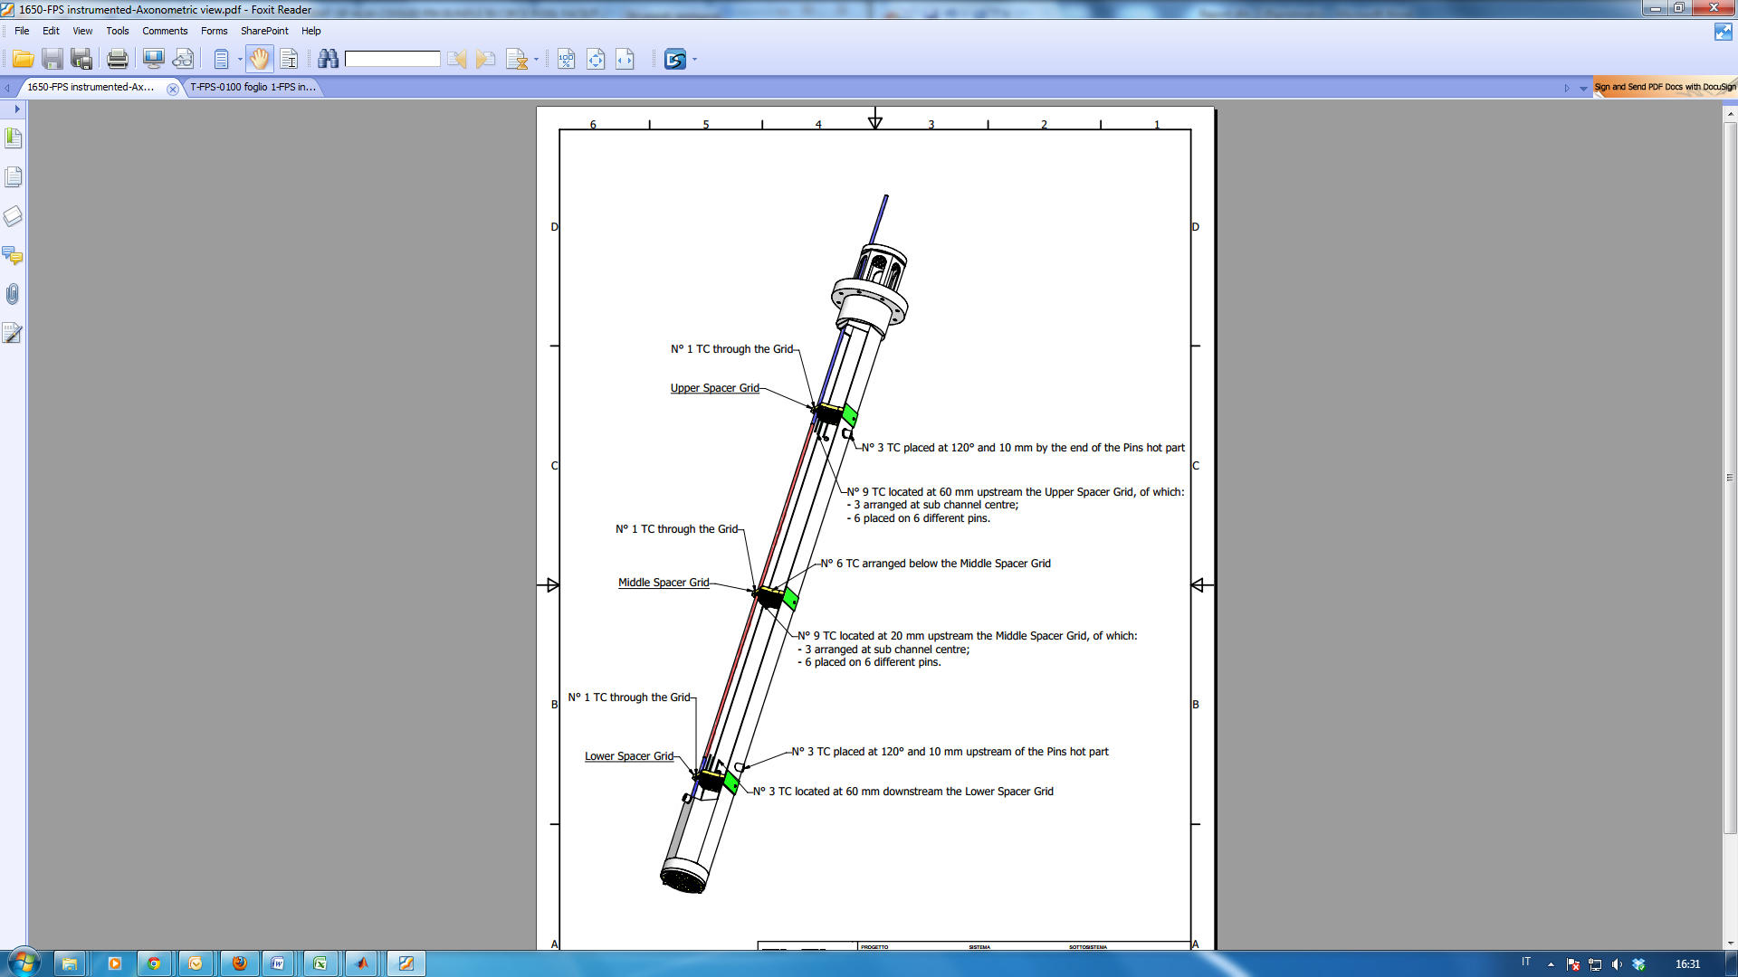

*Figure 1- FPS 3D sketch and instrumented sections [4]*

A grid independence study at the higher mass flow rate condition has been carried out to ensure a limited effect of the discretization error.

The Nusselt number and pin temperature analysis show good prediction capability for all the considered turbulence models with small difference between two equation models and negligible variation adopting the $BSL RSM$. Slightly better performances have been found for the $SST k-ω$, which never exits from the error bar of the experimental results.

The first computational cost reduction method is based on the high y+ approach at the wall: this choice reduces the mesh requirement at the boundary layer while committing the gradient prediction at the wall function, pre-build flow gradient that the code implements when the y+ is higher than 30 [5].

In this work, a y+ higher than 30 has been ensured in the entire domain and the application of the previously cited turbulence model has been compared with experimental and low y+ results for the 1FC test. The mesh reduction goes from 6.38M of cell with low y+ approach to 1.69M with high y+ approach.

TABLE 1. TEMPERATURE AND NUSSELT NUMBER COMPARISON BETWEEN EXPERIMENTAL DATA AND SIMULATION WITH DIFFERENT TURBULENCE MODEL AND WALL TREATMENT

|  |  |  |  |  |  |  |  |
| --- | --- | --- | --- | --- | --- | --- | --- |
|  | **Exp** | **y+1 SST** | **y+40 SST** | **y+1 k-eps** | **y+40 k-eps** | **y+1 BSL RSM** | **y+40 BSL RSM** |
| *Section 1* | | | | | | | |
| *T bulk [°C]* | 322.9 | 322.8 | 322.8 | 322.8 | 322.8 | 322.9 | 322.9 |
| *T pin [°C]* | 377.16 | 375.19 | 370.39 | 376.51 | 377.77 | 376.8 | 370.5 |
| *Nu [-]* | 26.3 | 26.5 | 29.6 | 25.9 | 25.6 | 25.8 | 29.6 |
| *Section 3* | | | | | | | |
| *T bulk [°C]* | 358.2 | 361.4 | 361.4 | 361.5 | 361.5 | 361.5 | 361.5 |
| *T pin [°C]* | 414.2 | 415.7 | 411.2 | 417.1 | 418.2 | 417.0 | 411.3 |
| *Nu [-]* | 24.5 | 24.6 | 27.2 | 24.0 | 23.8 | 24.1 | 27.2 |
|  |  |  |  |  |  |  |  |
| *Pressure drops [mbar]* | - | 167 | 164 | 156 | 159 | 169 | 164 |

The results (TABLE 1) show that the $SST k-ω$ and the $BSL RSM$ are not effective in high y+ mesh condition, while the $Standard k-ε$ could reproduce with good accuracy the result obtained with the resolved boundary layer. The last row of the table reports the pressure drops of the models where a variation around 8% could be found, however no experimental data are available for under this point of view and further analysis should be carried out in future works.

The second method for the computational cost reduction is based on porous media, analysing three different approaches, also in this case, adopting the 1FC test boundary condition:

* the single porous domain (PM1) for the entire fuel bundle:
* the two porous domains (PM2), which discretized the fuel bundle in two regions exploiting the different power generation density in the region of the last rank of the fuel pin bundle;
* the hybrid approach (Hybrid), so called since the fuel bundle is represented by a porous domain surrounded by a fluid layer to directly represent the fluid-solid interaction. For the hexagonal fuel bundle, the hexagonal key of the central porous domain of the hybrid approach is computed in such a way to have the same porosity corresponding to the infinite lattice domain.

To characterize the porous media behaviour a set of parameters has been defined, retrieving the hydraulic behaviour from a series of simulations on the infinite lattice domain of the bundle with different mass flow rate. In this way, for each porous media region, the geometrical based parameters (porosity and volumetric heat source) and the hydraulic parameters (permeability and loss coefficient) define the thermal hydraulic behaviour inside the bundle. Since the detailed description of the pin region is not required, the mesh is strongly reduced (around 90 K cells) with small differences between the three approaches.

|  |  |  |  |  |
| --- | --- | --- | --- | --- |
| C:\Users\Utente\Dropbox (Politecnico Di Torino Studenti)\Per passaggio immagini\RT_Temdeteiled.png | C:\Users\Utente\Dropbox (Politecnico Di Torino Studenti)\Per passaggio immagini\RT_Temdeteiled.png  (a) | C:\Users\Utente\Dropbox (Politecnico Di Torino Studenti)\Per passaggio immagini\RT_Temp1P.png  (b) | C:\Users\Utente\Dropbox (Politecnico Di Torino Studenti)\Per passaggio immagini\RT_Temp2P.png  (c) | C:\Users\Utente\Dropbox (Politecnico Di Torino Studenti)\Per passaggio immagini\RT_TempHsst.png  (d) |

*Figure 2 Outlet temperature maps in: Detailed CFD (a), PM1 (b), PM2 (c), Hybrid (d).*

TABLE 2 COMPARISON OF THE RESULTS BETWEEN THE DETAILED CFD AND THE THREE POROUS MEDIA APPROACHES ON THE CIRCE FPS*.*

|  |  |  |  |  |
| --- | --- | --- | --- | --- |
|  | **Detailed CFD** | **PM1** | **PM 2** | **Hybrid** |
| *Pressure drops [mbar]* | 167 | 167 | 168 | 161 |
| *Section 3 Bulk Temperature [°C]* | 361.4 | 361.2 | 361.2 | 361.2 |
| *Section 3 Max Temperature [°C]* | 428.0 | 379.8 | 371.3 | 368.1 |
| *Section 3 Min Temperature [°C]* | 319.4 | 358.1 | 344.9 | 322.4 |
| *Outlet Bulk Temperature [°C]* | 362.3 | 362.3 | 362.4 | 362.4 |
| *Outlet Max Temperature [°C]* | 369.0 | 372.7 | 372.7 | 369.4 |
| *Outlet Min Temperature [°C]* | 339.1 | 359.2 | 346.7 | 334.3 |

From the results could be seen that the three approaches well reproduce the bulk temperature and pressure variation in the system. The qualitative distribution of the temperature at the outlet section of the Hybrid model gets the best performance (*Figure 2*) as also confirmed from the minimum temperature at Section 3 and at the Outlet or the maximum temperature at the Outlet. The error in Section 3 on the maximum error is more relevant since the porous media method reproduces an averaged behaviour and thus does not get the peak temperature near the pins (TABLE 2).

All the simulations presented in this work satisfy the common convergence criteria of reaching normalized residual lower than 1e-5 and thus a comparison between the computational time needed for the different models could be carried out.



*Figure 3. Comparison on the computational time required by different CFD approaches (1-FC boundary condition).*

*Figure 3* reports the computational time required of the simulation corresponding to the 1-FC boundary condition with different approaches: PM-based models (green), detailed geometry model with low y+ approach and different turbulence models (red), and detailed geometry model with high y+ approach and different turbulence models (blue).

The following considerations can be made:

* the RSM is the most expensive turbulence model, while the *SST k-ω* and the *Standard k-ε* have similar time of convergence;
* the high-y+ approach allows a reduction of the needed CPU time of about one order of magnitude with respect to the low-y+ approach, thanks to the relatively coarse mesh at the walls reaching y+ ~ 40;
* the PM-based turbulence models allow a reduction of more than two orders of magnitude of the CPU time required for simulating the FPS condition.

The results demonstrate the effectiveness of the PM model under this point of view, with a reduction of the computational time by several orders of magnitude.

References

1. Pierdomenico Lorusso, Serena Bassini, Alessandro Del Nevo, Ivan Di Piazza, Fabio Giannetti, Mariano Tarantino, Marco Utili, GEN-IV LFR development: Status & perspectives, Progress in Nuclear Energy 105 (2018) 318–331
2. G. Bandini, M. Polidori, A. Gerschenfeld, D. Pialla, S. Li, W.M. Ma, P. Kudinov, M. Jeltsov, K. Kööp, K. Huber, X. Cheng, C. Bruzzese, A.G. Class, D.P. Prill, A. Papukchiev, C. Geffray , R. Macian-Juan , L. Maas, Assessment of systems codes and their coupling with CFD codes in thermal–hydraulic applications to innovative reactors, Nuclear Engineering and Design 281 (2015) 22–38. <http://dx.doi.org/10.1016/j.nucengdes.2014.11.003>
3. Daniele Martelli, Nicola Forgione, Ivan Di Piazza, Mariano Tarantino, HLM fuel pin bundle experiments in the CIRCE pool facility, Nuclear Engineering and Design 292 (2015) 76–86. <http://dx.doi.org/10.1016/j.nucengdes.2015.06.004>
4. Daniele Martelli, Ranieri Marinari, Gianluca Barone, Ivan di Piazza, Mariano Tarantino, CFD thermo-hydraulic analysis of the CIRCE fuel bundle, Annals of Nuclear Energy 103 (2017) 294–305. <http://dx.doi.org/10.1016/j.anucene.2017.01.031>
5. ANSYS CFX-Solver Theory Guide, November 2011