STANDARD CFD TECHNIQUE FOR SODIUM TO SODIUM HEAT EXCHANGERs

V. SUDHARSHAN¹, AMZAD PASH¹, U. PARTHA SARATHY¹, S. RAGHUPATHY¹

¹Indira Gandhi Centre for Atomic Research, Department of Atomic Energy, Kalpakkam, India.

Email contact of corresponding author: sudharshan@igcar.gov.in

Abstract

Effectiveness of standard CFD methodology in simulating the heat transfer behavior of sodium to Sodium Heat Exchangers is studied using test data from literature. There is a fair agreement between test and CFD results (maximum error is 3.8%). Hence, the CFD methodology is validated for steady state assessment of the HEs.

INTRODUCTION
Sodium cooled fast reactors use secondary sodium systems to detach contact of the primary system with final heat sink to minimize the chances of sodium - water/ air chemical reactions reaching the reactor vessel. Sodium to sodium Heat Exchangers (HEs) are used for exchanging heat with primary system. The HEs are designed for the nominal conditions using the correlations available for the heat transfer and pressure drop estimations. Detailed assessments of the HEs are required to confirm the design as there are uncertainties in the correlations, assumptions in the design and deviations in the geometries vis-à-vis the correlations etc. In addition to the nominal conditions, the HEs are required to transport heat during various operating conditions of the reactor. A mathematical model would help in checking the ability of HEs to perform during their intended service conditions. Computational Fluid Dynamics (CFD) is an effective technique for the above mentioned purpose. However, the HEs are generally large in size and doing a detailed study with CFD necessitates higher computational resources. To check the applicability of a standard CFD method, HE from reported literature [1] is taken and the test conditions are simulated for validation.

Description of the heat Exchanger & test conditions from the literature
The HE is a vertical counter-current unit with a removable tube bundle (Fig. 1), installed in the loop such that the sodium flows in hot and cold conditions through the shell side and the tube sides respectively. At rated 3 MW (th) capacity, 14.31 kg/s sodium at 811 K flows into the shell side of the HE through the 8 No. of 102 mm wide x 64 mm height equi-spaced inlet ports, gets cooled to 644 K by cold sodium flowing inside the tubes and exits the HE through the 12 No. of 64 mm wide x 60 mm height equi-spaced outlet ports (Fig. 1). Cold sodium at 616 K enters the tubes from the bottom tube sheet, flows upwards gets heated to 783 K and leaves the HE through the top tube sheet. The sodium is electrically heated in the heater vessel [1] before sending it to the shell side and it is cooled in the sodium-air cooler in order to maintain steady state temperature conditions in the test loop. The impurities in sodium are maintained below 10 ppm using cold traps. The sodium flow rate through the loop is measured by an electromagnetic flow meter. Thermocouples fixed in thermo wells at the inlets and outlets of the HE measure temperatures. Temperatures are maintained constant at the inlets to shell side and tube side and the flow rate is changed for increasing the heat transfer rate. The outlet temperatures are measured for estimating the capacity of the HE. Experiments are carried up to a maximum flow rate of 10.86 kg/s due to the limitation in heat rejection capacity of the loop.

geometry MODELLING AND boundary conditions
A 90° sector model of the HE between the top and bottom tube sheets is used for the study. The discretized model along with the boundary conditions used for the study is shown in Fig. 1. Both shell side and tube side fluids are considered for the study. The pressure drop offered by tube bundle supports at three locations is modelled using porous jump model with a specified pressure drop coefficient. Totally 48 tube surfaces are modelled with 6 semi tubes in consistency with symmetry of the arrangement. Shell side sodium region is discretized such that there are 3 cells between the tube surfaces, tubes are modelled as 16 node polygons with zero thickness. The number of cells used in the model are 6.6 lakhs.
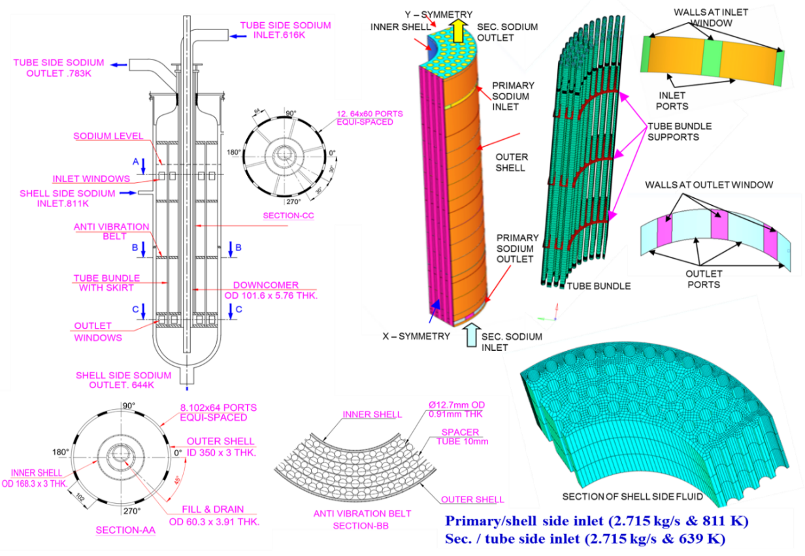
FIG. 1 Dimensions, modelling and Boundary conditions of the heat exchanger

3 – D conservation equations for mass, momentum and energy are solved using finite volume method to carry out steady conjugate heat transfer analysis of the HE in the tube bundle region. Boussinesq approximation [2] is used for considering density changes. The SIMPLE algorithm [3] is used for Pressure – velocity coupling. First order up winding scheme is used for convective and diffusive fluxes at the interfaces. The k – ɛ realizable model is used for accounting turbulence with enhanced wall function. The y⁺ values are in the range of 2 to 394. The convergence criteria is set at 10⁻⁶ for the residue terms. Uniform mass flux normal to the boundary along with the temperature are given as inlet conditions (Fig. 1) and pressure outlet boundary condition is specified at the outlets for both shell side and tube side fluids. Tubes are defined as coupled walls with 0.91 mm thickness on the inner side. Inner-shell, outer-shell, top of bottom tube sheet, bottom of top tube sheet are defined as adiabatic walls since the heat transfer from these surfaces are negligible in comparison to the actual heat transfer from shell side to tube side fluids. The HE geometry and shell side inlet flow distribution are nearly symmetric. The inlet port height is 64 mm which is considerably small in comparison to HE height of 4.65 m. Hence, the inlet flow distribution is not expected to affect the heat transfer capacity significantly. The tube side inlet flow distribution is expected to be nearly uniform. By extending the inlet domains, the estimations can be further improved which are planned for future studies.

Results and discussion
The shell side sodium enters through the inlet port and travels predominantly in the radial direction because of its momentum. After reaching the inner shell, the sodium changes its direction and moves axially. As the sodium flows in the axial direction, the flow gets developed and becomes nearly uniform by the time it reaches the middle region. As a result of this, in the top region the axial velocities are higher near the inner shell region as compared to the peripheral region (Fig. 2a). Because of the radial flow in the top region, the radial temperature drop is small (Fig. 2a). While travelling in the axial direction, in the top region, the axial velocities are higher in the inner region, resulting in smaller axial temperature gradients compared to the peripheral region. Hence, the inner region is hotter in the top region. As the flow develops, axial temperature gradients become uniform. This is clear from the Fig. 2a and 2b where the inner region temperatures are higher in the top and axial temperature profiles are parallel in the middle region. As the flow approaches the exit, the axial flow turns to radially outwards (Fig. 3a). This results in low sodium velocities near the inner region near the bottom tube sheet and the sodium temperature drop is more as compared to peripheral region. Temperature profile of shell side sodium at the outlet ports is show in Fig. 3a. It can be observed that there is a maximum of ~ 13 K temperature difference in the outlet ports because sodium at the outer periphery exits immediately (Fig 3a) from the top of the ports while the sodium from inner region cools down and exits from the bottom of the ports. The temperature distribution of tube side sodium at its outlet is shown in Fig. 3b. There is a maximum of 3.7 K difference in the sodium streams exiting the HE, mainly along the circumferential direction of the HE. Since the inlet of sodium to the shell side is through ports (Fig. 1), the temperatures of the tubes which are in line with the inlet ports have higher temperatures compared to the other tubes. The comparison of results from current study and reported results are given in Table 1. There is close match between the predictions and reported values. The maximum error in the heat transfer capacity is 3.8%, validating the application of the standard CFD for simulating steady state heat transfer of HEs.
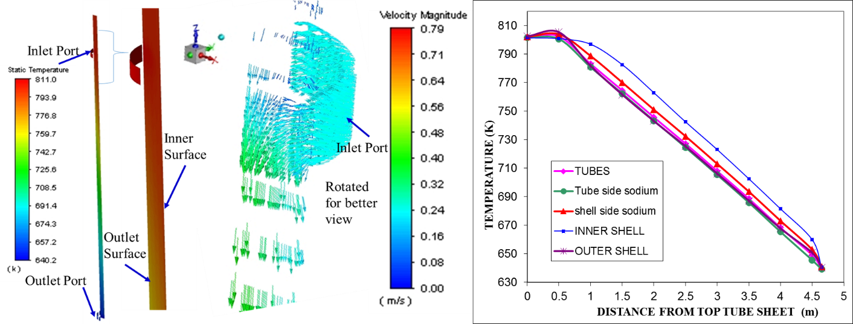
FIG. 2a Evolution of temperatures in the HE and velocity development at the inlet ports
FIG. 2b Average Axial Temperatures of the HE components

FIG. 2 Evolution of temperatures in the HE
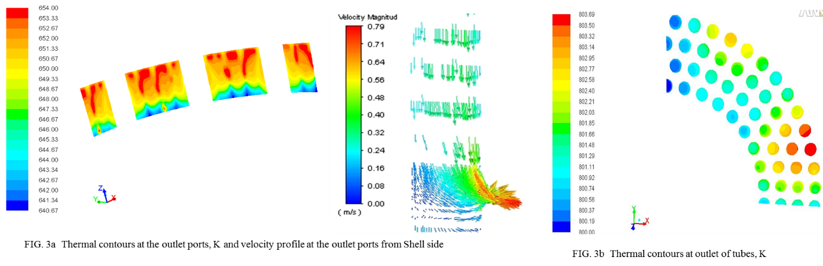FIG. 3 Temperature profiles of sodium at the outlet from the heat exchanger

TABLE 1. COMPARISON OF RESULTS FROM LITERATURE AND CURRENT CFD STUDY
Parameter | Literature | CFD | Error%
Shell side outlet temperature (K) | 654 | 649.2 | - 0.7
Shell Side heat transfer (kW) | 2160 | 2240 | + 3.7
Tube Side outlet temperature (K) | 795 | 801.7 | + 0.8
Tube side heat transfer (kW) | 2158 | 2239.9 | + 3.8

Conclusions
Application of standard CFD methodology for simulation of steady state conditions in HEs is validated. The maximum error in predicting the heat transfer capacity is 3.8%. Flow and Temperature distributions can be predicted with the methodology.

6. Future Scope

The induced un-certainty due to uniform inlet flow assumption at the inlet to tube side needs to be assessed to study the effect on the heat transfer capacity of the HE and temperature distribution in the tubes.
References
- PRAHLAD, B., KALE, R.D., RAJAN, K.K., Thermal Performance Tests on A Sodium to Sodium Heat Exchanger, Journal of Nuclear Science and Technology, 27 (6), pp. 547 – 553, (June – 1990).
- SADIK, K., YAMAN, Y.,Convective Heat Transfer, second edition, pp 311, CRC press (1994).
- PATANKAR, S.V., Numerical Heat Transfer and Fluid Flow, McGraw – Hill, New York (1980).

