REDUCED ORDER MODEL OF STANDARD K-$ϵ$ TURBULENCE MODEL

Jorge Yanez
Andreas G. Class
Institute for Thermal Energy Technology and Safety
Karlsruhe Institute of Technology
Hermann-von-Helmholtz-Platz, 1
76344, Eggenstein-Leopoldshafen, Germany
jorge.yanez@kit.edu

Abstract

A surrogate of the Standard $k$-$ϵ$ turbulence model is created utilizing Proper Orthogonal Decomposition and Galerkin projection. This is a complex task, since the turbulence model equations exhibit multiple non-linearities. Those are treated using the Discrete Empirical Interpolation Method, dealing effectively with the rational functions involved in $k$-$ϵ$ model. Subsequently, the capabilities of the construct to reproduce the CFD calculation in nominal conditions are assessed. Results are studied, thoroughly checking the validity of the creation.

INTRODUCTION
The prediction of fast nuclear reactor’s thermal hydraulics had relied in the past almost exclusively on experiments. Future development may rely more intensively on numerical calculations. With an enhanced usage of computational fluid dynamics (CFD), it becomes significant not only to obtain the results, but also to assess its own reliability. Also, it is relevant for the design to analyse the sensitivity of results on parameters, initial and boundary conditions. A promising strategy to address these matters, seems to be to create a very fast-running surrogate model and run it in numerous varying cases.
Several of the designs of fast reactors (FR) in actual development, i.e., the Lead-Cooled Fast Reactor, the Molten Salt Reactor and the Sodium-Cooled Fast Reactor [1][2][3], rely on the natural convection of an uncompressible fluid for the residual heat removal in case of an emergency. The onset of the natural convection –from the operation forced regime-- and the transients arising can be investigated utilizing a turbulent CFD calculation.
The results obtained--specially in such conditions of potential instability—may be prone to bifurcations phenomena [4]. Therefore, a thorough assessment of their own statistical trustworthiness is required to obtain conservative results. Also, the accurate calculation of the onset phenomena requires a very high resolution of the utilized CFD mesh [5].
Standard k-ϵ model [1] has been the workhorse for turbulent flow simulation since its creation in 1974. It has been one of the most utilized methodologies for the simulation of turbulence in fluids. Conceptually, Standard k-ϵ model belongs to the Reynolds-averaged Navier–Stokes (RANS) equations approach [7], a common frames in which the equations of fluid flow are time-averaged. Several other models belong to this category. Among others, we may cite the k-ω model [8], the Re-Normalisation Group k-ϵ model [9] and the Shear Stress Transport turbulence model [10]. In spite of the existence of these more modern models, Standard k-ϵ model, remains available in OpenFOAM [11] or Star-CCM [12].
Independently of the category of turbulence modelling we are considering, and of the concrete model that we are utilizing, there is a common characteristic that all those methodologies share: they are deterministic. This implicitly represents a serious drawback since the statistical trustworthiness of the results cannot be assessed.
As an example consider an initial value problem in which real initial conditions are similar but not exactly the same as the nominal considered in the analysis. Since a single result is obtained, the confidence interval of the solution remains unknown. The effect of the small initial divergence in the final solution remains an arcane. Actually, it cannot be mathematically stated that such small divergence in the initial conditions does not have a significant effect on the final result. This is the real meaning of an unknown confidence interval.

Considering an initial value problem, these methods provide a single solution. They disregard the bias and the unavoidable random variation of the realistic initial conditions compared with the nominal. The confidence interval of the solution remains unknown.
The analysis of the statistical trustworthiness of the results, is usually addressed by considering numerous initial conditions. The completion of so many calculations –hundreds or even thousands of them– is a task that requires of a specific methodology.
For this task, Reduced Order Models (ROM) are especially suited [14]. Those based on Proper Orthogonal Decomposition (POD-ROM) and Galerkin Projection (POD-Galerkin) provide simultaneously the necessary accuracy and calculation speed. They are mathematically sound and based –and derived from– first principles. They are also suitable for investigation of applied FR problems, since, in one hand they require no compromises in terms of spatial resolution, and on the other, they provide the speed to analyze the possible bifurcations through a Monte Carlo procedure [15].
Therefore, and taking into account all previous considerations, we inform in this document about our development and advancements for the creation of a POD-Galerkin ROM for the standard $k$-$ϵ$-model [6].
The POD-Galerkin ROM methodology consists of computing an initial value problem with a High Fidelity Solver, store a set of solutions and post process them finding a reduced base. Finally, the governing equations are rewritten in this new coordinate system and resolved.
The suitability of the methodology for uncertainty quantification and parametric studies has not remained unremarked by the research community. In recent years, POD has been widely utilized [16], [17]. In the field of fluid dynamics [18], without pretending to be exhaustive, we may cite recent research in the fields of thermal-hydraulics [19], heat transfer [20], Reynolds-averaged Navier–Stokes equations [21] and even applications to industry problems [22], [23].
The creation of a POD-Galerkin model of the standard $k$-$ϵ$ model is complex due to the non-linearities of $k$-$ϵ$ equations. This poses a serious challenge for the development of a ROM, that nevertheless can be addressed by different methodologies. Among them, we may cite the Discrete Empirical Interpolation Method [26].
With our construct ready, we apply our model for the investigation of the transient phenomena of natural convection [27], trying to validate our creation reproducing the results of a CFD. The topic of the example is of significance for the certification of refrigeration pools for nuclear industry [28], a challenging environment where the determination of confidence intervals is relevant.

Modeling
In this section we summarize the process intended to obtain the ROM for the standard k-ε model. The whole detailed and complex process cannot be included here, and therefore, we refer to [31] for details.
We start our investigation with the incompressible and dimensionless Navier-Stokes equations utilizing the Boussinesq approximation. We also consider the complementary $k$-$ϵ$ equations, the system considered in [12]. Conceptually, we will divide our modeling into three stages: extraction of the reduced basis, projection of the equations in the new basis and finally hyper-reduction, the process intended to deal efficiently with non-linear terms.

Reduced basis extraction
We utilize the Method of Snapshots [33] to create a simplified data basis, for each variable, $v$, $T$, $k$, $ϵ$ separately. That is, we obtain solutions $y$ of the k-$ϵ$ equations with the high fidelity solver STAR-CCM at times $\left\{t_{1},…,t_{n}\right\}$ of the problem we shall define later. We then post-process such solutions externally with self-developed code to obtain all the rest of necessary magnitudes. We consider the matrix formed by the snapshots and its gradients, Y. We then carry out its Singular Value Decomposition, Y = VΣG^{T}. V is an orthogonal matrix that allow to project the n dimensional vector space in a reduced–sub-space of dimension n − j dropping the last j vectors in V. Note that in our methodology [29][30], we utilize the Sobolev inner product to obtain the reduced order model formulation [31]. Its determination has been carried out in the same manner as it has been performed in [30], [29] and [32]. Also, since we utilize a commercial code for the obtaining of the snapshots, a completely non-intrusive approach has been followed, as that commercial code was completely closed for the authors.

Projection
We then rewrite our problem into the variational formulation of the equations, and re-express them in terms of the reduced order basis. This means, that the express both the test and the trial vector spaces in terms of the reduced order basis. Also, that we utilize H¹ inner product to derive the weak form of the differential equations. For the creation of the reduced order model we follow the same rationale as in [29],[32] and [30], in what is considered now a conventional procedure [17].

Hyper-reduction
At this stage the only remaining issue is the treatment of the non-linear quantities appearing in the model. For Standard k-ε model those are $|u|$, $ν_{t}=c_{μ}k^{2}/ϵ$ and $ϵ/k$. Those are analysed utilizing the Discrete empirical interpolation method (DEIM), [17], [26]. With the determination of just this three variables, the model is closed.
Shortly summarized, this methodology consists of calculating the values in the CFD snapshots of the non-linear magnitudes. Based on these, create a reduced basis of the non-linear variable utilizing the Method of Snapshots. Then, calculate the values of the variables in a set of selected points, the so called magic points [24]. Then resolve the amplitudes in the reduced basis based in the set of magic points. Note, that clearly the set of magic points have a much smaller cardinality than the CFD calculation. Actually, its cardinality is equal or larger (but of similar order) than the reduced basis of the non-linear magnitude. It means that amplitudes can be obtained solving a linear system. If it is overdetermined it solution can be obtained through least squares procedure. Magic points are usually calculated utilizing a Greedy algorithm [25] (to get optimal points). In our study, we will utilize point oversampling [38], with a random distribution strategy [36].
Pitifully, there are some difficulties to apply the DEIM methodology in the conventional way described above. These difficulties have to do with the rational nature of the functions we need to treat with DEIM. Significantly, both k and ε are strictly positive, but have a very large variation range. Notably both variables take very small values in some zones. This creates difficulties for the variable in the denominator. When that happens a tiny inaccuracy in the denominator can trigger a value, or set of values, that invalidate the DEIM procedure.
The source of these inaccuracies are twofold. Firstly, the deficiencies of the standard k-ε model and or the numerical mistakes coming from the CDF. Secondly, the small mistakes coming from the ROM, alone and or combined with the previous difficulties. That will produce very inaccurate mode amplitudes for the non-linear variable. The deficiencies of the standard k-ε model affects both the generation of the reduced basis as well as the obtaining of the amplitudes. The ROM inaccuracies affect just the amplitudes derivation procedure.
Our strategy to solve this severe deficiency has been to identify the domains where the mistake is high in the snapshots themselves. Then, exclude these domains from the reduced basis generation. Also, disregard the magic points included in these areas. For this, an oversampling strategy for the magic points is necessary, in order to be able to disregard as much points as necessary. The technical details of the procedure carried out for this task exceed this document and can be found in [37].

Final model
The previous rationale culminates in our final numerical system (1). Note that with the size of matrices D, E, F, J and G is that of the complexity of the reduced basis only, that is, several order of magnitude smaller than the dimension of the CFD.
$\left(D+\frac{Δt}{2}E+\frac{Δt}{2}FJ\right)\left(\begin{matrix}\vec{δu} \\ \vec{δT} \\ \vec{δk} \\ \vec{δϵ}\end{matrix}\right)-ΔtG=0.$, | (1)

Application

Conditions of simulation
We apply our construct to a problem relevant to the transients of natural convection [34]. The problem consist of a very simplified model of a refrigeration pool, a configuration which is of importance for the nuclear industry [35].
The facility is modelled as a parallelepiped of 4×4×5.8 meters, completely isolated for the whole set of variables, with zero gradient perpendicular to the boundaries, and filled with water. Inside of it, there are four large bodies, that are modelled as volumetric heat sources. The two in the centre, vertically aligned one above another, are heat sinks, while the two lateral are sources, see FIG. 1. The power of source one is 1 MW/m³. The power of lower sink is -2.3 MW/m³. The rest of the sinks and sources are disconnected.
Initial conditions are stagnant. In the high-fidelity solver, we set up the sources and sinks and start the simulation. After a period of 150s, the flow has been established. After this moment, we collect then our snapshots for the next 50s, between 150s and 200s.
We consider the conditions at 150s as the initial conditions for the ROM, see Fig. 2 and Fig. 3. At this time, although some movement has been already established, the flow still has strong transients. Those are the main interest of the simulation.
As a high fidelity solver, we utilize STAR-CCM version 2020.3. The conditions of the fluid are as follows. Density of the fluid is 997 kg/m³. Specific heat is 4200 J/kg/K. Heat conductivity is 0.0269 W/m/K.

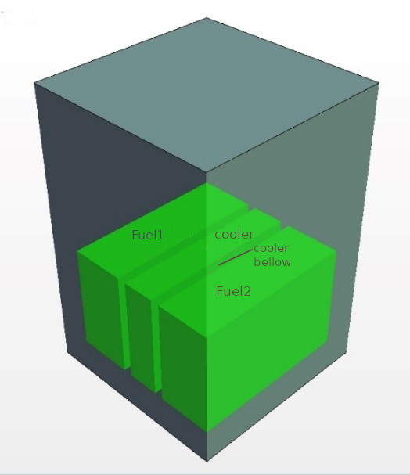

Fig. 1. Refrigeration pool.
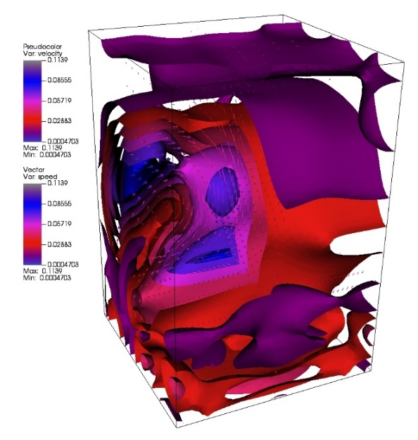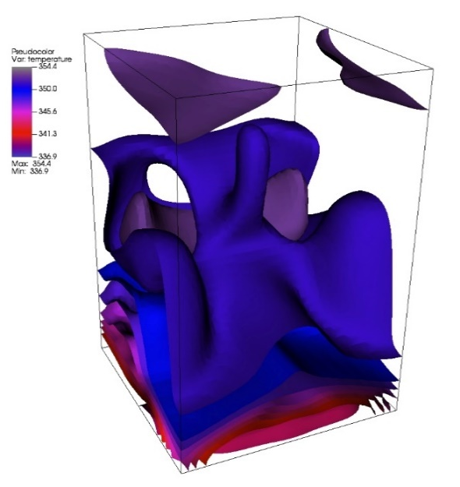

Fig. 2. Initial Conditions. Left: Speed (vectors) and velocity (iso-surfaces); Right: Temperature
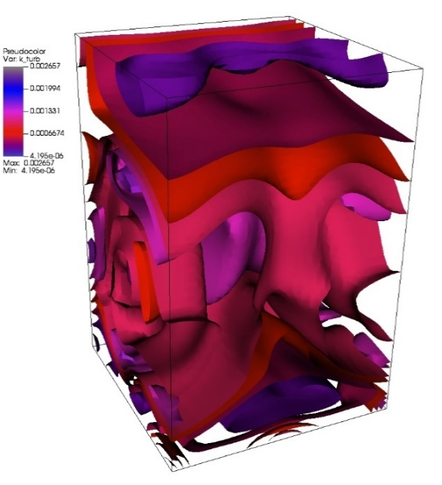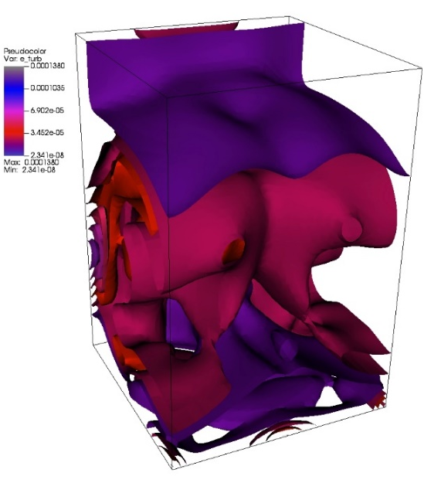

Fig. 3. Initial Conditions. Left: k; right: epsilon.

Reduced basis
The post-processing of the snapshots considering a maximum distance of 10⁻⁶ to the projection space provides dimensions 5, 3, 5, 6 for the velocity, temperature, k and ϵ respectively. Utilization of a second threshold, 10⁻⁷, for the aprioristic analysis of the mistake of the method [29][32] provides a projection space of an enhanced dimension 6,4,7,8 for the same variables mentioned above. Note that the matrices shown in section 2.4 are actually 25x25! In spite of the small dimension of the reduced order basis, the reproduction of the fields is very accurate. We consider the relative mistake, in one of its possible formulations, defined as $∥f-\hat{f}∥/∥f∥$, where $f$ is any field (snapshot) and the circumflex accent indicate the approximated solution. We have plot these magnitudes in FIG. 4. We may see that the mistake remains under 2%.
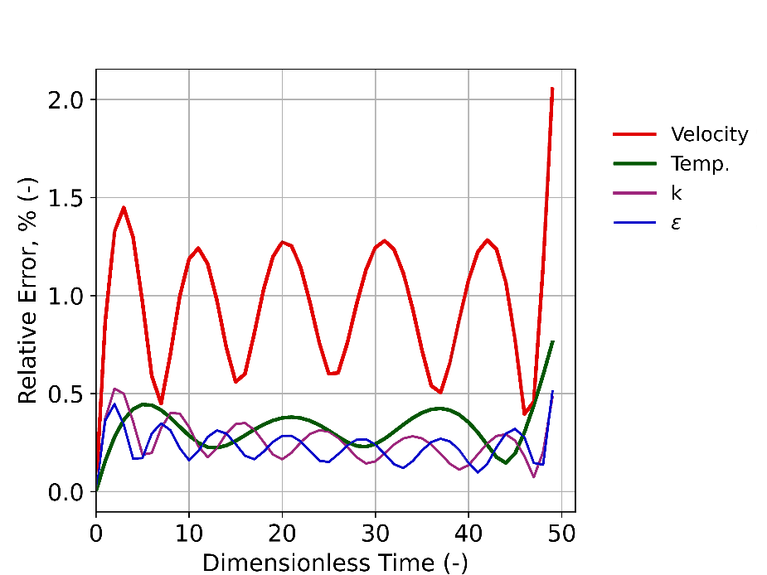

Fig. 4. Relative mistake created by the reduced basis

Reduced basis of the DEIM variables
To treat the non-linear variables, of the turbulent viscosity and $ϵ/k$, we need to create a specific reduced space for them. As before, we select that the resulting spaces have a maximum distance of ${10}^{-6}$ to the snapshots manifold. The dimensions of the turbulent viscosity is 5 and $ϵ/k$ is 5. For the enhanced threshold of ${10}^{-7}$, necessary for the a-priori error prediction, the same dimensions are 6 and 7 respectively.
Some of the vectors of the reduced basis for the variable $ϵ/k$ can be seen in Fig. 5. Note that because of the utilization of the procedure described in section 2.3 the reduced basis does not show artefacts that will invalidate the procedure. Note soft surface and transitions.

Magic points. Random oversampling
As mentioned in section 2.6, we follow the procedure of Peherstorfer et al. [36] and over-sample points in random positions. The location of magic points for variable $ν_{t}$ can be seen in Fig. 6.
Considering the procedure described above in section 2.3, different amounts of points were used for the oversampling. We have had two considerations: a) the amount of modes is of $O(100)$; b) the potential rejection of some of them, as may follow from the procedure of section 2.6.5 and 2.8, should not invalidate the procedure. The remaining points should be enough so that the superior characteristics of the random oversampling procedure in regard with stability [35] still apply for our construct. Therefore, 100 to 1000 points has been considered for the calculation. The different amounts did not have significant impact in the quality or performance of the calculation. We finally utilize 300 points, in order to have an ample margin above ten times the number of modes after the rejection procedure.

Main results
Finally, we analyze the results of the integration of the reduced order model. We compare them with the original CFD results. This can be done projecting the CFD results in the reduced basis. Then, the amplitudes in this basis of the ROM and the CFD can be directly confronted. Fig. 7 contains the comparisons for velocity and temperature. Velocity amplitudes are very good reproduced. Temperature amplitudes are almost indistinguishable. Fig. 8 shows the comparisons performed for $k$ and $ϵ$ variables. Differences in $k$ amplitudes are minimal, and those of $ϵ$ small. Trends are very well reproduced. Finally, in Fig. 9 the curves for the DEIM variables are shown. The differences are again quite small.

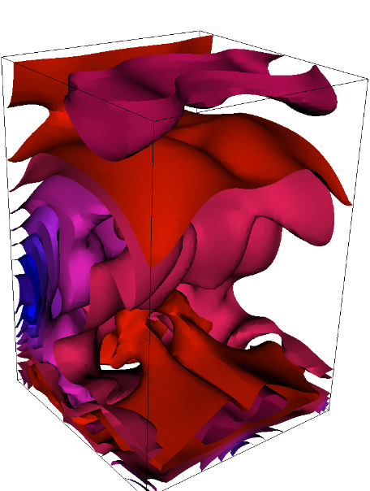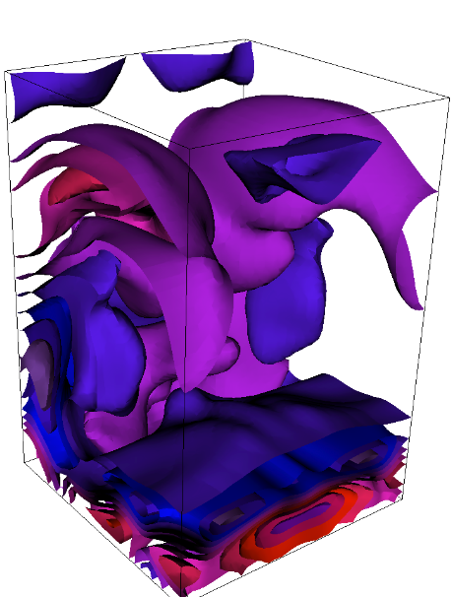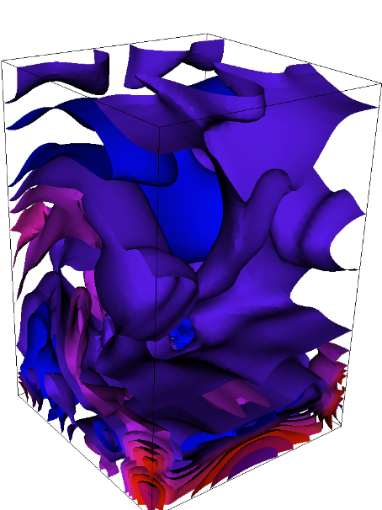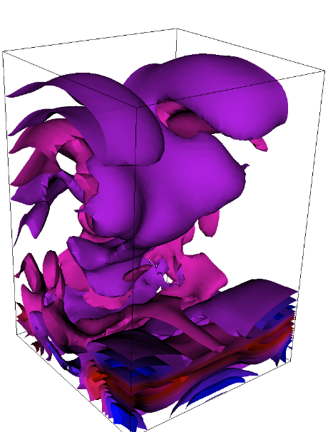
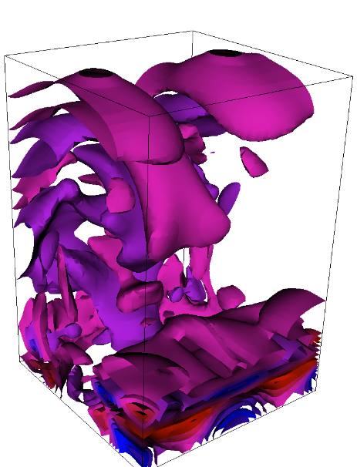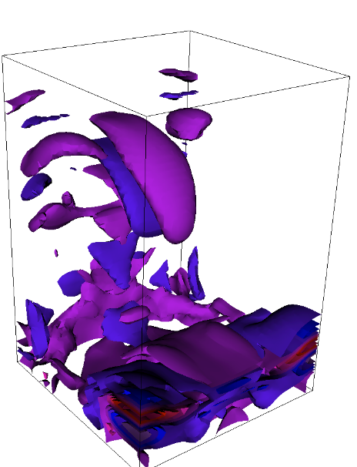
Fig. 5. First 6 vectors of the reduced basis for ε/k variable.

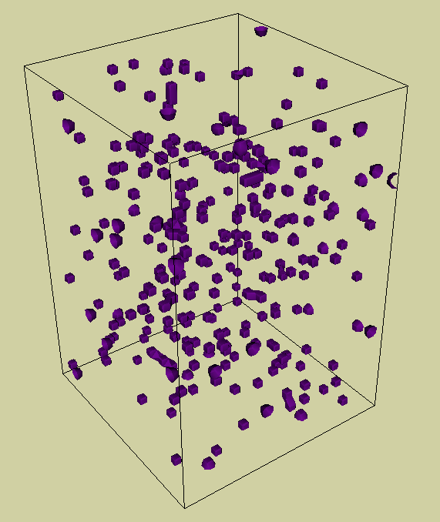
Fig. 6. Positions of the magic points necessary for the calculation of DEIM

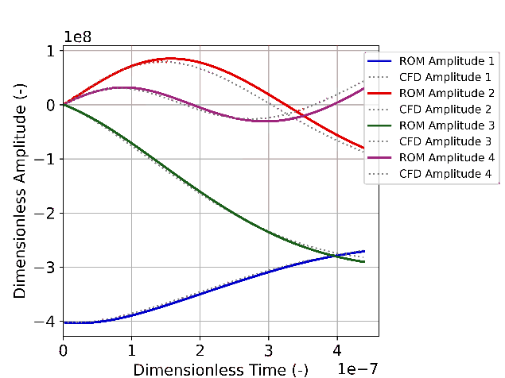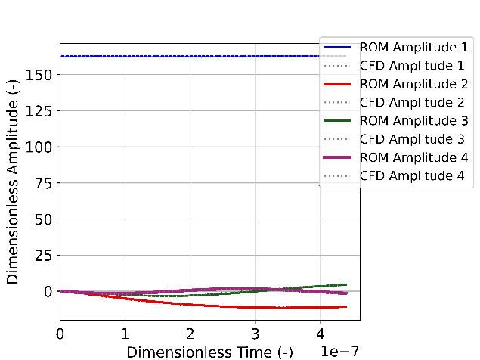
Fig. 7 Comparison of amplitudes between CFD and ROM. Left velocity and right temperature

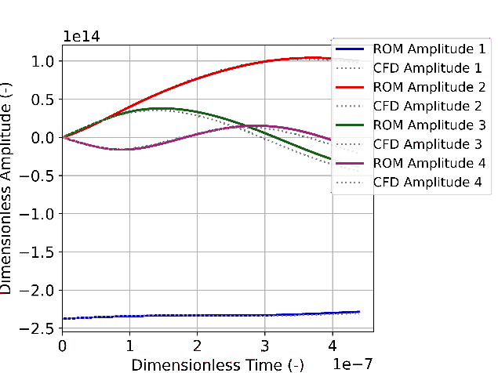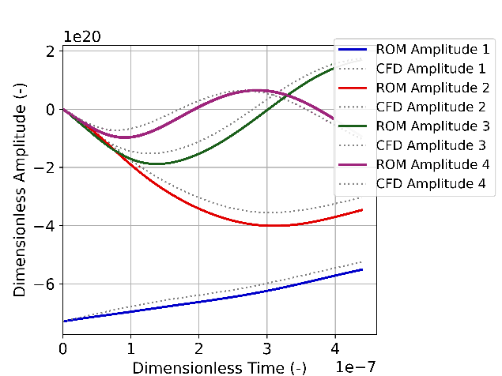
Fig. 8 Comparison of amplitudes between CFD and ROM. Left k, right $ϵ$

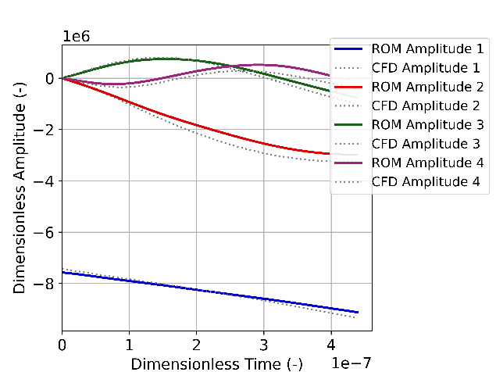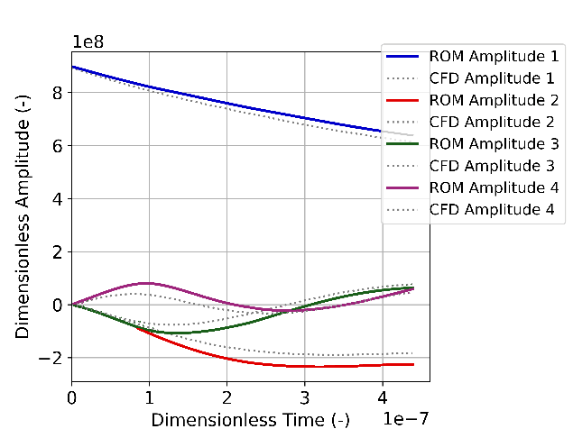
Fig. 9 Comparison of amplitudes between CFD and ROM. Non-linear variables left $ν_{t}$ right $ϵ/k$

Summary and Conclusions
This article describes the procedure followed for the creation of a reduced order model of the standard k-$ϵ$ turbulence model. The model is created in a conventional manner, utilizing the known techniques of Proper Orthogonal Decomposition and Galerkin projection.
The development presented here, is suitable to assess the uncertainty quantification for those reactors utilizing uncompressible refrigerants where the Boussinesq approximation is reasonable, namely the Lead-Cooled Fast Reactor, the Molten Salt Reactor and the Sodium-Cooled Fast Reactor. The method can be also utilized in the spent fuel refrigeration pools.
In spite of the length and complexity of the formulation, and the tedious derivation procedure, the model adopts the simple expression of equation (1). In the model, on-line operations have the complexity of the reduced basis. Only off-line tasks, those that are calculated once in a pre-processing stage, have the complexity of the original basis. The usage of DEIM methodology has allowed treating complex non-linear terms efficiently.
Nevertheless, the usage of DEIM has its own difficulties. A heuristic procedure has been developed to allow for its practical usage with the rational functions involved. This procedure has been explained in detail in [37].
The construct obtained is applied to a calculation proposed to illustrate its capabilities. It reproduced very well the CFD data and can be considered as an interesting step forward for the task of the uncertainty qualification in RANS and for the k-ε calculations. At the same time, the decrease of complexity of the 25x25 system of equation (1) is very significant compare with the high fidelity model, achieving an speedup of more than an order of magnitude.
The model should be extended in the future to deal with model complex boundary conditions.
ACKNOWLEDGEMENTS
We kindly acknowledge the Framatome Professional School.

References
- ALEMBERTI, A. "Lead cooled fast reactors." Reference Module in Earth Systems and Environmental Sciences; Elsevier: Amsterdam, The Netherlands (2020).
- MERLE-LUCOTTE, E., et al. "Introduction to the physics of molten salt reactors." Materials Issues for Generation IV Systems. Springer, Dordrecht, 2008. 501-521.
- MOISSEYTSEV, A., SIENICKI, J. J. "Dynamic simulation and control of the S-CO2 cycle: From full power to decay heat removal." Advances in Thermal Hydraulics (2012): 52-60.
- SHEU, T. W. H. and REUI-KUO, L. "Three-dimensional bifurcations in a cubic cavity due to buoyancy-driven natural convection." International journal of heat and mass transfer 54.1-3 (2011): 447-467.
- FRADENECK, A. D. and KIMBER, M. L. "Applicability of Common RANS Models for the Calculation of Transient Forced to Natural Convection." Journal of Verification, Validation and Uncertainty Quantification 5.2 (2020).
- LAUNDER, B., SPALDING, D., The numerical computation of turbulent flows. Computer Methods in Applied Mechanics and Energy, 3, (1974) 269-289
- TENNEKES, H. LUMLEY, J. A first course in turbulence. MIT Press. Cambridge (1992)
- WILCOX, D. C., Reassessment of the scale-determining equation for advanced turbulence models, AIAA journal 26 (11) (1988) 1299–1310
- YAKHOT, V., ORSZAG, S., THANGAM, S., GATSKI, T., SPEZIALE, C., Development of turbulence models for shear flows by a double expansion technique, Physics of Fluids A: Fluid Dynamics 4 (7) (1992) 1510–1520
- MENTER, F. R., Two-equation eddy-viscosity turbulence models for engineering applications, AIAA journal 32 (8) (1994) 1598–1605.
- WELLER, H. G., TABOR, G., JASAK, H., FUREBY, C., A tensorial approach to computational continuum mechanics using object-oriented techniques, Computers in physics 12 (6) (1998) 620–631
- STAR CCM+ Users Manual
- SAGAUT, P., Large eddy simulation for incompressible flows: an introduction, Springer Science & Business Media, (2006).
- QUARTERONI, A., ROZZA, G. ET AL., Reduced order methods for modeling and computational reduction, Vol. 9, Springer, 2014
- YANEZ, J., and CLASS, A.G. Analysis of the accuracy of residual heat removal in gen-IV reactors, Nuclear Engineering and Design 376 (2021): 111102.
- HESTHAVEN, J. S., ROZZA, G., STAMM, B., ET AL., Certified reduced basis methods for parametrized partial differential equations, Springer, (2016).
- QUARTERONI, A., MANZONI, A., NEGRI, F., Reduced basis methods for partial differential equations: an introduction, Vol. 92, Springer, (2015).
- REMPFER, D., On low-dimensional Galerkin models for fluid flow, Theoretical and Computational Fluid Dynamics 14 (2) (2000) 75–88
- VERGARI, L., CAMMI, A., LORENZI, S., Reduced order modeling approach for parametrized thermal-hydraulics problems: inclusion of the energy equation in the POD-FV-ROM method, Progress in Nuclear Energy 118 (2020) 103071.
- GEORGAKA, S., STABILE, G., ROZZA, G., BLUCK, M. J., Parametric POD-Galerkin model order reduction for unsteady-state heat transfer problems, arXiv preprint arXiv:1808.05175 (2018)
- LORENZI, S., CAMMI, A, LUZZI, L, ROZZA, G., POD-Galerkin method for finite volume approximation of Navier–Stokes and RANS equations, Computer Methods in Applied Mechanics and Engineering 311 (2016) 151–179.
- STAR, S. K., SPINA, G., BELLONI, F., DEGROOTE, J., Development of a coupling between a system thermal–hydraulic code and a reduced order CFD model, Annals of Nuclear Energy 153 (2021) 108056
- STAR, S., STABILE, G., ROZZA, G., DEGROOTE, J., A POD-Galerkin reduced order model of a turbulent convective buoyant flow of sodium over a backward-facing step, Applied Mathematical Modelling 89 (2021) 486–503
- BARRAULT, M., MADAY, Y., NGUYEN, N. C., PATERA, A. T., An ‘empirical interpolation’ method: application to efficient reduced-basis discretization of partial differential equations, Comptes Rendus Mathematique 339 (9) (2004) 667–672
- MADAY, Y., NGUYEN, N. C., PATERA, A. T., PAU, S., A general multipurpose interpolation procedure: the magic points, Communications on Pure & Applied Analysis 8 (1) (2009) 383
- CHATURANTABUT, S., SORENSEN, D. C., Nonlinear model reduction via discrete empirical interpolation, SIAM Journal on Scientific Computing 32 (5) (2010) 2737–2764.
- GRISHCHENKO, D., JELTSOV, M., KOOP, K., KARBOJIAN, A., VILLANUEVA, W., KUDINOV, P., The TALL-3D facility design and commissioning tests for validation of coupled STH and CFD codes, Nuclear Engineering and Design 290 (2015) 144–153
- ABDERRAHIM, H. A., BAETEN, P., DE BRUYN, D., HEYSE, J., SCHUURMANS, P., WAGEMANS, J., MYRRHA, a multipurpose hybrid research reactor for high-end applications, Nuclear Physics News 20 (1) (2010) 24–28.
- YANEZ, J., CLASS, A. G., Analysis of the accuracy of residual heat removal in gen-IV reactors, Nuclear Engineering and Design 376 (2021) 111102.
- ESCANCIANO, J. Y., CLASS, A. G., POD-Galerkin modelling of a heated pool, Progress in Nuclear Energy 113 (2019) 196–205
- IOLLO, A., LANTERI, S., DESIDERI, J.A., Stability properties of POD–Galerkin approximations for the compressible Navier–Stokes equations, Theoretical and Computational Fluid Dynamics 13 (6) (2000) 377–396
- YANEZ, J., CLASS, A. G., Analysis of the accuracy of residual heat removal and natural convection transients in reactor pools, Nuclear Engineering and Design 378 (2021) 111151
- BERKOOZ, G., HOLMES, P., LUMLEY, J. L., The proper orthogonal decomposition in the analysis of turbulent flows, Annual Review of Fluid Mechanics 25 (1) (1993) 539–575
- GRISHCHENKO, D., JELTSOV, M., KOOP, K., KARBOJIAN, A., VILLANUEVA, W., KUDINOV, P., The TALL-3D facility design and commissioning tests for validation of coupled STH and CFD codes, Nuclear Engineering and Design 290 (2015) 144–153
- ABDERRAHIM, H. A., BAETEN, P., DE BRUYN, D., HEYSE, J., SCHUURMANS, P., WAGEMANS, J., MYRRHA, a multipurpose hybrid research reactor for high-end applications, Nuclear Physics News 20 (1) (2010) 24–28.
- PEHERSTORFER, B., DRMACC, Z., GUGERCIN, S., Stability of discrete empirical interpolation and gappy proper orthogonal decomposition with randomized and deterministic sampling points, SIAM Journal on Scientific Computing 42 (5) (2020) A2837–A2864
- YANEZ, J., CLASS, A.G., Reduced Order Model of Standard k-ϵ turbulence model. Computers & Fluids 245 (2022): 105608.
- MADAY, Y., PATERA, A. T., PENN, J. D., YANO, M., A parameterized-background data-weak approach to variational data assimilation: formulation, analysis, and application to acoustics, International Journal for Numerical Methods in Engineering 102 (5) (2015) 933–965

