# NINE Thermal Hydraulic Contribution in IAEA CRPs Focused on Sodium Fast Reactors

D. DE LUCA1, M. CHERUBINI1, A. PETRUZZI1

1 Nuclear and Industrial Engineering (NINE), Lucca, Italy

Email contact of corresponding author: d.deluca@nineeng.com

**Abstract**

Global interest in fast reactors has been growing since their inception in 1960 because they can provide efficient, safe, and sustainable energy. Their closed fuel cycle can support long-term nuclear power development as part of the world’s future energy mix and decrease the burden of nuclear waste. In addition to current fast reactors construction projects, several countries are engaged in intense R&D and innovation programs for the development of innovative, or Generation IV, fast reactor concepts. Within this framework, NINE is very actively participating in various Coordinated Research Projects (CRPs) organized by the IAEA, aimed at improving Member States’ fast reactor analytical simulation capabilities and international qualification through code-to-code comparison, as well as experimental validation on mock-up experiment results of codes currently employed in the field of fast reactors. The first CRP was focused on the benchmark analysis of Experimental Breeder Reactor II (EBR-II) Shutdown Heat Removal Test (SHRT-17), protected loss of flow transient, which ended in the 2017 with the publication of the IAEA-TECDOC-1819. In the framework of this project, the NINE Validation Process– developed in the framework of NEMM (NINE Evaluation Model Methodology) – has been proposed and adopted by most of the organizations to support the interpretation of the results calculated by the CRP participants and the understanding of the reasons for differences between the participants’ simulation results and the experimental data. A second project regards the CRP focused on benchmark analysis of one of the unprotected passive safety demonstration tests performed at the Fast Flux Test Facility (FFTF), the Loss of Flow Without Scram (LOFWOS) Test #13, started in 2018. A detailed nodalization has been developed by NINE following its nodalization techniques and the NINE validation procedure has been adopted to validate the Simulation Model (SM) against the experimental data of the selected test. The present paper intends to summarize the results achieved using the codes currently employed in the field of fast reactor in the framework of international projects and benchmarks in which NINE was involved and emphasize how the application of developed procedures allows to validate the SM results and validate the computer codes against experimental data.

## INTRODUCTION

### Main Features, Advantages and Future of Sodium-cooled Fast Reactors

Global interest in fast reactors has been growing since their inception in 1960’s because they can provide efficient, safe and sustainable energy. Today, the installed nuclear capacity is by far from Generation III (GEN III) reactors, only a few of them belonging to the Generation III plus (GEN III+), and even less to other concepts. During their operation, such reactors produce, as by-products of the fission-conversion-breeding process, a large quantity of long-lived isotopes, quoted as Actinides and / or Minor Actinides, depending on their features and nature, which contribute to the activity of the spent fuel for thousands of years.

The build-up of such by-products turns-out a major challenge both from the non-proliferation and the waste management viewpoint. Their recycling in the reactor fuel as well as their incineration through suitable strategies will contribute to “close the cycle”, i.e., at least theoretically, to bring the spent fuel activity back to a level comparable to the natural earth radiation. The acceptance of the public of further installations of nuclear power plants will strongly depend in the future on this crucial problem.

Fast reactors closed fuel cycle can efficiently and effectively contribute to the solution of the problem decreasing the burden of nuclear waste and supporting long-term nuclear power development as part of the world’s future energy mix [1].

In addition to the current fast reactor construction projects underway, several countries are engaged in intense research and development programs for the development of innovative, Generation IV (Gen IV), fast reactor concepts, as proposed by the Generation IV International Forum (GIF). They include three fast neutrons concepts: the Sodium Fast Reactor (SFR), the Lead (or Lead-Bismuth) Fast Reactor (LFR) and the Gas Fast Reactor (GFR), as well as the Molten Salt Reactor (MSR) which can be declined both in a thermal and a fast neutrons version.

The SFR is, by far, the fast reactor technology most widely spread-out worldwide. It enjoys an acknowledged maturity due to the numerous constructions and because it underwent many years of operation in several countries, from the late ’60 prototypes up to the development and deployment of the industrial French fleet and other reactors now either in operation or under construction in Russia, India, China and Japan.

Design and operation of such reactors are demanding extended computation capacity, to assess their safety, security, and economics [2], which justifies the organization under IAEA’s umbrella of Coordinated Research Projects (CRPs) aimed at improving Member States’ fast reactor analytical simulation capabilities and international qualification through code-to-code comparison, as well as experimental validation on mock-up experiment results of codes currently employed in the field of fast reactors.

### NINE Involvement in Sodium-Cooled Fast Reactors

Starting from the considerations above regarding the deployment of fast reactors and the maturity gained by the SFR, NINE joints the effort of International community to assess the actual computational capabilities in modeling SFRs features. Taking advantage of reactor data gathered in full scale reactor demonstrators, NINE participated, and is still doing, in several International benchmarks aiming at demonstrating the applicability of its modeling methodology to Fast Reactor design and, in particular, to SFRs; to evaluate the level of assessment of computer codes available at NINE in respect to SFR specific features; to check the applicability of the NINE Validation Process, which is part of the more general framework of NEMM (NINE Evaluation Model Methodology) [3], with particular focus on the quantification of accuracies of the Thermal-Hydraulic (TH) simulations by means of Fast Fourier Transform Based Method (FFTBM).

The present paper summarizes the results of two IAEA CRPs. The first exercise was focused on the benchmark analysis of Experimental Breeder Reactor II (EBR-II) Shutdown Heat Removal Test (SHRT-17), protected loss of flow transient, which ended in the 2017 with the publication of the IAEA-TECDOC-1819. The second project regards a benchmark analysis of one of the unprotected passive safety demonstration tests performed at the Fast Flux Test Facility (FFTF), the Loss of Flow Without Scram (LOFWOS) Test #13, started in 2018. All the analysis presented hereafter have been performed following a best estimate approach which requires, among the other things, a high-fidelity Simulation Model (SM), i.e., a SM that represents with a high level of detail the hardware subject of the analysis to avoid the introduction of inaccuracies due to rough approximations and assumptions.

Finally, the paper discusses the main outcomes of the above-mentioned benchmark exercises, in the aim at underlying the wide convergence among the computational tools adopted by the participants, as well as detecting the main discrepancies and seeking for their common origin and trend, whether and whenever existing. That should enable defining a mid-term vision for further development of the computer codes in the field of fast reactors, whatever their features and nature, and identifying new needs for their extended validation against either available or expected experimental data.

## Analysis and Validation of EBR-II SHRT-17

The IAEA CRP “Benchmark Analyses of EBR-II Shutdown Heat Removal Tests” was initiated in 2012 [4] with the objective of improving the state-of-the-art SFR codes by extending their validation to include comparisons against whole-plant data recorded during landmark Shutdown Heat Removal Tests (SHRT) conducted at Argonne’s Experimental Breeder Reactor II (EBR-II) in the 1980’s.

The EBR-II plant was a uranium metal-alloy-fuelled liquid-metal-cooled fast reactor designed and operated by Argonne National Laboratory (ANL) for the U.S. Department of Energy at the Argonne-West site.

Several loss of flow tests were conducted in the facility between 1984 and 1986, as a part of SHRT series [5]. SHRT-17, protected loss of flow transient, was one of the mentioned tests to demonstrate the inherent safety of LMR type reactors. At the beginning of the test, the primary pumps were tripped and at the same time a scram was actuated through a full control rod insertion. The effectiveness of natural circulation cooling capability of the reactor, which makes them inherently safe under described accident conditions, was successfully demonstrated by this test.

### The NEMM Validation Process

#### Overview of SCCRED Methodology

A key feature of the activities performed in the field of nuclear reactor safety is the need to demonstrate the validation level of each tool adopted within an assigned process and of each step of the concerned process. Therefore, the validation of best estimate codes, models, “best modeling practices” and uncertainty methods must be considered of great importance to ensure the validity of performed Best Estimate and Uncertainty analysis. A consistent code assessment supported by a qualified experimental database is an important step for developing a solid ground for the uncertainty evaluation in the frame of Best Estimate and Uncertainty approach. Thus, the SCCRED (Standardized and Consolidated Calculated & Reference Experimental Database) methodology [6], embedded in NEMM [3], has been developed to generate a series of documents and tools to set up a qualified experimental and calculated database for Verification and Validation (V&V) purposes of Best Estimate and Uncertainty applications.

Figure 1 depicts the SCCRED diagram: the information contained in the experimental reports together with the code input nodalization are the sources to be elaborated in a systematic way by a qualified database made up of the following documents:

* The Reference Data Set for the selected facility or test (RDS-facility and RDS-test) containing the information (geometrical data of the facility and boundary and initial conditions of the selected test, respectively) needed for the code input development;
* The Validation Report (VR), which collects the results of the Validation Process of the performed code calculation;
* The Engineering Handbook (EH), that describes the code input file and provides the engineering justifications of the code-user choices.

The flow-chart linking the RDS, the Input deck, the VR and the EH is highlighted in Figure 1. The solid lines show the time sequence of the activities, the dotted lines indicate the feedback for the review and the dashed lines are the necessary input to develop the input deck and the EH.

#### The Validation Procedures

The Validation Process of a thermal-hydraulic system code calculation has the goal to demonstrate that the code results (obtained by the application of the code with the developed nodalization) constitute a realistic approximation of the reference plant behavior (a full-size Nuclear Power Plant or a facility). The flow chart of the adopted Validation Process is given in Figure 2.

A SM representing an actual system (ITF or NPP) is qualified when:

* It enjoys a large geometrical fidelity with the involved system;
* It reproduces the measured nominal steady state condition of the system;
* It shows a satisfactory behavior in time dependent conditions.

Based on this, three main phases of the Validation Process can be distinguished:

(1) The demonstration of the geometrical fidelity of the developed nodalization.

(2) The demonstration of the steady state achievement.

(3) The “on-transient” Validation.

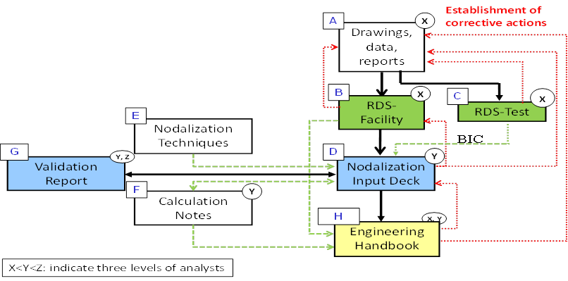

Figure 1: SCCRED Flow Chart.

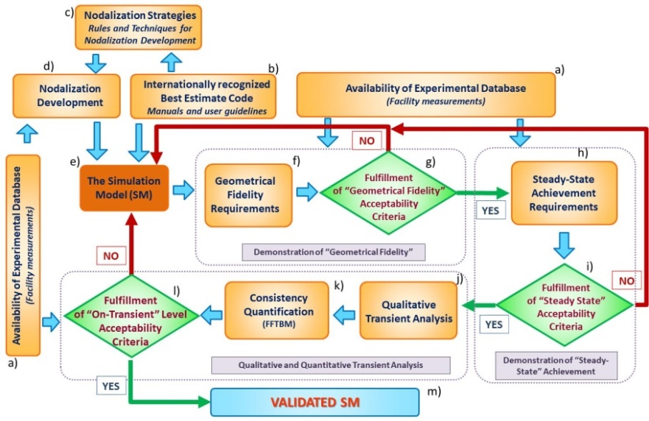

Figure 2: Flow Chart of the Validation Procedures for the SM.

In relation to the first step of the methodology it is worth demonstrating that the discrepancies between relevant geometrical parameters of the plant and the data implemented into the nodalization are within acceptable values.

The second step of the Validation Process deals with the achievement of the steady state. A set of significant parameters is identified to demonstrate that the discrepancies between calculated and measured data available from nominal stationary conditions are within acceptability thresholds.

The third step of the Validation Process is the “On-transient” validation, a very complex step requiring several different sub-steps which include qualitative and quantitative accuracy evaluations performed to evaluate the acceptability of the calculation on “transient level”. If the qualitative accuracy evaluation is acceptable, the accuracy of the code calculation can be quantified utilizing the Fast Fourier Transform Based Method (FFTBM) [7].

### EBR-II Plant and the Developed SM

The EBR-II plant, located in Idaho, was operated by ANL for the U.S. Department of Energy from the beginning of 1964 until 1994. EBR-II rated thermal power was 62.5 MW, with electric output of 20 MW. EBR-II was a sodium-cooled reactor fuelled with uranium metal alloy fuel, with a pool type primary system. Figure 3 shows the configuration of the main components in the EBR-II primary system [8] together with the developed RELAP5 SM. All major primary system components were submerged in the primary tank. Two primary pumps drew sodium from the pool and provided sodium to the two inlet plena for the core, through high pressure and low-pressure pipes.

|  |  |
| --- | --- |
|  |  |
| a) | b) |

Figure 3: EBR-II Primary System (a) and the Adopted Nodalization (b).

The reactor vessel accommodated 637 hexagonal subassemblies divided in three regions: central core (up to row 5), inner blanket (rows 6 and 7) and outer blanket (up to row 16). Hot sodium exited the subassemblies into a common upper plenum where it mixed before passing through the reactor outlet pipe (“Z-pipe”) into the Intermediate Heat Exchanger (IHX). Sodium then exited the IHX into the primary sodium tank before entering sodium primary pumps.

The EBR-II benchmark specifications [8] were used to develop a detailed thermal hydraulic model (see Figure 3b) of the reactor. The RELAP5 system thermal hydraulic code was used for both performing the nodalization and running the calculations.

The whole reactor core consisted of 96 channels representing all 10 types of subassemblies used in the reactor, and two bypass flow paths. The reactor vessel was first subdivided into 16 rows. The subassemblies in the first 6 rows have been modeled separately (1 by 1) with 81 channels, except for safety/control rods that have been merged into one channel. Rows 7 to 16 made of reflector and blanket subassemblies have been modeled with one channel per type of subassembly in each row. One heat structure component has been used to simulate the active part of the fuel pins for each subassembly in the central core region, assuming a flat and constant power profile along all the active length. The pool was modeled with a cylindrical multi-dimensional component having 3 azimuthal meshes, two of which were thermally linked to the pumps and the third one to the IHX. The heat exchanger was of counter-current flow type. The primary side of IHX has been modeled with a pipe which takes hot sodium flowing out from the “Z-pipe” and discharges the cold sodium directly into the pool. The intermediate side of IHX has also been modeled with a pipe equivalent to 3026 secondary tubes through which the intermediate sodium flows. The boundary conditions for the intermediate side were imposed by the time-dependent volume and time-dependent junction components.

### Transient Results and Sensitivity Analysis of EBR-II SM

#### Reference Results

The transient was initiated by a trip of primary and intermediate pumps, which instantaneously scrammed the reactor. While the coast-down shapes for SHRT-17 were designed to be identical for the two primary pumps, intrinsic differences between the two pump drive units caused a difference in the stop times.

The transient calculation was performed after the achievement of acceptable steady-state conditions. Starting from full power and flow, both the primary loop and the intermediate loop coolant pumps were simultaneously tripped, and the reactor was scrammed to simulate a protected loss of flow accident. Therefore, in the early stage of the pump coast-down (up to about 10 s) the cladding and the outlet coolant temperature decreased. During the transition from the forced to natural circulation (between 10 and 100 s) the mass flow rates decreased rapidly and the unbalance between the total core power and the energy removed from the primary coolant caused a rapid increase of the cladding temperatures and a slower increase of the coolant temperatures. When the natural circulation is fully established (after about 100 s) the total core power is efficiently removed in all subassemblies and the coolant and cladding temperatures decrease.

During the pump coast-down the mass flow rate in the instrumented subassembly XX09 remained a little bit higher than the experimental data (see Figure 4), which affected the coolant and cladding temperatures in the whole subassembly. Indeed, both the coolant temperatures below (Figure 5) and above (Figure 6) the active core region and the cladding temperatures at the middle and at the top of the core (Figure 7) were slightly lower than the experimental data. These small differences became negligible during the long-term cooling because the mass flow rate reached the correct value. It should be noted that the flowmeter temperatures, where the gamma heating occurs, were qualitatively correctly predicted by the simulation. Please, note that the results shown from Figure 4 to Figure 7 refers to the simulation performed during the open phase of the benchmark (Final results).

#### Sensitivity Analysis

During the phase 2 of the benchmark, a sensitivity analysis on the gamma heating was performed aimed at understanding the experimental behavior of the coolant temperature at the inlet and outlet of instrumented subassembly (in particular, the instrumented subassembly XX09).

|  |  |
| --- | --- |
| Figure 4: XX09 Subassembly Mass Flow Rate. | Figure 5: XX09 Flowmeter Temperatures. |
| Figure 6: XX09 Coolant Temperatures. | Figure 7: XX09 Clad Temperatures. |

To perform the sensitivity analysis a simple model (see Figure 8) of the instrumented subassembly XX09 was developed considering only the subassembly channel and the guide thimble annulus channel, thermally connected with a passive heat structure simulating the subassembly walls. The heat structure simulating the guide thimble wall has been isolated. Regarding the active heat structure, in addition to the flat power profile adopted in the early stage of the phase 2 of benchmark (Phase-2A), four different axial power distribution (see Figure 8) have been implemented:

1. Power supplied also below the active part of the core.
2. Power supplied also above the active part of the core.
3. Power supplied also above and below the active part of the core.
4. Axial power distribution as in SHRT-45.

The axial power distribution below the BAF has been calculated to match the experimental steady state values of the coolant temperature at the lower and upper flowmeter thermocouples. It can be noted that the power supplied below the active part of the core (sensitivity #1, 3 and 4) positively affects the temperature trends at the upper flowmeter thermocouples (see Figure 9).

On the contrary, the power supplied above the active part of the core (sensitivity #2, 3 and 4) results in minor effect on the temperature trends. In particular, the coolant outlet temperature (see Figure 10) shows a light delay in the temperature increase after the pump coastdown compared to the experimental data and to the other sensitivity cases.

|  |  |
| --- | --- |
|  |  |

Figure 8: Instrumented Subassembly XX09 Model and Axial Linear Heat Rate used in the Sensitivity Analysis.

|  |  |
| --- | --- |
| Figure 9: Upper Flowmeter Temperature. | Figure 10: Coolant Outlet Temperature. |

### Validation Process of the EBR-II SM

In the framework of the benchmark, a simplified version of the Validation Process was adopted selecting a smaller set of parameters to carry-out the demonstration of the geometrical fidelity and the demonstration of the steady state achievement (see §2.1.2). In addition, only a quantitative analysis by the FFTBM was carried-out, without performing the qualitative analysis (which is instead a mandatory step for a full application of the Validation Process) due to limited project’s recourses. The main goal of the quantitative evaluation, as well as the analysis carried out, was to support the interpretation of the results calculated by the CRP participants, i.e., to provide quantitative measures of the discrepancies between the assumptions made by the participants and the reference specification data. These discrepancies can provide a support to understand the reasons for the differences between the participants’ results and the experimental data. Results from the application of the Validation Process are available in [4].

First, a list of more than 50 parameters was selected to perform the geometrical fidelity between the EBR-II hardware and the developed nodalization. For the achievement of the steady state, a set of significant parameters was identified to demonstrate that the discrepancies between calculated and measured experimental data were within acceptability thresholds. Regarding the third step of the Validation Process, the “On-transient” Validation, the focus was only on the so called “Quantitative Accuracy Evaluation” that is performed by the FFTBM. A list of about 50 parameters was selected, varying from power, absolute pressures, velocity and mass flow rates, fluid temperatures, rod surface temperatures, pressure drops and mass inventory. In the case of parameters for which no reference or measured value was available a code-to-code comparison was performed.

## Analysis of FFTF LOFWOS Test #13

The IAEA CRP focused on benchmark analysis of one of the unprotected passive safety demonstration tests performed at the Fast Flux Test Facility (FFTF) was launched in 2018 to support collaborative efforts within international partnerships on the validation of simulation tools and models in the area of sodium fast reactor passive safety. The Fast Flux Test Facility was a 400 MW-thermal loop type SFR prototype with mixed oxide fuel, built to assist development and testing of advanced fuels and materials for fast breeder reactors. It was located at the Hanford site in Washington and designed by the Westinghouse Electric Corporation for the U.S. Department of Energy (DOE). FFTF reached criticality in 1980 and has been operating until 1992 [9].

The loss of flow without scram (LOFWOS) Test #13 was performed on July 18, 1986 as part of the Passive Safety Testing (PST) program with the aim of confirming the safety margins of FFTF as a liquid metal reactor, providing data for computer code validation, and demonstrating the inherent and passive safety benefits of its specific design features. One of the passive reactivity control devices are the Gas Expansion Modules (GEMs) located at the periphery of the FFTF core. GEMs are hollow tubes sealed at the top and open on the bottom with Argon cover gas trapped inside. During normal operation, the pressure head of the primary pumps compresses the gas to a level above the active part of the core, filling the GEMs with sodium. Following a pump trip and a corresponding decrease in the sodium pressure, the trapped gas would expand and displace sodium, increasing the neutron leakage from the core and decreasing the core reactivity.

Starting from 50% power and 100% flow, the Test #13 was initiated when the three primary sodium pumps were simultaneously tripped. The secondary loop sodium pumps remained operational throughout the whole test.

### Overview of FFTF and of the Developed SM

An overview of the FFTF coolant system is shown in Figure 11, where three main parts can be distinguished: the reactor vessel, the primary loop, and the secondary loop.

Regarding the reactor vessel, cold sodium was discharged from the three primary loop inlet pipes into an inlet plenum at the bottom of the reactor vessel. Sodium was then drawn up into the core support structure and distributed to the core assemblies and radial shields, as well as leakage and bypass flow paths. Sodium discharged from these flow paths was mixed above a horizontal baffle plate in a common outlet plenum before exiting the reactor vessel through one of three primary loop outlet pipes. The outlet plenum was bounded at the top by a region of Argon cover gas.

The IHX was vertically mounted counterflow shell and tube designs and separated activated sodium coolant in the primary loops from nonradioactive sodium in the secondary loops. Within each secondary loop, hot leg piping ran from the IHX outlet to a Dump Heat Exchanger (DHX) unit, which discharged heat to the environment. Each DHX unit contained four individual sodium-to-air dump heat exchanger modules. The cold leg sodium ran from the DHX unit to a sodium pump, and back to the IHX.

The FFTF core was loaded with 199 hexagonal assemblies, that could be grouped in 91 core locations, from row 1 to row 6, including 7 different types of driver fuel assemblies, control and safety rods and test locations, 60 internal reflector assemblies, in rows 7 and 8A, and 48 external reflector assemblies, in rows 8B and 9.

Starting from the benchmark specifications [9], a detailed SM of the FFTF facility was developed following the NINE nodalization techniques, except for the DHXs, that were replaced by boundary conditions.

The reactor vessel (see Figure 11b) has been modeled with a cylindrical multi-dimensional component having three radial meshes: the innermost region represents the area occupied by the core basket and the leakage flow that passes around the fuel assemblies and reflector assemblies (up to row 8A), the intermediate zone models the annular plenum and the flow around reflector assemblies (rows 8B and 9) and through radial shields, and the outermost region simulates the peripheral plenum and the in-vessel storage region. The flow through the assemblies in the reactor core was modeled with 18 channels, 16 pipe components simulating the sixteen assembly flow zones representing the different types of assemblies and 2 pipe components to simulate separately the instrumented assemblies, the Row 2 fast response Proximity Instrumented Open Test Assemblies (PIOTA) and the Row 6 fast response PIOTA. As for the hydraulic part, one heat structure was inserted in each channel to simulate the active part of the assemblies. A flat axial power profile was imposed along the active length of all the assemblies.

The three primary loops and secondary loops were modeled separately, each one having the same number of hydraulic components. Regarding the secondary loops, two time-dependent components were inserted to provide the proper boundary conditions, one component at the exit of the hot leg piping to set the secondary side pressure, and one component at the beginning of the cold leg piping, downstream the DHXs, to set the appropriate sodium temperature.

|  |  |
| --- | --- |
| *a)* | *Descrizione: C:\Users\Mimmo\AppData\Local\Microsoft\Windows\INetCache\Content.Word\FFTF_simple_DDL-RPV.WMF*  *b)* |

Figure 11: FFTF Coolant System (a) and Reactor Vessel Nodalization (b) Overview.

### Reference Results and Sensitivity Analysis of the FFTF SM

After imposing the boundary conditions (i.e., pumps speed, core power and secondary loops flow conditions) provided by the benchmark team, acceptable steady-state conditions were achieved before performing the transient simulation. The RELAP5 system thermal hydraulic code was used to make the analysis.

The FFTF LOFWOS Test #13 was initiated when the primary pumps tripped simultaneously. The row 2 PIOTA outlet temperature shown in Figure 12 can be observed to describe the behavior of the FFTF core during the transient.

The initial rapid rise of the PIOTA outlet temperature was caused by the increasing core power-to-flow ratio following the pump trips. The outlet temperature peaked at around 10 seconds when the power-to-flow ratio reached its maximum value. Then, the increase in core temperatures together with the drop of the GEM sodium level introduced a large negative reactivity feedback, so power decreased faster than the primary flow rate. The drop in reactor power was quick enough to compensate for the reduced flow rate in the primary loop and the sodium temperature started to decrease. As the GEM sodium level approached the bottom of the core, the negative reactivity insertion slowed down. The core outlet temperature began to rise again, and a second peak occurred when the natural circulation was established. Natural circulation was maintained while power continued to decrease resulting in a decrease of the core outlet temperature until the end of the test.

Figure 12 shows the comparison of the PIOTA outlet temperature predicted by the SM against the measurement (in this and subsequent figures the solid line shows the experimental data while the dashed line displays the SM results). The SM results are in good agreement with the experimental data for the entire duration of the transient. In particular, the time of occurrence of the two peaks is captured very well by the simulation.

The cold leg and hot leg temperatures in one of the primary loops are shown in Figure 13. The hot leg fluid temperature has been quite well predicted by the SM, showing a trend slightly oscillating around the experimental value. That may be due to a different prediction of the sodium mixing and thermal stratification phenomena in the outlet plenum of the reactor vessel during the natural circulation phase that are difficult to simulate by a system thermal-hydraulic code. The calculated cold leg fluid temperature showed a faster rise at the beginning of the transient following the increase in the DHX sodium outlet temperatures, it reached a higher peak value and it decreased faster compared to the experimental trend. In addition, it can be noted that the oscillations shown in the calculated time trend occurred about 30 seconds earlier and with a greater amplitude than the experimental data. Similar behavior can be observed in Figure 14, where the cold leg and the hot leg temperatures in one of the secondary loops are displayed. The cold leg temperature followed the time trends of the DHX sodium outlet temperatures, which had been specified as boundary conditions. The hot leg temperatures decreased quickly at the beginning of the transient reaching the cold leg temperature in about 200 seconds due to the reduction in heat transferred from the primary to the secondary systems across the IHXs, as the primary loop flow rates decreased, and the secondary pumps remained at full speed. It can be noted that, also in this case, the fluctuations of the SM results occur earlier than the measured data.

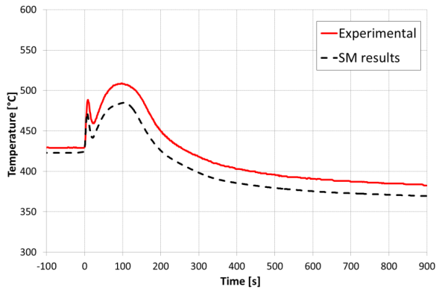

Figure 12: Row2 PIOTA Outlet Temperature.

|  |  |
| --- | --- |
| *Figure 13: Primary Loop Hot and Cold Leg Temperatures.* | *Figure 14: Secondary Loop Hot and Cold Leg Temperatures.* |

A sensitivity simulation to account for the thermal inertia of the temperature instrumentation has been performed to investigate the origin of the discrepancies between the SM results and the experimental data. Beyond the reactor vessel, sodium temperatures were measured in the hot and cold legs of all primary and secondary loops by the Resistance Temperature Detectors (RTDs). The RTDs were spring loaded against the bottom of a thermowell to provide a short response time. Unfortunately, there is no information in the benchmark specifications on the geometry of the temperature detectors, so, after a quick search in the literature and some assumptions, a cylindrical heat structure of 5 cm in diameter was inserted at each RTD location. The sodium temperatures detected by the heat structures are shown in Figure 13 and Figure 14 (dotted lines) for the primary loop and secondary loop, respectively. When considering the thermal inertia of the RTDs, the SM results are in a very good agreement with the experimental data, improving both the timing and the amplitude of the temperature oscillations.

Then, an additional sensitivity simulation was performed to study the effect of the modeling choice made for the reactor vessel outlet plenum and its impact on sodium mixing. As mentioned before, in the reference case, the reactor vessel and the upper plenum were modeled with a cylindrical multi-dimensional component having three radial meshes. In the two sensitivity simulations, the 3D volumes of the upper plenum were replaced by a 1D vertical pipe component in the first simulation and by a 1D single-volume component in the second simulation. Figure 15 shows the comparison of the sodium temperature in the hot leg primary loop #1 among the three different reactor vessel outlet plenum modeling choices and with the experimental data. In the reference case (3D) thermal stratification occurs with the hot sodium that tends to go upwards (it should be remembered that the hot leg connection is at the bottom of the outlet plenum, just above the core outlet). In the first sensitivity (1D PIPE), no thermal stratification is observed and the hot sodium exiting the core does not mix with the upper cold sodium at the triggering of natural circulation. In the second sensitivity (1D Single Volume) the hot sodium that would be deposited on top of the reactor completely mixes with the core outlet flow, thus resulting in a slightly higher sodium temperature in the hot leg after the beginning of the transient, compared to the reference case, and which continues to gradually increase even during natural circulation.

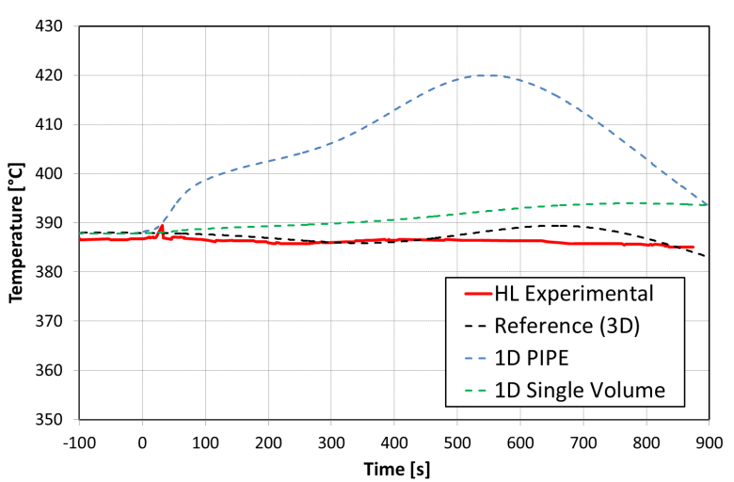

Figure 15: Sensitivity on Upper Plenum Modeling: Comparison of Primary Loop Hot Leg Temperature.

## main outcomes and perspective in the SFR Modelling and Simulation

Accounting for the outcomes of the investigations carried-out in the framework of the Benchmark exercises described in this paper, the participants were able to drive some general conclusions on the expected new features of the computation tools as well as on the up-dated methodologies to be adopted for the design and the safety assessment of the Sodium Fast Reactors.

These conclusions identify the main trends for improvement. They can either contribute to further and proficiently expanding the computation capacity of existing tools (and even considering the development of new ones), as well as adapting and / or updating the methodologies adopted so far in the studies.

The main topics found-out to be potential levers for further improvement in the SFR computation capacity and reliability are the following:

* A major need for the SFR M&S (Modelling and Simulation) appears to be the improvement of the calculation of inlet-plenum flow distribution and of lateral mixing of coolant flows in the assembly to reduce conservatism in the estimation of the peak fuel and cladding temperatures [10]. The high-fidelity Computational Fluid Dynamics (CFD) models should be developed, tested, and adapted for application to liquid sodium for the relevant flow characteristics and geometric configurations, especially wire-wrapped pin bundles contained within the hexagonal assembly boxes. Additional near-term needs for the SFR M&S are related to the thermal-mechanical modeling capabilities. Recent advances in modeling of oxide fuels behavior in thermal reactors (e.g., fuel and clad conductivity and gap conductance modeling) should also be adapted for fast reactor applications.
* The pressure drop and flow distribution estimation during the transients can be significantly improved when using suitable empiric correlations to model friction losses in the wire-wrapped fuel bundle region, as proposed by Cheng & Todreas [11] and Pontier [12].
* The sodium mixing and the thermal stratification phenomena play a crucial role during the transients, mainly during the natural circulation phase. They cannot be accurately predicted by the current existing SYS-TH (System Thermal-Hydraulic) codes. In addition, these phenomena are also sensitive to the nodalization scheme adopted in the calculations. It is suggested to address this major issue for design and operation through either suitable sensitivity analyses or more in-depth investigations (i.e., adopting CFD codes).
* SFRs use fuel pins tightly packed in a hexagonal duct. To maintain a gap for coolant to flow through, fuel pins are separated with a metallic helical wire spacer wrapped around the pin entire length. Additionally, these wraps mitigate vortex-induced vibration and increase convective heat transfer by enhancing sub-channel mixing. Modeling the flow in wire-wrapped rod bundles is still a challenging problem [13]. Large uncertainties exist in the treatment of wire spacers and drag models used for momentum transfer in current low- resolution (lumped parameter) models. Sub-channel codes apply “forcing functions” to model wrap induced flow mixing. However, these approaches are limited to conditions submitted to a specific validation (flow regime, channel geometry, or operating conditions) and rely on complex coefficients which were derived from fitting the experimental databases the models are based on. High fidelity tools such as CFD can simulate wire-wrapped rod bundles with more detailed resolution. However, CFD simulations are still limited in their capability to characterize long-term transients or large system simulations. They are also bounded by the quality and resolution of the experimental data these models are benchmarked against.
* The axial power profile and the gamma heating outside the core region, below and above the active fuel zone, affect the coolant temperature distribution. That way, they can have a significant impact on the behavior of some transients. In addition, approximations adopted in the calculation of the radial power distribution can engender large computation vs. measurement discrepancies for both dummy and reflector subassemblies (non-fuelled SAs). Accurately account for the gamma heating contribution to the power both in the active and non-active reactor regions can help to correctly address the issue, thus improving the quality of computation results.
* The axial conduction heat transfer modelling is generally either non available or quite poor in the current SYS-TH codes. Even if the contribution of the axial heat conduction with respect to the other heat transfer mechanisms is always negligible in fast systems, accounting for the phenomenon in the heat structures improves the simulation results for the coolant temperature distribution outside the core region, while it does not provide any measurable gain for the evaluation of the cladding temperature, and even, sometimes it turns-out damaging. No specific action is recommended on this issue.
* The correct and comprehensive simulation of the heat transfer between adjacent subassemblies is mandatory to improve the agreement between computation results and measured data. Accounting for radial heat transfer with neighboring subassemblies is mandatory to obtaining good coolant temperature predictions. Accordingly, it is recommended to accurately account for the heat transfer between adjacent subassemblies and developing the suitable computation capacity to do.
* Many experiments have been performed to study thermal- hydraulics characteristics, primarily pressure drops, of the wire-wrapped fuel bundles. Often however, the uncertainties of pressure drop measurements associated with these experiments is high due to the geometrical complexity of the hexagonal wire-wrapped fuel bundle. Recently ([14] and [15]), a database of pressure drops and flow-field measurements in a 61-pin wire-wrapped hexagonal fuel bundle was developed with the sole purpose to benchmark the existing correlations and validate the CFD calculations. These experiments investigate the flow characteristics in the near-wall region of the 61- pin wire-wrapped hexagon fuel bundle.

All the above-mentioned topics merit for careful consideration and further investigation in view of the definition of future R&D programs in support to the industrial development and the deployment of the SFRs. Due to their size and scope, they should mainly be addressed in the framework of international collaborations.

## Conclusion(s)

Sodium Fast Reactors is a branch of Fast Reactors technology developed since the early 60s, which nowadays regains large interest and attractiveness thanks to their flexibility and their potential to be operated as Actinide burners and/or breeders, thus playing a crucial role in the closure of nuclear fuel cycle and solving the burden of long-lived nuclear wastes.

Design and operation of such reactors require a noticeable computational capacity, but also specific means to assess their safety both in normal and downgraded operation as well as in emergency conditions. In this prospect, IAEA has organized several Coordinated Research Projects aimed at improving Member States’ fast reactor analytical simulation capabilities.

The participation in such research programs - allowing direct comparison of computation results with measured data - contributes to increase the confidence in the capabilities of available computational tool, in the meantime highlighting the potential for improvements which could address and solve the pending issues and for the identification of new ones.

NINE has been actively involved in such research activities within the IAEA CRPs, thus catching the opportunity to independently assess and validate some commonly and widely used Thermal-Hydraulic codes. Moreover, it contributed to the comparison of results and the interpretation of discrepancy origins, identifying trends, and driving conclusions for future developments.

The NINE’s Simulation Models have been developed strictly complying with the Best Estimate principle, which namely requires avoiding the introduction of inaccuracies due to rough approximations and assumptions, thus trying to represent at best the problem under investigation without adopting any major simplification. Despite this approach requires relevant and continuous computational efforts, the obtained results show-up highly satisfactory and encouraging in a whole. Moreover, as far as the computation capacity is concerned, the NEMM model methodology developed by NINE confirmed its applicability also in the case of SFR simulations.

The present chapter summarizes the activity carried-out, presents the results and discusses the main outcomes of the mentioned benchmark exercises, underlying the wide convergence among the computational tools, as well as detecting the main discrepancies and seeking for their common origin and trends, which should enable defining a mid-term vision for further development of the computer codes in the field of fast reactors and identifying new needs for their extended validation against either available or expected experimental data.

Among others, the following items have been identified as meriting careful and particular attention in the future: the need for an accurate modelling of the mixing of coolant flows in the assembly, the estimation of the pressure drop and the flow distribution during the transients which could be significantly improved using suitable empiric correlations, the sodium mixing and the thermal stratification phenomena which play a crucial role during the transients, and are sensitive to the nodalization scheme adopted and cannot be accurately predicted by the current existing SYS-TH codes, the need for a correct and comprehensive simulation of the heat transfer between adjacent subassemblies, the suitability for improvement of the calculation of inlet-plenum flow distribution.

Moreover, the importance of the representativeness, exhaustiveness and comprehensiveness of the data stored in the data base adopted for validation of the computation tools have been once more and even farther pointed-out. Accordingly, it is considered worth complementing and / or implementing the existing data base with the results of ad-hoc experimental programs, accurately designed, and engineered to match some specific validation needs, thus addressing, and filling the main and more crucial knowledge gaps.

References

1. COMMISSARIAT À L’ÉNERGIE ATOMIQUE ET AUX ÉNERGIES ALTERNATIVES, Les réacteurs nucléaires à caloporteur sodium, Ed. LeMoniteur, Paris (2014).
2. BRUNA. GB., et al., Advanced Numerical Simulation and Safety Demonstration, In Numerical Simulations - Applications, Examples and Theory, INTECH (2011).
3. PETRUZZI, A., GIANNOTTI, W., MODRO, M., NEMM - NINE Evaluation Model Methodology, NURETH-18, Portland OR, USNRC (2019).
4. INTERNATIONAL ATOMIC ENERGY AGENCY. Benchmark Analysis of EBR-II Shutdown Heat Removal Tests, IAEA-TECDOC-1819, IAEA, Vienna (2017).
5. PLANCHON, HP., et al., The Experimental Breeder Reactor II Inherent Shutdown Heat Removal Tests – Results and Analysis, Nuclear Engineering and Design, 91(1986) 287-296.
6. PETRUZZI, A., D’AURIA, F., Standardized Consolidated Calculated and Reference Experimental Database (SCCRED): a Supporting Tool for V&V and Uncertainty Evaluation of Best-Estimate System Codes for Licensing Applications, Nucl. Sci. Eng., 182(1) (2016) 13-53.
7. PETRUZZI, A., D’AURIA, F., Accuracy Quantification: Description of the Fast Fourier Transform Based Method (FFTBM), 3D S.UN.COP., Barcelona, Spain (2013).
8. SUMNER, T., WEI, TYC., Benchmark Specifications and Data Requirements for EBR-II Shutdown Heat Removal Tests SHRT-17 and SHRT-45, ANL-ARC-226 (rev 1), USA (2012).
9. SUMNER, T., Benchmark Analysis of Fast Flux Test Facility (FFTF) Loss of Flow Without Scram Test, IAEA CRP-I332011, ANL, USA (2018).
10. KHALIL, H., Modeling and Simulation Needs for Future Generation Reactors, Joint International Topical Meeting on Mathematics & Computation and Supercomputing in Nuclear Applications (M&C + SNA 2007), Monterey, California, USA (2007).
11. CHENG, SK., TODREAS, NE., Hydrodynamic Models and Correlations for Bare and Wire-Wrapped Hexagonal Rod Bundles – Bundle Friction Factors, Subchannel Friction Factors, and Mixing Parameters, Nuclear Engineering and Design 92 (1986) 227-251.
12. TENCHINE, D., et al., Status of CATHARE Code for Sodium Cooled Fast Reactors, Nuclear Engineering and Design 245 (2012) 140-152.
13. DELCHINI, MO., et al., Assessment of SFR Wire Wrap Simulation Uncertainties, ORNL/TM-2016/540 (2016)
14. NGUYEN, T., et al., PIV Measurements of Turbulent Flows in a 61-Pin Wire-Wrapped Hexagonal Fuel Bundle, International Journal of Heat and Fluid Flow 65 (2017) 47–59.
15. VAGHETTO, R., et al., Pressure Measurements in a Wire-Wrapped 61-Pin Hexagonal Fuel Bundle, Journal of Fluids Engineering 140 (2018).