Preliminary Assessment of the Safety Performance of Westinghouse LFR

S. J. LEE¹, J. LIAO², D.L. WISE², R.F. WRIGHT², P. FERRONI²

¹Fauske & Associates LLC, Burr Ridge, IL, USA
²Westinghouse Electric Company LLC, Cranberry Township, PA, USA

Email contact of corresponding author: lee@fauske.com

Abstract

The safety performance of Westinghouse Lead Fast Reactor (LFR) is evaluated using the SAS4A/SASSYS-1 system code coupled to the GOTHIC containment code. The Westinghouse LFR is a 950 MW(th) lead-cooled, pool-type reactor with microchannel primary heat exchangers (PHEs) directly immersed in the primary coolant. The reactor vessel (RV) is surrounded by a guard vessel (GV) to safeguard against the unlikely event of reactor vessel failure. The emergency decay heat removal is performed by the passive heat removal system (PHRS), which consists of a water pool system surrounding the GV filled with enough water to remove decay heat for the first seven days, and stacks to circulate air and remove decay heat indefinitely after the water has boiled off. The responses of the reactor system to Station Blackout (SBO) and Transient Overpower (TOP) are analyzed. During SBO, when the normal decay heat removal is assumed unavailable, the passive water-cooling transitioning to air-cooling outside of GV successfully removes the decay heat indefinitely. During TOP, where inadvertent withdrawal of most reactive control rods is postulated, the negative reactivity feedback of the core limits the power excursion to 140% of the normal operating power before the passive shutdown system is actuated and scrams the reactor. Fuel melting and cladding failure are avoided. The reactor design is evolving, and the preliminary results presented in the paper demonstrate the capability of the coupled SAS4A/SASSYS-1 and GOTHIC codes and characterize the safety performance of the Westinghouse LFR.

INTRODUCTION
The Westinghouse Lead Fast Reactor (LFR) is a 950 MW(th) (~460 MW(e)) lead-cooled, fast neutron spectrum, pool-type reactor being developed by Westinghouse in collaboration with domestic and international organizations [1]. The reactor features a pool-type configuration with hybrid microchannel-type primary heat exchangers (PHEs) directly immersed in the primary coolant. The reactor vessel (RV) is surrounded by a guard vessel (GV) to contain the lead coolant in the unlikely event of reactor vessel failure. The emergency decay heat removal is performed by the passive heat removal system (PHRS), which consists of a water pool system surrounding the GV filled with enough water to remove decay heat for the first seven days, and a number of stacks to circulate air and remove decay heat indefinitely after the water has boiled off. The extra water is stored in the upper safety pool, constituting a passive system.
To perform safety analysis of the Westinghouse LFR the SAS4A/SASSYS-1 (SAS) system code was coupled with the GOTHIC code. In addition to in-vessel thermal-hydraulics, SAS4A/SASSYS-1 simulates neutronics with reactivity feedback, thermal and mechanical responses of the fuel and core, fuel pin failure, and fuel pin failure propagation [2, 3]. It also has primary heat exchanger and reactor coolant pump models. GOTHIC tracks fluid flow and heat transfer outside of the RV in the PHRS, including the heat transfer between the RV and GV wall [4].
In the paper two accident scenarios, Station Blackout (SBO) and Transient Overpower (TOP), are selected and the response of the reactor system to each scenario is described as examples of safety analysis of the Westinghouse LFR. SBO is initiated by a loss of off-site power. Consequently, all active systems including the reactor coolant pumps, primary heat exchangers, and normal decay heat removal system become unavailable. The normal heat removal is provided by a small steam/condensing loop on the main steam and feed. The normal reactor shutdown system is assumed to fail. Hence, the fission power is dumped to the coolant briefly until a passive shutdown system is actuated by high coolant temperature. The passive shutdown system is not designed yet but is assumed to be based on the hot pool temperature. Subsequent heat up and gradual cooling of the fuel, fuel cladding, coolant, and RV wall; decay heat removal by PHRS; and successful water-to-air cooling transition in the PHRS are demonstrated. Other scenarios analysed is Transient Overpower (TOP). The safety performance of the Westinghouse LFR is evaluated by examining its response to each scenario.

MODELing approach
The SAS4A/SASSYS-1 system code is coupled to the GOTHIC containment code to simulate the response of the Westinghouse LFR to operational transients and accidents [5, 6]. SAS4A/SASSYS-1 models the core, in-vessel thermal-hydraulics, reactor components, and RV wall. GOTHIC models the PHRS and GV wall. The coupling occurs at the RV wall outer surface. SAS passes RV wall outer surface temperatures to GOTHIC and GOTHIC returns heat transfer rates at the RV wall outer surface. GOTHIC has the capability to run simultaneously with other codes and to communicate information back and forth by reading/writing run-time data at each time step to specified data files. The inter-process communication feature in GOTHIC is invoked using control variables. SAS was modified to read/write to the GOTHIC inter-process communication data files; Westinghouse and Argonne National Laboratory collaborated to enable code coupling between SAS and GOTHIC. Together, these codes are currently being used for the safety analysis of the Westinghouse LFR design.

SAS4A/SASSYS-1 Model of the Reactor Vessel
Fig. 1 shows the SAS4A/SASSYS-1 model of the Westinghouse LFR. Four compressible volumes are used to represent the primary coolant system: CV1 for the inlet plenum, CV2 for the hot pool, CV3 for the upper cold pool, and CV4 for the lower cold pool. Segments with elements are used to connect compressible volumes. Segment 1, comprised of element 1, represents the flow path through the core. Segment 1 connects the core inlet plenum to the hot pool. Segment 2, comprised of elements 2, 3, and 4, represents five of six primary heat exchangers (PHEs). Segment 3, comprised of elements 5, 6, and 7, represents one of six primary heat exchangers (PHEs). Segments 2 and 3 connect the hot pool to the upper cold pool. Segment 4, comprised of elements 8, 9, and 10, represents five of six reactor coolant pumps (RCPs). Segment 5, comprised of elements 11, 12, and 13, represents one of six reactor coolant pumps (RCPs). Segments 4 and 5 connect the upper cold pool to the lower cold pool. Segment 6, comprised of element 14, represents the flow path from the lower cold pool to the core inlet plenum.

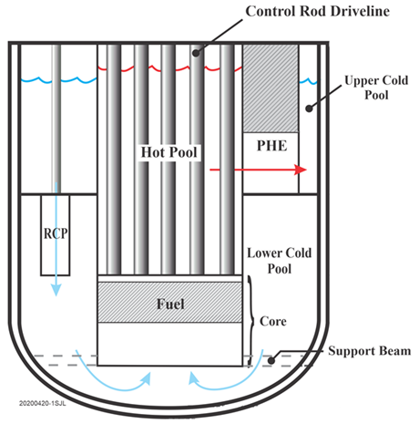 | 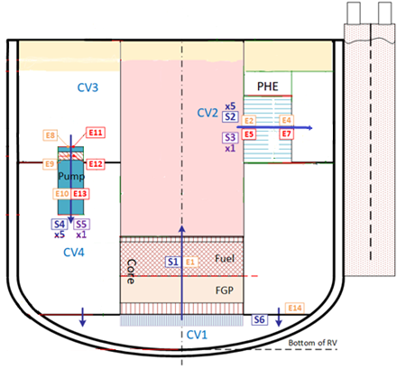

FIG. 1. SAS4A/SASSYS-1 model of Reactor Vessel

GOTHIC Model of the PHRS
GOTHIC is a general-purpose thermal-hydraulics software package for design, licensing, and safety and operating analysis of nuclear power plant containments, confinement buildings and system components. Applications may include pressure and temperature determination, equipment qualification profiles and inadvertent system initiation, and degradation or failure of engineered safety features. As a general-purpose tool, GOTHIC can be used for a wide variety of plant operations support issues involving single and multiphase heat transfer and fluid flow provided that the application is consistent with the underlying physical basis and assumptions and the code validation basis. A two-dimensional or three-dimensions model can be created with the actual plant geometry to calculate steady state or transient operating conditions. The code contains multiple options for heat transfer including two-phase and boiling correlations.
During the normal operation, heat is transferred from the GV wall to the PHRS pool, which is actively cooled by heat exchangers. During an accident, when the normal decay heat removal system and PHRS pool cooling are not available, the PHRS pool heats up and begins to boil. As the PHRS pool boils off, the GV wall becomes uncovered and the water cooling becomes less effective. When the PHRS pool water level drops below the baffle, the outside air starts to circulate into the PHRS, and the water-cooling transitions to air-cooling. The air-cooling removes the decay heat indefinitely. GOTHIC tracks fluid flow and heat transfer in the PHRS, i.e., outside of RV, including heat transfer between the RV and GV wall. The GOTHIC PHRS model consists of control volumes, flow paths, and thermal conductors. They are described below.
The PHRS is modelled using six control volumes as shown in Fig. 2: inlet atmosphere, outlet atmosphere, PHRS pool, RV-GV air gap, inlet plenum, and outlet plenums. Inlet atmosphere, outlet atmosphere, PHRS pool, and RV-GV air gap control volumes are subdivided to represent local conditions such as pressure, temperature, void fraction, heat transfer rate, and flow rate. The inlet and outlet atmosphere control volumes are each subdivided into two vertical nodes to represent the pressure at the entrance of inlet ducts and at the exit of outlet stacks.
The RV-GV air gap control volume contains thermal conductors representing the RV wall, where the interface with the SAS code occurs via inter-process communication. The RV-GV air gap is subdivided vertically consistent with the RV wall height and the PHRS pool vertical nodalization as shown in Fig. 2. This control volume also contains thermal conductors representing the GV wall, which interacts with the PHRS pool. Axial conduction is ignored in the RV and GV wall. The uncovered portion of the RV wall is ignored and is not credited for transferring heat from the RV, only the CV3 and CV4 sections (red) are heated from the coolant. Therefore, the blue section of the RV wall is adiabatic.
The PHRS pool is subdivided into twenty vertical nodes and four radial nodes as shown in Fig. 2. The baffle divides the PHRS pool into a downcomer region and a riser region with a gap at the bottom of the pool. A blockage is used to model the baffle in the PHRS pool control volume. The downcomer region is connected to the inlet plenum control volume. The riser region is connected to the outlet plenum control volumes. The baffle is designed to create a natural circulation flow path of air after the PHRS pool water has boiled off by drawing the outside air into the downcomer region, forcing the air up in the riser region to remove heat from the GV wall, and discharging it to the environment through the stacks.
The inlet and outlet plenum control volumes do not represent the physical geometry of the PHRS but are used to provide connection between inlet ducts and the downcomer region, and between the riser region and outlet stacks. This modelling approach forces uni-directional flows in all four inlet ducts and in all four outlet stacks.

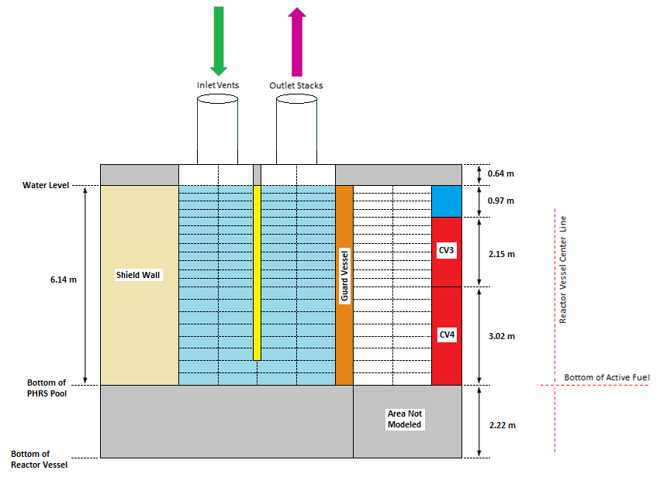
FIG. 2. Axial and radial subvolumes in the GOTHIC PHRS model

RESULTS AND DISCUSSION

Station Blackout (SBO)
In station blackout, a loss of offsite power event is postulated. The accident is assumed to occur at the end-of-cycle (EOC) in the reactor operation. EOC is selected for the highest fission gas pressure in the fuel rod. The fluence to clad and the decay heat in fuel are also highest at EOC. Heat removal by primary heat exchangers (PHE) is assumed to stop instantaneously at time zero. The reactor coolant pump (RCP) torque is reduced to zero in one second for all pumps. Subsequently, the pumps coast down following the homologous curve. The normal reactor shutdown system is assumed to fail. Also, the normal decay heat removal system is assumed unavailable.
Fig. 3 shows the core power in the first 2,000 seconds. With the normal reactor shutdown system failing to scram the reactor, the full normal operation power is dumped to the coolant in the first 20 seconds until a passive shutdown system is actuated by high coolant temperature. Subsequently, the reactor is scrammed.
Fig. 4 shows short-term temperature responses of the fuel, cladding, and coolant in the core. The coolant temperature increases due to the reduced coolant flow rate while receiving the full normal operation power. The fuel cladding temperature stays close to the coolant temperature. It increases above 1,000 ºC briefly due to conservative assumptions in the SAS model. However, the duration at elevated temperatures is short and creep rupture of the fuel cladding is unlikely. The fuel temperature increases with the coolant temperature but does not reach the melting point. Once the reactor is scrammed and fission ends, the temperature gradient in the fuel collapses and the fuel follows closely the fuel cladding and coolant temperatures.
Fig. 5 shows short-term temperature response of the lead pool in RV. Their responses are slower than the coolant in the core because of the large thermal mass of the pool. Pool temperatures converge following the loss of primary heat exchangers, although the mixing process is taking longer without operating RCPs. The lower cold pool has the largest thermal mass and hence responds more slowly.
Fig. 6 shows long term temperature response of the lead pool. Once the PHEs stop, the pool temperatures converge as the coolant circulates and mixes. In the long term, the natural circulation is driven by a difference of about 20 ºC in the pool. The pool temperatures peak three times during the transient: initial peak due to fission power, mid-term peak due to the mismatch between the decay heat and water-cooling, and long-term peak due to the mismatch between the decay heat and air-cooling.
Fig. 7 shows the reactor coolant flow rate. The long-term natural circulation flow rate is about 1000 kg/s, about 4% of the nominal coolant flow rate. The in-vessel natural circulation is strong enough to maintain the temperature distribution in the pool within 20 ºC.
Fig. 8 shows the PHRS pool water level. The water level stays constant for the first seven days as the makeup water replenishes boil-off. The makeup water is depleted after seven days and the water level starts to fall, steadily uncovering the GV wall.
Fig. 9 shows the GV wall temperatures. As the PHRS pool water level decreases, the GV wall is uncovered steadily starting from the top. The temperature of each vertical section of GV wall takes a step jump as it is being uncovered. Afterward, the temperate increases further as the uncovered section of GV increases and the steam coming up from below has longer distance to be heated. The water level falls below the baffle after 8.3 days, uncovering the flow path between the downcomer and riser, allowing air to circulate. Subsequently, the GV wall temperatures drop suddenly due to the forced convection heat transfer to air. The temperature drop is more pronounced for the GV wall section adjacent to the uncovered RV wall section, above 5.17 m (shown as blue section in Fig. 2). The uncovered RV wall section is not modelled in SAS (i.e., adiabatic) and hence the adjacent GV wall section does not receive heat from the RV wall and its temperature approaches the circulating air temperature. As the water level in PHRS falls below the baffle, the GV wall nodes below the bottom of the baffle take a step jump as they become uncovered successively. These wall nodes reach temperatures higher than other wall nodes because they radiate directly to the concrete shield, which is not as effectively cooled by the circulating air and hence is hotter than the baffle.
Fig. 10 shows the energy balance in the RV. After one day, the passive heat removal system (PHRS) can remove the decay heat except during the water-to-air cooling transition over about five days, during which the pool temperature rises and reaches the third, long-term peak.
Fig. 11 shows gas flow rates in the PHRS. Steaming in the water pool dictates the steam flow rate in the downcomer and in the riser. After the water level drops below the bottom of the baffle and clears the inlet of the riser region, air circulation dominates gas flow rates in the PHRS.
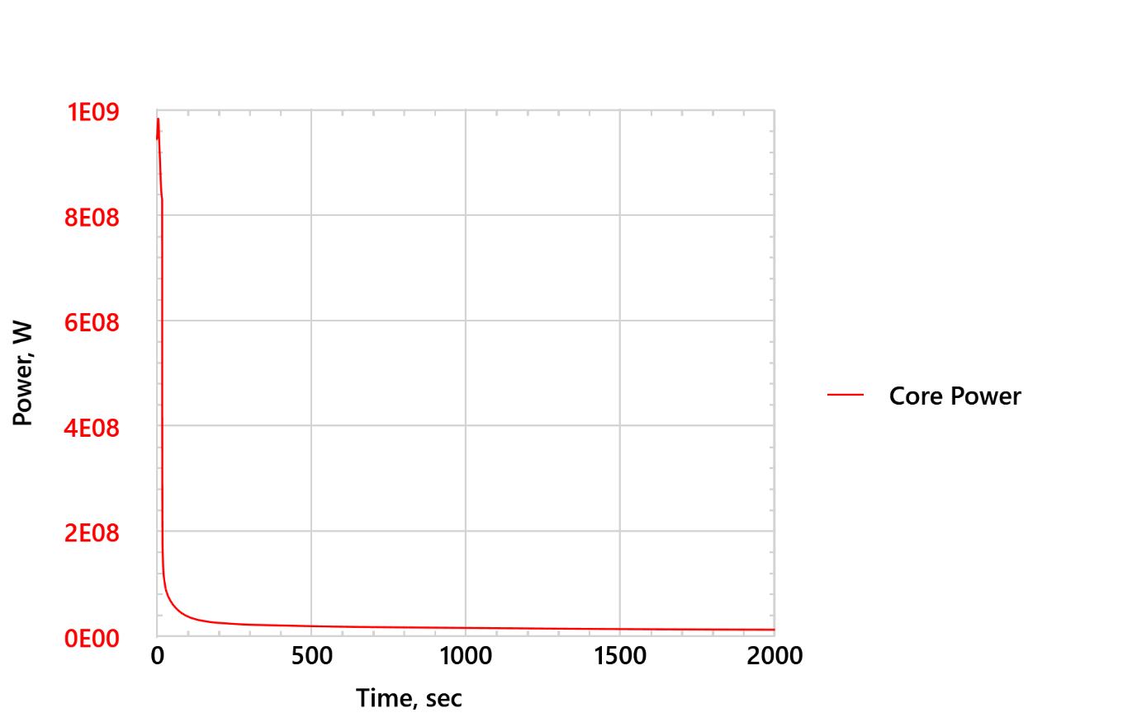
FIG. 3. Short-term core power – SBO
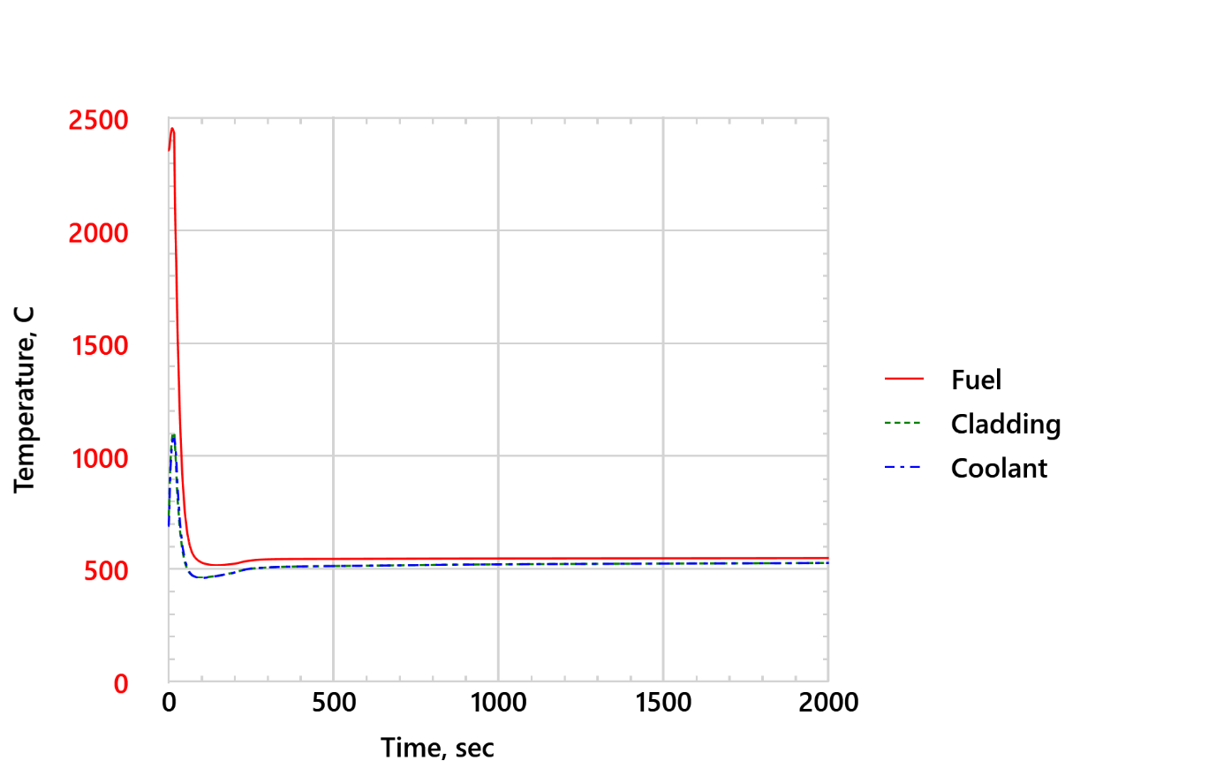
FIG. 4. Short-term peak fuel, cladding, and coolant temperatures in the Core – SBO
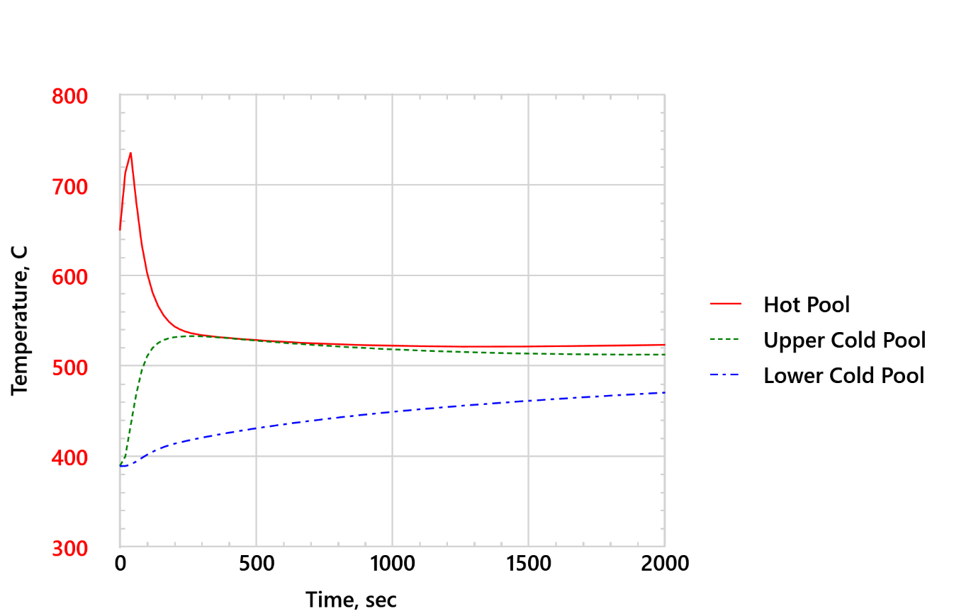
FIG. 5. Short-term lead pool temperatures – SBO
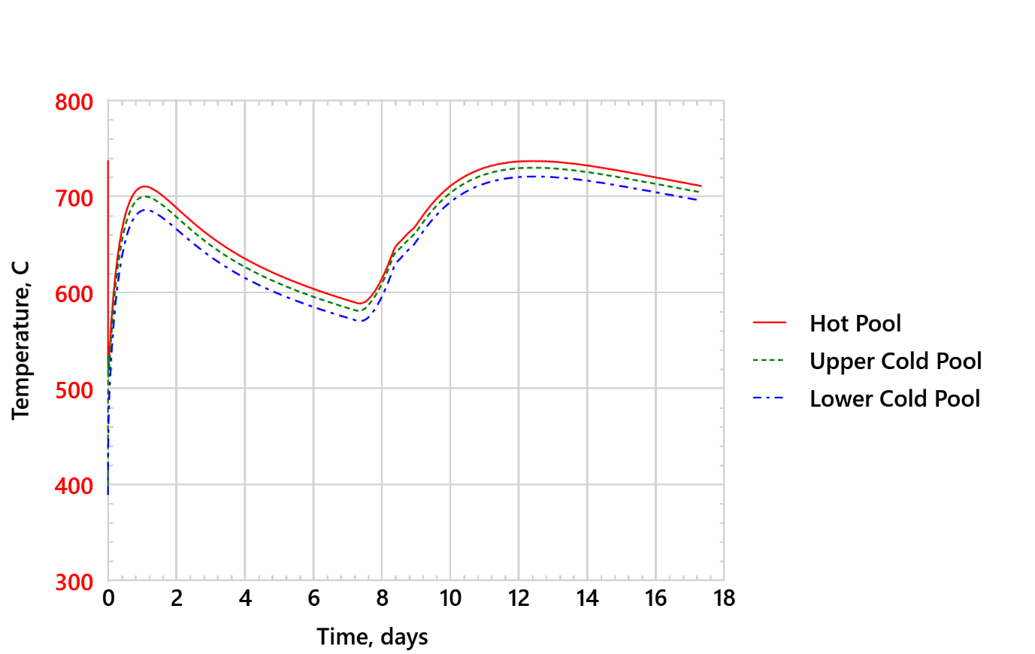
FIG. 6. Lead pool temperatures – SBO
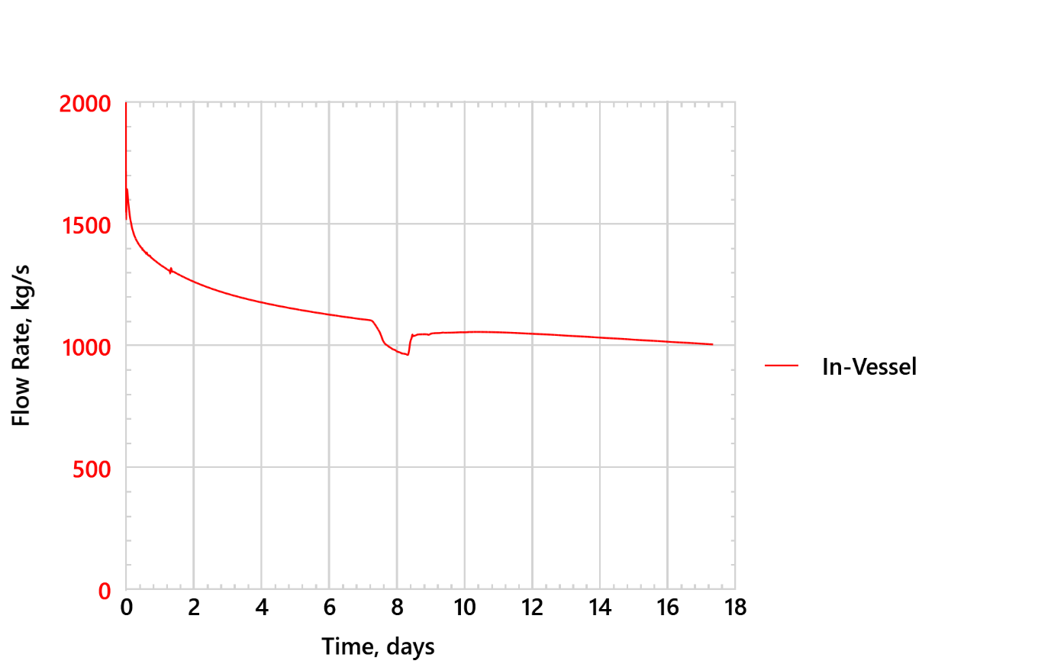
FIG. 7. Reactor coolant flow rate – SBO
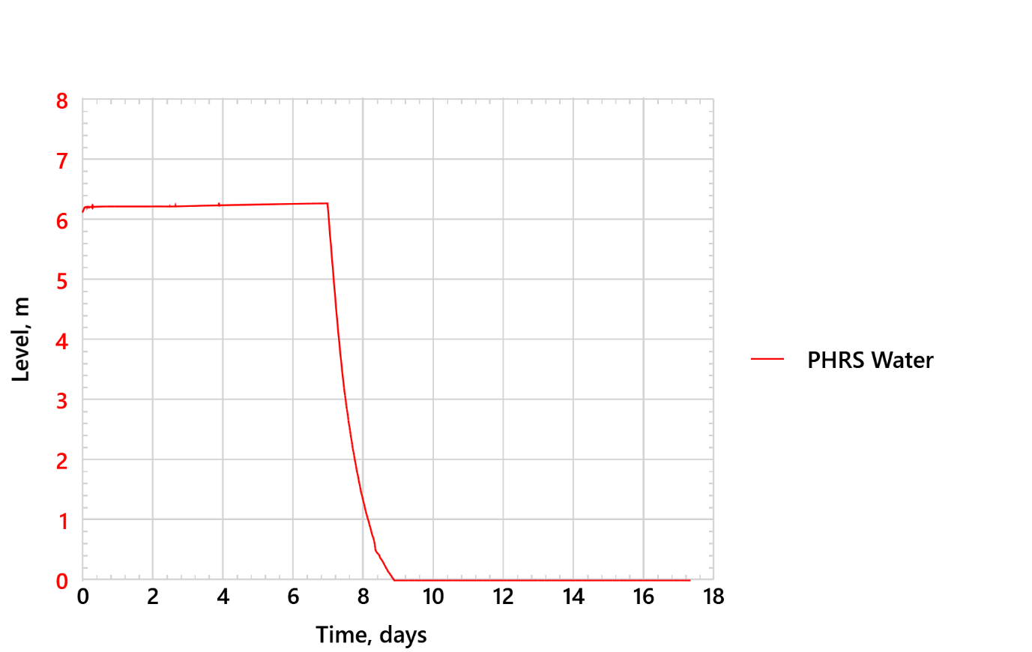
FIG. 8. PHRS water pool height – SBO
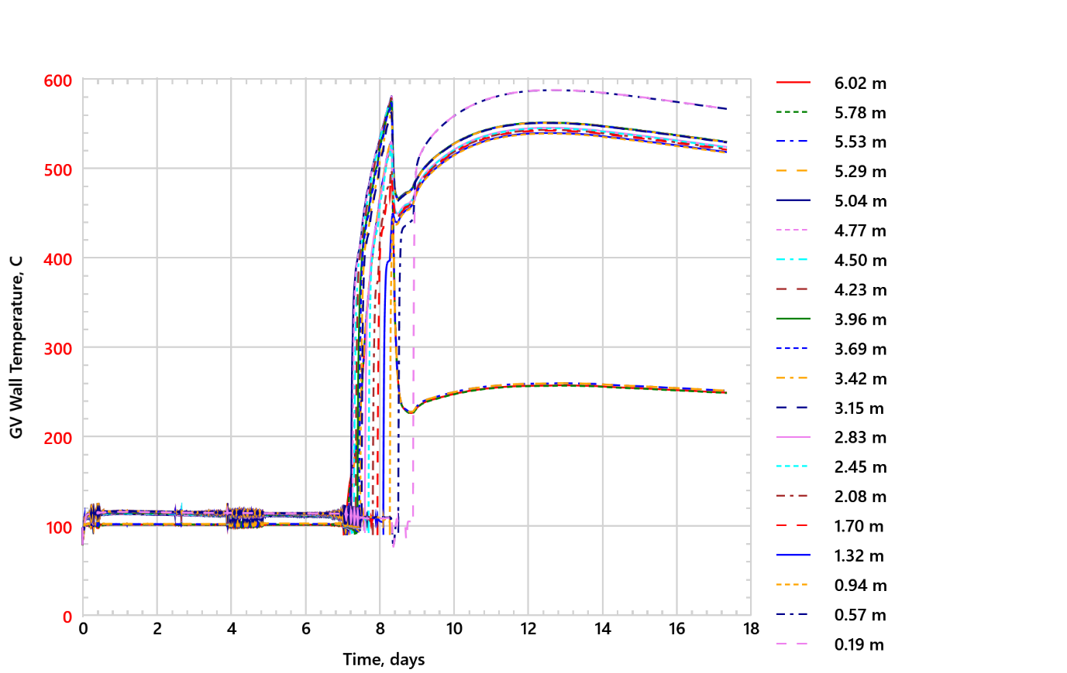
FIG. 9. GV wall temperatures – SBO
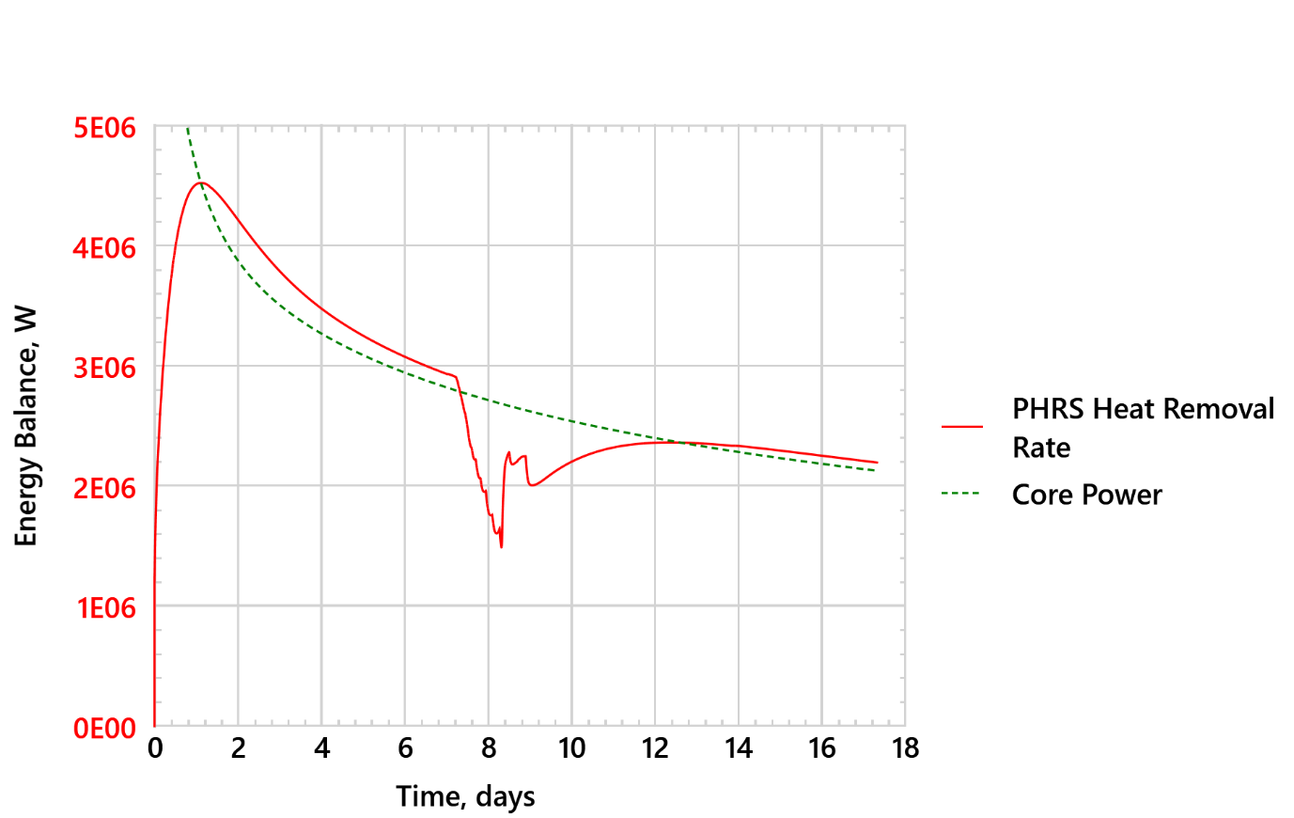
FIG. 10. Energy balance – SBO
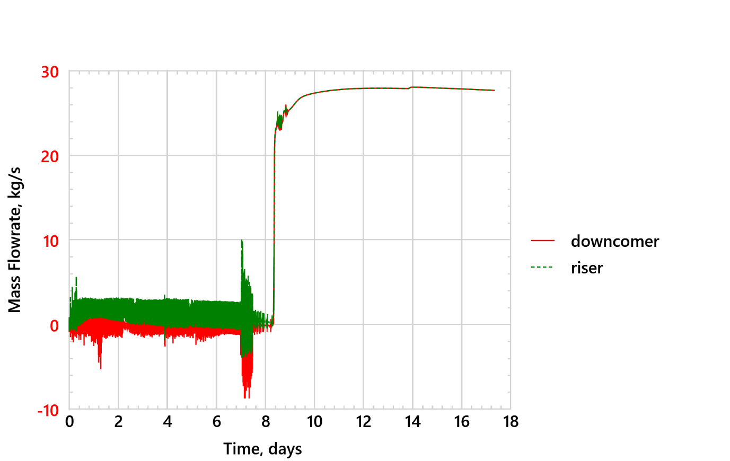
FIG. 11. Gas flow rates in PHRS – SBO

Transient Overpower (TOP)
A transient overpower accident is initiated by inadvertent withdrawal of most reactive control rods, inserting a positive reactivity of 74 cents in 60 seconds. All primary heat exchangers (PHEs) continue operating. All reactor coolant pumps continue operating. The accident is assumed to occur at the beginning-of-cycle (BOC) in the reactor operation. BOC is selected for the largest reactivity in the core at the beginning of cycle. The normal reactor shutdown system is assumed to fail. However, the passive shutdown system is available. The normal decay heat removal system is assumed unavailable. Normal decay heat system is not a safety related component, so it is not credited in design basis accident analyses.
Fig. 12 shows the short-term core power. The core power increases to 140% of the normal power due to the positive reactivity insertion until the passive shutdown system is actuated at 50 seconds due to high coolant temperature .
Fig. 13 shows various reactivity feedbacks in the core. The negative reactivity of passive shutdown system (not shown in the plot) overcomes the inserted reactivity due to rod rejection. Subsequently, the reactor is scrammed.
Fig. 14 shows short-term temperature responses of the fuel, cladding, and coolant in the core. The fuel and cladding heat up momentarily due to overpower. Then, they cool down rapidly after the reactor shuts down because the primary heat exchangers and reactor coolant pumps continue operating. The fuel does not reach the melting point of irradiated UO₂, 2845 ºC [7]. The fuel cladding does not reach the creep rupture temperature and duration, 900 ºC for 1 hour at 50 MPa equivalent stress [8].
Fig. 15 shows short-term temperature responses of lead pools in RV. The pools cool down and mixes, approaching the primary heat exchanger secondary side inlet temperature, 370 ºC.
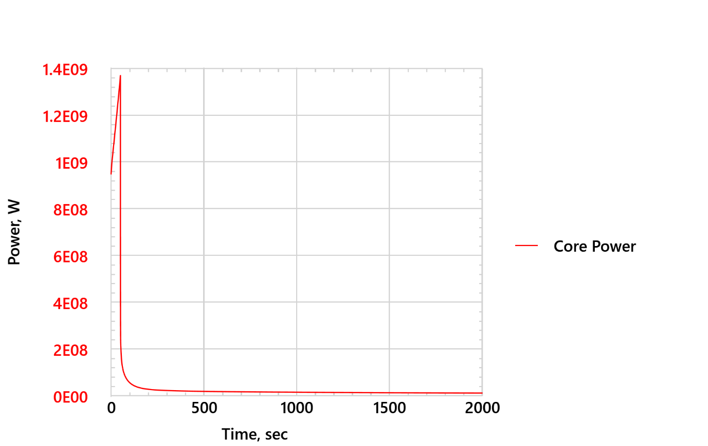
FIG. 12. Short-term core power – TOP
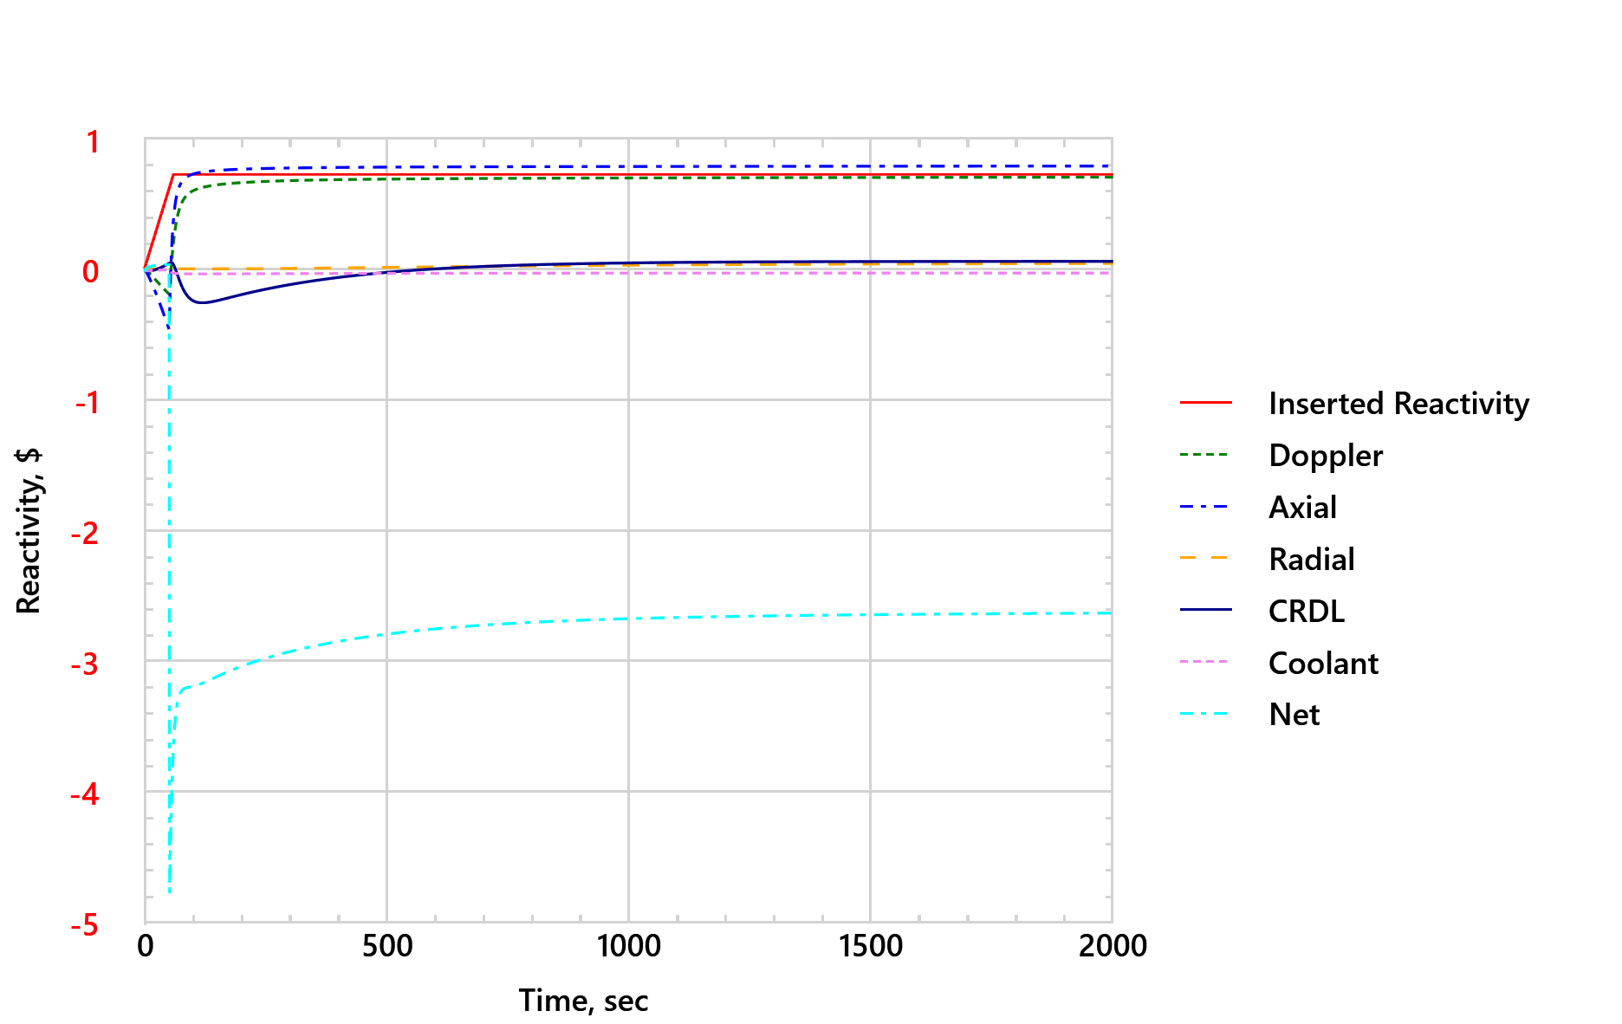
FIG. 13. Short-term reactivity feedback – TOP
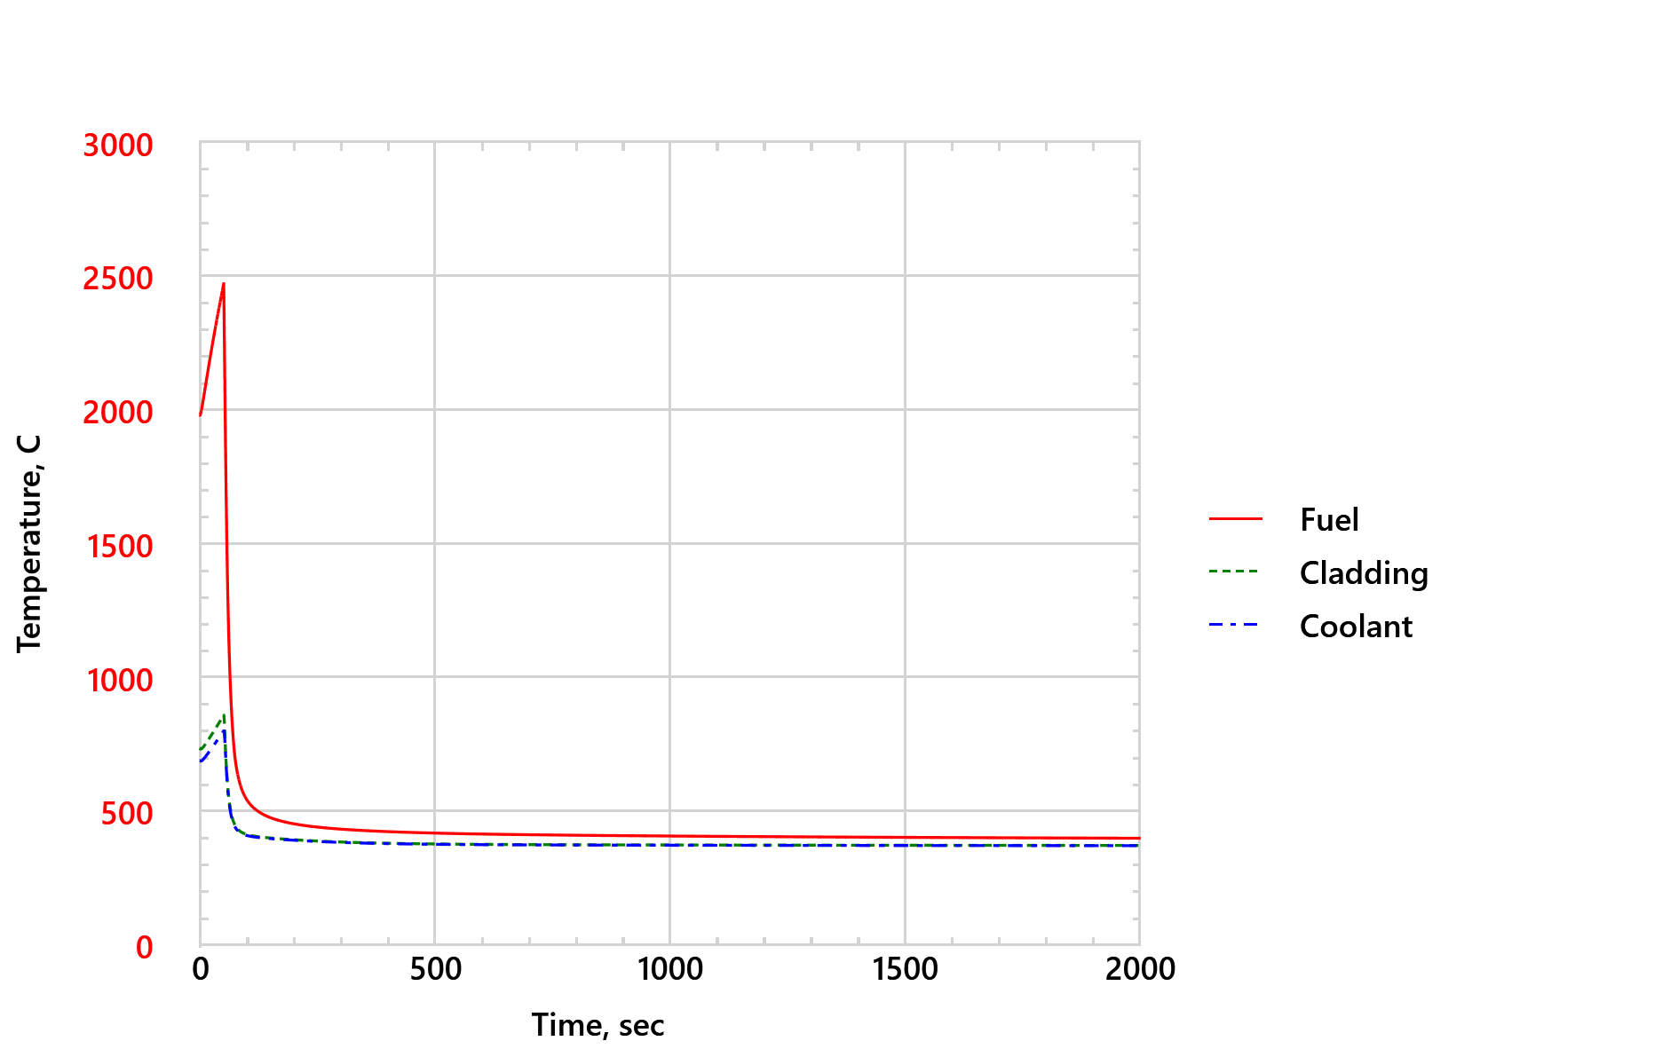
FIG. 14. Short-term peak fuel, cladding, and coolant temperatures in the core – TOP
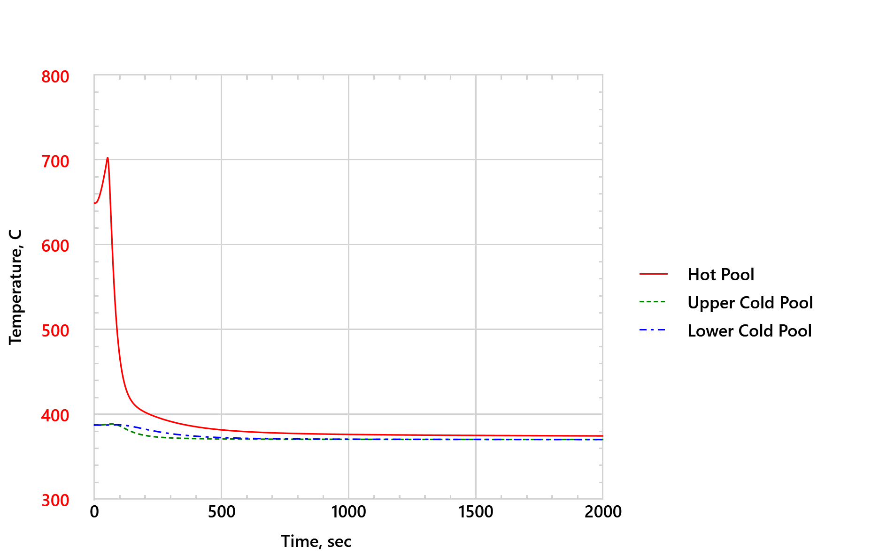
FIG. 15. Short-term lead pool temperatures – TOP

CONCLUSION
The response of the Westinghouse LFR during SBO and TOP accidents is assessed using the SAS4A/SASSYS-1 system code coupled to the GOTHIC containment code. For SBO, the performance of the passive decay heat removal system comprised of the safety (water) pool surrounding the GV, which transitions to air-cooling after the water in safety pool has boiled off, is evaluated. The magnitude of decay heat when the water in safety pool has boiled off, duration of the water-cooling to air-cooling transition, heat capacity of the lead pool, and the effectiveness of air-cooling determine the long-term peak temperature of the lead coolant, an important safety criterion. For TOP, temperature reactivity feedbacks in the core determine whether fuel melting and cladding failure will occur during the initial power excursion in the core. The analyses demonstrate capability of the coupled SAS4A/SASSYS-1 and GOTHIC codes to assess safety performance of Westinghouse LFR. The reactor design is evolving, and the results presented in the paper show the preliminary safety performance of the Westinghouse LFR.
References
- FERRONI, P., et al., “The Westinghouse lead fast reactor: design overview and update on development activities,” Proceedings of Conference on Fast Reactors and Related Fuel Cycles (FR22), Vienna, Austria (2022).
- FANNING, T.H., BRUNETT, A. J., and SUMMER, T., The SAS4A/SASSYS-1 Safety Analysis Code System, Version 5, United States (2017).
- KARAHAN, A., et al., “A stochastic clad damage propagation model for lead fast reactors,” ANS Winter Meeting, Chicago, USA (2020).
- WISE, D.L., LIAO, J., LEE, S.J., WRIGHT, R., FERRONI, P., “Passive heat removal analysis for the Westinghouse lead fast reactor,” Proceedings of Conference on Fast Reactors and Related Fuel Cycles (FR22), Vienna, Austria (2022).
- O’GRADY, D.J., BRUNETT, A.J., and FANNING, T.H., “Implementation of an extended reactor vessel heat rejection modeling capability in SAS4A/SASSYS-1,” ANS Winter meeting, 2020.
- LIAO, J., FERRONI, P., WISE, D., et al., “Joint SAS4A/SASSYS-1 development for lead cooled fast reactor safety analysis,” ANS Winter meeting (2020).
- YAMANOUCHI, S., TACHIBANA, T., TSUKUI, K, and OGUMA, M., “Melting Temperature of Irradiated UO2 and UO2-2wt%Gd2O3 Fuel Pellets up to Burnup of about 30 GWd/tU,” Journal of Nuclear Science and Technology 25 (1988): 528-533.
- CAUTAERTS, N., DELVILLE, R., DIETZ, W., and VERWERFT, M., "Thermal creep properties of Ti-stabilized DIN 1.4970 (15–15Ti) austenitic stainless steel pressurized cladding tubes,” J. Nucl. Mater. 493 (2017), 154–167.

