A STUDY OF THERMOPHYSICAL AND PHYSICOCHEMICAL CHARACTERISTIC OF THE KALLA EXPERIMENT FACILITY

K. SERGEENKO, K. SVIRID, V. NIKOLAEV, D. AFREMOV, A. TUTUKIN, F. BONDAR,
I. SAPOZHNIKOV

JSC NIKIET, Moscow, Russian Federation

Email contact of corresponding author: km.sergeenko@gmail.com

Abstract

Activities are currently underway across the world to build heavy liquid metal-cooled reactors. Thus, for example, the ALFRED and BREST-OD-300 reactor designs use lead coolant, while the MYRRHA and SVBR-100 reactors use lead-bismuth coolant. The high corrosive and erosive activity of the coolant requires regulation of oxygen concentration (1÷4Е-6 wt. %) and flow velocity (0.5÷2.5 m/s). Due to the complex geometry of the reactor circulation circuit flow paths, numerical simulation methods are used extensively to justify scheduled modes of operation for liquid metal coolants. Correct justification of the complex oxygen transport processes in liquid metals requires the respective physicochemical computation model, which takes into account the main reactions of oxygen with the coolant and the structural materials.
This paper presents a physicochemical model, which includes the following processes: erosion, growth, and dissolution of the two-layer oxide film, coagulation and dissolution of metal oxides in the circuit with subsequent deposition in a filter, and inflow of oxygen by the mass exchanger. StarCCM+, a commercial CFD code, was used as the tool in this study. The physicochemical model was implemented using models of passive impurities, which are used to simulate oxygen transport in the circulation circuit.
Capabilities of the presented model are demonstrated based on the results of investigating thermohydraulic and physicochemical processes obtained at the KALLA laboratory experimental facility. The duration of the simulation is set to 1000 hours.
The distributions of metal oxides concentrations, increased erosive activity areas, as well as the total amount of oxides deposited on the filter and the amount of oxygen entering the circuit have been obtained as a result of the calculations. The surface distribution of the oxide film thickness on the test facility surfaces contacting the coolant has also been calculated.
Simulation of thermocouples, as well as taking into account manufacturing technology made it possible to improve the accuracy of calculating the flow’s thermohydraulic characteristics as compared to earlier studies.

INTRODUCTION
Methods of Computational Fluid Dynamics (CFD) have currently become common in the nuclear industry. In most cases, the use of CFD is limited by the investigation of the coolant flow’s thermohydraulic characteristics, while many other physical processes could take place in the flow. As an example, heavy liquid metal coolant (HLMC) transfers oxygen from its source - mass exchanger to the consumer - steel surfaces. This process is important as the HLMC has a strong erosive effect on the structural materials while the oxide film could provide protection against the liquid metal erosion. Also, the oxide film, being less heat-conductive as compared with the coolant, could produce thermal resistance, thus leading to an increase in the steel temperature due to the heat transfer decreasing. Thus, even if the object of research is thermohydraulic properties of the coolant, the physicochemical processes must be taken into account.
There are two major reasons why coupled physicochemical and thermohydraulic calculations are not widespread: the lack of sufficient information on physicochemical processes and the complexity of their implementation in CFD codes. Physicochemical processes are underexplored because the object of the research is characterized by many processes, while only a limited number of parameters can be measured: the oxide film thickness, the thermodynamic activity of oxygen, etc. It should be noticed that experimental studies require considerable financial costs. The reason for the complexity of implementing physicochemical phenomena in CFD codes is that the typical time of the oxide film formation lies in the range from 1000 to 15000 hours [1], [2]. This requires using a time step that exceeds the convective Courant number, and often it leads to numerical errors.
As a result, usually a number of different simplifying assumptions are made. In [3], for example, the calculation time is limited by 50 sec, whereas a homogeneous oxide film thickness is postulated in [4], which enables calculations under stationary conditions. There are combined calculations in which data obtained using CFD codes are often used by codes that calculate physicochemical processes [5].
Activities have been underway at JSC NIKIET to design heavy liquid metal-cooled (HLMC) reactors. Several physicochemical models were developed for making design solutions, and they are subsequently integrated into the CFD-code StarCCM+[6].
This paper presents a physicochemical model that studies the processes of oxygen injection by the mass exchanger, the two-layer oxide film formation, the crystallization and dissolution of oxides in the coolant, the deposition of weighted oxides in the filter and on steel surfaces.
To illustrate the practical application of the developed physicochemical model, one of the experiments at the THEADES test facility [7], in which the thermohydraulic of the lead-bismuth eutectic alloy flow is investigated, was simulated. The simulation was performed for the time duration of 1000 hours.

originality, copyright and publication
The presented physicochemical model and its simulation results we’re not published earlier in open sources.

PROBLEM STATEMENT
The object of the research is the KALLA test facility (Fig. 1, left) which represents a circuit of lead-bismuth coolant with installed devices to support its technology, with a test section and the respective measuring tools.
In the simulation model, the coolant circulation path outside the working section was replaced by a simplified path while preserving its structural peculiarities (Fig. 1, right).

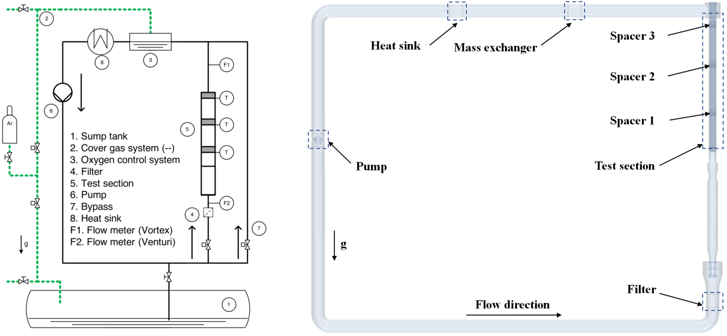
Fig. 1. Schematic representation of the THEADES LBE loop (left),
the geometry of the simplified hydraulic path model (right).

The test section is a triangular-packed rod bundle with a pitch to diameter ratio of 1.4. The grids installed at a different distance from each other are used for the rod spacing.
It is assumed that the pump, the mass exchanger, and the filter work continuously while supplied and extracted power is maintained at a constant level. All structural elements are assumed to be made of grade T91 steel. Table 1 presents the key parameters of the computational study.

TABLE 1. COMPUTATIONAL STUDY PARAMETERS

T_{in} | Q | Q_{v} | Re_{in} | Time | Co_{me} | Steel
300 | 102 | 10 | 95E3 | 1000 | 2E-6 | T91

where: T_{in} – the coolant temperature at the inlet of the test section, °C; Q – the heat flux, kW; Q_{v} – the flow rate, m³hr⁻¹; ${Re}_{in}=ρu_{b}d_{h,bdl}μ^{-1}$ – the Reynolds number; Time – the duration of simulation, hr; Co_{me} – the concentration of oxygen maintained by the mass exchanger, %wt.; Steel – the steel grade; $u_{b}$ – the bulk velocity, m s⁻; $μ$ – the viscosity, Pa s; $d_{h,bdl}=7.7$ – the hydraulic diameter of the bare-bundle flow channel, mm¹; $ρ$ – the coolant density, kg m⁻³.
The study was conducted in two stages. At the first stage, thermohydraulic characteristics are simulated and compared with the experimental data. At the second stage, the obtained distributions are used to calculate physicochemical processes.
The simulation model includes the measuring tools arranged exactly in the same positions as in the test bench. Also it takes into account the spacer grid manufacturing technology (“selective laser melting”) which forms a roughness of 35 to 40 μm [8] that affects the thermohydraulic characteristics as it shown in [9].

Thermohydraulic calculation
The thermohydraulic calculation forms the basis for the subsequent simulation of physicochemical processes. For this reason, the accuracy of this calculation directly impacts the subsequent physicochemical calculation.

Description of the thermohydraulic model
The computational model includes a hydraulic path, as well as spacer grids and rods.
The thermohydraulic calculation is provided in the steady-state statement. The coolant is driven by the revolution of the pump’s rotating parts and the volumetric force which provides for the target mass flow. Heat is supplied by defining a uniform heat flux on the inner surface of the pins and removed by the volumetric flux in the heat sink location (see Fig. 1). No-slip conditions are defined for surfaces. The thermophysical properties of the lead-bismuth coolant and Т91 steel were taken from [10] and are presented in Table 2.

TABLE 2. PHYSICAL PROPERTIES OF LBE AND T91 STEEL

Property | Expression
LBE
Density, kg m⁻³ | 11096-1.3236T
Heat capacity, Jkg⁻¹K⁻¹ | 159-2.72 10⁻²T+7.12 10⁻⁶T²
Thermal conductivity, Wm⁻¹K⁻¹ | 3.61+1.517 10⁻²T-1.741 10⁻⁶T²
Dynamic viscosity, kgm⁻¹s⁻¹ | 4.94 10⁻⁴exp(754.1/T)
T91 STEEL
Density, kg m⁻³ | 7860
Heat capacity, Jkg⁻¹K⁻¹ | 500
Thermal conductivity, Wm⁻¹K⁻¹ | 26.1

The simulation is performed in a RANS approach. The two-layer k-e realizable turbulence model [6] is used. The isotropic gradient-diffusion assumption is used to calculate turbulent heat flux. The formula for the turbulent Prandtl number is taken from [11]:
${Pr}_{t}=3.95⸱{Pr}^{-0.33}{Re}^{-1.975}\left[3⸱{10}^{-3}{y^{+}}^{2} exp\left({-{y^{+}}^{2}}/{{30}^{2}}\right)+tanh\left({y^{+}}/{30}\right)\right]$, | (1)
where: $Pr$ is the Prandtl number; $y^{+}=yu_{τ}/ν$ is the viscous scale; $u_{τ}={\left({τ_{w}}/ρ\right)}^{0.5}$ is the friction velocity, m s⁻¹; and $τ_{w}$ is the wall shear stress, Pa.

Thermohydraulic calculation results
Fig. 2 presents the velocity and temperature fields in the plane that passes through the axes of the headers (header plane). It can be seen in Fig. 2 that the maximum temperature value corresponds to 340 °С, while the model heat exchanger provides for the complete heat removal up to a value of 300 °С.
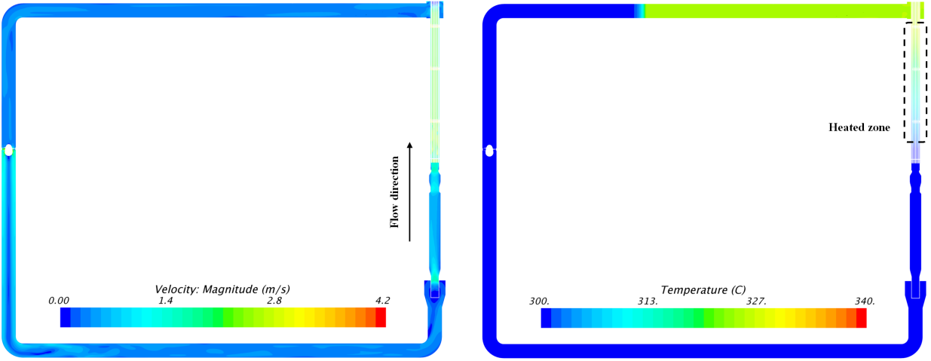
Fig. 2. Velocity fields (left) and temperature fields (right) in the header plane.

Fig. 3 and Fig. 4 present the velocity and temperature fields in the center of spacers correspondingly.

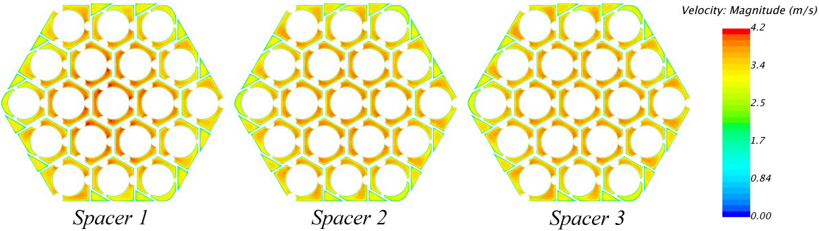
Fig. 3. Velocity field at the centers of spacers.

It can be seen in Fig. 3 that, at the first spacer, the velocity profile has a pronounced maximum in its central part. This is due to the flow non-uniformity at the rod bundle inlet.

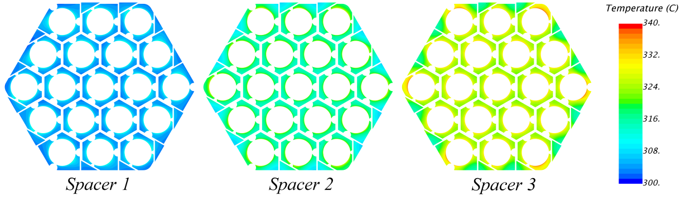
Fig. 4. Temperature field at the centers of spacers.

It can be seen in Fig. 4 that the rod bundle in the proximity of the channel chord intersection has the maximum temperature values. This is due to reduced coolant flow velocity at these locations (see Fig. 3).
The measurement data was processed, and dependences for the Nusselt number, the friction factor, and the drag coefficient were obtained. Table 3 presents the results of comparing calculated and experimental data. The value in the parenthesis corresponds with the coordinate of the considered section. The coordinate system origins correspond to the start of heated zone [7].

TABLE 3. INTEGRAL DATA COMPARISON

Case | f | K_{sp} (21.0) | K_{sp} (69.1) | K_{sp} (111.0) | Nu (17.0) | Nu (55.9) | Nu (89.8)
Experiment [7] | 0.0175 | 1.13 | 1.18 | 1.20 | 34 | 27 | 26
Simulation [8] | 0.0170 | 1.03 | - | - | 47 | 43 | 41
This work | 0.0180 | 1.14 | 1.13 | 1.12 | 36 | 27 | 26

where: $f=\left[{∆P_{f}}/{\left(0.5ρu_{b}^{2}\right)}\right]\left({d_{h,bdl}}/L\right)$ – the rod bundle friction factor; $K_{SP}={∆P_{SP}}/{\left(0.5ρu_{b}^{2}\right)}$ – the spacer grid drag coefficient; $Nu=\left[{q_{w}}/{\left(T_{w}-T_{b}\right)}\right]\left({d_{h,sch}}/λ\right)$ – the Nusselt number; $T_{w}$– the surface temperature (in the experiment, according to [8], this was determined from the averaged value of the thermocouples installed in the vicinity of the heat-exchange surfaces), ᵒC; $∆P_{SP}$ – the pressure drop on the rod bundle, Pa; $L=870$ – the heated length of the rods, mm; $∆P_{f}$ – the pressure drop in the entire measurement area, Pa; $d_{h,sch}=9.52$ – hydraulic diameter of a central sub-channel, mm; $λ$ – the thermal conductivity, Wm⁻¹K⁻¹;$T_{b}$ – the averaged mixed temperature, ᵒC.
It can be seen in Table 4 that the data calculated in present study and the experimental results agree well and the calculation error does not exceed 10%. The bigger error in study [8] can be probably explained by the fact that two issues were not taken into account: the roughness at the spacer grids and algorithm of experimental Nusselt number determination.

Chemical calculation
The goal of the physicochemical calculation is the determination of:
      - the spatial distribution of oxygen concentration in the coolant;
      - the oxide film thickness on the steel surfaces and its influence on heat transfer;
      - the steel thickness thinning;
      - the mass exchanger performance required to maintain the target oxygen concentration in the circuit (the injected oxygen is required to compensate its loses due to the processes of oxide formations);
      - the oxygen mass that is deposited on the filter in the form of metal oxides during the operation time.
An additional assumption of the physicochemical calculation is that the filter and the mass exchanger work continuously. Also, it is postulated that the filter removes from the flow 50% of the weighted oxides passing through it, and the mass exchanger maintains the target oxygen concentration. These assumptions are made due to the lack of information about the experiment.
The initial oxygen concentration and the film thickness are C_{o}=2E-6, % wt. and 0 μm correspondingly (no prepassivation procedure was implemented).
To accelerate the calculation, the time step changes from 0.1 sec at the beginning to 3600 sec at the middle of the calculation.

Description of the physicochemical model
The current physicochemical model has several assumptions:
      - there are oxides of four metals that might be present in the coolant: iron, chromium, nickel and lead;
      - metal oxides are represented by the following chemical formulas: Fe₃O₄, FeO, FeCr₂O₄, PbO, and NiO. Each of the metal oxides is presented in the form of weighted and dissolved fractions;
      - the effect of metal oxides on the coolant flow is neglected;
      - the effect of mass forces on the metal oxide behavior is neglected;
      - fractions of oxide particles of the same oxide type interact with each other via dissolution and crystallization;
      - oxides of different metals do not interact with each other;
      - the oxide film is characterized by the locally homogeneous thickness (there is no roughness);
      - the initial period of the oxide film formation is characterized by the presence of magnetite and spinel layers. As shown in [12], the magnetite layer is in direct contact with the coolant while the spinel layer is the inner one;
      - the magnetite layer prevents the erosive escape of the spinel layer oxide components;
      - the mass exchanger adds equal masses of dissolved and weighted lead oxide fraction to the circuit;
      - the oxide film forms due to the reaction of the dissolved lead oxide with steel;
      - the oxide film formation is accompanied by a partial escape of dissolved metal oxides;
      - the filter accumulates only weighted oxides;
      - the erosive destruction of the oxide film at a fixed temperature and oxygen concentration depends only on wall shear stress.
One of the key assumptions is that only dissolved particles of the lead oxide (PbO) form the oxide film via reaction of oxygen with the steel. This assumption is based on the works [13] and [14] where it is shown that lead oxide is the dominant oxide in the lead-bismuth coolant whereas the domination of PbO as compared with free oxygen is shown in the work [12]. Assumptions about iron and nickel oxides are taken from the works [16], [18] and 0.
Schematically, all assumptions for the physicochemical model are presented in Fig. 5.

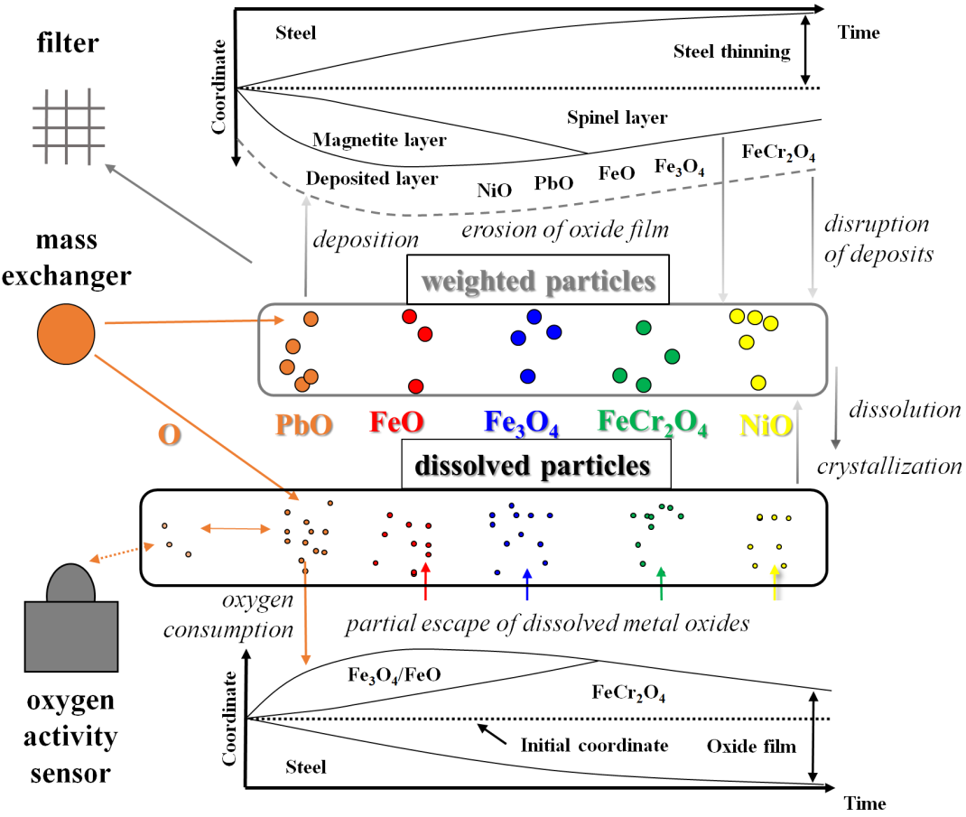
Fig. 5. A schematic representation of the physicochemical processes implemented in the considered model.

As shown in Fig. 5, the model takes into account 11 impurities that are simulated by passive scalars. For the convenience of analysis, all passive scalars are determined in such a way that their numerical values correspond to the density of oxygen (kg m⁻³) which is included in considered impurity.
The set of differential equations to be solved are the advection-diffusion equations of passive scalar:
$${∂ρ_{name}^{form}}/{∂t}+U∙∇ρ_{name}^{form}=div\left(D_{eff}∇ρ_{name}^{form}\right)+S_{name}^{form}$$ | (2)
where: $ρ_{name}^{form}$ is the selected impurity, kg m⁻³; $U$ is the velocity vector, m/s; $D_{eff}=2.4∙{10}^{-6}\exp\left(-{43073}/{RT}\right)+{ν_{t}}/{{Sc}_{t}}$ is the diffusion coefficient, m²s⁻¹ [10]; $ν_{t}$ is the turbulent kinematic viscosity, m²s⁻¹; ${Sc}_{t}$ is the turbulent Schmidt number; $S_{name}^{form}$ is the source term, that represent the sum of processes for the selected impurity, kg m⁻³s⁻¹. In equation (2) the upper index correlates with the fraction form (weighted or dissolved), while the lower index with selected oxygen impurities (O, PbO, FeO, Fe₃O₄, FeCr₂O₄, NiO – for the dissolved form and PbO, FeO, Fe₃O₄, FeCr₂O₄, NiO – for the weighted form).
The oxide film growth model is given by differential equations that describe the growth and the thinning of a two-layer oxide film consisting of a magnetite layer (chemical formula is Fe₃O₄ or FeO) and a spinel layer (chemical formula is FeCr₂O₄):
${{dh}_{m}}/{dt}={ \left(1-C_{diff_m}\right)J_{m}}/{ρ_{m}}-V_{err_m}$, | (3)
${{dh}_{s}}/{dt}={ \left(1-C_{diff_s}\right)J_{s}}/{ρ_{s}}-V_{err_s}$, | (4)
where:$h_{m}$ and $h_{s}$ – the thicknesses of the magnetite and spinel layers correspondingly, m; $C_{diff_m}$ and $C_{diff_s}$ – the proportion of magnetite and spinel masses correspondingly that escape the oxide film due to the process of its formation; $J_{m}$ and $J_{s}$ – the mass fluxes of magnetite and spinel correspondingly, kg m⁻² s⁻¹; $ρ_{m}=5000$ and $ρ_{s}=3600$ – the magnetite and spinel densities correspondingly, kg m⁻³;$V_{err_m}$ and $V_{err_s}$ – the magnetite and spinel erosion velocities correspondingly, m s⁻¹.
The two-layer approach has been chosen due to different properties of each layer having a different impact on the thermal and chemical processes. From the point of thermal processes this aspect is due to the different thermal conductivity of different layers [15], whereas for the chemical processes this is due to the different diffusion properties of each layer [16], [17]. The development of first-principles calculations promises to provide detailed information on the differences of the Cr spinel layer and the magnetite layer [19], including the properties of point defects in them [20].
It is assumed that new oxides form due to the reaction of dissolved lead oxide with the steel. Based on the mass balance and on the assumption that at temperatures higher than 570 ᵒC FeO oxide forms instead of Fe₃O₄, an equation that describes correlation between oxygen and steel fluxes is obtained:
$$J_{steel}=\left\{\begin{aligned}J_{o}{\left(W_{Fe}\frac{4 M_{o}}{3 M_{Fe}}+W_{Cr}\frac{4 M_{o}}{3 M_{Cr}}+W_{Ni}\frac{M_{o}}{M_{Ni}}\right)}^{-1}, T-273.15<570 \\ J_{o}{\left(W_{Fe}\frac{M_{o}}{M_{Fe}}+W_{Cr}\frac{3 M_{o}}{2 M_{Cr}}+W_{Ni}\frac{M_{o}}{M_{Ni}}\right)}^{-1}, T-273.15≥570\end{aligned}\right.$$ | (5)
where: $J_{steel}$ , $J_{o}$ – the mass fluxes of steel and oxygen correspondingly, kg m⁻² s⁻¹; $M_{o}=16$,$M_{Fe}=56$, $M_{Cr}=52$, $M_{Ni}=59$ – the atomic mass of oxygen, iron, chromium and nickel correspondingly;$W_{Fe}=0.88$, $W_{Cr}=0.11$, $W_{Ni}=0.006$ – the mass fraction of iron, chromium and nickel in the steel T91 correspondingly.
Equation (5) could be used to get the value of the steel thinning in case oxygen flux is known.
The steel flux might be interesting as it might be used to calculate the velocity of steel thinning:
$${{dh}_{steel}}/{dt}={- J_{steel}}/{ρ_{steel}}$$ | (6)
Based on the mass balance and on the chemical formulas of the magnetite and spinel layers, it is possible to obtain the correlations between steel fluxes and fluxes of magnetite and spinel layers:
$$J_{m}=\left\{\begin{aligned}J_{steel}\left(W_{Fe}-W_{Cr}\frac{M_{Fe}}{2 M_{Cr}}\right)\left(1+\frac{{4M}_{o}}{{3M}_{Fe}}\right), T-273.15<570 \\ J_{steel}\left(W_{Fe}-W_{Cr}\frac{{2M}_{Fe}}{M_{Cr}}\right)\left(1+\frac{M_{o}}{M_{Fe}}\right), T-273.15≥570\end{aligned}\right.$$ | (7)
$$J_{s}=\left\{\begin{aligned}J_{steel}W_{Cr}\left(1+\frac{M_{Fe}+4M_{o}}{2 M_{Cr}}\right), T-273.15<570 \\ J_{steel}W_{Cr}\left(1+2\frac{M_{Fe}+4M_{o}}{ M_{Cr}}\right), T-273.15≥570\end{aligned}\right.$$ | (8)
In the model, it is assumed that the process of oxide film formation might be divided into three stages:
$$N_{stage}=\left\{\begin{aligned}1, J_{diff}>C_{max}J_{max} \\ 2,{ h}_{m}>0, { J}_{diff}≤C_{max}J_{max} \\ 3, { h}_{m}=0, J_{diff}≤C_{max}J_{max}\end{aligned}\right.$$ | (9)
where:$J_{diff}$ and $J_{max}$ – diffusion and maximum mass fluxes of oxygen correspondingly, kg m⁻² s⁻¹.
The value of $J_{diff}$ depends on oxygen diffusivity properties of oxide film:
$$J_{diff}=\left[\left(C_{m}{h_{m}}/{h^{2}}\right)+\left(C_{s}{h_{s}}/{h^{2}}\right)\right]P_{o}^{0.11}exp⁡\left({-18980}/T\right)$$ | (10)
where:$C_{m}$ and $C_{s}$ – the diffusion coefficient of the magnetite and spinel layer correspondingly, kg m⁻¹ s⁻¹;$P_{O}$ – the partial pressure of oxygen; $h=h_{m}+h_{s}$ – the oxide layer (total) thicknesses, m.
Oxygen density cannot be less than zero, that corresponds to $J_{max}$, so the diffusion model should include a limitation on the maximum oxygen flux (equation (10) tends to infinity when the oxide layer thicknesses are zero):
$$J_{o}=min\left(J_{diff},C_{max}J_{max} \right)$$ | (11)
In the model, the oxide layer formation is described by the processes of its deposition and disruption:
$${{dh}_{sett_name}}/{dt}=V_{dep_name}-V_{disr_name}$$ | (12)
where: $h_{sett_name}$ is the thicknesses of the settled particles layer, m;$V_{dep_name}$ and $V_{disr_name}$ – the velocities of the deposition and disruption correspondingly, m s⁻¹; the lower index correlates with selected oxygen impurities of weighted fraction (PbO, FeO, Fe₃O₄, FeCr₂O₄, NiO).
The role of deposited impurities in the present model is the indication of the zone of weighted oxides accumulation.
The closing relations for the physicochemical model are summarized in the Table 4.

TABLE 4. CLOSING RELATIONS FOR THE PHYSICOCHEMICAL MODEL

Term | Expression
$P_{O}$, - | $$P_{O}^{sat}{\left({C_{O}}/{C_{O}^{sat}}\right)}^{2}$$
$P_{O}^{sat}$, - | $${10}^{\left[9.93-\left({22891.9}/T\right)\right]}$$
$C_{O}^{sat}$, wt % | $${10}^{\left[2.25-\left({4125}/T\right)\right]}$$
$C_{O}$, wt % | $$100{ρ_{PbO}^{D}}/ρ$$
$C_{diff_m}$, - | $$1\left(N_{stage}=3\right),0.05\left(N_{stage}=1,N_{stage}=2\right)$$
$C_{diff_s}$, - | 0.02
$V_{err_m}$, m s⁻¹ | $$C_{keller}C_{err_m}\left(N_{stage}=2\right),0\left(N_{stage}=1,N_{stage}=3\right)$$
$V_{err_s}$, m s⁻¹ | $$C_{keller}C_{err_s}\left(N_{stage}=3\right),0\left(N_{stage}=1,N_{stage}=2\right)$$
$C_{keller}$, - | $${τ_{w}}/{63}$$
$C_{err_m}$, - | $${10}^{-13}$$
$C_{err_s}$, - | $$0.2 C_{err_m}$$
$C_{m}$, - | $$9 {10}^{13}\exp^{\left(-0.046T\right)}$$
$C_{s}$, - | $$0.5 C_{m}$$
$C_{max}$, - | $$0.71748 \exp^{\left(-89413C_{O}\right)}$$
$V_{dep_name}$, m s⁻¹ | $$ρ_{name}^{W}C_{dep_name}$$
$V_{disr_name}$, m s⁻¹ | $$C_{keller}C_{disr_name}\left(h_{sett_name}>0\right),0\left(h_{sett_name}=0\right)$$
$C_{dep_name}$, - | $${10}^{-10}$$
$C_{disr_name}$, - | $${10}^{-6}$$
$S_{name}^{D}$, kg m⁻³s⁻¹ | $$-8.361 {10}^{-5}\left\{1-\left({ρ_{PbO}^{D}}/{ρ_{O}^{D}}\right)6.126exp\left[{\left(-2.2067 {10}^{5}+101 T\right)}/{RT}\right]\right\}, (name=O)$$
$S_{name}^{D}$, kg m⁻³s⁻¹ | $$C_{rate}ρ_{name}^{W}\left(1-A_{c_name}\right)-C_{rate}ρ_{name}^{D}A_{c_name}, (name≠O)$$
$S_{name}^{W}$, kg m⁻³s⁻¹ | $$-1 S_{name}^{D}$$
$C_{rate}$, - | $${10}^{-3}$$
$A_{c_name}$, - | $$0.5\left(1-tanh\left[10a_{name}-10\right]\right)$$
$a_{name}$, - | $${C_{O}}/{C_{O}^{sat}} \left(name=O\right), 1 (name≠O)$$

In Table 4 the lower index “name” correlates with selected oxygen impurities.
It can be seen, that at the first stage ($N_{stage}=1$) the film growth occurs at a constant rate due to the constant value of $J_{max}$. Then, the oxygen flux depends on the diffusivity properties of the oxide film. The flux decreases with the oxide film growth and leads to a parabolic growth law. At the final stage, when the outer magnetite layer has been disrupted by the erosion, only the spinel layer is formed. It can be seen, that at the end of the process of film formation there is no film growth due to a mutual compensation of oxide film formation and its erosion.
The process of generation of the weighted form of oxide PbO is activated when the oxygen activity is close to unity ($a_{O}≈1$). After producing the weighted form of oxides it activates the process of deposited layer formation.

Results of the physicochemical calculation
Fig. 6 presents the calculated distribution of the density of oxygen included into fractions of dissolved lead oxide and weighted iron oxide (Fe₃O₄) at the header plane at the time 1000 hours after the start of the operation. Distribution of the weighted fraction of iron oxide is of interest in the present simulation due to the demonstration of filter operation. Also, this fraction could be used for the analysis of iron spatial distribution.

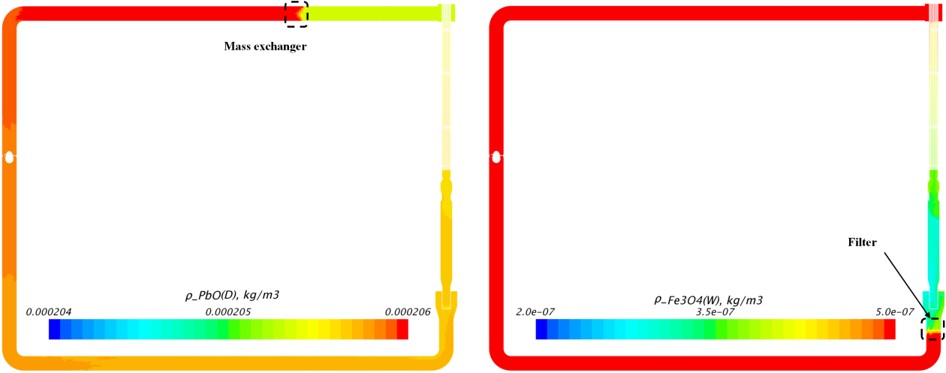
Fig. 6. Oxygen density at the header plane included into:
dissolved lead oxide fraction (left), weighted fraction of oxide Fe₃O₄ (right).
From Fig. 6 it can be seen that the mass exchanger and the filter are under the target characteristics. The magnitude of the inhomogeneity of lead oxide density in the circuit is about 1%, while the inhomogeneity of iron oxide is about 70%. The magnitude of iron oxide inhomogeneity is explained primarily by the assumed filter efficiency. The value of the weighted magnetite density is increasing at the outlet of the test section due to the erosion process at the oxide layer, whereas the opposite situation with the dissolved lead oxide due to the oxygen consuming process.
Fig. 7 and Fig. 8 present the distribution of the density of the dissolved oxygen that includes fractions of dissolved lead oxide and weighted oxide of Fe₃O₄ at the time 1000 hours after the start of the operation at the centers of spacers.

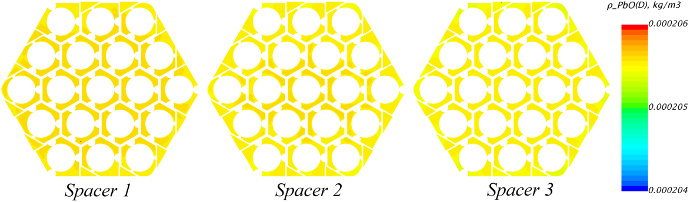
Fig. 7. Oxygen density included into dissolved lead oxide fraction at the centers of spacers.

It can be seen from Fig. 7 that the oxygen concentration decreases locally by 0.4% while the bulk concentration change between the inlet and the outlet of the test section is approximately 0.2%. Taking into account the volume of the simulated circuit, its oxygen reserve is about 1 h. It should be noticed that the volume of the computational model (Fig. 1) is 1.8% from the experimental one. Therefore, in case of the same proportion of surface to volume in the experimental circuit the value of oxygen supply maintains.
At the time 1000 hours after the start of the operation, the added mass of oxygen by the mass exchanger is 15.9 g, whereas the mass of oxygen that is included into weighted oxides accumulated in the filter is 10.4 g.

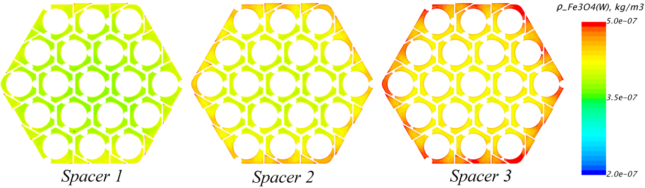
Fig. 8. Oxygen density included into weighted fraction of oxide Fe₃O₄ at the centers of spacers.

Fig. 9 presents the calculated value of the oxide film thickness at the time 1000 hours after the start of the operation on the surfaces of the experimental assembly components. It can be seen that the oxide film thickness increases in the downstream direction. This is due to the temperature increase in this direction. It can be also seen that the oxide film is heavily non-uniform on the spacer grid surfaces and it has a uniform distribution in the rod bundle. This circumstance is caused by a more uniform wall shear stress at the rod bundle.

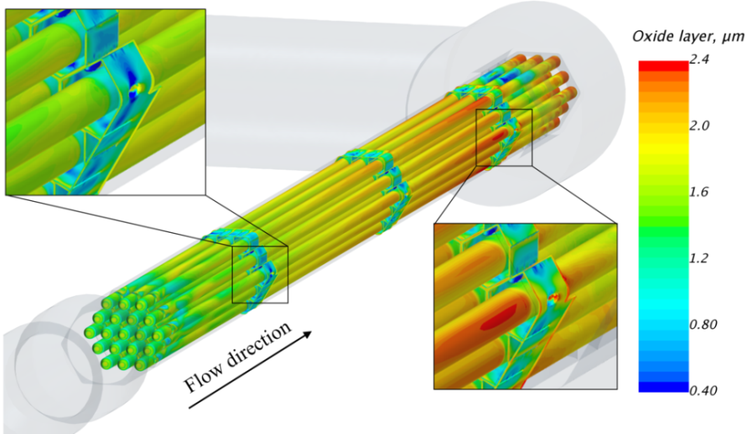
Fig. 9. Oxide film distribution.

To analyze the film growth dynamics, it is useful to plot the magnitude of the average oxide thickness for the typical areas: the rod bundle and the spacer grid surfaces (Fig. 10). It can be seen from Fig. 10 that the steel surface thinning for 1000 hours is approximately 1 μm, while the oxide film thickness is about 2 μm and 1 μm for rods and spacers correspondingly. It can be also seen in Fig. 10 that, on average, the oxide film thickness on the spacer grid is smaller than on the rod bundle. This is due to the coolant velocity being higher in the spacer region and, accordingly, the higher intensity of film erosion process. This explains the fact that the oxide film thickness on the grid surface reaches a stationary value for several hundred hours and that the rod surface fails to do so for 1000 hours.
Apart from the protective properties of the oxide film, there is an impact on heat transfer. This is due to the less heat-conductive properties of the oxide layer than the coolant. To calculate this impact it’s useful to use an equation:
$${Nu}_{film}=Nu\left(T_{w}-T_{b}\right){\left[\left(T_{w}-T_{b}\right)+q\left({h_{m}}/{λ_{m}}+{h_{s}}/{λ_{s}}-{δ_{steel}}/{λ_{steel}}\right)\right]}^{-1}$$ | (13)
where: $λ_{m}=4.23-1.37 {10}^{-3}T$ and $λ_{s}=50.78T^{-0.36}$ is the magnetite and spinel thermal conductivity correspondingly [15], Wm⁻¹K⁻¹;$T_{w}$ is the surface temperature, К;$T_{b}$ is the average mixed coolant temperature, К; $δ_{steel}$ is the steel thinning, m; $q$ is the heat flux, W m⁻² and $λ_{steel}$ is the steel thermal conductivity, Wm⁻¹K⁻¹; $Nu$ is the Nusselt number under the condition of zero thickness oxide layer and steel thinning.
Analyzing the equation (13) it can be seen that at the first time (period of oxide film formation) there is a trend to reduction of Nusselt number while after it there is an increase due to steel thinning.

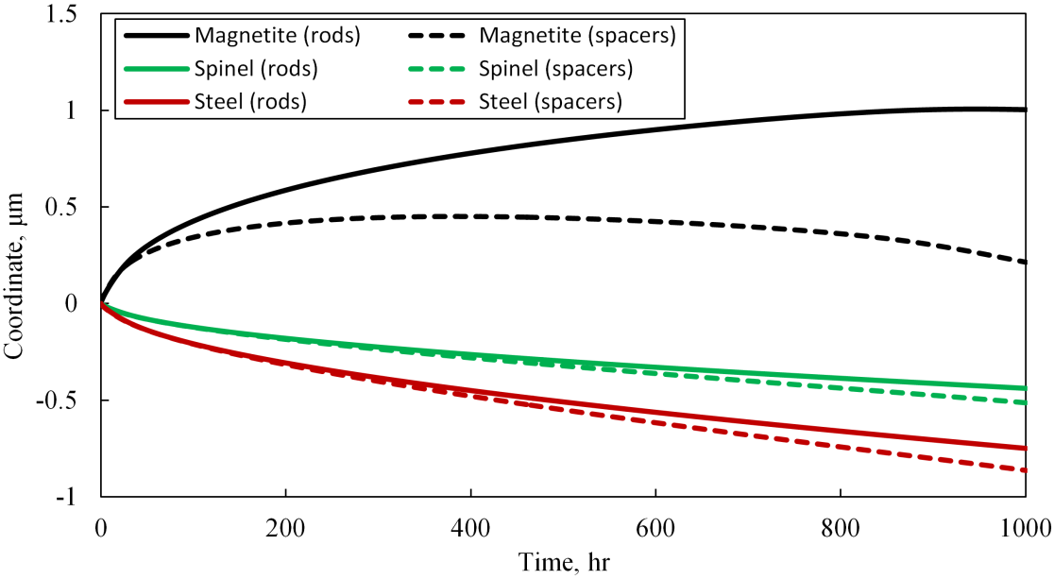
Fig. 10. Surface averaged values of the magnetite, spinel, and steel coordinates.
The zero coordinate corresponds to the initial steel position.

The Nusselt number calculated from equation (13) for different sections is summarized in Table 5.

TABLE 5. COMPARISON OF NUSSELT NUMBERS

Section | 17.0 | 55.9 | 89.8
$$Nu$$ | 36 | 27 | 26
$${Nu}_{film}$$ | 35.4 | 26.5 | 25.5

It can be seen from Table 5 that the contribution of physicochemical processes to heat transfer is about 1.5% which means that these processes do not lead to a major change in the Nusselt numbers. It should be however understood that the calculation based on the relation (13) stems from the assumptions made in this study: the stationary status of thermohydraulic and physicochemical processes, the operation time, and the content of oxygen in the coolant, etc.

CONCLUSIONS
One of the most robust physicochemical models developed at JSC NIKIET to calculate physicochemical processes in heavy liquid metal cooled reactors has been demonstrated as part of the study based on an example of the KALLA experiment simulation. Thermohydraulic characteristics of the test facility were determined as a part of the investigations. A good agreement with the available experimental data has been obtained. Probably this agreement is due to providing the same analysis of results and taking into account the spacer grid manufacturing technology as the one used on the test bench.
The calculated value of oxygen inhomogeneity is approximately 1%, while the inhomogeneity of weighted iron oxide is about 70% what is due to the selected filter efficiency. For 1000 hours of operation, the film thickness grows to approximately 2 μm. The rod bundles oxide film continues to grow, while its growth stops on the spacer grid surfaces. It has been shown that the film has a non-uniform thickness in the spacer grid region. The steel thinning is 1 μm which attests to the favorable conditions of the circuit operating as a whole. The contribution of the physicochemical processes to the heat transfer characteristics was estimated as a result of which the heat transfer coefficient has been found to decrease by 1.5%.
In the case of providing additional experimental data from the KALLA test facility it would be possible to make the validation of the present chemical model. In addition it is also important to provide a list of conforming tests to check all the assumptions that are used in the present chemical model.
ACKNOWLEDGEMENTS
The authors express their gratitude to V. Stegailov, Y. Zhuravleva and V. Lemekhov for their help in present work.
References
- Rusanov A.E., Birzhevoy G.A., Levin O.E., Lysova G.V., Sugonyaev V.N., Shulepin S.V. Results of a study of the corrosion resistance of fuel element cladding made of EP823 steel after testing in a Pb coolant flow. Proceedings of MNTK NIKIET-2014. Moscow: NIKIET.
- Weisenburger A, Schroer C, Jianu A, Heinzel A, Konys J, Steiner H, et al. Long term corrosion on T91 and AISI1 316L steel in flowing lead alloy and corrosion protection barrier development: Experiments and models. Journal of Nuclear Materials. 2011;415(3):260 – 269.
- W. Feng, et al. Simulation of oxygen mass transfer in fuel assemblies under flowing lead-bismuth eutectic. Nuclear Engineering and Technology 52 (2020) 908-917.
- A. Marino, J. Lim, S. Keijers, J. Deconinck, A. Aerts, Numerical modeling of oxygen mass transfer in a wire wrapped fuel assembly under flowing lead bismuth eutectic. Journal of Nuclear Materials (2018), doi: 10.1016/j.jnucmat.2017.12.017.
- Daniel J. Walter, Brian K. Kendrick , Victor Petrov, Annalisa Manera, Benjamin Collins , Thomas Downar. Proof-of-principle of high-fidelity coupled CRUD deposition and cycle depletion simulation. Annals of Nuclear Energy. 2015. 85(6):1152-1166.
- Siemens PLM Software. User Guide. STAR-CCM+. Version 12.06, 2017.
- Pacio, J., Daubner, M., Fellmoser, F., Litfin, K., Marocco, L., Stieglitz, R., Taufall, S., Wetzel, T., 2014. Heavy-liquid metal heat transfer experimentin a 19-rod bundle with grid spacers. Nucl. Eng. Des. 273, 33–46.
- J. Pacio, K. Litfin, A. Batta, M. Viellieber, A. Class, H. Doolaard, F. Roelofs, S. Manservisi, F. Menghini, M. Böttcher. Heat transfer to liquid metals in a hexagonal rod bundle with grid spacers: Experimental and simulation results. Nuclear Engineering and Design. Volume 290, 15 August 2015, Pages 27-39.
- K. Rehme, "Convective Heat Transfer over Rod Bundles," Handbook of Single Phase Convective Heat Transfer, eds. S. Kakaq, R. K. Shah, and W. Aung, Wiley-Interscience, John Wiley & Sons, New York, 1987.
- Nuclear Energy Agency, 2007. Handbook on Lead-bismuth Eutectic Alloy and Lead Properties, Materials Compatibility, Thermal-hydraulics and Technologies. OECD/NEA Nuclear Science Committee Working Party on Scientific Issues of the Fuel Cycle Working Group on Lead-bismuth Eutectic.
- Sergeenko, K.M. Application of Direct Numerical Simulation methods to improve the accuracy of RANS models: candidate of technical sciences dissertation abstract. M., (2022) 20 p.,
https://mpei.ru/diss/Lists/FilesAbstracts/590-Автореферат.pdf.
- Martinelli L., Balbaud-Célérier F. Modelling of the oxide scale formation on Fe-Cr steel during exposure in liquid lead-bismuth eutectic in the 450-600 °c temperature range. Materials and Corrosion. 2011. V.62. №6. Pp. 531-542.
- Yichun Xu, Yange Zhang, Xiangyan Li, Wei Liu, Dongdong Li, C.S. Liu, B.C. Pan, Zhiguang Wang. Effects of iron and chromium on the dynamic properties of oxygen in liquid lead–bismuth eutectic alloy. Corrosion Science. V. 118, April 2017, Pages 1-11.
- Balbaud F., Martinelli L. Corrosion issues in lead-cooled fast reactor (LFR) and accelerator driven systems (ADS) Woodhead Publishing Series in Energy. Nuclear Corrosion Science and Engineering. 2012. – Pp. 807-841.
- Fenglei Niu, Robert Candalino, Ning Li. Effect of oxygen on fouling behavior in lead–bismuth coolant systems. Journal of Nuclear Materials. 2007. V. 366. Р. 216-222.
- Laure Martinelli, Courouau Jean-Lounis, Balbaud-Célérier Fanny. Oxidation of steels in liquid lead bismuth: Oxygen control to achieve efficient corrosion protection. Nuclear Engineering and Design. Volume 241, 2011, Pages 1288-1294.
- J. Zhang and N. Li. Oxidation Mechanism of Steel in Liquid-Lead Alloys. Oxidation of Metals. Vol. 63, Nos. 516. June 2005.
- Fazio C., et al. Handbook on Lead-bismuth Eutectic Alloy and Lead Properties, Materials Compatibility, Thermal-hydraulics and Technologies. 2015 Edition (NEA-7268). Nuclear Energy Agency of the OECD (NEA). 2015.
C.Schroer, J.Konys. Physical Chemistry of Corrosion and Oxygen Control in Liquid Lead and Lead-Bismuth Eutectic. Forschungszentrum Karlsruhe in der Helmholtz-Gemeinschaft. 2007.
- Santos-Carballal D. et al. First-principles study of the inversion thermodynamics and electronic structure of Fe M 2 X 4 (thio) spinels (M= Cr, Mn, Co, Ni; X= O, S) //Physical Review B. – 2015. – V. 91. – №. 19. – P. 195106.
- Shutikova M.I., Stegailov V.V. Frenkel pair formation energy for cubic Fe3O4 in DFT+U calculations //J. Phys.: Cond. Matter. (accepted) https://doi.org/10.1088/1361-648X/ac9440.

