# Test Matrices definition for the SIRIO

# facility in the frame of the H2020-PIACE

# project

Pre-test simulation results and conclusions

T. HAMIDOUCHE1, R. FERNANDEZ1, F. GIANNETTI2, V. NARCISI2, M. MOLINARI2,

M. CARAMELLO3, M. FRIGNANI3, I. KLJENAK4, J. ODER4, R. KRPAN4, G. JIMENEZ5,

C. QUERAL5, L. NITULESCU6, A. ACHILLI7, D. MAZZI8, T. DEL MORO2, M. TARANTINO9,

P. LORUSSO9, F. S. NITTI9,10

1 Belgian Nuclear Centre, SCK CEN, Mol, Belgium

2 Sapienza University of Rome, Rome, Italy

3 Ansaldo Nucleare S.p.A, Genova, Italy

4 Jozef Stefan Institute, Ljubljana, Slovenia

5 Universidad Politécnica de Madrid, Madrid, Spain

6 Institutul de Cercetari Nucleare, Pitesti, Romania

7 SIET, Piacenza, Italy

8 Servizi di Ricerche e Sviluppo s.r.l., Rome, Italy

9 Energia Nucleare ed Energie Alternative ENEA, Camugnano, Italy

10 PIACE project coordinator

Email contact of corresponding author: [tewfik.hamidouche@sckcen.be](mailto:tewfik.hamidouche@sckcen.be); [fabio.giannetti@uniroma1.it](mailto:fabio.giannetti@uniroma1.it)

**Abstract**

Passive safety is one of Generation IV nuclear plants leading pillars. In this perspective, several new passive safety systems have been proposed and tested to demonstrate their inherence passive safety features for the GEN IV reactor technologies under development.

For Lead Fast Reactor (LFR), a self-regulating system, referred to as Isolation Condenser (IC) passive safety system, is considered to ensure long-term safe state without needs for external actions or energy supply. The IC concept is able to remove the decay heat, in order to both reach a safe shutdown state and reduce the power removal capabilities over time delaying primary cooling freezing. This IC devoted safety function is achieved by allowing the Decay Heat Removal system (DHR) loop to be flooded by Non-Condensable (NC) gases when needed (at low pressure) to passively control the rate of energy transfer via condensation in the heat exchange components. The concept is applicable to water-cooled reactors as well, to limit the temperature decrease rate during accidental events, hence reducing the thermal stresses on the primary and secondary system components.

The HORIZON 2020 Passive IsolAtion CondEnser (PIACE) project, started in 2019, aims at testing the IC passive safety system in a new experimental facility, at SIET premises in Piacenza (Italy). An experimental program is defined to test the applicability of the IC concept for selected reactor technologies: LFR, MYRRHA ADS, PWR, BWR, PHWR.

Pre-test simulations were run to provide a comprehensive evidence of the applicability of the IC solution for these technologies, and confirmed its efficiency. Test matrices have been defined for the SIRIO experimental campaign.

The paper presents the pre-test simulations performed with system thermal-hydraulic codes to demonstrate that the proposed DHR solution is able to accomplish the DHR safety function for the particular case of liquid metal fast reactors technologies: ALFRED and MYRRHA ADS.

## INTRODUCTION

The GEN IV international forum has been established to led international collaborative efforts to develop advanced nuclear energy systems than can help secure the world energy needs [1]. In this perspective GEN IV has selected six reactor technologies for further research and development [2]. GEN IV has defined several goals in terms of sustainability, economy, safety, reliability and proliferation resistance. For the particular safety goals, among the three safety pillars, GEN IV will eliminate the need for offsite emergency responses, as safety systems will be passive.

LFR technology is among the GEN IV six selected reactor concepts and Advanced Lead-cooled Fast Reactor European Demonstrator (ALFRED) is the demonstrator of this technology in Europe [3]. ALFRED adopted design, safety criteria and lines of defences to ensure safe operation of nuclear reactors [3]. For instance, the main ALFRED DHR system is designed to keep the core and the Primary Cooling System (PCS) internals below the defined safety limits and to drive the reactor into a safe shutdown state in the short and long term after reactor scram. A second DHR system is considered for redundancy and diversity and also for emergency conditions (E-DHR). Both systems are passive which main functions are to provide adequate cooling in the primary system and to delay the primary coolant freezing [3].

In this respect, the solution chosen to delay lead freezing in ALFRED consists in trying to decrease the heat transfer rate between the primary system and the final heat sink, during the long-term cool down phase, when the reactor is in a safe shutdown phase. This is achieved by mixing a certain fraction of NC gases in the two-phase liquid water-steam mixture, thus obtaining a detrimental effect on the heat transfer process via condensation and considerably slowing down the pressure decrease, at least during the grace time period of 72 hours. Such system must achieve the highest degree of passivity, to exclude as much as possible active system intervention (such as heating up the coolant by auxiliary system).

Because a demonstration is needed, the HORIZON 2020 PIACE project has been launched in 2019, which aims at testing this innovative passive safety system in a dedicated experimental facility, SIRIO (SIstema di rimozione della potenza di decadimento per Reattori nucleari InnOvativi) that was built at SIET premises in Piacenza (Italy).

In the frame of the PIACE project, test matrix definitions and pre-test simulations were run to provide comprehensive evidence of the applicability of the DHR solution to the following technologies: LFR, ADS (MYRRHA), PWR, BWR, and PHWR, which confirmed the efficiency of the IC concept. The experimental campaigns started in January 2022.

The paper presents the pre-test simulations performed with two system thermal-hydraulic code, RELAP5-3D© and a modified version of RELAP5/MOD3.3, to demonstrate that the proposed DHR solution is able to accomplish its safety function for liquid metal fast reactor such as the ALFRED and MYRRHA-ADS reactors.

## piace project overview

The PIACE project is part of the activities co-financed by the European Commission to increase the technology readiness level of an innovative passive safety system. The total cost of the project is expected to be in the order of 3 M€ with a human resources commitment quantified in the order of 400 man-months over a 3-year period (2019-2022). The project is led by the Italian national research organisation, ENEA and sees the involvement of 10 other research centres, universities and private companies in the nuclear sector (Sintec, SIET, Ansaldo Nucleare, Tractebel engineering, Empresarios Agrupados, Raten, Gen Energija, Universidade Politecnica de Madrid, SCK CEN, Institut Jozef Stefan). The project is structured through six distinct work packages devoted to feasibility studies on the integration of the safety system on the five selected reactor technologies (PWR, BWR, CANDU, LFR, ADS) [4]. The work packages include definition of the test matrices and SIRIO facility adaptation for the selected technologies and performance of experimental programs [5]; pre and post-test analysis to qualify the calculation codes on the phenomena of interest for the passive safety system and validating them for the performance forecast and drawing conclusions and recommendations to improve the design of the safety system for the various plant technologies. A work package is defined for the project objectives follow-up and management of times and costs as well as maintaining communications with the European Commission. Dissemination and training activities for young researchers and students are also part of the project objectives.

## sirio facility layout and objectives

The supporting infrastructure for the development of the project experimental activities is the SIRIO facility which was born as part of a project promoted and co-financed by the Italian Ministry for Economic Development is currently running at the SIET laboratories in Piacenza (Italy).

The facility is presented as in the conceptual scheme of Fig. 1. Overall, the height of the structure is more than 20 m and was scaled on the ALFRED DHR system. In the lower area there is a heat source consisting of the bayonet Steam Generator (SG), connected by piping to two Heat eXchangers (HX) located in separate pools in the upper region. The first is called the Bypass Heat Exchanger while the second is the IC. The bypass HX consists of 2 parallel pipes inside a small pool externally supplied with water from the demineralized water system, while the IC consists of a single pipe immersed in a pool.

The IC is connected, in the lower region, to a NC gas tank. The branches where the upper HXs are located can be isolated by means of motorized valves. The SG uses bayonet tubes bundle; each tube is made of coaxial pipes where the fluid from the feed water header descends into the innermost tube, reaches the bottom and rises into the annulus created between the two tubes until it reaches the steam header. The bayonet heating system is carried out by heating a bath of molten salts outside each tube of the bundle by means of electrical heaters. The NC tank consists of a vessel of approximately 130 l.



Fig. 1. SIRIO facility layout

The facility serves to mimic stationary operating conditions of the ALFRED SG and to simulate the operation of the passive safety system on a small scale. During the first operating condition, the water moves as two-phase flow between the SG and the bypass HX in natural circulation, while the branch where the IC is contained, is isolated and contains gas (nitrogen) at a lower pressure than the water circuit. To test the safety system, the branch of the bypass HX is isolated while the IC is aligned with the SG. The power is then modulated to simulate the decay heat.

Pre-test numerical analyses have shown a compression of the gases inside the tank followed by an expansion after a certain period of time and a migration into the IC to degrade the heat transfer via condensation. In this way a passive control of the power removed from the system is done and the aligning of the power removed from the isolation condenser with that absorbed by the SG, except for heat losses, can be ensured. The experimental facility will be used during PIACE WP3 to produce the experimental qualification data of the safety system, for the new ALFRED configuration and for thermodynamic conditions similar to those of the other plants studied in the project.

### SIRIO and LFR technology

The IC installed in SIRIO is a single tube immersed into a pool filled by water. From the scaling procedure to reproduce the ALFRED IC, the tubes are based on the same external and internal diameter, with a reduced length of 0.68 m in comparison with the 2 m height of full-scale ALFRED component [3]. Also, the ALFRED IC top header and bottom header are scaled, and to guarantee a feasible scaled geometry these volumes are substituted by one 2⅟₂’’ SCH 160

This reduction of the tube length is due to the small number of the IC tubes used (less than the ones obtained with the selected scaling factor) and has a possible impact on natural circulation. However, considering the scope of the experiment and the overall height of the legs (about 15 m), the distortion introduced in comparison of the theoretical power-to-volume scaling are limited and acceptable (as shown in TABLE 1).

A bypass line is inserted into the facility to allow the fluid natural circulation initial start with a different initial condition (the start of the transient is at decay power and not at full power). The bypass line is installed in parallel to the IC and is fully disconnected after the starting of the transient and has the function to connect the bypass HX during the steady state to remove the heat generated into the SG during this phase.

The two connection lines (feed water and steam line) were designed to respect the right height, global length and pressure drop but the routing was adapted to consider the specific thermo-mechanical verification and the layout of the existing structure. Into the feed water line, a small orifice with a diameter of 5 mm is inserted to calibrate the pressure drop in this line and to guarantee enough liquid water in this part of the circuit.

TABLE 1. ALFRED - SIRIO SCALING RATIO

|  |  |  |  |  |
| --- | --- | --- | --- | --- |
| Parameter | Unit | ALFRED | SIRIO | Ratio |
| Decay Power | kW | 2 625 | 55 | 47.72 |
| SG Power per tube | kW | 5 | 5 | 1 |
| SG Heat Transfer surface | m2 | 244.2 | 5.27 | 46.37 |
| SG Thermal flux | kW/m2 | 10.75 | 10.44 | 1.029 |
| Total volume | l | 8059 | 173.4 | 46.47 |
| Water mass | kg | 2 034 | 37.9 | 53.66 |
| Power density | kW/l | 0.326 | 0.317 | 1.028 |

To show the applicability of the system, a pre-test calculation was carried out using RELAP5/mod3.3 [6] modified by Sapienza for passive systems [7] for the first test planned in the SIRIO facility [8]. The RELAP5 model used is described in [9].

The starting point for this test will be a steady state condition reached at 55 kW of SG power, followed by a transient phase with decay heat generation simulated with a decreasing of this power, depicted in Fig. 2. At the beginning of the transient, the steam line is isolated from the bypass HX, causing a pressure increase in the primary circuit, shown in Fig. 3. This increase leads the DHR activation by opening the upstream valve of the IC, by the high-pressure signal in the steam line, set at 190 bar. With a delay of 60 s from the opening of the upstream valve, also the downstream valve of the IC opens as well, guaranteeing the DHR activation. After that, a decay heat generation trend is imposed in the power source, reaching about 5 kW in 24 h. The difference between the SG and the IC power is mainly due to the heat losses of the loop.

|  |  |
| --- | --- |
|  |  |
| Fig. 2. SG and IC power | Fig. 3. IC tube pressure |

During the first minutes of the transient, the NC gas is confined and pressurized into the NC gas tank and connected line. The steam condensation with the negligible presence of NC gas guarantees a good Heat Transfer Coefficient (HTC) and this leads an initial depressurization of the circuit due to the large power removed from the circuit into the IC.

In Fig. 4 it is possible to observe that the temperature trend into the IC tube, after an initial small increase is in practice coincident with the saturation temperature. It is possible to also verify that in practice the saturation temperature is present in all the pipes of the circuit.

The change in the power removed by the IC is mainly due to the trend of the NC quality into the IC tubes, shown in Fig. 5. In particular, after the fast decrease occurred in the first phase and due the IC tubes low pressure, the NC gas is able to flow back in the cold leg, reaching the IC. The presence of the NC gas in this zone causes the decrease of the heat transfer inside the tubes (the cause is a decrease of the partial pressure of the steam, then a reduction of the water temperature) and of the mass flow rate. The NC gas during the transient is able to reach also the SG down comer, for more than 10000 s, and the SG riser for only about 3300 s. In this time, the NC quality in the down comer reaches a maximum value of 0.87 whereas in the riser it is limited to 0.0085. At about 15000 s after the start of the IC downstream valve opening, a large fraction of the NC gas into the water circuit are able to reach the IC, reaching a NC quality around 0.9. During the rest of the transient the NC quality has a very small crescent trend, in contrariwise to the heat generated into the SG, reducing the power removed by the IC.

|  |  |
| --- | --- |
|  |  |
| Fig. 4. ic outlet temperature | Fig. 5. nC gas quality in IC tubes |

### SIRIO and MYRRHA ADS technology

For the demonstration of the IC concept to ADS technology, the MYRRHA-ADS reactor [11] is selected. MYRRHA is a Multi-purpose hYbrid Research Reactor for High-tech Applications that is under development at SCK CEN (Belgium). MYRRHA is conceived as a pool-type ADS reactor with a proton accelerator linked to a subcritical core fuelled with MOX and cooled by liquid Lead Bismuth Eutectic (LBE), with the chain reaction sustained by the interaction of the proton beam with the LBE spallation target [11].

The reactor main scope requirements can be summarized as follows:

* Demonstration of the ADS concept;
* Transmutation of high-level nuclear waste;
* Provision for fusion material development;
* Advanced nuclear material and fuel experiments;
* Advanced radioisotope production – without neutron thermalization;
* Technology demonstrator for HLM-cooled reactors, and components.

The Primary Cooling System (PCS) is thermally coupled by four primary heat exchanger (PHX) units to four independent Secondary and Tertiary Cooling System (SCS and TCS, respectively) loops, working in forced circulation during normal operation conditions and in natural circulation in decay heat removal conditions. Each SCS loop is operated with a two-phase water mixture at 16 bars (200°C) with saturated water entering the PHX and exiting with a dynamic flow quality of about 0.3. The phases are separated in a steam separator, from where the steam is directed towards air condensers, while the liquid phase is recirculated back to the PHX through the feed-water pump. The separated steam phase is condensed in the Aero-Condenser (AC) units and flows back into the steam separator. The TCSs use the environment as the ultimate heat sink. A pressure control system is used to maintain the SCS pressure at 16 bar (or temperature at 200°C) [12].

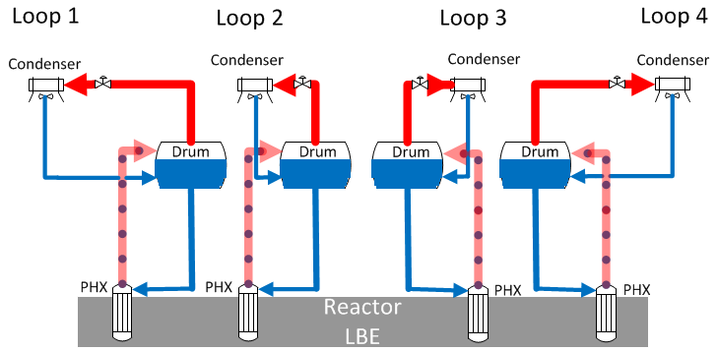

Fig. 6. MYRRHA STCS system layout

In design basis conditions and shutdown conditions, the STCS ensure the function of the first decay heat removal (DHR1) system with the SCS and TCS systems operating in passive mode. DHR1 is a passive system which continuously remove the decay power and release it to the atmosphere by natural convection as the pressure control system is off, featuring LBE freezing if the temperature drops below the LBE melting point (~125 °C). Therefore, a passive anti-freezing system is needed and has to be tested.

The PIACE project and the SIRIO facility represent a good opportunity to consider the application and testing of the IC for the MYRRHA ADS. However, since the SIRIO facility has been scaled from the ALFRED DHR system [6], several modifications were proposed considering a new scaling analysis and adaptations of the IC to the MYRRHA DHR1 system [13] because the two reactors are different (power, pressure, temperature …).

For financial and time considerations, the modification of the SIRIO facility has been made minimal (see Fig. 7) and therefore a full compatibility with the MYRRHA conditions is not reached as shown in TABLE 2. Nevertheless, it is deemed sufficient within the objective of demonstrating the IC concept for MYRRHA conditions (low power, low pressure). Two different options for modified SIRIO operation conditions were proposed and supported by pre-test simulations using the system thermal hydraulic code RELAP5-3D© [14]. The nodalization of the SIRIO facility adapted to MYRRHA DHR1 operation conditions is shown in Fig. 8. Sensitivity studies are also performed to highlight the key parameters that affect the facility with respect to MYRRHA conditions such as:

* Sensitivity on nitrogen tank volume (2.5 m³ – 10m³);
* Sensitivity on nitrogen tank pressure (12 bar ± 2 bar);
* Sensitivity on nitrogen injection trigger pressure (10 bar ± 2 bar);

In the following, the results of the pre-test simulation for the option 1 that requires minimum modifications of the SIRIO facility are discussed. At the beginning of each test, a steady state is achieved, reproducing the test matrix fixed initial conditions: the power delivered to the SG is removed by the HX and the loop heat losses, and the main thermal-hydraulic parameters converge towards a value (or oscillate in a specific range).

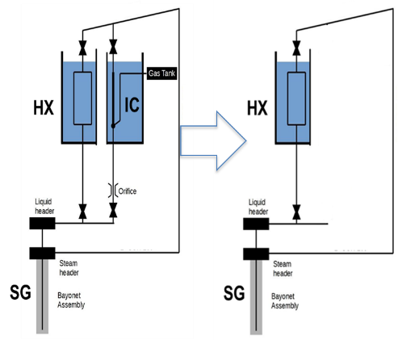

Fig. 7. MODIFIED SIRIO facility layout for myrrha ads

TABLE 2. MYRRHA - SIRIO RATIOS ASSUMING SCALING OPTIONS

|  |  |  |  |  |  |  |
| --- | --- | --- | --- | --- | --- | --- |
| Parameter | Unit | MYRRHA | Option 1 | Ratio | Option 2 | Ratio |
| Power | kW | 1925 | 28.3 | 68.0 | 3.25 | 592.3 |
| Power per tube | kW | 2.57 | 2.57 | 1.0 | 0.30 | 8.7 |
| SG Heat Transfer surface | m2 | 182.50 | 5.27 | 34.6 | 5.27 | 34.6 |
| Thermal flux | kW/m2 | 10.55 | 5.55 | 1.9 | 5.55 | 1.9 |
| Total volume | l | 65000.0 | 110.3 | 589.3 | 110.31 | **589.3** |
| Water mass | kg | 30000.0 | 37.9 | 791.7 | 50.70 | **591.7** |
| Power density | kW/l | 0.03 | 0.26 | 0.12 | 0.03 | **1.0** |
| Specific power | W/kg | 64.17 | 746.84 | 0.09 | 64.10 | **1.0** |

The model is capable of predicting stable steady state conditions in agreement with the scaling analysis shown in TABLE 2. The only notable difference is represented by the SG mass flow rate value (and the quality, as a direct consequence) which can be explained by the fact that the SIRIO facility operate only in natural circulation while in MYRRHA SCS the flow is forced by a feed water pump. Therefore, the water-steam mass flow rate does not represent a determined steady state value, as it cannot be imposed.

The transient proposed in the test matrix is the Loss Of Off-site Power (LOOP). A transient power profile is imposed through the electrical heating system to match the decay heat. The case without IC is also simulated in order to highlight the effectiveness of the IC concept to reduce the freezing risks. The transient conditions were run for more than 15 hours. The Figures show therefore the results for simulation with and without the IC and also the sensitivity analysis results.

The most relevant conclusion shown here is that, after ~5 hours, the system reaches a new quasi-static equilibrium in which the power removed by the SCS (+ heat losses) are the same as the heat provided by the PCS as shown in Fig. 9. This means that this system is able to regulate the heat exchange to maintain a sufficient margin to freezing. Fig. 10 shows the results of the sensitivity analyses on the loop pressure (left part) and the molten salt temperature (right part) evolution during the LOOP event. As the power decreases, the molten salt temperature decreases and consequently the pressure in the loop.

When the pressure set-up is triggered, the NC tank valve opens, flooding the system with NC gas, reducing gradually the heat transfer rate in the HX/IC and in the SG until new equilibrium conditions are reached. With the IC concept implemented, stable conditions are observed after a certain time, characterized by a very low water pressure (~9.4 bar for the reference case) and temperature (~175°C for the reference case) whereas without the IC, the pressure stabilize around 2 bar (120°C). These results show the advantage and the effectiveness of the IC to maintain the molten salt temperature (~176°C) stable with sufficient margins above the LBE melting temperature (125°C), thus preventing the occurrence of solidification.

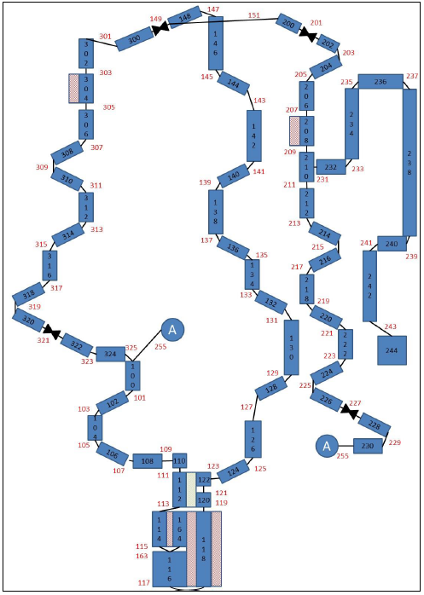

Fig. 8. MODIFIED SIRIO facility Nodalization

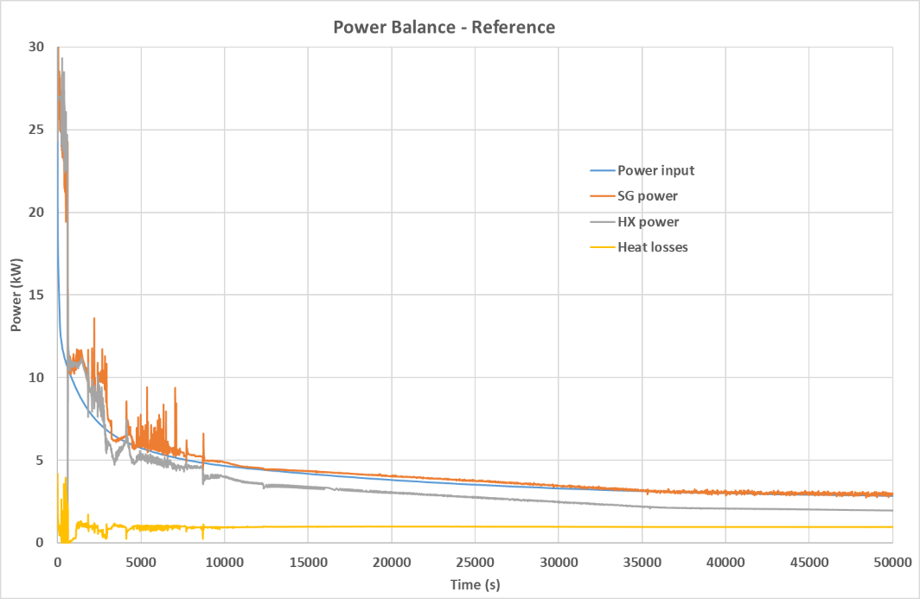

Fig. 9. power balance in sirio facility during the loop event

It should be mentioned however that the estimated SG mass flow rate was quite unstable, most likely because of the notable density difference (a factor ~100) between the liquid and the steam phase, resulting in instabilities in the natural circulation behaviour. The mass flow rate value oscillates between 0.5 g/s and 2.5 g/s in all cases, which proves to be enough to remove the residual heat injected in the loop.

The sensitivity analyses were run for the most influencing parameters that play a key role in the heat transfer moderation and in achieving the final system’s state are the initial reactor power, the nitrogen tank volume or initial pressure and the tank isolation valve pressure set point. The sensitivity analyses showed that:

* the tank volume has no impact on the valve opening time;
* the tank pressure has no impact on the transient behavior;
* The valve pressure setup is obviously important for the course of the transient.

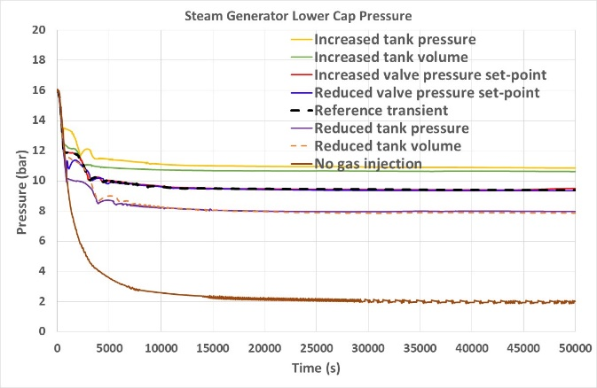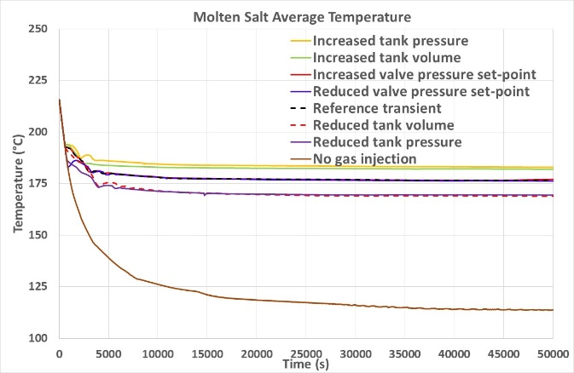

Fig. 10. pressure and temperature – sensitivity analyses

## Conclusion

The IC concept developed to delay the freezing of lead during long term decay heat conditions in the ALFRED reactor was proposed to be tested in the SIRIO facility within the HORIZON 2020 PIACE European programme. The project was also a good opportunity to test this concept for other technologies and objectives such as PWR, BWR, PHWR and ADS.

The pre-test calculations carried out for the first planned ALFRED tests are able to show that the SIRIO facility would be able to validate the working principle of the IC with the NC gas tank inserted to self-regulate the power removed from the SG, with a reduced changes in the temperature behaviour in the primary circuit avoiding a possible lead freezing.

The implementation of the IC concept in the MYRRHA ADS DHR1 required modifications of the SIRIO layout and operation conditions, even without fully respecting the scalability rules. The pre-test simulations showed that the adapted concept to MYRRHA ADS proves to be efficient to prevent with sufficient margins LBE freezing in the PHX.

ACKNOWLEDGEMENTS

This project has received funding from the European Union’s Horizon 2020 research and innovation programme under the Grant Agreement No. 847715.

References

1. John E. Kelly, Generation IV International Forum: A decade of progress through international cooperation, Progress in Nuclear Energy, vol. 77, pp. 240-246, 2014.
2. “www.gen-4.org,” [Online].
3. A. Alemberti et al., ALFRED reactor coolant system design, Nuclear Engineering and Design, vol. 370, art. no. 110884, 2020.
4. PIACE Project WP1 deliverable, Identification of enveloping transient and system configuration for reactor technologies of European interest. 2020
5. PIACE Project WP3 deliverable, Technology demonstration in relevant environment.
6. The RELAP5/MOD3.3 Code Development Team 2003 RELAP5/MOD3.3 Code Manual Volume I: code structure, system models, and solution methods, Washington DC., U.S. Nuclear Regulatory Commission NUREG/CR-5535/Rev P3-Vol I.
7. V. Narcisi, L. Melchiorri, F. Giannetti, Improvements of RELAP5/Mod3.3 heat transfer capabilities for simulation of in-pool passive power removal systems. Annals of Nuclear Energy, 160, art. no. 108436, 2021.
8. P. Lorusso, M. Tarantino; PIACE Project, Deliverable 2.1. Test Matrix definition for the LFR reference reactor, 2020
9. M. Molinari, V. Narcisi, M. Caramello, M. Tarantino, F. Giannetti, Transient analysis of SIRIO using RELAP5/MOD3.3 system code, submitted to 39th UIT Conference, June 20-22, 2022, Gaeta (Italy).
10. V. Narcisi, F. Giannetti M. Caramello, G. Caruso, Preliminary evaluation of ALFRED revised concept under station black out. Nuclear Engineering and Design 364, art. no. 110648, 2020.
11. Aït Abderrahim, H., MYRRHA An Accelerator Driven system based on LFR technology, https://www.gen-4.org/gif/jcms/c_97818/prof-hamid-ait-abderrahim-webinar-annoucement-rev1, 2018.
12. Castelliti, D., Preliminary design description of the MYRRHA ADS secondary cooling system (SCS) and tertiary cooling system TCS), SCK•CEN/19503100, 2016.
13. D. Castelliti; PIACE Project, Deliverable 2.2. Test Matrix Definition and Facility Upgrade for ADS reference reactor, 2020.
14. RELAP5-3D© RELAP5 Development Team, Code manuals, INEEL-EXT-98-00834.