Development of ARKADIA-Design for Design

Optimization Support

Application of coupling method using

multi-level simulation technique for

plant thermal-hydraulics analysis

N. DODA¹, K. YOSHIMURA¹, E. HAMASE¹, K. YOKOYAMA¹, T. UWABA¹, and M. TANAKA¹
¹Japan Atomic Energy Agency, Oarai, Ibaraki, Japan

Email contact of corresponding author: doda.norihiro@jaea.go.jp

INTRODUCTION
To design advanced nuclear reactors as a safe, economic, and sustainable carbon-free energy source, Japan Atomic Energy Agency (JAEA) has begun the development of the “Advanced Reactor Knowledge- and AI-aided Design Integration Approach through the whole plant lifecycle (ARKADIA)” [1]. The development is done in two phases: ARKADIA-Design [2] and ARKADIA-Safety which respectively deal with the design and the safety problems of the advanced nuclear reactor will be constructed independently till the end of FY2023 and they will be merged into one system, ARKADIA, in the second phase till the end of FY2028. ARKADIA-Design offers functions to support design optimization both in normal operating conditions and design basis events mainly during the conceptual design stage in the fields of core design, plant structure design including thermal-hydraulics analysis, and maintenance plan optimization. For the design optimization, various numerical analyses must be conducted using the one-dimensional plant dynamics analysis (1D) code which evaluates various design options and the multi-dimensional analysis code which evaluates local phenomena in detail. In the conventional design procedure, for instance, to find the core specifications that satisfy the feasible conditions and achieve the maximum core performance, physical phenomena in the core have been analysed individually using the models in different scales and fields where a certain amount of the conservativeness is included at the boundary conditions in each analysis. Hence, the core specifications as the solution tend to be conservative. ARKADIA-Design, therefore, performs a whole plant analysis based on the multi-level simulation (MLS) technique in which the analysis codes with the resolution required by the user are coupled to simulate the phenomena. For the MLS technique, at present, three coupling methods are implemented in the ARKADIA-Design: (1) the coupling method with 1D and computational fluid dynamics analysis (CFD) to predict the effect of multi-dimensional thermal-hydraulics phenomena in local components on the whole plant dynamics, (2) the coupling method with the core thermal-hydraulics analysis in the 1D code, neutronics calculation, and core structural mechanics analysis to evaluate core deformation reactivity feedback, and (3) the coupling method with 1D and subchannel thermal-hydraulics analyses to evaluate detailed temperature distribution in a subassembly with thermal interaction between adjacent subassemblies and to offer the detail wrapper tube temperature distribution for accurate prediction of core deformation. This paper outlines these coupling methods in ARKADIA-Design and presents the numerical result of the 1D-CFD coupling method for the experimental fast breeder reactor EBR-II tests [3] as a representative example of the numerical analysis in ARKADIA-Design.

COUPLING ANALYSIS METHODS IN ARKADIA-DESIGN
In the ARKADIA-Design, any numerical analysis codes can be used to build a virtual plant based on the MLS technique by coupling code analyses, whose level of detail is determined depending on the user’s requirements including the objective, accuracy, and region of interest. In the MLS approach, the models at different degrees of resolution are employed in the decomposed domains, and the models at different resolutions depending on the requirements by a user can be coupled. The numerical analysis option can be selected in the single analysis using 1D code for efficient analysis, the single analysis using CFD code for detailed analysis, and the coupled analysis using 1D and CFD codes. The domain assignment is based on the separate domain approach, in which domains of interest treated by the different codes at different resolution levels are not overlapped. The boundaries at the inlet and outlet of each domain are connected to those of the other domain. For the time synchronization of the coupled codes, the sequential two-way coupling method [4] is employed as a base technology. Algorithms for coupling stability will be considered to introduce in the future. In the case of the 1D-CFD coupling method, in a one-time step calculation from time step of n to n+1, the 1D code runs using boundary conditions calculated by the CFD code at the previous time step n, and the CFD code runs using boundary conditions calculated by the 1D code as predicted values. Currently, the user prepares the input for the analysis code to the resolution required by the user, but the goal is that the input generation is aided by the knowledge-base system which is separately developed [1].

NUMERICAL SIMULATIONS OF EBR-II TESTS BY COUPLING ANALYSIS METHODS

Natural circulation and thermal stratification analysis by 1D-CFD coupling method
The coupling method using Super-COPD [5] as a 1D code and FLUENT as a CFD code has been developed through the analyses of loss of flow tests of SHRT-17 and SHRT-45R [6], and also loss of heat sink tests of BOP301/302R [7] conducted in EBR-II. In the analyses, the upper plenum, Z-pipe, and cold pool were modelled by FLUENT, and the other regions were modelled by Super-COPD. Figure 1 shows the CFD models by FLUENT for EBR-II. The flow rates and temperatures at the inlets of the CFD regions with FLUENT as boundary conditions were obtained by 1D with Super-COPD. The temperatures at the outlets and the pressure differences between the inlets and outlets of the CFD regions obtained by FLUENT were as inlet boundary conditions of Super-COPD. Thus, the coupled analysis with 1D and CFD codes was advanced by the sequential two-way coupling method. Figure 2 shows the typical coupled analysis result of the temperature distribution in the upper plenum and Z-pipe at a representative time step in the SHRT-17 test. The thermal stratification locally formed in the upper plenum and Z-pipe could be predicted by the coupled analysis while predicting the natural circulation in the whole plant.
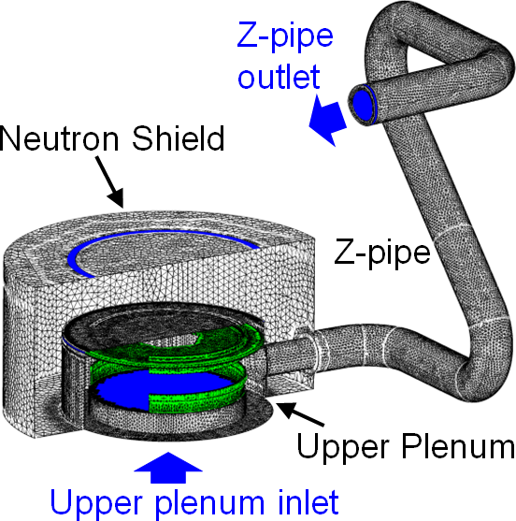 | 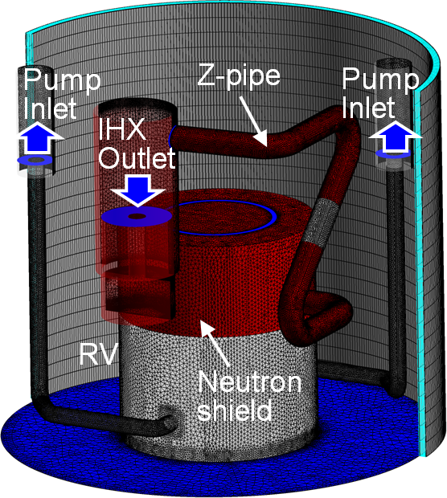 | 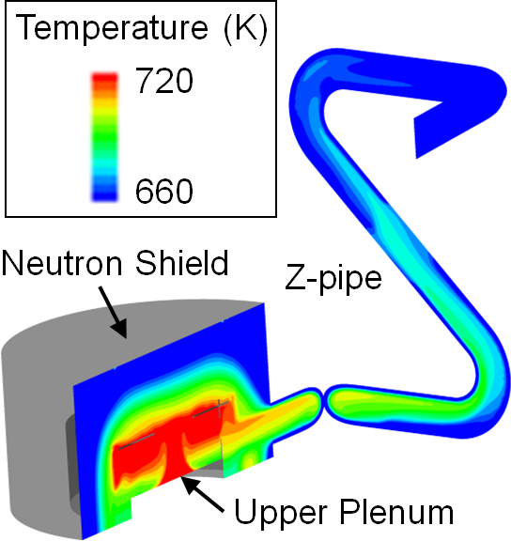
(a) Upper plenum and Z-pipe | (b) Cold pool | FIG. 2. Temperature distribution in upper plenum and Z-pipe at 240s after scram in SHRT-17 test.
FIG. 1. CFD models for EBR-II.

Core deformation reactivity analysis by coupling method of neutronics, thermal-hydraulics, and structural mechanics
The coupling method of neutronics calculation using MARBLE [8], core thermal-hydraulics using Super-COPD, and structural mechanics using FINAS [9] has been applied to the analysis of unprotected loss of flow test of SHRT-45R conducted in EBR-II. In the analysis [10], the temperature distribution of the fuel subassembly was firstly estimated by Super-COPD, and then using the temperature distribution, the deformation of fuel subassemblies was estimated by FINAS. The obtained information on the temperature and deformation was used to analyse the core deformation reactivity based on a diffusion perturbation theory in MARBLE. From the simulation results, a negative feedback effect by the core deformation reactivity on reactor power was successfully indicated and the natural circulation behaviour during the plant transient could be predicted.

Subassembly thermal-hydraulics analysis by 1D-Subchannel coupling method
The coupling method using Super-COPD as the 1D code and ASFRE [11] as a subchannel analysis code has been applied to the analysis of unprotected loss of flow test of SHRT-45R conducted in EBR-II. In the analysis [12], the whole core thermal-hydraulics behaviour was analysed by Super-COPD and the thermal-hydraulics analysis in subassembly was done by ASFRE. Super-COPD analysed thermal-hydraulics firstly with the boundary conditions given by the results of the ASFRE calculated in the previous time step, and then the ASFRE calculated with the boundary conditions given by the Super-COPD in the same time step. The temperatures of the inlet of the subassembly and the adjacent inter-wrapper gap region, the inlet flow rate, and subassembly power were estimated by Super-COPD as boundary conditions of ASFRE. The outlet temperature of the subassembly, pressure difference between the inlet and the outlet, and heat flux on the wrapper tube surface were estimated by ASFRE as boundary conditions of Super-COPD. The temperature distribution in a subassembly could be predicted considering the inter-subassembly heat transfer in the radial direction of the core during the plant transient from forced circulation to natural circulation conditions.

CONCLUSION
ARKADIA-Design has been developed to support design optimization both in normal operating conditions and design basis events mainly during the conceptual design stage in the fields of core design, plant structure design including thermal-hydraulics analysis, and maintenance plan optimization. ARKADIA-Design performs a whole plant analysis based on a multi-level simulation technique by coupling analyses, whose level of detail is determined depending on the user’s requirements including the objective, accuracy, and region of interest. The simulation capability of the coupling analysis methods in ARKADIA-Design was demonstrated through the application to the experimental fast breeder reactor EBR-II tests.
ACKNOWLEDGEMENTS
The paper includes some of the results of the “Technical development program on a common base for fast reactors” ensured to JAEA by the Ministry of Economy, Trade and Industry in Japan (METI).
References
- OHSHIMA, H. et al., “ARKADIA–For the Innovation of Advanced Nuclear Reactor Design”, To be published in Journal of Nuclear Engineering and Radiation Science, NERS-21-1157 (2022).
- TANAKA, M. et al., “Development of numerical analysis codes for multi-level and multi-physics approaches in an advanced reactor design study”, Proc. of the 19th International Topical Meeting on Nuclear Reactor Thermal Hydraulics (NURETH-19), Brussels, Belgium (2022).
- INTERNATIONAL ATOMIC ENERGY AGENCY, Benchmark analysis of EBR II shutdown heat removal, IAEA-TECDOC-1819, IAEA, Vienna (2017).
- HU, R. et al., “Strategy for Multi-Scale Single-Phase Flow Coupling,” ANL/NE-13/4, Argonne National Laboratory (2013).
- NAKAI, S. et al., “Super-COPD module integrated plant dynamics analysis code; Code system description (Programmer's manual),” PNC-TN9520 88-019 (1988).
- YOSHIMURA, K. et al., “Development of 1D-CFD coupling method through benchmark analyses of SHRT tests in EBR-II”, Proc. of NURETH-19, Brussels, Belgium (2022).
- YOSHIMURA, K. et al., “Application of 1D-CFD coupling method to unprotected loss of heat sink event in EBR-II focusing on thermal stratification in cold pool”, Proc. of ICONE29, Shenzhen, China, ICONE29-89259 (2022).
- YOKOYAMA, K. et al., “Development of comprehensive and versatile framework for reactor analysis, MARBLE,” Annals of Nuclear Energy, 66, pp. 51-60 (2014).
- JAPAN ATOMIC ENERGY AGENCY, “Finite Element Nonlinear Structural Analysis System Version 13,” PNC TN9520 95-014 (1995).
- DODA, N. et al., “Development of evaluation method for core deformation reactivity feedback in sodium-cooled fast reactor by coupled analysis approach”, Proc. of NURETH-19, Brussels, Belgium (2022).
- OTAKA, M. et al., “Validation of single-phase subchannel analysis code ASFRE-III,” PNC-TN9410 96-212 (1996).
- DODA, N. et al., “Development of multi-level simulation system for core thermal-hydraulics coupled with plant dynamics analysis – prediction of transient temperature distribution in a subassembly under inter-subassembly heat transfer effect –”, Proc. of Fast Reactors and Related Fuel Cycles: Next Generation Nuclear Systems for Sustainable Development (FR22), Vienna, Austria (2022).

