MODELLING OF THE DYNASTY EXPERIMENTAL FACILITY FOR NATURAL CIRCULATION UNDER DISTRIBUTED HEATING

G. BENZONI¹, C. INTROINI¹, A. CAMMI¹, S. LORENZI¹, F.C. GIACOBBO¹

¹Politecnico di Milano, Department of Energy, Nuclear Engineering Division
Via La Masa 34, 20156 Milan, Italy

Email contact of corresponding author: antonio.cammi@polimi.it

Abstract

DYNASTY (DYnamics of NAtural circulation for molten SalT internallY heated) is an experimental facility designed and built to investigate natural convection under distributed heat generation. Molten salt reactors are characterized by liquid fuel, a unique feature amongst all nuclear reactor concepts, which implies that the decay heat source is no longer localized within the core but distributed within the entire primary circuit. As such, instability conditions may arise during reactor cooling, with unwanted oscillations in the flow regime and even inversion because of the interactions of several forces, such as buoyancy ones and pressure losses. The DYNASTY facility aims at studying the various phenomena that may occur within the molten salt reactor during cooling by simulating a distributed heat source. The modelling of this experimental facility has been carried out using the object-oriented programming language MODELICA; this work focuses on the sensitivity analysis of the available numerical algorithms and facility parameters and the validation of the model. To this end, experiments have been done using the DYNASTY facility to identify the peculiarities of natural circulation heating and cooling compared to the forced one and to validate the model. Results show a very good agreement between model and experiments, identifying some interesting phenomena such as flow inversion during cooling and fluid oscillations due to Welander wave packets.

INTRODUCTION
Natural circulation is the physical phenomenon that describes the spontaneous flow in a fluid induced by buoyancy forces, which are due to density variations in the fluid caused by temperature or phase change [1]. Natural circulation is of particular interest to the nuclear industry since it can provide a passive mechanism to remove the decay heat from the core without the need for active systems. For this reason, it is currently used in the AP-1000 [2] and in the ESBWR [3] Generation-III+ nuclear reactors as a system to dissipate the decay heat during the shutdown. As such, its study is a primary concern in the development of safety systems for the Generation IV nuclear reactors, such as the Decay Heat Removal System (DHRS) of the Molten Salt Fast Reactor (MSFR) [4]. Natural circulation is the outcome of the balance between the buoyancy forces that drives the fluid and the friction forces which hinders the fluid motion [6,7,8]. These two forces heavily rely on the fluid thermal properties, which in turn depend on the fluid temperature. The higher the temperature difference, the higher the mass flow rate induced by natural circulation. Two opposite feedbacks are then involved: with the increase in mass flow rate also the pressure losses and the heat transfer coefficient increase, and the growth of the latter causes a further increase in the temperature differences in the fluid, which in turn leads to a further increase in the mass flow rate, thus defining positive feedback. In contrast, the increase in pressure losses leads to a decrease in the mass flow rate, causing negative feedback. Since natural circulation is the result of a balance between friction losses and buoyancy forces, a possible outcome could be an oscillating flow regime or even an inversion in the motion of the fluid [5] conditions that must be avoided to safely design the DHRS.
During the shutdown, the MSFR shows a peculiar phenomenon, that is, natural circulation with Internal Heat Generation (IHG) in the DHRS [9]. As the fissile fuel is present in a liquid phase and is homogeneously mixed with the coolant if the active cooling system fails the DHRS operates in natural circulation with IHG. This is because the nuclear fluid fuel is homogeneously mixed with the coolant liquid so that when the reactor is shut down the decaying nuclear fuel act as an internally distributed heat source. When designing the DHRS of MSFRs, a careful analysis of IHG from the thermo-physical properties to the effect on mass flow and pressure losses and thus to the stability of natural circulation needs to be performed. A major issue in studying natural circulation with IHG is collecting experimental data to validate the developed models, as a facility which can internally heat the fluid requires either chemical or nuclear reactions to occur. However, a facility with an axial section long enough to consider the radial one negligible represents a reasonable first approximation to neglect the difference between IHG and an External Heat Source (EHS) system [10]. This workaround is adopted in Natural Circulation Loops (NCLs), as it allows the set-up of an experimental facility using EHS rather than IHG, thus allowing the comparison of the results obtained using both EHS and IHG numerical models. NCLs are also very useful to study the stability and behaviour of natural circulation. Some facilities include the Bhaba Single Phase Natural Circulation Loop [11, 12] and the L2 loop [13, 14].
In these facilities, it was observed that the flow behaviour is mainly affected by density wave instabilities. The characteristic velocity of this phenomenon strongly depends on properties characteristic of each section of the facility, such as temperature and pressure losses. To investigate the problem of NCLs stability, in 1967 Welander [6] proposed a model based on the growth of small oscillation caused by the formation and circulation of hot and cold wave packets inside the system. The amplification of hot wave packets caused by their transit through the heat source leads to a positive contribution to the buoyancy flow, which promotes fluid motion with an increase in the mass flow rate value. When the hot wave packets pass through the heat sink, the buoyancy flow receives a negative contribution that makes the mass flow rate decrease, hindering the fluid motion. The decrease in the mass flow rate and the subsequent slowdown of the fluid allows the formation of a new hot packet in the heat source. The same reasoning applies to the cold wave packet so that the fluid behaves like a pendulum.
In the above context, the DYNASTY (DYnamics of NAtural circulation for molten SalT internallY heated) facility has been built at Politecnico di Milano [15, 16]. DYNASTY is a large and flexible NCL that allows the use of either a Distributed Heat (DH) or a Localized Heat (LH) source. The facility is realized in AISI316 stainless steel to sustain the high temperature entailed when operating with molten salts [15], although DYNASTY can operate also with other working fluids such as glycol and water.
Modelling has been previously tackled both with a 1D [15, 16] and with a 3D approach [15, 16, 17]. This work considers the preliminary 1D model of the facility, which was done in the DYMOLA Integrated Development Environment (IDE) based on the MODELICA language [18]. This initial model lacks as it does not consider the heat losses with the environment (as in its current configuration the facility is without insulation, and it consider a smooth cooling pipe instead of a finned one as present in the facility. In addition, the preliminary simulations performed with the original model showed its strong dependence on the numerical integration algorithms selected. As 3D simulations are still too computationally expensive, reliable 1D simulation tools are needed for quick performance analysis and parameters testing. As such, compared to the work in [15, 16], this paper improves the 1D model whilst performing a performance analysis of the various stiff numerical integration algorithms present in DYMOLA.
MODELICA is an acausal Object-Oriented (O-O) simulation language that uses physical and engineering principles and balance equations to model complex systems [19, 20]. First, MODELICA translates the developed model into a solvable system of equations, which then is solved by numerical integration algorithms. In the case of DYMOLA, this is done using a modified version of the Pantelides algorithm [21], to obtain a system of Stiff Ordinary Differential Equations (ODEs) that are then solved using the integration algorithms presents in DYMOLA with the default being a modified DASSL algorithm [22], although other algorithms can be used. Modelling a complex phenomenon like natural circulation in DYNASTY with MODELICA is a good first step in studying the facility behaviour, despite the simplifications introduced, as the code allows for relatively fast execution of several simulations, which, when validated with suitable experimental data, can give an inkling on where to focus the experimental activities and more detailed modelling.
The paper structure is the following: in Section 2, the developed models are briefly described and analysed both from the performances of the numerical algorithms and the general model behaviour point of view; in Section 3, the simulations results are compared with the experimental ones obtained during the DYNASTY preliminary experimental campaign [23]. Lastly, in Section 4, the main outcomes are discussed along with the required further development of the modelling efforts.

DYNASTY 1D MODELICA MoDELLING

The modelling of the DYNASTY facility has been carried out using a 1D approach with the MODELICA system code [20]. This work adopted the DYMOLA IDE, developed by Dassault systems [18]. MODELICA is an Object-Oriented simulation language that employs an acausal description of the system based on physical and engineering principles and balance equations. The particularity of MODELICA is that it allows the description of the various parts of the system by using single components (i.e., the pipe component), linking them by using interfaces (connectors). This feature allows to set up models with different degrees of complexity, without the need of rewriting the whole model from scratch (for example, by adding or changing a single component). The acausal modelling also allows MODELICA to couple in a very straightforward way the different physics of the system. The main drawback of acausal modelling is the need of solving a Differential Algebraic Equation system (DAE). To solve it, DYMOLA first translates it into a system of Stiff Ordinary Differential Equations (SODEs). Since solving the SODE system obtained in the translation of the DYNASTY model require a substantial amount of computational resources, due to the inherent complexity of natural circulation, this work also probes the behaviour of the various stiff numerical integration algorithms present in DYMOLA. Fig. 2 shows the layout of the facility, highlighting the different legs and the location of sensors used both in the experiments and in the simulations.

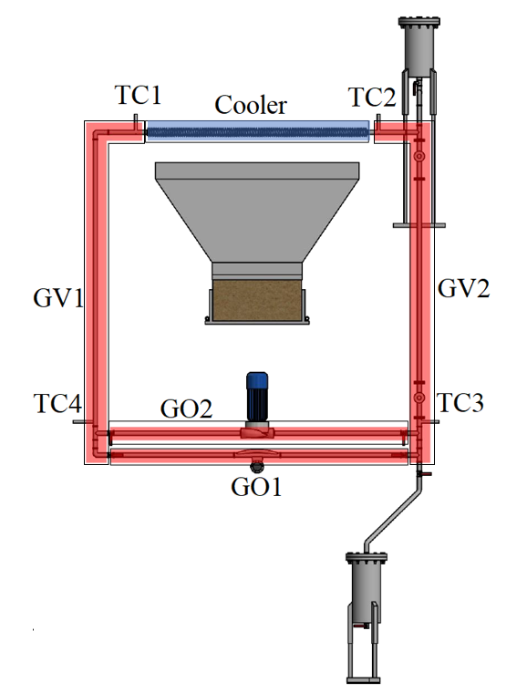
Fig. 2. DYNASTY facility layout: red sections correspond to heating ones, blue to the cooling sections

DYNASTY model description
The model used in this work to describe the behaviour of the DYNASTY facility is an improved version of the one developed in [15, 16], and is stored in the ThermoPowerIHG library. This model is built using custom components derived from the ThermoPower library [24, 25], which was developed at Politecnico di Milano to simulate power plants, and is shown in Fig. 3. In this model, L1- L7 represents the DYNASTY pipes, and accounts for heating in the facility by imposing heating power on the outer wall of the pipe; L4 is the horizontal unheated section that represents the DYNASTY mass flow rate meter. These two pipe models also account for the thermal losses between the facility and the environment (as currently the facility is not insulated). DYNASTY cooler is modelled by the component LC1, which, compared to the component in [16], also accounts for the presence of the fins and the natural circulation with air: thus, it has two more external inputs, one for the air velocity and one for the air temperature. These additional inputs are V_air and T_air which respectively sets the air velocity and the air temperature. The component T_air is also used in the pipe sections to calculate the heat losses. PressDrop is the model that accounts for the localised pressure drop in the system due to all the localised pressure drops of the facility like the elbows, the mass flow rate meter, the valves, the flanges, etc. The component that simulates the open tank of DYNASTY is SinkPressure, this component set the pressure on the entire loop to the environmental one. The heating power applied to the DYNASTY heater is set by both the ExtPower and the IntPower inputs components, these two inputs deliver the power signal to the sections required: ExtPower delivers the external heating, while IntPower delivers the internal heating. Finally, all the simulation parameters are housed in the Parameters block.

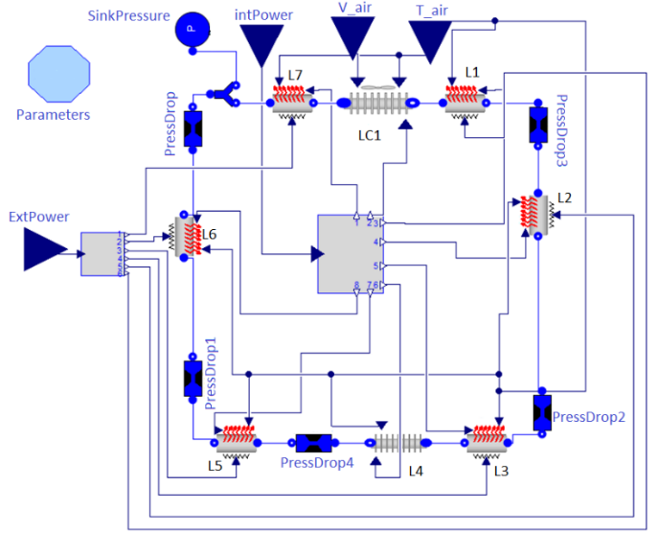
Fig. 3. Improved DYNASTY model

This model was developed to improve the description of the facility (from the previous one) by implementing the heat losses with the environment and the fins in the cooler component (LC1) and using a better description of the different sections of the plant. Compared to the real system, the two vertical heaters are composed of a vertical component (L6 and L2) and a horizontal section before/after the cooler (L7 and L1). The horizontal section instead is divided into two heaters (L3 and L5) with the unheated mass flow rate meter components in the middle (L4 and pressDrop4), which represent a discontinuity in the heat source of the horizontal section. The DYNASTY pipe model is shown in Fig. 4: this model houses an additional wall component between the heat source and the environment that describe the presence of the insulation layer and the heat losses in the DYNASTY pipes. The pipe model is made of different components, customFlow1DFEM is the main component of the pipe model, which houses the hydraulic part and the thermal exchange between the inner medium and the pipe walls. This component sets the mass, energy and momentum balance equation in the fluid and allows flow inversion during the simulation. The connections between the pipe component and the rest of DYNASTY are provided by flangeA/B, these two flanges are responsible for establishing the balance conditions at the inlet and outlet section of the pipe. The EHS component is the one responsible to deliver the external power signal to the pipe outer external wall, mimicking the heating strips.
This input is used by the doubleHeatsource1DFEM component for the heat transfer between the pipe metal wall and the insulant layer. The components metaltubeFEM and metaltubeFEM_insulator are the two wall components that account for the thermal conduction in the pipe metal wall and the insulant layer, respectively. The component which accounts for the heat transfer between the pipe outer insulant layer and the environment is heat_transfer_tube_nat_conv_rad1, this component uses the external input T_air_f to set the air temperature. Lastly, iHG1DFEM is the component that accounts for the internal heat source.

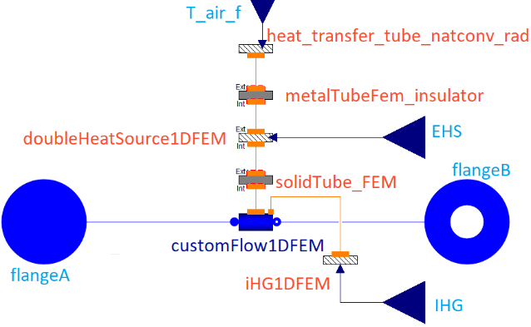
Fig. 4. DYNASTY pipe model

The DYNASTY pipe models use the Churchill-Bernstein correlation for smooth pipe in crossflow [1]. This correlation is also used in the cooler model, although it was modified with a correction coefficient to account for the surface increase due to the finning of the pipe [1]. The MODELICA model of the DYNASTY cooler is akin to the pipe model in Fig. 3 with minor differences as shown in Fig.5. The major differences are that The EHS and the outer insulation layer are missing, the input V_air is a component that sets the volumetric airflow rate to the cooler, and the subcomponent Heat_Transfer_Coefficient_Source calculates the heat transfer coefficient between the cooler and the environment.

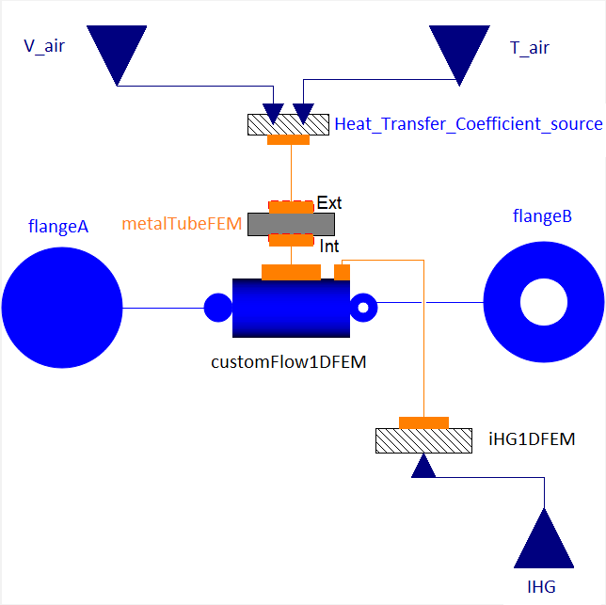
Fig. 5. DYNASTY cooler model

DYNASTY numerical algorithms test
Due to its complexity, the developed DYNASTY model requires a significant amount of computation time (CPU time) to complete the simulations. This was especially observed using the default DYMOLA numerical integration algorithm DASSL [22]. A preliminary analysis pointed towards chattering as the main issue occurring during the simulations. Chattering is a numerical problem that arises when logic conditions keep being triggered (as in an if/else statement), such as an if statement that switches from true to false; this leads to events being constantly generated, which in turn leads to an increase in the computational time. This issue highlighted the need for testing different numerical integration algorithms to confirm if chattering was indeed the issue encountered with DASSL and to test the numerical behaviour of the simulation.
An important concept needed when discussing numerical integration algorithms is the order of accuracy of the numerical method, which quantifies the rate of convergence of the numerical approximation of a differential equation to the exact solution: the higher the order, the higher the accuracy that can be achieved with the same step size [26]. Without entering into details on their mathematical implementation, the main algorithms chosen for this comparison are i) DASSL, a linear multi-step algorithm based on the Backward Differentiation Formulae (BDF) [22] with adaptive step size and up to 5th order; ii) RADAU2a, a single step Fully Implicit Runge Kutta (FIRK) [26] algorithm of 5th order with adaptive step size; iii) SDIRK34hw, a Single Diagonal Implicit Runge Kutta (SDIRK) [27] algorithm of 4th order with adaptive step size; iv) ESDIRK45a, an Explicit Single Diagonal Implicit Runge Kutta (ESDIRK) [27] algorithm of 5th order with adaptive step size. All the numerical integration algorithms tested are for stiff problems: in general, when any DAE system of equations [21] is translated, a stiff ODE system to be solved is obtained, as in the case of the DYNASTY model. The different numerical integration algorithms are tested by comparing the CPU time required to complete the simulation and considering the number of events triggered during computation, as they provide insights into where the algorithm is requiring the most amount of computational power. The simulation settings are all the same and of minor concern for the algorithms tests, since in this case, the important outcome is the numerical behaviour of the simulation and not the actual physical result. The mass flow rate is used as a test variable to observe the behaviour of a physical quantity during the simulation. These tests are performed using an AMD RYZEN® 5 2600 (6 Core 12 Threads) CPU with a 3.9GHz maximum clock speed. Fig. 6 shows the first second of the simulation in terms of mass flow rate, as the initialization is the most cumbersome part of the simulation. It can be observed how the DASSL algorithm is not capable of dampening the oscillations during this initial phase. Instead, the algorithm that manages to use the least amount of time to dampen the oscillations is the fully implicit Radau2a, which requires less than 0.1 seconds of simulation time (Fig 6b).

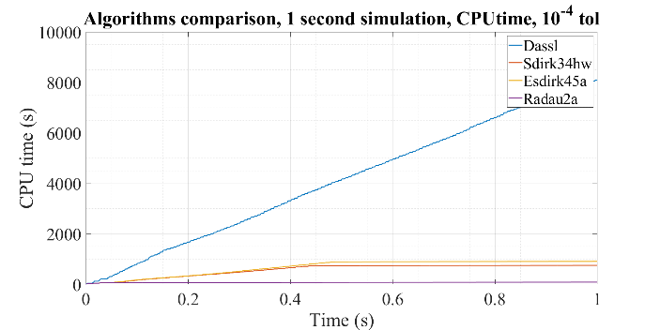 | 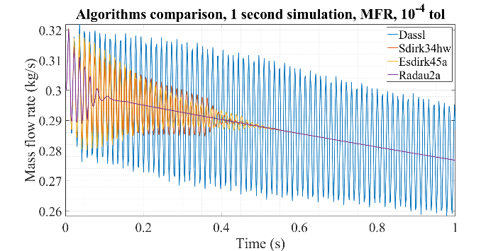
(a) | (b)
Fig. 6. First second of the simulation for the numerical algorithm test: (a) CPU time, (b) Mass flow rate

TABLE 1. Numerical Integration Test results summary

Integration algorithm | DASSL | RADAU2a | SDIRK34hw | ESDIRK45a
Method | Linear multi step (BDF) | Single step (RK) | Single step (RK) | Single step (RK)
Stiff/non stiff | stiff | stiff | stiff | stiff
Implicit | yes | yes | yes | yes
Order | 1-5 | 5 | 4 | 5
Dampen oscillations | no | yes | yes | yes

This is expected result, as during the initialization part of the simulation the largest amount of step size adjustments are required. In such a scenario, a linear multi-step method like DASSL has major shortcomings, while a single-step method, despite being less efficient, is not affected as much when frequent step size changes are required [26]. This is clearly shown in Fig. 5a, where the CPU time of DASSL keeps growing and the algorithm requires more than 8000 seconds of CPU time to simulate just one second of real-time. Instead, the CPU time curve of the other RK algorithms reaches a sort of plateau, with RADAU2a being the fastest one. The main outcome of this integration algorithm performance comparison is the choice of the single-step fully implicit RK method RADUA2a as the default algorithm for simulating the DYNASTY model.

DYNASTY model sensitivity analysis
To characterize the model response to analyse the experimental behaviour of the DYNASTY facility, the model shown in Fig. 2 was used in a sensitivity analysis to test the simulation response to the variation of some of the input parameters. The selected parameters were the airflow rate and the air temperature, as they represent the constraints for the heat exchange between the facility and the environment. Based on the results shown in Section 2.2, this analysis was performed using the RADAU2a integration algorithm and using water as a working fluid. The conditions used for these simulations are that the air temperature is set at 22 °C as the reference value and that the power delivered is 450 W, with 5/8 of it in GV1 (L7 and L6) and the remaining 3/8 in GV2 (L1 and L2); GO1, composed by L3, L4 and L5, is not powered. In this model, TC1 and TC2 are taken at the inlet and outlet section of the cooler (LC1). The first test performed was the one testing the DYNASTY behaviour with different cooling fan velocities, starting from a value of 0.005 m³s⁻¹ up to 4 m³s⁻¹, which corresponds to the maximum airflow rate of the cooling fan. Airflow rate values lower than 0.005 m³s⁻¹ were not used as they caused the simulation to crash. This test was performed to understand where the effect of the fan is most visible in the DYNASTY facility operative range, to characterize the heat transfer in the cooler and more the effect of the fan on the whole DYNASTY model. At low fan speeds, the mass flow rate is more affected than at higher values (Fig. 7a); the cooler heat exchange coefficient values range from 15 to 400 Wm⁻²K⁻¹: the influence of the airflow rate on the convective heat exchange coefficient is more significant at low fan speeds, losing effectiveness the more the convective heat transfer coefficient value increase (Fig. 7). The temperature values follow the same behaviour, passing from 90°C to 50°C for the first four values of the airflow rate, showing the biggest change in the interval between 0 and 0.5 m³s⁻¹(Fig. 7b and 7c). Interestingly, the decrease of TC1 and TC2 is not simultaneous: as the airflow rate increases, the temperature difference increases, meaning that TC2 is decreasing faster than TC1 (Fig. 7d).

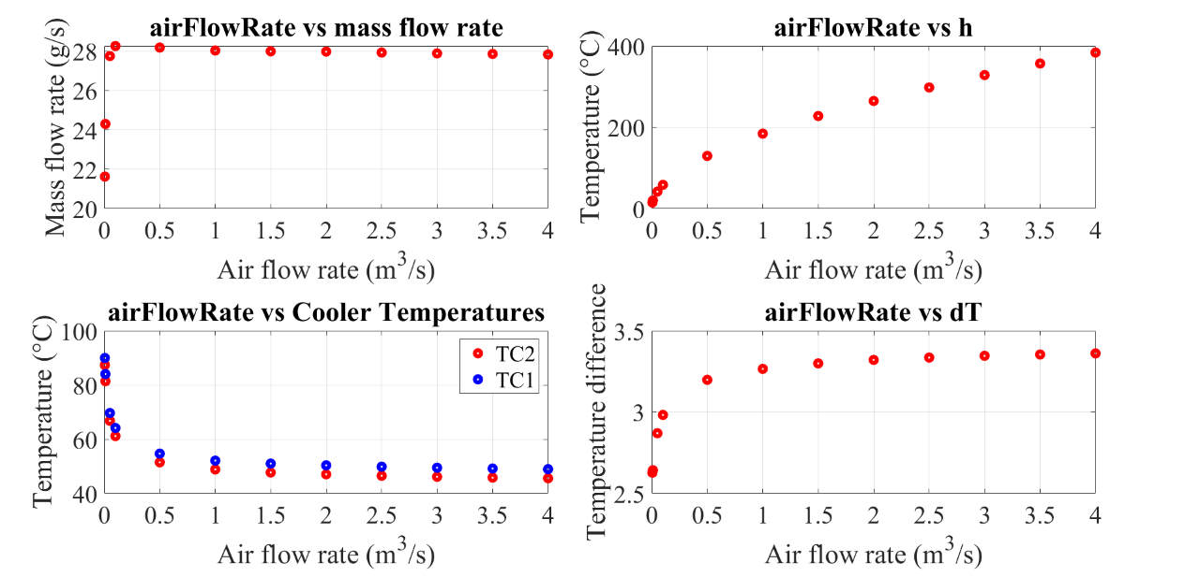
Fig. 7. fan speed test results, mass flow rate, TC1, convective heat transfer coefficient h, and temperature difference

The second test performed used different air temperatures, with the fan airflow rate set to the maximum of 4 m³s⁻¹. The range of air temperature values considered for the test goes from 10 °C up to 34 °C, which corresponds to the possible environment temperature range in the experimental facility. These results show the expected behaviour, as with an increase in the environmental air temperature the convective heat transfer coefficient decrease. Thus, to preserve the required exchange heat rate, the system needs to adjust the mass flow rate and/or the temperature of the fluid, and in this case both the mass flow rate and the fluid temperature increase at the same time. However, the increase in the two-fluid temperatures is not of the same value, so globally the temperature difference decreases when increasing values of the air temperature (Fig. 8).

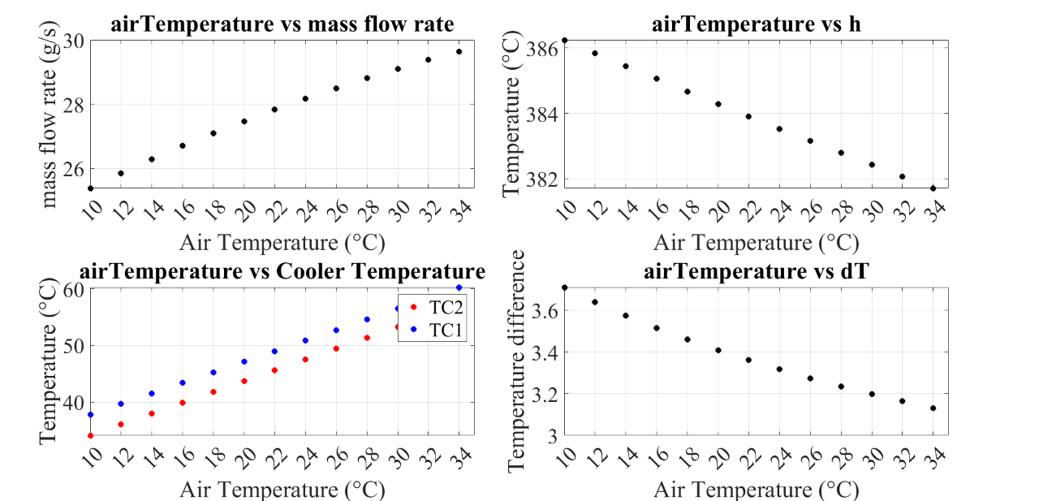
Fig. 8. fan speed test results, mass flow rate, TC1, TC2 and temperature difference

DYNASTY modelica models EXPERIMENTAL COMPARISON
To characterize the model capabilities of predicting the physical behaviour of the facility, the validation of the model was performed using the results of the preliminary experimental campaign on DYNASTY [23]. The model tested is the one reported in Fig. 2, adopting the numerical integration algorithm RADAU2a and using water as working fluid. The simulations are subdivided into heating and cooling transients. During the heating transient, power is provided to the selected heater at the maximum value as a step. The possible heating configurations are GV1, GV2, GO1 and DH (Fig. 9). In the cooling transients, power is turned off keeping the cooler fan active at the same airflow rate value as the heating transient. The first tested configuration is the VHHC one, applying power only to the left vertical leg GV1; the second VHHC configuration is obtained by powering the right vertical leg GV2. The HHHC configuration instead provides heat to the lower horizontal leg GO1. Lastly the DH configuration is obtained by powering all the heating sections of DYNASTY at the same time, namely GV1, GV2 and GO1. The different DYNASTY heating sections are shown in Fig.2.
In the experimental comparison the model uses tuning coefficients for the heat losses of the pipe to the environment (obtained by preliminary analysis with the experiments), as this value cannot be measured but only estimated through an energy balance. The power values used for the simulations are 1800W for the VHHC case and 800W for the HHHC one. The two power values are different since the vertical legs house three heating strips of approximately 800W each, while the horizontal leg only houses two heating strips. The power applied to the model was estimated accounting for all the power losses of the facility. In these comparisons, the transients are composed of ~ 15’000 seconds of heating and ~10’000 seconds of cooling as in the experiments [23]. The DYNASTY measuring system is made of four ELSI type-J thermocouples [28] and one PROMASS-F80-DN25 mass flow rate meter [29]. Error boundaries in both the temperature differences and the mass flow rate were introduced to account for experimental errors due to the measuring system, electrical noise, and data acquisition. The value used is ±2.15 °C for the temperature differences and ±0.2138 g/s for the mass flow rate.

3.1 DYNASTY model comparison results
The comparison results for the HHHC (GO1) cases are shown in Figs. 9 and 10 for both the temperature difference at the cooler and the mass flow rate curves for the cases with the fan at 0% and 50% of maximum airflow rate. As observed, the simulations manage to correctly predict the experimental results in the heating transient, albeit with a more pronounced oscillatory behaviour. Still, the simulated values always lay between the error boundaries of the experiments in the heating transient (barring the initial unphysical oscillations).

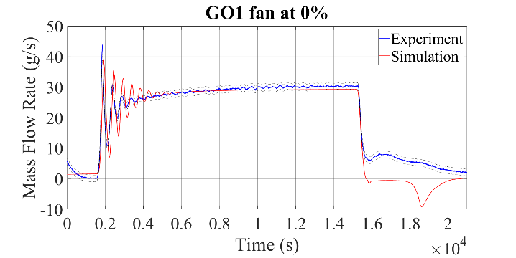 | 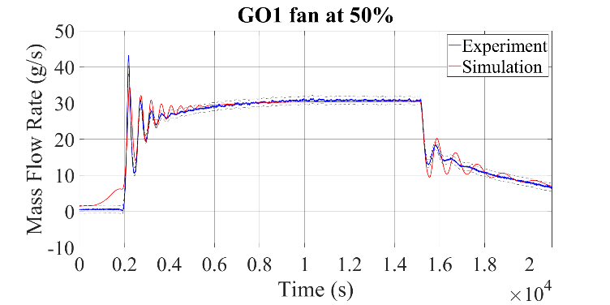
(a) | (b)
Fig. 9. GO1 comparison, mass flow rate evolution. The dashed lines represent the upper and lower uncertainty range bands.

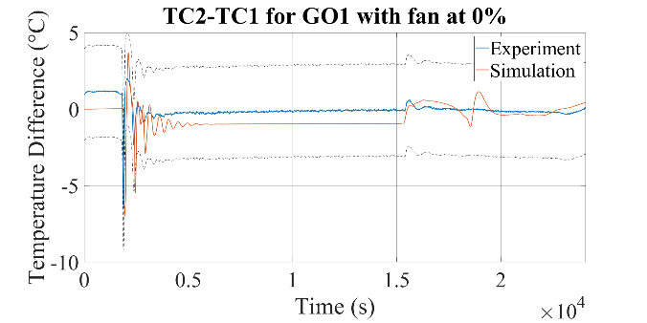 | 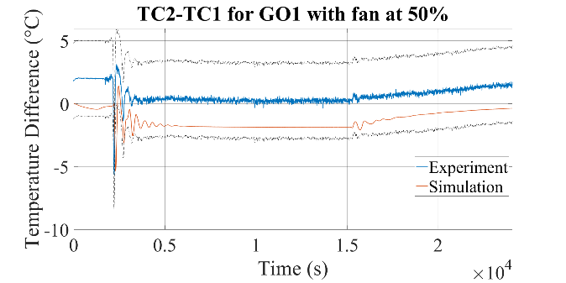
(a) | (b)
Fig. 10. GO1 comparison, temperature evolution. The dashed lines represent the upper and lower uncertainty range bands.

The comparison results are also promising for the cooling transient: even though the simulation has a more pronounced oscillatory behaviour in the mass flow rate, the numerical results agree with the experimental ones for the case with the fan at 50%. In general, the simulation seems to underpredict the transient compared to the experimental data, especially for Fig. 11b (where the behaviour in time is the same): the initial discrepancy could be due to some discrepancies between initial conditions set by the model and those measured by the thermocouples. The mass flow rate comparisons highlight that, despite the tuning of the heat transfer coefficient and the promising results, the cooling dynamics are still not properly simulated. This is probably due to the 3D effects that DYMOLA cannot model. Such effects include turbulence phenomena, recirculation (especially in the region of the open tank) and possible boiling near the pipe inner walls (as the latter temperatures, according to the DYMOLA simulation but not experimentally verified, are expected to overshoot the onset temperature for nucleate boiling).
The more oscillatory behaviour of the simulation compared to the experimental case is true also in the temperature difference graph, although the simulation results remain between the error boundaries of the measure for both transients. The oscillatory behaviour in the temperature difference and the mass flow rate is observed in both the model and the experiments at the start of the heating transient, albeit with different magnitude. Still, the results are promising in the sense that the 1D model can capture these dynamics of natural circulation. This behaviour was found to be due to the wave-packet nature of NC in DYNASTY, as shown in Fig. 11, where the temperature peaks correspond to the hot fluid packet reaching the corresponding thermocouple (Fig. 2).

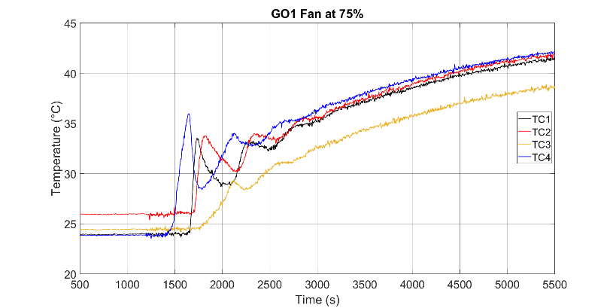
Fig. 11. Temperatures zoom during the initial transient of GO1, adapted from [16]

The next comparison is the one for the VHHC configuration powering only the left vertical leg GV1, and the results are reported in Figs. 12 and 13 for the cases with the cooler fan at 0% and 50% of the maximum airflow rate. These first comparisons show good agreement between the model and the experiment in both the mass flow rate and the temperature differences graphs. The simulation manages to predict the curve behaviour of the experimental cases for both the mass flow rate and the temperature difference graphs, and the model results mostly stay inside the error boundaries, especially during the heating transient. The exception is the case with the fan turned off, where the model temperature difference fails to stay in the error boundaries. However, in this experimental case, the temperature values are compatible with subcooled nucleate boiling conditions [23], which is not currently accounted for in the model. The simulation also predicts the negative peak due to flow inversion in the mass flow rate graph for the case with fan speed at 50% during the cooling transient, although with a time shift and without the slow dampening of the experimental case.

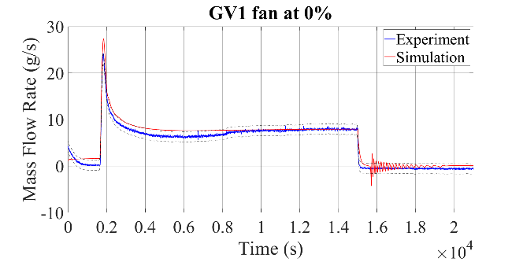 | 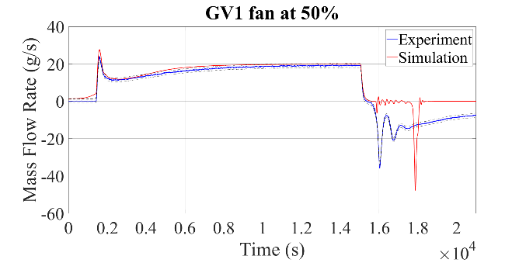
(a) | (b)
Fig. 12. GV1 comparison, mass flow rate evolution: (a) 0% fan speed, (b) 50% fan speed. The dashed lines represent the upper and lower uncertainty range bands.

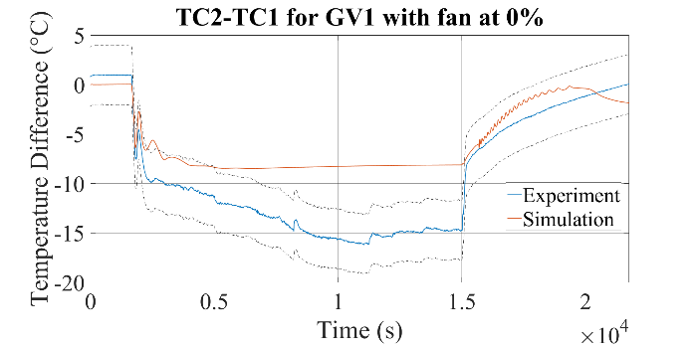 | 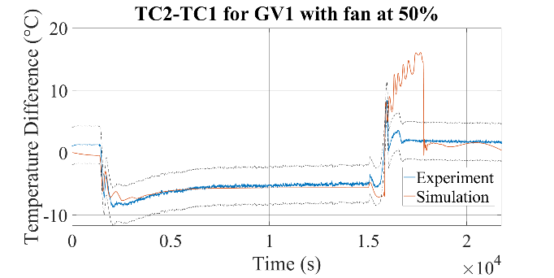
(a) | (b)
Fig. 13. GV1 comparison, temperature evolution: (a) 0% fan speed, (b) 50% fan speed. The dashed lines represent the upper and lower uncertainty range bands.

Tables 2 and 3 summarize the results of the comparison results between the simulations and the experiments. For both cases, positive performances for the heating transient are observed, whereas the cooling one has some margins of possible improvement. At the current state, the models are not able to predict the facility behaviour during the DH transient, as the higher applied power makes the system reach temperatures compatible with phase change that the model is not currently capable of simulating. Table 2 shows a summary of the comparison between the simulations and the experimental results for the mass flow rate; the results are compared in terms of mean quadratic relative error in the mass flow rate measurement on the whole experiment, discriminating between the heating and the cooling transient. As reported, the model manages to have a mean quadratic error with a maximum value of 10% in the heating transient only for the GV1 configuration with the cooler fan speed of 0%.

TABLE 2. Mass flow rate mean relative error in the different comparison cases with increasing value of fan speed

Fan speed | GO1 heating | GO1 cooling | GV1 heating | GV1 cooling | GV2 heating | GV2 cooling
0% | 2.64% | 129.29% | 10.23% | 192.31% | 5.63% |  | 115.93%
25% | 2.79% | 16.1% | 7.91% | 108.24% | 5.86% |  | 99.36%
50% | 1.28% | 14.81% | 6.74% | 101.27% | 5.64% |  | 100.45%
75% | 2.53% | 39.38% | 5.91% | 120.67% | 5.39% |  | 99.39%

Table 3 shows a summary of the comparison between the temperature difference at the cooler (TC2-TC1) with increasing cooling fan speed for both cooling and heating transient. This table shows the root square mean difference value between the simulation results and the experimental error boundaries. As observed in the temperature difference graphs, the model manages to correctly simulate the experiments in the heating transient, being usually within the temperature difference error boundaries.

TABLE 3. Temperature difference root square mean distance between the model and the experimental error boundaries with increasing fan speed.

Fan speed | GO1 heating | GO1 cooling | GV1 heating | GV1 cooling | GV2 heating | GV2 cooling
0% | Within | Within | within | Within | Within |  | 2.56°C
25% | Within | 0.48°C | Within | 6.11°C | 0.34°C |  | 5.54°C
50% | 0.05°C | 0.16°C | Within | 5.94°C | Within |  | 5.65°C
75% | within | within | Within | 6.06°C | within |  | 6.35°C

Conclusions
The modelling efforts in describing the DYNASTY facility, which operates with natural circulation in which flow inversion can occur, with a 1D approach using MODELICA proved to be a rather challenging task. This work reports the improvements in the modelling of the facility, improving the physical description of DYNASTY by including the thermal losses between the facility and the environment and the surface increase due to the finning of the cooler.
The improvements made added more layers of complexity to the DYNASTY model. Due to the computational demand of the simulation, the performances of some of the numerical integration algorithms present in DYMOLA® were analysed. The performance test on the model highlighted the importance of the initialization when simulating DYNASTY, and that the Runge-Kutta family of integration algorithms can dampen the initial oscillations faster than the DASSL algorithm. It was found that the RADAU2a manages to complete the simulations faster than the other methods, making it the algorithm of choice when simulating DYNASTY. The models were also analysed with different boundary conditions in terms of airflow rate to the cooler (different values of the cooling fan speed) and different air temperature values. These tests explored the different working conditions of the facility which were also found in the experimental analysis [23]. The model was also compared, for the first time, against the experimental data from the preliminary DYNASTY experimental campaign [23]. The comparison highlighted the need to tune both the heat losses and the cooler convective heat transfer coefficient to correctly simulate the experiments. The tuned model was able to provide an accurate prediction of the experiments in the heating transient while showing margins of improvement for the cooling transient. In the experimental comparison, in the HHHC case also promising results for the cooling transient were found, as the mass flow rate and the temperature difference curve have similar behaviour to the experimental ones. The VHHC cases instead showed a good prediction of the heating transient and margins of improvements for the cooling transient. However, the simulation still managed to catch the dynamics of the facility by exhibiting a negative mass flow rate peak, even if shifted in time.
The promising results of the first validation activity on the DYNASTY 1D model set the path for further developments, for what concerns the simulation capabilities for the cooling transient and the DH configuration. Furthermore, the validity of the experimental tuning will need to be tested with the insulated facility model and with different working fluids.
References
- T. L. Bergman, A. S.Lavine, F. P.Incropera, D. P.dewitt, Fundamentals of Heat and Mass Transfer Seventh Edition, John Wiley & Sons Inc, (2011).
- B. SUTHARSHAN, M. MUTYALA, R. P. VIJUK, A. MISHRA, The ap1000tm reactor: Passive safety and modular design, Energy Procedia, 7, (2011), 293–302.
- S. RASSAME, T. HIBIKI, M. ISHII, Esbwr passive safety system performance under loss of coolant accidents, Progress in Nuclear Energy, 96, (2017), 1–17.
- J. SERP, M. ALLIBERT, O. BENEˇS, S. DELPECH, O. FEYNBERG, V. GHETTA, D. HEUER, D. HOLCOMB, V. IGNATIEV, J. L. KLOOSTERMAN, L. LUZZI, E. MERLE-LUCOTTE, J. UHL ́IˇR, R. YOSHIOKA, D. ZHIMIN, The molten salt reactor (MSR) in generation IV: Overview and perspectives, Progress in Nuclear Energy 77, (2014), 308–319.
- D. E. RUIZ, A. CAMMI, L. LUZZI, “Dynamic stability of natural circulation loops for single phase fluids with internal heat generation,” Chemical Engineering Science, 126, pp. 573–583 (2015)
- P. WELANDER, On the oscillatory instability of a differentially heated fluid loop, Journal of Fluid Mechanics 29 (1967) 17–30.
- P. J. SCHMID, L. BRANDT, Analysis of fluid systems: Stability, receptivity, sensitivity, Applied Mechanics Reviews, 2, (2014), 66.
- Y. S. JEONG, S. B. SEO, I. C. BANG, Natural convection heat transfer characteristics of molten salt with internal heat generation, International Journal of Thermal Sciences, 129, (2018), 181–192.
- D. GERARDIN, M. ALLIBERT, D. HEUER, E. MERLE-LUCOTTE, C. SEUVRE, “Design evolutions of Molten Salt Fast Reactor,” Proc. nternational Conference on Fast Reactors and Related Fuel Cycles: Next Generation Nuclear Systemes for Sustainable Development (FR17), Yekaterinburg, Russia, (2017)
- A. CAMMI, L. LUZZI, A. PINI, The influence of the wall thermal inertia over a single-phase natural convection loop with internally heated fluids, Chemical Engineering Science, (2016), 153.
- P. VIJAYAN, V. BHOJWANI, M. BADE, M. SHARMA, A. NAYAK, D. SAHA, R. SINHA, Investigations on the effect of heater and cooler orientation on the steady state, transient and stability behaviour of single-phase natural circulation in a rectangular loop, No. BARC--2001/E/034, IAEA, India, (2001).
- P. K. VIJAYAN, Experimental observations on the general trends of the steady state and stability behaviour of single-phase natural circulation loops, Nuclear Engineering and Design, 215, (2002), 139–152.
- M. MISALE, Overview on Single-Phase Natural Circulation Loops, (Proc. of the Intl. Conference on Advances in Mechanical and Automation Engineering), Italy, I, (2014), 12.
- M. MISALE, P. GARIBALDI, Dynamic behaviour of a rectangular single-phase natural circulation loop: influence of loop inclination, 20th National and 9th International ISHMT-ASME Heat and Mass Transfer Conference, India, (2010), paper #353, pp. 1350-1357
- A. PINI, A. CAMMI, M. T. CAUZZI, L. LUZZI, Dynasty: An experimental loop for the study of natural circulation with internally heated fluids, PhD Thesis, Italy, (2016).
- M. T. CAUZZI, A. CAMMI, L. LUZZI, Modelling and Experimental Investigation of Natural Circulation in Presence of Distributed Heating, PhD Thesis, Italy, (2019).
- A. BATTISTINI, A. CAMMI, S. LORENZI, M. COLOMBO, M. FAIRWEATHER, Development of a cfd – les model for the dynamic analysis of the dynasty natural circulation loop, Chemical Engineering Science 237 (2021) 116520.
- Dassault Syst`emes, Dymola (2020).
https://www.3ds.com/products-services/catia/products/dymola/
- P. FRITZSON, Principles of Object-Oriented Modeling and Simulation with Modelica 3.3: A Cyber-Physical Approach, John Wiley & Sons, Ltd, 2014.
- M. M. Tiller, ModelicaByExample (2019).
https://mbe.modelica.university/
- C. C. PANTELIDES, The Consistent Initialization of Differential-Algebraic Systems, SIAM Journal on Scientific and Statistical Computing, 9, (1988), 213-231.
- L. PETZOLD, A description of DASSL: A differential/algebraic system solver, (Proc. 10th IMACS World Congress), Canada, (1982).
- G. BENZONI, A. CAMMI, S. LORENZI, M. COLOMBO, C. INTROINI, Preliminary results from the DYNASTY experimental campaign, NURETH-19 (2022), paper #35761.
- F. CASELLA, A. LEVA, Modelica open library for power plant simulation: design and experimental validation, (Proc. of the 3rd International Modelica Conference), Sweden, (2003) 41–50.
- F. CASELLA, A. LEVA, Object-Oriented Modelling & Simulation of Power Plants with Modelica, (Proc. of the 44th IEEE Conference on Decision and Control), IEEE, Spain, (2005), 7597–7602.
- F. E. CELLIER, E. KOFMAN, Continuous system simulation, Kluwer Academic Publishers, (2006).
- J. B. JØRGENSEN, M. R. KRISTENSEN, P. G. THOMSEN, A family of esdirk integration methods (2018).
- ELSI, Type J Thermocouples,
http://www.elsi.it/en/products/thermocouple/ELSI_TC_Q1 UK.pdf (S.r.l.).
- ENDRESS-HAUSER, Proline-Promass-80F (2016),
https://www.it.endress.com/en/field-instruments-overview/flow-measurement-product-overview/Product-Coriolis-flowmeter-Proline-Promass-80F.

