# IMPLEMENTING An ANDVANCED Isolated

# Condenser SYSTEM with SELF REGULATING noncondensable gases passive safety

# system a CANDU6 POWER plant

I.P. NITA1, R. PANCEF1, M. Bigu1, L. Nitulescu2

1RATEN-CITON, Magurele, ROMANIA

2RATEN-ICN, Mioveni, ROMANIA

Email contact of corresponding author: nitai@router.citon.ro

**Abstract**

This paper presents work made by CITON engineering department in order to implement a new passive system based on a solation condenser system ANSALDO patent [8]. After Fukushima even plants designed with sufficient electrical back-up diesel generation have considered introduction of supplementary measure to prevent core damage during a possible Station black out (SBO) accident. The first measure was to introduce new Design Base Earthquake (DBE) qualified back-up diesel generation in order to increase electric back-up preparation for SBO but engineering is exploring possibility for a gen IV passive safety system to be implemented together with existing active safety systems.

## INTRODUCTION

This paper presents a step forward in order to implement a passive safety level D system in CNE Cernavoda PHWR power plant. The starting point of the system is based on an ANSALDO patent [8] on an upgraded passive system provided with an IC system supplied with self-regulating non-condensable gases reservoirs. The IC system is isolated at normal operation and it is put in operation by opening of isolation valves. Opening of isolation valves is the only action of the operator of the plant permitted by passive safety level D classification of the plant. The system will be in operation only in SBO accident condition.

## System Requirements

The system has a requirement to be able to act as reactor core heat sink in condition of SBO accident, using only passive components. The new designed system shall be able to transport decay heat from reactor core for at least 72 hours without almost any plant operator intervention. The only action allowed, as per Level D Passive system classification, is opening of the system isolation valves if a target pressure maximum value is reached. The system will have to be the first system to intervene in case of SBO accident. The IC system will have to retain all the secondary circuit cooling agent inventory, in order to preserve a natural circulation strong enough to cool down 2% of nominal heat flux of the reactor.

## Engineering design

The system will be designed to be provided with one IC and one non-condensable tank for each steam generators of the plant. Each of the four IC will be on in an independent loop in order to have a redundance of 3 of 4 IC. This means that in order to be successfully only 3 of 4 loops need to operational during SBO event. The main problem of a passive safety is that it cannot be regulate using actioned regulating valves. In order to control the IC heat flux ANSALDO had patterned a self-regulating heat exchanger using pressurized non-condensable gases in order to reduce IC heat flux after the residual heat of reactor decrease with passing of time.

In order to design the system, the first step was to calculate total energy that is to be produced in reactor core after reactor trip during 72 hours. Calculation of energy of used fuel bundles from reactor core was made with computational code ORIGEN 2.2. The computation was made with hypotheses that the fuel burn degree is half of maximum for normal fuel burned in a life cycle. This hypothesis takes in consideration continuous fuelling process specific for natural uranium CANDU reactor types. The result was the value of energy about 3.5 ∙105 J (see Figure 3).

The decay heat power for PHWR CANDU 6 is presented graphical in figure 1 and figure 2 and numerical in Table 1. PAGE AND SECTION BREAKS

TABLE 1. Total Decay heat power for CANDU 6 NPP [1], [2]

|  |  |  |  |  |  |
| --- | --- | --- | --- | --- | --- |
| Time | Time | Time | Power percent | Thermal Power | Duration |
| [seconds] | [hours] | [days] | [%] | [MW] | [seconds] |
| 0 | 0 | 0 | 100.000% | 2180 | 0.1 |
| 0.1 | 0.00003 | 0.00000 | 6.530% | 142.354 | 0.9 |
| 1 | 0.00028 | 0.00001 | 6.180% | 134.724 | 1 |
| 2 | 0.00056 | 0.00002 | 5.790% | 126.222 | 3 |
| 5 | 0.00139 | 0.00006 | 5.290% | 115.322 | 5 |
| 10 | 0.00278 | 0.00012 | 4.900% | 106.82 | 10 |
| 20 | 0.006 | 0.000 | 4.450% | 97.01 | 20 |
| 40 | 0.011 | 0.000 | 4.010% | 87.418 | 40 |
| 80 | 0.022 | 0.001 | 3.560% | 77.608 | 70 |
| 150 | 0.042 | 0.002 | 3.190% | 69.542 | 150 |
| 300 | 0.083 | 0.003 | 2.810% | 61.258 | 200 |
| 500 | 0.139 | 0.006 | 2.520% | 54.936 | 250 |
| 750 | 0.208 | 0.009 | 2.300% | 50.14 | 250 |
| 1000 | 0.278 | 0.012 | 2.140% | 46.652 | 250 |
| 1250 | 0.347 | 0.014 | 2.010% | 43.818 | 250 |
| 1500 | 0.417 | 0.017 | 1.900% | 41.42 | 500 |
| 2000 | 0.556 | 0.023 | 1.740% | 37.932 | 3000 |
| 5000 | 1.389 | 0.058 | 1.320% | 28.776 | 5000 |
| 10000 | 2.778 | 0.116 | 1.050% | 22.89 | 5000 |
| 15000 | 4.167 | 0.174 | 0.948% | 20.6664 | 5000 |
| 20000 | 5.556 | 0.231 | 0.882% | 19.2276 | 10000 |
| 30000 | 8.333 | 0.347 | 0.790% | 17.222 | 20000 |
| 50000 | 13.889 | 0.579 | 0.693% | 15.1074 | 20000 |
| 70000 | 19.444 | 0.810 | 0.629% | 13.7122 | 20000 |
| 90000 | 25.000 | 1.042 | 0.581% | 12.6658 | 20000 |
| 110000 | 30.556 | 1.273 | 0.546% | 11.9028 | 30000 |
| 140000 | 38.889 | 1.620 | 0.507% | 11.0526 | 30000 |
| 170000 | 47.222 | 1.968 | 0.475% | 10.355 | 30000 |
| 200000 | 55.556 | 2.315 | 0.448% | 9.7664 | 59200 |
| 259200 | 72 | 3 | 0.381% | 8.3058 | 259200 |

Fig. 1. Decay heat power in percent from nominal power for CANDU 6 NPP [1], [2]

Fig. 2. Total Decay heat power for CANDU 6 NPP [1], [2]

Fig. 3. Decay heat (total energy) to be taken by IC pool [1] [2]

By considering that the active safety system is unavailable, this energy from the reactor core shall be removed only by the water from the DHR pool. There were available 2 solutions:

Solution 1: All energy shall be removed by heating pool water from 40°C to 100°C without evaporation. In this case the required water from pool is about 15000 m3. The advantage of this solution is that -if in a limited volume- it could be placed inside containment. The main disadvantage of this solution is the very large volume of water to be placed inside containment, and for current configuration of CANDU 6 NPP there is not enough space to accommodate it inside.

Solution 2: All energy shall be removed by heating pool water from 40°C to 100°C with evaporation. In this case the required water from the pool scaled down to 1650 m3. The main advantage of this solution is that the volume is almost 10 times lower and can be accommodated inside containment. The main disadvantage of this solution is that it evaporates 1650 m3 of water in a contained space, the pressure inside containment shall increase over 100 bar (g) comparing with the maximum of 3.3 bar (g) allowed in the containment. In order to not dry-out the IC it has been decided to consider a 2000 m3 pool; in this way all four ICs remain under water for 3 days.

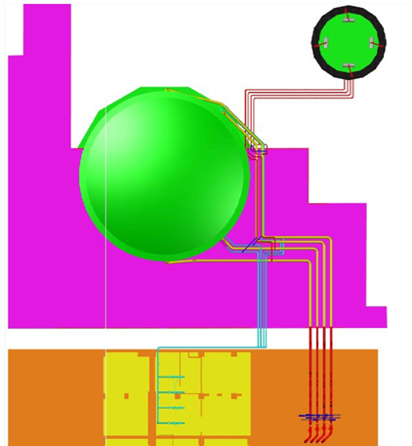

Fig. 4. General arrangement - top view of the DHR system

Taking into consideration the 2 available solutions, it has been concluded that the pool cannot be accommodated inside containment and have to be installed outside the containment.

In the DHR system design the natural circulation of fluids has been considered as consequence of SBO design condition. This requirement leads to pool positioning as close as possible to the containment.

Also, for natural circulation, there is an additional system requirement which regards the DHR pool elevation. In the normal operation of DHR system, there are 2 natural circulations involved:

- one from reactor core to steam generation;

- the second one, from steam generation dome to DHR pool.

Figures 4 and 5 show the general arrangement of the pool inside Cernavoda Unit 2 N.P.P.

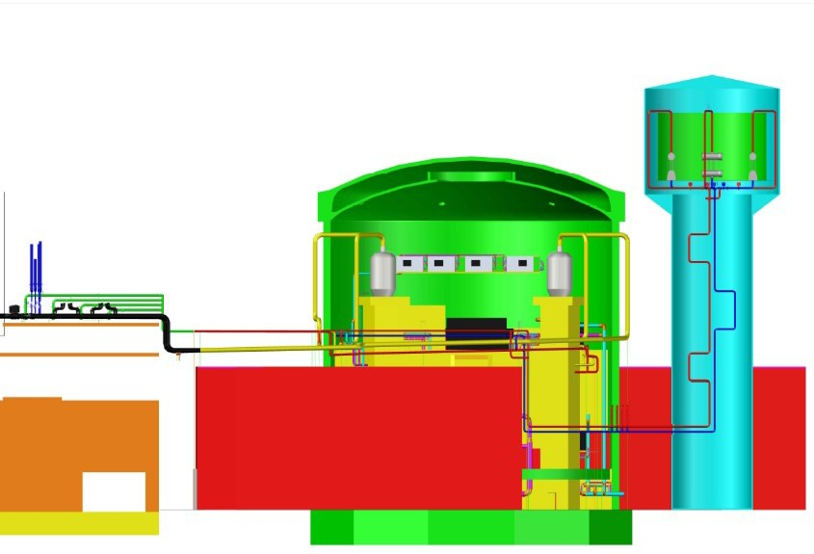

Fig. 5. Decay heat (total energy) to be taken by IC pool [1] [2]

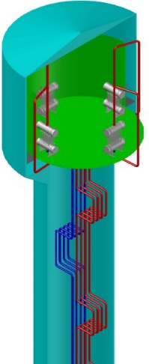In case of natural circulation, the thermal-hydraulic analyses show that the cold source have to be at about 10 m above the hot source. The elevation of steam generator dome is about 30 m above the ground [3] [4]. In conclusion, the pool has to be at least at 40 m above the ground. In order to accommodate this high elevation of the pool, one should consider the construction of a water tower near the containment. A section through the tower is shown in Figure 6. The final elevation of the tower will be assessed based the on RELAP5 thermal hydraulic analyses.

Fig. 6. Section through the water tower.

In order to size the IC heat exchangers, it has been considered an availability of 3/4 heat exchangers, a total heat flux of 2% of the nominal thermal power of the reactor, corresponding to 20 minutes delay after the SBO is initiated. This led to a heat exchange surface required of about 130 m2 for each IC; this surface was considered as corresponding to 220 tubes with a diameter of 38.1 mm. The conceptual design of the heat exchanger can be seen in Figure 7.

The system has a 3/4 redundancy, only 3 ICs are required to start in order to remove all the energy generated in the reactor core. Supplementary, the headers of ICs were not taken into consideration in the heat exchange calculation; this leads to an additional conservative calculation margin.

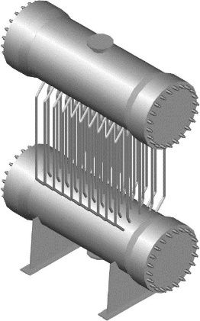Each IC will be connected to a non-condensable gases' recipient of about 10m3. Most probable the non-condensable tank will be located below the ICS. The gas inside will be nitrogen and the initial pressure and volume of the recipient will be determined/confirmed by RELAP5 calculations.

Fig. 7. Isolating condenser concept design

The process diagram, without maintenance subsystems (filling, draining, heat trace cables), is presented in Figure 8.

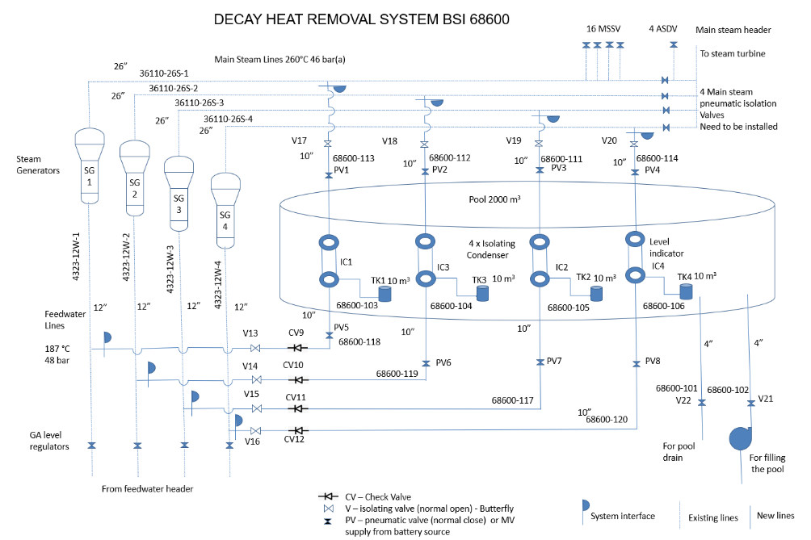

Fig. 8. System process diagram

## Relap5 Modelling of the system

The thermal-hydraulic simulations using RELAP5/MOD3.2 imply the modelling of the significant systems of the CANDU 6 NPP. The systems considered in the simulation (Figure 9) are: Heat Transport System (HTS), Pressure and Inventory Control System (PICS). Also, there is a RELAP5/MOD3.2 model for Emergency Core Cooling System (ECCS).

In Figure 9 are shown the active zone modelled with 2 loops in "figure of eight" which have 2 equivalent passes (Zone 1, ..., 4), the reactor inlet header (RIH 102, 104, 106 and 108) and outlet header (ROH 103, 101,105 and 107), as well as the steam Generator 301, 302, 303, 304.

The components included in thermal-hydraulic model of the active zone of CANDU 6 NPP are specific RELAP5/MOD3.2 components, i.e. branch, pipe, snglvol, tmdpvol component (interconnected with simple junction), and pump, valve, separator component.

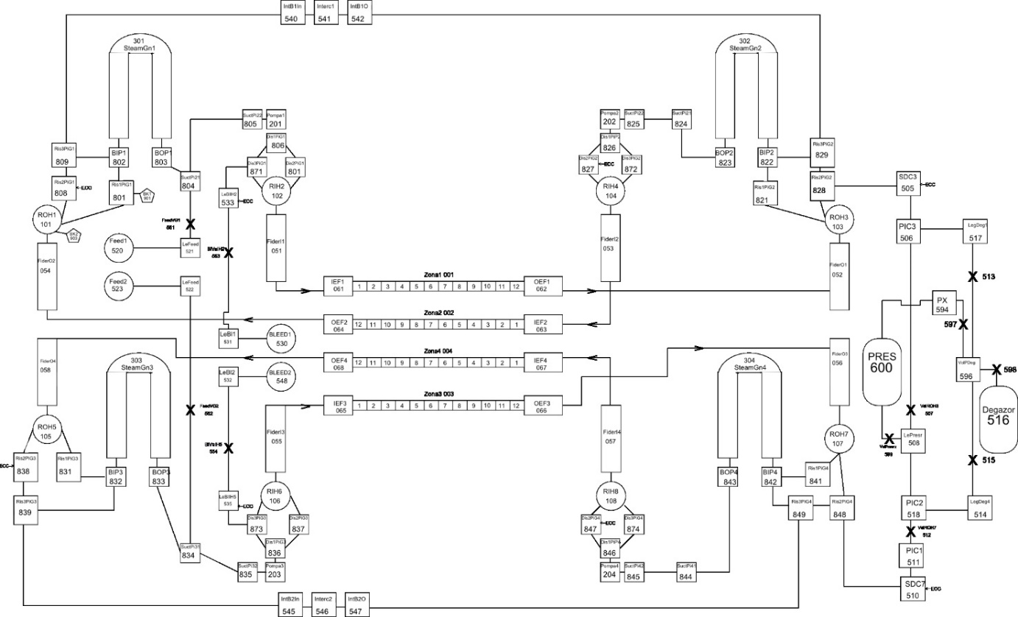

Fig. 9. Main scheme of CANDU 6 NPP used in RELAP5/MOD3.2 computer code [5,9]

For the feedwater that supplies the steam generators and removes the heat from the primary coolant and which has a separate circuit (see Figure 10), an input model has been also created using RELAP5/MOD3.2 code and has been included in the final input model of CANDU 6 active zone.

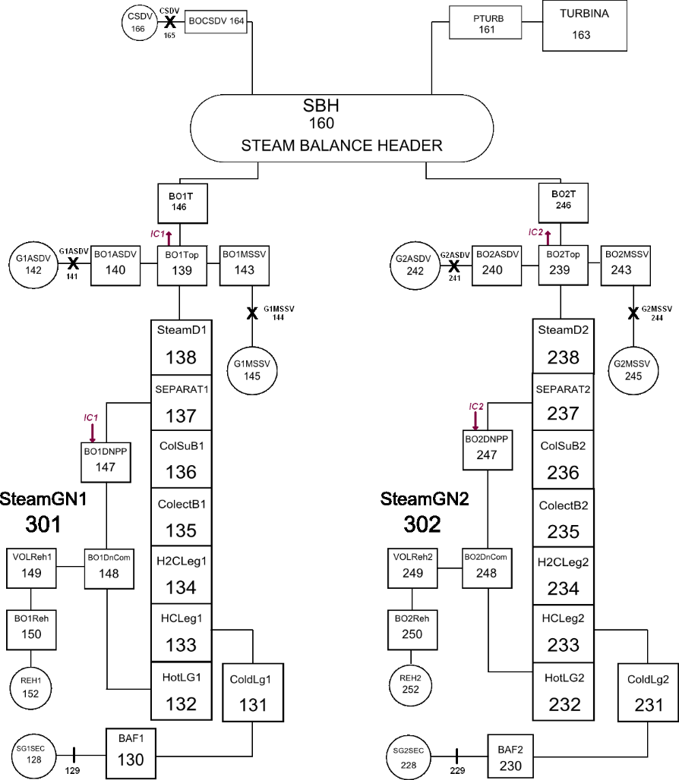

Fig. 10. The scheme adopted in the modelling of the secondary side of the steam generator [9]

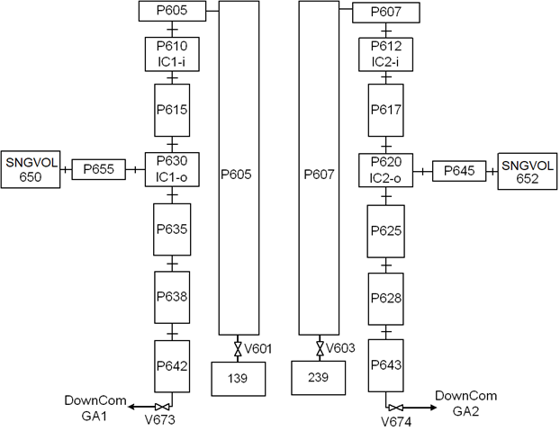

*Fig. 11. The scheme adopted in modelling the isolation condenser coupled to Steam Generator 1 and 2 [9]*

## RELAP5 Model of PASSIVE SAFETY SYSTEM for CANDU 6 STEAM GENERATOR TYPE

It was proposed a passive safety system in order to transport the reactor core residual heat after shutdown of the reactor using steam generator cool down system composed by (see Fig. 12):

- primary agent circulating through pipes submerged in a pool of demineralised water;

- isolating valves;

- noncondensable air tank;

- connecting pipes.

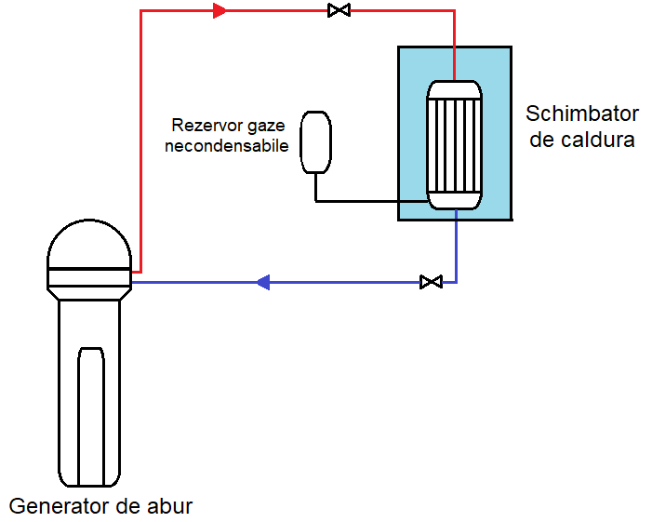

Fig 12 Schiţa sistemului pasiv de securitate nucleară pentru răcirea generatorului de abur

This system has an independent loop for each steam generator, and its location requires further studies, the main problem being the location of the heat exchanger cooling tank/pool.

TABLE 2. Technical specifications of the proposed system

|  |  |
| --- | --- |
| Operating pressure | 46.2 bar (a) |
| Operating temperature | 260 °C |
| IC Nominal flowrate | 7 kg/s |
| Initial temperature of water inside IC pool | 40 °C |
| Outside diameter of tube | 0.0391 m |
| Inside diameter of the tube | 0.0381 m |
| Tube length | 2 m |
| Tube number | 255 |
| Connecting pipes | 10” |

The system is considered to take the steam from the top of the steam generator above the moisture separator and introduce the cooled fluid down the steam generator downcomer into the area where the Emergency Water Supply (EWS) system is coupled. The passive system is started by opening a valve when a setpoint value is reached. Initially, the system is filled with fluid at a pressure lower than the setpoint pressure corresponding to the valve opening.

First Isolation valve (upstream of IC) opening leads to system filling with steam with a pressure above 45 bar. In the passive system there is a fluid pressure rise, and with 60 seconds delay of the second isolation valve (downstream of IC) leading to an open natural circulation in steam generator secondary side.

On the primary side of the plant (PHTS), corresponding cooling of steam generator and , implicitly and of the primary agent circulating through the pipes, leads to a pressure decrease in the reactor core.

Accident scenario had been taken in consideration in modeling of a CANDU6 loop for intervention of passive safety system for transporting residual heat of reactor core is describe in the following paragraphs**.**

  In order to assess how the cooling of the reactor core is carried out following the intervention of the passive safety system, the following accident scenario presented in Table 3, equivalent to the Station blackout event (SBO), was assumed:

Table 3. Time schedule of SBO for CANDU6 Reactor

|  |  |
| --- | --- |
| Moment | Description / Action |
| **0s** | Shut down of PHTS circulation pumps |
| (0-5) s | Shut down of steam generators feedwater pumps |
| MSSV (main steam safety valve) and ASDV (are not credited for this accident) |
| Main Steam isolation valves are closed |
| **0.5s** | Reactor trip using shut down rods (Shut Down System no.1) |
| **20s** | Opening of upstream (on steam) IC steam isolation valve |
| **100s** | Opening of downstream (on condensate drain) IC steam isolation valve |

* The thermal-hydraulic model developed with RELAP5/Mod3.2 code, was run for a time of 12000s (3.30 hours), with a minimum time step of 10-12s and a maximum time step of 0.001s, the value of the minimum time step being imposed by the presence of non-condensable gases in the circuit. Only an equivalent loop of the CANDU 6.
* In the RELAP model developed, the power reduction curve corresponding to the CANDU 6 reactor was implemented.

The model of plant was made in order to simulate SBO accident for 12000 seconds. In Figure 13 it is presented pressure in steam generator and in IC during 12000 from initialization of event. The model will be upgraded, now is in testing and validation period in order to simulate complete natural circulation in PHTS, secondary circuit and IC System.

The occurrence of the accident by shutting down the main primary agent circulation pumps in the active zone leads to an increase in pressure in the active zone, which results in the reactor tripping at the high pressure signal in the reactor outlet header (See Fig. 13)



*Fig. 13 Fluid pressure evolution in the reactor core (D2O) and in the passive system loop over the simulated event*

- Forcing the valves of each steam generator to remain closed leads to increased fluid pressure in the steam generators (see Fig. 13).

- When the pressure of 60 bar is reached (about 20s after the transient is initiated), the passive safety system is activated, creating a closed loop through which steam is circulated only due to pressure differences.

- The pressure reached in the closed loop is approximately 30 bar after the model has been running for 3.30 hours.

- In the active zone, after the main circulating pumps have stopped and the reactor has shut down, a fluid flow of about 60 kg/s is stabilized due to the installation of the natural circulation phenomenon in the primary circuit – (see Fig. 14)



*Fig. 14 PHTS flowrate through the rector core during the simulated event*

- The natural circulation phenomenon is specific to CANDU power plant designs, as the steam generators are located above the active zone.

- Sufficient coolant flow is established to cool the active zone, with the coolant temperature reaching a value of 239°C at the reactor outlet header (see Fig.15)



*Fig. 15 PHTS Temperature flowrate at outlet header of rector core during the simulated event*

Figure 7 shows the fluid flow through the passive system connected to the steam generator reaches a value of about 3kg/s at 12000 second from the start of the analysis.

When the system comes into operation, when the pressure difference is greater, the fluid flow through the heat exchanger is higher, thus more heat is taken up and the steam generator is cooled more.

The initial gas pressure in the modeled passive safety system was assumed to be 50 bar. After mixing the gas with the steam discharged from the steam generator, it decreases over time. Their influence throughout the operation of the system is indicated by the gas content in the unit volume, a quantity identified by the code by the size quala whose variation is shown in Fig.16.



*Fig. 16 Mass flow variation through the passive safety system heat exchanger*



*Fig. 17 Non-condensable gas content in the passive safety system throughout the simulated event*

It can be seen that in the first seconds after the transient is switched on, the gas content in the heat exchanger is low, then it has an increasing trend. The gases remain mainly concentrated at the bottom of the heat exchanger.

## Conclusion

The current situation as per [6] and [7] concluded that Cernavoda CANDU 6 has 23 hours of time in order for operation in complete passive safety condition (SBO accident) in order to preserve integrity of combustible bundle.

In this paper we presented steps forward in order to implement a complete new passive safety system for CANDU 6 NPP, a system derived from ALFRED LFR demonstrator reactor project, a system capable to increase window time opportunity for main operator in order to find a proper heat sink from existing 23 hours to at least 72 hours-time. The work is very complex and it needed a interaction between engineering design from CITON and modelling in RELAP5 from ICN of the system. The modelling of the system is required in order to validate elevation of IC pool and diameters of connection pipes in order to have enough natural circulation in secondary circuit. Moreover, RELAP5 model is compulsory to verify IC heat exchanger heat flux with non-condensable gases and feasibility of synchronously of two natural circulation in PHTS and in secondary circuit.

RELAP5 modelling of system is to be integrated with engineering design, because the system was design from scratch, CANDU hadn't yet provided a system capable to operate in passive safety conditions for more than 24 hours.

RELAP5 modelling of heat transfer with non-condensable gases and natural circulation of water/gases combination is to be validated with experimental data in PIACE Project at ENEA Laboratory.

We are confident that in very short time the system will have a complete technical specification with isometric drawings, layout plan, date sheet, PID, ATH with RELAP5 model and a very good integration in existing safety principle and proceedings of the CANDU 6 Cernavoda NPP

References

1. ANSI/ANS-5.1-1979, Decay Heat Power in Light Water Reactors
2. Data compared with results from ORIGEN 2.2 Computer code - OAK Ridge National Laboratories
3. https://www.unene.ca/essentialcandu/
4. The Essential CANDU A textbook on the CANDU Nuclear Power Plant Technology - CANDU Owners Group
5. Elena DINCA Contributions to deterministic analysis of severe accidents at CANDU type Nuclear Power Plants phd diploma- - CNCAN 2015
6. National Report on the Implementation of the Stress Tests - CNCAN
7. SAFETY FEATURES OF CANDU 6 DESIGN AND STRESS TEST SUMMARY REPORT CERNAVODA NPP UNITS 1 & 2, ROMANIA
8. ITALIAN Patent WO 2015059672 A1, 2015. Heat exchange system and method with passive regulation of the amount of heat removed
9. Passive Isolation Condenser - https://cordis.europa.eu/project/id/847715