Road to qualification of the anteo+

sub-channel code

FRANCESCO LODI
Italian National Agency for New Technologies, Energy and Sustainable Economic Development (ENEA)
Bologna, Italy
Email: Francesco.lodi@enea,it

GIACOMO GRASSO
Italian National Agency for New Technologies, Energy and Sustainable Economic Development (ENEA)
Bologna, Italy

Abstract

To support the licensing of a nuclear installation any software tool used in substantiating performance-related claims, with particular regard for the safety ones, must be qualified. Nuclear Regulatory Authorities indeed demand that for software used in the safety demonstration, the uncertainties affecting target quantities, in a given application domain, are known with traceable confidence.
In the perspective of approaching the licensing of the Advanced Lead-cooled Fast Reactor European Demonstrator (ALFRED), the need for qualified software tools involves ANTEO+, a sub-channel code used for the steady-state thermal-hydraulic analysis of the fuel assemblies in support to the design of the core.
The path to qualification of any software is composed of several steps, the most relevant of which are validation and the subsequent uncertainty quantification. The former, in particular, is also a milestone of the software development process and is here presented in relation to the ANTEO+ code, with a scope extended to the steady-state thermal-hydraulic analysis of fuel assemblies of liquid metal-cooled reactors in general.
Based on the guidelines and best practices in place in the European context, the validation effort has been devised as composed of a number of steps with the intent of unambiguously define the target quantities (in the ANTEO+ case namely, the coolant temperature field, the clad temperature and the pressure drops through the pin bundle) and the domain over which the validation claim can be supported. Via a cascade of physical dependencies of the quantities of interest to elementary phenomena, and by connection of the latter with basic operational and geometrical parameters defining a given configuration, it is indeed possible to establish a bounding validation domain.
Inside such domain both a separate-effects (i.e., for each main phenomenon independently) and an integral (i.e., for each target quantity) validation are comprehensively performed so to retrieve the uncertainty to be associated to the target quantities for a given confidence level, feeding the successive uncertainty quantification step for completing the qualification path.
This rigorous approach, once fine-tuned via a dialogue with the pertinent regulatory body can be applied in the future, together with the standard practices of software quality assurance, to all other computational tools envisaged for the given safety demonstration.

INTRODUCTION
For advanced reactor systems approaching licensing, the need for qualified tools supporting the safety demonstration arises so to comply with the compulsory requirements of the various Nuclear Regulatory Authorities (NRAs). Albeit details of the qualification procedure can be slightly different among the various NRAs, the common denominator is the request of a sound proof, and with traceable confidence, of the uncertainties affecting target quantities in a given application domain.
Specifically for the purpose of this work, the system of interest is the Advanced Lead-cooled Fast Reactor European Demonstrator (ALFRED) [1], approaching the licensing process in Romania, where it will be built; among the multitude of software tools needing qualification attention is here devoted to the sub-channel (SC) code ANTEO+ [2], used for the steady-state thermal-hydraulic analysis of the fuel assemblies in support to the design of the core.
In this paper, after a brief introduction to the code, the approach followed for preliminary qualifying ANTEO+ is described in some detail so to highlight the main steps pursued in drafting the related validation dossier.

THE ANTEO+ SUB-CHANNEL CODe
Initially conceived as a design-oriented tool for light water-cooled reactors, the ANTEO+ sub-channel code has been extended to the realms of liquid metal coolants (like sodium, lead and lead-bismuth) with the objectives of aiding in designing innovative generation IV systems [2]. Specifically, ANTEO+ solves the thermal-hydraulic problem of sub-assemblies based on the closed concept (i.e., using a wrapper) in steady-state and single-phase situations; physically, the encompassed domain includes both forced and mixed convection regimes.
The solved set of equations is composed of the mass conservation
$\frac{d\dot{m_{i}}}{dz}=-\sum_{j=1}^{J}{W_{ij}}$, | (1)
the energy conservation
$\frac{d\left(\dot{m_{i}}h_{i}\right)}{dz}=χ_{i}-H^{*}W_{i}-\sum_{j=1}^{J}{W_{ij}^{H}\left(h_{i}-h_{j}\right)}$, | (2)
the axial momentum conservation
$\frac{d(P_{i}A_{i})}{dz}=-\frac{d\left(\dot{m_{i}}v_{i}\right)}{dz}-A_{i}ρ_{i}g-\frac{1}{2}ρ_{i}v_{i}^{2}A_{i}\frac{f_{i}}{D_{Hi}}-A_{i}ΔP_{form,i}-V^{*}W_{i}-\sum_{j=1}^{J}{W_{ij}^{M}(v_{i}-v_{j})}$, | (3)
while the transverse momentum equation is simplified to the point of assuming a constant pressure among SCs (at the same axial elevation). The clad outer temperature ($T_{co}$) is then calculated as
$T_{co}=T_{i}+\frac{χ_{p}}{πDα_{p}}$. | (4)
The meaning of the terms on the equations are: $i$ and $j$ are SCs indexes, $\dot{m_{i}}$ is the mass flow rate, $W_{ij}$ is the mass exchanged per unit length between neighboring SCs, $χ_{i}$ is the linear power discharged to the SC, $h_{i}$ is the enthalpy (that is then converted to the SC temperature $T_{i}$), $H^{*}$is an effective enthalpy for energy exchange (modeled equal to $h_{i}$), $W_{i}$ equals $\sum_{j=1}^{J}{W_{ij}}$, $W_{ij}^{H}$ is the effective transverse flow for energy exchange, $P_{i}$ is the coolant pressure, $A_{i}$ is the flow area, $v_{i}$ is the coolant axial velocity, $ρ_{i}$ is the coolant density, $g$ is the gravity, $f_{i}$ is the friction factor, $D_{Hi}$ is the hydraulic diameter, $ΔP_{form,i}$ are the form pressure losses (e.g., grid spacers), $V^{*}$is an effective velocity for momentum exchange (modeled equal to $v_{i}$), $W_{ij}^{M}$ is the effective transverse flow for momentum exchange (related to $W_{ij}^{H}$), $p$ is the pin index, $D$ is the pin diameter and $α_{p}$ is the heat transfer coefficient between coolant and clad.
To close the system the code needs to know how to split the total mass flow rate among SCs, this is done via the flow split model, derived from the transverse momentum equation, which takes the form
$\frac{X_{i}}{X_{j}}=\sqrt{\frac{f_{j}(X_{j})}{f_{i}(X_{i}) }\frac{D_{Hi}}{D_{Hj} }}$, | (5)
where $X_{i}$ is the flow split parameter of the SC defined as the ratio between the SC coolant velocity and the average bundle velocity. The system is closed by the continuity equation to preserve the total mass and it is solved iteratively.
A number of constitutive relations are also needed to close the system and specifically for: $f_{i}$, $ΔP_{form,i}$, $W_{ij}^{H}$ ($W_{ij}^{M}$ is indeed derived from $W_{ij}^{H}$) and $α_{p}$. Without entering into the details of all the model implemented in ANTEO+ (see [2] and [3] for a thorough presentation), in Table 1 the major correlation available in the code are summarized.

TABLE 1. SUMMARY OF THE MAJOR MODELS IMPLEMENTED IN ANTEO+ (SEE [3] FOR DETAILS)

Parameter | Model
$$f_{i}$$ | Blasius  Cheng-Todreas  Rehme (bare/wire)
$$W_{ij}^{H}$$ | Cheng-Todreas  Kim  Zhukov
$$α_{p}$$ | Mikityuk  Ma  Zhukov

THE qualification roadmap
Relying on guidelines and best practices in place in the European context [4], the road to qualification can be seen as composed of a number of steps:
- clear indication of the field of application of the software tool in the context of the safety demonstration or design substantiation;
- unambiguous definition of the target quantities for which uncertainties must be assessed;
- identification of the main physical phenomena contributing to the quantitative definition of the target quantities inside the established field of application;
- pinpointing of the most influential parameters (e.g., geometry, operating conditions) for each physical phenomenon of interest;
- via a cross-check of the available experimental database with the established influential parameters, the validation domain can be formalized;
- inside such domain both a separate-effects (i.e., for each main phenomenon independently) and an integral (i.e., for each target quantity) validation are comprehensively performed so to retrieve the tool uncertainty to be associated to the target quantities for a given confidence level.
In cases in which gaps between the validation domain and the field of application exist, an extrapolation of the uncertainties (called domain transposition) must also be performed based on expert judgement of the extendibility of the models to the different conditions envisaged and/or via dedicated sensitivities analysis.

Application to The ANTEO+ case
Following the process depicted in Section 3, ANTEO+’ qualification has been preliminary carried out. Hereafter, each step is described so to better convey the practical ramifications of the followed approach:

field of application (a)
As a direct consequence of ANTEO+ capabilities, the steady-state, single-phase forced and mixed convection regimes of wrapped pin bundles has been defined as the field of application so to help designers in:
- respecting the limit on the maximum clad temperature in nominal conditions,
- guaranteeing a uniform coolant temperature radial (i.e., on the sub-assembly cross section) profile, avoiding hot spots and
- assessing the pressure drops though the pin bundle.

target quantities (b)
Naturally descending from the three main design missions supported by ANTEO+, the target quantities object of the qualification process have been identified as:
- the SC temperature and its distribution,
- the clad outer temperature and
- the pin bundle pressure drops.
More precisely, the SC temperature is intended as the temperature increase for a certain SC, at some axial some axial level, from the given inlet temperature while the clad outer temperature is instead intended as the average temperature facing a SC.

Main physical phenomena (c)
The broad relations between input and models parameters with the target quantities defined in Section 4.2 is depicted in Figure 1.

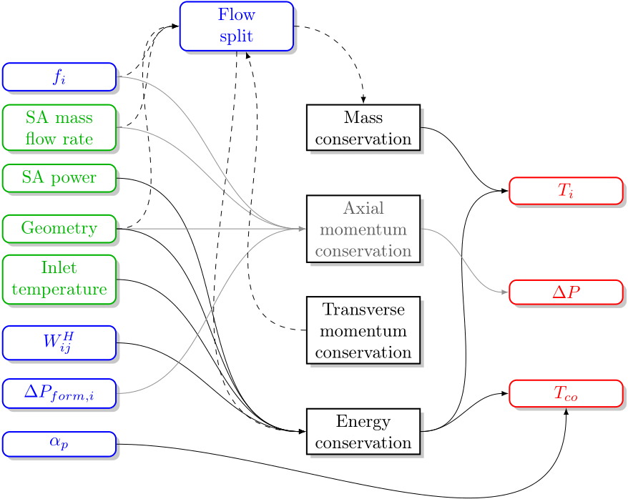
FIG. 1. Representation of the link between all the input (green) and models (blue) parameters to the defined target quantities (red) in ANTEO+.
Figure 1 allows to better grasp the main physical phenomena affecting each target quantity, and it is seen that:
- the SC temperature is influenced, via the energy equation, by the flow split and coolant mixing models (via $W_{ij}^{H}$), the former deciding the mass flow rate of each SC, while the latter the degree of energy exchanged between neighbouring SCs and thus how the energy discharged by the pins is distributed in the assembly cross-section. In the anticipated field of application (Section 3.2.1) the flow split model is generally more impacting than the mixing one, the latter only acting as a feedback mechanism in response to gradients in power and/or flow among SCs, while the former directly impact the SC temperature increase. Typically, only in situations strongly falling into the mixed convection regime mixing can become as important as flow split;
- the clad outer temperature is directly impacted by the SCs temperature surrounding the pin and by the model employed for the heat transfer coefficient. Since the former has been already discussed focus is here on the latter. Generally, the axial temperature increase (i.e., inlet-outlet) in a SC is higher than the radial one (i.e., coolant-clad) making the contribution of $α_{p}$ less important than the SC temperature increase. Only in peculiar situations with low power-to-flow ratios and (relatively) high heat fluxes the two phenomena can become comparable in magnitude;
- the bundle pressure drops are influenced, via the axial momentum equation, by the bundle friction factor and the concentrated pressure drops models. In almost all cases of interest, friction is the dominant contributor indeed, form pressure losses – mainly due to grid spacers (if present) – intimately depends on the specific design adopted but are generally set up to be low.

Influential parameters (d)
The next step is the breakdown of the most influential parameters governing each of the main physical phenomena previously identified. Going into the details of all of them is beyond the scope of this paper so in the following only the example case of the SC temperature is discussed (a summary of which is reported in Figure 2).

Flow split
The flow split model, originating from the simplification of the transverse momentum equation, mainly depends on the geometry and the bundle friction factor.
Geometry comes similarly into play also in the friction factor so it can be included in the latter for the sake of the discussion. Moving thus to the friction factor, it depends on the bundle geometry and flow conditions. In particular, the geometry-based influential parameters are:
- the type of lattice of the pins (either square or hexagonal for ANTEO+);
- the number of pins in the bundle;
- the pin pitch-to-diameter ratio ($P/D$);
- the minimum pin axis-wrapper distance-to-diameter ratio;
- the wire spacer lead pitch-to-pin diameter ratio (if present).
Flow conditions instead are principally described via the a-dimensional Reynolds’ number (Re), at least as long as the regime does not tend to the free convection (outside the code field of application however). Quantitatively, this means that the $Y_{mix}$ parameter defined as the ratio of buoyancy forces and fluid inertia (i.e., the ratio of the Grashof’s and Reynolds’ numbers) is below 100 [2].

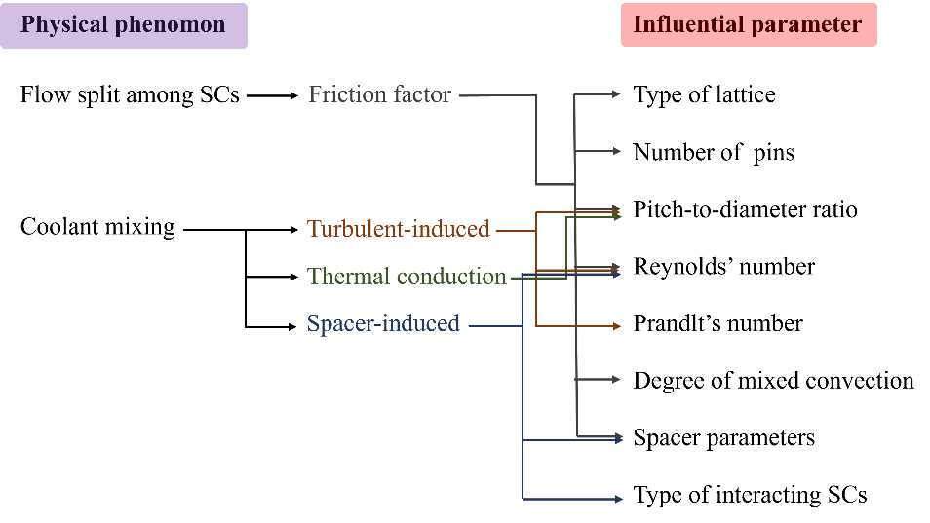
FIG. 2. Breakdown of physical dependencies for the SC temperature in ANTEO+.

Coolant mixing
In ANTEO+ the energy exchange among SCs is composed of three contributions:
- the turbulence-induced mixing;
- mixing due to thermal conduction;
- the flow sweeping mixing due to the swirling of the wire spacer (if present) around the pin.
Turbulent mixing is mainly influenced by geometry, flow conditions and the nature of the fluid: (i) although geometry should be considered as generally as depicted for the friction factor due to the complexity of the phenomenon and the less experimental knowledge available, models are usually dependent only on the $P/D$ which is related to the gap among pins and thus the shared area for exchange; (ii) flow conditions are summarized via the Reynolds’ number, historically known for regulating turbulence related phenomena; (iii) the fluid’s nature is quantified via the Prandlt’s number (Pr) establishing the degree to which eddy diffusivity contributes to energy transfer.
The mixing component due to thermal conduction is modeled via the conduction shape factor. Since it is a correction for considering the lumped nature of the SC approach, in which a finite difference between adjacent SCs can entail large errors, the dependency is mainly geometrical, especially via the distance among SC barycenter and thus, ultimately, the $P/D$ ratio.
Finally, the flow sweeping due to the wire spacers depends on the geometry and flow condition. The latter is, as usual, described by Re, the former is, on the other hand, a mixture of wire spacers and bundle geometric parameters. Given the peculiarities of near-wall SCs relative to the inner ones, e.g., the wire sweeps only in one direction, the type of interacting SCs can be also considered an influential factor.

Validation domain (e)
With logics similar to the one exposed in Section 4.4 is possible to retrieve all the influential parameters for each target quantity, this enables the specification of the validation domain via a direct comparison with the available experimental data. This is true for both the separate effects and integral validation cases.
For separate effects validation of each main physical phenomena, an extremely wide array of data has been used, spanning several thousands of single measurement points across hundreds of different bundles; this makes their presentation in the context of this paper out of scope and so, hereafter, focus is directed towards the integral validation case.
A number of relevant facilities have been used trying to cover as uniformly as possible the envisaged field of application of the code. Focusing again on the sole SC temperature, for conciseness, the used (integral) database, in terms of spanned influential parameters, is reported in Table 2 where it is seen that it consists of 9 experimental bundles for a total of 1136 experimental points. Both hexagonal and square arrangements are encompassed as well as grids- and wire-spaced bundles, also several different coolants are included ranging from the very low Pr of sodium to the higher one of lead-bismuth and sodium-potassium (used as a simulant of lead) eutectics.

TABLE 2. LIST OF EXPERIMENTAL FACILITIES USED FOR THE SC TEMPERATURE VALIDATION

Ref. | Coolant/Pr | $$N_{pin}$$ | $$P/D$$ | $$H/D$$ | Re ($∙{10}^{3}$) | $$Y_{mix}$$
Hexagonal bundles
[5] | Sodium/0.004 | 19 | 1.243 | 52.2 | 1.3-89.9 | 0.09-1.13
[6] | Sodium/0.004 | 37 | 1.210 | 47.2 | 0.9-11.9 | 0.07-0.52
[7] | Sodium/0.004 | 61 | 1.243 | 52.2 | 1.1-80.4 | 0.32-0.51
[8] | Sodium/0.004 | 61 | 1.082 | 7.70 | 0.5-13.0 | 0.30-0.41
[9] | Sodium/0.004 | 91 | 1.067 | 11.4 | 0.6-3.3 | 0.27-0.29
[10] | Lead-Bismuth/0.02 | 19 | 1.279 | 40.0 | 37.9 | 5.47
[11] | Lead-Bismuth/0.02 | 37 | 1.800 | grids | 15.4 | 1000
[12] | Lead-Bismuth/0.02 | 61 | 1.116 | 25.0 | 3.4-49-8 | 1.46-22.70
Square bundles
[13] | Sodium-Potassium/0.02 | 25 | Variableª | grids | 53.4 | 5.74-7.14
ª Pins with different diameters are present so pitch-to-diameter ratio varies between 1.250 to 1.458.

Validation results (f)
Simulating each experiment available, it was possible to retrieve the code uncertainty for each main phenomena (in the separate effect validation framework) and target quantity (in the integral validation framework). The separate effect validation was also exploited for determining, in a variety of situations, the best correlations and models, among the one implemented in the code, so to use them in the subsequent integral validation step (see correlations label written in bold in Table 2 a s a general guideline).
Again, for compactness, only results for the SC temperature will be investigated explicitly. A graphical summary of the calculation-to-experiment comparison is depicted in Figure 3, where the quantity reported is the normalized SC temperature increase ($Δ\tilde{T_{i}}$) defined as
$Δ\tilde{T_{i}}=\frac{T_{i}-T_{inlet}}{T_{outlet}-T_{inlet}}$ , | (5)
where $T_{inlet}$ and $T_{outlet}$ are the bundle averaged coolant temperature at the inlet and outlet sections, respectively. $Δ\tilde{T_{i}}$ has been selected as the reference quantity for uncertainty quantification since it really represents the contribution of the code to the total definition of $T_{i}$, purged from the external factors coming from the boundary conditions (i.e., $T_{inlet}$), and in line with the target quantity definition in Section 4.2
In Table 3 a statistical summary of ANTEO+ performances in the whole validation domain is reported. It is seen the overall good behaviour of the code which shows only a very small bias (-0.3%) and an acceptable standard deviation (6.71%), if compared with the typical measurement uncertainties of the order of (5%), and considering the high variability of both geometries and physical conditions included in the used database. Clearly, if the specific application covers only a fraction of the overall domain spanned in the validation, uncertainties could be retrieved for that specific area so to have a more faithful representation of the accuracy to be expected by the code.

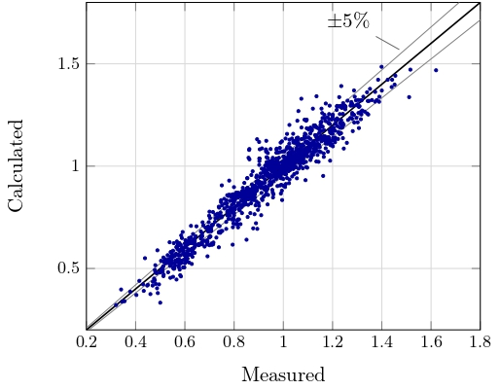
FIG. 3. SC temperature validation results. The plotted quantity is the normalized temperature increase of a SC.

TABLE 3. SUMMARY OF SC TEMPERATURE VALIDATION OF ANTEO+

Average relative error  [%] | Standard deviation (σ)  [%] | Confidence^{b} (1/2/3 σ)  [%]
-0.30 | 6.71 | 5.87/14.38/25.62
^{b} The absolute value of the relative error under which falls the 68% (1σ), 95% (2σ) and 99.7% (3σ) of the data.

CONCLUSIONS
The ANTEO+ SC code is in its qualification phase so to support the design of the ALFRED reactor in lieu of its licensing in Romania. In line with guidelines available in the European framework a rigorous approach has been followed for establishing the confidence in the code predictive abilities in a number of situations of foreseen interest and for defining via a physically based process the boundary of the validation domain.
In this paper the practical application of the followed procedure has been demonstrated exploiting the SC temperature parameter, one of the most important outcomes of any thermal-hydraulic code tackling the fuel assembly scale. The process has been depicted from the definition of the application field until the retrieval of the integral uncertainty (in terms of relative error and confidence intervals) to be associated to the simulation of the code.
The more case dependent details of the procedure will of course be fine-tuned via a dialog with the pertinent regulatory body.
References
- ALEMBERTI, A. et al., ALFRED reactor coolant system design, Nuc. Eng. Des. 370 (2020) 110884.
- LODI, F. et al., Extension of the sub-channel code ANTEO+ to the mixed convection regime, Nuc. Eng. Des. 322 (2017) 368-378.
- LODI, F. et al., ANTEO+: A sub-channel code for the thermal-hydraulic analysis of liquid metal cooled systems, Nuc. Eng. Des. 301 (2016) 128-152.
- ASN., Qualification des outils de calcul scientifique utilisés dans la demonstration de sûreté nucléaire- 1re barrière, Guide N°28, 2017.
- FONTANA. M.H. et al., Temperature distribution in a 19-rod simulated LMFBR fuel assembly in a hexagonal duct (fuel failure mockup bundle 2a) – record of experimental data, ORNL TM-4113, 1973
- NAMEKAWA, F. et al., Buoyancy effects on wire-wrapped rod bundles heat transfer in an LMFBR fuel assembly, in AlChE Symposium Series, pp. 128-133, Niagara Falls, 1984.
- MORRIS, R.H. et al., Single phase sodium test in 61-pin full-length simulated LMFBR assembly – record of phase 1 experimental data for THOR bundle 9, ORNL TM-7313, 1980.
- ENGEL, F.C. et al., Characterization of heat transfer and temperature distributions in an electrically heated model of an LMFBR blanket assembly, Nuc. Eng. Des. 62 (1980) 335-347.
- RAMEAU, B., MENANT, B., Sodium thermal hydraulics under natural and mixed convection in bundle geometry, ASME winter annual meeting, (Proc. Int. Conf., New Orleans, 1984), ASME.
- PACIO, J. et al., Thermal-hydraulic study of the LBE-cooled fuel assembly in the MYRRHA reactor: experiments and simulations, Nuc. Eng. Des. 312 (2017) 327-337.
- MARTELLI, D.et al., HLM fuel bundle experiment in the CIRCE pool facility, Nuc. Eng. Des. 292 (2015) 76-86.
- LYU, K. et al., Preliminary thermal-hydraulic sub-cannel analysis of 61 wire-wrapped bundle cooled by lead bismuth eutectic, Ann. Nuc. En. 92 (2016) 243-250.
- ZHUKOV, A.V. et al., Specification of the benchmark problem “hydraulics and heat transfer in the model pin bundles with liquid metal coolant”, in Hydrodynamics and heat transfer in reactor components cooled by liquid metal coolants in single/two-phase, IAEA Report, pp. 138-172, 2004.

With a similar argument brought forward for the concentrated pressure losses, if a grid spacer is present a dedicated validation is necessary for the specific design adopted.
More precisely it is the turbulent Prandtl’s number which however depends on the standard Prandtl’s number.

