Numerical analyses of the CIRCE-THETIS facility by mean of STH and CFD codes

P. STEFANINI

Università di Pisa, Dipartimento di Ingegneria Civile e Industriale

Pisa, Italy

Email: p.stefanini@studenti.unipi.it

A. PUCCIARELLI

Università di Pisa, Dipartimento di Ingegneria Civile e Industriale

Pisa, Italy

Email: andrea.pucciarelli@unipi.it

N. FORGONE

Università di Pisa, Dipartimento di Ingegneria Civile e Industriale

Pisa, Italy

Email: [nicola.forgione@unipi.it](mailto:nicola.forgione@unipi.it)

I. DI PIAZZA

Enea Brasimone

Camugnano, Italy

Email: [ivan.dipiazza@enea.it](mailto:ivan.dipiazza@enea.it)

D. MARTELLI

Enea Brasimone

Camugnano, Italy

Email: daniele.martelli@enea.it

**Abstract**

During the last decade the European Union funded numerous projects with the aim to pave the way for the development of Gen IV reactor technologies. The recently started EU project PATRICIA, to which the University of Pisa participates, provides room for further investigations of the involved phenomena (e.g. thermal stratification inside the pool, LBE heat transfer capabilities, transition from forced to natural circulation) by means of both experimental and numerical analyses. In the frame of the PATRICIA project, the ENEA Brasimone research centre foresees to carry-out an experimental campaign involving the CIRCE facility. The facility will be updated substituting the steam generator, which will exhibit an helicoidal steam generator configuration (THETIS): the experimental campaign will involve the analysis of steady-state and postulated accidental scenarios. The University of Pisa will provide numerical support both in the pre-test and post-test phases to assist the design of the experiment. This work reports about the preliminary results obtained by numerical simulations of the CIRCE-THETIS facility. The analyses were performed both using CFD codes (ANSYS Fluent) and STH codes (RELAP5-3D). The analyses mainly focused on temperature and velocity distributions inside the CIRCE pool during the postulated nominal steady-state conditions. Also, a transient analysis was performed investigating the behaviour of the addressed facility in case of a PLOFA scenario. The limits and capabilities of both the approaches were observed and are discussed in the present work trying to provide guidelines for a correct application of the adopted codes. The obtained results provide interesting suggestions for the experimentalists and represent a valuable support in better setting the experimental conditions and measurements tools layout, e.g. the need to isolate the fitting volume preventing excessive heat losses from the loop towards the pool. In the frame of future works, further analyses will be performed also trying to develop coupled STH/CFD application.

## INTRODUCTION

Obtaining a good representation of the phenomena involved in liquid metals thermal-hydraulics (e.g. thermal stratification inside the pool, LBE heat transfer capabilities, transition from forced to natural circulation) still represents one of the key issues to be solved for the development of the upcoming GEN IV Liquid Metal Fast Reactors (LMFRs). Liquid Metals (LM) used as coolant represent a further step in terms of safety and efficiency [1][2] for new nuclear power reactors. From a neutronic point of view LM present a low moderation capability, this allows to exploit a fast neutron spectrum, enabling for burning long-lived fission products and for breeding reactions. For these reasons, in the last decade many EU projects aimed to develop this technology by means of both experimental and numerical analyses (e.g. PATRICIA [3], MYRTE [4] and SESAME[5]). Among the main purposes of these projects there were the analysis of heat transfer capabilities of liquid metals and the investigation of the chance of adopting passive heat decay heat removal systems. Several facilities were established in order to support the common effort, e.g. TALL-3D [6] , E-SCAPE [7] and CIRCE [8]

In the frame of ongoing PATRICIA EU [3] project, the ENEA Brasimone Research centre foresees to carry-out an experimental campaign involving a new configuration for the CIRCE facility: a new steam generator with a new helical coil design, named THETIS, will be installed inside the already existing CIRCE-pool[8]. Further modifications will be applied to the loop side, forced circulation will no more be achieved through the Argon injection system, which will be substituted by a Main Coolant Pump (MCP)[8].

In the present paper, the thermal-hydraulic analysis of the new CIRCE-THETIS configuration is performed. The analysis was carried on by means of STH and CFD codes: in particular, RELAP5-3D was used as STH code[9] and ANSYS Fluent[10] for what concerns the CFD part. The two codes were also adopted in a previous analysis which provided a preliminary validation of the modelling tools. This process of validation was performed by simulating the old CIRCE-HERO configuration[11] with the two codes and comparing the obtained results with available experimental data[12]. Particular attention was mainly paid to the assessment of the capabilities of the considered codes in reproducing the thermal stratification phenomena occurring inside the pool.

During the previous steps of this work[13], mesh validation and sensitivity analyses were performed, good results were obtained, thus providing a sound base for the application of the considered modelling techniques even to the CIRCE-THETIS configuration[8].

Two reference cases for the CIRCE-THETIS facility were thus studied[14]: a steady-state case, considering the foreseen nominal operating conditions, and a possible transient scenario. In the RELAP5-3D application the CIRCE-pool was simulated as a 3D component while the other loop components were kept mono dimensional. For this code, a closed loop was considered in order to investigate the postulated transients. For the CFD, instead, an open loop was considered and, for the transient, only the final steady state conditions were simulated, in similarity with the CIRCE-HERO campaign carried on during the MYRTE project. Being pre-test analyses, the boundary conditions for the final steady state for the CFD simulation were provided via precursor calculation by RELAP5-3D: the STH results were in fact used as a basis for the definition of the boundary conditions for the CFD simulation.

## FACILITY DESCRIPTION AND CONSIDERED EXPERIMENTAL CONDITION

CIRCE is an integral effects test facility made of AISI 316L stainless steel designed to hold about 70 tons of Lead-Bismuth Eutectic alloy (LBE); the pool includes a primary circuit that allows for natural and forced circulation of the LBE. The primary loop is composed by a feeding conduit, a Fuel Pins Simulator (FPS), a Fitting Volume (FV), the Main Coolant Pump (MCP), the Riser, the Separator, and the new HeliCoidal Steam Generator (HCSG)[8]. FIG. 1 shows the flow path of the LBE inside the loop: LBE enters in the FPS region from the Feeding conduit; here it is heated up by the electrical heaters of the FPS. Once it reaches the top part of the FPS, the LBE enters inside the FV where it is collected and directed towards the Riser, the MCP and the Separator. After the Separator, the LBE’s flows downward inside the steam generator, where it is cooled down by water and steam, flowing inside the helical pipes.



*FIG. 1. Full view of the flow path and the main component of CIRCE-THETIS facility, taken from [8]*

The secondary side is composed of a once-through loop where pressurized water at 18 MPa enters inside the loop and superheated steams exits. The THETIS steam generator is composed of an outer shell where LBE flows and 15 helical pipes arranged in three ranks, where water and steam flow. The pipes have an active length of about 6 meters and based on a design evaluation THETIS is foreseen to be able to exchange about 450 kWth in the planned operating conditions.

In the present paper a steady state scenario and a postulated transient were considered for the numerical analyses; the operating condition reported by ENEA[14] resumed in the Table 1 and Table 2 were considered as reference.

TABLE 1. NOMINAL STEADY STATE BOUNDARY CONDITION

|  |  |  |
| --- | --- | --- |
| Reference case | unit | Value |
| Tpool | °C | 400 |
| FPS power | kW | 450 |
| mflowLBE | kg/s | 35.17 |
| mflowwater | kg/s | 0.26 |
| Pressure H2O | bar | 180 |
| Th2o | °C | 335 |

TABLE 2. POSTULATED TRANSIENT

|  |  |  |  |
| --- | --- | --- | --- |
| Transient | Time starts | Time end | Final value |
| Scram | 0 s | 240 s | 5%* |
| Feed water reduction | 0 s | 3 s | 10% |
| MCP reduction | 1 s | 11 s | 0% |
|  |  |  |  |
| *The reduction follows the decay heat curve | | | |

## ADOPTED NODALIZATION AND MESH SETTING

### RELAP5-3D nodalization

The STH code RELAP5-3D was used for the performed analyses. With respect to the RELAP5/Mod3.3 adopted in previous works[15], this code allows the user to simulate 3D components. In this analysis, only the pool was represented by a 3D pipe, while the internal loop was modelled using 1D thermal-hydraulics components. The pool was represented as a 3D pipe having 6 azimuthal subdivisions, 4 radial subdivisions and 50 axial subdivisions; inside the pool, volume factors were considered; to take in account, the volume occupied by the internal loop elements. The volume factors were calculated in accordance with the horizontal surface ratios as depicted in FIG. 2, showing the most relevant pool sections. It must be stressed that for the new geometry of the HCSG THETIS, no heat transfer correlations for helical tubes are implemented inside the code; this aspect is to be better investigated in the frame of future works, which will also consider the chance to implement heat transfer correlations specific for the addressed geometry. The new HCSG was here represented as an annulus component for the LBE side, while the helical pipes, where water and steam flow, were represented as a single inclined pipe having the same flow area and the active length of the 15 tubes. The elevation of the pipe was set equal to the real elevation of the steam generator being 1.5 m. This type of scheme is widely used in literature[16][17]. A scheme of the nodalization adopted for the steam generator tubes is shown in FIG. 3.

FIG. 2. Scheme of the considered volume factor inside the 3D pool

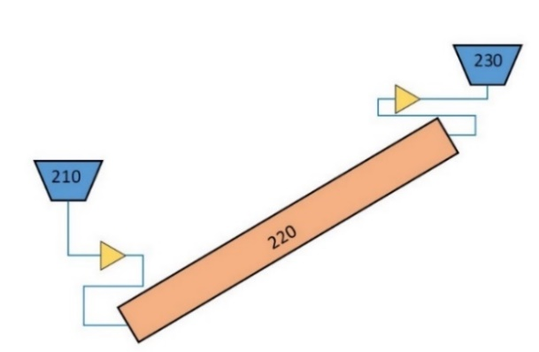

FIG. 3. Nodalization for the helical pipe adopted

Aiming to represent the postulated transient, a closed loop was simulated. No cover gas is present in the top part of the pool because the presence of gas inside a 3D component impairing the stability of the calculation. A scheme of the loop is reported in FIG. 4. It must be stressed out that for RELAP5-3D, no axial heat conduction, neither azimuthal nor radial, are present, this imply that the heating up of the pool occurs only thanks to the convection: the hotter fluid is collected in the upper region due to buoyancies forces and it is almost thermally insulated from the colder fluid in the bottom part. This may also imply problems when heat transfer towards the environment is considered: the colder region at the bottom of the pool would thus be cooled down until it reaches the room temperature, resulting in a nonphysical meaning. For this reason, no heat exchange towards the environment is assumed at the pool external boundaries for this preliminary analyses. This contribution will instead be considered in future works in order to better comply with the actual experimental conditions; as a further remark, the ongoing analyses seem supporting the results reported in the present paper, thus suggesting that at least the main phenomena were already sufficiently well captured even with the presently considered assumptions.

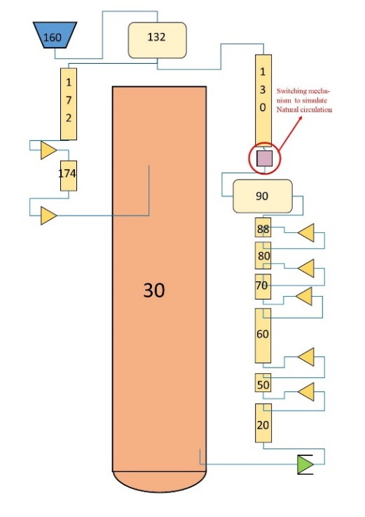

FIG. 4. Closed loop representation

FIG. 5 reports the scheme of the component highlighted FIG. 4 by a red circle, it is a switching mechanism composed by two motor valves and a time dependent junction, acting like the MCP, and a single junction. This tool was introduced to allow the transition between forced circulation, provided by the MCP, and the Natural circulation, which occurs once that the MCP is completely switched off during the initial seconds of the postulated transient.

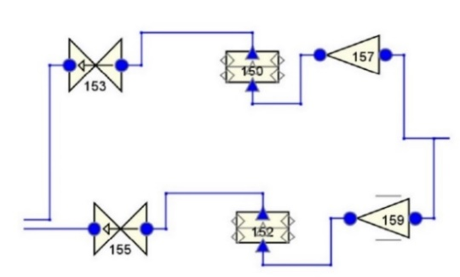

FIG. 5. Switching mechanism

### CFD Mesh Setting

CFD simulations were performed adopting ANSYS Fluent because of the good experience gained at the University of Pisa in the frame of previous works (see e.g.[18]-[19]) and since it represents one of the cornerstones of the coupled STH/CFD methodology developed at UniPi ([20]-[22]). The present work also focuses on the prediction of possible thermal distributions occurring inside the CIRCE pool. In the present work, in order to reduce the computational costs, the CFD domain only consists of the pool, thus excluding the internal components of the loop and the external wall of the vessel. It must be stressed that for this CFD application the reference nominal steady state condition was simulated, while for the postulated transient, only the final steady state was considered deriving the corresponding boundary conditions from the STH simulation, in which the entire transient was instead simulated.

FIG. 6 shows the boundary conditions applied to the CFD domain: an imposed mass flow rate, equal to nominal condition[14] for the steady state case, was set at the THETIS outlet while for the transient the value was set in accordance with what RELAP5-3D predicted. The heat exchange trough the FPS and FV walls was simulated through a convective heat transfer condition. It must be stressed that the wall temperature profile imposed on the heated region, being a pre-test analyses, was set in accordance with the STH predictions. In this sense, data from RELAP5-3D was used as a precursor simulation for ANSYS Fluent. A convective heat transfer coefficient of 3500 W/m2K was derived by calculating the equivalent resistance between the internal loop and the pool environment. Eventually, heat transfer towards the environment was also included in the model: a heat transfer coefficient of 2.5 W/m2K and a room temperature of 298.15 K were taken as reference, in accordance with previous works on the same facility [23]. For what concerns the adopted mesh, the settings were selected in accordance with previous works performed at the University of Pisa[18]-[19], thus guaranteeing the suitability of the obtained mesh. Following other works in this field[18]-[19], calculations were performed adopting the SST-k-ω turbulence model, which seems to be among the most reliable ones for this kind of applications; a turbulent Prandtl number of 1.5 was also assumed, in accordance with the vast majority of the works proposed in the available literature [19]-[23]. Table 3 resumes the main settings for the Fluent mesh, while FIG. 7 shows the obtained nodalization for three selected sections of the pool. Though the considered assumptions may look relevant, the ongoing calculations considering a domain simulating the whole facility (pool, loop, structures …) support the results provided hereinafter, thus suggesting, again, that the main phenomena were already sufficiently well captured even with the presently considered assumptions.

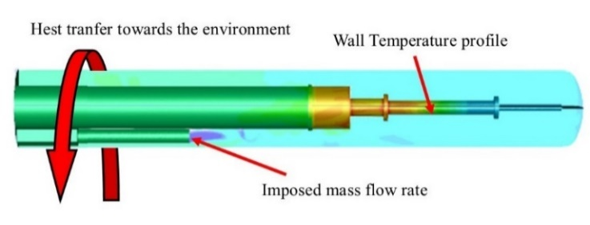

FIG. 6. Boundary conditions for THETIS

TABLE 3. CFD Mesh Setting

|  |  |  |
| --- | --- | --- |
| Fluent setting | Value | |
| Element Size | | 0.02 m |
| Capture proximity | | 0.001 |
| Prism stretching | | 1.5 |
| Number of layers | | 10 |
| Prism thickness | | 0.02 m |
| Total number of cells | | 16607353 |

FIG. 7. Obtained mesh for the pool environment

## RESULTs

### Test Reference - Nominal steady state

The present section reports results obtained for the considered steady-state case from the two selected codes. Comparing the results from CFD and STH codes, differences in the range of 15°C can be noted for the predicted temperature field inside the pool. In fact, FIG. 8 shows that the two codes predict different behaviours for the thermal stratification inside the pool: the cold region below the THETIS outlet in RELAP5-3D reports a larger penetration capability with respect to the one predicted by the CFD. In FIG. 9, instead, the temperature profile predicted inside the pool by the two codes is reported. As it can be noted, RELAP5-3D predicts a much lower mean temperature compared to the CFD results even in the assumed absence of heat transfer toward the environment. It must be pointed out that the temperature profile used as boundary conditions for the CFD was obtained from the STH calculation: the temperatures predicted by CFD for the pool seems to be much higher with respect to the one provided by RELAP5-3D. The higher temperatures predicted by CFD are mainly due to the large heat transfer, in the range of 100 kW, predicted between the pool and the Fitting Volume. This phenomenon did not occur in the previous CIRCE-HERO configuration chiefly owing to the different positioning of the SG outlet. This result was considered relevant by the experimentalists who decided to improve the isolation of the FV in order to prevent the predicted large heat transfer thus supporting the importance of the performed work. As a final remark, at the present stage of the work, even if not matching the obtained predictions may be considered sufficiently close, the mean pool temperatures provided by the two codes differ by about 10°C and the results provide at least an idea of the phenomena which may occur inside the pool.

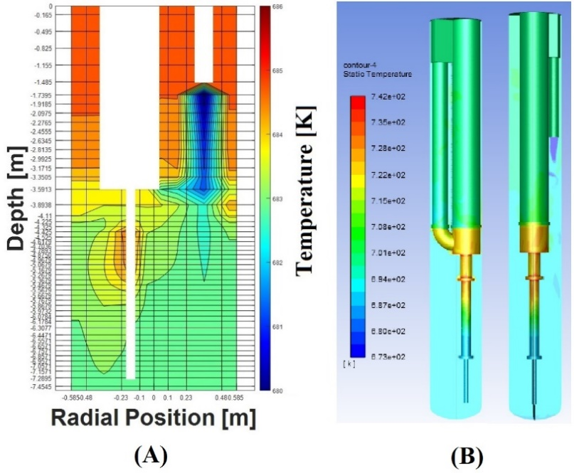

FIG. 8. Comparison between CFD and STH results for the steady state condition

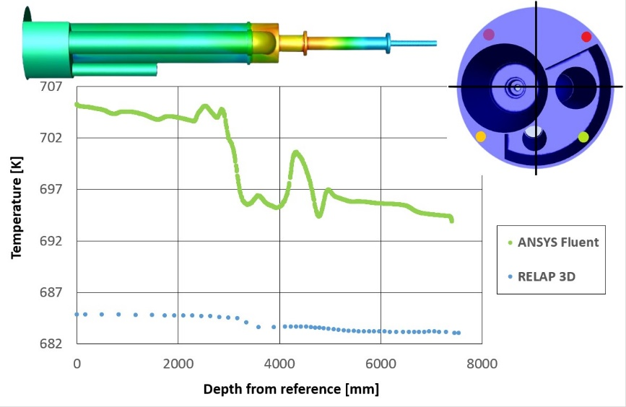

FIG. 9. Test reference results

Looking at the velocity fields predicted by both the codes, a relevant difference can be highlighted. FIG. 10 shows that the velocities predicted by the STH code are much higher than the ones predicted by CFD. This difference is probably due to the lack, in the STH code, of shear forces that enhance the radial diffusion of the fluid. In the STH code, in fact, the LBE jet can easily reach the bottom part of the pool and goes directly towards the FPS inlet, as pointed out by the blue light branch at the bottom left of the FIG. 10a. All the mixing phenomena reported by CFD (FIG. 10b) are completely absent in the RELAP5-3D prediction. This fact suggests that the STH code seems not able the well manage the present configuration of the CIRCE-pool. This limited capability is probably connected with the positioning of the steam generator outlet at the top of the pool. In the previous CIRCE-HERO facility, instead, with a steam generator outlet section located at the bottom of the pool, the CFD and STH prediction were in better agreement.

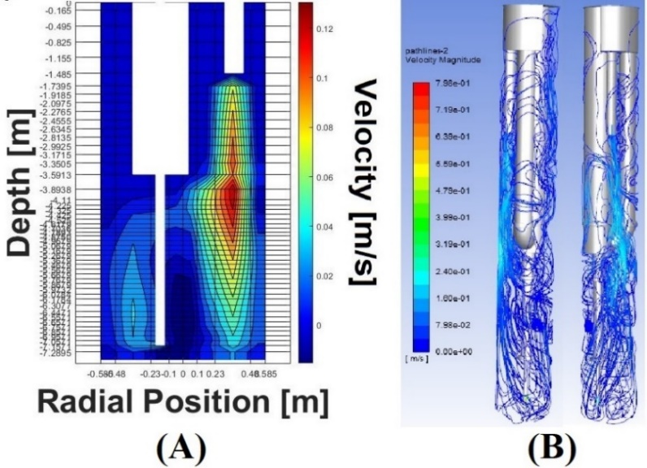

FIG. 10. Velocity field predicted by STH and CFD codes for the steady state conditions

### Postulated Transient

The postulated transient starts from the reference steady-state condition reported in the previous section, the transient calculation performed with RELAP5-3D suggests that about 50000s are required to reach these steady-state conditions. Once steady-state conditions were reached in the pool, the incidental scenario starts: feedwater flow rate is reduced, and the pump is switched off in 10s starting with one second of delay with respect to the power scram; the power supplied at the FPS is instead reduced following a postulated decay heat curve reported in Table 4. The simulation ran until the new steady-state condition was reached for the loop side. In FIG. 11 it is reported the temperature behaviour for the HX-outlet and for the FPS inlet and outlet sections. As it can be noted, once the transient begins, temperature drops following the FPS power decrease. It must be pointed out that, for the LBE temperature at the exit of the SG, a peak is reported. This phenomenon is due two main factors: the reduction in the feedwater mass flow rate (almost instantaneous) and the reduction in the power supplied at the FPS, which is experienced instead with a certain delay at the steam generator. In fact, the cold front, coming from the FPS takes about 120 seconds to reach the SG inlet, in the meantime a temperature increase at the outlet section of the steam generator temperature is experienced since, owing to the almost instantaneous feedwater mass flow rate reduction, the steam generator is no more able to remove the nominal thermal load.

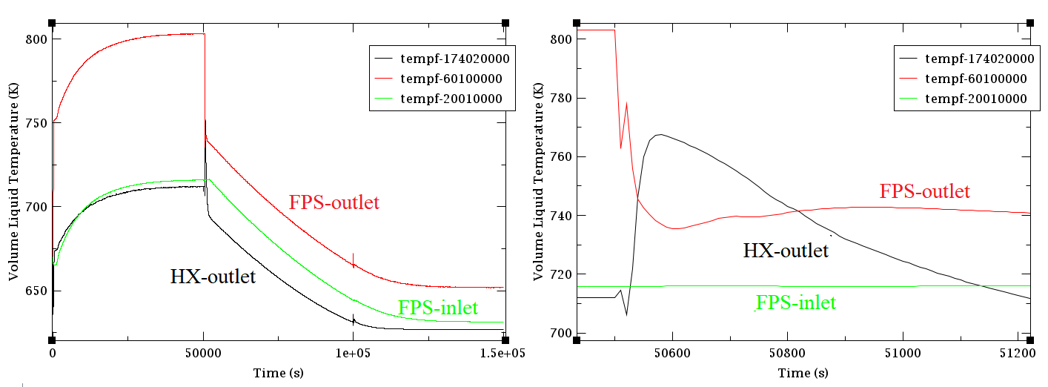

FIG. 11. Temperature profile predicted by RELAP5-3D (transient starts t=50000s)

TABLE 4. Decay heat curve

|  |  |  |
| --- | --- | --- |
| Time (s) | Power % | |
| 0 | | 100 |
| 1 | | 25 |
| 2 | | 22 |
| 3.5 | | 19 |
| 5 | | 17 |
| 10 | | 15 |
| 22.5 | | 10 |
| 30 | | 9 |
| 50 | | 8 |
| 60 | | 7 |
| 90 | | 6 |
| 180 | | 6 |
| 240 | | 5 |

Looking at the temperature predicted by RELAP5-3D for the pool in FIG. 12a, it is clear, that for this code, the absence of axial conduction limits its capabilities. It can be noted that the hot LBE is collected in the top part of the pool, due to buoyancies forces, and in that position, it is almost thermally insulated from the colder region in the bottom part.

In the CFD results, FIG. 12b, it can be noted that the temperature is more homogeneous, a colder region can be spotted in the lowest part of the pool. The reasons of the presence of this region can be understood looking at the velocity fields predicted by the CFD and reported in FIG. 13b. As a consequence of the reduced mass flow rate experienced at the SG outlet at the final steady-state, the flow jet exiting THETIS is weak, hance the mixing phenomena is suppressed and stagnant LBE is collected in the bottom region of the vessel. In fact, most of the fluid is moved by convective motions that take place due to the heating from the FPS, while only a small portion of fluid reaches the bottom following a swirling motion. As consequence the fluid in the lower part of the pool is almost stagnant and turns to be colder because of the heat exchange towards the environments through the external wall.

FIG. 13a, points out, instead, the difficulties for RELAP5-3D to deal with large 3D environments. Even in this case, the LBE jet exiting THETIS easily reaches the bottom part of the pool, underling the wrong managing of viscus forces of the fluid itself. Being convinced that the CFD approach should be the most reliable for addressing the considered operating conditions, it thus seems that RELAP5-3D, while having shown success for other conditions, especially for thermal stratification in the CIRCE-HERO configuration[13], should not be instead suitable for this application.

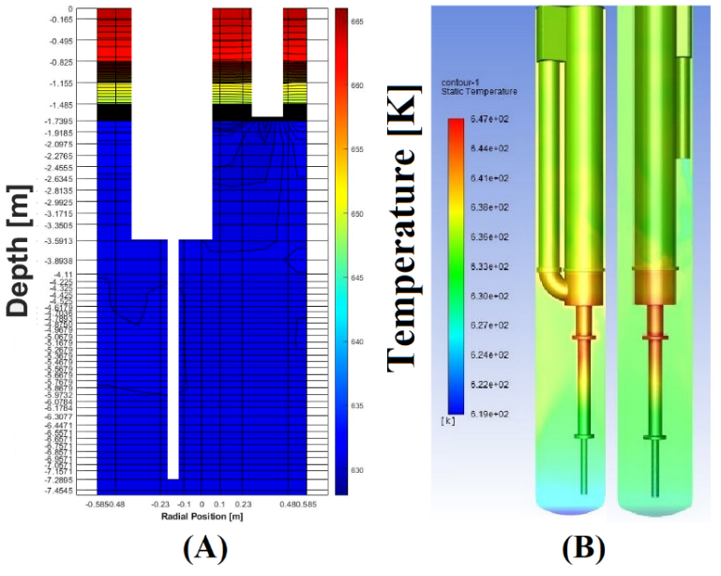

FIG. 12. Pool behaviour predicted by STH (A) and CFD (B) code (final steady state t=1.5*106s)

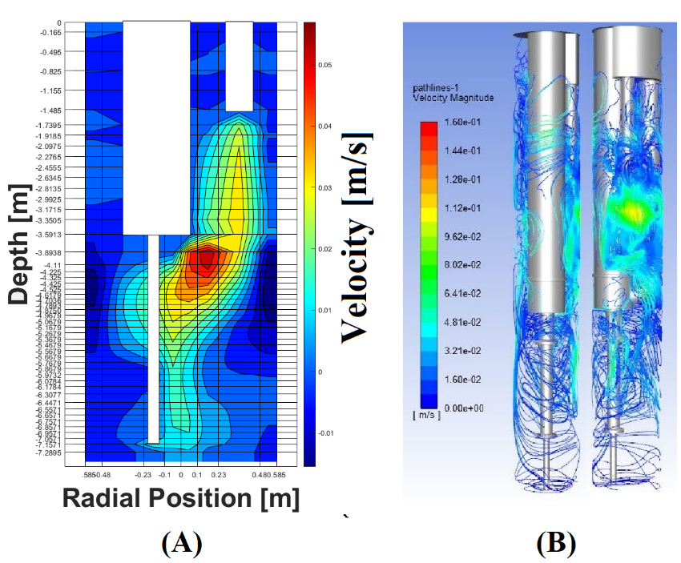

FIG. 13. Velocity field predicted by STH (A) and CFD (B) codes for the postulated transient (final steady state t=1.5*106s)

## Conclusion

In the present paper, pre-test analyses for the new configuration of the CIRCE test section were performed. With respect to the old configuration, the new SG, named THETIS, presents a higher outlet section elevation and a more compact design. According to the performed analyses, this should enhance the mixing phenomena inside the pool, weakening (but not preventing) thethermal stratifications reported by the old configuration. As pointed out in the considered reference steady state case, in this new test section’s layout a milder temperature transition from the bottom to the top part of the pool was predicted with respect to the old CIRCE-HERO configuration[12].

Concerning the comparison of the results provided by the two codes, it must be pointed out that RELAP5-3D seems not to be able to well manage the addressed large 3D environment. Looking at the velocity field predicted by the STH code, it seems that the cold jet of LBE exiting the SG is not affected by the viscosity of the fluid itself and manages to reach the bottom of the pool with high velocity. This high velocity may trigger a venturi effect near the heated region, that drags the heated LBE towards the FPS inlet; this way the heating up of the pool results less effective, leading to the low temperature distributions observed in the results section.

The postulated transient was simulated only with RELAP5-3D, while for the CFD only the final steady-state after transient was considered, adopting as boundary condition the values provided by RELAP5-3D. As in the previous case, RELAP5-3D seems not able to well manage the viscous stresses inside the fluid itself, and again the LBE jet easily reaches the bottom part of the pool in contrast with the CFD prediction. In addition, lacking a model for pure axial conduction, in RELAP5-3D the hotter fluid is collected in the top part of the pool due to buoyancy forces and, once there, it remains almost thermally insulated by the colder fluid in the lower region, slowing down the cooling process of the pool.

Though the present work represents the first step in the pre-test analyses to be performed for the CIRCE-THETIS experimental campaign, the obtained results were already considered as relevant suggestions for the refinement of the test matrix and for the improvement of the experimental facility itself. The provided results will support the experimentalists in the positioning of the instrumentation and suggested the need of a better insulation of the FV in order to prevent large undesired heat transfer towards the pool. The analyses also suggest that, in this case, only CFD may provide suitable predictions of the pool environment, RELAP5 should thus be only considered for the internal loop. In this sense, in future works, together with a comparison of the numerical and experimental results, coupled STH/CFD calculations will be performed to better represent the interesting phenomena occurring inside the CIRCE-pool (CFD for the pool, STH for the loop and the secondary side) for both steady-state and transient conditions.

## acknoledgements

This project has received funding from the Euratom research and training programme 2019-2020 under grant agreement No 945077 in the frame of the PATRICIA project.

Reference

1. NUCLEAR ENERGY AGENCY, Handbook on Lead-bismuth Eutectic Alloy and Lead Properties, Materials Compatibility, Thermal hydraulics and Technologies, NEA No. 7268 © OECD 2015.
2. IRSN, 2012, “Overview of Generation IV (GENIV) Reactor Designs, Safety and Radiological Protection Considerations.”, IRSN Report 2012/158
3. PATRICIA, <https://patricia-h2020.eu/>
4. MYRTE Project, 2015 MYRTE Project (No. Grant Agreement N. 662186), 2015. EURATOM H2020.
5. SESAME <https://sesame-h2020.eu/>
6. GRISHCHENKO D., JELTSOV M., KÖÖP K., KARBOJIAN A., VILLANUEVA W., KUDINOV P., 2015. “The TALL-3D facility design and commissioning test for validation of coupled STH and CFD codes”, Nucl. Eng. Des. 290, 144-153
7. K. VAN TICHELEN, F. MIRELLI, “Experimental investigation of steady state flow in the LBE-cooled scaled pool facility E-SCAPE”, Proceedings of the 17th International Topical Meeting on Nuclear Reactor Thermal Hydraulics, Xi’an (China), September 3-8 (2017).
8. LORUSSO P., DI PIAZZA I., MARTELLI D., MUSOLESI A., TARANTINO M., 2021. PRELIMINARY DESIGN OF THETIS TEST SECTION FOR THE CIRCE FACILITY. Enea report for MYRTE, Ref CI-I-R353.
9. RELAP5-3D Code Manual, 2018, “RELAP5-3D code manual Volume I: Code structure, System models and solution methods”. INL/MIS-1-36723 2018
10. ANSYS, Inc., “ANSYS Fluent User’s Guide, Release 19.2”, August 2018.
11. PESETTI, A., FORGIONE, N., NARCISI, V., LORUSSO, P., GIANNETTI, F., TARANTINO, M., 2018, “ENEA CIRCE-HERO test facility: geometry and instrumentation description”, ENEA report for Project H2020 SESAME WP5.2, Ref CI-I-R-343
12. LORUSSO, P., PESETTI, A., TARANTINO, M., POLAZZI, G., SERMENGHI, V., “CIRCE Experiment report” ENEA report for Project MYRTE, Ref. CI-I-R-353, 2018.
13. STEFANINI P., 2021.Thermal Hydraulic Investigation of the CIRCE-THETIS Facility by the use of STH and CFD Codes, MSc Thesis in Nuclear Engineering, DICI, University of Pisa, Italy.
14. DI PIAZZA I., LORUSSO P., MARTELLI D., TARANTINO M., 2020. Experimental investigation of the transition between natural circulation modes in CIRCE. Kick-off meeting for PATRICIA, October 29th 2020 WP11-Task 11.11.
15. MOSCARDINI M., GALLENI F., PUCCIARELLI A., MARTELLI D., FORGIONE N., 2020. Numerical Analysis of the CIRCE-HERO PLOFA Scenarios.Applied Sciences 2020, 10, 7358.
16. XU Z., LIU M., XIAO Y., GU H. 2021. Development of a RELAP5 model for the thermo-hydraulics characteristics simulation of the helically coiled tubes. Annals of Nuclear Energy 153 108032.
17. LIAN Q., TIAN W., GAO X., CHEN R., QIU S., SU G.H., 2020. Code improvement, separate-effect validation, and benchmark calculation for thermal-hydraulic analysis of helical coil once-through steam generator. Annals of Nuclear Energy 141, 107333.
18. BUZZI, F., PUCCIARELLI, A., GALLENI, F., TARANTINO, M., FORGIONE, N., 2020, “Analysis of thermal stratification phenomena in the CIRCE-HERO facility”. Annals of Nuclear Energy, Volume 131, June 2020, 107320.
19. BUZZI, F., PUCCIARELLI, A., GALLENI, F., TARANTINO, M., FORGIONE, N., 2020, “Analysis of the temperature distribution in the pin bundle of the CIRCE facility”. Annals of Nuclear Energy, Volume 147, November 2020, 107717.
20. PUCCIARELLI, A., GALLENI, F., MOSCARDINI, M., MARTELLI, D., FORGIONE, N., STH/CFD Coupled simulation of the Protected Loss of Flow Accident in the CIRCE-HERO Facility Appl. Sci. 2020, 10, 7032.
21. A. PUCCIARELLI, F. GALLENI, M. MOSCARDINI, D. MARTELLI, N. FORGIONE “STH/CFD coupled calculations of postulated transients from mixed to natural circulation conditions in the NACIE-UP facility” Nucl. Eng. Des., 370 (15) (December 2020), Article 110913
22. A. PUCCIARELLI, A. TOTI, D. CASTELITI, F. BELLONI, K.VAN TICHELEN, M. MOSCARDINI, F. GALLENI, N. FORGIONE., Coupled system thermal Hydraulics/CFD models: General guidelines and applications to heavy liquid metals Annals of Nuclear Energy, vol. 153, April 2021, Article 107990
23. PUCCIARELLI, A., FORGIONE, N., MARTELLI., D., DOVIZIO, D., ZWIJSEN, K., MOREAU, V., LAMPIS, S., CIRCE Post-test CFD calculation report, Report D3.4 of the MYRTE project, Grant Agreement number: 662186 - Activity: NFRP-09-2015, 2019.