Development of Efficient AND Improved Core Thermal-Hydraulics Predictive Capability for Fast Reactors

Summary of research and development activities at the North Carolina State University

C. TAKASUGI¹, A. ALY¹, D. HOLLER¹, A. ABARCA¹, B. BEELER¹, M. AVRAMOVA¹, K. IVANOV¹

¹North Carolina State University, Raleigh NC 27695, USA

Email contact of corresponding author: knivanov@ncsu.edu

Abstract

The improved understanding of the safety, technical gaps, and major uncertainties of advanced fast reactors will result in designing their safe and economical operation. This paper focuses on the development of efficient and improved core thermal-hydraulics predictive capabilities for fast reactor modeling and simulation at the North Carolina State University. The described research and development activities include applying results of high-fidelity thermal-hydraulic simulations to inform the improved use of lower-order models within fast-running design and safety analysis tools to predict improved estimates of local safety parameters for efficient evaluation of realistic safety margins for fast reactors. The above-described high-to-low model information improvements are being verified and validated using benchmarks such as the OECD/NRC Liquid Metal Fast Reactor Core Thermal-Hydraulic Benchmark and code-to-code comparisons.

INTRODUCTION
The safety and reliability of nuclear power plant operation have always been a priority for the nuclear industry and its regulators. The development, validation, and application of efficient and reliable Modelling and Simulation (M&S) capabilities have historically played a crucial role in designing, licensing, and operation of the current generation of nuclear reactors and it is becoming equally essential for the design and licensing of small modular reactors and advanced reactor designs. Innovations in nuclear engineering and associated domain sciences, especially computer science and high-performance computing hardware, have enabled a wide range of high-fidelity applications letting the scientific and engineering community to gain insights into physical systems in ways not possible with traditional approaches alone. In the last few years, the combination of the relatively efficient traditional M&S with more costly novel high-fidelity simulations is raising in popularity as it is able to emulate the high-fidelity model at cheaper computational cost. To address the integration of high-fidelity and low-fidelity codes to predict quantities of interests in an efficient manner, a framework of High-to-Low (Hi2Lo) model informing procedures is usually utilized for each physics M&S in a reactor core and combined in multi-physics simulations. Such an innovative framework will likely improve the modelling of the local effects without compromising the computational costs and will result in more efficient and accurate predictions of safety parameters and margins. These developments are of high importance for both safety and performance improvements as well as for enabling the end users with credible and efficient tools for the design, analysis, and licensing of advanced nuclear systems. This framework will be able to provide in-depth analyses, and evaluations that will support an understanding of the safety, technical gaps, and major uncertainties of Fast Reactors (FRs). The improved understanding of the safety, technical gaps, and major uncertainties of advanced FRs will result in designing their safe and economical operation.
This paper focuses on the development of efficient and improved core thermal-hydraulics predictive capabilities for FR M&S at the North Carolina State University (NCSU) and closely related or supporting developments of FR neutronics and fuel performance modelling. The described research and development activities include applying results of high-fidelity thermal-hydraulic simulations to inform the improved use of lower-order models within fast-running design and safety analysis tools to predict improved estimates of local safety parameters for efficient evaluation of realistic safety margins for FRs. Due to their complexity, high-fidelity calculations are computationally expensive. This motivates the use of low-fidelity models, which are less comprehensive but provide numerical efficiency required for practical applications in design and safety evaluations. To address the integration of high-fidelity and low-fidelity codes to predict quantities of interest in an efficient manner, a framework of Hi2Lo model informing procedures is usually utilized for hydraulics and fuel simulations in a fast reactor core and then combined in overall thermal-hydraulics calculations. The overall goal of research and development activities at the NCSU is to improve FR M&S capabilities based on Hi2Lo fidelity informing methodology in a multi-physics coupling of the NEM (Nodal Expansion Method) nodal neutronics code, CTF (Coolant Boiling in Rod Array – Two Fluid) subchannel thermal hydraulics and CTFFuel, CTF’s independent fuel solver. Though each component codes have historically been utilized and developed primarily for Light Water Reactor (LWR) analysis, recent developments have enabled and improved their capability to model FR systems. These codes respectively solve the physical fields of reactor physics (neutronics), thermal hydraulics, and fuel performance and recent work has created an initial coupling of the codes in a NEM/CTF/CTFFuel multi-physics platform. Serpent, a Monte Carlo neutronics code, was selected to provide the nodal diffusion code NEM with homogenized group cross-section and other parameter data necessary to generate discontinuity factors as a method to reduce error introduced in the cross-section homogenization procedure. Nek5000, a computational fluid dynamics (CFD) thermal hydraulics code, was selected to improve CTF subchannel modelling of the flow effects induced by the wire-wrapped fuel geometry of SFRs. In addition to the application of the Hi2Lo methodology to these three component codes, these activities further develop both standalone and coupled NEM/CTF/CTFFuel codes for FR applications to investigate and address identified remaining gaps in modelling capabilities.

CURRENT NCSU PREDICTIVE CAPABILITIES
The current multi-physics predictive capabilities at NCSU were originally developed for LWR M&S and are illustrated in FIG.1 Please note that in this multi-physics coupling the CTFFuel solver is embedded within the core thermal-hydraulic subchannel CTF code.

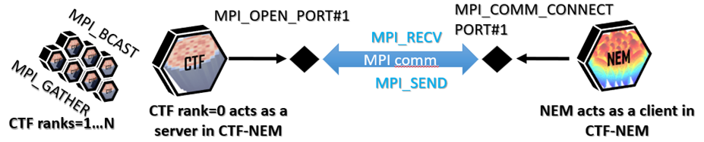
Fig. 1. Schematic of the NCSU parallel multi-physics core simulator for LWR applications.

CTF, a version of COBRA-TF, is a subchannel thermal hydraulics code developed and maintained by the Reactor Dynamics and Fuel Modeling Group (RDFMG) at NCSU in cooperation with Oak Ridge National Laboratory (ORNL) [1]. The code has been extensively validated for LWRs and recent developments have enabled CTF to model FRs. To enable FR M&S, CTF has been modified by the addition of sodium properties, implementation of a heat conduction model across subchannel-to-subchannel gaps, and implementation of friction and mixing correlations for wire-wrapped hexagonal fuel bundles [2].
CTFFuel [3] is an independent fuel solver code, utilizing the fuel heat transfer capabilities of CTF to simulate steady state and transient thermo-mechanical responses within nuclear fuel rods. CTFFuel rod modelling can be performed either in a standalone capacity or interfaced to CTF at the cladding-coolant boundary. The isolation of CTFFuel yields advantages for benchmarking and calibration, as well as direct coupling of the fuel performance to other physics such as neutronics and surface chemistry codes. CTFFuel capabilities are being extended to include capabilities for modelling both oxide fuels and metallic fuels including a sodium bonding in FR cores. The Vienna Ab initio Simulation Package (VASP) code is being utilized to investigate the effect of irradiation on the thermal conductivity of U-Zr metallic fuel and inform CTFFuel models to account for these effects. Specifically, the focus of this work is to accommodate the burnup-dependent infiltration of sodium into the fuel, which can lead to significant changes in the thermal conductivity of the fuel. Thermal expansion remains a significant gap for CTF and CTFFuel modelling, however some initial work has been completed to calculate density changes based on thermal expansion of fuel rods [4]. This implementation, however, does not physically expand the materials and functions only as a calculation of the density for thermally expanded conditions of a few fuel types and further developments are planned.
NEM is a three-dimensional (3D) multi-group nodal diffusion code written in the Fortran programming language developed by the RDFMG at NCSU and formerly at Pennsylvania State University (PSU) [5]. It is capable of modelling Cartesian, hexagonal-z and cylindrical geometries for both steady-state and transient conditions, utilizing a fourth-order polynomial representation of transverse integrated flux and quadratic leakage formulation based on the nodal expansion method. Nodal coupling is expressed via a partial current formulation, utilizing a response matrix technique to perform inner iterations. nem has primarily been developed for LWR analysis with a focus on the Cartesian solver; however, recent efforts have sought to extend the applications of NEM to FRs. It is important to note that there is no fundamental difference in the equations used for FRs versus LWRs such as VVER designs which share the hexagonal geometry. As such, recent developments have been focused on enhancing and verifying the existing capabilities of the multi-group hexagonal-z solver in NEM.
High-fidelity Monte Carlo and Computational Fluid Dynamics (CFD) simulations are being used to inform the lower fidelity, but computationally efficient, NEM and CTF calculations. In addition, CTFFuel, the CTF’s independent fuel solver is undergoing developments to improve thermal conductivity predictions for irradiated metallic fuel through informed modelling. Along with standalone developments, the FR-modelling capabilities of the codes will be synchronized and demonstrated in multi-physics tests in near future.

FAST REACTOR MODEL RELATED DEVELOPMENTS
Sodium coolant properties were originally implemented in an older version of CTF [6] based on correlations collected in [7]. These older sodium coolant properties were recently updated for the latest version of CTF and have been validated against experimental data, available in [8]. These updates were necessary due to changes in the implementation of correlations within the code in the time since the original implementation. Frictional pressure losses in FRs differ significantly from those in LWRs due to the use of wire-wrapped rods. Therefore, friction factor models for the specific geometry of wire-wrapped fuel must be utilized in CTF. The Cheng and Todreas mixing correlation [9] is implemented in CTF for wire-wrapped rod bundles. This correlation differentiates between bundle corner/edge subchannels and interior subchannels by assuming that the primary mixing effect for interior subchannels is due to effective eddy diffusivity, while mixing in edge subchannels is due to transverse flow velocity due to flow sweeping by the wire-wrap. CTF’s existing flow mixing framework, developed for modelling the turbulent mixing and void drift in LWRs, was appended with the Cheng and Todreas mixing correlation for wire-wrapped rods. This provides a relatively simple implementation of the mixing correlation to facilitate the exchange of mass, momentum, and energy between subchannels. Subchannel-to-subchannel heat conduction is not an important phenomenon in LWR modelling and was not originally implemented in CTF; however, this phenomenon is significant for FRs. A heat conduction model was implemented in CTF to compute the heat transfer between subchannels from the subchannel average temperatures over a distance between subchannel centres and modified by a geometry-dependent shape factor [10]. This shape factor is necessary to approximate the local behaviour of the heat conduction, despite being performed on the subchannel level using subchannel averaged temperatures.
Additional work has been carried out to extend the capabilities of the original CTF FR M&S implementation. This primarily focused on the addition of more rigorous friction factor correlations, debugging issues related to full core modelling and demonstrating a CTF-Dakota uncertainty propagation framework. Different versions of the Cheng and Todreas friction factor correlation have been implemented in CTF for wire wrapped, hexagonally ducted fuel, including: Cheng and Todreas Simplified (CTS) [9], Cheng and Todreas Detailed (CTD) [9], Upgraded Cheng and Todreas Simplified (UCTS) [11] and Upgraded Cheng and Todreas Detailed (UCTD) [11] correlations. Upgraded versions of the correlations adjust the Reynold’s number calculation and modify the transition regime correlation. These upgraded versions were developed in order to update the correlations to provide a better fit to additional experimental data than the original versions.
FR designs may contain ducted fuel assemblies within a bulk coolant pool of sodium; one simple method for modelling this geometry in CTF can be to consider the bulk sodium pool as stagnant and connecting adjacent assemblies by a multiple-layered wall-type heat structure with duct-material/sodium/duct-material properties. While the option for multiple material layers in wall-type heat structures was available in CTF, this specific feature would not be necessary for most standard LWR cases and was not sufficiently tested in previous verification. Recently, while developing a full core FR model and making enabling modifications to CTF, it was discovered that the implementation of multiple layered walls would fail to define some heat conduction nodes if more than two layers exist. The algorithm for node placement in single layer walls places nodes on both outer boundaries, and evenly spaces additional node locations between. For walls with multiple layers, there are shared boundaries and no need for connecting wall layers to each place a node at the same boundary location – see FIG. 2.

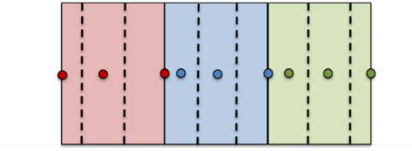
Fig. 2. Wall heat structure node and node boundary placement.

Parallelization of the CTF simulations allows for the efficient calculation of large-scale core geometries. Work was previously done to enable these capabilities for LWRs [12], in particular pressurized-water reactors. A restriction of this existing parallel framework was in the definition of the coolant inlet flow as a uniform mass flux. While this is a reasonable approximation in pressurized-water reactors, ducted SFR fuel bundles may have significant differences in mass flow rate despite sharing a common geometry. Modifications were made to allow for variable mass flow rates to be assigned from the input file as initialization flow rates and as inlet boundary conditions for parallel runs.
Dakota is an analysis tool developed by Sandia National Laboratories (SNL) for optimization and uncertainty quantification (UQ) [13]. Dakota provides the capability to perform parameter and sensitivity studies as well as performing input sampling for uncertainty propagation. Dakota was loosely coupled to CTF via Dakota’s black-box interface to a driver script that preprocesses inputs, runs CTF, extracts quantities of interest (QOIs) from CTF outputs and returns QOIs to Dakota for analysis and results summary. This uncertainty propagation framework was developed around a preliminary evaluation of the OECD/NRC Liquid Metal Fast Reactor Core Thermal-Hydraulic Benchmark for Verification, Validation, and Uncertainty Quantification of Subchannel and Computational Fluid Dynamics Codes. Specifically, the framework was developed around the isothermal, single-bundle Texas A&M University (TAMU) facility experiments [14-17], which analyze p-cymene fluid flow in a wire-wrapped FR-like bundle geometry. This implementation should be sufficient for bundle-level uncertainty propagation but may require modifications on a case-by-case basis depending upon the available input and desired output uncertainties, but several tools and steps taken in this implementation will be useful to reference for future uncertainty analyses. With a focus on the development for the TAMU facility, the developed framework enabled sampling of correlation uncertainty multipliers (to capture correlation uncertainties), relevant p-cymene material properties (density and viscosity), flow conditions (inlet temperature, flow rate, outlet pressure) and geometric uncertainties. The full CTF/Dakota implementation is illustrated in FIG. 3.

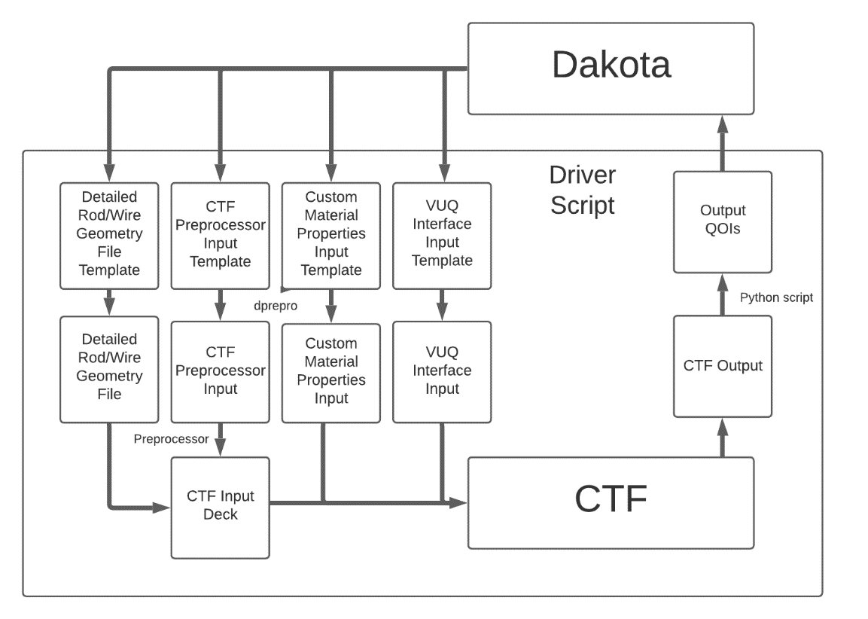
Fig. 3. CTF-Dakota uncertainty propagation scheme.

Planned enhancements of CTF/CTFFuel include applying results of high-fidelity simulations to inform the improved use of lower-order models within CTF/CTFFuel. The high-fidelity computational fluid dynamics code Nek5000 [18], developed and maintained at ANL, will inform CTF for improved modelling of pressure losses and inter-channel mixing in wire-wrap fuel bundles. First, the high-fidelity CFD results are compared and validated with the high-resolution measured results from the TAMU experiments from the OECD/NRC LMFR Core TH benchmark to create an intermediate-fidelity modelling capability for Hi2Lo model information of subchannel/pin-bundle thermal-hydraulics for CTF [19]. This work is expected to fill the gap between RANS-based methods and traditional subchannel methods. A three-dimensional velocity and pressure distribution functions characterizing flows across subchannels is being developed. These functions represent the effects of wire-wrap spacers on the hydraulics in the rod bundle. The wire-wrapped rod bundle is simulated using a bare-bundle geometry while subchannel mixing is still accounted for. This approach significantly reduces the number of computational cells, thus allowing the possibility of simulating full core configurations and transients. Currently, CTF modelling of wire wrapped fuel geometries is based on correlations from literature which are fit to experimental data from various wire wrapped bundle geometries. The option to calibrate the mixing for specific models is also desirable and is performed by modification of correlation coefficients based on high fidelity CFD simulations. In the current framework, the Nek5000 CFD code will be used to improve modelling through calibration the implemented wire wrap models and through the addition of source term lookup tables in CTF as an alternative to the current literature-based correlations.
The use of metallic fuel requires understanding of the behaviour of the uranium alloys. The doping of the uranium metal with zirconium affects its properties, such as thermal conductivity and heat capacity, as well as its performance. The presence of the sodium between fuel and cladding as a bonding element is another difference between the mixed oxide or uranium dioxide fuels, and the uranium metal fuel. The bonding sodium can infiltrate and diffuse into the fuel due to porosity interconnection, further modifying the fuel temperature profile and effective thermal conductivity. The VASP code is being utilized to investigate the effect of irradiation on the thermal conductivity of U-Zr metallic fuel and inform CTFFuel models to account for these effects. Specifically, the focus of this work is to accommodate the burnup-dependent infiltration of sodium into the fuel due can lead to significant changes in the thermal conductivity of the fuel as well as the effect of adding Zr to the alloy. Finally applying some assumptions about the amount of sodium infiltrating the fuel and its diffusion led to investigation of the effect of sodium on the thermal conductivity and model development for thermal conductivity of metallic fuel that takes Zr content and fuel burnup into account.
With primary development of NEM focused on LWR applications, necessary steps were taken to update the hexagonal-z geometry option with intermediate developments that had been made in the Cartesian geometry and to perform general updates to the NEM code. One of the intermediate developments made in NEM includes the utilization of discontinuity factors (DFs). Previously, this was carried out in the Cartesian geometry using the code PARAGON for reference calculations. To allow for flexible geometry options, development of discontinuity factors based on Serpent Monte Carlo reference calculations were developed. As a result of the added flexibility, the previous implementation was extended to include the capability for axial discontinuity factor generation and use. An additional capability was added alongside these developments to convert Serpent-generated cross sections to a tabulated NEMTAB-format cross section input for direct use by NEM, simplifying the state parameterization of cross sections for anticipated multi-physics and transient models.

VERIFICATION, VALIDATION AND UNCERTAINTY QUANTIFICATION
Accompanying test cases were developed to verify and demonstrate the new modifications made to the CTF source code. First, repair of the multi-layer wall nodalization was tested by unit and verification tests, including further investigation to mitigate error observed in some of the verification testing. The CTS and newly implemented CTD friction factor correlations were applied in single assembly code-to-code comparisons to SE2-ANL and STAR-CCM+. Finally, the current capabilities of CTF for SFRs were demonstrated on a model of the driver fuel assemblies of the Versatile Test Reactor (VTR), including multi-layer wall modelling of inter-assembly regions and parallelization of a multi-assembly model with variable inlet mass flux [20].
A unit test was developed to test repairs made to the node placement in the multiple layer wall heat structure, which may be used as a simple model of the inter-assembly region in an SFR. The modification made to CTF successfully fixed a discovered coding error which failed to place some nodes and node boundaries in multi-layer wall heat structures. To test that the multiple layer wall heat structure meets expectations, beyond the placement of nodes, a verification test was also developed. This verification test constitutes a solution verification against the analytic solution of the steady state conduction equation (solving for wall temperature profile) for a simple problem. In CTF, conduction in heat structures such as walls and slabs among others, is calculated using a finite-difference form of the heat conduction equation formulated by a heat balance approach. This method would provide not only a steady state heat conduction solve, but also permit transient state calculations. For this verification test, however, a steady state case was used so that a closed form solution to the conduction equation can be solved analytically for the temperature profile.
To verify and validate the other above-described CTF/CTFFuel developments, benchmarks to publicly available SFR experiments have been performed as well as code-to-code comparisons have been conducted with the STAR-CCM+ [21] and SE2-ANL [22] for VTR [24] driver fuel rod bundles. The coolant temperature profiles calculated by CTF, SE2-ANL (SE2), and STAR-CCM+ (CFD) were compared for five bundles of the VTR core – representative results from bundle 203 are shown in FIG. 4. The radial temperature distribution of CTF calculations, for both CTS and CTD friction factor correlations, was found in good agreement with SE2-ANL results. Note that upgraded versions, UCTS and UCTD were near identical to the nonupgraded correlations within the modelled flow regime and therefore are excluded from plotted temperatures. STAR-CCM+ results have a relatively good agreement with both codes among interior subchannels; however, they have notable differences from SE2-ANL and CTF at near-edge (with a higher temperature) and corner (with a lower temperature) subchannels. Discrepancies between these two codes and the STAR-CCM+ results can likely be attributed to the swirl mixing effect of the wire wrap, and the intermediate development of the STAR-CCM+ model used for this comparison. A multi-assembly VTR model was also developed to demonstrate CTF/CTFFuel capability to perform the parallel full-core modelling of SFRs at the subchannel level. A subchannel coolant temperature profile at the top of the active fuel region is shown in FIG. 5. The development of multi-assembly modelling is a major step in enhancing CTF application to SFRs that will be useful for future code verification studies. A major advantage CTF has over legacy codes is the capability to model transients. While further validation of CTF for SFRs is necessary, the good agreement between CTF and SE2-ANL (which has been validated for SFRs) for steady-state calculations allow CTF to proceed with greater confidence to a SFR transient simulation.
The Hi2Lo model information improvements to CTF from Nek5000 are being verified and validated using benchmarks such as the OECD/NRC Liquid Metal Fast Reactor (LMFR) Core Thermal-Hydraulic (TH) Benchmark, and code-to-code comparisons. The developed CTF/Dakota framework for uncertainty propagation was applied to benchmark models based on the TAMU 61-pin liquid metal fast reactor (LMFR) bundle, an experimental facility developed to analyse flow behaviour in wire-wrapped hexagonal fuel bundles. This facility utilizes p-cymene as a working fluid and is isothermal.

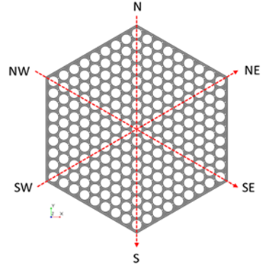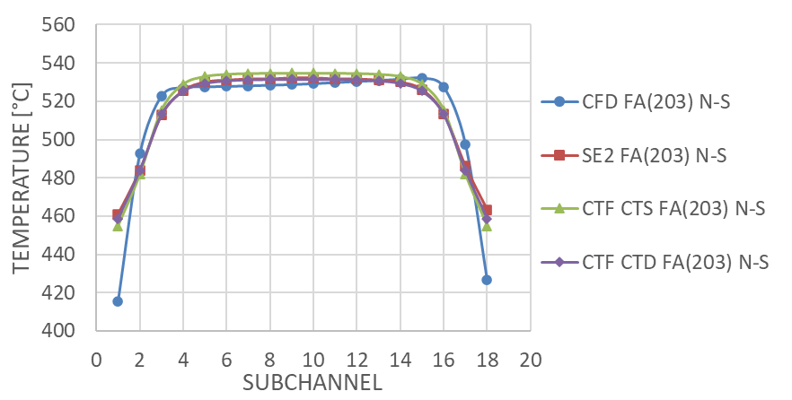
Fig. 4. North-South Coolant Temperature at Top of Active Fuel for Bundle 203.

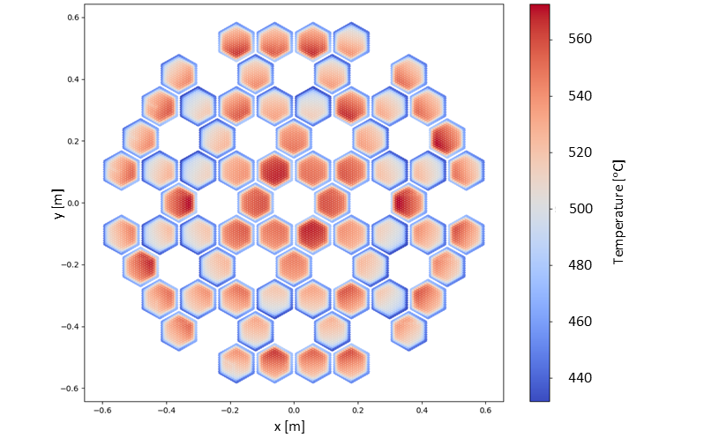
Fig. 5. Subchannel Coolant Temperature at Top of Active Fuel.

Standalone tests have been carried out for updated NEM hexagonal-z geometry implementation including several benchmarks based on multigroup cross sections provided in respective benchmark documentation that do not include a cross section generation step or discontinuity factor equivalence from Serpent [24]. These benchmarks highlight some limits of the hexagonal NEM method, in particular when applied to LWRs due to the large node sizes and steep flux gradients outside of the active core regions. An SFR benchmark based on the SNR-300 reactor [25] was also evaluated, including multigroup (4 energy group) cross sections. NEM solutions were compared against available results from other codes, including for most cases, DIF3D’s hexagonal nodal solutions. This method in DIF3D is based on the same Lawrence approach, which is utilized in the NEM code and provides a useful point of comparison for reference. Additional tests were carried out to verify the newly implemented DF equivalence options, successfully demonstrating the reproduction of reference Serpent solutions.

DISCUSSION
Modelling of the inter-assembly and/or assembly bypass is challenging due to the drastic difference in flow conditions in these regions. While previous work has enabled the ability to treat them as stagnant utilizing a multi-layer wall geometry, explicit flow modelling capabilities are desirable and should be possible. In order to properly converge the thermal hydraulics calculations in CTF, the inlet flow for inter-assembly and assembly bypass regions must be reasonably established. Similar issues occur in the modelling of BWRs due to separation by channel boxes but has been addressed in CTF using an outer iteration loop to determine inlet flow distributions. Because of the similarity between the two issues, the same approach may be directly applicable to FR modelling. Work to be done for FRs in this case may be restricted to demonstrating this outer iteration loop to enable flow distribution calculations for FRs, organizing separate CTF application of FR correlations and conduction shape factors from this region and addressing any currently unidentified considerations in the use of the BWR outer iteration inlet flow distribution calculations.
Implementation of liquid sodium properties in CTF was one of the first steps to enabling FR modelling. However, these developments were based on equations for single phase sodium made without considering sodium vapor properties. With the desire to extend CTF to include the option for vapor phase modelling, the implementation of vapor equations should be revisited. Implementation in CTF will require conversion of any significant verification and validation of vapor correlations as a first step, followed by further extension of physical models to enable and improve two-phase flow modelling for FRs.
The multi-physics platform based on coupling interface of CTF/CTFFuel with three-dimensional NEM neutronics is being extended for FR applications by supplementing it with a FR feedback modelling framework. As mentioned above, NEM has been coupled with CTF/CTFFuel and applied to different LWR steady state and transient applications. The FR feedback effects include thermal expansions and plans to demonstrate the parameterization of thermal expansions into the cross sections are under development. Specific areas that would, however, need to be addressed are the diagrid and axial expansions. The implementation of thermal expansion effects in CTF and CTFFuel can be separated into a few different parts that can be managed separately. These include radial expansion within the fuel rod (fuel + gap/bond + cladding) for fuel temperature calculations, radial expansions which affect the subchannel flow areas, and axial expansions. For these applications, some of the work previously developed to calculate thermal expansions and adjust densities can be expanded on to a more complete implementation.
CTFFuel has the capability to model thermal expansions within the fuel rods of LWRs utilizing fuel deformation models. The original purpose of this capability was to modify gap heat transfer for a gap thickness based on fuel pellet and cladding stresses. The fuel deformation methods are similar to that desired for FR applications; however, some reconfiguration is necessary. Fuel deformation subroutines are only applicable to the “NUCL” nuclear fuel rod geometry type, which is not currently used for FR models. The FR models utilize instead a “HROD” heated rod geometry, which is similar in function but was previously deemed more flexible for assignment of material properties to model the sodium bond of metallic fuels. However, it should be possible to implement the necessary information in the fuel deformation models to enable this capability.
CTF currently has the capability to construct models where subchannel geometries vary between axial levels which may be modified to account for cladding, duct and diagrid expansion effects on subchannel geometries. The mesh construction subroutines that perform this function are typically called only once, following the reading of the relevant input cards. However, the thermal expansions which affect the subchannel areas may be able to exploit this capability by calling to these subroutines (or a modified version thereof), altering the subchannel parameters in either an iterative or on-line fashion. Modelling of axial expansion in CTF may be more challenging to completely address than radial expansions due to the necessity to maintain the axial nodalization of subchannels. If an iterative scheme is utilized, the mesh can be modified in a similar way to that planned for radial rod expansions but could only consider uniform expansions. It may also be possible to approximate the effect by manipulation of the power profile. Currently, if a power profile extends over only part of an axial node in CTF, the integrated power of the partial profile is applied over the full axial node height. By movement of the boundary between powered and unpowered portions of the rod within an axial node, some control over the relative power of that node is possible. In addition, refinement of the axial nodalization may offer some mitigation of error.
The development of a simplified expansion solver which does not account for the more complex interactions between structural components can be developed as an initial step of thermal expansion considerations. By neglecting the complex interactions between components of displaced bundle geometries, the expansion effects can be approximated with thermal expansion coefficient calculations with some logical constraints (e.g., rods should not expand into the boundary of adjacent rods). The basic thermal expansion solver can be used to approximate distorted CTF subchannel geometry, adjustments in fuel-bond-clad radii in a CTFFuel model, or a state parameter for NEM cross section interpolation. This provides a practical substitute for a more rigorous thermo-mechanical capability in the multi-physics framework. The main benefit of this approach is that it will promote the development of some of the multi-physics interfaces for thermo-mechanical capabilities in NEM, CTF and CTFFuel. Requirements for interfacing with NEM are minimal, with the expanded state being sent to NEM from the expansion solver. CTF will require development of the necessary capabilities to adjust subchannel geometries in an on-line/iterative process together with the proposed expansion solver. CTFFuel will need to be able to account for fuel deformation based on the expansion information sent from the proposed solver. While this proposed development will not be a complete thermo-mechanical code, the role it serves is to support development of the NEM/CTF/CTFFuel interfaces and provide a basic capability to account for expansion effects. Upon future development or access to a more rigorous thermo-mechanical code for implementation in the multi-physics framework, the developed interfaces should minimize additional work required. The envisioned multi-physics platform for FR M&S along with Hi2Lo model fidelity informing interfaces for different physics phenomena in the reactor core is shown in FIG. 6.
In addition to addressing the identified FR modelling challenges, there are ongoing relevant developments including extension of NEM transient capabilities and development of an uncertainty propagation framework for multi-physics modelling in consideration of the Serpent to NEM two-step scheme [26]. The proposed Hi2Lo model improvements in CTF/CTFFuel as well as the coupled CTF/CTFFuel/NEM code system capabilities will be verified and validated using benchmarks such as the OECD/NRC LMFR Core TH Benchmark, OECD/NEA Sodium Fast Reactor (SFR) Uncertainty Analysis in Modeling (UAM) benchmarks [1], and code-to-code comparisons. The result will be a verified and validated coupled multi-physics code for FR applications.

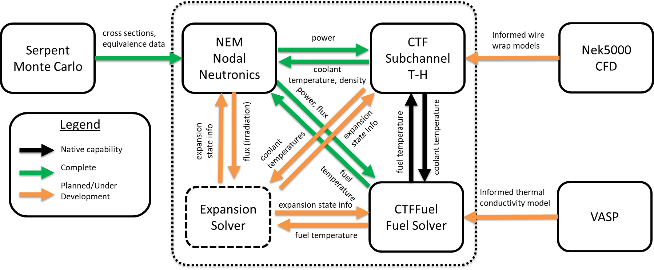
Fig. 6. Envisioned multi-physics platform for SFR modelling.

SUMMARY
The advanced subchannel thermal-hydraulic code CTF and its fuel rod solver CTFFuel capabilities have been extended to model FRs. These improvements included adding sodium material property correlations for pressure drop in the hexagonal fuel bundles, a flow mixing correlation for wire-wrapped rod bundles, and the addition of a heat conduction model across subchannel gaps. Modifications to CTF/CTFFuel were made to enable parallel full-core modelling of fast reactors. The obtained verification and validation results demonstrated that CTF/CTFFuel has the capability to simulate wire-wrapped FR fuel and to perform the parallel full-core modelling of FRs. The on-going work is focused on further improving these capabilities through implementation and demonstration of modelling strategies to manage inter-assembly flow and thermal expansion effects important to SFR modelling. The planned implementation is to adapt existing CTF capabilities to closely related FR-counterparts, specifically for explicit flow modelling in assembly bypass and inter-assembly regions and managing radial thermal expansion effects on the core geometry. Improvements to capture the flow mixing effects of the wire-wrapped fuel rod geometry supported by CFD calculations are also planned. The nodal neutronics code NEM is also being developed in parallel to support multi-physics M&S of FRs in a NEM/CTF/CTFFuel coupled code.
ACKNOWLEDGEMENTS
This research made use of the resources of the High-Performance Computing Center at Idaho National Laboratory, which is supported by the Office of Nuclear Energy of the U.S. Department of Energy and the Nuclear Science User Facilities. This work was supported by the United States Nuclear Regulatory Commission, Grant 31310021M0009. The described benchmark activities are endorsed by OECD-NEA.
References
- SALKO, R., et al, “CTF Theory Manual”, ORNL/TM-2019/1145, Oak Ridge National Laboratory, 2019.
- ALY, A., AVRAMOVA, M., IVANOV, K, “Extending CTF Modeling Capabilities to SFRs and Validation against SHRT Tests”, PHYSOR 2020: Transition to a Scalable Nuclear Future, (Proc. Int. Conf. Cambridge, United Kingdom, 2020), (2020).
- AVRAMOVA, M., et al, “CTFFuel User's Manual”, NCSU, 2019.
- GODBOLE, C., “Enabling CTF for Thermal Expansion Analysis of Metallic Fuels in Advanced Nuclear Reactors”, North Carolina State University, MS Thesis, (2019).
- IVANOV, K., et al, “NEM Theory Manual”, NCSU, 2019.
- HIRSHHORN, J., “Incorporating Liquid Sodium Analysis Capability into CTF”, Pennsylvania State University, BSc. with Honors, (2016).
- LERCHL, G., "Excerpt of ATHLET Models & Methods," GRA, Munich, Germany, (2011).
- SOBOLEV, V., “Database of Thermo-physical Properties of Liquid Metal Coolants for GEN-IV," Scientific Report SCK.CEN.BLG-1069, (2011).
- S.-K. Cheng and N. Todreas, "Hydrodynamic Models and Correlations for Bare and Wire-Wrapped Hexagonal Rod Bundles-Bundle Friction Factors, Subchannel Friction Factors and Mixing Parameters," Nuclear Engineering and Design, vol. 92, pp. 227-251, 1986.
- H. Jeong and et al., "Evaluation of the Conduction Shape Factor with a CFD Code for Liquid-Metal Heat Transfer in Heated Triangular Rod Bundles," Nuclear Engineering and Design, vol. 237, pp. 648-654, 2007.
- S.-K. Chen, Y. Chen and N. Todreas, "The Upgraded Cheng and Todreas Correlation for Pressure Drop in Hexagonal Wire-wrapped Rod Bundles," Nuclear Engineering and Design, vol. 335, pp. 356-373, 2018.
- SALKO, R., SCHMIDT, R., AVRAMOVA, M., "Optimization and Parallelization of the Thermal-Hydraulic Subchannel Code CTF for High-Fidelity Multi-Physics Applications", Annals of Nuclear Energy, vol. 84, pp. 122-130, (2015).
- ADAMS, B., "Dakota, A Multilevel Parallel Object-Oriented Framework for Design Optimization, Parameter Estimation, Uncertainty Quantification, and Sensitivity Analysis: Version 6.15 User's Manual," Sandia Technical Report SAND2020-12495, (2021).
- VAGHETTO, R., JONES, P., GOTH, N., CHILDS, M., LEE, S., NGUYEN, D., HASSAN, Y., “Pressure measurements in a wire-wrapped 61-pin hexagonal fuel bundle,” Journal of Fluids Engineering, vol. 140, (2018).
- NGUYEN, T., GOTH, N., JONES, P., VAGHETTO, R., HASSAN, Y., “Stereoscopic PIV measurements of near-wall flow in a tightly packed rod bundle with wire spacers,” Experimental Thermal and Fluid Science, vol. 92, pp. 420-435 (2018).
- GOTH, N., JONES, P., NGUYEN, T., VAGHETTO, R., HASSAN, Y., SALPETER, N., MERZARI, E., “PTV/PIV measurements of turbulent flows in interior subchannels of a 61-pin wire-wrapped hexagonal fuel bundle,” International Journal of Heat and Fluid Flow, vol. 71, pp. 295-304 (2018).
- NGUYEN, T., GOTH, N., JONES, P., LEE, S., VAGHETTO, R., HASSAN, Y., “PIV measurements of turbulent flows in a 61-pin wire-wrapped hexagonal fuel bundle,” International Journal of Heat and Fluid Flow, 65, pp. 47-59 (2017).
- NEK5000 Version 19.0, Argonne National Laboratory, Argonne, Illinois, (2019).
- HOLLER, D., AVRAMOVA, M., TAKASUGI, C., VAGHETTO, R., HASSAN, Y., “Phase I Specifications and Preliminary Sensitivity Analyses of the OECD-NRC Liquid Metal Fast Reactor Core Thermal-Hydraulics Benchmark”, PHYSOR 2020: Transition to a Scalable Nuclear Future, (Proc. Int. Conf. Cambridge, United Kingdom, 2020), (2020).
- TAKASUGI, C., et al, “Development of a Thermal Hydraulic Model for the Versatile Test Reactor Using the CTF Subchannel Code”, Proceedings of 2021 Mathematics & Computation (M&C) Conference, Raleigh, NC, (2021).
- Siemens PLM Software, STAR-CCM+® Documentation, Version 12, (2018).
- K. BASEHORE, TODREAS K., “SUPERENERGY-2: A Multi-assembly, Steady-State Computer Code for LMFR Core Thermal-Hydraulic Analysis,” PNL-3379, Pacific Northwest Laboratory, USA (1980).
- HEIDET, F., ROGLANS-RIBAS, J., “Core Design Activities of the Versatile Test Reactor–Conceptual Phase,” Proceedings of PHYSOR 2020: Transition to a Scalable Nuclear Future, Cambridge, United Kingdom, (2020).
- CHAO, Y. A., SHATILLA, Y. A., “Conformal Mapping and Hexagonal Nodal Methods – II; Implementation in the ANC-H Code,” Nuclear Science and Engineering, vol. 121, pp. 210-225, (1995).
- BUCKEL, G., KÜFNER, K., STEHLE, B., “Benchmark Source Situation BSS-18 and Benchmark Problem,” National Energy Software Center: Benchmark Problem Book, ANL-7416-Suppl.3, Argonne National Laboratory, pp 794-796, (1985).
- VALTAVIRTA, V., "Nuclear data uncertainty propagation to Serpent generated group and time constants," VTT Technical Research Centre of Finland, VTT-R-04681-18 (2018).
- STAUFF, N., et al, “Evaluation of the OECD/NEA/SFR-UAM Neutronics Reactivity Feedback and Uncertainty Benchmarks”, IAEA-CN245-149.

