# SIMMER ModelLing of Accident Initiation Phase in Sodium Fast Reactors

X.-N. CHEN

Institute for Neutron Physics and Reactor Technology, Karlsruhe Institute of Technology,

Karlsruhe, Germany

Email: xue-nong.chen@kit.edu

A. RINEISKI

Institute for Neutron Physics and Reactor Technology, Karlsruhe Institute of Technology,

Karlsruhe, Germany

**Abstract**

The SIMMER-III code was developed mainly for simulation of hypothetical reactor accidents after core melting, but can be applied also for accident initiation phase simulations in sodium and other liquid-metal-cooled fast reactors. New thermal hydraulic and neutronic simulation approaches and models have been developed for the treatment of the initiation phase. Two examples of simulation of unprotected loss of coolant flow (ULOF) transients, in ESFR-SMART and FFTF reactors, are presented. It can be concluded that the SIMMER code has a large potential for application to initiation phase analyses.

## INTRODUCTION

The SIMMER code (SIMMER-III and SIMMER-IV) includes advanced fluid-dynamics/multiphase-flow and neutronics models [1, 2]. The code is applied for simulation of hypothetical severe accidents in sodium fast reactors (SFRs) and other systems with focus on core behaviour after core melting. An accident initiation phase (IP) of a severe accident in SFR, before can-wall melting onset, can usually be simulated with a different code; this may facilitate IP analyses but may introduce uncertainties related to coupling of SIMMER with this different code at the end of IP. We have developed several new simulations approaches and models for SIMMER recently in order to facilitate its application to IP. The following thermal hydraulic simulation approaches have been applied and tested at KIT:

* Treatment of coolant in inter-subassembly gaps, for which special meshes in plane are allocated,
* Sub-channel-scale mesh modelling,
* Heat exchanger modelling with boundary conditions for the secondary circuit coolant, instead of a simpler approach for heat sink in the primary circuit
* Gas-Expansion Module (GEM) treatment.

Moreover, the following neutronic models have been developed and tested in KIT:

* Reactivity feedbacks due to thermal core expansion in axial and radial directions,
* Control rod driveline (CRDL) reactivity feedback model.

As examples of application of some of abovementioned models, we show in the following our recent transient simulation results, in particular for unprotected loss of coolant flow (ULOF) in ESFR-SMART and for the loss of flow without scram (LOFWOS) test in the Fast Flux Test Facility (FFTF) [4] with emphasis of Gas Expansion Module (GEM) direct simulation in the FFTF case. The former case (ESFR-SMART) comes from an EU-Project, where ULOF transient was investigated as a benchmark. The latter one is a benchmark that was organized as an IAEA collaborative research project (CRP), including a blind phase and a second phase, during which the models can be improved using experimental results. The GEM and Doppler feedback effects are two dominant ones, which are negative and positive during the transient, respectively. The flow rate, the net reactivity and the power are simulated quite accurately with the improved GEM model. As for the GEM modelling, we focus on calculations of the sodium level in GEM and related reactivity feedbacks.

## SIMMER Application to ESFR-SMART

In this example, we would like to show SIMMER simulation of an ESFR-SMART ULOF transient case. The power, reactivity and the mass flow rate are well predicted, while all abovementioned neutronic models are included [3]. In particular the fuel-clad gap is assumed to be closed and the axial thermal expansion is driven by the clad temperature. During the transient, the sodium boiling takes place, which induces power oscillations through the sodium density/void feedback. Fig. 1 shows this phenomenon, where the power trough and peak correspond to sodium void and re-flooding states. The reason for the oscillation is that the sodium boiling above the core gives a negative feedback and forces the power to decrease and, due to the condensation and remained sodium flow, the sodium liquid comes back into the voided region, which causes a positive feedback in the reactivity and makes the power increase. This procedure repeats with a period of about 10 s. The heat transfer from the fuel to coolant needs a certain time and this time shift plays an important role in Hopf bifurcation [4]. Therefore, it is another significant reason for the periodic oscillation.

Fig. 2 shows the reactivity and its major components. The results show that the power oscillation is due to the negative effect void reactivity and the time delay of fission thermal power to the coolant. Therefore the fuel Doppler and coolant density reactivity feedbacks are anti-phased.

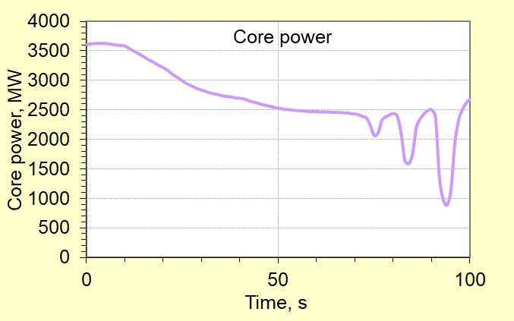

  

1. t= 83 s (b) t= 89 s (c) t= 94 s

*Fig. 1.* *Coolant void and re-flooding scenarios, which corresponds exactly to the moments of power trough and peak. In the lower plots the sodium boiling regions above the active core are presented in white, while the gas plena below the core are also in while.*

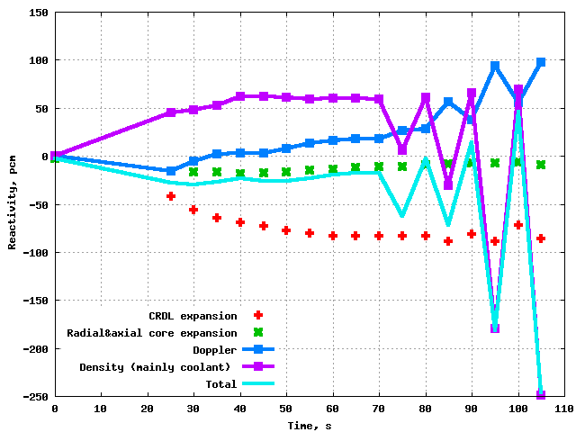

*Fig. 2.* *Total reactivity and its components at selected time points.*

As showed in the previous case, where the fuel gap is closed in the case of high burn-up, it is driven by the clad temperature (Clad Driven). If the fuel gap is open, which is the case of fresh or low burn-up fuel, the axial fuel thermal expansion is driven by the fuel temperature (Fuel Driven). Note that the fuel- and clad-driven axial thermal expansion effects give reactivity feedbacks of different signs: the fuel-driven one is positive, as the fuel temperature decreases during the transient, while the clad-driven one is negative, as the clad temperature increases. Fig. 3 shows the comparison of these two cases. Case “Fuel Driven” results in a power excursion and core degradation, where the reactivity is slightly over 1 $ during the transient, while Case “Clad Driven” results only in sodium boiling, but no power excursion, where the reactivity can be positive, but clearly below 1 $ during its oscillation. This is in line with earlier studies showing that the sodium boiling can lead to a power excursion, if the negative reactivity feedback is not good enough.

Fig. **3**. Comparison of ULOF results of clad driven and fuel driven axial thermal expansion cases by mass flow rate, power and total reactivity.

## SIMMER application TO FFTF

A particular component of FFTF is GEM. In the ULOF transient, the core/GEM inlet pressure decreases, the gas volume in GEM increases. Therefore the reactivity feedback becomes negative due to a larger neutron leakage. The SIMMER code can simulate this GEM and its associated phenomena directly. Fig. 4 illustrates the SIMMER 2-D GEM model. The calculated with SIMMER GEM void worth is -448 pcm, which is comparable to the reference value of -442 pcm provided by ANL [5]. Fig. 5 shows the SIMMER calculated sodium level as function of the relative flow rate during the ULOF transient in comparison with the theoretically predicted one.

 

*Fig. 4.* *SIMMER 2-D GEM model.*



*Fig. 5.* *SIMMER calculated GEM sodium level vs. relative flow rate during the ULOF transient in FFTF, where dots stand for SIMMER results and the curve for theoretic prediction [5].*

We show our results of blind and improved simulation together with the available experimental ones in Fig, 6. The improved and experimental ones are quite similar. The large discrepancy for the blind results is mainly due to the GEM modelling, where a very large orifice coefficient, that resists the coolant flow, was set in the GEM inlet. This coefficient has been removed in the improved simulation. Unfortunately, no experimental results of GEM sodium level are available to compare with calculation results shown in Fig. 6.

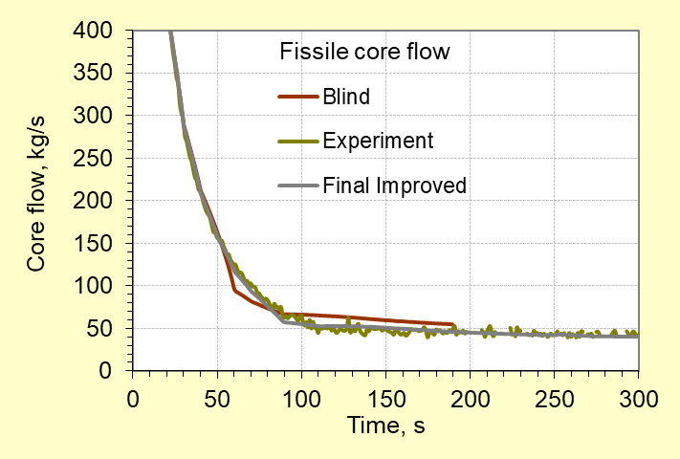 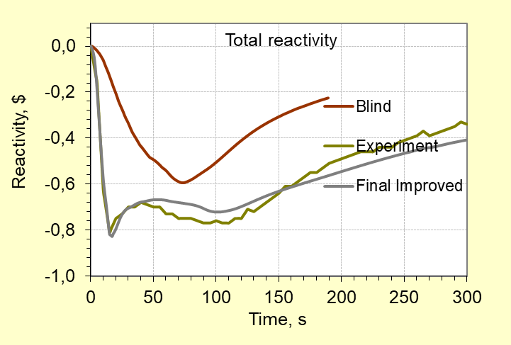

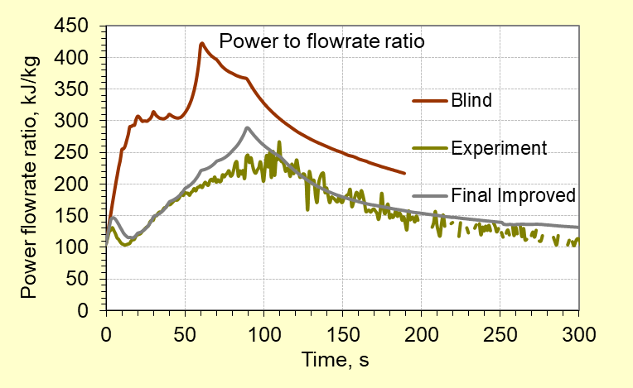 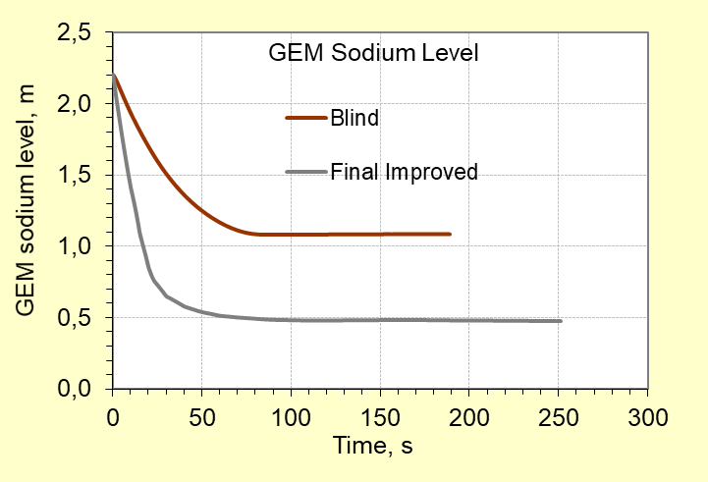

*Fig. 6.* *Results of core mass flow rate total reactivity, power to flow rate ration and GEM sodium level during the ULOF transient in FFTF.*

## CONCLUSION

By benchmarking our results with other partners and experimental ones, one may conclude that the SIMMER code has a large potential to application to initiation phase analyses in sodium-cooled and other liquid-metal-cooled fast reactors.

ACKNOWLEDGEMENTS

The research leading to these results has received funding from the EURATOM research and training programme 2014-2018 under grant agreement No 754501. FFTF studies were done for an IAEA Collaborative Research Project (CRP), Project Code I32011.

References

1. KONDO, S., TOBITA, Y., MORITA, K., SHIRAKAWA, N., “SIMMER-III: An advanced computer program for LMFBR severe accident analysis”, Proceedings of the International Conference on Design and Safety of Advanced Nuclear Power Plant (ANP’92), Vol. IV, Tokyo, Japan, 1992, pp.40.5-1 to 40.5-11. Also JAEA, “SIMMER-III: A Computer Program for LMFR Core Disruptive Accident Analysis”, JNC TN9400 2003-071 (2003).
2. YAMANO, H., et al., “Development of a three dimensional CDA analysis code: SIMMER-IV and its first application to reactor case”, Nuclear Engineering and Design, (2008), 66-73.
3. CHEN, X.-N., et al. “Simulations of ULOF initiation phase in ESFR-SMART with SIMMER-III”. International Conference on Fast Reactors and Related Fuel Cycles FR22: Sustainable Clean Energy for the Future (CN-291), 19-22 April, 2022, IAEA, Vienna, Austria. Paper CN291-295.
4. Hopf bifurcation: https://en.wikipedia.org/wiki/Hopf_bifurcation
5. SUMNER, T., et al. “Benchmark specification for FFTF LOFWOS Test #13”, ANL-ART-102, Argonne National Laboratory, USA (2017).