studies of liquid metal boiling in fuel assemblies
of fast reactors in accident conditions

A.P. SOROKIN
IPPE JSC
Obninsk, Russian Federation
Email: sorokin@ippe.ru

Yu.A. KUZINA
IPPE JSC
Obninsk, Russian Federation

G.A. SOROKIN
MIPT
Moscow, Russian Federation

N.A. DENISOVA
IPPE JSC
Obninsk, Russian Federation

Abstract

The paper presents the results of experiments carried out at IPPE JSC on heat transfer and circulation stability at sodium-potassium alloy boiling on models of single fuel assemblies and in a system of parallel fuel assemblies, taking into account the influence of various factors on the boiling process at coolant natural convection.
The obtained experimental data have shown that the stable nucleate boiling in the simulated fuel assemblies is observed only in a restricted region of heat fluxes, its transition to unstable pulsating slug boiling is determined by various factors, the transition boundary from nucleate boiling to slug, annular-dispersed and dispersed regimes of two-phase liquid metal flow in fuel rod assemblies are approximated by simple dependences.
The onset of an oscillation process at coolant boiling in one of the parallel fuel assemblies leads to an antiphase oscillation process in another fuel assembly, the hydrodynamic interaction of the loops in various fuel assemblies may cause a significant increase in the amplitude of coolant flow rate oscillations ("resonance" of flow rate oscillations) and “choking” or inversion of the coolant flow rate in the loops, the temperature rise in the coolant and fuel rod cladding (the effect of inter-channel instability) and, eventually, a critical heat flux (CHF).
In the assembly with low surface roughness of the rod simulators, evolution of an unstable (slug) regime with sharp coolant flow rate oscillations and overheating of the simulator wall results in a CHF, in fact, the CHF ratio is lacking. For the fuel rod simulators with industrially-manufactured surface roughness, due to the appearance of a liquid film on the surface of the simulators, a transition from the unstable slug regime to the stable annular-dispersed one is observed.
For sodium boiling in the fuel assembly model with a sodium “cavity" located above the reactor core, which is designed for compensation of the positive sodium void reactivity effect in case of boiling onset, the feasibility of long-term sodium cooling of fuel rod simulators in the fuel assemblies has been demonstrated for these conditions.
The data on liquid metal boiling heat transfer in the assemblies were generalized, a cartogram of the flow regimes for a liquid metal two-phase flow in the assemblies was constructed, which significantly differs from a cartogram of the flow regimes for water. The paper presents the results of the calculated and experimental data comparison.

INTRODUCTION
State-of-the-art modeling of dynamic alkali liquid metal boiling is of prime importance for an integrated analysis of the neutronic and thermohydraulic characteristics of a fast reactor core in accident conditions (UTOP, ULOF) in the course of their safety justification [1–3]. In accident conditions, the sodium boiling regime can lead to an increase in reactivity due to the positive sodium void effect of reactivity, overheating of fuel elements, depressurization and melting of their cladding and fuel, etc. Experimental studies of the liquid metal boiling were carried out on simulated fast reactor fuel assemblies with a different number of fuel rod simulators for conditions as close as possible to full-scale conditions. [4–8].
For regimes with low flow rates or natural convection in fuel rod assemblies, typical for emergency situations, only limited data have been obtained on the boiling of liquid metals. [7–8].
The research results obtained at the IPPE JSC have shown that the liquid metal boiling process in fuel assemblies to be developed under the effect of various factors, to have a complex structure, to be characterized by both stable and pulsation regimes with significant fluctuations of process parameters (flow rate, pressure, temperature), which can go on for tens of seconds and give rise to a critical heat flux (CHF) [3, 9, 10].
The model of the two-phase liquid metal flow used in the methods and calculation codes has a significant impact on the calculation results, which requires improvement and experimental confirmation. [3, 11].
To exclude the development of an accident situation leading to the destruction of fast reactor core components, a design solution was proposed, which consists in the arrangement of a “sodium cavity” in the fuel assembly between the reactor core and the upper end shield.
The purpose of this work is to analyze the physical features and quantitative characteristics of the liquid metal boiling processes in fuel assemblies in regimes with low velocities, to determine the boundaries of stable heat removal during boiling in relation to beyond design basis accidents with the loss of forced core cooling, taking into account the influence of various factors on the two-phase flow regimes in particular, the “sodium cavity” located above the fuel rod assembly, experience in developing a mathematical model of the process, studying the possibility of using the obtained data for reactor conditions.

Experimental equipment and system for measuring a characteristics
of liquid metal boiling in assemblies of fuel rosd simulators
The experimental apparatus created at the IPPE JSC at the AR-1 facility for research into liquid metal coolant boiling [12, 13], contains two 3 m high vertical channels, connected to each other at the top and bottom and forming a down comer and riser legs of the circulation loop, a surge tank and a heater at the riser channel inlet (Fig. 1).

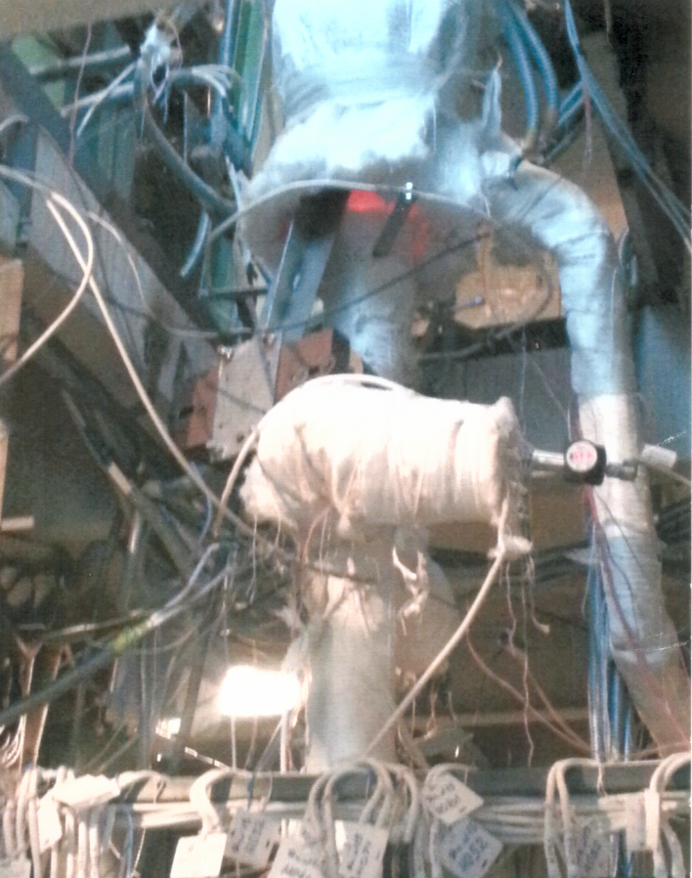  a) | 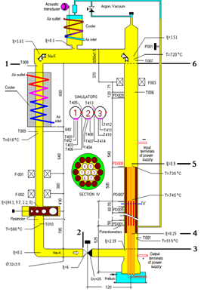  b)
Fig. 1. Part of the experimental apparatus (a) and a test section diagram (b) for studies of liquid metal boiling
using FA models in accident conditions

In the lower part of the riser channel there is a test section with a model fuel assembly (FA) representing a bundle of 7 fuel rod simulators and 12 displacers in a triangular lattice with a pitch of 1.185 enclosed in a steel tube with a diameter of (50×1.5) mm. Restrictors with 12 mm, 16 mm and 20 mm orifices are installed in front of the FA in the circulation loop.
The simulators represent (8×1) mm diameter tubes, with spiral heaters 4 mm in diameter installed inside, they are made from molybdenum wire 1 mm in diameter. The space between the spiral and the cladding is filled with high-temperature dielectric filling material and helium. The cladding consists of two co-axial tubes, fabricated from refractory steel. Four longitudinal grooves are made in the smaller diameter tube for installation of thermocouples with the heads distributed along the length of the heat generation section.
The apparatus is equipped with a large number of primary transducers (sensors) to measure: pressure in the gas cavity, flow rate and coolant flow rate oscillations, static pressure in the boiling section and fluctuations (pulsations) of the coolant pressure, pressure drop between the boiling assembly and the surge tank, coolant temperature at different points of the circulation loop, temperature and temperature fluctuations of the coolant and the cladding (surface) of the fuel rod simulators in three cross sections along the height of the heat generation section, detection of the presence of a vapor phase along the height of the model FA (potentiometric sensors), electric power supplied to the heaters of the fuel rod simulators, a liquid metal level in the surge tank, acoustic emission signals.

Phenomenology and analysis of the sodium-potassium coolant boiling process in model fuel assemblies with smooth and rough rods
The liquid metal boiling in the model fuel assembly in the natural convection regime was reached by way of increasing the heat generation rate of the fuel rod simulators. The liquid metal heated in the fuel assembly model rose into the surge tank, where it was cooled and then entered the down comer region. The power of the fuel rod simulators was increasing discretely in small steps until the onset of sodium boiling [10].
Sodium-potassium coolant boiling in the model FA with fuel rod simulators with a smooth surface with low roughness (0.5 microns). Nucleate boiling of liquid metal occurred at a heat flux density on the fuel rod simulators’ surface of 117 kW/m² at the end of the heat generation region and, as the power supplied to the model FA increased, it gradually extended to the entire heat generation area.
At the same time, the flow rate at the model FA inlet remained almost unchanged at the level of values before the boiling onset. The stable boiling regime was maintained up to a heat flux density of 133 kW/m², until boiling covered the entire heat generation area.
With the further increase in the input power, transition to the pulsation (slug) regime occurred, which had a periodic nature. At the beginning of the cycle, the heat generation region was filled with sodium vapor, then the formed vapor plug (slug) floated up, the released heating zone was filled with the coolant supplied to the mockup inlet (Fig. 2).
The wall-to-liquid temperature difference in the stable boiling regime was 20 °C on the average. In the pulsation regime, sharp fluctuations of simulator wall overheating were observed, which were increasing as the heat generation increased to (80–90) °C, which can be accounted for by the simulator surface drying in the slug area. The overheating temperature of the simulator wall in relation to the coolant and the readings of the void fraction sensor at the model FA outlet are correlated with the coolant flow rate at the inlet. At a heat flux density of 151 kW/m², the surface of the simulators was dried out (dryout) and the cladding melted.
Boiling in the FA model with industrial-manufactured rough surface fuel rod simulators (1.5 microns). In the experiment with a 20 mm diameter flow restricting orifice option, at the initial stage of the boiling process, when the heat flux density reached 125 kW/m², the boiling process was observed with stable parameters characteristic of the nucleate boiling: the temperature of the coolant and simulators, the pressure drop across the bundle, the coolant flow rate at the inlet and outlet of the heating zone (Fig. 3).
With the heat generation growth up to 140 kW/m², transition to an unstable, pulsation regime took place. This regime was characterized by a high amplitude of wall temperature pulsations (up to 100 °С) and coolant flow rate (ranging from 0.3 to 1.2 m³/h). Larger vapor bubbles (slugs) formed with an interval of 4 s and more, at the time of floating up caused a sharp increase in the coolant flow rate at the inlet to the bundle and significant fluctuations of all the parameters. Obviously, the fluctuations of the parameters were of a hydrodynamic nature and were determined not only directly by the coolant boiling process in the FA alone, but also by the complex of processes occurring in the assembly and the circulation loop as a whole. The gradually declining pulsation (slug) regime in the heat flux range from 200 to 230 kW/m² changed to the annular-dispersed regime, characterized by the stability of the parameters measured.
When the heat flux is above 230 kW/m², a decrease in the coolant flow rate in the circulation loop and transition from the annular-dispersed to dispersed boiling regime (post-CHF heat transfer) were observed, since the true volumetric vapor quality increased insignificantly, and the two-phase flow friction (as well as void quality) became essential.

 | 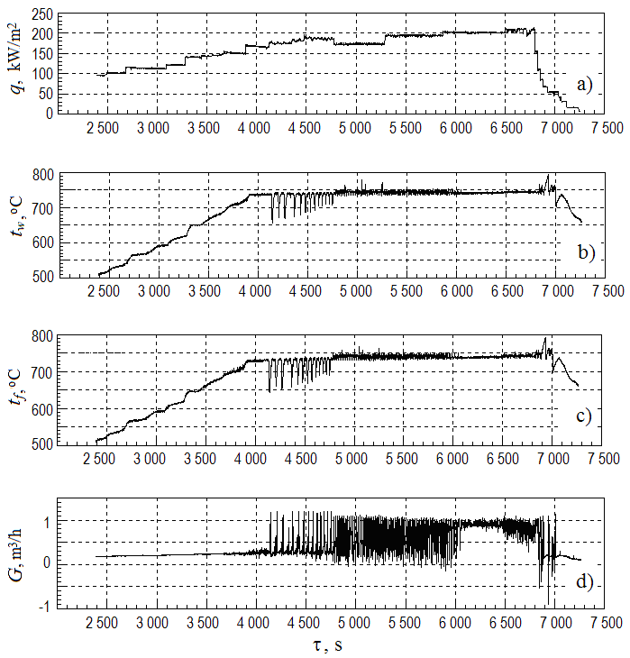
Fig. 2. Change in time of the simulator wall temperature (a),  the coolant (b) and the wall-to-liquid temperature difference (c) at the heat generation area outlet during sodium-potassium alloy boiling in the fuel assembly model with smooth simulators with a low surface roughness | Fig. 3. Heat flux density (a), the simulator temperature (b) and coolant (c) at the heat generation region outlet and volumetric flow rate of coolant (d)  in the experiment with a 20 mm diameter orifice

Hydraulic characteristics and a two-phase flow cartogram
for a liquid metal coolant in fuel rod assembly
As a result of experimental data processing for each of the experiments on liquid metal boiling in fuel rod assemblies, the following hydraulic characteristics were constructed: point cartograms of the pressure drop dependence in the test section of the circuit on the volumetric flow rate (Fig. 4), as well as a cartogram of the liquid metal mass velocity dependence on flow quality (Fig. 4), which characterizes various two-phase flow patterns of a liquid metal coolant in the rod assemblies [14].
The location of the points on the point cartograms (Fig. 4) made it possible to draw approximating lines similar to the classical hydraulic characteristic corresponding to unstable boiling. Along with the set of points characterizing the pulsation boiling regime (a central region of the hydraulic characteristic), there is a separate set of points related to the stable boiling regime (left and right regions of the hydraulic characteristic).

a) | b)
Fig. 4. Hydrodynamic characteristic of the experiment with 12 mm diameter orifices (a) and a clamped valve (b)

The coolant flow oscillations are caused by dynamic interactions between the flow parameters (velocity, density, pressure, enthalpy) due to delay effects and feedback processes. Depending on the range and combination of thermohydraulic parameters, different components of the pressure drop may play a major role in self-sustained flow rate oscillations, including the situation when a constant pressure drop in the test section is maintained. It results in dissimilar impact of design and operating parameters on the boundary of flow stability, depending on the pressure drop component that governs the flow fluctuations. Internationally, it is common practice to interpret such a mechanism as a hydrodynamic instability of density waves.

Interchannel instability in the event of sodium-potassium coolant boiling in a system of parallel simulated rod assemblies
Experimental test section. An experimental test section for study of liquid metal boiling within the system of parallel simulated rod assemblies [9] is installed on the sodium-potassium loop of the AR-1 facility in IPPE JSC (Fig. 5). The test section consists of two natural circulation loops, in each of them model assemblies with electrically heated elements are installed, with a common down comer region of the loop where the cooler is located. The vessels above the assemblies are also interconnected. Each of the assemblies can operate autonomously, being included in its own circulation circuit.

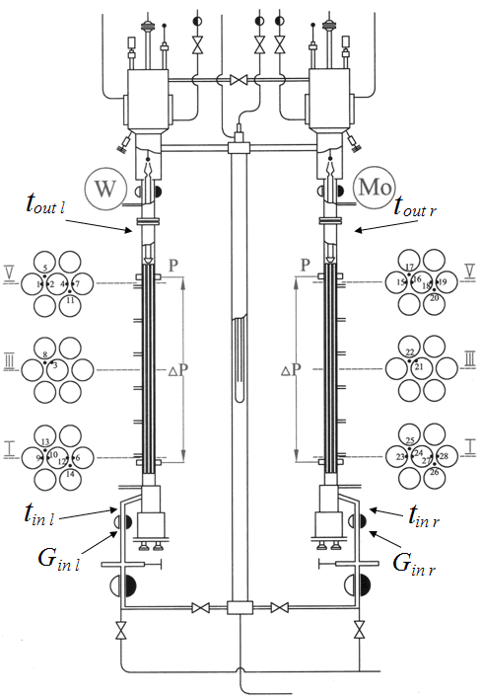
Fig. 5. Diagram of the experimental test section and the location of sensors for studying the boiling of liquid metal in a system of parallel fuel assemblies: l – left assembly; r – right assembly; in, out is the coolant temperature at the inlet and outlet of the fuel assembly, respectively

The diameter of the heated elements is 8 mm, the pitch-to-diameter ratio is 1.19, and the length of the heat generation zone is 830 mm. The fuel elements are located in a basket of 12 unheated elements to provide a geometry configuration of an infinite grid.
Heat is removed from the loops by coolers of two types. One cooler of “Field tube” type is installed on the down comer lines of the loops. The second cooler of “jackets” type is located on the tanks in the upper part of the circulation loop. “Shirts” are equipped with lens compensators to compensate for uneven temperature expansion.
In front of the fuel assembly, in the right and left circulation loops, restriction devices are installed in the form of movable rails with orifices of three sizes (12 mm, 16 mm and 20 mm), with the help of them, it is possible to perform various restriction of the flow in the loops during the test section operation.
Research technique, measurement system and sensors. Experimental studies of heat transfer and the stability of the coolant circulation at eutectic sodium-potassium alloy boiling in the fuel assembly models were carried out initially separately for the left and right circulation loops, and then during their parallel operation in coolant natural convection regimes.
The experiments were carried out with a gradual increase in the heat generation in the fuel assembly models. The heat flux density of the fuel elements increased with a step of 10–20 kW/m². The pressure in the surge tanks was about 0.4 bar, which corresponded to the pressure in the upper area of heat generation in the fuel assembly models in the range of 0.49–0.52 bar.
The following parameters were controlled by measurement system in experimental study: electric power supplied to the fuel rods and electric heaters; coolant flow rate; static pressure and pressure pulsations in the boiling area; pressure drop in fuel assembly models in heat generation areas; the temperature of the fuel rod walls and coolant temperature in 3 sets along the height of the energy generation area as well as in different points of the circulation loop; flow rate of the cooling water.
The outer cladding walls temperature of the electrically heated rods and the coolant temperature were measured by chromel-alumel thermocouples in stainless steel covers with a diameter of 0.5–0.8 mm.
Results of experimental studies for a system of parallel fuel assemblies. The data obtained in the experimental studies of sodium-potassium alloy boiling in the system of two parallel simulated fuel assemblies in a loop with natural alloy circulation show [9]:
- With a heat flux density of the fuel rods ~ 130 kW/m², the nucleate boiling of the coolant in the fuel assemblies changes to a developed slug regime, characterized by large-amplitude fluctuations in the thermohydraulic parameters of the coolant.
- The coolant boiling oscillatory process onset in one of the parallel assemblies gives rise to an antiphase oscillatory process in the another assembly, further, fluctuations of thermohydraulic parameters in different loops are antiphase.
- Hydraulic interaction of the system of parallel loops in the slug flow regime in the heat generation regions in the course of time results in a significant increase in coolant flow rate oscillation amplitude in them (“resonance” of flow rate oscillations) and to potential "choking" or inversion of the coolant flow in the loops, to temperature rise in the coolant and the fuel rod simulator cladding (the effect of inter-channel instability) and further to the critical heat flux (CHF).
- In case of different heat flux densities of fuel rod simulators in the system of parallel assemblies, the "resonance" of the oscillatory process increases.

Heat transfer numerical modeling at liquid metal boiling
For numerical modeling of heat transfer at liquid metal boiling in a single fuel assemblies and in a system of parallel fuel assemblies, a version of the SABENA code [11, 15] created earlier for thermohydraulic analysis of sodium boiling in fast reactor fuel assemblies, which implements a two-fluid model of a two-phase liquid metal flow in the approximation of equal pressures in the vapor and liquid phases was modified.
The fuel rod assembly is modeled in a multidimensional channel-by-channel approximation, the rest of the circulation loop in a one-dimensional one, closing relations and thermophysical properties of the eutectic sodium-potassium alloy were refined by performing a special analysis.
The results of numerical modeling of hydrodynamics and heat transfer for the experimental conditions for a single heat generating fuel assembly in the circulation loop have shown:
- In the calculation, the onset of coolant nucleate boiling is detected slightly later than in the experiment.
- Further, the calculation results do not describe the experimentally obtained high-order parameters pulsations.
- The calculation results adequately describe the time history of the average temperature values for the coolant and fuel rod simulator cladding, as well as the coolant flow rate change throughout the entire transient until the power shutoff.
The results of computational studies for a system of parallel fuel assemblies (Fig. 6):

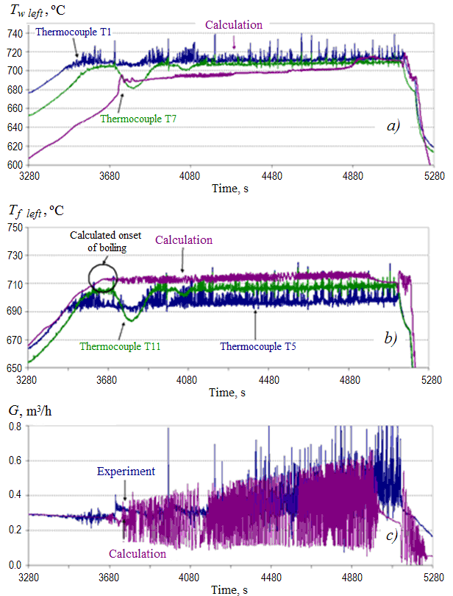
Fig. 6. Comparison of the calculated and experimental time history of the fuel rod simulator surface temperature (a), coolant temperature (b) and coolant flow rate (c) in the left bundle in the course of parallel operation of the assemblies
with the same heat generation
- Reproduce the temperature variation, the development of single-phase flow regimes (nucleate, slug), liquid metal flow rate oscillations.
- Demonstrate antiphase oscillations of the coolant flow rate in parallel assemblies, inter-channel instability characterized by significant increase in the amplitude of the coolant flow rate oscillations in the parallel assemblies as compared to the single assemblies, a periodic drop in the coolant flow rate in the assemblies to almost zero and potential assembly drying.

sodium boiling Heat transfer in a simulated rod assemblies
with a "sodium cavity" above the heat generation region
An assembly of fuel rod simulators, consisting of 7 fuel rod simulators with a diameter of about 9 mm and a length of 1200 mm, packed in a triangular lattice with a pitch-to-diameter ratio of 1.11 and wire wrapped with a 180 mm pitch, is placed in a hexagonal cover made of heat-resistant steel, which serves as the body of the model. Above the simulated core model there is a “sodium cavity” 430 mm long [10]. After pre-heating in the loop heater of direct heating, sodium first enters the inlet chamber of the test section, then the simulated core model region, where it is heated by the fuel rod simulators. Further, the sodium passes through the area, cramped with the upper axial blanket simulator, which, together with the body of the section, forms a narrow annular gap.
The coolant boiling up was recorded at the time of 9799 s according to the flow meter readings – boiling indicator, the flow meter in the single-phase region, signals of the acoustic system and pressure pulsations. At this point, sodium flow rate drops to zero. After 0.5 s, a short-term jump in the central simulator wall temperature was recorded, it was associated with a coolant flow stoppage, the liquid temperature in the initial region of the "sodium cavity" grows by 6 °С, them the flow rate increases to 0.3 m³/h and the simulator wall temperature is reduced to 911 °С within 3 s. This process is repeated several times in the course of the experiment and represents an intense boiling up and attenuation of sodium boiling due to a flow rate growth. At other times the nucleate regime with variable intensity prevails, sometimes completely attenuating, then significantly intensifying and accompanied by a flow rate enhancement for a period of up to 10 s.
With an increment in the heat flux of the simulator from 120 kW/m² to 135 kW/m² (Fig. 7) a clearly defined oscillatory regime of two-phase flow with an oscillation period from 3 to 14 s and a fuel rod simulator temperature fluctuation amplitude up 55 °С sets in.
The process of intensive nucleation in the fuel assembly is accompanied by sodium vapor condensation in the "sodium cavity" with the cold liquid filled from the upper part of the model FA. A steep drop in temperature in the "sodium cavity" (to 820 °С) is indicative of it. Simultaneously with the condensation of vapors in the "sodium cavity", the coolant flow rate increases, which ensures the inflow of colder liquid into the model FA and termination of boiling, then the process is repeated again. As the heat flux increases up to 140 kW/m², the continuous propagation of the wall temperature fluctuations begins. When the wall temperature of the simulator reaches 985 °С, the power supply of the model FA is automatically cut off by the emergency protection system.

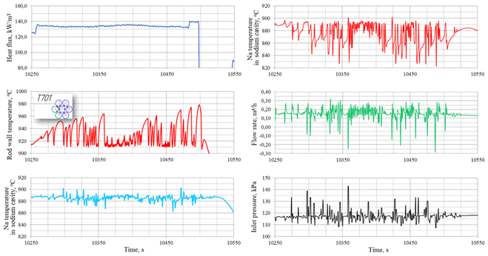
Fig. 7. Variation in the wall temperature of the central simulator (T701), the coolant temperature in the "sodium cavity"
and the sodium boiling flow rate within the heat flux from 120 to 135 kW/m²

Cartogram of two-phase flow regimes of liquid metal coolant
in a simulated rod ASSEMBLies
The data obtained for the simulated fuel assembly with a “sodium cavity” in the mass velocity – flow quality coordinates (Fig. 8) are in agreement with the data of the series of experiments using the model FA without a “sodium cavity” (without an axial blanket) in the natural circulation sodium-potassium alloy loops. For the nucleate boiling conditions, the data are located in the area of quality (0.1–2.5) %, for the slug regime (2.5–9) % in the range of sodium mass velocity (100–200) kg/(m²·s).

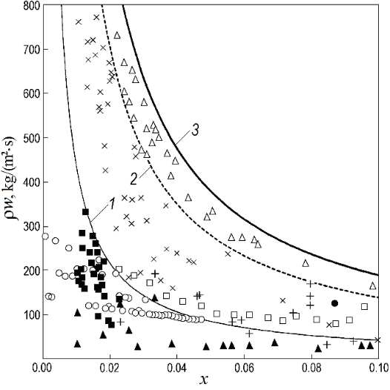
Fig. 8. Cartogram regimes of two-phase flow liquid metal coolants:
1 – boundary of nucleate and slug boiling regimes; 2 – boundary of slug and annular-dispersed boiling regimes;
3 – border of transition to post-CHF heat transfer; ○, □ – nucleate and slug regimes, IPPE JSC data on sodium boiling;
▲, +, ● – the first stable regime, pulsation and second stable regime, respectively, according to Yamaguchi [8];
■, ×, △ – IPPE JSC data on sodium-potassium alloy boiling: nucleate, slug and annular-dispersed regimes, respectively

Between these areas, the boundaries of these regimes can be roughly drawn, they are described by the following relationship:
, (1)
where the coefficient A for the boundaries of the transition from nucleate to slug boiling, annular-dispersed and dispersed regimes has the values of 4.3, 14.0 and 19.0, respectively.

Heat transfer of alkali metal boiling in tubes and fuel rod assemblies
Pressure, heat flux density, the state of heat transfer surface (roughness), heat transfer surface wetting with a coolant, two-phase flow regimes, etc. affect liquid metal coolant boiling heat transfer.
The data on heat transfer of liquid metal coolants in the channels and rod assemblies are scattered and not systematized, the generalizing dependence that takes into account the impact of these factors is lacking. With the forced flow of a vapor-liquid mixture of metals in a tube (at a pressure of about 0.1 MPa), at a flow quality as low as (1–5) %, an annular-dispersed regime sets in, it is characterized by (95–99) % of the liquid being in the form of drops in the central area of the flow. The heat transfer coefficient under such conditions has approximately the same value as in pool boiling (Fig. 9).
In the annular-dispersed regime, the phase transition is associated with the surface evaporation of the near-wall liquid metal film, which has a small thickness and high thermal conductivity. The effect of mass velocity and flow quality on heat transfer under these conditions, apparently, is insignificant. The experiments carried out by Yu.A. Zeigarnik et al. [17], confirmed this assumption – the sodium boiling heat transfer coefficient in a wide range of heat flux density (0.2–1.1) MW/m² remained essentially unchanged and equal to (2.5–4)·10⁵ W/(m²·K).
In the experiments with potassium boiling in tubes, the data are described by a well-known boiling heat transfer dependence α ~ q^{0.7} for non-metallic liquids [9]. This dependence is close to the dependence for liquid pool boiling heat transfer. The coincidence of the α(q) dependence in the liquid metal pool boiling experiments and in the tubes is not accidental. A similar coincidence is observed during water boiling, namely, the ratios for heat transfer in the event of boiling in the channels at a moderate mixture velocity correspond to the ratios for heat transfer for water pool boiling. At a low velocity of the liquid-gas bubble mixture α ~ q^{0.7}, at a high velocity – α ~ w^{0.8}, as is observed in convective heat transfer.
Comparison of the heat transfer data shows (Fig. 9) that sodium-potassium alloy boiling heat transfer in the rod assemblies [9, 16] and potassium in the tubes [16] in the range of heat flux density above 100 kW/m² on an average is 1.5 times higher than in case of alkali liquid metal pool boiling [17].

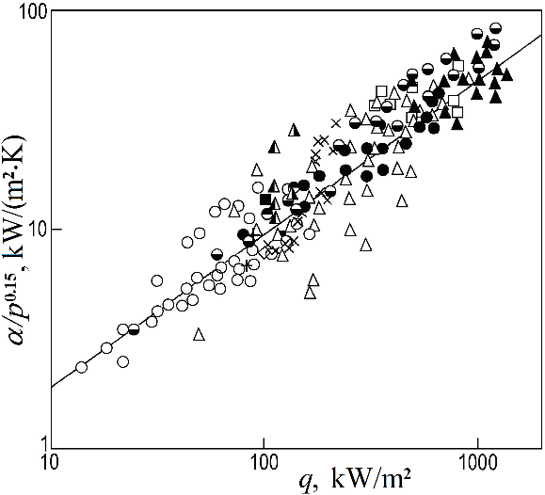
Fig. 9. Comparison of experimental data obtained by different authors on liquid metal boiling heat transfer in tubes
with the IPPE JSC data for fuel rod assemblies:
potassium boiling data [16]: ○ – pool boiling; ● – tube Ø10 mm (electric heating); ◒ – tube Ø10 mm (heat exchanger); □ – tube Ø8,3 mm; ■ – tube Ø22 mm; ▲ – tube Ø4 mm (electric heating); △ – tube Ø6 mm; data on of sodium-potassium alloy boiling in fuel assemblies (IPPE JSC): × – single assemblies (7 rods, the length of heat generation area 420 mm) [12]; + – parallel assemblies (7 rods, the length of the heat generation area 840 mm); ◓ – parallel assemblies (same power); ◮ – parallel assemblies (4 powered simulators in the left assembly and 7 in the right one) [11]; data on sodium boiling (IPPE JSC): ◭ – single assembly (7 rods, length of the heat generation area 600 mm) [9]; ––––––– – calculation according to V.M. Borishansky formula [16]

Conclusion
Liquid metals boiling in the cramped channels of fuel assemblies is a complex and dynamic high-temperature process (the sodium saturation temperature at atmospheric pressure is 883 °С). The vapor phase formation dynamics can be explosive, especially in view of potential overheating of the liquid metal relative to the saturation temperature at boiling inception. From this perspective, the operational control of the facility during the experiments is carried out at a high speed; with continuous real-time data recording and processing.
The results of liquid metal boiling experiments in simulated fuel assemblies in the natural convection condition show:
- Stable nucleate boiling in the simulated fuel assemblies is observed only in a restricted region of heat fluxes, its transition to unstable pulsation slug boiling is determined by various factors.
- In the assembly with low surface roughness of the rod simulators, evolution of an unstable (slug) regime with sharp coolant flow rate oscillations and overheating of the simulator wall can result in a CHF, in fact, the CHF ratio is lacking.
- For the fuel rod simulators with industrially-manufactured surface roughness, due to the appearance of a liquid film on the surface of the simulators, a transition from the unstable slug regime to the stable annular-dispersed one has been observed.
- The boundaries of the transition from the nucleation regime to the slug, annular-dispersed and dispersed flow regimes of liquid metal two-phase flow in the rod assemblies are approximated by simple dependencies, the cartogram of two-phase liquid metals flow regimes differs significantly from the cartogram for water.
- The occurrence of an oscillatory process during coolant boiling in one of the parallel fuel assembly results in an antiphase oscillatory process in another fuel assembly, further, the oscillations in different loops are antiphase in nature.
- In course of time, hydrodynamic interaction of the loops causes a significant increase in the amplitude of coolant flow rate oscillations in them (“resonance” of the flow rate oscillations) and a potential “choking” or inversion of the coolant flow rate in the loops, an increase in the temperature of the coolant and the fuel rod cladding (the effect of inter-channel instability) and, eventually, to the gives rise CHF.
- The heat transfer coefficients at sodium-potassium alloy boiling in model fuel assemblies and potassium in the tubes on an average are 1.5 times higher than in case of alkaline liquid metals boiling in the pool boiling, when the heat flux is above 100 kW/m².
- For the first time the possibility of prolonged cooling of fuel element simulators during sodium boiling in fuel assemblies for a new technical solution (“sodium cavity” between the core and the upper axial blanket) is shown.
The modified computational code SABENA-3D makes it possible to simulate the heat exchange process and the stability of the coolant circulation during liquid metal boiling both in single fuel assemblies and in a system of parallel fuel assemblies in a natural circulation loop.
References
- Sorokin, G., Avdeev, E., Zhukov, A., Bogoslovskaya, G., Sorokin, A., Development of thermohydraulics codes for modeling liquid metal boiling in LMR fuel subassemblies, IAEA-TECDOC-1157, LMFR core thermohydraulics: Status and prospects (2000) 107–126.
- Ashurko, Yu., Volkov, A., Raskach, K., Solomonova, N. Influence of the Neutronic Model on the Calculation of a Severe Sodium Boiling Accident in a Fast Reactor, Atomic Energy, 122 4 (2017) 183–189.
- Sorokin, G., Sorokin, A., Experimental and Numerical Investigations of Liquid Metal Boiling in Fuel Subassemblies under Natural Circulation Conditions, The Progress in Nuclear Energy Journal, Special Issue: “Innovative Nuclear Energy System for Sustainable Development of the World”, Proc. First COE-INES International Symposium,
INES-1, 2004, Tokyo, Japan, 47 1–4 (2005) 656–663.
- Kikuchi, Y., Transient Boiling of Sodium in Seven Pin Bundle under Loss of Flow Conditions, Journal of Nuclear Science and Technology, 15 9 (1978) 658–667.
- Kikuchi, Y., Boiling in 19-Pin Bundle under Loss-of-Flow Conditions in Local Blockage, Nuclear Engineering and Technology, 66 5 (1981) 357–366.
- Seiler, J., Cognet, Y, Leborgue, E., et.al, French LMFBR Core Thermal Hydraulic Studies for Nominal and Accident Conditions, Nuclear Engineering and Design, 124 3 (1990) 403–416.
- Kaizer, A., Huber, F., Sodium Boiling Experimental a Low Power under Natural Convection, Nuclear Engineering and Design, 100 3 (1987) 367–376.
- Yamaguchi, K., Flow Pattern and Dryout under Sodium Boiling Conditions, Nuclear Engineering and Design, 9 (1987) 247–263.
- Efanov, A., Sorokin, A., Ivanov, Eu., Sorokin, G., Bogoslovskaia, G., Ivanov, V., Volkov, A., Sorokin, G., Zueva, I., Fedosova, M., Heat Transfer under Natural Convection of Liquid Metal during Its Boiling in a System of Channels, Thermal Engineering, 54 3 (2007) 214–222.
- Sorokin, A., Kuzina, Yu., Ivanov, E., Heat transfer during boiling of liquid metal coolants in fuel assemblies of fast reactors in accident regime, Problems of Atomic Science and Technology. Series: Nuclear Reactor Constants, 3 (2018) 176–194 https://vant.ippe.ru/en/year2018/3/thermal-physics-hydrodynamics/1527-17.html
- Sorokin, G., Ninokata H., Sorokin, A., Endo, H., Ivanov, Eu., Numerical Study of Liquid Metal Boiling in the System of Parallel Bundles under Natural Circulation, Nuclear Science and Technology, 43 6 (2006) 623–634.
- Efanov, A., Sorokin, A., Ivanov, Eu., Bogoslovskaya, G., Kolesnik, V., Martsinyuk, S., Sorokin, G., Rymkevich, K., An Investigation of the Heat Transfer and Stability of Liquid-Metal Coolant Boiling in a Natural Circulation Circuit, Thermal Engineering, 50 3 (2003) 194–201.
- Sorokin, A., Kuzina, Yu., Ivanov, Eu., Features of Heat Exchange during Liquid Metal Boiling under Accidental Conditions in Fuel Assemblies of Fast Reactors, Atomic Energy, 126 2 (2019) 69–76.
- Sorokin, A., Ivanov, E., Bogoslovskaya, G., Martsinyuk, D., Kolesnik, V., Malkov, V., Rymkevich, K., Boiling of Liquid Metal in Natural Circulation Loop, Proc. of 11th International Heat Transfer Conference. August 23–28 (1998), Kyongju, Korea, 2 (1998) 357–361.
- Sorokin, G., Ninokata, H., Endo, H., Efanov, A., Sorokin, A., Ivanov, Eu., Bogoslovskaia, G., Ivanov, V., Volkov, A., Zueva, I., Experimental and Computational Modeling of Liquid Metal Boiling Heat Transfer in a System of Parallel Fuel Assemblies in a Natural Convection Regime, Izvestiya Vuzov. Yadernaya Energetika, 4 (2005) 92–106.
- Borishansky, V., Kutateladze, S., Novikov, I., Fedynsky, O., Liquid Metal Coolants, Atomizdat, Moscow (1976).
- Zeigarnik, Yu., Litvinov, V., Boiling of Alkali Metals in Channels, Nauka, Moscow (1983).

