# SAFETY REVIEW AND ASSESSMENT OF CORE THERMAL HYDRAULICS OF PFBR

ANANYA MOHANTY, HEMANT K KULKARNI, SUNILKUMAR B CHAFLE

Atomic Energy Regulatory Board, Mumbai, India

Email contact of corresponding author: ananyamohanty@aerb.gov.in

**Abstract**

As a part of the India’s three stage nuclear power program, Fast Reactors play a significant role towards maximizing utilization of limited resources of uranium and vast resources of thorium available in the country for the long term and sustainable energy demands. The operation of Fast Breeder Test Reactor (FBTR) in Kalpakkam has successfully demonstrated the fast breeder technology. With the experience gained from the operation of FBTR, the design of a 500MWe pool type prototype fast breeder reactor (PFBR) was taken up. The PFBR is currently in the initial stages of commissioning. Sodium cooled reactors with pool type design have a large volume of primary sodium and its thermal capacity and high conductivity reduces thermal transients in the primary circuit. The prediction of temperature distribution in the core during steady-state, transient and shutdown states play an important role in establishing design limits for core, coolant and structures. Several unique thermal hydraulics phenomena that were encountered during the review of design are thermal stripping, cover gas entrainment, free level fluctuations, buoyancy effects within the hot and cold pools, flow distribution in the subassemblies, flow recirculation etc which needs detailed understanding and improved codes for accurate prediction. The reactor design of PFBR has undergone extensive safety review by the regulatory body based on the Safety criteria for Sodium cooled fast reactors. Further the improvements in regulation are being incorporated by considering operating experience feedback, assessment of changes in national and international regulation etc. A Safety Code on design of sodium cooled fast breeder reactors has been developed by the Atomic Energy Regulatory Body (AERB). This paper brings out the evolution of safety requirements of Fast Breeder reactors with emphasis on core thermal hydraulics, challenges in the review and acceptance of unique thermal hydraulic characteristics of the sodium cooled core such as thermal stratification, cellular convection, thermal stripping, gas entrainment, natural circulation under decay heat removal etc.

## INTRODUCTION

The PFBR is a 500 MWe, pool type sodium cooled, mixed oxide (MOX) fuelled, pool type fast breeder reactor [1]. The reactor core consists of fuel, blanket, storage, reflector and shielding subassemblies (SA), which are mounted on a grid plate. The grid plate is mounted on the core support structure. The core is surrounded by an inner vessel which separates the hot pool from the cold pool. Two centrifugal pumps are used to circulate the sodium from the cold pool through core to the hot pool. The primary sodium flows into the intermediate heat exchangers (IHX) which transfers heat to the secondary sodium circuit.

The reactor assembly consists of Control plug (CP) which is a hollow cylindrical shell supported on the roof slab. It is located above the core outlet in hot pool and houses the absorber rod drive mechanisms (ARDM), thermocouples for measuring core outlet sodium temperature, core power monitoring instrumentation, sampling tubes etc.

Argon gas is provided between the sodium pool free surface and the top shield. The reactor components are housed in the Main vessel (MV) which is surrounded by a safety vessel housed inside the reactor vault.

Design of the core components largely depends upon the thermal hydraulic parameters existing in the core. The aim of a good thermal hydraulic design is to achieve as high a coolant outlet temperature as possible while satisfying the design safety limits. This necessitates a high sodium flow rate in the core which also causes a few issues such as free level fluctuations, gas entrainment, oscillations in stratified layer, etc. Also, owing to large temperature difference between the hot and cold sodium pools coupled with core components made up of austenitic stainless steel (high thermal expansion coefficient and low thermal diffusivity), certain unique thermal hydraulic phenomena occurs such as thermal stripping which impose high cycle fatigue (HCF) on components. This high cycle fatigue can further enhance the damage caused by low-cycle fatigue (LCF) imposed due to the envisaged transients and shut-down operations. These phenomena need detailed understanding through experiments and improved codes for accurate assessment.

To address the above phenomena several theoretical and experimental methods have been adopted by the designer i.e., Indira Gandhi Centre of Atomic Research (IGCAR). The assessment methodologies have been based on extensive literature review, discussions with experts and feedback from operating experiences from the Fast Breeder Test Reactor (FBTR) and worldwide. The thermal hydraulic design along with supporting experimental and analytical findings have been reviewed by the regulatory body i.e., Atomic Energy Regulatory Board (AERB). The computer codes used for thermal hydraulics analysis have been reviewed by a special task force in AERB. The capability of the code for analysing various event scenarios, modelling details, numerical methods used, validation problem definition and sensitivity studies were reviewed. Several suggestions were made for better interpretation and assessment of validation results and were incorporated in the codes by the designer.

The structural design of core components taking thermal hydraulic parameters as input have been carried out based on the French code RCC-MR .The provisions of ASME codes have been employed for situations where the rules are not yet defined in RCC-MR. These codes specify the limits on allowable stresses in materials, however such limits are not explicitly available for thermal hydraulic parameters. For PFBR, designers have established important thermal hydraulic limits which have been reviewed and accepted.

The guidance document called the “Safety Criteria for design of PFBR[1]” [2] was extensively followed during the design safety review of PFBR. Also, compliance with IAEA safety standard NS-R-1[3] was verified. Presently, a new Safety code for Design of Fast Breeder Reactors [4] is under development with improvements in regulation based on the review experience of PFBR, operating experience feedback, assessment of changes in national and international regulations, etc. Specific requirements to be considered during thermal hydraulics design such as thermal stripping loads, fatigue loading due to free level fluctuations and stratification, decay heat removal during design extension conditions, etc. have been incorporated.

This paper covers the thermal hydraulic characteristics of the sodium cooled core such as thermal stripping, thermal stratification, gas entrainment, cellular convection and natural circulation during decay heat removal, establishment of design limits and challenges in the review and acceptance of these aspects along with the evolution of design safety requirements for Fast Breeder reactors.

## THERMAL STRIPPING at CORE OUTLET

In PFBR, there is a large temperature difference (about 100 K) between the sodium outlets from fuel SAs and control SAs as well as between fuel and blanket SAs which causes random fast temperature fluctuations at core exit. Due to large heat transfer coefficient of sodium, these temperature fluctuations are transmitted to the adjoining structures with minimal attenuation, thereby inducing high cycle fatigue in components made up of austenitic stainless steel. The bottom portions of Control Plug consisting of the lattice plate, core cover plate (CCP) and outer shell are subjected to thermal striping risks.

There were several reported failures due to thermal stripping in operating reactors such as Phenix, SPX and BN 600 [5]. Feedback from these events have been considered in the development of design criteria to avoid thermal stripping and during regulatory review of the same.

* + 1. **Analysis methods and findings**

The investigations carried out by the utility consists of simulations at two levels carried out using the commercial CFD code FLUENT. In the first level, locations prone to thermal striping were identified by performing a global conjugate 3-D simulation of hot and cold pools on a symmetric sector of the core. Four localized zones in the primary sodium circuit have been identified to be prone to thermal striping. They are (a) fuel-breeder interface around the lattice plate, (b) fuel-breeder interface around the CCP (c) bottom portion of ARDM and (d) main vessel near IHX outlet as described in Fig 1. In the second level, these localised zones were analysed for the prediction of sodium flow and temperature oscillations by performing DNS calculations. The calculations have been carried out without the use of any turbulence or wall function models. To capture the turbulent eddies responsible for flow and temperature fluctuations, very fine mesh pattern (∼ 0·1mm) and small time steps size (∼ 1 ms) have been selected for the simulation. The near wall mesh is selected in such a way that the y+ (wall coordinate) is less than unity.



FIG 1: Locations in the core prone to thermal stripping and the corresponding peak-to-peak sodium temperature fluctuation (adapted from [10]).

Data from experiments carried out internationally such as by KAERI and JAEA [5] have been used to test the turbulence models and LES approach. In a collaborative study with Indian Institute of Technology-Madras, experiments [7] were conducted on lattice plate geometry which simulates the core cover plate of the control plug and parallel water jet model which simulates the coolant outlet flow. The CFD code was validated with the experiment results and was used to predict thermal stripping in the PFBR core. The key findings from the analysis are as follows:

* The frequency of temperature fluctuations range from 0.01 Hz to 10 Hz which yields cumulative load cycles in the order of 1x107 to 1x1010 considering 45 year reactor life with 75% load factor.
* The peak-to-peak values of sodium temperature fluctuations are 98 K and 60 K respectively near absorber rod drive mechanism shroud and lattice plate. The corresponding values of surface temperature fluctuations are 44 K and 24 K respectively which is less than the acceptable temperature limit of 60 K.
* The main vessel experiences a maximum temperature variation of about 20 K only at the elevation of outlet window of IHX.
* The metal surface temperature fluctuation is less than 50 % of the fluid temperature fluctuation.

To establish the acceptable limit, thermo-mechanical and fracture mechanics analyses based on UK creep-fatigue procedure and the RCC-MR code [8] were performed by utility. The peak to peak temperature fluctuations on structures has to be limited to 60 K for control plug and 40 K for main vessel and inner vessel [9]. Based on the above findings, the following criteria and design provisions were adopted [9]:

* Mixed mean coolant outlet temperature from the SA shall not differ by more than 100 K with respect to coolant outlet from adjacent SA.
* The heat generation in source SA is very low as compared to the adjacent fuel SA and hence to avoid thermal striping in the control plug, fuel pin bundles are incorporated in source SA. Fuel pin bundles are supported above the source region in the source sub-assemblies.
  + 1. **Regulatory requirements**

The Safety criteria for Design of PFBR [2] states that “*Components constituting the reactor core shall be designed and mounted in such a way that they withstand the static and dynamic loading expected in all operational states and accident conditions so that core integrity is maintained to ensure safe shutdown and adequate cooling is maintained so that design limits are not exceeded*”.

To take into account the phenomena of thermal striping in design, the requirement has been specifically included in the latest AERB draft safety code for Fast breeder reactors [4] as “*The reactor assembly components shall be designed with due account taken of the creep properties, thermal striping, fast neutron induced changes, other ageing effects, and the material compatibility with sodium and its compounds. The design shall take into consideration the behaviour of boundary material under operational, maintenance and testing conditions and in design basis accidents, taking into account the expected end of life properties (which are affected by creep properties, erosion, thermal striping, fast neutron fluence, and other ageing effects, as well as its compatibility with sodium, and with thermal stress and dynamic load on thin-walled structures used under low pressure and high temperature conditions), any uncertainties in determining the initial state of the components, and the rate of possible deterioration*” .

## Stratification in pool

Stratification of sodium is observed in pool type reactors due to the large temperature difference (150 K) between the hot pool which is at 820 K and cold pool at 670 K. In the interface between these two pools, the temperature varies from 870 K to 720 K in length of 1 m.The redan portion of the inner vessel is the most affected location. In this zone, a cold boundary layer exists at the redan shell due to heat transfer to the cold pool and cold sodium flow from peripheral SAs (storage, reflector, shielding SAs). The hot sodium from core outlet recirculates and penetrates into the cold stable layer causing mixed convection and stratified flow in this region (Fig. 2). The stratified layers oscillates over the range of 50-150 mm with frequencies of about 0.1 Hz to 1 Hz which induces high cycle thermal fatigue on the adjacent structures.

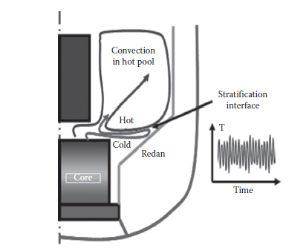

*FIG 2: Thermal stratification in hot pool (adapted from [6])*

### Analysis methods and findings

1. Thermal hydraulics and structural mechanical analysis have been carried out by designer to analyse the effect of thermal gradients on the inner vessel. Regulatory review emphasized on establishing limits for inner vessel for thermal striping. During safety review of plant transients, such as unprotected transient over-power accident, it was emphasized to consider the non–uniformity in the hot pool and cold pool temperatures for prediction of peak temperature of clad and coolant.

The 3-D thermal hydraulics code PHOENICS has been used to predict the sodium flow and temperature at various power levels. In the initial design, stratification was observed even at full power conditions with a Richardson number (Ri) (Ri ∝ ∆T/V2) ~ 0.25, where ∆T is maximum temperature difference between core outlet sodium streams and V is core outlet sodium velocity. To reduce stratification, a perforated shroud with 10 % porosity was introduced at the bottom of the control plug. This shroud increased the radial velocity of sodium entering the hot pool and eliminated formation of stratified layer (Fig 3a & 3b). The Richardson number with skirt reduced to ∼ 0·065.

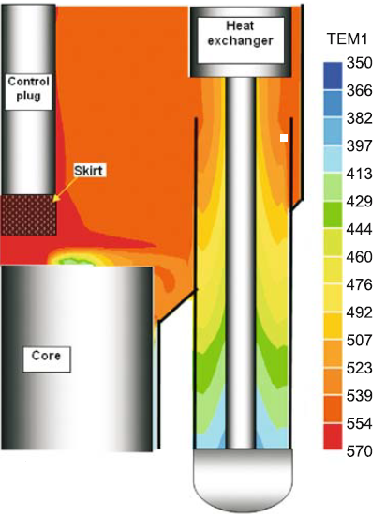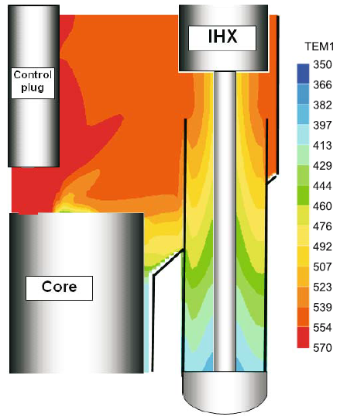 *FIG 3(a): Hot pool temperature field (0C) without skirt [10] FIG 3(b): Hot pool temperature field (0C) with skirt [10]*

1. The initial design envisaged reduction in core flow proportional to reactor power so that temperature increase across the core (∆T ~150K ) is maintained at all power levels. However, it was observed that stratification was still occurring at low flow conditions even with the skirt. This made the designers to select core flows such that the Richardson number is maintained same as that in full power (∼ 0·065). Due to this the core sodium flow rate is not proportional to reactor power. The flow fraction at part load condition is always more than the power fraction and hence the ∆T is less at low power than at full power.
2. Conjugate heat transfer analyses indicate that the axial temperature gradient in the inner vessel is 100 K/m after introduction of perforated shell at the Control plug. The maximum temperature drop across the thickness of the vessel is 64 K and the creep fatigue damage is 0.1 at the critical junction between the lower shell and the redan. Based on this, the acceptable fluctuation is 0.54 m at the redan location and the amplitude should be restricted to 270mm at the mean positon [9].

### Regulatory requirements:

The Safety criteria [2] states that “*Components constituting the reactor core shall be designed and mounted in such a way that they withstand the static and dynamic loading expected in all operational states and accident conditions so that core integrity is maintained to ensure safe shutdown and adequate cooling is maintained so that design limits are not exceeded*”.

The latest AERB draft safety code on Design of FBRs [4]states that the “*design of the reactor core components shall account for the static and dynamic loadings expected under operational states and design basis accidents with due regard to the effects of temperature, pressure, irradiation, ageing, creep, corrosion, erosion, vibrations, fatigue etc*”. The phenomena of stratification and oscillations of the stratified layers though not explicitly mentioned, gets addressed while considering all phenomena imposing fatigue loading on the core components.

## Free level fluctuations

In pool reactors, the sodium jet emerging from the core causes free surface oscillations at the interface with cover gas. Due to these surface oscillations two phenomena occur, (a) cover gas entrainment and (b) thermal fluctuations resulting in fatigue loading on the adjacent structures.

The entrainment of cover gas into the sodium pool has a major bearing on safety as the agglomeration of the gas and its passage in the core will lead to addition of significant positive reactivity.

Due to level fluctuations, structures in contact with the hot pool which is at 820 K and partly exposed to cover gas which is at 670 K see alternating temperatures. This imposes high cycle fatigue on the components especially the inner vessel upper shell and the control plug shell. The main vessel doesn’t experience significant temperature fluctuations due to the presence of main vessel cooling system which is a system of concentric cylindrical baffles attached to the main vessel through which fraction of cold pool flow is directed to flow through outer annulus, then into the inner annulus and enters the cold pool (Fig4) .However, gas entrainment can also occur at the over flow weir over the thermal baffles.

*FIG 4: Flow through the core with main vessel cooling system (adapted from [8])*

### Analysis methods and findings

#### Investigations for gas entrainment

Initial 3-D thermal hydraulics studies and experiments carried out in Scale Model for Reactor Thermal Hydraulics (SAMRAT) [11] (which is¼ scale water model of PFBR) indicates that vertical velocity of jet entering hot pool is 3 m/s and the maximum horizontal velocity is 1 m/s at the surface. It was found that the free surface velocity should be limited to 0·5 m/s to avoid gas entrainment. To address this issue, baffle plates were introduced on the inner vessel to break the jet velocity and reduce free surface velocity. The 3-D CFD code PHOENICS was used to study the flow fluctuation by varying the plate shape, size and location. The results indicated that a horizontal baffle of 0.5 m on the upper shell of the inner vessel and lowering the roof slab inner shell upto IHX inlet, resulted in reduction of the free surface velocity to ~ 0.4 m/s [9, 10].

To investigate gas entrainment at the main vessel cooling baffles, liquid film thickness, flow separation etc experiments on a full scale slab model was carried out by utility. It was observed that gas bubbles got entrained in the collector plenum for all fall heights greater than 100 mm, irrespective of the flow rate. However, all the entrained gas bubbled out to free surface after penetrating to a maximum depth of only 700 mm. There is sufficient depth of sodium available in the collector plenum to avoid gas entrainment in main vessel cooling system.

During safety review, it was opined that possibility of argon gas entering the pool due to differential solubility and leakage through thermocouples or ARDMs may not be ruled out. Towards this issue, designers confirmed that in case of argon entrapment, the same will bubble to the cover gas directly. In the eventuality of bubbles being carried through a circuitous route through IHX, PSP etc., the same will get collected within grid plate at the periphery of the core, wherein 6 Purger subassemblies are provided to purge out the gas. This arrangement ensures prevention of large gas accumulation within grid plate and sudden passage of the same through the core.

#### Investigations for structural integrity

One of the important safety review recommendations was to establish thermal stripping limit for inner vessel due to free surface oscillations. Designers were asked to investigate the possibility of measuring the sodium level fluctuations. To address the issue, hydraulic experiments on scaled down models were carried out and the results indicated that during normal operation, the oscillation over mean level in the hot pool is of the order of 40 mm and the frequency of oscillations is about 1 Hz. Fatigue analysis indicated that amplitude of level oscillations should be less than 55 mm, to prevent failure due to thermal striping for inner vessel [9]. Hence the predicted amplitude of 40 mm was found to be acceptable. It was further confirmed that the level oscillations can be measured with hot pool level detectors.

### Regulatory requirements:

The latest AERB draft safety code on Design of FBRs [4] states that “*The primary coolant circuit shall be designed to prevent ingress of oil or gas into it. In case of insertion of gas or oil, the likelihood of which shall be remote, the resulting reactivity change shall be within the capabilities of the shutdown systems*”.

The requirement to consider thermal fatigue loading on structures due to free surface fluctuations, gets addressed while considering all phenomena imposing fatigue loading on the core components as mentioned in section 3.4.

## CELLULAR CONVECTION

The primary sodium pool is covered by a top shield which is in contact with cover gas at ~ 700 K at the bottom and by atmosphere of the reactor containment building at the top. A warm roof concept has been adopted in PFBR to prevent freezing of sodium aerosols. Air cooling system is provided in each compartment within roof slab to maintain the temperature at ~393 K. There are several penetrations on the top shield for components like IHX, DHX, sodium pumps, control plug, rotating plugs, etc forming annular enclosures. The width of these annuli have been kept minimum (10-20 mm). The height of the enclosures is ~ 2 m based on shielding requirements. Due to large aspect ratio, the natural convection of argon cover gas in the annuli is asymmetric and produces temperature asymmetry in the roof slab penetration shells. (Fig 5)

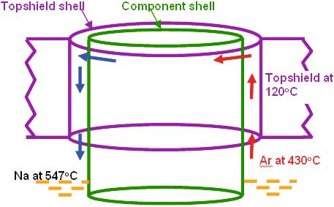

*FIG 5: Asymmetric cellular convection of argon (adapted from [10])*

### Analysis methods and findings

Cellular convection of argon in the pump and IHX penetrations in the roof slab has been analysed by designers using the in-house developed code THYC-2D and by commercial CFD codes such as STAR-CD. The argon velocity and temperature distribution in the annuli were calculated considering interactions between heat conduction in shells, thermal radiation and forced cooling of air. It is found that the circumferential temperature difference in gas decreases with height and maximum circumferential temperature difference occurred at the bottom of the annulus. For a typical case of primary pump penetration, the mean circumferential ∆T in the pump penetration shell in roof slab (which is cooled by air) is 18 K and that in the shell forming part of the pump (where there is no cooling) is 38 K[9,12]. Thermal stress analysis based on the circumferential temperatures indicate the maximum stress at the vicinity of the bottom plate of 34 MPa which is acceptable. The radial temperature gradient in the sectors because of variation in the heat transferred (due to variation in cooling flow) is estimated to be ~12 K against the acceptable limits of 30 K. The 3-D CFD simulations have also been validated against the experiments carried out in full scale model of Large component Test Rig (LCTR) at IGCAR and the COBA experimental facility [6]. The circumferential ∆T observed in the experiments ~10 to 15 K.

### Regulatory requirements:

The AERB safety code on Design of FBRs [4] states that “*Auxiliary cooling circuits (like reactor assembly top shield cooling, reactor vault concrete cooling) shall be designed with sufficient capacity and redundancy to remove the heat from the sources to the ultimate heat sinks without exceeding the specified limits during all the operational conditions and design basis events. Considerations shall be given for the compatibility of fluids in the two circuits”.*

## NATURAL CONVECTION AND ROLE OF INTER-WRAPPER FLOW IN DECAY HEAT REMOVAL

In PFBR, two parallel decay heat removal systems viz Operational Grade decay heat removal system (OGDHRS) and Safety Grade Decay Heat removal system (SGDHRS) remove decay heat from the core to the ultimate heat sink. During loss of power, decay heat is removed through SGDHRs which is an intermediate sodium circuiting working on the principle of natural convection. The SGDHR consists of four independent loops with each having 8 MWth heat removal capacity. Each loop is provided with a sodium-sodium heat exchanger called Decay heat exchanger (DHX) dipped in the hot pool and sodium-air heat exchanger (AHX) with thermal centres difference of ~ 41 m. The AHX is housed in a tall stack of 30 m height. The primary sodium flows through the DHX and exchanges heat with the intermediate circuit. Natural convection loop gets established in the SGDHR loop and heat is transferred to the AHX. The AHX rejects heat to the ambient air which is the final heat sink.

In the event of loss of forced flow through the core, natural convection currents set up inside the SAs driven by buoyancy forces generated by the heat transfer from core to the secondary circuit through IHX and to the SGDHR circuit through DHX. A small fraction of sodium leaks from the grid plate and exists in the gaps between the SAs. Natural convection currents also set up in these gaps due to thermal hydraulic interaction amongst the narrow inter-wrapper space. This flow is known as the Inter-Wrapper Flow (IWF) (Fig.6).

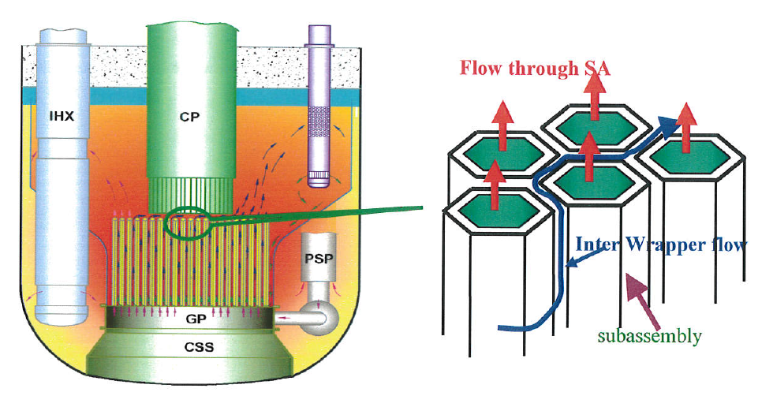

*FIG 6: Schematic of Inter-wrapper flow (adapted from [6])*

### Analysis methods and findings

Initial 1-D studies indicated that heat removal by the IWF is significant and can reduce SA peak temperatures especially during the onset of natural circulation. Based on the detailed review by AERB, it was opined that interaction of inter-wrapper flow (order of 3mm) with hot pool (dimensions in order of 10 m) is a multi-scale heat transfer problem and required 3-D analysis and validation against experimental data. It was recommended that the various SGDHR experiments and the studies on natural convection have to be carried out to prove establishment of natural convection inside the reactor pool and the performance of SGDHR to remove decay heat from the core to atmosphere, to carry out parametrical studies of natural circulation and to address all the uncertainty in parameters on establishment of natural convection.

A steady state 3-D analysis [9, 13] using the coupled CFD code STAR-CD (2005) validated against Phenix data has been carried out by designers for the case of off-site power failure and station blackout. A 360 degree sector model for hot pool and cold pool has been modelled. The 3-D model of the primary circuit has been coupled with 1-D model of secondary sodium circuit using a user subroutine with heat transfer in the IHX as a boundary condition. The k-ε turbulence model has been used to model turbulence effects. The convective terms in the transport equations have been addressed by applying first order upwind differencing scheme. The major findings of the study were:

* The sodium outlet temperatures of fuel and blanket SAs calculated by 3D simulations, were marginally lower compared to those estimated by heat balance calculations. There is a reduction in the fuel and blanket SA outlet temperature by 3-5 K due to heat transferred by IWF.
* The outlet temperatures from peripheral SAs are higher (by 3K-13K) than the estimated temperatures due to heat absorption from inter-wrapper sodium to the sodium flowing inside these SAs.
* It was seen that IWF was able to reduce the peak temperature by about 20 K in the fissile core and 60 K in the blanket zone.
* Study on effect of uncertainty in inter-wrapper flow pressure drop and heat transfer indicated that a 20% uncertainty in pressure drop and heat transfer correlations resulted in negligible variation in fuel SA and hot pool temperatures.

During safety review, it was observed that for certain categories of events, design thermal limits of fuel SAs could not be satisfied (e.g. for the case of Station Black-out and both the pony motors not operating) without taking credit of inter-wrapper flow in fuel subassemblies. Also, it was found that with the consideration of IWF only, the storage SA temperature limits can be respected during decay heat removal by SGDHRS. It was opined that as the inter-wrapper flow is playing an important role in heat removal and its advantage is considered in analysis, a quantitative estimation should be carried out by experiment. Designers carried out the following experiments to demonstrate the IWF phenomena.

* To study the pool hydraulics during decay heat removal, experiments were carried out in SAMRAT experimental facility [11] for thermal hydraulic studies based on Froude number similitude using water as stimulant. It is observed that in case of heat removal by IWF alone there was a 20% rise in the temperature gained by the water in core compared to normal case which indicates the significance of heat removal by Inter Wrapper Flow.
* An IWF Slab Model (Water Model) [9] which is a 1:1 scaled slab model of the reactor with fuel and blanket SA was simulated. The approximate contribution of the IWF to the core heat removal was found to be 25 % as per Particle Image Velocimetry (PIV) measurements.

### Regulatory requirements:

The Safety criteria for Design of PFBR [2] states that *“At least 2 diverse decay heat removal systems shall be provided to transfer heat from the core to ultimate heat sink under shut down condition, at a rate such that specified limits on Fuel, Clad and Coolant are not exceeded with one system not available and with single failure in the operating system. The non-availability in the DHR function should be less than 10 -7 /reactor year. Suitable redundancy shall be provided in each system to fulfil these requirements, assuming a single failure.”* In the draft AERB safety code [4] few additional requirements with consideration of latest International Atomic Energy Agency (IAEA) Safety Standard Series No. SSR-2/1 [14] and safety design criteria for Gen-IV safety systems [15] have been included such as design for external events, prevention of freezing of sodium coolant to avoid blockage of coolant circulation ,use of passive mechanism to the extent possible, provision of core cooling under postulated plant conditions with core degradation etc.

SGDHRS being a First of a Kind (FOAK) system needs to satisfy certain special regulatory requirements. As per regulatory requirements laid out in AERB draft safety code [4] any FOAK system since they are not proven by operating experience, are required to be qualified by prototype or scaled experimentation and/or by analysis for establishing their ‘basis of acceptance’ before putting into reactor use.

## CONCLUSION

The thermal hydraulics features of sodium cooled fast reactors such as thermal stripping, stratification, free level fluctuations, cellular convection, inter wrapper flow and the challenges in safety review and assessment of these parameters have been brought out in this paper. The fatigue loading imposed by thermal stripping, gas entrainment and decay heat removal by IWF have an important bearing on the life of the reactor components and on reactor safety. The thermal hydraulics limits have been established for various parameters specific to PFBR design based on safety analysis with the help of in-house as well as commercial thermal hydraulic codes, large scale water experiments, limited sodium experiments, extensive literature review and operating experiences feedback.

Detailed safety review of the analytical and experimental prediction of these issues based on standard codes and guides have been carried out for acceptance of the thermal hydraulic limits. These design limits will be further confirmed during the ongoing commissioning tests. Operating experience feedback from reactors such as Phenix, Super Phenix, Monju, PFR-250, BN-600 etc. have been extensively considered during safety review. Based on the safety review experience, the requirements to address these thermal hydraulic parameters have been brought out in the safety code for sodium cooled fast reactor based NPPs.

References

1. CHETAL , S.C., et al., The design of the Prototype Fast Breeder Reactor, Nuclear Engineering and Design,236, (2006), 852-860.
2. ATOMIC ENERGY REGULATORY BOARD, Safety Criteria for Design of Prototype Fast Breeder Reactor (1990).
3. INTERNATIONAL ATOMIC ENERGY AGENCY, Standards Series No. NS-R-1, Safety of Nuclear Power Plants: Design, IAEA, Vienna, (2000).
4. ATOMIC ENERGY REGULATORY BOARD, Safety Code on Design of Sodium Cooled Fast Breeder Reactor based Nuclear Power Plants-Draft, (2020).
5. GILINEAU, O., et al., “Thermal fluctuation problems encountered in LMFRs”, Specialists' meeting on correlation between material properties and thermos-hydraulics conditions in LMFRs, Aix-en-Provence (France), (1994).
6. BALDEV RAJ, CHELLAPANDI, P., VASUDEVA RAO, P.R., Sodium Fast Reactors with Closed Fuel Cycle, ISBN: 9781138893047, Taylor and Francis Group, (2015).
7. VELUSWAMY, K., et al, Thermal Hydraulic Investigations of Thermal Striping in the Primary Circuit of LMFBR, Collaborative project between IGCAR and IIT Madras internal report, Indira Gandhi Centre for Atomic Research, Kalpakkam, (2002).
8. CHELLAPANDI, P., et al., Thermal striping limits for components of sodium cooled fast spectrum reactors, Nuclear Engineering and Design 239, (2009), 2754-2765.
9. Preliminary Safety Analysis Report of PFBR, Indira Gandhi Centre for Atomic Research, (2010).
10. K.VELUSWAMY, BALDEV RAJ , Overview of Pool Hydraulic Design of Indian Prototype Fast Breeder Reactor, Indian Academy of Sciences , Sadhana Vol. 35, Part 2, (2010), 97–128.
11. PADMA KUMAR, G., et al., “Commissioning of and experiments in ¼ scale Reactor Assembly Model of PFBR”, www.dae.gov.in
12. VELUSAMY, K., et al., Natural Convection in Narrow Component Penetrations of PFBR Roof Slab, Journal of Energy, Heat and Mass transfer, Vol.20, (1998), 1-11.
13. PARTHASARATHY, U., VELUSWAMY, K., 3-D Transient Analysis on Pool Hydraulics including Inter Wrapper Flow under Natural Circulation, internal report, Indira Gandhi Centre for Atomic Research ,Kalpakkam,(2011).
14. INTERNATIONAL ATOMIC ENERGY AGENCY, Safety standards series, Specific Safety Requirements No. SSR-2/1, Safety of Nuclear Power Plants: Design, (2012).
15. INTERNATIONAL ATOMIC ENERGY AGENCY, Safety Design Criteria (SDC) for Gen-IV Sodium Cooled Fast Rector, SDC-TF/2013/01, IAEA, Vienna, (2013).

1. Since most of the regulatory documents were for Light Water Reactors, a separate safety criteria for PFBR considering novelties in technology was prepared by an expert group (DAE-SRC sub-committee) and approved by AERB in 1990.