Extension of the DYN3D/ATHLET code system to transient analyses of SFRs

E. FRIDMAN¹, E. NIKITIN¹, A. PONOMAREV¹, A. D. NORA^{1,2}, S. KLIEM¹, K. MIKITYUK^{2,3}

¹Helmholtz-Zentrum Dresden-Rossendorf, Dresden, Germany
²Paul Scherrer Institute, Villigen, Switzerland
³Polytechnique Fédérale de Lausanne, Lausanne, Switzerland

Email contact of corresponding author: e.fridman@hzdr.de

Extended abstarct
Recently, 3D Light Water Reactor core simulator DYN3D was extended to perform steady-state and transient calculations of Sodium cooled Fast Reactors (SFR) on reactor core level [1]. The essential supplementary methods included, among others, time-dependent axial and radial core expansions models.
Scaling up the simulation capabilities to system level requires the coupling of DYN3D with thermal-hydraulics (TH) system code capable of sodium flow modeling. Moreover, the coupled code system should be able to model thermal expansions of out-of-core (OOC) structures (e.g. control rod drive lines (CRDL), primary vessel, core support structure, etc.) impacting the effective position of the control rods.
In this study, the adaptation of existing coupling of DYN3D with the TH system code ATHLET to transient analyses of SFRs is described. In addition, the capabilities of the coupled ATHLET-DYN3D are verified and validated using the Phenix reactor natural convection test [2] and the Superphenix (SPX) startup transient benchmark [3].
For the Phenix modelling, the application of the stand-alone DYN3D code with internal TH module for this benchmark exercise has already been reported [4]. Thus, the application of the coupled code system in this study had a twofold objective.
First, the TH models of ATHLET and result of the coupled solution are verified at the core level in comparison with stand-alone DYN3D and its TH module. The same core model and few-group cross section (XS) data applied in [4] were used in the current study. The XS were parametrized with respect to fuel and sodium temperatures, radial expansion of the core driven by expansion of the diagrid plate, and axial expansion of the core driven by cladding temperature. A simplified TH model in ATHLET was developed consisting of 1D channels connecting the inlet and outlet plenums. The channel parameters in ATHLET were identical to those of the stand-alone DYN3D model. In this way, the developed coupled DYN3D/ATHLET model of the core is equivalent to the stand-alone DYN3D model. For the simulated transient, a reasonable agreement was stated between the results obtained with the stand-alone DYN3D code and with the coupled ATHLET-DYN3D system without modelling of OOC and corresponding CR position feedback effect.
Second, the simulation was extended to account for the thermal expansion of the OOC structures, driven by sodium temperature at different locations, thus introducing an additional reactivity effect due to variation of CRs position. The simplified models and parameters were selected for primary vessel, conical shell, and strongback for calculation of expansion based on the core inlet temperature as boundary condition for the transient. For the coupled simulation with modelling of OOC, the effect of the CR position change becomes noticeable at the end of the simulated time period, resulting in a correction of the outlet sodium temperature, reactivity and power shape. The decomposition of reactivity for this simulation is shown in Figure 1, where the net reactivity in the case without OOC is also presented for the comparison.
For the analysis of the SPX startup transient benchmark, the ATHLET model was adopted from the previous related study, where ATHLET was applied to the SPX calculations as a stand-alone code [5] with point kinetics approximation. The TH model with the simplified approach for modelling of the structures of vessel, diagrid and strongback was used, as recommended in [3]. The 24-group XS library was prepared with Serpent [6]. The XS were parametrized with respect to fuel and sodium temperatures, radial diagrid expansion, and axial fuel expansion driven by fuel temperature. Reasonable agreement was observed for main parameters as compared to the experimental data.

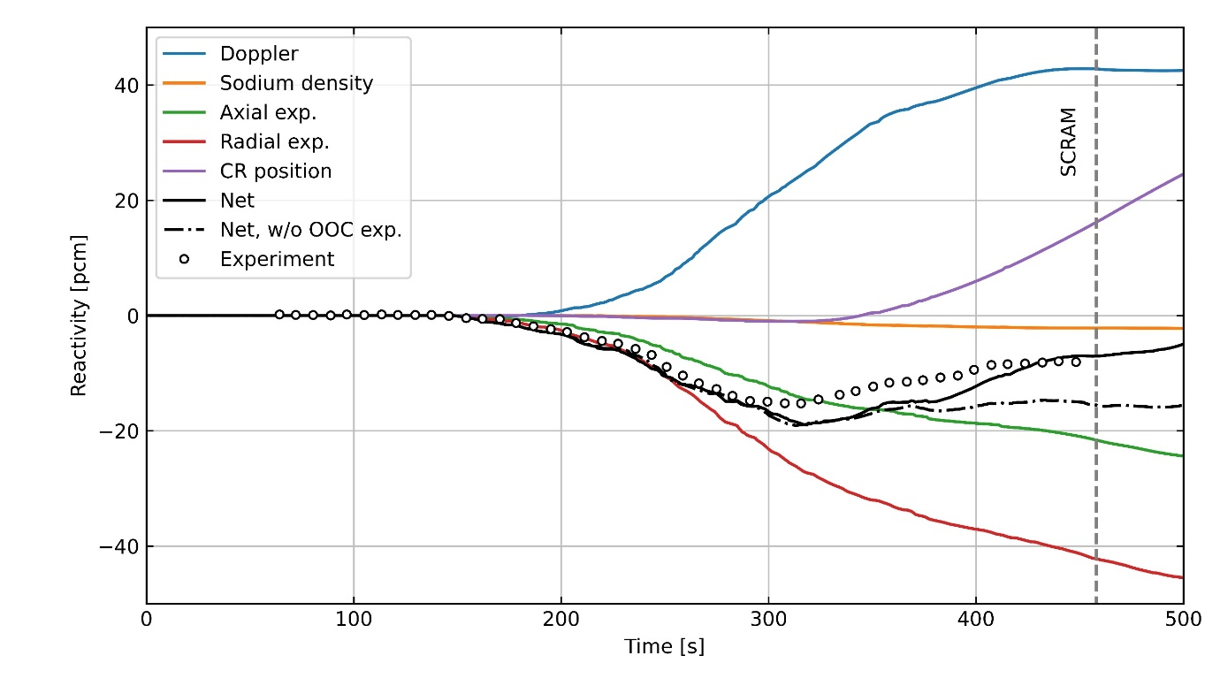
Fig. 1. Transient evolution of the reactivity and its components in Phenix reactor natural convection test calculated with the ATHLET-DYN3D coupled system with account for out-of-core structures thermal expansion
ACKNOWLEDGEMENTS
The research leading to these results has received funding from the Euratom research and training programme 2014–2018 under Grant Agreement No. 754501 (ESFR-SMART).
References
- NIKITIN, E. & FRIDMAN, E., 2018a. Extension of the reactor dynamics code DYN3D to SFR applications – Part I : Thermal expansion models. Annals of Nuclear Energy, Volume 119, pp. 382-389.
- IAEA, 2013. Benchmark Analyses on the Natural Circulation Test Performed during the PHENIX End-of-life Experiments, s.l.: s.n.
- PONOMAREV, A. et al., 2021. Superphénix Benchmark Part II: Transient Results. Journal of Nuclear Engineering and Radiation Science, p. 8(1).
- NIKITIN, E. & FRIDMAN, E., 2018b. Extension of the reactor dynamics code DYN3D to SFR applications – Part III: Validation against the initial phase of the Phenix EOL natural convection test. Annals of Nuclear Energy, Volume 119, pp. 390-395.
- DI NORA, V. A., FRIDMAN, E. & MIKITYUK, K., 2019. Benchmarking ATHLET against TRACE as applied to Superphénix start-up tests. International Congress on Advances in Nuclear Power Plants - ICAPP2019, 12.-15.05.2019, Juan-les-Pins, France, s.n.
- NIKITIN, E., FRIDMAN, E. & MIKITYUK, K., 2015. On the use of the SPH method in nodal diffusion analyses of SFR cores. Annals of Nuclear Energy, Volume 85, pp. 544-551.

