# Fast Reactor Thermal Hydraulics in the Dutch PIONEER program

F. ROELOFS, H. UITSLAG-DOOLAARD, K. ZWIJSEN, A. MATHUR, D.C. VISSER, E.M.A. FREDERIX, D. DOVIZIO, E. CERVI, M. STEMPNIEWICZ, I. DE KOCK, P. BREIJDER, E.M.J. KOMEN

NRG

Petten, the Netherlands

Email: roelofs@nrg.eu

**Abstract**

The multi-year research program carried out by NRG and funded by the Dutch ministry of economic affairs and climate is called ‘Program for Innovation and cOmpetence development for NuclEar infrastructurE and Research’ (PIONEER). The program comprises seven themes, i.e. long term operation, nuclear modelling and simulation, nuclear safety and compliance, fuels & materials, radioactive waste management, radiation protection, and innovative nuclear systems. One of the pillars in the theme of innovative nuclear systems is fast reactor research, particularly in the field of thermal hydraulics. This paper provides an overview of all fast reactor thermal hydraulics activities in the program, covering development and validation of System Thermal Hydraulics (STH) and 3D (engineering as well as high-fidelity) Computational Fluid Dynamics (CFD) codes and simulation approaches. Applications range from fundamental turbulent heat transport to core, pool and system thermal hydraulics. With the recent improvements in computational infrastructure and power, also further developments of multi-scale and multi-physics computational approaches are being integrated in the PIONEER program. A generic coupling tool ‘myMuscle’ is under development which is introduced in this paper. Recent results and current developments are presented together with an outlook for the results to be expected at the end of the current multi-year program and beyond.

## INTRODUCTION

The world is facing an enormous challenge to provide access to electricity and energy on the one hand and to reduce CO2 emissions on the other hand. Globally, governments try to reach an agreement during the so-called Climate Change Conferences of the Parties (COP). The most recent of these conferences was organized in 2021 in Glasgow. At that conference, the goal to limit global warming to well below 2 degrees and aim for 1.5 degree was confirmed by the participating countries [1]. To illustrate the gigantic task ahead, Fig. 1 shows the historical development of the energy consumption by source, taken from [2]. If the CO2 emitting fossil energy sources (oil, coal, and gas) are to be replaced, the sustainable, low CO2 emitting energy sources will need to combine their efforts to cover the consumption of fossil sources.

Deployment of nuclear reactors to generate electricity and increasingly also to provide high caloric heat for district heating, process industry and hydrogen production with hardly any CO2 emissions is considered by many a viable and necessary action in the frame of preserving our planet for future generations. As a start, deployment of currently available reactor designs, using a thermal spectrum and water as coolant, should be pursued. However, in order to make the nuclear fuel cycle more sustainable and to increase the application area of nuclear energy beyond the production of electricity, reactors operating with a fast spectrum should be considered, developed, and deployed. Such reactors allow to reduce the uranium consumption dramatically while at the same time they allow to reduce the amount of long-lived nuclear waste and operate at an elevated temperature which increases the application areas.

This paper will describe the contribution of the Dutch ‘Program for Innovation and cOmpetence development for NuclEar infrastructurE and Research’ (PIONEER) R&D program [3] to the development of liquid metal fast reactors in the field of thermal hydraulics. The next section will introduce the Dutch PIONEER program. After that, section 3 will deal with the development and validation of system thermal hydraulic codes and section 4 will describe Computational Fluid Dynamics (CFD) code applications. In section 5, these two computational approaches will be brought together in a multi-scale multi-physics code platform under development within the PIONEER program. Finally, section 6 will summarize the status and ongoing activities within PIONEER.

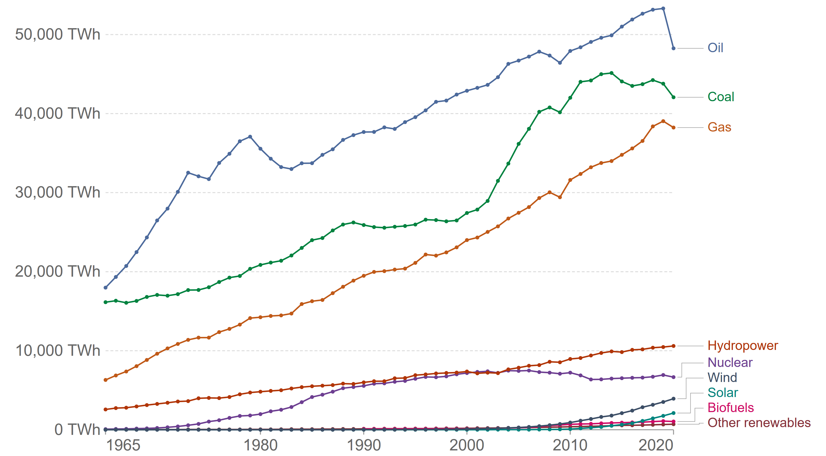

*Fig. 1. World energy consumption by source [2]*

## PIONEER PROGRAM

Within the PIONEER programme, the work is divided in seven themes. One of these themes is called Innovative Nuclear Systems and deals with advanced reactors systems. Within this theme, work is being directed to a selection of advanced nuclear reactor systems, which is illustrated in Fig. 2. Currently, the emphasis in PIONEER is on molten salt systems, while the efforts on high temperature and liquid metal fast reactors are mainly but not solely carried out in European collaborative projects and international benchmarks e.g. organized by the IAEA and the OECD/NEA.

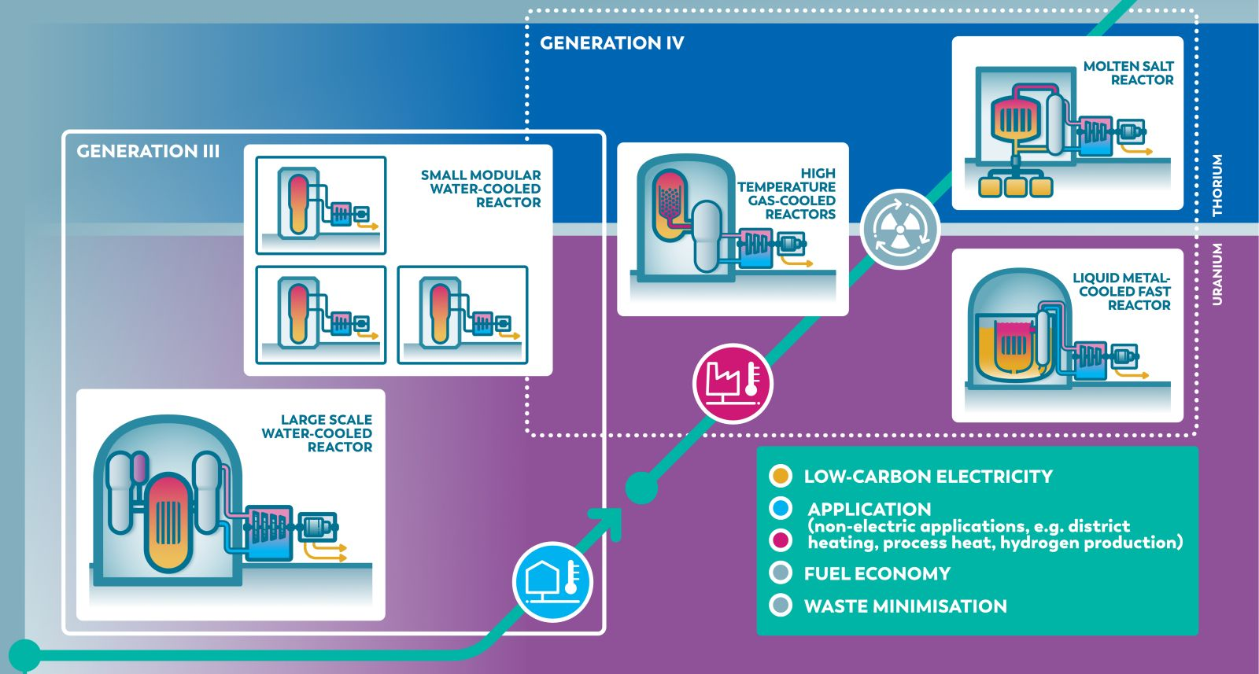

*Fig. 2. Nuclear Innovation Roadmap based on the PIONEER programme [4]*

Starting from the bottom left corner, large water-cooled reactors which are mainly utilized for electricity production will be the first step towards development and deployment of advanced reactors. Going up in the figure, small modular water-cooled reactors will add flexibility in application, siting and financing and should be deployable in a relatively short term. With their flexibility in siting, they should be able to open up nuclear energy applications with low caloric heat for, e.g. district heating or the industry. At the top right of the figure, advanced reactors are indicated. These operate at high temperatures and can use either uranium or thorium, making the nuclear fuel cycle more sustainable. A clear role is envisaged within PIONEER for fast reactors and in particular for liquid metal cooled fast reactors. With the expertise of NRG, international development of such reactors is supported in a collaborative effort. The remainder of this article will highlight the status and activities for thermal hydraulic support to liquid metal cooled fast reactors in PIONEER.

## Development and Validation of System Thermal Hydraulics Codes

### Development of the SPECTRA Code for Fast Reactor Applications

Thermal hydraulic experts at NRG use a variety of reputed system thermal hydraulic codes like RELAP5, MELCOR, and TRACE. These codes have mainly been developed for water-cooled reactors and have achieved a very high level of validation for that application. NRG also developed its own system thermal hydraulics code SPECTRA originally for water-cooled reactor applications [5] allowing to have full control over the code and easy implementation of new models. However, for advanced reactor applications new developments are required. Therefore, NRG is further developing the SPECTRA code. Like similar codes, it finds its application in analysis of accident scenarios such as loss-of-coolant and loss-of-flow accidents, operational transients, and other accident scenarios. In short, models include multidimensional two-phase flow, non-equilibrium thermo-dynamics, transient heat conduction in solid structures, and general heat and mass transfer with built-in models for steam/water/non-condensable gases, including natural and forced convection, condensation, and boiling. Currently, a point reactor kinetics model and a nodal kinetics model are available, with an isotope transformation model to compute concentrations of important isotopes. The radioactive particle transport model in the code captures radioactive fission product chains, release of fission products, aerosol transport, deposition, and resuspension. All SPECTRA developments, models and verification and validation efforts are documented in the code manuals [5].

Thanks to the flexible code set-up, it is also feasible for High Temperature Reactors, Molten Salt Reactors, and Liquid Metal Fast Reactors [6]. For liquid metal applications, the flexible input of fluid properties and heat transfer correlations is a particularly important feature, since the knowledge of the properties and correlations is still limited in some cases and updates are published on a regular basis, in contract to the established properties and correlation for water and air. In SPECTRA, this is accommodated by an option for providing tabular user input which replaces the standard water properties and correlations. This gives the user full flexibility, enabling the use the latest standards with respect to properties and correlation, but also the use of historical data which is sometimes helpful when comparing to existing simulations or experimental data which are not leveraging the latest standards for properties or correlations. Simulations in which liquid metals are used, e.g. in the primary system, but also other coolants (e.g. water or oil) in the energy conversion system, can be performed by synchronized parallel simulations.

### Examples of Liquid Metal Fast Reactor Applications

Since 2010, an ever increasing number of liquid metal facilities has been analysed using the SPECTRA code. When new models were implemented, thorough verification of the implemented models was performed. In addition, various code-to-code comparisons were made, and experimental as well as real reactor data were used as means of validation of the code for liquid metal applications.

Table 1 provides an overview of the simulations carried out with SPECTRA for liquid metal applications. Because no other means of comparison were available, for non-existing reactor designs only code-to-code comparisons were carried out. However, with participation to IAEA-coordinated research projects (EBR-II [8], and FFTF [11]) and to European collaborative projects in which experimental ([15] and [16]) or reactor data [10] were used, more substantial means of comparison became available. Also, the experiments in the 1:6 scale ESCAPE facility, which is a mock-up of the Belgian MYRRHA reactor design [18], promise to be a valuable source of experimental validation data. Please note that the applications do not extend to severe accident conditions. Based on needs, this could be a future development.

TABLE 1. Liquid metal applications studied with SPECTRA

|  |  |  |  |  |  |
| --- | --- | --- | --- | --- | --- |
| Facility | Metal | Comparison | Focus | Year | Reference |
| ESFR | Na | Code-to-code | Unprotected Loss-of-Flow  Unprotected Transient OverPower | 2014 | [7] |
| EBR-II | Na | Reactor data | (Un)Protected Loss-of-Flow | 2017 | [8] |
| ASTRID | Na | Code-to-code | Unprotected Loss-of-Flow | 2018 | [9] |
| Phénix | Na | Reactor data | Dissymmetic Loss-of-Flow | 2019 | [10] |
| FFTF | Na | Reactor data | Unprotected Loss-of-Flow | ongoing | [11] |
| ELSY | Pb | Code-to-code | Reactor Start-up and Shutdown | 2010 | [12] |
| ALFRED | Pb | Code-to-code | Unprotected Transient OverPower | 2013 | [13] |
| SEALER-Arctic | Pb | Code-to-code | Unprotected Transient OverPower | 2019 | [14] |
| CIRCE | PbBi | Experiment | Protected Loss-of-Flow | 2021 | [15] |
| TALL-3D | PbBi | Experiment | Loss-of-Flow | 2022 | [16] |
| ESCAPE | PbBi | Experiment | Asymmetric Operation & Loss-of-Flow | ongoing | [17] |

As mentioned, the SPECTRA code can flexibly be applied to different kinds of liquid metals. This is visualized in Fig. 3 in which sodium applications are shown at the left of the figure and pure lead and lead-bismuth applications at the right. The NRG analyses of the Phénix reactor were reported in a collaborative benchmark paper [10]. In this paper, some of the NRG results will be presented separately.

*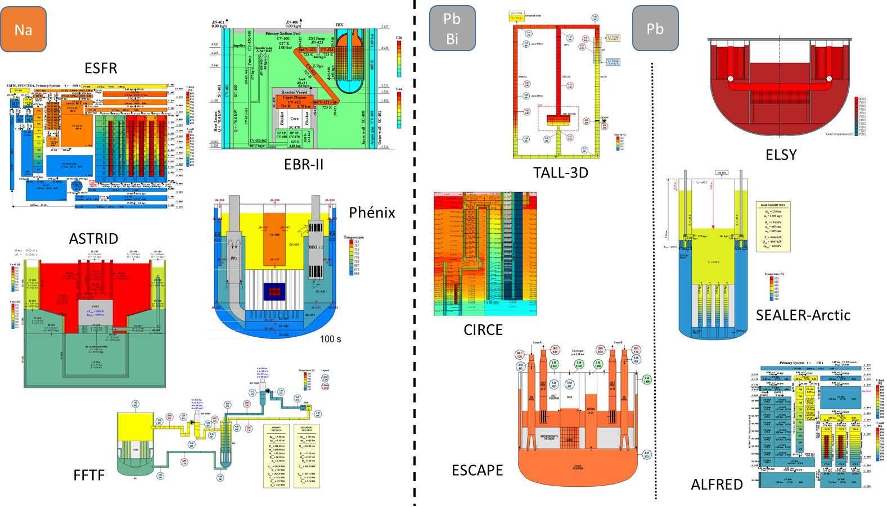Fig. 3. Graphical impression of liquid metal application SPECTRA models. Sodium applications (left) and lead(bismuth) applications (right)*

The Phénix reactor was a sodium cooled reactor with 563 MWth and 240 MWe which was operated in France from 1973 to 2009. In 2009 and 2010, when the reactor was taken from the grid, a unique set of experimental tests were performed which serve the community as validation cases. One of these tests is the dissymmetric test. This test starts in nominal steady state conditions, with reduced thermal power. The initiating event is the trip of one of the secondary pumps, reducing speed from 700 to 100 rpm in 13s. After 5s from the beginning of the test, the reactor automatically shuts down by the insertion of control rods in 45s, and the speed of the other secondary pump is reduced from 700 to 110 rpm in 60s. The reactor is scrammed at 48s. Finally, the test terminated after 1800s from the beginning. The SPECTRA model of the reactor includes the following main components: core, sodium pool, primary pumps, and primary side of the heat exchangers. The secondary side of the heat exchangers is modelled with boundary conditions. Solid structures are defined to model heat transfer and heat capacity in the system. The overall inventory of sodium in the primary system is 800.8 tons.

It should be noted that the nodalization scheme adopted for the SPECTRA model of Phénix was prepared as a first step in the preparation of a coupled STH/CFD calculation. Therefore, a relatively coarse nodalization is adopted for the model of the large pool regions. Furthermore, the nodalization takes into account three azimuthal sectors, corresponding to the three sets of primary pumps and heat exchangers. This results in the hot pool, the cold pool, the diagrid and the core being each split in three symmetric azimuthal sectors. More information on the set-up of the computational model can be found in [10].

The steady-state results, which mark the onset of the transient, show good resemblance with the experimental data, see Fig. 4. For the transient simulation, the initial (blind) STH simulation results were in reasonable agreement with the experimental results and within modelling uncertainty associated with a numerical model that neglects 3-dimensional effects in the complicated dissymmetric transient. In the subsequent open phase of the benchmark, these results were further improved. This was achieved by taking into account the heat capacity of the elements surrounding the core, which receive no flow, but are in contact with the hot pool sodium. And in addition this was achieved by taking into account the heat transfer between the hot pool and the cold pool, the heat transfer between the cold pool and the vessel cooling bypass system and the heat losses from the external vessel. This resulted primarily in a better agreement between simulation and experimental results during the initial phase (first 200 seconds) of the transient.

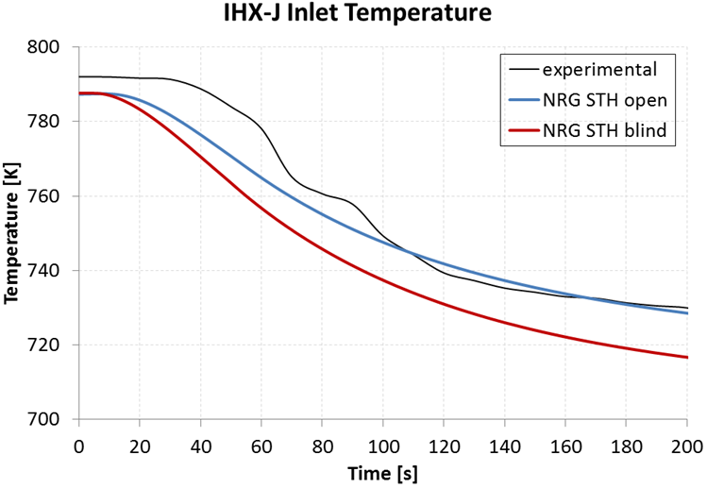

*Fig. 4. Comparison of STH and experimental results for the inlet temperature of a primary pump (left) and an intermediate heat exchanger (right) for the blind (red) and open (blue) phase of the Phénix dissymmetric transient.*

## CFD Code Applications

### Turbulent Heat Transfer

In 1963, Feynman stated that ‘turbulence remains the most important unsolved problem in classical physics’ [19]. Even though this statement is already more than half a century old, it is still true. For the analysis of flow and heat transport in a nuclear reactor, turbulence plays a key role. This not only holds for the contemporary water cooled reactors, but also for advanced nuclear reactors, like liquid metal cooled reactors [20]. In [21], a state-of-the-art of turbulent heat transfer model development approach is provided for CFD applications in nuclear reactors. These applications involve complicated geometries, a variety of convection regimes and a range of scales which make adequate turbulence modelling a real challenge. Preferably, a model should demand affordable computational resources, be robust, be able to deal with anisotropic turbulence, and be able to deal with the various convection regimes (natural, mixed, and forced convection) simultaneously. This challenge is visualized in Fig. 5.

The summary of [21] indicates that advanced turbulent heat flux models, such as the Algebraic Heat Flux Models (AHFM), might provide a reasonable compromise between robustness, computational efficiency, and accuracy. It should be mentioned that a vast number of AHFMs is available from literature, among which a few focus on liquid metal applications. At NRG, an implicit AHFM was selected as one of the most promising modelling routes [22]. The selected model was based on a model which was developed for natural convection of air flows. With this model as a basis, equations were derived for the model parameters providing a good compromise for flows with Prandtl numbers up to unity and for all convection regimes. However, it should be noted that the convection regime has to be preselected by the user. Robustness was achieved by coupling the anisotropic AHFM to an isotropic momentum turbulence model which in itself is not consequent. Finally, the model was only employed with the commercial code STAR-CCM+ which does not allow significant changes to the model required for automated selection of the convection regime. Therefore, currently efforts are ongoing to implement the base model in the open source code OpenFOAM and to re-calibrate its equations. After that, the aim is to couple the AHFM to an anisotropic turbulence model and to automate the selection of the convection regime. Finally, with the target of fast and robust computation, the aim will be to switch from a wall resolved approach to a wall modelled approach, relaxing the requirements on computational meshing.



*Fig. 5. Turbulent heat and momentum transfer model (development) for liquid metals with modelling targets in the center aiming at fast, robust simulation and flexibility at reasonable accuracy.*

### Core Simulation

Most liquid metal reactor core designs foresee wire-wraps as spacers as well as designs with grid spacers. For both spacer types, validation of Reynolds Averaged Navier Stokes (RANS) simulation approaches are essential. Typically, this validation uses both isothermal and heated comparison data from experiments as well as high-fidelity CFD simulations, either from Direct Numerical Simulation (DNS), quasi DNS (Q-DNS), or Large Eddy Simulations (LES). This validation exercise is important for ideal operational conditions, as well as for non-ideal conditions like deformed or blocked assemblies.

Table 2 provides an overview of the extensive set of related CFD simulations performed at NRG for various liquid metal coolants and conditions. The data used for comparison is often obtained in collaboration with organizations that perform experiments or high-fidelity CFD simulations. In some cases, these data have been produced by NRG.

TABLE 2. CFD simulations performed and planned by NRG for hexagonal liquid metal bundles. Simulations indicated with * have not been performed yet but are planned in European collaborative projects.

|  |  |  |  |  |  |
| --- | --- | --- | --- | --- | --- |
| Bundle | Fluid | Condition | Comparison | Turbulence | Ref. |
| ∞-pin bare | PbBi | heated | DNS | RANS | [23] |
| ∞-pin bare | Pb | heated | n.a. | LES | [24] |
| ∞-pin bare | Pb | heated | LES | RANS | [25] |
| 7-pin grid spacer* | water | deformed, heated | Exp. | RANS | - |
| 19-pin grid spacer | PbBi | heated | Exp. | RANS | [26] |
| 19-pin grid spacer | PbBi | internal blockage, heated | Exp. | RANS | [26] |
| 19-pin grid spacer* | Pb | deformed, heated | Exp. | RANS | - |
| 127-pin grid spacer | Pb | heated | n.a. | RANS | [26] |
| 127-pin grid spacer | Pb | internal blockage, isothemal | n.a. | RANS | [26] |
| ∞-pin wire wrap | PbBi | heated | n.a. | Q-DNS | [27] |
| ∞-pin wire wrap | PbBi | heated | Q-DNS | RANS | [28] |
| 7-pin wire wrap | Na | isothermal | LES | RANS | [29] |
| 7-pin wire wrap | water | isothermal | Exp. | RANS | [30] |
| 7-pin wire wrap* | water | (un)deformed, heated | Exp. | RANS | - |
| 19-pin wire wrap | Na | isothermal | LES | RANS | [31] |
| 19-pin wire wrap | PbBi | Heated | Exp. | RANS | [32] |
| 19-pin wire wrap | PbBi | Heated | LES, Exp. | RANS | [33] |
| 19-pin wire wrap | PbBi | solid int. block., heated | Exp. | RANS | [34] |
| 19-pin wire wrap* | PbBi | porous int. block., heated | Exp. | RANS | - |
| 61-pin wire wrap | p-cymene | isothermal | LES | RANS | [30] |
| 127-pin wire wrap | PbBi | heated | n.a. | RANS | [32] |
| 127-pin wire wrap | PbBi | deformed, heated | n.a. | RANS | [35] |
| 127-pin wire wrap | PbBi | eccentric, heated | n.a. | RANS | [35] |
| 127-pin wire wrap | PbBi | inlet & internal blockage, heated | n.a. | RANS | [34] |

As it may be concluded from table 2, extensive validation has been performed for ideal design conditions both for isothermal as well as heated cases, and can be considered mature. However, the validation status for non-ideal cases, like deformed or blocked fuel assemblies is much less mature. Recognizing this, in the more recent European collaborative projects, an effort has been made to create new datasets for validation and, related to that, new simulation campaigns are under preparation at NRG to support these experiments and finally use their data for validation. Fig. 6 shows the efforts on two of such cases.

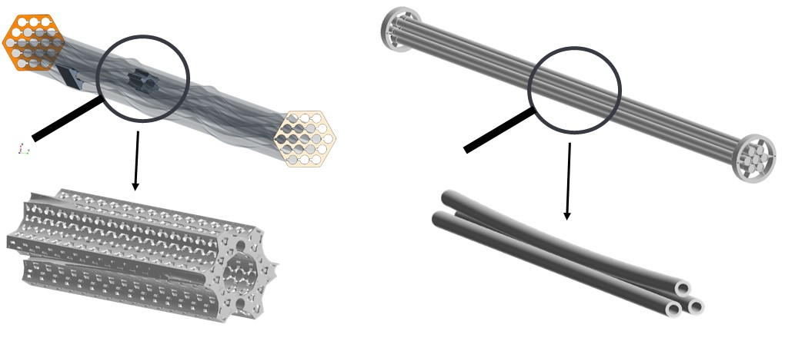

*Fig. 6. Ongoing developments in the field of CFD applications for liquid metal rod bundles: porous blockage (left) and deformed pin simulation (right)*

The effects of solid internal blockages were studied in [26] and [34]. Both studies show significant differences between simulations and experimental results which are not clearly understood despite an extensive sensitivity study which was performed for the simulations. In an effort to reduce uncertainties on the one hand and to come closer to a realistic blockage situation on the other hand, a new experimental and simulation campaign now focuses on a well-defined porous blockage. Fig 6 (left) shows a 19-pin wire wrapped pin bundle which will be installed in the KALLA facility in Karlsruhe using a porous blockage similar to the design shown in the figure. This porous blockage design uses state-of-the-art 3D printing techniques and will lead to a well-defined porous blockage.

The effects of deformed pins or assemblies are even less known. Therefore, in another campaign, this will be studied in a 7-pin water experiment to be set-up at the Von Karman Institute in Belgium. As depicted in Fig. 6 (right), the centre pin of this 7-pin bundle will be deformed and the effects of this deformation will be studied both experimentally as well as computationally with CFD.

### Pool Simulation

A big challenge in liquid metal cooled reactors with respect to operational and safety analysis is formed by the inherently 3-dimensional nature of the coolant flow in the reactor pool(s). Traditionally, this was analysed by scaled experimental setups often employing water as simulant fluid. Such scale models remain important up to this day. But with increasing computational power, additional insight in the complex flow patterns and heat transport behaviour can be obtained by application of CFD. However, even with the current computer power, a full pool simulation without simplification or physical modelling is not feasible. Components like the reactor core, heat exchangers, and pumps still require careful attention. Especially heat exchanger modelling is being further developed at NRG. Above that, the computer simulations require proper validation, not only for the flow patterns but especially for the heat transport behaviour.

Table 3 summarizes the past and present efforts from NRG in this field. Data from various experimental facilities are being used to gain confidence in the modelling approach, whereas various liquid metal cooled reactor designs are being analysed with such approaches. The table also shows the focal points of the analyses. In most cases, analyses start from simulating a steady state situation and afterwards a loss-of-flow or other accident situation is performed.

TABLE 3. CFD simulations performed and planned by NRG for primary pool analysis. Simulations indicated with * have not been performed yet but are planned.

|  |  |  |  |  |
| --- | --- | --- | --- | --- |
| Pool | Fluid | Comparison | Focus | Reference |
| CIRCE-ICE | PbBi | Experiment | Steady-state +  Protected Loss-of-Heat Sink and Flow | [36] |
| CIRCE-HERO | PbBi | Experiment | Steady-state | [36] |
| TALL 3D* | PbBi | LES, Experiment | Steady-state, Loss-of-Flow | - |
| ESCAPE | PbBi | Experiment | Steady-states | [37] |
| ELSY | Pb | n.a. | Sloshing | [38] |
| ESFR | Na | n.a. | Sloshing | [39] |
| SEALER-Arctic | Pb | n.a. | Steady-state | [40] |
| SEALER-UK | Pb | n.a. | Steady-state + Asymmetric Conditions + Unprotected Loss-of-Flow | [41] |
| ALFRED | Pb | n.a. | Steady-state + Core Outlet Flow | [42][43] |

Lessons learned from the analyses of the various experiments were directly applied in the 3-dimensional simulations of the SEALER UK reactor design [41]. The strategy of modelling the various components of a liquid metal hot and/or cold pool is explained in Fig. 7. On the left, the CAD model which was created based on SEALER UK is shown. The various modelling approaches for the main components are indicated in this figure as well. More specifically, the argon cover gas is modelled as through a multiphase volume-of-fluid approach allowing for the liquid level to change during a transient analysis. The internals of the reactor in the primary pool are modelled as no-slip walls and allow heat transfer using a conjugate heat transfer model. The heat exchangers and dip coolers are modelled as a porous medium with a volumetric heat sink, whereas the pump is modelled through a volumetric momentum source. The core is also modelled as a porous medium. It includes a volumetric heat source and the by-pass flow is neglected. Finally, the lead coolant is modelled using temperature dependent properties and the constant turbulent Prandtl number has been adapted to take into account the effect of liquid metal heat transfer [44]. After a steady state simulation for standard operational conditions was performed, asymmetric conditions were studied in which not all pump and heat exchanger sections were operational, as well as an unprotected loss-of-flow transient scenario was analysed in which the dip coolers are extracting the heat from the system together with the heat loss through the reactor vessel wall, and the heat exchanger and pump sections are not active.

The first 500 seconds of the postulated transient are simulated, initially showing a strong increase in core outlet temperature, with the highest temperatures found for the central zones. This is a result of the rapidly dropping pump strength not being balanced completely by the reduction in core power. The maximum core outlet temperature is found after 105 seconds for the most central fuel assembly. After this maximum has been reached, a gradual drop in outlet temperatures is observed. Finally, it was observed that the argon-lead interface stays nearly stationary during the whole transient, suggesting that in future similar simulations the argon-lead surface can be modelled by a slip boundary condition.

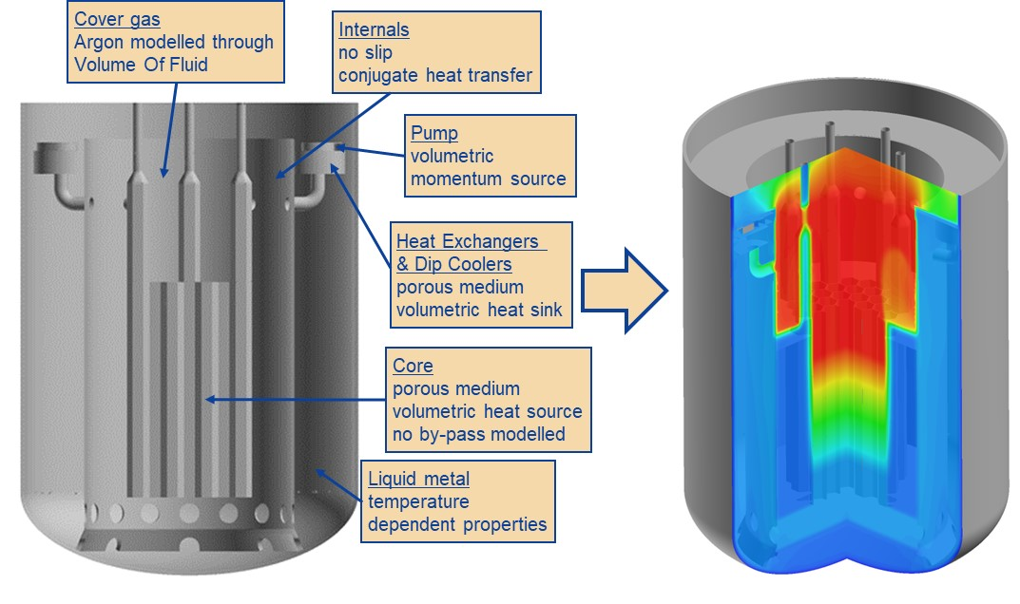

*Fig. 7. Typical simulation set-up for the SEALER-UK primary system transient analysis*

Recently, NRG has started using the available data from the Swedish TALL-3D experimental campaigns from the collaborative THINS and SESAME projects sponsored by the European Commission. This small scale pool in a tall loop system was designed for validation of some major three dimensional and transient effects representative for an actual reactor pool. One of these effects is a stratification occurring under loss-of-flow conditions. Fig. 8 (left) shows the three dimensional TALL-3D test section which is mounted in the lead bismuth TALL loop. The centre and right figure show an impression of the velocity and temperature field in this test section resulting from preliminary simulations. Complete analysis of a loss-of-flow transient from the experiments is expected to be published in the future.

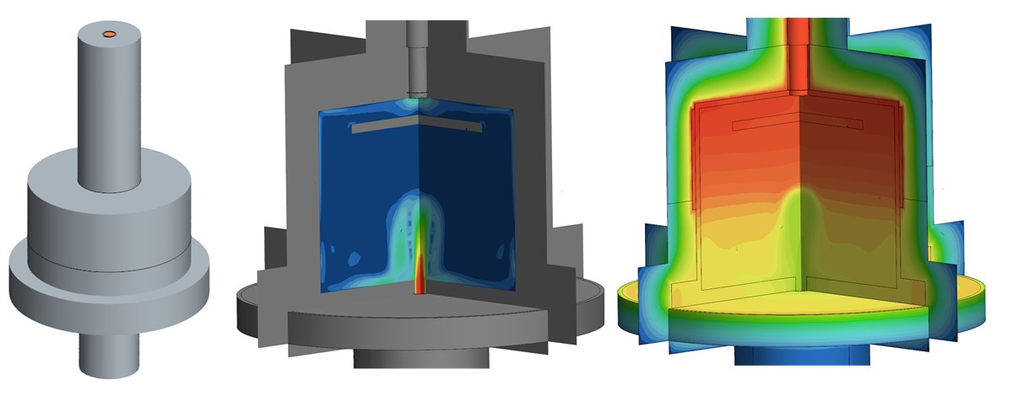

*Fig. 8. Preliminary CFD model (left) and simulation results for velocity (center) and temperature (right) of the TALL-3D experimental facility.*

## Multi-scale Multi-Physics Approach Development and Application

### Initial Applications

Design and safety analysis of nuclear reactors mostly relies on system thermal hydraulic codes which have a long standing tradition of verification and validation. Many system thermal hydraulic studies have been performed and form the basis of the acceptance of such codes for licensing purposes. However, liquid metal cooled reactors often involve large plena in which inherently 3-dimensional flow features are present which cannot be captured correctly with the traditional system thermal hydraulics codes. This illustrates the need for extending the existing system thermal hydraulics codes with 3-dimensional elements, or for coupling the existing code to a 3-dimensional CFD code. All over the world, attempts to couple such codes are currently ongoing. Used codes are often tailored to a specific case at hand. Table 4 shows the initial efforts from NRG in this field.

TABLE 4. Initial multi-scale coupled simulations performed by NRG for system analysis.

|  |  |  |  |  |
| --- | --- | --- | --- | --- |
| System | Fluid | Comparison | Focus | Reference |
| CIRCE-HERO | PbBi | Experiment | Protected Loss-of-Heat Sink and Flow | [45] |
| EBR-II | Na | Reactor Data | (Un)Protected Loss-of-Flow | [46] |
| Phénix | Na | Reactor Data | Dissymmetric Loss-of-Flow | [47] |

The multi-scale model development at NRG started with the EBR-II case. This simulation was merely a proof-of-principle of the coupling mechanism to work correctly, since the results obtained with the multi-scale approach could also well be met with a system thermal hydraulics code. After that, the CIRCE-HERO and Phénix cases were developed in parallel, making use of the experiences gained in the first application. For these three initial cases, the SPECTRA code [5] was used as system thermal hydraulic code while ANSYS CFX was used as CFD code. The interested reader can find more details about the coupling approaches used for the various cases in an accompanying paper [48].

Among the three initial cases, the Phénix case is the most complex. Without any prior knowledge and experience with modelling the Phénix reactor, NRG constructed the computational models in the separate codes and coupled them through a case-specific coupling mechanism. The results, reported in [47], were satisfying and promising. Fig. 9 provides a snapshot of the transient results from this simulation, which clearly shows the 3-dimensional temperature distribution in the upper plenum which affects the heat extracted in the intermediate heat exchangers. Fig. 10 compares the STH stand-alone and the coupled multi-scale simulation results for the open phase by means of the inlet temperatures of the primary pump (left) and the intermediate heat exchanger (right). The multi-scale simulation is better able to simulate the transient behaviour or fluctuations that were also found experimentally and caused by 3D effects, especially from 60 s onwards.

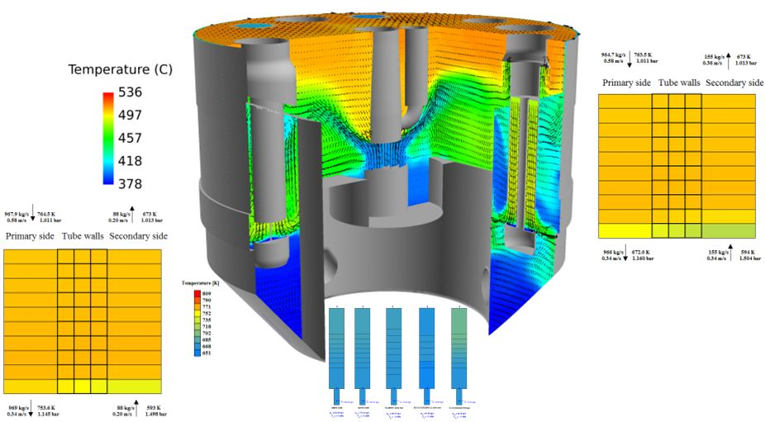

*Fig. 9. Instantaneous results from the multi-scale Phénix dissymmetric benchmark*

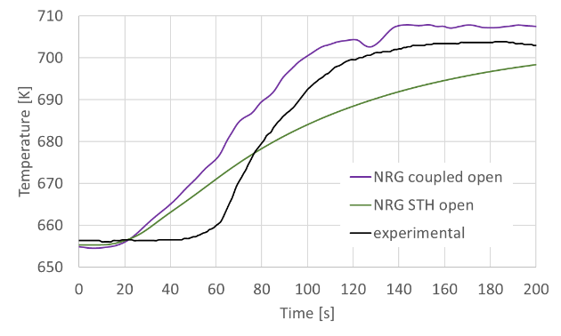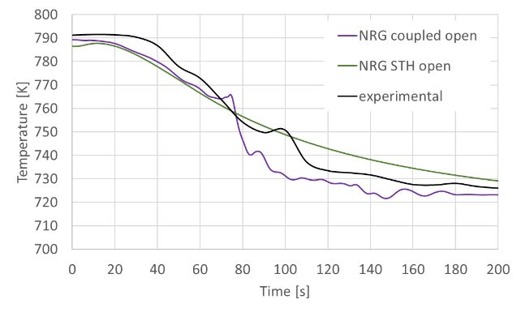

*Fig. 10. Comparison of STH, multi-scale and experimental results for the inlet temperature of a primary pump (left) and an intermediate heat exchanger (right) for the open phase of the Phénix dissymmetric benchmark*

### myMUSCLE and MUSCLE-Foam Development and Application

After the initial applications, reported in the previous subsection, it was realized that developing a multi-scale coupling mechanism on a case-to-case basis is not efficient, and more importantly, will require verification and validation for each individual application. It is more efficient for the user, and more clear for licensing purposes, to develop a generic coupling tool. Above that, it was realized that not only a multi-scale coupling will be required, but also coupling codes dealing with different physical aspects. Such a coupling is referred to as a multi-physics coupling. To this latter aspect, two different approaches are currently under development at NRG.

The first approach is through the development of a generic coupling platform. This coupling platform is called myMUSCLE (MultiphYsics MUltiscale Simulation CoupLing Environment) [49]. This platform is an independent, Fortran-based code, which establishes an efficient and robust coupling of different codes.

As a first step, the platform is being developed for multi-scale simulations, coupling the system code SPECTRA to a variety of commercial CFD codes available at NRG, i.e. ANSYS CFX, ANSYS FLUENT, STAR-CCM+, but also to the open-source CFD code OpenFOAM (see Fig. 11, bottom). The workflow and input are the same for each coupling. myMUSCLE takes care of the transfer of, and connection to each of these codes in a generic way. Through an interactive menu, myMUSCLE asks the user to select the codes to be coupled, the coupling interface(s) to be used, and the variable(s) to be coupled. Also, through this interaction, under-relaxation factors (or in the future more sophisticated coupling algorithms) and the data-exchange time-step can be selected. Subsequently, myMUSCLE writes the input data for both codes in the correct format and will arrange the coupled simulation procedure. The proof-of-principle of this platform has been demonstrated in [49]. However, this publication also identifies some improvements to be made which are currently included in the planning for development over the years to come.

The second approach is the development of a multi-physics code platform based on the open-source CFD code OpenFOAM. This development by NRG employees takes advantage of existing multi-physics code coupling developments by [50], [51], and [52] in which various neutron physics solvers, namely a multi-group neutron diffusion solver, a multi-group SP3 approximation of the neutron transport equation, and a multi-group discrete ordinate neutron transport code, are coupled to the multi-material OpenFOAM CFD and thermal mechanics solver with the possibility of using an Arbitrary Lagrangian-Eularian model to deal with computational mesh deformations [52]. Note that MUSCLE-Foam only adopts lower-Mach equation of states and does not adopt the hypersonic models presented (e.g. in [53]) which are not needed for nuclear reactor applications. The neutronics code package is setup in a flexible way allowing easy coupling to any OpenFOAM solver. These existing routines, which can be coupled to OpenFOAM, have formed the basis of a multi-physics OpenFOAM-based platform called MUSCLE-Foam, Multi-phYsics Simulation CoupLed Environment based on openFOAM (see Fig. 11, top).

Since MUSCLE-Foam is fully integrated with the OpenFOAM code, it should be possible to couple the separate elements of this multi-physics platform through myMUSCLE to SPECTRA and/or other CFD codes, as depicted in Fig. 11. Future developments will focus on verification and validation of the MUSCLE-Foam platform and on the proof-of-principle of coupling MUSCLE-Foam through myMUSCLE to the SPECTRA system thermal hydraulics code or commercial CFD codes.

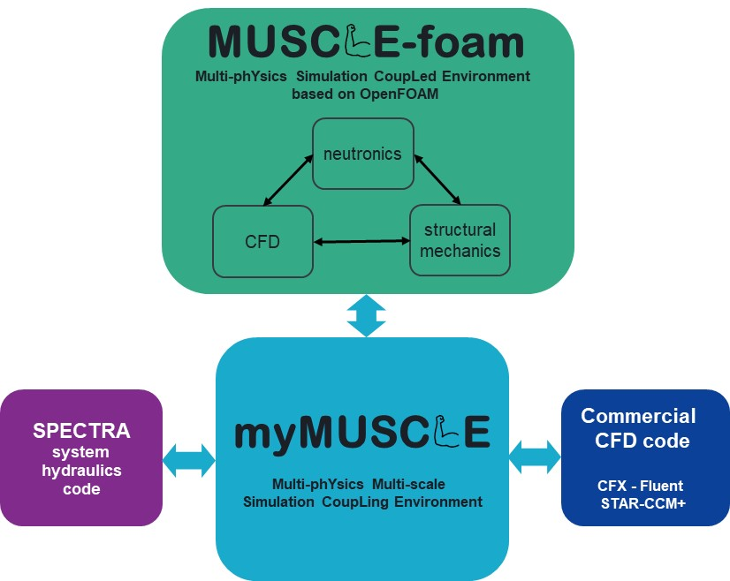

*Fig. 11. Combined myMUSCLE and MUSCLEfoam multi-physics multi-scale simulation platform*

## SUMMARY AND FUTURE DIRECTIONS

This paper has provided an overview of the liquid metal thermal hydraulics activities within the multi-year PIONEER research program carried out by NRG which is funded by the Dutch ministry of economic affairs and climate. The paper has elaborated on liquid metal reactor applications of the SPECTRA system thermal hydraulics code which has been developed by NRG. Also, the paper shows the many applications of CFD at NRG to liquid metal reactor applications, including turbulence and turbulent heat transport, core and pool thermal hydraulics. Finally, the paper has introduced the multi-physics and multi-scale developments at NRG, showing initial cases for which a case-to-case approach was being developed. The paper also shows the developments of a generic coupling platform for multi-scale applications called myMUSCLE and an open-source multi-physics code platform called MUSCLE-Foam, with the possibility of coupling these platforms later in the current multi-year PIONEER program and beyond.

A number of future directions for the PIONEER program are identified:

* Since the validation base of numerical codes for liquid metal applications is significantly smaller than the validation base for water cooled reactors, further verification and validation of all computational approaches is required. This will imply performing new experiments and high-fidelity CFD numerical simulations to generate the necessary data for comparison.
* In the field of core thermal hydraulics, a lot of attention has been paid in recent years to validation of 3-dimensional CFD simulation approaches. Further R&D in the field of core thermal hydraulics shall focus on non-ideal situations, i.e. the effects of deformations and blockages. Next to that, accurate, suitable and fast running simulation approaches should be developed for full core simulations, including heat transport and by-pass flows.
* Mastering efficient and accurate pool simulation including the major components will especially require a thorough assessment of the modelling of (the secondary side of) heat exchangers.
* First steps have been taken in the development of a multi-scale and multi-physics simulation platform. However, further extensions and especially validation will be required for various applications amongst which liquid metal applications. Therefore, the PIONEER program will focus on further development of the multi-scale and multi-physics simulation platforms myMUSCLE and MUSCLE-Foam, making use of the advantages of open-source computing where possible and needed, but also benefitting from the robustness and significant developments in commercial simulation codes.

Apart from these future directions, a recommendation is identified for liquid metal reactor operators:

* Operators of liquid metal cooled (test) reactors are encouraged to consider performing high quality experiments during start-up, operation but also at the end-of-life (following the example of the Phénix reactor), adding valuable data to the understanding and validation base of liquid metal cooled reactors.

ACKNOWLEDGEMENTS

The work presented in this paper is all related to the multi-year PIONEER R&D program sponsored by the Dutch ministry of Economic Affairs and Climate. Also the continuous support of the European Commission through the various framework programs and the numerous European collaborative projects (too many to be mentioned individually here) is gratefully acknowledged. Finally, all contacts and interactions with international colleagues and companies in this field of expertise should not be forgotten. Without cooperation, our achievements would not have been significant.

References

1. UNITED NATIONS, “COP26: The Glasgow Climate Pact”, 2021.
2. RITCHIE, H., ROSER, M., "Energy". Published online at OurWorldInData.org. Retrieved from: 'https://ourworldindata.org/energy' (accessed on 17 Dec 2021), 2020.
3. NRG, “PIONEER NRG research programme 2021-2024”, NRG-24408/20.175271, Petten, Netherlands, 2020.
4. VAN DEN BROEK, J., ROELOFS F., “Innovation Roadmap on Nuclear Energy Development”, Nuclear Innovation Conference Webinar, on-line, 2021.
5. STEMPNIEWICZ, M.M., SPECTRA Sophisticated Plant Evaluation Code for Thermal-Hydraulic Response Assessment, Version 3.61, Volumes 1-3. NRG report K6223/21.190817 MSt-210129, Arnhem, Netherlands (2021).
6. STEMPNIEWICZ M.M., ROELOFS, F., Molten salt modelling in SPECTRA applied to MSRE, Nuclear Engineering & Design, vol. 384, 111483 (2021).
7. LAZARO, A., SCHIKORR, M., MIKITYUK, K., AMMIRABILE, L., BANDINI, G., DARMET, G., SCHMITT, D., DUFOUR, PH., TOSELLO, A., GALLEGO, E., JIMENEZ, G., BUBELIS, E., PONOMAREV, A., KRÜSSMANN, R., STRUWE, D., STEMPNIEWICZ, M.M., Code assessment and modelling for Design Basis Accident analysis of the European Sodium Fast Reactor design. Part II: Optimised core and representative transients analysis, Nuclear Engineering and Design, vol. 277, p.p. 265-276 (2014)
8. BRIGGS, L., KRIVENTSEV, V., MONTI, S., HU, W., SUI, D., SU, G., MAAS, L., VEZZONI, B., SARATHY, U.P., DEL NEVO, A., PETRUZZI, A., ZANINO, R., OHIRA, H., VAN ROOIJEN, W., MORITA, K., CHOI, C., SHIN, A., STEMPNIEWICZ, M., RTISCHEV, N., MIKITYUK, K., TRUONG, B., Benchmark Analyses of EBR-II Shutdown Heat Removal Tests, IAEA Fast Reactor Conference, Yekaterinburg, Russia (2017)
9. STEMPNIEWICZ, M., DE GEUS, E., ROELOFS, F., NRG analysis of SFR heterogeneous core under ULOF conditions, Nuclear Engineering and Design, vol. 339, p.p. 65-74 (2018)
10. NARCISI,V., GIANETTI, F., DEL NEVO, A., ALCARO, F., WANG, X., KRAUS, A., BRUNETT, A., THOMAS, J., GIRAULT, N., GROSJEAN, B., CARUSO, G., GERSCHENFELD, A., System thermal-hydraulic modelling of the phénix dissymmetric test benchmark, Nuclear Engineering and Design, vol. 353, 110272 (2019)
11. IAEA, Benchmark Analysis of FFTF Loss of Flow Without Scram Test, <https://www.iaea.org/fr/projects/crp/i32011> (accessed 4 April 2021)
12. CASAMASSIMA, V., GUARGLIARDI, A., CANEVESE, S., JONNET, J., Results of Operational Transient Analysis, ELSY Del/2010/27, Milano, Italy (2010)
13. BANDINI, G., BUBELIS, E., SCHIKORR, M., STEMPNIEWICZ, M.M., LAZARO, A., TUCEK, K., KUDINOV, P., KÖÖP, K., JELTSOV, M., MANSANI, L., Safety Analysis Results of Representative DEC Accidental Transients for the ALFRED Reactor, IAEA Fast Reactor Conference, Paris, France (2013)
14. STEMPNIEWICZ, M., ZWIJSEN, K., ROELOFS, F., WALLENIUS, J., BORTOT, S., MICKUS, I., Thermal-Hydraulic Analysis of SEALER under Steady-state and Accidental Scenarios, SESAME International Workshop, Petten, The Netherlands (2019)
15. LORUSSO, P., DEL NEVO, A., NARCISI, V., GIANETTI, F., CARUSO, G., ZWIJSEN, K., BREIJDER, P., HAMIDOUCHE, T., CATELLITI, D., ROZZIA, D., TARANTINO, M., Total loss of flow benchmark in CIRCE-HERO integral test facility, Nuclear Engineering and Design, vol. 376, 111086 (2021)
16. DE KOCK, I., STEMPNIEWICZ, M., ROELOFS, F., HU, G, HUA, T., HU, R., Comparison of the approaches followed towards modeling of the TALL-3D facility using the systems thermal hydraulics codes SAM and SPECTRA, NURETH19, Brussels, Belgium (2022)
17. ROELOFS, F., TARANTINO, M., GRASSO, G., VAN TICHELEN, K., SCHUURMANS, P., Liquid Metal Thermal Hydraulic Activities in European Collaborative Projects. NURETH19, Brussels, Belgium (2022)
18. AÏT ABDERRAHIM, H., Realization of a new large research infrastructure in Belgium: MYRRHA contribution for closing the nuclear fuel cycle making nuclear energy sustainable, EPJ Web of Conferences 246, 00012 (2020)
19. FEYNMAN, R., LEIGHTON, R., SANDS, M., The Feynman Lectures on Physics Vol 1 Quotes. Addison-Wesley, USA (1963).
20. ROELOFS, F., Thermal Hydraulics Aspects of Liquid Metal Cooled Nuclear Reactors. ISBN 978-0-08-101980-1, Woodhead Publishing, Elsevier (2019).
21. SHAMS, A., ROELOFS, F., TISELJ, I., ODER, J., BARTOSIEWICZ, Y., DUPONCHEEL, M., NICENO, B., GUO, W., STALIO, E., ANGELI, D., FREGNI, A., BUCKINGHAM, S., KOLOSZAR, L., VILLA ORTIZ, A., PLANQUART, P., NARAYANAN, C., LAKEHAL, D., VAN TICHELEN, K., JÄGER, W., SCHAUB, T., A collaborative effort towards the accurate prediction of turbulent flow and heat transfer in low-Prandtl number fluids. Nuclear Engineering and Design, vol. 366, 110750 (2020).
22. SHAMS, A., DE SANTIS, A., ROELOFS, F., An overview of the AHFM-NRG formulations for the accurate prediction of turbulent flow and heat transfer in low-Prandtl number flows. Nuclear Engineering and Design, vol. 355, 110342 (2019).
23. SANTUCCI, M., ANGELI, D., STALIO, E., MATHUR, A., ROELOFS, F., Validation of Turbulent Heat Flux Models for Forced and Mixed Convection around a Bundle of Heated Rods, NURETH19, Brussels, Belgium (2022)
24. SHAMS, A., MIKUZ, B., ROELOFS, F., Numerical prediction of flow and heat transfer in a loosely spaced bare rod bundle, International Journal of Heat and Fluid Flow, vol. 73, p.p. 42-62 (2018)
25. MIKUZ, B., SHAMS, A., Assessment of RANS models for flow in a loosely spaced bare rod bundle with heat transfer in low Prandtl number fluid, Annals of Nuclear Energy, vol. 124, p.p. 441-459 (2019)
26. MATHUR, A., UITSLAG-DOOLAARD, H., ROELOFS, F., Reduced-resolution RANS approach to grid spacer fuel assemblies, Nuclear Engineering and Design, vol. 356, 110374 (2020)
27. SHAMS, A., ROELOFS, F., BAGLIETTO, E., KOMEN E., High fidelity numerical simulations of an infinite wire-wrapped fuel assembly, Nuclear Engineering and Design, vol. 335, p.p. 441-459 (2018)
28. DOVIZIO, D., SHAMS, A., ROELOFS, F., Numerical prediction of flow and heat transfer in an infinite wire-wrapped fuel assembly, Nuclear Engineering and Design, vol. 349, p.p. 193-205 (2019)
29. MERZARI, E., FISCHER, P., YUAN, H., VAN TICHELEN, K., KEIJERS, S., DE RIDDER, J., DEGROOTE, J., VIERENDEELS, J., DOOLAARD, H., GOPALA, V., ROELOFS, F., Benchmark exercise for fluid flow simulations in a liquid metal fast reactor fuel assembly, Nuclear Engineering and Design, vol. 298, p.p. 218-228 (2016)
30. DOVIZIO, D., MIKUZ, B., SHAMS, A., ROELOFS, F., Validating RANS to predict the flow behavior in wire-wrapped fuel assemblies, Nuclear Engineering and Design, vol. 356, 110376 (2020)
31. DOOLAARD, H., SHAMS, A., ROELOFS, F., VAN TICHELEN, K., KEIJERS, S., DE RIDDER, J., DEGROOTE, J., VIERENDEELS, J., DI PIAZZA, I., MARINARI, R., MERZARI, E., OBABKO, A., FISCHER, P., CFD Benchmark for a Heavy Liquid Metal Fuel Assembly, NURETH16, Chicago, USA (2015)
32. ROELOFS, F., UITSLAG-DOOLAARD, H., DOVIZIO, D., MIKUZ, B., SHAMS, A., BERTOCCHI, F., ROHDE, M., PACIO, J., DI PIAZZA, I., KENNEDY, G., VAN TICHELEN, K., OBABKO, A., MERZARI, E., Towards validated prediction with RANS CFD of flow and heat transport in a wire-wrap fuel assembly, Nuclear Engineering and Design, vol. 353, 110273 (2019)
33. UITSLAG-DOOLAARD, H., ROELOFS, F., BROCKMEYER, L., DEGROOTE, J., DOLFEN, H., DI PIAZZA, I., MARINARI, R., PACIO, J., KEYERS, S., VAN TICHELEN, K., Comparison of RANS and LES Heat Transfer Results for a 19-rod Bundle Experiment with Wire Spacers Cooled by Lead Bismuth Eutectic, NURETH19, Brussels, Belgium (2022).
34. ROELOFS, F., DOVIZIO, D., UITSLAG-DOOLAARD, H., DE SANTIS, D., MATHUR, A, MIKUZ, B., SHAMS, A., Core thermal hydraulic CFD support for liquid metal reactors, Nuclear Engineering and Design, vol. 355, 110322 (2019)
35. SOSNOVSKY, E., BAGLIETTO, E., KEIJERS, S., VAN TICHELEN, K., CARDOSO DE SOUZA, T., DOOLAARD, H., ROELOFS, F., CFD Simulations to Determine the Effects of Deformations on Liquid Metal Cooled Wire Wrapped Fuel Assemblies, NURETH16, Chicago, USA (2015)
36. ZWIJSEN, K., DOVIZIO, D., MOREAU, V., ROELOFS, F., CFD modelling of the CIRCE facility, Nuclear Engineering and Design, vol. 353, 110277 (2019).
37. VISSER, D., ROELOFS, F., MIRELLI, F., VAN TICHELEN, K., Validation of CFD analyses against pool experiments ESCAPE, Nuclear Engineering and Design, vol. 369, 110864 (2020).
38. GOPALA, V.R., ROELOFS, F., Numerical Simulation of Liquid Lead Sloshing in the ELSY Reactor Vessel, 5th International workshop on materials for HLM-cooled reactors and related technologies (HeLiMeRT), Mol, Belgium (2009).
39. ROELOFS, F., GOPALA, V.R., JAYARAJU, S., SHAMS, A., KOMEN, E.M.J., Review of Fuel Assembly and Pool Thermal Hydraulics for Fast Reactors, Nuclear Engineering and Design, vol. 265, p.p. 1205-1222 (2013).
40. ROELOFS, F., ZWIJSEN, K., UITSLAG-DOOLAARD, H., ALCARO, F., STEMPNIEWICZ, M., WALLENIUS, J., Validation of Thermal Hydraulic Design Support and Safety Methodology and Application SEALER. IAEA Tecdoc 1972, Vienna, Austria (2021).
41. ZWIJSEN, K., UITSLAG-DOOLAARD, H., ROELOFS, F., WALLENIUS, J., Thermal-Hydraulic Design Support and Safety Analyses of SEALER UK DEMO. ICONE28, Virtual, Online (2020).
42. MOREAU, V., PROFIR, M., ALEMBERTI, A., FRIGNANI, M., MERLI, F., BELKA, M., FRYBORT. O., MELICHAR, T., TARATINO, M., FRANKE, S., ECKERT, S., CLASS, A., YANEZ, J., GRISHCHENKO, D., JELTSOV, M., KUDINOV, P., ROELOFS, F., ZWIJSEN, K., VISSER, D., BADILLO, A., NICENO, B., MARTELLI, D., Pool CFD modelling: Lessons from the SESAME project, Nuclear Engineering and Design, vol. 355, 110343 (2019).
43. VISSER, D., ROELOFS, F., MERLI, F., CARAMELLO, M., FRIGNANI, M., ALEMBERTI, A., CFD Analyses of the ALFRED Hot Plenum, FR22, Vienna, Austria, 2022.
44. OECD/NEA, Handbook on Lead-bismuth Eutectic Alloy and Lead Properties, Materials Compatibility, Thermalhydraulics and Technologies, NEA No. 7268, Paris, France (2015).
45. ZWIJSEN, K., MARTELLI, D., BREIJDER, P., FORGIONE, N., ROELOFS, F., Multi-scale modelling of the CIRCE-HERO facility, Nuclear Engineering and Design, vol. 355, 110344 (2019).
46. STEMPNIEWICZ, M., BREIJDER, P., DOOLAARD, H., ROELOFS, F., Multi-scale Thermal Hydraulic Analysis of the EBR-II Loss of Flow Tests SHRT-17 and SHRT-45R, NURETH17, Xi'an, China (2017).
47. UITSLAG-DOOLAARD, H., ALCARO, F., ROELOFS, F., WANG, X., KRAUS, A., BRUNETT, A., THOMAS, J., GEFFRAY, C., GERSCHENFELD, A., Multiscale modelling of the Phénix dissymmetric test benchmark, Nuclear Engineering and Design, vol. 356, 110375 (2020).
48. ZWIJSEN, K., UITSLAG-DOOLAARD, H., ROELOFS, F., CERVI, E., STEMPNIEWICZ, M., Fast Reactor Multi-scale and Multi-physics Modelling at NRG, IAEA Technical Meeting on State-of-the-Art Thermal Hydraulics of Fast Reactors, Brasimone, Italy (2022).
49. UITSLAG-DOOLAARD, H., ZWIJSEN, K., ROELOFS, F., STEMPNIEWICZ, M., myMUSCLE, a new multiphysics multiscale simulation coupling environment, NURETH19, Brussels, Belgium (2022).
50. CERVI, E., LORENZI, S., CAMMI, A., LUZZI, L., Development of a multiphysics model for the study of fuel compressibility effects in the Molten Salt Fast Reactor, Chemical Engineering Science 193, 379-393 (2019).
51. CERVI, E., LORENZI, S., CAMMI, A., LUZZI, L., Development of an SP3 neutron transport solver for the analysis of the Molten Salt Fast Reactor, Nuclear Engineering and Design 346, 209-291 (2019).
52. CERVI, E., LORENZI, S., LUZZI, L., CAMMI, A., Multiphysics analysis of the MSFR helium bubbling system: A comparison between neutron diffusion, SP3 neutron transport and Monte Carlo approaches, Annals of Nuclear Energy 132, 227-235 (2020).
53. CERVI, E., LORENZI, S., LUZZI, L., CAMMI, A., An Arbitrary Lagrangian-Eulerian, coupled neutronics-shock physics model for the analysis of shockwave implosion of solid fissile materials, Annals of Nuclear Energy 141, 107322 (2020).