# Review and main outcomes from the

# experimental program carried on the

# PLATEAU facility

D. GUENADOU1, P. AUBERT1, J-P. DESCAMPS1, L. CACHON1, G. CHIARA1, T. GILARDI1, M. SADEK1, U. BIEDER2, H. BHATIA 2

1CEA, DES, IRESNE, Nuclear Technology Departement, Center of Cadarache, 13108, Saint-Paul-Lez-Durance Cedex, France

2 Université Paris-Saclay, CEA, Service de Thermo-hydraulique et de Mécanique des Fluides, 91191, Gif-sur-Yvette, France.

Email contact of corresponding author: david.guenadou@cea.fr

**Abstract**

In the purpose of the design of SFR reactors the CEA is developing codes, which must be validated from experimental data. Since experiments with sodium are complicated, part of the studies is performed on small scale mock-ups using water thanks to the dimensional analysis. In this purpose, the PLATEAU hydraulic loop has been designed and built to provide hydraulic conditions to those mock-ups. This facility has been operated during five years with numerous models characterizing different parts of the reactor and specific issues. The first mock-up, MICAS, representative of the ASTRID upper plenum at a scale 1/6th, provided numerous results about the thermal hydraulic behavior in the vessel. Comparisons to numerical calculations show that the velocities are in good agreement. Regarding the gas entrainment study, the experimental and numerical results do not correlate. The second mock-up at scale 1, DANAH, aims at studying the flow in a sodium gas exchanger for validating CFD calculation and design optimizations. The velocity, measured by PIV and LDV for different geometries, are in good agreement with the numerical results. It allowed further CFD studies for optimizing the design. The third mock-up dealt with sodium fire in case of a pipe breach. It aimed at studying the droplets induced by a jet for implementing a model in a code. The droplet size were measured using the shadowscopy technic for different configurations of the nozzle. The last mock-up was dedicated to study the cavitation in the pump-diagrid pipes. Fast pressure sensors and accelerator gauges were installed at different locations along the pipe. The measurements showed the occurrence of the cavitation from a threshold. Afterthought are in progress to transpose this result to the sodium case. Since, most of these results were obtained on reduced scale mock-up, investigations are in progress to assess their transposition to higher scales, especially to the reactor one.

## INTRODUCTION

Nuclear energy can play an important role to provide sustainable and carbon-free electricity. However, the current Gen II and Gen III reactor types only burn uranium 235, which accounts for a very low part (0.71%) of the raw mineral. The CEA is involved in the development of Gen IV sodium fast neutron reactors (SFR), which intend to use the wide spread uranium 238 isotope (99.28%) in the purpose to close the nuclear fuel cycle.

The CEA has a lot of experience in sodium cooled reactors thanks to the reactors built in France during the 70s and 80s (Phénix and Superphénix) and the experiments carried out in the 90s for the EFR project. During 9 years, from 2011 to 2019, the CEA has been involved in the development of the 4th generation ASTRID prototype. In this framework, experimentations were both needed for studying the new design choices and for validating the code calculations. However, since experimentations with sodium are very complex and water and sodium are close regarding their physical properties, in terms of density and viscosity, most experiments were performed with water. In this framework, the PLATEAU facility built in 2012 [1] aims at providing the experimental conditions, in terms of flow rate and temperature, to the various models dedicated to study the specific issues shown on the FIG. 1. To investigate each ones, 4 mock-ups were commissioned. This article is devoted to present them and sums up their main results and advances.

**Hot Plenum**:

Gas entrainment, temperature and velocity fields, stability of the outlet core jet

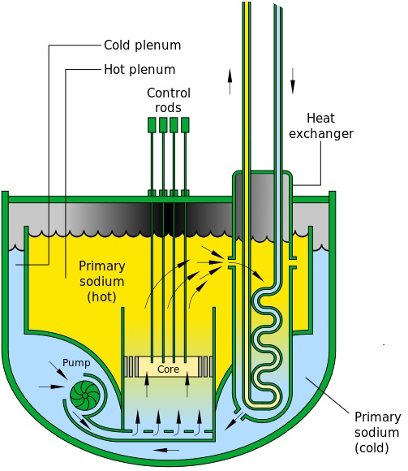

**Sodium Gas Heat Exchanger**:

Misdistribution of the flow

**Pipes**:

Leak, sodium fire

**Pump-diagrid pipe**:

Cavitation

FIG. : Main issues investigated with the PLATEAU facility.

## The Plateau loop

This facility has been built in 2014 in the framework of the ASTRID program. It was designed as versatile as possible to accommodate various mock-ups. The circuits without the utility networks are shown on the FIG. 2. The loop enables three injection points (named 1, 2 and 3 on the FIG. 2) in the mock-up at different temperatures and flow-rates. It allows a maximal flow rate of 400 m3/h and a range of temperature from 10 to 60°C. Numerous sensors, mainly temperature and flow meters, permit to control the thermal hydraulic operating conditions in a wide range.

**Mock-up**

**TA01**

**TA02**

**EX01**

**HEAT01**

**P01**

**P02**

**P03**

**MCM**

**TIC**

**CSC**

**HSC**

**1**

**2**

**3**

*FIG. 2 The PLATEAU loop main circuits (HSC stands for Hot Secondary Circuit, CSC for Cold Secondary Circuit, MCM for Main Circuit Mock-up, TIC for Transitory Injection Circuit)*

## Thermal hydraulic in the primary circuit (MICAS mock-up)

The first mock-up, MICAS [1], commissioned in 2015, represents the upper plenum of the reactor at a 1/6 scale. It aimed at studying the main different thermal hydraulic issues in the primary circuit of a sodium reactor and at providing data for the code validation.

A top-view of the MICAS mock-up is shown on the FIG. 3. Its dimensions are about 2.5 m in diameter and 1.7 m in height. A scale of 1/6 was chosen to be a compromise between the overall size and the detail of the geometry of the vessel, but some geometrical simplifications were necessary. For example, the hexagonal fuel assemblies in the core were replaced by cylindrical tubes and the flow and temperature distribution pattern was reduced to three zones. Since the Upper Core Structure (UCS) highly influences the flow due to its location just above the core, its geometry in MICAS is very detailed. This component holds the control rods and the instrumentation monitoring the temperature and the velocity at the exit of the fissile assemblies.

Around 90% of the flow ejected from the core impinges the UCS and is deviated downstream along the core surface due to the Coanda effect. The other part flows across the UCS, then to the upper plenum. The water of the upper plenum enters inside the Intermediate Heat Exchangers (IHX) and is pumped back to the core using the P03 pump of the PLATEAU loop.

The experimental conditions are determined in order to observe the dimensionless numbers regarding the phenomena studied. However, as it is not possible to keep all of them, we had to accept some distortions.

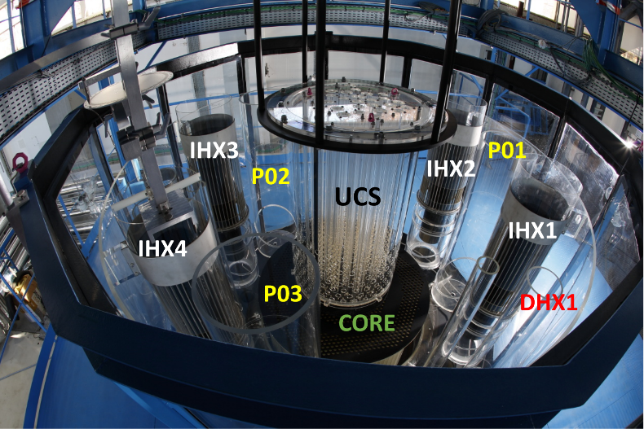

FIG.  Top view of the MICAS mock-up (P0x stands for the pump pit, UCS, for the Upper core Structure, IHXx, for the Intermediate Heat Exchanger, DHX1, for the decay heat exchanger)

The thermal hydraulic flow is rather complex in the primary circuit so that the codes need validation data. In this purpose, in the MICAS mock-up, the velocity was measured at different locations and for a wide range of operation conditions using the PIV technic [5]. The results were compared with the code calculations. The computations were performed with TrioCFD prior to the experimental campaign in order to avoid any influence on the models chosen [6]. The quantitative comparison are showed on the FIG. 4 for two examples of locations around the core and the IHX. Except some slight differences, the accordance is rather good both in terms on flow direction and magnitude. TrioCFD is able to simulate the water flow in the MICAS mock-up, which is very encouraging to be confident on the calculations for the reactor case.

|  |  |
| --- | --- |
| C:\Users\ub154735\Documents\priceles\konferenz\cfd4nrs-7\papier\figures\AZ1\AZ1-V1-786-JN_neu.png | C:\Users\ub154735\Documents\priceles\konferenz\cfd4nrs-7\papier\figures\EI1\EI1-V6-786-JN_new.PNG  Experimental |
| Numerical |  |

FIG. 4 Comparison of measured and calculated velocity fields around the core (left) and the IHX (right) [6]

One of the main issues for the SFR is the gas accumulation in the diagrid. If a gas pocket was released into the core, a positive reactivity effect would occur and may lead to safety problems. One of the origins of gas [8]-[9] is due to the vortices created at the free surface in the upper plenum. An argon blanket covers the sodium to avoid any contact with air and limits the temperature of the top of the vessel. At the surface, water flowing at the immerged components walls promotes vorticity and if the local downward velocity is high enough, the free surface is curved downward to create a vortex. Depending on the flow conditions, this vortex can be dimple or cone shaped, with the inner gas area called the core and the bottom one, the vortex tip. Gas entrainment may occur at the tip of some vortices by various processes: bubbles may be teared from the gas core tip; the gas core may be sucked into the IHX as shown on the FIG. 5. This process is very difficult to handle in complex structures with CFD code especially because of the multiphase flow aspect. Sakai and al. suggested forecasting the vortex occurrence by implementing the code with a simple criterion based on the local thermal hydraulic conditions and the Burger model [7]. This one, which is an exact solution of the Navier-Stockes equations, gives the velocity components of the liquid phase around a vortex. Using this model, the vortex length can be calculated. By assuming that the gas entrainment occurs when the vortex length is equal to the distance between the free surface and the IHX inlet, we are able to calculate a theoretical value of the criterion for which gas entrainment occurs. Calculations show it only depends on the local circulation and downward velocity. However, this criterion includes an experimental factor, which is geometry dependent. It has been calculated by measuring the velocity components by PIV around the vortex by assuming that they follow the Burger model. The comparisons show that this experimental factor in the case of the MICAS mock-up is far lower than the theoretical value and the one determined by Sakai [7]. It means that the vortex may occur in larger ranges of experimental conditions than the ones of the analytical experiments carried out by Sakai [7].

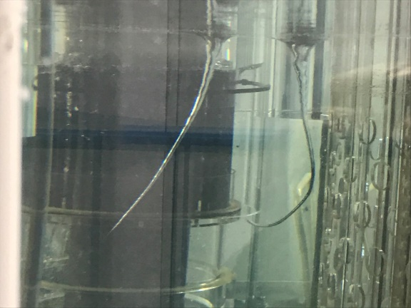

FIG. 5 Front view of vortices in the MICAS mock-up

The flow fluctuations in the upper plenum induce thermal oscillations in the immerged components that lead to thermal fatigue [8] and reactor lifetime decrease. The jet outgoing the core is especially subject to oscillations when it rises to the surface and experiments were carried out on the MICAS mock-up to investigate the range of the operating conditions for which it occurs. As shown on the FIG. 6, the velocity was measured around the core by PIV for different operating conditions and locations around the MICAS mock-up (angles 135 and 315°). From those results, the angle of the jet regarding the horizontal was calculated by two technics. In the first one, the jet core is extracted from the global flow by applying a longpass filter based on the maximum value reported in the measurement field ( the  parameter being determined empirically). The jet path is determined along the horizontal axis from the spatial average of the vertical coordinates of the jet core. In the second technic, we assume that the maximum velocity defines the centreline of the jet. For a given abscissa, the path of the jet is determined by searching the vertical coordinate for which the velocity magnitude reaches its maximum. For both technics, the angle of the jet is calculated using a linear regression of the jet path. From those calculations, the threshold operating conditions for which the jet angle heads downward was determined. The results were set dimensionless regarding the Richardson number, which features the competition between the inertial and buoyancy forces. The graph of the FIG. 7 shows the evolution of the angle of the jet versus a normalized Richardson number and the locations around the mock-up (angles 135 and 315°). Ri’=1 corresponds to the nominal operating conditions. On the FIG. 7, the transition to a rising jet can clearly be identified for a value between Ri’=13 and 27. Further investigations are in progress to study the possibility of transposition of this result to higher scales. Same experiments are being investigating at two lower scales. If the results show no dependence of the Ri number, this will validate the possibility of the transposition to the reactor scale.

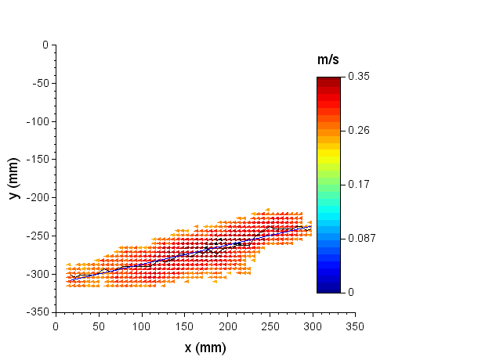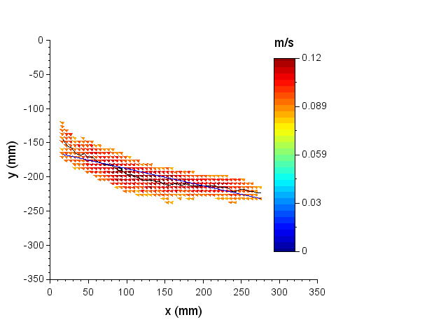

Ri’=27

Ri’=1

FIG. 6 Jet at the core outlet for the R’=1 (nominal operating conditions) and Ri’=27 normalized Richardson – The dark curve in the jet stands for the vertical coordinate average of the jet – The line is a linear regression of this curve.

FIG. : Angle between the horizontal plane and the jet (calculated with the two technics). The dots on the lines stands for the positons “135°” and the “315°” labeled dots stands for the position “315°”.

## Flow in a sodium gas exchanger (DANAH mock-up)

In order to use a Brayton conversion system in a SFR reactor, a multi-channel compact sodium-gas heat exchanger (SGE) was developed in the framework of the ASTRID reactor. Sodium enters the exchanger from the top in a header to be distributed in channels with a 3 x 6 mm2 cross section, while gas enters from the bottom to be heated in a counter flow manner [10]. One issue of the original design of this SGE was the maldistribution of the sodium in the channels; the flow rate was higher in certain parts of the system. It induces a decrease of the global efficiency of the exchanger. In order to optimize the geometry of the header for avoiding this maldistribution, CFD calculations have been performed. However, they needed to be validated with experimental results, which was the aim of the DANAH mock-up (see FIG. 8). It replicated at scale 1 the inlet header and half height of the channels bundle. It was built with a transparent polymer for optical measurements. The experiments were carried out using water as a simulant fluid on the PLATEAU loop.

The CFD calculations of the flow in the DANAH mock-up were performed using the ANSYS FLUENT solver. The boundary conditions are shown on the FIG. 8. Only half of the mock-up is considered in the whole numerical simulation since it exhibits a symmetry. A specific model of the porous source terms allows setting the desired pressure drop value (50000 Pa for DANAH experiment) in a very short channel length. The fluid domain was meshed with 35 000 cells and the k- turbulence model was applied.

In the DANAH mock-up, the flow pattern was investigated with both the PIV and LDV technics in the header and at the channels exit. As shown on the FIG. 9, the good agreement between the experimental and numerical velocity fields confirms us in the models chosen in code [11]. The difference noticed at the inlet is a measurement artefact due to the flange connected to the feeding pipe. On the FIG. 9, the velocity profiles over the dashed line on the images of velocity fields show a quite good agreement, which validates our numerical calculations. Further calculations were performed by optimizing the geometry of the SGE in order to minimize the maldistribution. This one was assessed by calculating the standard deviation of the mass flow rate in the exit of the channels. With respect to the original design of the SGE, the maldistribution decreased from 25 to 2%.

|  |  |
| --- | --- |
| Pressure outlet  (0 Pa)  Porous media  (30 mm 🡺 DP=5000 Pa)  Non slipping walls  Mass flow inlet (25 kg/s)  Symmetry |  |

FIG. : The DANAH mock-up

|  |  |
| --- | --- |
|  |  |
|  | |

FIG.  Comparison of measured and calculated velocity at the inlet header

## Jet break-up during a breach (JET-SER mock-up)

In SFR reactor, the chemical reactivity of sodium has to be assessed regarding the safety analyses. In case of a sodium leakage during a breach, the sodium jet may burn in contact with air in respect of the flow behaviour. The intensity of the fire depends on different parameters, mainly on the degree of fragmentation, which impacts on the surface of contact with air. As studying the fragmentation of a sodium is a tough task, preliminary experiments were performed with a water. Water and sodium behave differently regarding the fragmentation because their surface tension and their viscosity differ from each other. However, the main purpose of this study is to validate the fragmentation models which can be achieved with a simulant fluid. The JET-SER mock-up was designed and built to study the droplet size in the case of a water jet on the PLATEAU loop.

The JET-SER mock-up, shown on the FIG. 10, is a box made up of metal rails covered with transparent hydrophobic windows for visualisation of the jet. A shadowscopy device allows to measure the shape of the jet and the droplets size in the whole mock-up volume, as presented on the FIG. 11. A specific imaging treatment was developed to analyse the break-up and calculate the velocity and size of the droplets. Different operating conditions were experimented to determine the influence of the angle of the jet, the nozzle diameter and the flow rate. As we can notice on the FIG. 11 that the amount and the size of droplets growths along the jet. An increase of the velocity at the nozzle exit enhances the fragmentation by generating smaller and more numerous droplets that leads to higher surface of exchange. As shown on the FIG. 12, in the case of downward jets, the results correlates the model developed by Wu [12] with a slight adjustment of some parameters. However, for horizontal and upward jets when the gravity forces are no longer in the same direction of the jet, the Wu model is only valid near the nozzle exit, some discrepancies occurring in the developed areas of the jet. The gravity seems to influence a smaller fragmentation due to a more important stretching of the droplets. Preliminary calculations were performed with the two phases flow NEPTUNE\_CFD code on the JET-SER mock-up geometry. Turbulence, fragmentation, drag and surface tension forces were taken into account using the available models of the code. However a new model to calculate the droplet diameter has been implemented. First results, presented on the FIG. 12, shows a quite good agreement with the experimental results in terms of droplet diameter.

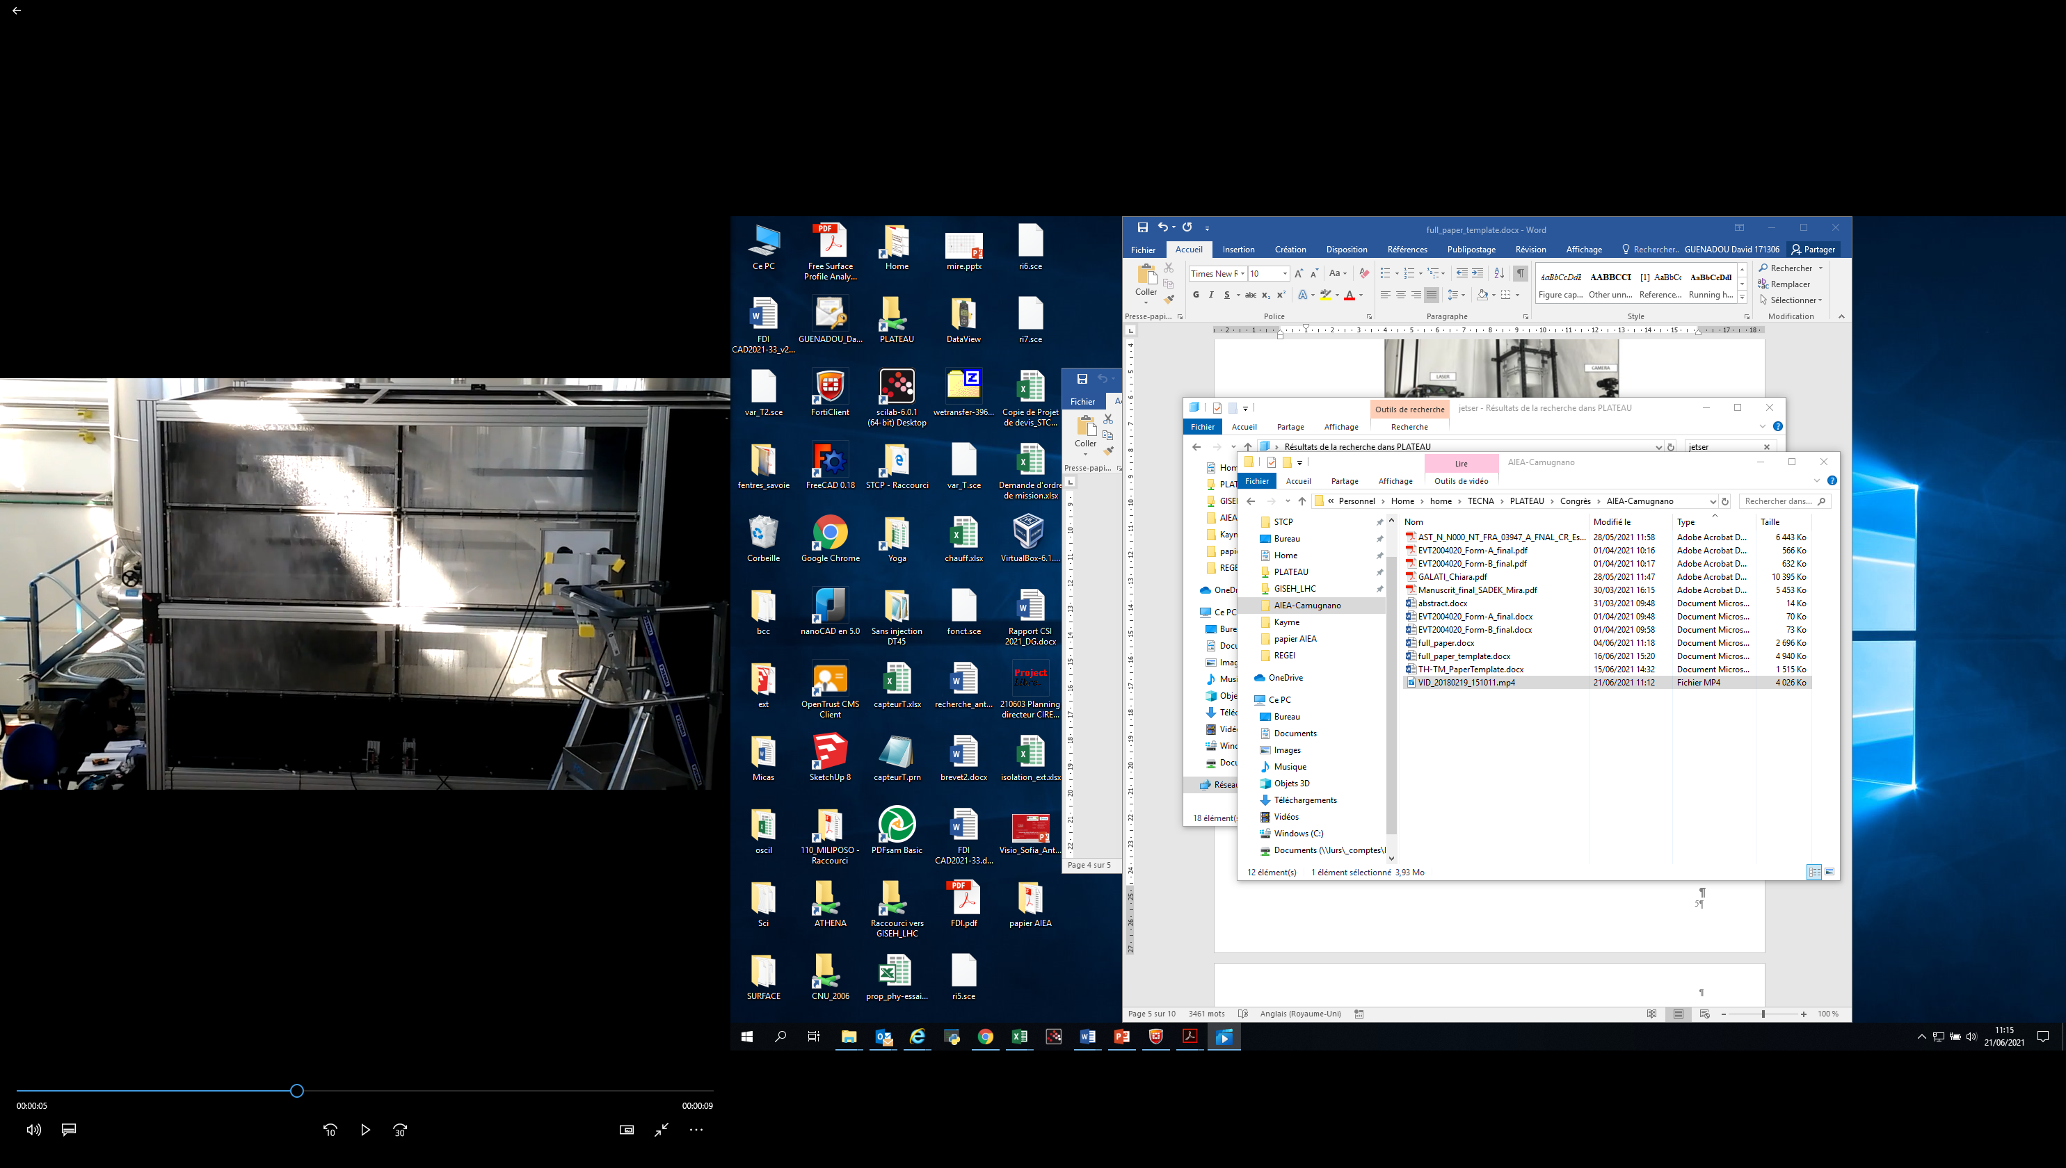

**X**

**Y**

**Jet**

**Lighting device**

FIG.  JET-SER mock-up and shadowscopy measurement device



FIG.  Break-up of a horizontal jet

*FIG. 12: Comparison of the experimental results with the CFD calculations and the Wu model for a downward jet at about 600 mm downstream from the nozzle.*

## Cavitation in the pump-diagrid pipe

The pump-diagrid pipe allows the transfer of the sodium from the pump outlet to the diagrid inlet. As the ASTRID reactor is an integrated design where all the components are gathered in a single vessel, the space is limited which constrains short curvatures of the pipes. The ASTRID pump-diagrid pipe is ram shaped and cavitation may occur in its elbows. Gas and bubbles are prohibited because of the erosion [13] they could induce on the pipe or the downstream components such as the core. Investigations were carried out to assess the onset of the cavitation on the PLATEAU loop with the setup shown on the FIG. 13.

As previously, the experiment were not performed with sodium but with water as a simulant fluid as they behave in the same manner regarding the cavitation [14]. Fast rate pressure sensors and accelerometers were located along the setup (see FIG. 13) to record the noise induced when the cavitation occurs. Two configurations were tested, with the flow in one leg or with both legs. The results, plotted on the FIG 14, versus the cavitation number show the onset of the cavitation for a value around 7 for the one leg configuration. In the case of two legs, we were not able to reach the cavitation due to the limitation of the PLATEAU pump. The accelerators are better adapted to determine the cavitation compare to the pressure sensor as we can notice on the FIG 14. Further studies need to be performed to transpose those results obtained at a small scale with water to the reactor case.



Fast pressure sensors

Cavitation

FIG. : Setup for the analysis of the cavitation in the pump-diagrid pipe

FIG : Normalized standard deviation of the response of an accelerometer and standard deviation of the pressure versus the cavitation number.

## Conclusion

The PLATEAU facility was built in the framework of the ASTRID project to validate the codes and study specific issues. It was designed to accommodate various mock-ups and as versatile as possible. The first commissioned one, MICAS at the scale 1/6 of the hot plenum, aimed at studying the main different thermal hydraulic issues in the primary circuit and at providing data for the code validation. PIV technic enabled to measure the velocity in wide range of operating conditions and areas in the model. Comparisons with code calculations showed quite a good agreement, which is encouraging for the code validation. Gas entrainment was carefully studied because gas accumulation in the diagrid is a safety issue and very difficult to take into account in the current codes. Using a simple model from the literature, the gas entrainment can be forecasted. However, a parameter was tuned to fit the experimental results. It is far lower compared to the theoretical value, which means gas entrainment occurs precociously. The jet outgoing the core is subject to oscillation when it rises to the surface and it may induce thermal fatigue to the immerged components. Velocity measurements were carried out to investigate the range of the operating conditions for which it occurs. As the behavior of the jet is determined by the competition between the inertia and buoyancy forces, the results were expressed using the Richardson number. They showed a threshold value between 13 and 27 for which the jet starts to rise.

The ASTRID design included a sodium gas exchanger in order to allow the use of a Brayton conversion system. This exchanger, made up with tiny multi channels, needed optimizations especially regarding the distribution of the flow to increase its efficiency. In this purpose, CFD calculations were performed but they required validations from the experiments. The DANAH mock-up replicated the exchanger at scale 1 and the velocity was investigated in different locations for various operating conditions. The results correlated the calculations which allowed validating the models chosen in code. CFD studies permitted to improve the exchanger yield by reducing the maldistribution.

In the framework of the sodium fire studies in case of a pipe leakage, the JET-SER mock-up was designed, built and connected to the PLATEAU loop. It aimed at studying the droplet sizes and velocities during a jet break-up using the shadowscopy technic at different operating conditions. The main results showed that the amount of droplets increase along the jet and the velocity at the nozzle outlet enhanced the fragmentation. Comparisons with a model from the literature are in good agreement for the downward jets not influenced by the gravity. The gravity seems to induce a smaller fragmentation.

Cavitation in the ram-shaped pump diagrid pipe was investigated using both accelerometer and pressure sensors. The results highlighted that the cavitation can occur for a cavitation number around 7 and the accelerometer are more sensitive to determine the cavitation onset.

As those experiments were performed with water and in the major cases at small scales, studies are in progress to assess the possibility to extrapolate this results at higher scales and for sodium.

References

1. GUENADOU, D, TKATSHENKO, I, AUBERT, P, “Plateau Facility in Support to Astrid and the SFR Program: An Overview of the First Mock-Up of the Astrid Upper Plenum, MICAS”, Proceedings of the16th International Topical Meeting on Nuclear Reactor Thermal Hydraulics (NURETH16), Chicago, Illinois, USA , 2015, August 30-September 4.
2. GUENADOU, D, AUBERT, P, BISCAY, V, BOTTIN, M, DESCAMPS, J-P, “Study of the Free Surface Flow in the MICAS Mock-Up in Support of the ASTRID SFR Program”, Proceedings of the 11th International Topical Meeting on Nuclear Reactor Thermal Hydraulics, Operation and Safety (NUTHOS-11), Gyeongju, Korea, 2016, October 9-13 .
3. GUENADOU, D, AUBERT, DESCAMPS, J-P, “Analysis of the Gas Entrainment by Vortex in the Upper Plenum of the ASTRID Reactor Mock-up”, Proceeding of the 12th International Topical Meeting on Nuclear Reactor Thermal-Hydraulics, Operation and Safety (NUTHOS-12) Qingdao, China, 2018, October 14-18.
4. GUENADOU, D, AUBERT, DESCAMPS, J-P, “Gas Entrainment Criteria at the Free Surface of a Sodium Fast Reactor Mock-up”, Proceeding of the 10th International Conference on Multiphase Flow (ICMF), Rio de Janeiro, Brazil, 2019, May 19 – 24.
5. GUENADOU, D, AUBERT, DESCAMPS, J-P, “Flow Analysis in the Upper Plenum of the MICAS Model in Support of the ASTRID Reactor Program”, Proceedings of the17th International Topical Meeting on Nuclear Reactor Thermal Hydraulics (NURETH17), Xi’an, China, 2017 September 3-8.
6. BIEDER, U, MAILLARD, J, GORSSE, Y, GUENADOU, D, “CFD Analysis of the Flow in the MICAS Experimental Facility, a Water Model of the Hot Pool of a Sodium Cooled Fast Reactor”, Nuclear Engineering and Design 350, August 2019, pp. 67-77.
7. SAKAI, T,.EGUCI, Y, MONJI, H, ITO, K, OHSHIMA, H, “Proposal of Design Criteria for Gas Entrainment from Vortex Dimples Based on Computational Fluid Dynamics Method”, Heat Transfer Engineering, 29(8), pp 731-739 (2008).
8. TENCHINE, D, “Some Thermal Hydraulic Challenges in Sodium Cooled Fast Reactors”, *Nuclear Engineering and Design,* **240**, pp. 1195-1217 (2010).
9. TENCHINE, D, FOURNIER, C, DOLIAS, Y, “Gas entrainment issues in sodium cooled fast reactors”, *Nuclear Engineering and Design,* **270**, pp. 302-311 (2014).
10. CACHON, L et al. “Status of the Sodium Gas Heat Exchanger (SGHE) development for the Nitrogen Power Conversion System planes for the ASTRID SFR prototype” Proceeding of ICAPP’15, Nice (France), Mai 03-06, Paper 15362.
11. GALATI, C, CACHON, L, PRAT, L, GOURDON, C, “Experimental and numerical validation of flow maldistribution in compact Heat exchanger”, Proceeding of NURETH’17, Xian (China), September 03-08, Paper 21083.
12. WU, P., TSENG, L, FAETH. G, “Primary breakup in gas/liquid mixing layers for turbulent liquids”. At. Sprays 1992, pp. 295‑317.
13. COURBIERE, P, “Sodium cavitation erosion testing”, 1979; 10 p; 6. Conference on fluid machinery; Budapest, Hungary; 17 - 22 Sep 1979
14. BISCI, R, COURBIERE, P, “Analogy of water as compared to sodium in cavitation”, International Atomic Energy Agency, Vienna (Austria). International Working Group on Fast Reactors; p. 62-67; Jun 1976; p. 62-67; Specialists meeting on cavitation in sodium and studies of analogy with water as compared to sodium; Cadarache, France; 12 - 16 Apr 1976