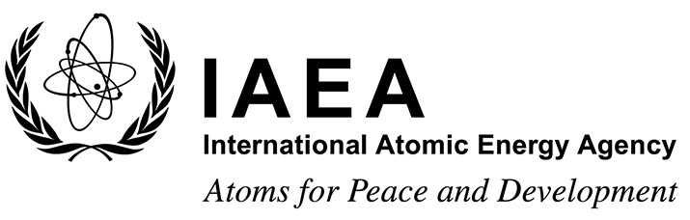 |  |  | Form A  EVT2004020
Participation Form
Technical Meeting on State-of-the-art Thermal Hydraulics of Fast Reactors
Camugnano, Italy
26–30 September 2022
To be completed by the participant and sent to the competent national authority (e.g. Ministry of Foreign Affairs, Permanent Mission to the IAEA, or National Atomic Energy Authority) of his/her country for subsequent transmission to the International Atomic Energy Agency (IAEA) either by email to: Official.Mail@iaea.org or by fax to: +43 1 26007 (no hard copies needed). Please also send a copy by email to the Scientific Secretary V.Kriventsev@iaea.org and to the Administrative Secretary K.Abdurasulova@iaea.org.
Participants who are members of an invited organization can submit this form to their organization for subsequent transmission to the IAEA.
Deadline for receipt by IAEA through official channels: 1 July 2022
Family name(s): (same as in passport) |  | First name(s): (same as in passport) |  | Mr/Ms
Institution:

Full address:

Tel. (Fax):

Email:

Nationality: | Representing following Member State/non-Member State/entity or invited organization:
If/as applicable:

Do you intend to submit a paper? Yes No

Would you prefer to present your paper as a poster? Yes No

Title:

