Current opportunities and challenges in a period of 2D to 3D transition in Radiation therapy in Mongolia

M. Minjgeeª
E.Vanchinbazar, B. Luvsandorjª, E. Nansalmaaª

ªNational Cancer Center of Mongolia,
Nam-Yang-Ju Street, Bayanzurkh District, Ulaanbaatar-13370, MONGOLIA

Email address: minjmaa@cancer-center.gov.mn

BACKGROUND AND OBJECTIVE
The National Cancer Center of Mongolia (NCCM) takes main responsibility for implementation of national policies to control cancer and provides tertiary level diagnostic and specific treatment of most types of cancer.
Increasing number of cancer cases causes higher demand for services of NCCM. The most common cancers in Mongolia are liver, stomach, lung for men; and liver, cervix uteri and stomach for women. Cervical cancer occupy 38% of patients undergoing radiation therapy. Over 200 cervical cancer patients receive Brachytherapy and about 800 applications are performed each year.
Due to lack of equipment and technological obsolescence over the past years, only less than 15 percent of newly diagnosed cancer patients have undergone radiation therapy.
Many efforts have been made and step-by-step measures have been taken to improve radiotherapy facility at NCCM. 3D volume based treatment has become available in both external beam radiotherapy and brachytherapy in 2018-2019. An implementation of the project "Improving quality and access to cancer diagnostics and treatment" resulted in an introduction of Linear accelerators first time in June 2019 and 3D conformal radiation therapy has become available.
METHODS
Commissioning of low and high energy linacs was done simultaneously from March to June 2019 under supervision of international experts. The experts were invited at different stages of commissioning.
- Acceptance test, radiation survey and beam data collection (8 Mar- 8 April, A. Cyelan, ACPSEM)
- Beam data modeling (S.H. Choi, KIRAMS 15-20 Apr),
- Validation and verification (Ritu Raj, IAEA (27-31 May)
- Train MPs and RTTs on Linac operation and planning (T. Lowe, RANZCR, 3-22 June)
- Conduct first treatment live-go (Soo Min, IAEA, T. Nakashima, HUH, 17-21 June)
- Electron commissioning and QA improvement (Alison Scott, AVI, 24 Aug - 8 Nov)
PDDs and profiles were measured for square fields sizes of 3-40 см² at SSD 100 cm. Beam quality factors were calculated from those values and were compared with BJR25. Profiles were compared Golden beam data. By first absolute dose measurement, it was 6.3% higher the factory calibrated value due to low atmosphere pressure of Mongolia. It was audited by IAEA Postal Dose Quality Audit. Standard deviation relative to IAEA mean dose was 2%. Output was measured at certain field size which was from 3×3 cm² to 40×40 cm², calculation defined by the ratio reading in 10x10 field. According to the chart, Output Factor is equal 1 in 10x10cm² and less than 1 in smallest field and more than 1 in largest fields. MLC transmission factor is 0.015
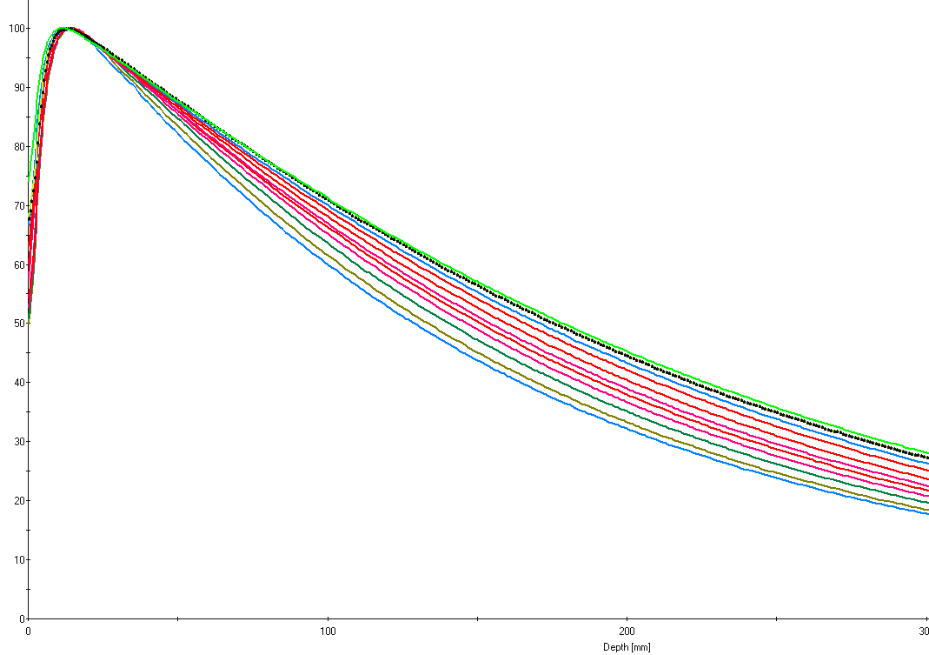
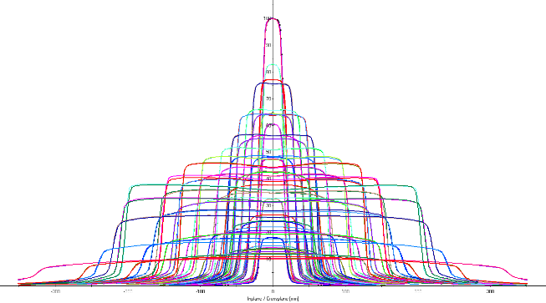
PDD
Profile

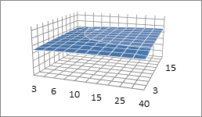
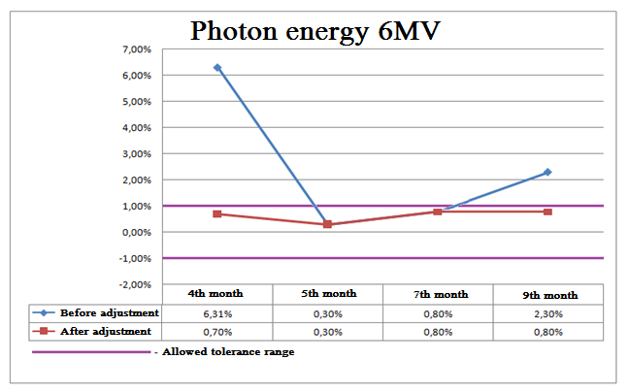
OF

Figure 1. Beam data: 6MV, Low energy linac

RESULTS AND DISCUSSION
The successful implementation of this project will contribute towards national efforts to respond to the growing demand for radiotherapy in the country. During the important step of transition of Cobalt-60 with linear accelerator with this phase I project, we have had a variety of new experiences with treating more than 1200 patients with Linac:
1. Delayed building of Premise of linacs that caused warranty period to expire only after 1 year. It has been built with insufficient air circulation system. 2. Commissioning: It was a first experience for medical physicists to commission our first linacs and it was a learning process at the same time. As a Member State of the IAEA since 1973, Mongolia has been closely involved with the Agency for decades, and it was one of many assistance that Mongolia has received in using nuclear applications to better the lives of its people.
3. Mongolia also suffered some significant exogenous shocks during the transition, including insufficient supply of some devices and applications of the linear accelerators
4. Maintenance of equipment: as a landlocked nation located within the interior of a vast continent, Mongolia faces challenges given by its topography. Sometimes it takes hours or days, even weeks to repair linear accelerators
5. Along with introduction of new technologies and equipment, we could improve radiation control and protection, and safety practices in accordance with international standards and guidelines with help of IAEA.
In order to further improve access to radiation therapy technological advancement in radiation therapy such as intensity modulated radiation therapy (IMRT), 4D gating, stereotactic body radiation therapy (SBRT) has to be introduced for reduced damage to normal tissue, enhanced quality of life for cancer patients. With the implementation of the proposed phase II project on equipment and human resources, Mongolia will be able to deal with the problems identified.
CONCLUSIONS
Any transition period in implementing higher technology needs solid experience of its previous adopted technology and successful cooperation with international organizations and institutes like IAEA, RANZCR, APSIG, KIRAMS with excellent experts would help us in safe introduction of new nuclear technology.

