Optimization parameters in bladder and rectum for gynecologic cancer treatment with VMAT Technique through ProKnow platform.
M. Berteroª, R. González Armestoª, J. De Bridaª, M. S. Galloª, R. Ruggeriª.

ª Centro Oncológico Integral, Industriales Neuquinos 2800, Neuquén, Argentina

Email address of Corresponding Author(s): mbertero@lebensalud.com, rgonzalez01@lebensalud.com

BACKGROUND AND OBJECTIVE
Gynecologic cancer represents 14% of new cancer cases in women in Argentina [1] . The main treatment options to this disease are external radiotherapy, brachytherapy and chemotherapy. In the first two, the predominant concern are the dose levels administered to organs at risk (OARs), where bladder and rectum are considered critical organs due to their proximity to the treatment region.
Although the tolerance doses defined for these organs in QUANTEC [2] are higher than the prescription dose recommended for gynecologic treatment, it represents good practice to optimize dose to healthy tissues to the minimum values achievable, according to ALARA principle. Volumetric Arc Therapy (VMAT) technique allows optimization of the dose delivered to these organs without compromising the dose to the target volume (PTV). That is the reason why sometimes this technique is chosen over Tridimensional Conformal Therapy (3D-CRT) technique, where dose optimization is limited.
In this work, Dose Volume Histograms (DVH) from gynecologic treatment plans using VMAT techniques are analyzed with Elekta’s ProKnow platform, to collect statistical data from our population and know about average dose distributions in OARs, with the objective of establishing dose optimization parameters.
METHODS
Whole pelvic radiotherapy plans for gynecological malignancies, with a prescription dose of 46 Gy, in fractions of 2 Gy per day, planned in Elekta’s TPS Monaco with VMAT technique and treated between June 2018 and June 2020 at Centro Oncologico Integral and Fundación Médica de Río Negro y Neuquén were identified. The selected plans were anonymized and uploaded to Elekta’s platform Proknow, grouping these patients in a data collection destined for investigation. A scorecard was created in order to evaluate the dose delivered to organs at risk, as well as the PTV dose coverage.
In the development of the scorecard, evaluation metrics were defined: V10, V15, V20, V25, V30, V35, V40, V45, medium dose and maximum dose both in bladder and rectum and, homogeneity and conformality index, as well as D95 to evaluate the PTV. Lastly, the number of monitor units (MU) were included in the analysis as an indicator of the treatment plan’s level of complexity. For statistical analysis, the median of each evaluated metric was selected. These values were used to define optimization parameters.
Next, the plans were replanned using the optimization values established. These plans were then uploaded to ProKnow platform and subjected once again to evaluation by scorecards to assess the results of optimization.
RESULTS AND DISCUSSION
A comparison of the DVH of the original and optimized plans shows a reduction in the evaluated metrics, represented by the box diagrams in Figure 1. With regards to the rectum, the median of low dose values (V10-V20) decreased by up to 18%. At medium dose levels (V20-V35), the reduction in the median had greater impact, achieving a decrease of up to 23%; for the high dose range, (V35-V45), a decrease in the median of up to 11% was achieved. The median dose distribution in the rectum was reduced by 10%, from 30 Gy to 27 Gy.
In the bladder, the median of the low dose values (V10-V20) decreased by 19%; for medium doses (V20-V35), the median decreased by 21% and for high doses (V35-V45), the decrease in doses had a considerable result, reaching a decrease of 36% for V40 and 47% for V45. The median dose was reduced by 12%.
As for the PTV and the complexity of the plan, no significant variations were observed.
Figure 1. Scorecards for original plans and optimized plans.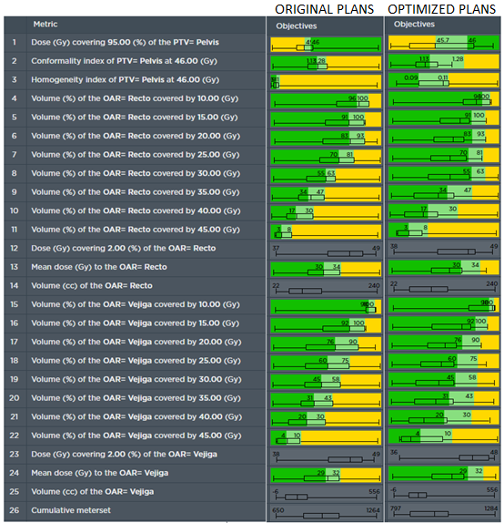
CONCLUSIONS
Considering that the tolerance values of the OARs involved in the irradiation of gynecological treatments are higher than the dose levels irradiated in the treatment, all the plans analyzed in the first instance comply with the reference values adopted.
With the implementation of ProKnow platform it was possible to quickly and effectively recognize the dose distributions of our population, and determine optimization parameters for these treatment plans.
As expected, the dose distributions of our population were homogenized, showing less variability in values since all treatment plans were executed under the same optimization criteria. In most cases, a decrease in the dose values delivered to the risk organs was found without a considerable compromise to PTV coverage and plan complexity.
ProKnow proved to be a useful tool for statistical analysis of the population that allows continuous improvement in treatment planning and optimization of workflow, streamlining the evaluation and comparison of plans for clinical decision-making.

REFERENCES
[1] Instituto Nacional del Cáncer MdSdlRA. Estadísticas - Incidencia 2018 www.argentina.gob.ar/salud/instituto-nacional-del-cancer/estadisticas/incidencia
[2] B E. Tolerance of normal tissue to therapeutic irradiation. In: Lyman J BA, Coia L, Goitein M, Munzenrider JE, Shank B, Solin LJ, Wesson M., editor. 1 ed. Int J Radiat Oncol Biol Phys. 1991. p. 109-22.

