Competences of Medical Dosimetrists and Radiation Therapy Technologists working in a Costa Rican Radiotherapy Department: a benchmarking approach to the recommended ESTRO Core Curriculum using a Training/Competency Matrix

Primary Author: J.A. Villalobos-Rosales^{a,b}

ªCaja Costarricense del Seguro Social, Hospital San Juan de Dios, Servicio de Radioterapia.
^{b}Universidad de Costa Rica, Escuela de Tecnologías en Salud, Imagenología Diagnóstica y Terapéutica.
Email address of Corresponding Author(s): jorgevillarosales@gmail.com

BACKGROUND AND OBJECTIVE
The literature identifies various competences required for Medical Dosimetrists (CMD) and Radiation Therapy Technologists (RTT); however, these are varied and scattered among different publications [1]. The aim of this study was to identify the actual competences of CMD and RTT practicing on treatment planning (TP) with tri-dimensional conformal (3DC) or intensity modulated (IM) radiation therapy (RT) and linear accelerator (LINAC) respectively and their future training needs in Hospital San Juan de Dios Radiotherapy Department (RT-HSJD) according to a benchmarking approach over the recommended ESTRO Core Curriculum for RTTs [2], [3].
METHODS
The recommended ESTRO Core Curriculum for RTTs [2], [3] was scrutinized for competences practiced by CMD and RTT. A systematic approach was performed by direct observation of the CMD and RTT daily practices to find relevant competences and training needs. A thematic analysis was performed to organize the competences according to themes [1], [4].
The themes analyzed were: 1) Non-technical competences (Quality and risk management, Decision making and critical analysis, Management and leadership, Team work and multidisciplinarity, Communication). 2) General technical competences in RT (Professionalism, Patient Care, Research, Education, Equipment quality assurance, File verification). 3) Technical competences in TP (Simulation, Contouring, 3DCRT-TP, IMRT-TP, Planning quality assurance). 4) Technical competences in LINAC (Positioning and immobilization, Delivery of treatment, Verification of patient setup, IGRT Image Verification).
Then, a Training/Competency Matrix (T/C-M) was created to identify the relationship of the competences and the actual level achieved by each CMD and RTT in the RT department (Table 1). The competency level was set in the following qualifications: Great competency, autonomy and can teach others (4 points, purple color), Advanced competency and independent decision making (3 points, green color), Basic competency and dependent decision making (2 points, light blue color), In training (1 point, orange color) and Needs training (0 points, red color).
RESULTS AND DISCUSSION
The actual level, distribution and results achieved by each CMD and RTT in RT-HSJD can be observed in Table 1. A T/C-M is a tool used to document and compare the required competences for a position with the current skill level of the employees performing the role. It is used in a gap analysis to determine where an organization has critical training needs and as a tool for managing people development [5].

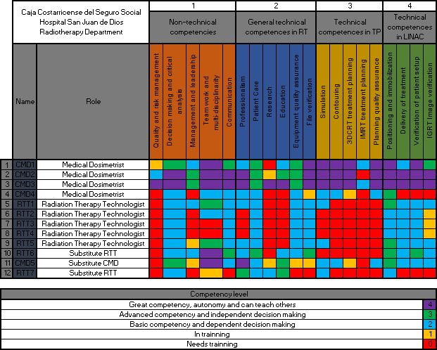
Table 1. Training/Competency Matrix for Medical Dosimetrists and Radiation Therapy Technologists in Hospital San Juan de Dios Radiotherapy Department.
Source: Quality Management Committee RT-HSJD, 2020.
CONCLUSIONS
The T/C-M provides a comprehensive view of all the skills and behaviors needed in a RT department. It aids in managing the training budget because it identifies skill gaps across the organization rather than just one person at a time. It assists with planning by helping identify and target new skill areas that RT departments might need for the long term [5].
RT-HSJD has only two of nine fixed employees with professional training, and they summarize the highest competency levels. Both has a Licentiate degree in Diagnostic Imaging and Radiotherapeutics from the University of Costa Rica (LIC-IDT-UCR) with specific training in Radiation Oncology. The other team members are radiographers with empiric training in this specialized area.
Actual CMD and RTT across RT-HSJD must be formal trained to bridge the gap with professional standards or recommendations published such as the ESTRO Core Curriculum for RTTs and to ensure the best care possible is given to patients [6]. This study also promotes and emphasizes in the importance to incorporate professionals on CMD and RTT roles, as the ones with LIC-IDT-UCR.
REFERENCES
[1] COUTO, JG. et al, Competencies of therapeutic radiographers working in the linear accelerator across Europe: A systematic search of the literature and thematic analysis, Radiography, (2019).
[2] EUROPEAN SOCIETY FOR RADIOTHERAPY & ONCOLOGY, Benchmarking document for Radiation TherapisTs, European Higher Education Area Level 6, (2014).
[3] COFFEY, M., LEECH, M., The European Society of Radiotherapy and Oncology (ESTRO), European Higher Education Area levels 7 and 8 postgraduate benchmarking document for Radiation TherapisTs (RTTs), Technical Innovations & Patient Support in Radiation Oncology, 8, 22–40, (2018).
[4] INTERNATIONAL ATOMIC ENERGY AGENCY, A Handbook for the Education of Radiation Therapists (RTTs), Training Course Series 58, Vienna, Austria (2014).
[5] KURUBA, M., Role Competency Matrix: A Step-By-Step Guide to an Objective Competency Management System, 1st edn, Springer Nature, Singapore, (2019).
[6] COFFEY, M., LEECH, M., POORTMANS, P., Benchmarking Radiation TherapisT (RTT) education for safe practice: The time is now, Radiotherapy and Oncology, 119(1), 12–13, (2016).

