Small field absorbed dose to water determinations in LINAC MV photon beams during site visit authority inspection of radiotherapy

I. Jokelainenª
P. Sipiläª

ªRadiation and Nuclear Safety Authority (STUK), Laippatie 4, 00880 Helsinki, Finland
Ilkka.jokelainen@stuk.fi
petri.sipila@stuk.fi

BACKGROUND AND OBJECTIVE
Use of radiotherapy in Finland is controlled by Radiation and Nuclear Safety Authority (STUK). The use of radiotherapy must fulfill requirements of national legislation and orders given by STUK. An effective method to verify the fulfillment of the acceptance criteria for radiotherapy equipment in use and the requirements for radiation safety of personnel and patients is site visit inspection. Absorbed dose to water measurements in reference geometry and treatment planning system (TPS) verification by determinations of the TPS-calculated patient doses in LINAC beams are routine methods of authority control for radiotherapy in Finland. As radiotherapy treatment techniques focus on VMAT and IMRT treatments, the need of TPS verification of small fields has increased in authority control.
During the period 2015 – 2019 STUK verified the TPS-calculated small field patient doses by a total of 1500 absorbed dose to water determinations performed as part of authority site visit inspections of 45 linear accelerators in 13 Finnish radiotherapy centers LINAC photon beams with different field sizes shaped with collimator jaws or multileaf collimator (MLC).

METHODS
The absorbed dose to water determinations were made in Varian and Elekta accelerator conventionally filtered beams (WFF: 6MV, 10MV, 15MV and 18MV) and in beams without flattening filter (FFF: 6MV and 10MV). The absorbed doses to water were determined by ionization measurements using ionization chambers and synthetic diamond as the detectors following IAEA TRS398 absorbed dose determination protocol [1]. The calibrations of 0,6cm³ Farmer-type ionization chamber PTW30013 and the used electrometer PTW UNIDOS E are traceable to calibration laboratory SSDL-Helsinki. The small volume (0,03 cm³) PinPoint-type ionization chamber PTW31015 and diamond detector PTW60019 (0,004 mm³) were cross calibrated in reference geometry (SSD 100 cm, FS 10x10 cm², depth 10 cm) during the inspections with each hospital LINAC MV photon qualities with Farmer chamber as a reference instrument. For Farmer- and PinPoint-chamber the recombination corrections (k_{rec}) were determined for every accelerator photon quality and the beam profile specific chamber volume averaging correction factors (k_{vol}) [2] were determined for every accelerator FFF photon qualities. All dose determination and dose plans were made with SSD 100 cm and in depth of 10 cm in hospitals water phantoms (50cm x 50cm x50cm). Dose plans were calculated for field sizes from 30x30 cm² to 2x2 cm². Farmer-type chamber was used for dose determinations in fields from 5x5 cm² to 30x30 cm², PinPoint chamber and diamond detector in fields from 2x2 cm² to 10x10 cm².
RESULTS AND DISCUSSION
Most of the dose plans were in good agreement with doses measured by STUK to be within ±2 %. In one hospital the dose deviation exceeded the STUK acceptance criteria (±3 %) with field sizes 4x4 cm², 3x3 cm² and 2x2 cm² in 6 MV beam and with 2x2 cm² field size in 15 MV beam, having max. deviation of 7 % in 6 MV 2x2 cm² field. After updating the hospital dose planning system algorithm and the input data the deviation decreased below 4 %. The agreement with doses measured with cross calibrated diamond detector and PinPoint chamber was within 0,5 %, except for 2x2 cm² field size were the deviations of 1 % were found. The deviation in the calibration factors of cross calibrated diamond detector PTW60019 and ionization chamber PTW31015 in different LINAC beams having same nominal energy were within ±0,6 %.
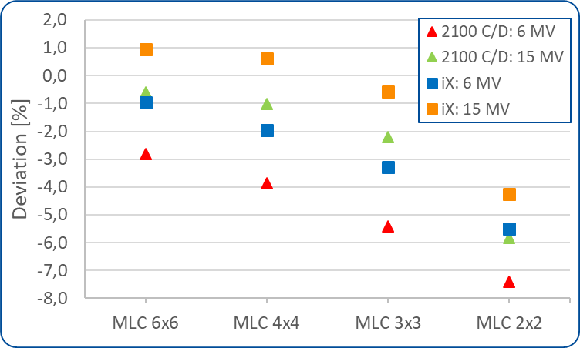
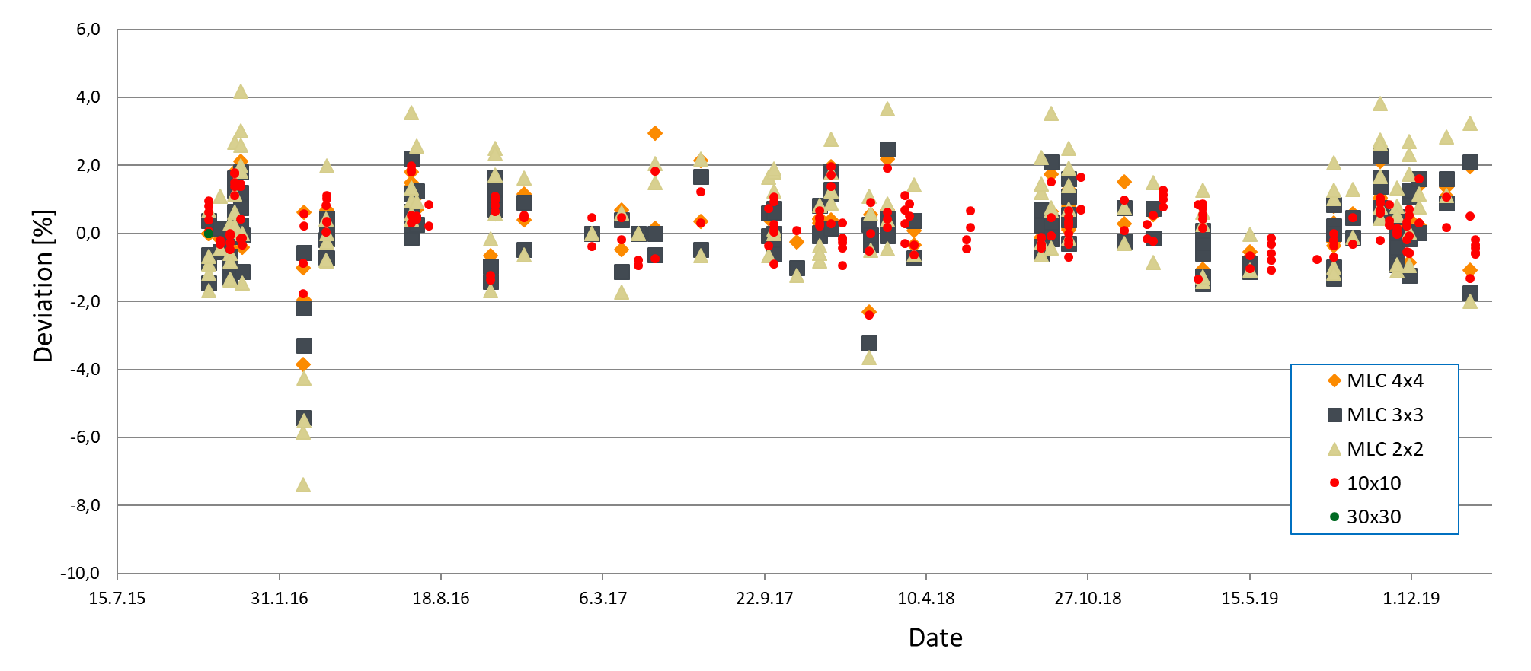
Figure 1. Deviation of TPS-calculated and measured point doses of rectangular treatment fields in LINAC MV photon beams.
CONCLUSIONS
For verification the input data of hospital TPS the absorbed dose to water measurements in LINAC MV beams with field sizes bellow 10x10 cm² has been found useful authority control method. The synthetic diamond detector having high spatial resolution and small energy dependence has been found suitable cross calibrated detector for small field dosimetry with field sizes down to 2x2 cm², and PinPoint ionization chamber PTW31015 down to 3x3 cm².
REFERENCES
[1] IAEA, INTERNATIONAL ATOMIC ENERGY AGENCY, Absorbed dose determination in External Beam Radiotherapy. An international code of practice for Dosimetry Based on Standards of Absorbed Dose to Water. Technical Reports Series no. 398, V12, 05 June 2006.
[2] IAEA, INTERNATIONAL ATOMIC ENERGY AGENCY, Dosimetry of Small Static Fields Used in External Beam Radiotherapy. An international code of practice for Reference and Relative Dose Determination. Technical Reports Series no. 483, November 2017.

