Dose verification from imaging to delivery during site visits in radiotherapy
Primary Author: P.Sipilä
Co-Author: I.Jokelainen

ª Radiation and Nuclear Safety Authority (STUK)
Email address of Corresponding Author: petri.sipila@stuk.fi
BACKGROUND AND OBJECTIVE
A lightweight, portable and water filled phantom was developed in STUK for radiotherapy site visits to verify the dose from imaging to delivery, especially for VMAT and IMRT beams, but suits for conventional beams as well. The phantom has been manufactured in STUK mechanical workshop from PMMA and it is light to transport when empty and easy to fill and set up in hospital. Different type of detectors can be fitted in the phantom easily. Most measurements are done as point measurements with a waterproof 0.6cc chamber or Semiflex IC. Micro-ionization chamber, diamond detector or semiconductor are used seldom. If a dose distribution is needed, a piece of Gaf-Chromic radiochromic film EBT3 can be inserted in the phantom. Normally the phantom is used without any inhomogeneities, but different type of inhomogeneities can be inserted in several positions when needed. Mostly used inserts are lung and bones, but e.g. hip replacement prosthesis can also be inserted. In order to avoid artefacts and calculation errors from IC chamber, a plastic dummy IC is placed in the phantom during CT scan. be provided.
METHODS
The phantom has been in regular use since 2014 and about 2400 photon beams has been measured during site visits. The phantom has been measured with all accelerators in Finland more than three times and has been used in some clinics abroad. The phantom has been scanned in each hospital with the local CT scanner, the same what is used for cancer patients. If there was a need for verify the image quality parameters, a CT-quality insert is added inside the phantom. This allows to verify HU values, image and contrast resolution. After analyzing image parameters in CT scanner, the images are transferred to planning station and several type of treatment beams will be planned. If conventional beams are verified, usually only point dose at isocenter is calculated and measured. If VMAT or IMRT beams are verified, a CTV is drawn to detector volume and PTV and some OAR according local procedures to mimic pelvis area if no inserts are set or lung tumor region if lung insert is used. The phantom and Farmer type chamber on the patient tabletop is shown in Figure 1.

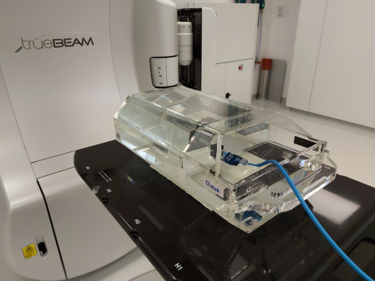
Figure 1. The Phantom.

RESULTS AND DISCUSSION
Most of the measured beams were in excellent agreement. The difference between calculated and measured dose between 2017 to 2020 has been less than 1% with 75% of the beams. The rest of the beams has been in good agreement to be within 3%. Only 22 plans exceeded our tolerance limit 3% but were still within 5%. Single cases with larger dose deviation over 5% up to 12% was found before 2017, during commissioning and dose error could be corrected before patient treatments.
CONCLUSIONS
Portable, water filled phantom with interchangeable inhomogeneities, and online measurements has been found very suitable instrument for verifying the correct dose to radiotherapy patients. If too large deviation is found, the root cause for the discrepancy can be solved at site. The measurements should be done first without any inhomogeneities and if agreement for the dose is within tolerances, inhomogeneities can be used.
REFERENCES
[1] SIPILA, P., Gafchromic EBT3 film dosimetry in electron beams — energy dependence and improved film read-out. Journal of Applied Clinical Medical Physics (2016) 17(1):360

[2] OJALA, J., et Al. The accuracy of Acuros XB algorithm for radiation beams traversing a metallic hip implant — comparison with measurements and Monte Carlo calculations. Journal of Applied Clinical Medical Physics (2014) 15(5):162

