Application of geopolymers in management of problematic radioactive waste

M. PRAZSKA
Jacobs Slovakia s.r.o.
Trnava, Slovak Republic
Email: milena.prazska@jacobs.com

M. BLAZSEKOVA
Jacobs Slovakia s.r.o.
Trnava, Slovak Republic

H. MRAZOVA
Jacobs Slovakia s.r.o.
Trnava, Slovak Republic

Abstract

In the context of decommissioning of many various NPPs worldwide and also a remediation of old legacy sites, it is necessary to process various problematic waste streams, which have been stored for many years, and for their properties were not processible by classical technologies. These include solid and liquid wastes, in varying quantities, sometimes located in a variety of difficult-to-access locations across large sites. The longer these RAWs are stored, the harder they can be processed - both from technical and economical point of view. The general trend in the world is therefore gradual replacement of conventional radioactive waste processing technologies by new, more efficient and more versatile ones. There is a portfolio of methods to safely treat these materials in readiness for long term storage or disposal. The choice of an appropriate method depends on various aspects and influencing factors such as the categorization of the waste to be treated in terms of radioactivity, its chemical and physical properties and homogeneity. The decision-making also includes security aspects, economic issues, availability and sustainability of raw materials. Moreover, the final product processed by this technology must comply with the Waste Acceptance Criteria for disposal or storage and the whole process must be approved by the competent supervisory authorities. Encapsulation of the waste using geopolymer matrices (e.g. Jacobs’ SIAL®) is an example of new generation waste solidification technology, that offers a safe and cost-effective alternative conditioning technique. The process is based on polycondensation reaction of aluminosilicate materials (solid phase) in a basic medium (liquid phase) at room temperature and pressure, producing a crosslinked, inorganic geopolymer which has good physical strength, hardening characteristics, leachability performance, radiation stability, biodegradability, flammability, explosivity and stability in frost. The SIAL® geopolymer solidification technology now has a track record of over 20 years which includes on-going research and development. The presentation summarises the most interesting performance records of this technology, the applied mobile devices as well as the characteristics of final products.

INTRODUCTION
Recent years, as more and more NPPs are coming to the decommissioning phase, the effective technologies of their systems' and components' characterisation, dismantling, fragmentation, decontamination, measurements and monitoring are becoming more important.
Treatment, conditioning and disposal of the radioactive waste from decommissioning and especially management of the heavily treated (problematic) waste as sludge, spent resins, crystalline sediments, organic solutions etc. that have been accumulated in the on-site storage tanks is also actual important scope.
In both cases conventional technologies are gradually being replaced by new, more efficient and more versatile ones.
There is a portfolio of new encapsulation methods to treat these materials using matrices such as various types of cement, various organic polymers and using geopolymers. In this article, attention is paid to the use of geopolymers in the treatment of radioactive waste.
Geopolymers are inorganic artificial polymeric materials - an alkaline aluminosilicate, in which, depending on the nature of the starting materials and the reaction conditions, the structures are either amorphous (gel) or crystalline. The term "geopolymerisation" was introduced by the French scientist Joseph Davidovits in 1978 [1], who used the term to name a newly discovered synthesis that produces inorganic polymeric materials. During more than 40 years since Professor Davidovits' first geopolymer introduction, a number of laboratory researches have been carried out in the world with different chemical systems and various radioactive wastes. The result of this development is that geopolymer matrices seem to be the most promising substitute for cements.
Developed and tested over the last 20 years, Jacobs’ SIAL® is an example of new generation waste solidification technology, that offers a safe and cost-effective alternative conditioning technique and that was developed to solidify various radioactive waste streams. The technology has been licensed for use by both the Slovakian (UJD SR) and Czech (SUJB) nuclear regulators since 2003 and 2006. In 2016, the CEZ company (Czech Republic) successfully extended its existing license also for the solidification of liquid and solid borates into the SIAL® matrix. Up to date, SIAL® has been used successfully to immobilize approximately 3000 tons of radioactive waste which includes sludge, resins, crystalline borates and contaminated organic waste from Jaslovske Bohunice and Mochovce (Slovakia) nuclear power plants (NPP) and approximately 300 m³ of spent ion exchange resins and sludge from tanks on site at the Dukovany NPP in Czech Republic. The International missions WANO (the World Association of Nuclear Operators) and OSART (the Operational Safety Review Team) evaluated the SIAL® matrix technology at Dukovany NPP as an example of good practice (2010).
This paper provides an insight into the practicality of deploying the SIAL® process based upon a technical review of the available information and experience gained in Central Europe.

SIAL® solidification technology procedure
Various goals were considered in developing and testing of the SIAL® matrix, solidification technology and equipment. Firstly, the aim was to convert the quasi-liquid and dangerous waste streams (sludge, spent sorbents, organic materials etc.) into a form safe for transportation, temporary storage or to dispose in a radioactive waste repository. The second aim was to perform the solidification local to the point of retrieval, quickly and with consideration of properties and parameters of the waste streams.

SIAL® technology principle and mechanism
Chemical principles of the SIAL® technology have been described in detail in many previous articles and presentations, e.g. [2-4]. This technology is based on polycondensation reaction of inorganic aluminosilicate components in a basic environment at normal temperature and pressure. During the immobilisation process, some radionuclides are physically or chemically bound to a certain part of the SIAL® matrix components, the others are mixed into the SIAL® volume and encapsulated in 3D structures during polycondensation process. The three-dimensional network of the SIAL® matrix allows comparable compressive strength to cement and moreover improves leachability to standard cement matrix not only for all radionuclides but also for macro components of waste. The resulting stable geopolymer also has good hardening characteristics, good radiation stability, biodegradability, flammability, explosivity, low volatility, posing a low fire risk and excellent physical stability in the presence of frost and water (no distortion or cracking).
The SIAL® technology is deployed at room temperature. The polycondensation process during curing is a slightly exothermic reaction with the maximal temperature reached in the middle of the drum being approximately 55 °C [2].

SIAL® technology application
As well as the principles of the technology, the procedure of its application, including the equipment used, was described in detail in previous articles [3].
There are two ‘Baseline’ approaches to the application of the SIAL® technology – out drum (pouring) application and in drum encapsulation of waste.
Generally, in both modes of application, the SIAL® solidification process is always adjusted and slightly modified for individual radioactive waste streams with different compositions. To determine the most appropriate composition, the SIAL® application technology is laboratory tested on imitating and/or real samples of each individual waste stream. Then an appropriate mixture of aluminosilicate composition and other inorganic compounds is as a given solidification application.
Also, in both mentioned methods all application devices are tailor-made, therefore they also meet the specific requirements of clients. Always with new applications, devices are improved, both in terms of safety and efficiency.

Pouring (out drum) application of SIAL® technology
LLW and ILW can be stabilized by entombment within a matrix so that the combination of waste form and container providing a suitably robust, multi-barrier waste package that satisfies the requirements for interim storage, transport, and disposal. The most common encapsulation matrix for radioactive materials is a cementitious grout selected due to the cementation process being relatively simple, low cost and low temperature and because cementitious systems have proven durability in high radiation environments, resistance to degradation and provide a beneficial chemistry (high pH) for the disposal environment.
Grouting/encapsulation by geopolymer (e.g. SIAL®) can be considered as an alternative technology for encapsulation of heterogeneous solid radioactive materials. The greater fluidity of geopolymers when compared to cementitious grout is a distinct advantage to the process as it is able to penetrate more easily and readily and does not require the development of superplasticiser which have been suggested over recent years.
Recent research on the advanced SIAL® matrix is showing its increasing potential even when applied underwater with a high salt content or under higher temperature water (~ 90°C). SIAL® can be also applied to solid surfaces at temperatures close to 300 °C. The formed solid layer immobilizes the present radionuclides, which in specific cases, allows the radioactive waste to be processed in a safer manner.
Application of SIAL® technology can be used in case of need to improve certain consequences raising from accidents on nuclear facilities.

In drum application of SIAL® technology
The solidification of waste in drum or in other approved packages is a classic way of radioactive waste processing [3].
Depending on the amount of waste and site characteristics (e.g. multiple reactors and/or sparsely spaced tanks), waste can be either processed using the mobile equipment (e.g. FIZA S 200) in situ, or a dedicated centralised facility can be installed to service the multiple locations.
The current equipment used to deploy SIAL® is modular, flexible and versatile. It can encapsulate waste quicker than cementation.

Characterization of SIAL® final product

Strength and stability
The strength of SIAL® final product in operation is measured by using non-destructive methods. Values of the typical compressive strength for solidified radioactive sludge and resin were ranged in the interval from 15 to 40 MPa.
The standard destructive measurement of compressive strength for solid concrete products proceed according STN EN 12390-3:2003 guidance „Testing the hardened concrete“, Part 3: The compressive strengths of the test specimens. Years of our experience for solidification of various waste streams into the SIAL® matrix shown a very good agreement between the results obtained by destructive compressive strength determination of cube-shaped with unified dimensions of 15 x 15 x 15 cm and operational non-destructive determination of compressive strength measured on the surfaces in 60ltr and 200ltr drums in operation using Concrete test Hammer - Digi Schmidt.
Majority of measured samples reach the same or higher value of compression strength in time. Table 1 shows one of drum's compressive strength measurement's stability in operation.

Table 1: Long-term strength stability of SIAL® with fixed sludge in 200 ltr drums

Drum No. | Time [days] | 28 | 370 | 490
14 | Compression strength [MPa] | 24,0 | 26,4 | 27,1
21 | Compression strength [MPa] | 24,0 | 27,1 | 27,8

Leaching resistance
One of the best features demonstrating strong radionuclides binding in the SIAL® matrix is the determination of leachability properties. Leaching test for main radionuclides content is an integral part of radioactive waste treatment process.
The leaching characteristics for individual radionuclides are shown in Table 2 [5].
These below stated leaching characteristics fully confirmed an effective way to capture of radionuclides content safely in the SIAL® matrix.

TABLE 2. The comparison of leachability and diffusivity coefficient for individual radionuclides in samples of solidified real mixture of sludge and resins to matrix SIAL®

Radionuclides | Diffusion coefficient  [cm²/s] | Leachability Index  Li (7) | Waste type
¹⁴C | 5.10⁻¹⁰ -10⁻⁹  1,5.10⁻¹⁰-1,5.10⁻ ⁹ | 9-9,3  8,8-9,8) | sludge  resins
⁵⁹Ni  ⁶³Ni | (1,5-3).10⁻¹¹  (2-3).10⁻¹¹  10⁻¹²-3.10⁻¹¹  3. 10⁻¹³-10⁻¹² | 10,5-10,8  10,5-10,7  10,5-12,1  12,1-12,5  9,9-12,8 | resins (Ni)  sludge (Ni)  sludge (Co)  resins (Co)  resins 50-90 %
⁹⁰Sr | 10⁻¹⁵- 1,5.10⁻¹³  10⁻¹²  3. 10⁻¹³ | 12,8-15  12  12,5 | sludge A1  resins  sludge
⁹⁴Nb |  | sludge + resins undetectable for low activity
¹³⁷Cs | 2. 10⁻¹¹ -3. 10⁻⁹  (3-4). 10⁻¹⁰ | 8,5-10,7  9,4-9,6  8,94-9, 8 | sludge A1  sludge + resins  resins 50-90 %
²³⁹Pu | 3. 10⁻¹⁹-6. 10⁻¹³ | 12,2- 18,5 | sludge A1
²⁴¹Am | 6. 10⁻¹⁷- 4. 10⁻¹³ | 12,4-16,2 | sludge A1  other-low activity

Heat resistance
During the years 2016-2017 the study for the pouring application of blank (no waste loading) SIAL® matrix in conditions of increased temperature has been completed. The possibility of using the SIAL® matrix at elevated temperature was tested for its application under hot water (below the water boiling point ~ 90 °C) as well as on direct pouring application on hot metallic surfaces (300°C). The course of blank SIAL® pouring application under hot water by using peristaltic pump is shown on Fig. 1 and 2.

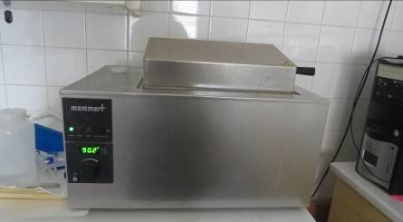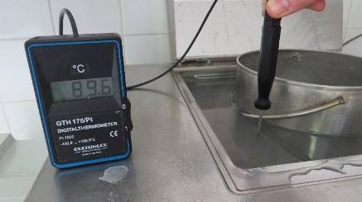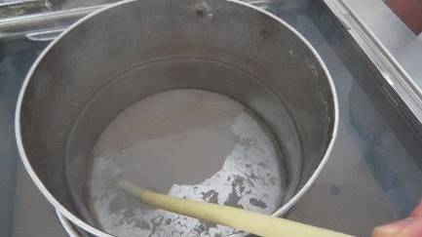
FIG. 1. Pouring application of SIAL® under hot water by using water bath set at 90 °C.

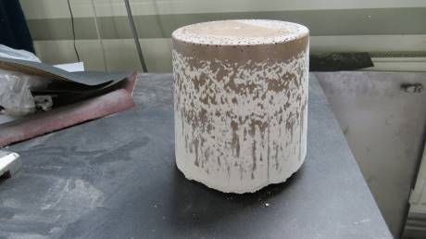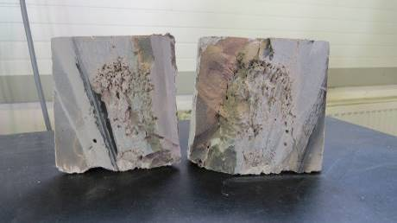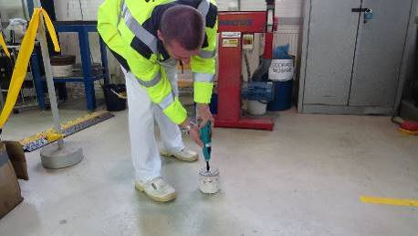
FIG. 2. View of SIAL® final product and its compressive strength test (under hot water application)

Radiation resistance
The influence of ionising irradiation has been investigated (using a total dose of 10⁶ Gy which approximates the time of irradiation in a typical repository of 300 years). Products (sludge and resin in SIAL® matrix) were irradiated by a ⁶⁰Co source (dose rate approx. 2.5 kGy/hour) for a total dose of 1.027 MGy. No reduction of compression strength was found [2].

Hydrogen generation
The radiolytic hydrogen generation from SIAL® matrix studies were carried out to examine the rate of radiolytic produced hydrogen. The results were obtained in co-operation between Jacobs Slovakia laboratories and Jacobs’ laboratories in Harwell (UK).
Crushed blank SIAL® samples and crushed SIAL® samples with solidified waste streams (sludge and slurry) were irradiated in Jacobs’ ⁶⁰Co irradiation facility at separate dose rates of 1 and 3 kGy hr⁻¹ at room temperature to total doses of 40 and 1000 kGy. The G_{H2} values measured for the SIAL®/waste simulant samples after irradiation to 40 kGy ranged from 0.01 - 0.14 molecules per 100 eV [5,6].
The G_{H2} data for SIAL® are consistent with data from grouts that have the lowest radiolytic hydrogen release rates. Therefore, in terms of hydrogen release, it is suggested that SIAL® should be ranked alongside the more stable types of cementitious grout encapsulants.

Chemical stability
A possible impact of selected chemical agents on SIAL® solidification technology has been reviewed. The effects of high concentrations of sodium, sulphate, liquid and solid borate forms have been investigated and was confirmed that these wastes can be effectively and safely encapsulated into the SIAL® matrix.
The SIAL® matrix itself can effectively retain not only radionuclides presented in treated radioactive waste, but also the majority of macro components forming a chemical character of the waste as were above mentioned borates, cyanides or sulphates at quite high concentrations. At the same time has been confirmed very low level of these waste macro components presented in leachate solution (e.g., leachability level concentration of 100 ppm for sulphate or 0.120 ppm for cyanide) confirming very high efficiency of SIAL® solidification technology.

Homogeneity of final product
Term homogeneity, in the case of dry samples, is defined as uniform distribution of fine, visible particles (have a size in the order of mm) throughout the volume of SIAL® matrix with no apparent signs of sedimentation of these particles in the solid matrix.
Cross section of the SIAL® matrix is usually performed after 28 days of matrices maturing by means of semiautomatic band saw BOMAR DG 230. Examples of cross section observation for SIAL® samples is shown on Fig.3 and Fig.4.

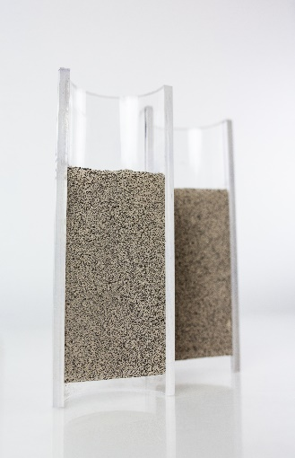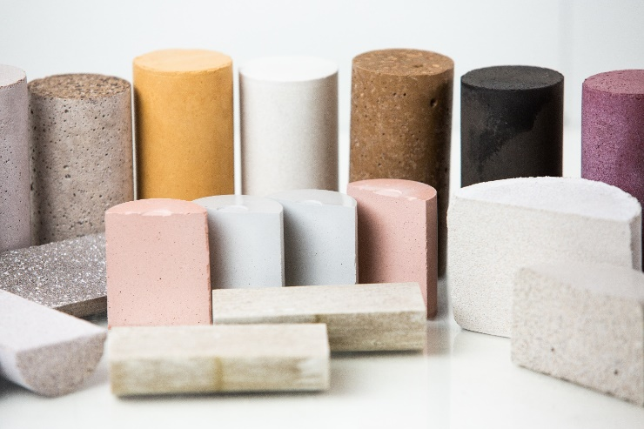
FIG. 3. Cross section observation for series of SIAL® samples solidified with different waste streams (Resin, Sorbents type)

Homogeneity of final product is important also in case of pouring (out drum) application. Fig. 4 illustrates examples of solid waste distribution in solid matrices. Cross section of final product confirms uniform distribution of solid waste in the SIAL® final solid product.

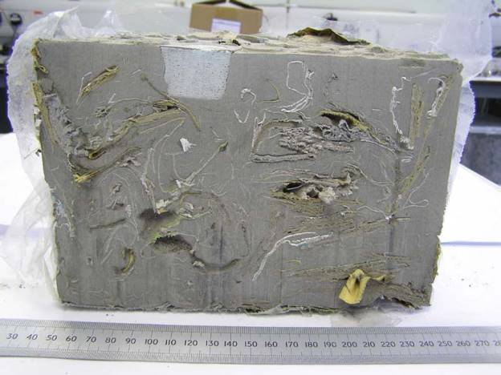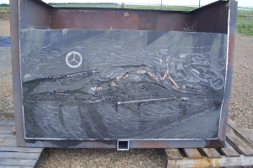
FIG. 4. Cross section observation of final solid product after pouring application

Economic acpects of SIAL® technology
There are numerous benefits to using the SIAL® geopolymer for waste solidification or encapsulation not only in terms of quality and safety, but also in economic terms.
In case of in drum solidification the technology can be used at room temperature and can incorporate significantly more waste (sludge, resin) as a cement matrix equivalent depending on the waste being treated. One of the economic advantages is therefore zero energy consumption (neither cooling nor heating is necessary) except of the electricity consumption required for the facility operation (waste and matrix mixing, operation control) which is comparable with cementation facility.
The technology represents a comprehensive solution for processing of various liquid radioactive waste. On the basis of adjusted composition of the SIAL® matrix it is possible to fix the radioactive sludge, spent resins and also residues from the contaminated oil and decontamination solutions. Therefore SIAL® solidification facility can be used largely universal – for processing of various waste streams and in the case of mobile variant also at different locations of these streams' production.
SIAL® solidification facility can be also designed and manufactured both for immobilisation of liquid waste and for encapsulation/embedding of solid radioactive waste.
An important economic advantage of SIAL® solidification technology is „higher volume reduction rate“, in comparison to cementation technology. Based on more than 20 years of experience, we can say with hundred-percent certainty that the loading capacity of the SIAL® matrix (volume reduction rate) is significantly higher than in the case of the cement matrix (the values are different for different waste streams).
One of the great advantages of SIAL® technology is the ability to solidify some types of waste together. This method has been used in practice for many years. Several options may be selected, and the most appropriate one is selected based on the current situation and the client's requirements.
E.g. when removing spent ion exchangers from storage tanks, contaminated water containing radioactive sludge is used as a transport medium. It is often several cubic meters of water placed on the surface of the spent ion exchanger, which serves as shielding medium during storage. This liquid is also radioactive waste and is typically processed by evaporation to the desired salinity concentrate which is then solidified into a cement or bitumen matrix. SIAL® technology, thanks to its technological design and chemical solidification principle, is able to use this liquid to transport the waste to the pre-treatment module and also as the technological water needed for solidification process. An excess liquid is in the pre-treatment module removed and returned back to the waste storage tanks and the other (calculated) part of this radioactive liquid is used as reaction water which is needed to polycondensation reaction. In this manner, the whole volume of shielding water containing sludges is usually consumed. It saves the cost of the treatment of liquid to the concentrate and the cost of following processing this concentrate. The technology has been successfully used, for example, in the treatment of spent sorbents at Dukovany NPP [3] and in the project of treatment of historical waste – sludge and sorbents at the NPP V1, Jaslovske Bohunice, Slovakia [3].
In this project of NPP V1 historical waste treatment also another efficient combination of different waste streams was used. To spent ion exchangers dosed in drums, a calculated amount of sludge with a small amount of liquid borates was added, thereby the waste dry matter content in the matrix increased and the resulting number of solidified drums was reduced. The advantage of the SIAL® matrix was used that it can solidify also a certain amount of borates which are not processable into the cement matrix (so called “cement poison”).
The solidification of combined waste streams - spent sorbents and sludge – is frequently used also in other projects. The spent ion exchangers originating from decontamination of NPP V1 primary circuit were treated together with sludge removed from the bottom of storage tanks within the parallelly realized project of decontamination these tanks. On average, 40 % of spent ion exchangers and 10 % of sludge were combined and solidified in each 200ltr drum.
Costs´ comparison of different technologies and their application must therefore be complex and must be based on a multi-criteria analysis that also takes into account the quality of the resulting product.
Consideration also must be given to the fact that the limits and conditions will be stricter in the future and therefore the quality of the final product should not only meet today's values but should be the best and beyond them.
The result of rough estimation and comparison of waste processing costs for various waste treatment technologies is that SIAL® technology significantly reduces both the production cost of the final product and the disposal cost in the surface repository.

Brief comparison of the most used waste solidification technologies
In order to process of various standard and non-standard waste streams usually the following solidification processes could be applied: cementation, bituminization or solidification into geopolymer (SIAL®) alumina-silicate matrix.
Cementation through the use of specially formulated grouts provides the means to immobilise radioactive material that is on solids and in various forms of sludge. The main disadvantage of the cementation is its low load capacity and relatively high leachability index of final product.
Radioactive elements added to grout typically do not partition into the typical grout phases. For example, ¹³⁷Cs is thought to reside in the space between solid phases, only ⁹⁰Sr can substitute for calcium in the various calcium-rich minerals. Accordingly, the radioactive nuclides are more vulnerable to release into aqueous solutions that may enter into the solidified waste form outside of the disposal system, causing them to be more easily leached. Inclusion of clay in cement reduces the leaching rates of the radionuclides significantly, however, clay additions in excess of 15 wt. % causes a significant decrease in the hydrolytic stability and compressive strength of cement product [7].
Cement is also not always compatible with all wastes - there is a growing group of incompatible wastes types, for example ion exchange resins, high salt content waste (including sulphates, nitrates, phosphates or various borate forms), and various liquid mixtures with complicated chemical composition (decontamination liquids, mixtures from lab operations etc.). These incompatible wastes, the so-called “problematic” or “non-standard” wastes, can cause various undesirable phenomena e.g. formation of components resulting volume changes of the final product, and/or unsatisfactory leaching, strength, or stability results.
Moreover, waste chemistry and physical properties can limit waste loading, for example when high levels of soluble zinc are present or where waste form viscosity becomes too high (see below). The significantly reduced leaching rate of certain radionuclides has proved a major driver for the use of geopolymer. This has allowed waste loadings to be higher in geopolymer than in cement, while still meeting the required waste acceptance criteria [7].
Bituminisation (encapsulation in a bitumen matrix) of radioactive waste is a technology that has been applied and that is still being applied in many countries
Bitumen has the advantage over cements of higher waste loading, but it also has some disadvantages, the most important being its potential fire hazard. The possibility of combustion in the case of an accidental fire has led to certain restrictions on the use of bitumen as an immobilising matrix and it is not used in the UK or USA. Two significant fire incidents occurred in Belgium in 1981 and in Japan in 1997 in bitumen containing nitrates from evaporator concentrates. Bituminisation facilities must therefore include fire suppression and extinguishing systems.
At temperatures of about 150 °C anionic ion exchange resins start to decompose, resulting in the release of amines. At the conditioning temperature and in contact with bitumen, these compounds may give rise to spontaneous exothermic reactions to occur, finally resulting in fire accidents.

Conclusions
The advanced (SIAL®) geopolymer solidification technology offers an alternative route for problematic waste streams treatment. Their superior mechanical properties allow for good waste loadings, allowing the number of packages to be reduced, while maintaining the integrity of the waste forms. Their resistance to liquids makes them highly durable, and they exhibit excellent radionuclide retention and leach resistance.
For solidification of the real waste streams, it is important to consider also corresponding radioactivity values of waste streams related to required encapsulation. It is important due to dose rates from solidified product to allow safe handling of the product and meet waste acceptance criteria for subsequent disposal valid in the country concerned.
Operational application of proven SIAL® solidification technology has been cited by the IAEA:
“Recent favourable construction experience with geopolymer materials suggests that their more widespread application to waste conditioning is possible. SIAL® geopolymers have demonstrated enhanced compressive strength and low leachability of ¹³⁷Cs and are licensed for use in the Czech Republic and Slovakia for radioactive sludge and resin solidification. Research in Australia, the Russian Federation, Slovakia and the United Kingdom is likely to generate more knowledge, including information about their long-term durability.”; IAEA Nuclear Technology Review, 2014.

References
- DAVIDOVITS, J., “Geopolymers - inorganic polymeric new materials,” Journal of Thermal Analysis, vol. 37 (1991) 1633-1656.
- J. Hill et al; “Geopolymer solidification technology approved by Czech / Slovak Nuclear Authority to Immobilise NPP resins and Sludge waste” (15555), WM2015 Conference, March 15 – 19, 2015, Phoenix, Arizona, USA.
- PRAZSKA, M., BLAZSEKOVA, M., TATRANSKY, P., HLAVACKA, R. “Application of SIAL® Solidification Technology for Processing of Problematic Waste Streams” (18267), WM 2018 Conference, March 2018, Phoenix, Arizona, USA.
- PRAZSKA, M., BLAZSEKOVA, M., GREEN, A., TUXWORTH, A., HOWELLS, R., INVERNIZZI, D. “Comparison between Cement and Geopolymers: Progress of Waste Encapsulation using Geopolymers in the UK” (21207), WM2021 Conference, March 7 - 12, 2021, Phoenix, Arizona, USA.
- BURCLOVA, J. et all: Podklady pro doplnění podmínek přijatelnosti ÚRAO Dukovany - zahrnutí matrice SIAL, internal report, Z-OB/SOD/097-01-31/12/04, ALLDECO.CZ, Hodonin, 2004.
- BLAZSEKOVA, M., The solidification research of Sludge and Slurry in the SIAL® geopolymer, internal report, FUJI-SPR/02-71503, JACOBS Slovakia, Trnava, 2016.
- BLAZSEKOVA, M., The solidification research of Absorbents in the SIAL® geopolymer, internal report, FUJI-SPR/04-71601, JACOBS Slovakia, Trnava, 2017.
- PRAZSKA, M., BLAZSEKOVA, M., Investigation work concerning properties and specifications of solidified body / solidified processes of SIAL®, internal report, FUJI-SPR/07-71901, JACOBS Slovakia, Trnava, 2019.

