Radioactive waste management issues and challenges in i.r. of iran

A. MALEKI
Iran Radioactive Waste Management Co. (IRWA),
Atomic Energy Organization of Iran (AEOI),
Tehran, Iran, Islamic Rep. of
Email: amaleki@aeoi.org.ir

S. MOMENZADEH
Iran Radioactive Waste Management Co. (IRWA),
Atomic Energy Organization of Iran (AEOI),
Tehran, Iran, Islamic Rep. of

M. ASADIAN
Iran Radioactive Waste Management Co. (IRWA),
Atomic Energy Organization of Iran (AEOI),
Tehran, Iran, Islamic Rep. of

Abstract
IRWA is designated by the AEOI as the Central Waste Management Organization in Iran to be responsible for performing all aspects of radioactive waste management activities in the country, and for transportation, processing and storage of institutional radioactive waste received from the minor waste generators. IRWA will also be responsible for the disposal of all radioactive wastes in Iran including operational and decommissioning wastes. This vast scope of responsibilities causes challenges and need practical efforts in order to satisfy regulations and stakeholders simultaneously.
Effective and safe management of such wastes requires a comprehensive program, coordinated under a defined national waste management strategy, based on the present and future requirements. From 2001, IAEA has provided technical assistance and support for the development of National WM Strategy & Policy (NWMSP) and Radioactive Waste Disposal Program, covering the whole spectrum of radioactive waste generated and anticipated radioactive waste.
Operation of the first NPP in Iran, limitation on accessing to novel technology and expertise, undefined responsibilities and shortages in design and sometimes trainings, caused problems that need special solutions in a short time. On the other side, the sudden increase in the application of Sealed Sources and Radioisotopes and operation of nuclear fuel cycle facilities in the country generated large amount of DSRSs and a variety of waste streams. In the last decade, IRWA started siting and construction of a near surface disposal facility in order to increase its capabilities for dealing with such a sudden increase in waste streams and volumes. The NPP’s wastes issues were quite varied: unsuitable formulation for stabilizing the wastes which lead to improper final waste packages, improper design of stabilization process devices which lead to cost increase and non-conformances, lack of final solution for high activity wastes (group III), non-compliance in number and radioactivity of generated final waste in comparison to FSAR document and … .
Licensing process and dealing with INRA for the disposal facility was also a challenge because of the lack of experience on the waste disposal and the specific and unique issues in disposal of radioactive waste.
By increase in the generation of DSRS, IRWA devised a methodology for their storage in order to store large no. of DSRSs in a small and controlled area and to retrieve them for reuse. Reuse is one of the main solutions in the management of DSRSs.

INTRODUCTION
IRWA is designated by the AEOI as the Central Waste Management Organization in Iran to be responsible for performing all aspects of radioactive waste management activities in the country, and for transportation, processing and storage of institutional radioactive waste received from the minor waste generators [1]. IRWA will also be responsible for the disposal of all radioactive wastes in Iran including operational and decommissioning wastes.
In Iran, radioactive waste is generated from a large number of different activities including the application of radionuclides in medicine, research and industry, and the use of nuclear reactors for research, training, radionuclide production and power generation in Bushehr Nuclear Power Plant. In addition, waste containing naturally occurring radionuclides is generated in mining and milling of uranium ores. Waste with technologically enhanced concentrations of naturally occurring radioactive materials (NORM or TENORM) is also generated in oil industry and in some other industrial or mining activities.

Nation Policy and strategy
The National Radioactive Waste Management Strategy (NRWMS) is a key tool and comprehensive framework in ensuring the long-term implementation of practices needed to manage radioactive waste within the national and international legal principles [2]. NRWMS concerns all categories of radioactive waste arising from different streams regardless of its origin except spent nuclear fuel coming from research or power reactors.
The set of declared national goals and requirements for the safe management of radioactive waste has to be translated into a more practical and operational form or strategy to provide for their implementation.
Considering the importance of stages such as treatment, conditioning, storage and volume reduction of radioactive waste, it is necessary to develop a national strategy for radioactive waste management. Strong relation between radioactive waste management and waste generators has a prime significance in order to improve the waste management conditions.
In 2005, IRWA developed the first revision of NRWMS through a Technical Cooperation (TC) project with International Atomic Energy Agency (IAEA). Since then, NRWMS was revised a few times based on the Iran Nuclear Regulatory Authority standards (INRA) and organizational and technological changes.

NRWMS was developed based on:
- National Act of AEOI (1974),
- National Act of Radiation Protection (1989) and related regulations
- The basic waste management principles formulated by IAEA
- IAEA Safety Principles, RADWASS Program, …
- Joint Convention on the Safety of Spent Fuel and Radioactive Waste Management (1997)

National Policy is briefly addressed in the same document and consists of the following principles:
- Protection of human health
- Protection of environment
- Protection beyond national borders
- Protection of future generations
- Burdens of future generation
- National legal framework
- Control of rad-waste generation
- Rad-waste generation and management interdependencies
- Safety of facilities.
- Security and Physical Protection of the facilities
- Research and Development (R&D)
- Decision and Policy making
- Financial and Human Resources

Responsibilities of the parties involved in radioactive waste management activities are presented in Table 1.

TABLE 1. RESPONSIBILITIES OF THE PARTIES INVOLVED IN RADIOACTIVE WASTE MANAGEMENT IN IRAN
Activity | INRA | Nuclear Facilities & NPPs | Industry & Medical Radiation centres | IRWA
 |  |  |  | Mandatory | Upon request
Collection | C | R | R | TA* | A
Characterization | C | R | R | TA | O+A
Waste transportation | C | R | R | TA | O+A
unprocessed waste storage | C | R | R | TA | O+A
Decay storage  (Short half-life) | C | R | R | TA | O+A
Disposal of exempt waste | C | R | R | TA | O+A
Treatment | C | R | R | TA | O+A
Conditioning | C | R | R | TA | O+A
Delivery & loading | C | R | R | TA | O+A
Transportation | C | R | - | - | O
Interim storage & Long term storage** | C | - | - | R | -
Disposal | C | - | - | R | -
Long-term monitoring of repository | C | - | - | R | -
C – Control & Licensing R – responsible, A - advisory services, O – Operation, TA - Technical Audit
* Technical audit is a service process through which weak points of main waste generators will be detected and suggestions to optimize waste management operation will be presented.
** According to IRNA regulations and based on the existing contracts, all responsibilities related to delivered waste, have to be taken over by IRWA.

main issues in radioative waste management in iran
Operation of the first NPP in Iran, limitation on accessing to the novel technology and expertise, undefined responsibilities and shortages in design and sometimes trainings, caused problems that need special solutions in a short time. On the other side, the sudden increase in the application of Sealed Sources and Radioisotopes and operation of nuclear fuel cycle facilities in the country generated large amount of DSRSs and a variety of waste streams. In the last decade, IRWA started siting and construction of a near surface disposal facility in order to increase its capabilities for dealing with such a sudden increase in waste streams and volumes. The NPP’s wastes issues were quite varied: unsuitable formulation for stabilizing the wastes which lead to improper final waste packages, improper design of stabilization process devices which lead to cost increase and non-conformances, lack of final solution for high activity wastes (group III), non-compliance in number and radioactivity of generated final waste in comparison to FSAR document and … .
Licensing process and dealing with INRA for the disposal facility was also a challenge because of the lack of experience on the waste disposal and the specific and unique issues in disposal of radioactive waste.
By increase in the generation of DSRS, IRWA devised a methodology for their storage in order to store large no. of DSRSs in a small and controlled area and to retrieve them for reuse. Reuse is one of the main solutions in the management of DSRSs.

Development of a Near Surface Disposal Site and Effective communication with Regulatory Authority (INRA)
Islamic Republic of Iran plans to build 7000 MW of installed nuclear power capacity which the first attempt of this program is the operation of Bushehr NPP. The planned NPPs and operation of other peaceful activities such as centralized waste management facility for processing of Low and Intermediate level (LIL) waste will generate a large volume of LILW which shall be finally disposed in a suitable repository.
In 2001, IRWA decided to launch a site selection project for a near surface disposal site. In order to obtain international experience and to train countries engineers, IRWA requested for assistance from IAEA through a TC project. This project started on 2003. An Integrated, stepwise approach for the development of Iran Near Surface Repository (INSuRe) was adopted. Based on IAEA recommendations a four stage site selection process was adopted as below:
- Conceptual and Planning Stage
- Area Survey Stage
- Site Characterization Stage
- Site Confirmation Stage
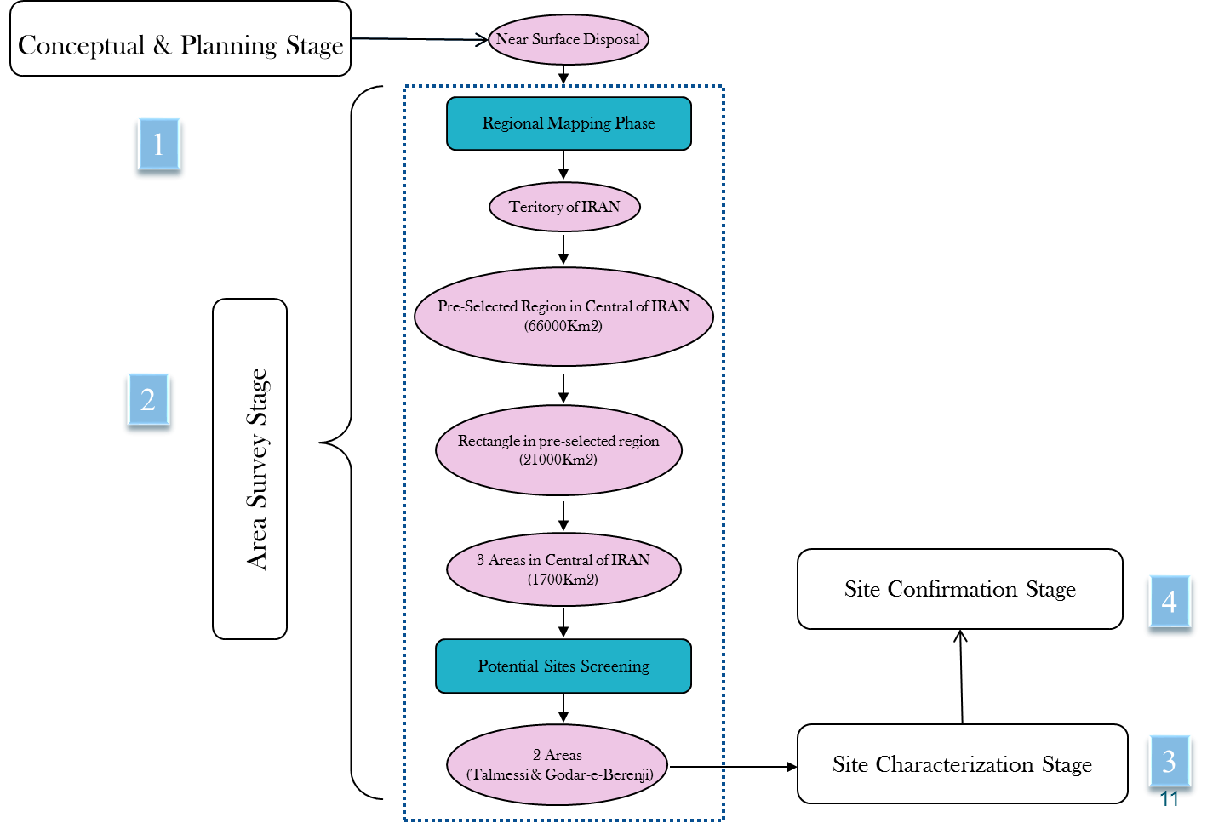
.

FIG. 1. The main activities performed in the siting stages.

Based on detailed criteria in each stage and application of GIS integration and analysis methodology and scio-economic factors a site has been chosen. It is located in the District of Anarak 25 km west of Na'ein- Anarak road. In 2010, site license was issued by INRA.
The site with 1 km² area is located in a red colure syncline structure which consists of clayey formation with an elevation of approximately 2000m above mean sea level. This structure with an elevation of approximately 1480m above mean sea level and its bowl shape can act as the best protector for disposal site. Very low precipitation and high evaporation rate are the dominant desert climate in this site, so there is no runoff in the whole site except some streams result from short seasonal rainstorms.
This site plays an important role on the ability of IRWA for the safe and effective management of different types of the wastes. All steps of a waste management process (long term storage, treatment, volume reduction, conditioning and final disposal) will be available in this site.

Effective communication with Regulatory Authority (INRA)
Due to low storage capacity in BNPP, early construction of a temporary storage was needed in this site. IRWA negotiated with INRA to apply for a series of constructions and operation permits for minor buildings in order to facilitate faster construction of storage building(s). It was agreed to continue the construction work based on the issuing permits until final application for the operating licence of the whole disposal site.
Fig. 2 shows the schedule and activities for the life-cycle of INSuRe.

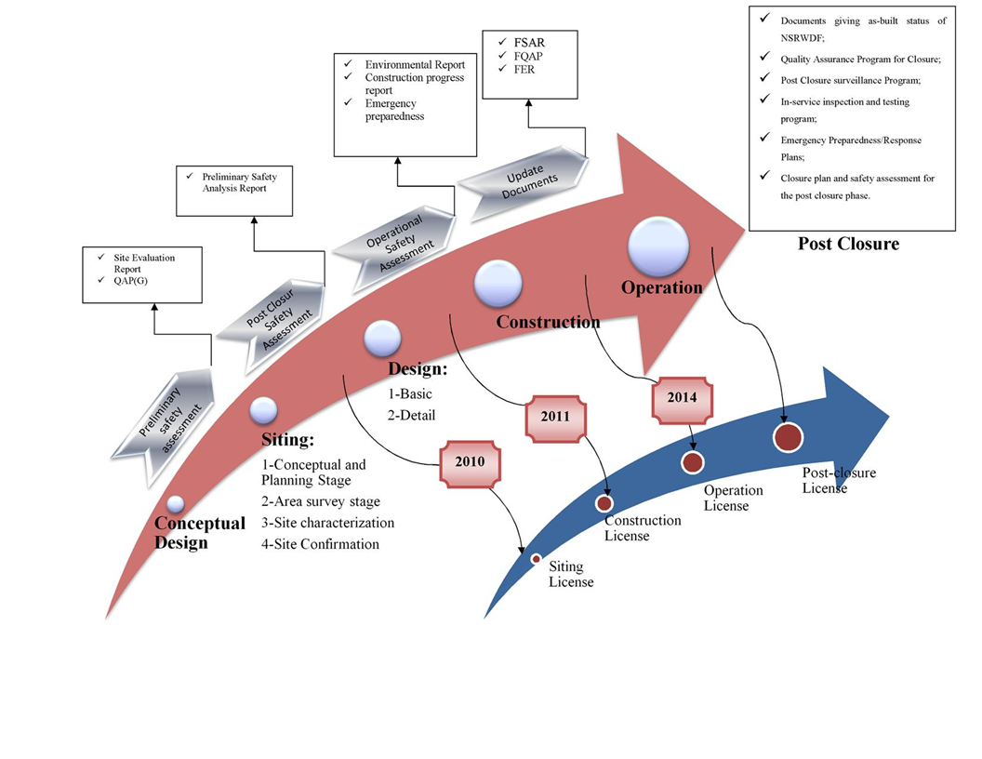
2010
2012
2014
Only For Buildings
For Disposal
2001
2025
FIG. 2. The schedule and activities for the life-cycle of INSuRe.

Development of Waste Acceptance Criteria (WAC)
Based on the trench design features and outputs of safety assessment, a WAC was developed. Agreement on the WAC among BNPP operator, INRA and the repository operator is a real challenge. There will be cost loads and some design alteration for the BNPP operator when it accepts the disposal WAC. Therefore, there will be resistance for its acceptance. IRWA is trying to solve this by technical communication and mutual understanding through many meetings with BNPP operator and the regulatory body as well.

Cooperation with the operator of the first NPP on operational radioactive waste issues

Managing highly-active waste from BNPP
Three main categories of waste which are generated in BNPP are unconditioned solid waste, solidified waste and finally high-active spent instruments (neutron activated). All of these wastes should be transferred to IRWA for long-term storage and disposal. Solid and high-active spent instruments have fewer problems because of their predefined management plan for long-term storage and solid waste management strategy adopted by IRWA for using incineration and/or super-compaction which has not been decided yet.
The neutron channels due to the neutron activation process, will become radioactive material approximately with the total activity of 100 Curies each, are taken out of reactor core of the BNPP and replaced every four years. These channels, 12 meters long and 1 mm thick, are collected in a coil shape at the end of their service life and are directed into a steel capsule inside 13-ton container. Each capsule holds about 15000 Ci of activity after placing 9 coils inside. Table 2 shows the main radionuclides and their typical activity for one capsule on the time of removal from reactor core. Most of the activity belongs to the short-lived radionuclides, therefore activity reduces to about 1000 Ci after 4 years of storage in BNPP.
IRWA has devised new boreholes for long term storage of steel capsules in INSuRe facility and loaded 12 ones inside them (Fig. 3).

TABLE 2. THE MAIN RADIONUCLIDES AND THEIR TYPICAL ACTIVITY FOR ONE COIL
Parameter | Radionuclides
 | Cr-51 | Mn-54 | Co-58 | Fe-59 | Co-60
Nuclides % | 79.4 | 3.7 | 9.2 | 1.7 | 6.0
Activity Bq | 4.49E14 | 2.09E13 | 5.22E13 | 0.97E13 | 3.44E13
Total Activity | 566 TBq

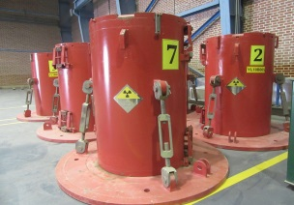
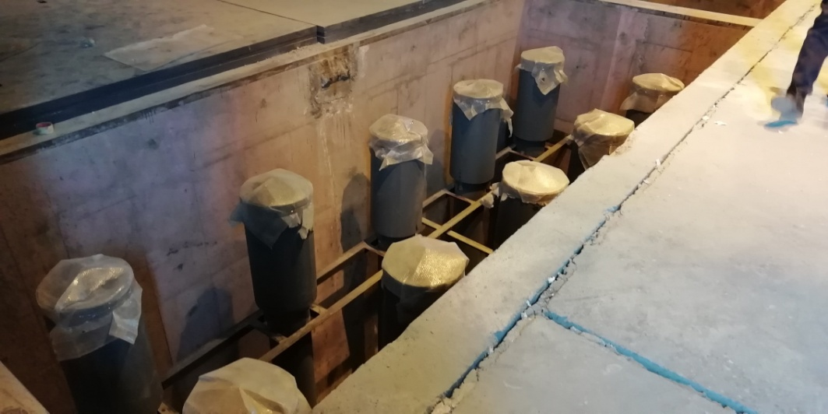
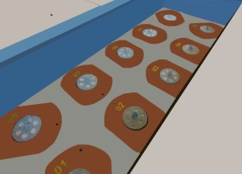

FIG. 3. New boreholes for long term storage of steel capsules (high-active solid waste)

Non-conformances in the solidified waste
Solidified wastes packages which are the result of liquid waste evaporation and cementation of its sludges in BNPP, were not conformed to the WAC for near surface disposal. Cementation procedure recommended by BNPP contractor, has been applied from the start of the operation and about 2000 packages were produced. Many of them could not pass the disposal WAC due to the unsuitable cementation formula, high amount of Boron and high salinity (800 gr/lit). The formula has been tested in IRWA laboratory and its result was announced to BNPP.
Some technical problems such as in-drum mixing with the lost-paddle approach, deep evaporator that make high saline concentration and so on, reported to contractor to be considered in their new design for new NPP phases.

IRWA is going to prepare a justification report for non-conformances of the waste packages. Two main options (Over pack and engineered vault) are foreseen for these packages. Final decision could be made when feasibility and financial evaluation of both options were done.

Management of NORM waste
IRWA has undertaken the responsibility of NORM waste management in all Iranian industries. In recent years and along with the growth of nuclear and non-nuclear industries, environmental consequences and long-term intensive impacts of producing wastes is a matter which has to be seriously taken into consideration and needs to be dealt with in a safe and proper manner.
The development of industries such as the oil and gas industry, mining, and chemical fertilizer industry has led to a remarkable increase of NORM waste and residues discharge to the environment.
During the different phases of production and operation, and depending on the selected processes, NORM waste and residues are produced and concentrated in different environmental bodies which could endanger the environment and human health. Oil and gas and minerals/ores processing industries are the main contributors to the generation of NORM waste and residues in Iran. In a large number of mines, mining and mineral processing activities in order to extract minerals from ore bodies are one of the main origins and resources of producing, concentrating, and releasing NORM to the environment.
To protect human health and the environment, environmental management activities have to be planned and appropriately carried out in mentioned industries.
Industries in Iran generating NORM wastes and residues are including Oil and gas production; Mining and mineral processing; Phosphate industry, including phosphoric acid and phosphate fertilizers production; Ceramics and building materials; Metal Recycling; Water and wastewater treatment facilities;
Much emphasis is being given to the management of NORM wastes and residues due to the existence of a large number of industries involved in the processing of Naturally Occurring Radioactive Materials (NORM).

TABLE 4. NORM GENERATING INDUSTRIES IN IRAN
Industry | Number | Industry | Number
Oil and Gas | 150 | Nonferrous metallic mining | 150
Water treatment plants | 138 | Chemical non-metallic minerals | 5
Wastewater treatment plants | 196 | Coal mining | 91
Iron and steel production | 7 | Iron ore mine | 131
Uranium mining and milling | 3

One of The Main Issue Related to NORM management in Iran is the lack of legal documents to force NORM waste producers to properly management of their waste.
A project entitled “Determination of action levels, investigation on activity concentration and safe management of NORM waste in oil and gas and mining industries” has been defined by the national regulator (INRA).
IRWA as the contractor of this project is performing a review and assessment of NORM management in Iranian industries including determination of the national inventory of NORM wastes.
For investigating of NORM residues among all categories of potential NORM producing industries, some case studies are defined and carried out.

Iodine production facility
Managing of NORM residues and wastes causing by extraction of iodine from deep underground brine water was assigned to IRWA. Firstly all process units and operation units investigated carefully, beside that environmental data were gathered. Based on the provided information, field monitoring by using portable devise was conducted. Gamma dose maps prepared and by providing these kind of layers,
Water Samples, soil and sediment, scale and waste samples and air particulate samples were gathered and analyzed to investigate activity level of NORMs. All the results from active and passive measurement of NORM, evaluated by using amber code considering different scenarios for NORM management options. Fig. 4 shows is a quick brief of project description in 4 phases.
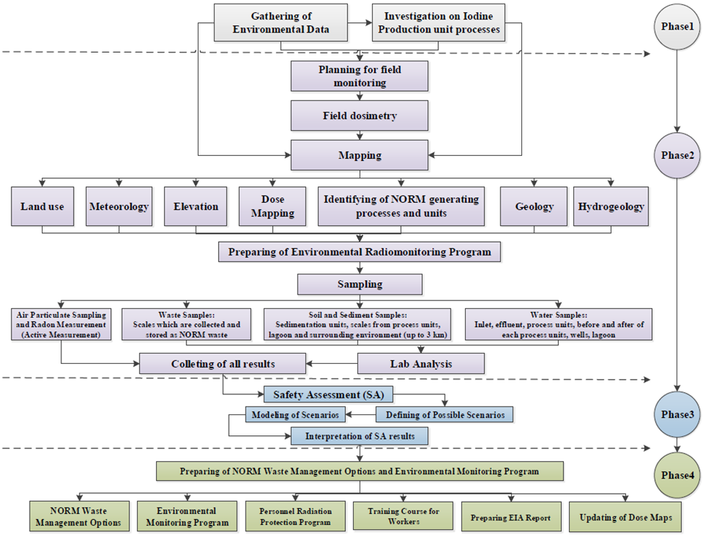

FIG. 4. Schematic diagram for managing NORM waste from Iodine producing industries in Iran

Uranium mining and milling facility
A two year monitoring of the uranium milling site has been carried out, including: terrestrial gamma radiation dose measurement, uranium, thorium and potassium mapping. 80 samples including foodstuff, surface and ground water, soil and sediment, radon and external radiation were gathered and analyzed to investigate activity level of various radionuclides.
In conclusion, Based on the results derived from environmental monitoring, waste characterization survey and provided basic information, remediation planning and decontamination techniques were considered for proper management of the uranium waste and tailing pond in compliance with the best national and international practices.

Development of a novel system for storage of DSRSs
Radioactive sources are used in a wide range of practices in industry, medicine, agriculture, research and education. The sources, used in these applications, contain a variety of radionuclides, forms and quantities of radioactive material and exhibit a wide range of physical, chemical and radiological properties.
A radioactive source that is no longer in use or not intended to be used, for the practice for which an authorization has been granted, is termed as disused. There are several reasons a user may no longer need or want their sealed source; the source may have decayed below a useful activity, the user’s priorities may have changed or business dissolved, the user may have replaced the source with a new source or an alternative technology, or the source/device may have been damaged. If a source is no longer suitable for its intended purpose as a result of radioactive decay, it is considered as spent. A source that has no foreseeable use or method of recycling is considered waste. Sources classified as waste can be recycled if a new use or recycling method is identified before the waste is permanently disposed of.
It is important to emphasize that a source declared by one user as disused or spent may still be used by a different user, supplier or manufacturer. A disused or spent SRS may still be highly radioactive and potentially hazardous to human health and the environment and are commonly placed into long term storage.
Having mentioned above; IRWA has played a clearing house role in radioactive source management in Iran. A Clearing house is a centralized collection, inspection and characterization facility with the role of identifying source disposition paths which would include disposal, storage for decay, and identifying sources that are good candidates for reuse or recycling. This role became more prominent when international sanctions were added.
Return to supplier, transfer to another user, Storage for decay and conditioning followed by storage and disposal are IRWA DSRS management strategy.
Previously, IRWA has only a room with some small holes and more than one disused sources placed in one big shield (Fig. 5). There were some old DSRSs that stabilized with cement in barrels as well.
Considering industry’s need and difficulties of finding suitable sources among others, IRWA decided to make a new system for reuse them with less difficulties and characterized all sources (Fig. 6).

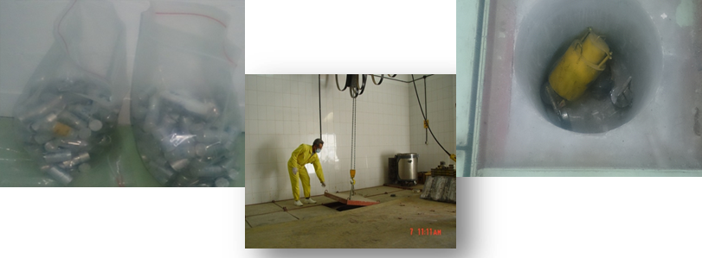

FIG. 5. Old method of DSRS storing

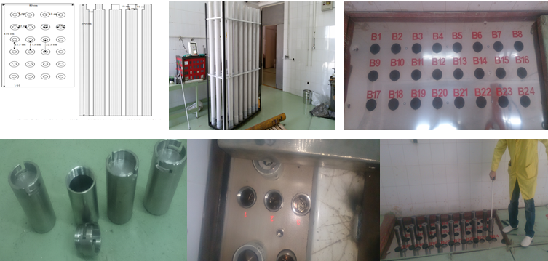

FIG. 6. New method for storing and reusing the DSRS: Small boreholes

Some main features and advantages of this new system are:
- Underground placement; use it as a shield;
- Double parallel pipe which allow retrievability of structure itself (non-routine happening)
- Maximum activity capacity: 240 Ci of Co-60 or 960 Ci of Cs-137
- Safe and reliable storage, safe and easy reuse or recycling of the needed sources

summary and conclusion
Despite all limitations and sanctions against Iranian nuclear industry, IRWA has achieved many of its aims and plans for developing a safe and reliable system for managing all radioactive waste types and streams in Iran. By developing a national waste management strategy and following the national and international requirements, it seems that IRWA is now on the right track for effective and sustainable improvement of the in-place waste management systems in the country.

References
- INRA, "Regulations on radioactive waste management," INRA-MA, 2010.
- INTERNATIONAL ATOMIC ENERGY AGENCY, Policies and Strategies for Radioactive Waste Management, NUCLEAR ENERGY SERIES No. NW-G-1.1, IAEA, Vienna (2009).

