Innovative applications of abrasive
waterjet for irradiated graphite
dismantling and decommissioning
S. PANDIN, E. MOSSINI
Department of Energy, Politecnico di Milano
Milan, Italy
Email: eros.mossini@polimi.it

F. Perotti
Department of Mechanical Engineering, Politecnico di Milano
Milan, Italy

M. Annoni, M. MONNO
Department of Mechanical Engineering, Politecnico di Milano
Milan, Italy

E. MACERATA, M. MARIANI
Department of Energy, Politecnico di Milano
Milan, Italy

Abstract

The characterization, dismantling and pre-disposal management of radioactive materials have an important role in safe decommissioning of nuclear facilities. One of the main challenges is related to the management of irradiated graphite (i-graphite) used as moderator and reflector in several nuclear power plants and research reactors. In addition to common radiation protection issues typical of most radioactive waste, easily volatizing long-living radionuclides (above all ³H, ¹⁴C, and ³⁶Cl) and stored Wigner energy can be released during imprudent retrieval and processing of i-graphite, that hence require careful considerations and precautions. It is well known that Wigner energy release can be avoided by monitoring the i-graphite temperature, that must be kept below its irradiation temperature, with about 50 °C safety margin. This is especially important for those blocks irradiated below 100 °C. With this regard, among all cutting techniques, the abrasive waterjet (AWJ) can be a promising technical solution that achieves all the thermo-mechanical and radiation protection objectives. In this work, the application of AWJ to segmentation of graphite blocks has been explored, aiming at optimizing the retrieval, storage and disposal of such waste. This would have benefits from the points of view of safety, management, and costs. AWJ technology may represent a valuable alternative to mechanical dismantling techniques from the perspective of following process requirements:
- Restraint of suspended dusts;
- Low cutting temperature;
- Limitation of secondary waste;
- Easy remote use;
- Low cost.
This work was aimed at characterizing the AWJ machining capability of 100x100x600 mm blocks of non-irradiated graphite. Several factorial experiments were designed to optimize the machining process parameters (e.g. traverse speed, abrasive mass flow rate, water pressure). The preliminary results obtained in this work promote AWJ as a valid alternative to other conventional techniques. In particular, secondary waste can be limited by optimizing the abrasive mass flow rate.

INTRODUCTION
Nuclear graphite is widely used as a neutron moderator and reflector and as a structural material in Gas Cooled Reactors (GCR). The core of these reactors contains thousands of tonnes of graphite blocks. These are removable blocks that become highly radioactive and are often classified as intermediate level waste (ILW). The graphite in most of these reactors has been exposed to very high neutron fluxes that produce several effects in the material, such as neutron activation of constituents and impurities, dimensional changes, modification of mechanical properties, and formation of defects leading to the accumulation of Wigner energy [1]. Although nuclear graphite is very pure, it does contain impurities. They are typically activated by (n, γ), (n, p) and (n, α) reactions during the period of neutron irradiation. Neutron activation results in the production of a wide range of radionuclides in the graphite matrix, most of them being very volatile or long-living, such as ³H, ¹⁴C and ³⁶Cl.
As above written, radioactivity content is not the only issue when dealing with i-graphite. Accumulated Wigner energy is another problem, especially for graphite irradiated below 100 °C. In fact, to release the stored energy, it is sufficient to heat the i-graphite to a temperature approximately 50 °C higher than the irradiation temperature [2]. Consequently, special care must be taken in handling of i-graphite, in order to avoid Wigner’s energy release and radionuclides losses.
Over the years, many solutions have been explored to dismantle and manage i-graphite [3]. In most cases, the safe storage has been chosen as decommissioning strategy to reduce the residual radioactivity in the activated graphite blocks to be disposed of, if necessary after treatment and conditioning. This approach would certainly ease the organization of work shifts to limit the operational dose received by operators. Afterwards, one of the most accredited option is to extract the whole blocks and then either treat or dispose them directly. In any case, it is advantageous to try to reduce the volume occupied by the waste. There are several techniques, such as surface decontamination of graphite blocks, even if this strategy is not convenient since radionuclides content mainly comes from neutron activation, that occurs both in the bulk and on the surface. Another option is to cut the blocks so that they can be stored in a more space-efficient way into containers [4]. As they are already classified as ILW, this technique would increase the specific activity of the blocks, but without an increase in classification.
Some Member States that have operated just few graphite moderated nuclear power plants (NPP) or just few nuclear research reactors are certainly more inclined to postpone the issue of choosing and implementing a definitive i-graphite management approach. In these cases, i-graphite is usually kept for some decades inside the reactor building or transferred in temporary repositories, waiting for a final solution. That is also the case of Italy, that, besides a MAGNOX NPP (Latina, Sogin), has shut-down a L-54M nuclear research reactor (Milan, Politecnico di Milano). The decommissioning of both facilities has been managed according to deferred dismantling strategy. In particular, low amount (around 11 t) of i-graphite was generated in L-54M nuclear research reactor, where it was employed as neutron moderator and reflector [5].
In this context, the abrasive waterjet (AWJ) cutting technique can offer several valid advantages over traditional cutting techniques [6]. It usually produces small amounts of dust during cutting and can also be performed under water, which greatly reduces the possibility of dust production. It is also a technique that already has remote-control. Both under water and remote-control operation proficiently contribute to limiting the operational dose received by operators. Another interesting feature, especially from the point of view of Wigner's energy release, is the fact that it usually entails limited thermal alteration of the material during cutting.

Experiments
The experimental activity was conducted using a 5 axis CNC (Computerized Numerical Control) abrasive waterjet machine (PRIMUS 322, Intermac - Biesse, Pesaro (Italy)), with a double effect high pressure intensifier pump (Ecotron 40.37, BFT GmbH, Hönigsberg, Austria), (Figure 1). The high-pressure water from the pressure intensifier is sent to the cutting head, where the primary orifice transforms potential energy into kinetic energy. Afterwards, the abrasive is mixed to the water jet to form the abrasive waterjet. During the mixing process, a momentum transfer from water to abrasive particles causes their acceleration, along the mixing tube. Finally, the abrasive jet exits the focusing tube, gets airborne, then interacts on the workpiece producing the removal of material. The waterjet cutting ability strongly depends on process parameters [7][8][9] such as:
- Water pressure, p
- Abrasive mass flow rate, $\dot{m_{a}}$
- Traverse speed, $v_{f}$
A series of cutting experiments were designed and conducted in order to identify the range of process parameters to obtain a separation cut. Therefore, a two-level, three-factor factorial design was developed to evaluate the effects of each parameter and their combinations. The levels established for the process parameters are reported in in Table 1. Experimental runs were randomized, and three replicates of each treatment combination were conducted. Randomization is used to statistically neutralize the effects of unknown uncontrolled factors that may affect the experiment [10].
Cutting tests were performed on blocks of non-irradiated AGOT (Atcheson Graphite Ordinary Temperature by US National Carbon Company) graphite of size 100x100x600 mm. Some of the main properties of this type of graphite are listed in Table 2.

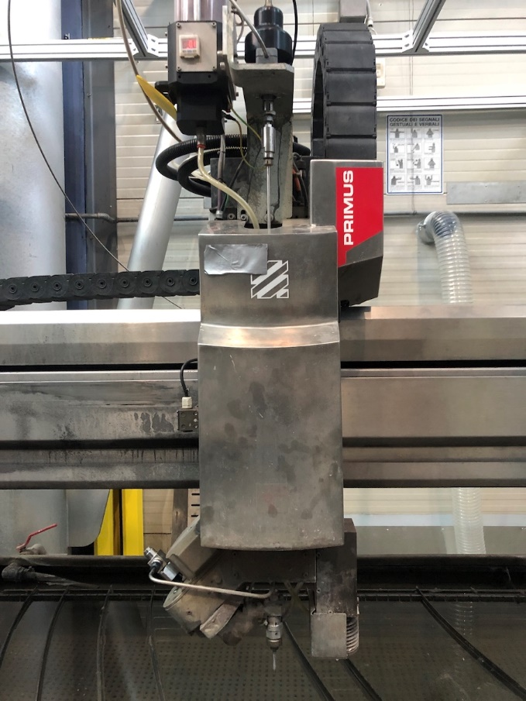
FIG. 1. Detail of the AWJ machine: handling system and cutting head.

TABLE 1. CONSTANT PARAMETERS AND VARIABLE FACTORS OF THE EXPERIMENTAL DESIGN

Factors | Value
Focusing tube length, l_{f} (mm) | 75
Type of abrasive | Barton Garnet
Abrasive mesh# | 80
Water pressure, p (MPa) | 100, 240, 380
Standoff distance, sod (mm) | 3
Abrasive mass flow rate, ${\dot{m}}_{a}$(g∙min⁻¹) | 50, 200, 350
Traverse speed, v_{f} (mm∙min⁻¹) | 30, 165, 300
Thickness, t (mm) | 100
Primary orifice diameter, d_{n} (mm) | 0.33
Focusing tube diameter, d_{f} (mm) | 1.02

TABLE 2. AGOT GRAPHITE PROPERTIES

Property | Value
Bulk density | 1.7 g/cm³
Thermal conductivity | 166 W/m°C
Specific heat capacity | 760 J/kg°C
It was also decided to evaluate the graphite removed during cutting to estimate the volume of secondary waste present in the catcher after cutting. Before and after cutting, the blocks were dried in an oven at controlled temperature of 115 °C until constant weight was reacted to remove residual moisture and weighed.

results and discussion
The experiments have shown that many combinations of parameters result in successful separation cut of virgin graphite blocks (100 mm thickness). In this way it is possible to study combinations of process parameters to meet different requirements from operational, economic, and radiation protection points of view. The qualitative results of the screening cutting experiments are shown in Figure 2.
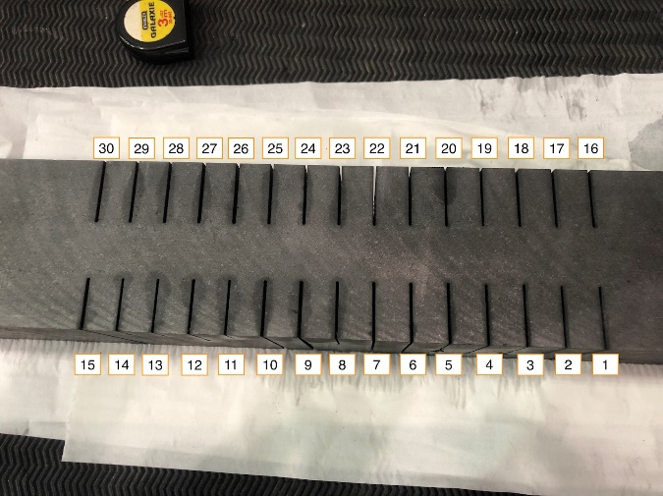
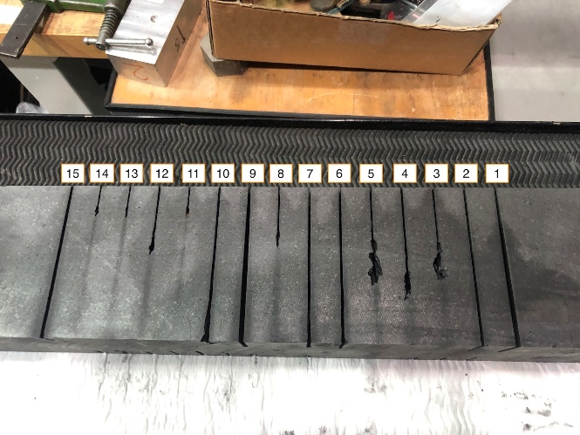
FIG. 2. Graphite block after the factorial plan cutting.

For example, if the interest is the reduction of possible secondary waste volume and therefore using as little abrasive as possible, it is possible to study combinations of parameters that keep the abrasive mass flow rate to a minimum, but vary the other two quantities so that the cut is still successful. It is noteworthy underlying that, as already mentioned, not only the abrasive material contributes to secondary waste, but also graphite material removed during cutting. Alternatively, if the interest is in reducing costs, combinations of parameters can be found that minimise the cost, e.g. by increasing the traverse speed and reducing the abrasive mass flow rate, but still ensuring a successful cut.
With respect to secondary waste, it has been noted that most of the solid residue in the catcher is composed of the abrasive used and the percentage of graphite is between 2-5%. Moreover, the two materials have different densities, so it will certainly be possible to manage their separation. Further studies on this topic will be evaluated.

Conclusion
From the results obtained, it can be concluded that this technique is a suitable candidate for cutting graphite. So, in this case, it is possible to capitalise on the specific features of this cutting technique. Different combinations of parameters result in a successful cut, so it is possible to optimise the parameters according to economic or technical requirements.
As above mentioned, with this type of cutting technique it is possible to cut under water. In addition to reducing the risk of dust production, the shielding action of water can reduce the biological shields around the machine. Another advantage of underwater cutting is the fact that it can reduce the temperature variation experienced by the block. In fact, the thermal exchange coefficient of water is higher than that of air. Further experiments are planned to evaluate the actual temperature of a graphite block during cutting.
The preliminary results obtained are very promising for the application of AWJ to the cutting of irradiated graphite.
References
- Characterization, Treatment and Conditioning of Radioactive Graphite from Decommissioning of Nuclear Reactors, TECDOC Series 1521, IAEA, Vienna (2006).
- Processing of Irradiated Graphite to Meet Acceptance Criteria for Waste Disposal, TECDOC Series 1790, IAEA, Vienna (2016).
- Wareing, A. et al. “Development of integrated waste management options for irradiated graphite”, Nuclear Engineering and Technology 49.5 (2017), pp. 1010–1018.
- Fujii, S., Shirakawa, M., Murakami, T., Study on efficient methods for removal and treatment of graphite blocks in a gas cooled reactor, Tech. rep. (2001).
- Parma, G., Rossi, F.M., Mossini, E. et al, MCNP model of L-54 M nuclear research reactor: development and preliminary verification, J Radioanal Nucl Chem 318, 2247–2255 (2018).
- Cacuci, D. G., Handbook of Nuclear Engineering, Vol. 5, Springer Science, 2010.
- Hashish, M. “Kinetic power density in waterjet cutting”, BHR Group - 22nd International Conference on Water Jetting 2014 (Jan. 2014), pp. 27–42.
- Copertaro, E., Perotti, F., Castellini, P., Chiariotti, P., Martarelli, M., & Annoni, M. (2020). Focusing tube operational vibration as a means for monitoring the abrasive waterjet cutting capability. Journal of Manufacturing Processes, 59, 1-10.
- Momber, A. W., & Kovacevic, R. (2012). Principles of abrasive water jet machining. Springer Science & Business Media.
- Montgomery, D. C. (2017). Design and analysis of experiments. John Wiley & Sons

