# Adoption and Implementation of an Integrted waste management strategy to support and deliver the next generation of young professionals in the remediation of the UK’s nuclear legacy.

Celia Wighton

Radioactive Waste Management Ltd.

Harwell, United Kingdom

Email: celia.wighton@nda.gov.uk

**Abstract**

The Nuclear Decommissioning Authority (NDA) is a non-departmental public body of the Department for Business, Energy, and Industrial Strategy, formed by the Energy Act 2004. The NDA is responsible for cleaning up the UK’s earliest nuclear sites safely, securely, and cost effectively, with consideration and care for people and the environment [1]. In 2019 the NDA published the Integrated Waste Management (IWM) Strategy, aiming to promote cross-category waste management optimisation across the whole waste management lifecycle, within the NDA estate. This supports a risk-informed approach while protecting people and the environment to deliver the NDA mission [2]. The adoption and implementation of an IWM strategy will require people, with the appropriate range of skills and knowledge, to provide capability throughout all the relevant disciplines involved across the waste management lifecycle. The IWM strategy should offer opportunities for young professionals to drive the delivery of the NDA mission, and create a culture in which they can thrive. I believe the NDA nucleargraduates programme, Nuclear Skills Strategy Group (NSSG), early career networks, mentoring and shadow Boards are essential to support the next generation of young professionals in the remediation of the UK’s nuclear legacy.

## INTRODUCTION

The Energy Act 2004 created the Nuclear Decommissioning Authority (NDA), a non-departmental public body to take responsibility for decommissioning 17 legacy NDA sites across England, Wales and Scotland. Some of these sites present unique and difficult nuclear decommissioning challenges [1]. The NDA are also responsible for implementing both geological disposal and the UK’s nuclear industry’s Solid Low-Level Radioactive Waste (LLW) Strategy. It is estimated that the NDA mission will take more than 100 years to complete at a cost of over £120 billion to deliver.

In 2019, the Integrated Waste Management (IWM) Radioactive Waste Strategy was published, whereby NDA made a commitment to: *‘ensure that wastes are managed in a manner that protects people and the environment, now and in the future, and in ways that comply with government policies and provide value for money’[2]*.The IWM Strategy replaces the Higher Activity Waste Strategy published in 2016 with a greater focus on promoting cross-category waste management optimisation across the entire waste management lifecycle within the NDA estate. This ranges from planning and preparation, to treatment and packaging, storage, and final disposal as well as materials that may be declared as waste in the future, as highlighted in Figure 1 below. The strategy also supports a risk informed approach with greater emphasis placed on the radiological, physical and chemical properties of the waste, and the safety case rather than classification (i.e. High Level Waste (HLW), Intermediate Level Waste (ILW), Low Level Waste (LLW) and Very Low Level Waste (VLLW)), aiding identification of the most appropriate management route [2].

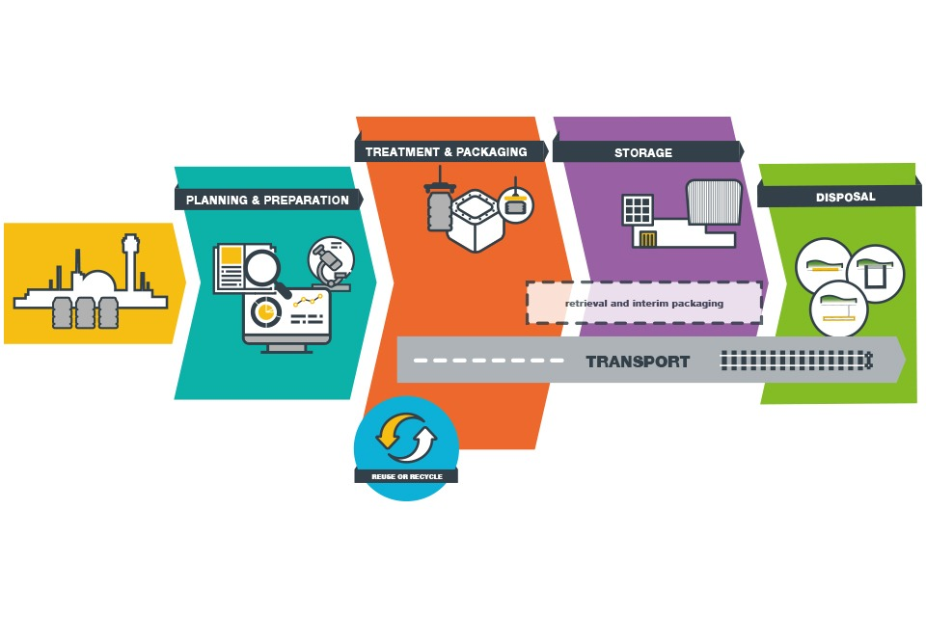

Figure 1: The NDA Waste Lifecycle [2]

The successful adoption and implementation of this strategy will require people, with the appropriate range of skills and knowledge, to provide capability across all the relevant disciplines involved in the waste management lifecycle [2]. By its very nature, radioactive waste management is an intergenerational issue due to the very long timescales associated with the waste lifecycle. It is estimated that the existing workforce must grow by 4,700 people a year over the next 6 years to overcome the challenges associated with the ageing workforce and attraction and retention rates [3] . In addition, over the same period 3,900 people are expected to leave the sector, mostly due to retirement meaning that the sector must recruit approximately 8,600 people every year to sustain the UK’s nuclear skills base [3]. Therefore, it is essential that plans to address this are put in place now. This could include addressing issues such as skill gaps, management of data and information and succession planning. The exact timing and availability of the required skill sets is vital to the success of this strategy.

In this paper, an overview of the adoption and implementation of the IWM strategy will be provided, and how it can support and deliver the next generation of young professionals in the remediation of the UK’s nuclear legacy. The paper also provides some case studies which highlight examples of how IWM can support and deliver the next generation of young professionals.

It should be noted that other areas within the wider NDA mission that require support, such as Site Decommissioning and Remediation and Spent Fuels and Nuclear Materials, are beyond the scope of this paper.

## An Integrated Radioactive Managment Strategy

A risk-informed approach will provide the NDA with greater flexibility in seeking solutions for treatment, packaging, storage and disposal of both radioactive, non-radioactive wastes and materials yet to be classified as wastes. For example, for some wastes, it may be necessary to adopt a multi-stage process to achieve a final disposable product. This could include the separate management of bulk retrievals and residual material to support hazard reduction programmes. The strategy will ensure there is sustainable waste management infrastructure to facilitate timely decommissioning and remediation of facilities and sites, making best use of existing waste management assets and developing new fit-for-purpose waste management routes as required [2].

The risk-informed approach also enables the more effective application of the waste hierarchy (Figure 2), where it is practicable and appropriate to do so, recognising that hazard and risk reduction and nuclear safety priorities may limit its application in certain circumstances. The waste hierarchy highlights the importance of waste minimisation, re-use, recycling and other environmentally sustainable options as well as a more optimal use of all waste infrastructure to minimise overall volumes and drive waste prevention [2]. This also includes driving and facilitating changes in waste management behaviours and cultures. For example, using alternative waste management and treatment routes and consolidation, where appropriate, to improve the overall management of Higher Activity Waste (HAW)[1] has negated the need for building ILW storage facilities at Dungeness A, Sizewell A, Oldbury and Wylfa. Use of the waste hierarchy ensures that radioactive waste is disposed of efficiently [2].

The NDA estate need to apply and consider all stages of the waste hierarchy, to extract as much value as practicable from their waste and to manage their environmental impacts appropriately.

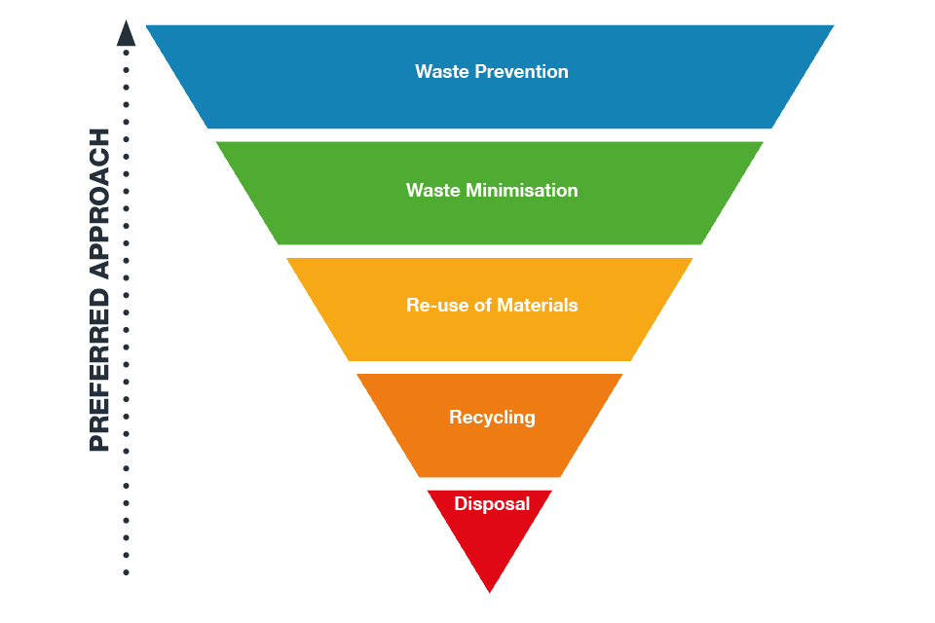

Figure 2: Applying the waste hierarchy [2]

To deliver the strategy, the NDA are developing a programme of work (an Integrated Waste Management Programme (IWMP) [3]) that will drive forward activities to enable NDA businesses to manage its radioactive waste from waste generation through to disposal in a more sustainable, efficient and unified way.

### Benefits of the IWM Strategy

The IWM strategy, presenting the NDA’s strategic requirements for radioactive wastes in a single document, will provide greater opportunities to optimise the management of wastes, resulting in reduced costs and schedules. This will contribute towards helping to achieve the commitments set out in the Nuclear Sector Deal (NSD), such as savings of 20% in the costs of waste management and decommissioning by 2030 [4].

It will also provide the mechanism for an IWMP as mentioned in Section 2 above. The strategy seeks to improve coordination across the industry and waste management lifecycle, and to assist waste producers and site operators overcome a range of possible challenges in relation to risk and hazard reduction [5]. This can be achieved through promoting and supporting robust decision-making processes and identifying the most advantageous options for managing legacy waste facilities at Sellafield, for example.

Integrated Project Teams (IPTs) led by Sellafield Ltd, Radioactive Waste Management Ltd. (RWM), and Low-Level Waste Repository Ltd. (LLWR) have also been developed to address cross industry issues, develop thermal treatment technologies and improve the management of problematic wastes.

## Supporting and Delvering the next generation of Young Professionals

To attract, retain and develop high performing, highly skilled, talented and motivated young professionals in the remediation of the UK’s nuclear legacy, opportunities must be offered for young professionals. This is stated in Strategy 4 as an objective under one of the key critical enablers; people and is essential in driving the delivery of the NDA mission and creating a culture in which they can thrive [1].

Methods of support and delivering the next generation of young professionals are discussed in Section 3.2 below. The application of these methods will ensure understanding of radioactive waste will remain resilient (due to the rapidly changing technological landscape), be clearly recognised (due to social and organisational change) and taken seriously, whilst supporting both professional and personal development.

The IWMP is committed to working closely with SLC’s and the supply chain across the nuclear industry. The purpose being to identify the key skills and knowledge requirements, to develop plans to maintain capability and manage any skill gaps.

### The NDAs ‘Our People’ Strategy

The NDA recognise that people are a critical enabler to deliver the NDA’s mission. The People Strategy presented within Strategy 4 considers the complexity of skills requirements, unique geographies of some NDA sites, diverse range of stakeholders who have a legitimate interest in the progress of the NDA’s mission; relationship with regulators, UK government and devolved administrations and the necessity to deliver value from the taxpayers perspective [1].

Since the beginning of the Covid-19 pandemic, employee expectations continue to change markedly around flexible working, agile and digital working, environmental challenges, sustainability and mental health. Diversity and inclusivity are also driving internal workplace culture and wider societal considerations that enable employees to feel accepted and valued. Inclusivity also attracts a broader range of perspectives and a broader pool of talent across the nuclear sector. In addition, the NDA must be more responsive to the changing implications for the workforces, present and future, of new technologies and increasing digitalisation; aiming ultimately to reduce exposure to risk and improve safety performance [1]. The NDA must harness the most effective communication methods available and, if necessary, provide new platforms for the more focused dialogue to engage with a broader range of stakeholders.

The benefit of nurturing a positive workplace culture, whereby all employees within the NDA Group, regardless of their position or who they are, should be able to work in an environment where they feel they are respected, included and valued.

### The Right Role for the Suitably Qualified Personnel

It is essential for the delivery of the NDA’s mission that relevant roles are fulfilled by Suitably Qualified and Experienced (SQEP) personnel at the right time. This includes, and not limited to: identifying recruitment and development programmes for specific skills to support functional strategies and priorities (such as stakeholder relations, procurement and the supply chain); ensuring that specific niche and nuclear skills are maintained and invested through the NDA Group and supply chain (including cyber security, environmental science and radiation protection); supporting and actively championing the sharing of resources to develop careers; and deploying skills effectively on a NDA Group-wide basis.

Other areas of significant importance are being clear about what great leadership looks like within the NDA Group and ensuring ‘One NDA’ leadership standard is clearly understood and embedded within the next generation of young professionals. The standard sets clear expectations for all NDA Group business leaders across four lenses including creating the future, safely delivering results, inspiring our people and collaborating to unlock potential. ‘One NDA’ was created in 2017 and aims to transform how the NDA manages its businesses (listed below) – through working together to find more effective and efficient approaches to nuclear clean-up and decommissioning on behalf of the UK taxpayer.

* Radioactive Waste Management Ltd
* Nuclear Transport Solutions (NTS)
* NDA Archives Ltd
* NDA Properties Ltd
* Sellafield Ltd
* Dounreay Site Restoration Ltd
* LLW Repository Ltd
* Rutherford Indemnity Ltd
* Magnox Ltd
* Energus

Developing a talent acquisition approach for the short, medium, and long-term, recognising the challenges in attracting skilled individuals including groups generally regarded as hard-to-reach groups (including those geographically and digitally isolated [1]) and addressing the public perception of the industry, will also be of equal importance in ensuring the successful delivery of the NDA’s mission. This includes supporting and encouraging the uptake of key study areas to meet the NDA’s demand for wide-ranging future skill requirements.

It is essential to embed the NDA’s ongoing commitment to apprentices and graduates in line with government targets and priorities (i.e. the Nuclear Sector Deal) and develop school engagement strategies as well as develop NDA Group-wide attraction. Initiatives are already in place to excite the next generation and their influencers on the career opportunities within the nuclear industry and are discussed in detail in Section 4 below.

### Create a culture in which our people can thrive

The NDA strives to create a positive workplace environment across all aspects of the employee lifecycle such as attraction, recruitment into the NDA Group, onboarding, professional and personal development with effective leadership, retention and separation. Therefore, promotion opportunities and secondments should be made available across the NDA Group to attract and retain the younger generation.

A strong mental health and wellbeing culture should also be encouraged. This will ultimately create a supportive working environment, where the young generation feel they are able to openly discuss mental health in the workplace and access support, if they need it.

A culture of equality, diversity and inclusion is also necessary to ensure every voice is felt welcomed, heard and respected and is fundamental to the sustainability, growth and improvement of organisations. High levels of employee engagement and satisfaction are not only ethically correct but also drive significant business value and support an effective nuclear and environmental safety and security culture.

## Initiatives for Supporting and Delivering the next generation of young professionals

Several initiatives have been established to support and deliver the next generation of young professionals in the remediation of the UK’s nuclear legacy and address the intergenerational issues as discussed above. The Nucleargraduates programme [7] is a comprehensive scheme to train and develop the next generation of young professionals. Graduates and those with experience can influence people through their attitude and actions to help effect change and drive efficiencies across the nuclear industry without compromising its excellent safety record. The Nuclear Strategy Skills Group (NSSG) [4] is another initiative to address the key risks to skills and resources facing the industry as well as the NDA Young Generation Network (YGN) Industry Partnership [10] that is committed to creating closer working relationships between the NDA and the YGN.

Further details of the initiatives as well as a personal perspective on the adoption and implementation of the IWM strategy, to support and deliver the next generation of young professionals, in the remediation of the UK’s nuclear legacy are provided below.

### Case Study 1 – Nucleargraduates

The NDA Nucleargraduates programme, founded in 2008, demonstrates NDA’s commitment to attracting, retaining and developing a highly skilled, talented and motivated workforce and creating a positive workplace culture [1]. The nucleargraduates programme is a 2-year graduate development programme managed by Energus and sponsored by a range of organisations including: the NDA, Sellafield Limited, Magnox Limited, Nuclear Transport Solutions (NTS), Rolls-Royce, Office of Nuclear Regulation (ONR)and the Environment Agency (EA) [6]. To-date the programme has recruited over 400 graduates, has gained an outstanding reputation having been awarded the Princess Royal Training Award in 2020 for outstanding training and skills development and plays a key role in attracting diverse, critical skills and talent into the nuclear sector [1].

Nucleargraduates recruits in a broad range of specialisms such as engineering, science, human resources, commercial, project management, communications, strategy and risk [1]. The programme has developed excellent relationships with universities across England, Scotland, Wales and Northern Ireland and continues to attract high calibre graduates from across a diverse range of backgrounds and specialisms. The programme includes 3 industry placements to expand their knowledge and develop their professional networks. Placements also deliver great business benefit to the sponsoring organisations by enhancing industry exposure and enabling graduates to bring a wider perspective back to their sponsors [6].

All graduates are STEM (Science, Technology, Engineering and Maths) Ambassadors and participate in various STEM activities over the 2 years, helping to influence the next generation of young people through various events and activities and encouraging them to think about the nuclear industry as a career [1]. The programme is aligned to the priorities of the UK government’s NSD and contributes to the 40% of females employed by the sector by 2030 [1]. In 2019, 46% of the nucleargraduate intake was female and nucleargraduates continue to strive to achieve greater levels of diversity and inclusion.

### Case Study 2 - Nuclear Skills Strategy Group (NSSG)

The NSSG aims to bring together major employers, Government, regulators and trade unions to address the nuclear sector skills challenge [6]. The group is accountable for developing a Nuclear Skills Strategic Plan that is aligned with the NSD themes, addressing the key risks to skills and resources facing both the civil and Defence nuclear sectors. Themes include enhanced skills leadership, sector transferability, pathways, and apprenticeships, staying at the cutting edge and exciting the next generation about nuclear [8].

Through the planning and implementation of the above themes, the group intends to launch the Next Generation schools outreach programme to attract young people into the nuclear sector, increasing visibility of nuclear careers (2019), establish sectoral transfer pipeline to improve the mobility of skilled people (2021) and achieve a highly skilled and diverse workforce (target of 40% women in nuclear) by 2030 [8].

#### Shadow Boards

Sellafield Ltd is responsible for the safe and secure operation and clean-up of the Sellafield nuclear site located on the coast of Cumbria, England. From cleaning-up the country’s highest nuclear risks and hazards to safeguarding nuclear fuel, materials and waste, its mission is nationally important. Sellafield employs over 11,000 nuclear experts through direct employment and the supply chain [9].

Sellafield Ltd has recently formed a Next Generation Executive Committee which acts as a shadow to the formal Executive team and aims to bring diversity of thought and the voice of those earlier in their career. The Group aims to bring the thoughts, opinions and perceptions of a new generation to the business of running Sellafield. The Group is set to challenge norms and ask questions to bring about positive change and aims to address issues regarding social impact, the environment and equality, diversity and inclusion [9].

Shadow Boards provide opportunities to succession plan and attract, identify and develop people with the potential for good leadership.

### Case Study 3 – The NDA Young Generation Network (YGN) Industry Partnership

The NDA has partnered with the Nuclear Institute’s YGN as the YGN’s Industry Partner for a 12-month term, with the aim of creating a closer working relationship between the NDA Group and the YGN [10].

The Young Generation Network is the young members section of the Nuclear Institute (the professional body and learned society for the nuclear industry) for those under the age of 37. A committee of young generation representatives, from each of the NDA group companies, has been created to help the NDA Group maximise the benefits from the partnership for the young professionals within their organisations [10]. This has included organising webinar series and virtual tours of NDA sites, producing articles for Nuclear Institutes national *Nuclear Future* Journal and the UK Government website, and increasing apprentice engagement across the NDA estate.

The representatives are united by their passion for improving the working relationships between NDA Group subsidiaries and bringing together the young generation. This platform can aid and support the adoption and implementation of an IWM strategy to deliver the next generation of young professionals. Through increasing exposure of YGN events and opportunities across the NDA Group, increasing representation of the NDA Group across YGN events, and influencing YGN’s contributions to support the NDA mission.

### Case Study 4 - Personal Perspective

Personally, as a young professional with 2 years’ experience in the nuclear industry, I believe strengthening collaborative working relationships, learning from experience across the NDA Group and the wider nuclear industry, will enable the benefits of the IWM Strategy to be maximised, leading to a sustainable future. I also believe sharing approaches to skills gaps and training, and where appropriate, co-creating and procuring solutions to the challenges and opportunities ahead will also benefit the nuclear sector.

Throughout my time at Radioactive Waste Management Ltd. (RWM), I have volunteered and engaged with STEM activities at primary schools and participated in outreach events. I also volunteer for early career networks including becoming an RWM Company Representative for the NDA Industry Partner Steering Committee, Young Generation Network (YGN) and the Young Nuclear Professionals Forum (YNPF). The Young Nuclear Professionals Forum provides an alternative perspective on the challenges facing the nuclear industry today, supporting the Safety Directors Forum (SDF) and the Nuclear Engineering Directors Forum (NEDF).

Mentoring has also been a beneficial development tool for myself since I joined RWM, whereby I have received practical advice, encouragement and support as well as learning from the experience of my mentor. Fortunately, an exciting opportunity arose to become a ‘buddy’ for a nucleargraduate who had recently joined RWM. Buddying meant that I was responsible for providing guidance and advice and support them with their transition into the organisation. I found this incredibly rewarding to know I am making a difference to someone else. Both mentoring and buddying schemes ultimately aim to support people with their personal and career development, creating both an inclusive and supporting culture that will attract and retain young professionals.

These platforms have collectively allowed me to network, engage and collaborate with individuals across the NDA Group and the wider nuclear industry, supporting both my professional and personal development.

## Conclusion

The successful adoption and implementation of the IWM Strategy to support and deliver the next generation of young professionals in the remediation of the UK’s nuclear legacy will require people with the appropriate range of skills and knowledge to provide capability across all relevant disciplines involved in the waste management lifecycle. Suitably qualified and experienced people will continue to be needed who have a thorough understanding of chemical and waste processing hazards to support the safe and secure management of radioactive waste.

NDA must work closely with SLC’s and the nuclear industry to identify key skills and knowledge requirements, develop plans to maintain capability and to manage any gaps, as well as drive and facilitate changes in waste management behaviours and cultures. Mechanisms for doing so, have been discussed throughout this paper, including the nucleargraduates programme, young generation networks and the Nuclear Skills Strategy Group. It is also vital that NDA Group businesses engage with primary and secondary schools through STEM related activities as well as organising and attending outreach events at Universities and Colleges who offer apprenticeships and degree programmes. This will ultimately support and deliver the next generation of young professionals in the remediation of the UK’s nuclear legacy.

ACKNOWLEDGEMENTS

I would like to thank RWM’s Strategic Waste Programme team for their support and guidance towards the production of this paper.

References

1. Nuclear Decommissioning Authority., Strategy, Effective from March 2021, Nuclear Decommissioning Authority, Cumbria (2020).
2. Nuclear Decommissioning Authority., Integrated Waste Management Radioactive Waste Strategy, Cumbria, 2019.
3. HM Government., Sustaining our Nuclear Skills, London, 2015.
4. HM Government., Industrial Strategy Nuclear Sector Deal, London, 2018.
5. Nuclear Decommissioning Authority., One NDA The Handbook, Cumbria (2019).
6. Nuclear Decommissioning Authority., Integrated Waste Management Programme (2020), <http://www.gov.uk/government/news/nda-develops-ground-breaking-programme-for-waste-management>
7. Nucleargraduates., About nucleargraduates (2021), <http://www.nucleargraduates.com>
8. Nuclear Skills Strategy Group., About the NSSG (2021), <http://www.nssguk.com/about-nssg/overview/>
9. Nuclear Skills Strategy Group., Case Study: Sellafield’s Next Generation Group sets its direction (2021), <https://www.nssguk.com/media/1911/sellafield-next-generation-group-case-study-final.pdf>
10. The Nuclear Institute., NDA Group launches partnership to inspire Nuclear Institute’s Young Generation Network (YGN) nuclear professionals (2020), <https://www.nuclearinst.com/News-Insights/nda-group-launches-partnership-to-inspire-young-ni-nuclear-professionals>

1. Higher Activity Waste refers to all radioactive material that has no further use that falls into the following categories: High Level Waste (HLW), Intermediate Level Waste (ILW) and the relatively small volume of Low Level Waste (LLW) that is not deemed suitable for disposal at the Low Level Waste Repository or the LLW facility at Dounreay.