Deep borehole disposal as an avenue for multinational collaboration
H. KRISTIANSEN
Norwegian Nuclear Decommissioning
Halden, Norway
Email: havard.kristiansen@nnd.no

Abstract

Deep borehole disposal has received increased attention in recent years as a potential method for safe disposal of high-level radioactive waste, including spent nuclear fuel. Borehole disposal is of particular interest to small-inventory states, because the economies of scale are different than for deep geological repositories that involve access tunnels, shafts, and tunnel galleries (mined repositories). The driver for countries to combine their waste inventories in a shared multinational repository (MNR) is thus not as strong for borehole repositories, but large benefits can still result from multinational cooperation. The ERDO Association is conducting a project that assesses the strategic potential of borehole disposal for several European countries, based on their existing and projected national waste inventories. The project has identified a basic design that could enable disposal of both spent fuel and high-level waste from reprocessing, thereby enabling disposal of a significant portion of the collective waste inventory. Strategic implications, such as required support facilities, implementation time, risks, and costs have been assessed. The generic process for concept development has been described. The concept is in an early, generic stage. Central uncertainties have been assessed, and topics for continued research and development have been identified. The differences between fixed and variable costs for borehole disposal and mined repositories may enable a multinational approach that focuses on sharing R&D-resources, encapsulation facilities, tools, and methods, rather than constructing one shared repository. This may open attractive opportunities for national and international organizations, as well as commercial companies with relevant competence.

INTRODUCTION

Deep Borehole Disposal - Background
Deep borehole disposal (DBD) involves emplacing containers of spent fuel (SF) and other high-level radioactive waste (HLW) 1 to 5 kilometres below ground, via a hole that is drilled from the ground surface or a near-surface cavern and then sealing and backfilling the borehole [1, 2]. DBD can be contrasted with mined repositories, which are deep geological repositories that involve access tunnels, shafts, and tunnel galleries, but both borehole repositories and mined repositories are a form of deep geological disposal.
The use of drilling technology from the oil- and gas-industry for disposing of radioactive waste has been researched since at least as early as 1976 [3]. This was around the same time as the first version of what has since become the KBS-3-concept, which is now the most advanced concept for deep geological disposal [4, 5]. From then until the early 90s, large nuclear waste programs opted for mined repositories rather than borehole disposal. In recent years, advances in drilling technology and simultaneous lack of progress for some disposal programs have reinvigorated research into borehole disposal, as shown by the reference list.
The literature contains a variety of DBD concepts, based on different assumptions about waste form, geological conditions, and safety strategy. Such generic concepts have been used to demonstrate the feasibility of borehole disposal. Concepts typically involve boreholes with diameters in the range 0.3 to 0.8 m and depths in the range 2000 to 5000 m. Boreholes with the necessary depth and diameter can be drilled with technology that is currently available. [1, 2, 8, 9, 10, 11]. Many publications have estimated the costs of DBD [1, 7, 8, 12, 13, 14]. Several of these have indicated that the concept could compete with mined repositories on costs. Preliminary, generic safety analyses have been carried out for specific concepts. These show that the methods and principles for demonstrating the safety of geological disposal are applicable to DBD and that it is feasible to meet the same overall safety requirements as for mined repositories [15, 16, 17].

ERDO – The European Repository Development Organisation
Each State is responsible for ensuring the safety of SF and other radioactive waste. Article xi of the Joint Convention states that countries can in certain circumstances fulfil this responsibility by sharing a disposal facility [18, 19]. A multinational disposal facility is of particular interest to countries with relatively small inventories of radioactive waste. The term “small inventory” is relative but is useful for describing inventories of intermediate-level waste (ILW) or HLW whose volume could make construction, operation, and closure of a mined repository financially challenging, due to the fixed costs associated with constructing such a facility [20]. Countries that do not have nuclear power plants at all or do not have a large enough fleet of nuclear power plants to accumulate sufficient funds to finance a domestic disposal program, might fall within the category of small-inventory state. However, countries that do not have nuclear power also need to handle radioactive waste arising from medical, industrial, and research uses of radioactive substances.
One way to resolve the financial challenges of disposing of small national inventories could be to implement a multinational repository, which would enable countries to pool their resources and share the fixed costs of developing, siting, and constructing a disposal facility. Many small-inventory states have adopted a dual-track approach, where domestic and multinational solutions are pursued in parallel [19, 21]. The European Repository Development Organisation (ERDO) is an association whose purpose is to act as a knowledge centre for both national and multinational solutions. One of its projects has examined the potential use of DBD as a part of a domestic or multinational solution.
The project has considered HLW from Croatia, Denmark, The Netherland, Norway, and Slovenia. Waste-management organizations from each country (Fund for Financing the Decommissioning of the Krško NPP, Danish Decommissioning, COVRA, NND, and ARAO, respectively) have contributed to the project [22, 23, 24, 25]. The work has been carried out in a way that may be the simplest form of multinational collaboration: NND needed to develop concepts for disposing of Norwegian radioactive waste, including a DBD concept. NND technical specialists to develop such a concept for the Norwegian inventory, and then used the result as a reference concept for the ERDO project. The results include:

- Feasibility assessments [1, 2, 26, 27];
- Cost estimates [12];
- Host rock target properties [28];
- A compilation of relevant regulatory requirements, including international guidelines such as IAEA Safety Standards [28, 29];
- A generic post-closure safety assessment (ongoing until 2022).

In addition to extrapolating from the studies in a Norwegian context and information about the respective national waste inventories, the project is based on abundant publicly available literature on DBD.

Waste inventory

The Netherlands
The Netherlands has one NPP in operation, in Borssele (485 MW_{e}). Another NPP in Dodewaard (60 MW_{e}) was in operation from 1969 to 1997 and is now in a state of safe enclosure. Two research reactors are in operation, and one is being decommissioned. Dutch Government practice in principle leaves the choice of whether or not to reprocess SF to the operator of a nuclear facility. In practice, this has meant that SF from NPPs has been reprocessed, while research-reactor fuel has not [30]. The fuel has been reprocessed at Sellafield (UK) or La Hague (France). Residues from reprocessing are returned to The Netherlands, where they are stored at the facilities of COVRA. Two types of residues are returned:

- CSD-v (Colis Standard Déchet-vitrified): Fission products and actinides contained in a glass matrix;
- CSD-c (Colis Standard Déchet-compacted): Compacted hulls and end-pieces from SF.

COVRA classifies CSD-v as heat-generating HLW and CSD-c as non-heat-generating HLW. Both waste forms are contained in the same type of primary container: stainless-steel cylinders with 0.43 m diameter and 1.335 m height. SF and other HLW from the Dutch research reactors are stored in so-called ECN containers, which are cylindrical, with a diameter of 0.846 m and are 1.236 m long. The Dutch waste management strategy involves storing waste at COVRA until 2130, by when a disposal route should become operational. The estimated quantity of waste packages in 2130 is 478 CSD-v, 600 CSD-c, and 350 ECN [24].

Croatia and Slovenia
Croatia and Slovenia share ownership and responsibility for the nuclear power plant (NPP) in Krško. The NPP has 696 MW_{e} net output and has been in operation since 1983. It was originally designed with a 40-year lifetime but plans for a 20-year extension until 2043 are underway. By then, it is foreseen that 2282 assemblies (926 tons heavy metal, HM) of fuel will have been used. The outer dimensions of the spent-fuel assemblies are 0.2 m x 0.2 m x 3.76 m. Each assembly contains 235 fuel rods, consisting of ceramic uranium dioxide pellets in zircaloy-4-cladding. SF is currently stored in a storage pool onsite at Krško. A licensing process for establishing a spent fuel dry storage (SFDS) is ongoing. The SFDS is intended to be operational from 2022. Preliminary plans for disposal envisage a facility following the KBS-3-concept, with operations beginning in 2093. That would allow the waste a minimum cool-down time of 50 years. In accordance with the dual-track-principle, Croatia and Slovenia participate in projects related to multinational repositories. The reference scenario envisages direct disposal (no reprocessing). However, a study has shown that if the SF was reprocessed, then the returned residues would be contained in 730 CSD-v and 780 CSD-c [22, 31, 32].
Decommissioning of NPP Krško is foreseen to generate some materials that will be classified as HLW. Current plans are to store and dispose of these in HI-SAFE-casks that have an outer diameter of 2.5 m.

Denmark
Three research reactors have been operated in Denmark: Danish Reactor (DR) 1, DR 2, and DR 3. All have been shut down. DR 1 and DR 2 have been fully decommissioned. Decommissioning of DR 3 is ongoing. The SF from DR 2 and DR 3 have been transferred to the USA according to an agreement with the US Department of Energy. SF from DR 1 (4.9 kg U) and 233 kg U residues from post-irradiation experiments remain in Denmark. This waste is not heat-generating (the heat output is less than 1 kW/m³, while 2 kW/m³ is generally used as a threshold for classifying waste as heat generating [33]). The 233 kg of residues consist of uranium oxide pellets mostly in zircalloy tubes. These are stored in 33 stainless-steel canisters with diameter 0.22 m and length 0.87 m. The SF from DR 1 is a solution of 20 % enriched uranyl sulphate in light water. This must be transformed to a solid waste form before disposal, by e.g. evaporation or solidification. Because information about the final waste form is not available, the ERDO DBD-project has assumed that after treatment, the SF could be packed in one canister of the same type as used for the 233 kg residues. This means that the total Danish inventory amounts to 34 stainless-steel canisters.
The main parts of the Danish strategy for management of radioactive waste are to construct a storage facility with an expected lifetime up to 50 years, scope the opportunities for establishing a national disposal facility for all classes of radioactive waste, and simultaneously pursue any potential developments in international solutions for disposal of long-lived and high-level radioactive waste [34, 35].

Norway
Four research reactors have been in operated in Norway. All are shut down. Two of the reactors were partially dismantled in the 1960s. Plans are being developed for complete decommissioning of all the reactors and associated support facilities. 17 tons of SF and residues from post-irradiation are currently stored on-site. Contrary to research reactors in several other countries, Norwegian SF and residues from post-irradiation experiments have not been subject to repatriation programs [36]. 10 of the 17 tons consists of metallic uranium in aluminium cladding. This is from the pioneering work in the 1950s and early 1960s. The chemical properties of metallic uranium makes it less suitable for disposal than uranium oxide, which is used in modern nuclear fuel. Therefore, options for pre-disposal treatment are being studied. The options include direct disposal, reprocessing, and dry oxidation [37, 38].

Deep borehole disposal Concept description

Development process and borehole trajectory

The development of a DBD facility is an iterative process that starts with the canister. The size of the canister determines how wide the borehole must be and how thick the walls of the borehole casing (internal support) can be. It also influences the trajectory of the borehole. The simplest trajectory is a straight, vertical borehole, where the waste is placed in the lower part. Another DBD concept uses directional drilling to make the borehole gradually bend from a vertical to a horizontal orientation. The horizontal section of the borehole is where the waste is emplaced. The angle of the bend could be slightly greater than 90 degrees, so that the inner end of the borehole is slightly higher than the lowest point of the bend. With such a configuration, there is no linear pathway from the waste to the surface, as opposed to in a vertical borehole. Therefore, any gaseous species that may be generated by corrosion, radioactive decay, or release from the waste, will migrate be towards the inner end of the borehole, not up to the surface along the borehole. Another advantage is that the canisters are not placed one on top of another, the way they are in a vertical borehole [9]. In a vertical borehole, stacking the canisters can lead to great pressures on the canisters at the bottom. However, this problem can be solved by emplacing seals and support matrixes around and between the canisters [2, 8]. Another advantage with a horizontal borehole, is that the horizontal portion could be made very long, without having to drill to greater depths. This could increase the capacity of a horizontal borehole, compared to a vertical one. On the other hand, the disadvantages of a horizontal borehole are that that drilling may be more technically demanding, slower, and therefore more expensive, and that it could be more difficult to emplace the waste without damaging the canister. Drilling a wide borehole could be easier if the borehole is straight (vertical), which means that the interdependency between canister and borehole design is less complex for the vertical concept [2, 39]. For simplicity, the ERDO project has used a vertical borehole as a reference design. However, this does not mean that a horizontal borehole has been excluded from a potential future development process. Refinement of the canister design, the waste inventory, and adaption to site-specific geological conditions could lead to a conclusion that a horizontal borehole is preferable.

Safety concept, depth, and diameter
Like any other disposal concept, the reference concept consists of multiple passive safety functions. Geological and engineered barriers contain the radioactivity within the repository. Great depth isolates the radioactivity from the biosphere. Fig. 1 illustrates the safety concept. The depth of the borehole should be adapted to site-specific geological conditions and detailed description of the waste inventory. In the generic reference design, the borehole is vertical and 3500 m deep. Waste is emplaced in the lower 2000 m (the emplacement section). The emplacement section must be located within a containment-providing rock zone (CRZ), which is a volume of rock that has no major fractures or faults through which groundwater can flow. The upper 1500 m are used for seals and backfill. Under good geological conditions, waste could be emplaced closer to the surface. Required distance to the surface also depends on the level of containment provided by the engineered barriers, the transient radionuclide content of the waste, and the solubility and sorptive tendencies of the radionuclides. The site should not contain significant deposits of natural resources. It should be volcanically and tectonically inactive. The host rock should be mechanically stable. Ideally, the rock should be stable enough that it is unnecessary to encase the lower portion of the borehole. In oil- and gas wells, which are more often drilled in softer rocks with high pore pressures, a steel or aluminium tube is usually installed in the borehole to provide mechanical support and to avoid unintentional exchange of gases and liquids between the borehole and the surrounding formation. In a strong, mechanically stable host rock with low pore-pressures (which is preferable for both operational and post-closure safety), such casing may not be necessary. The shorter operational lifetime of a disposal borehole compared to a borehole for oil- and gas-extraction could also reduce the need for casing. Selection of appropriate drilling fluids might ensure sufficient wellbore stability. The temperature at the position of the seals should fit the chemical conditions of the sealing materials. This depends on the temperature gradient, the heat output of the waste, and the thermal conductivity of the host rock. High thermal conductivity is preferable, because that enables efficient heat dissipation. Chemical conditions should be favourable for the canister and the seals. The redox potentially generally decreases to reducing conditions with depth, which reduces the corrosion rate of the canister and the mobility of several radionuclides typically present in HLW [2, 28].
Increasing depth increases the likelihood that the groundwater has been decoupled from the biosphere for a time that is greater than the time it takes for HLW to decay to natural levels of radiotoxicity (more than a few hundred thousand years). This would reduce the probability of any transport of radioactivity to the living environment [8, 15]. However, this increase in probability must not be mistaken for a guarantee that deep groundwater everywhere is always old. Meteoric water may reach several kilometres below ground [39, 40].

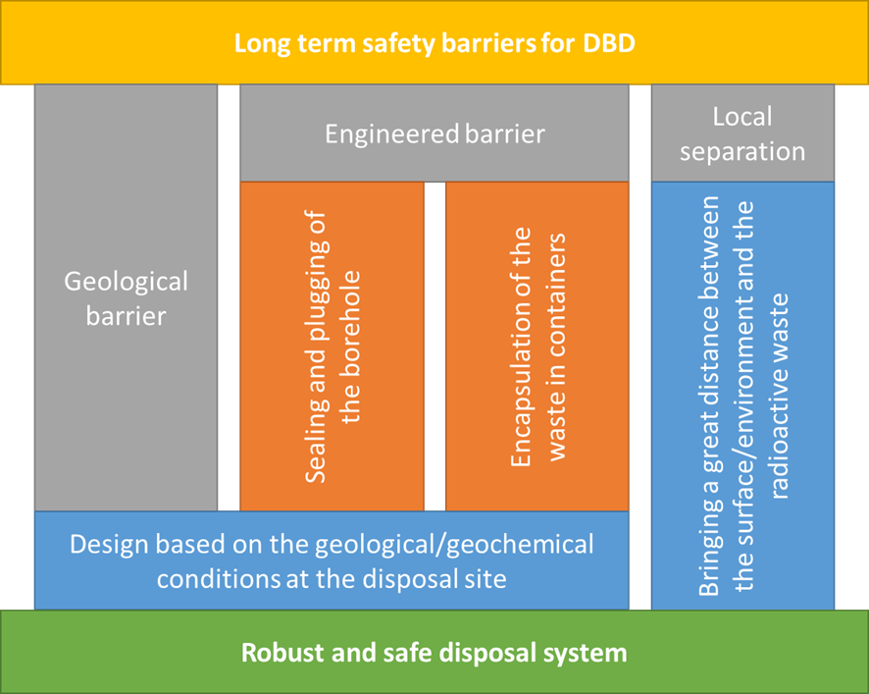

FIG. 1.Barrier systems for the deep borehole disposal concept [28].

Canister
The purpose of canister is to contain the waste before, during, and after it is emplaced in a borehole. The reference design includes a canister that is large enough to take either SF or waste from reprocessing. It is 4.23 m long and has an external diameter of 0.6 m. The walls are a 80 mm thick. and made of austenitic steel. That should withstand the pressures at 3500 m depth [10]. Different inserts could enable disposal of different wase forms, see Fig. 2.

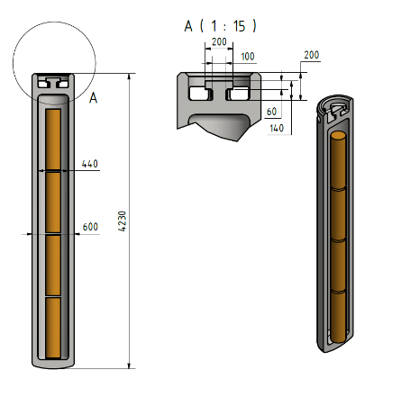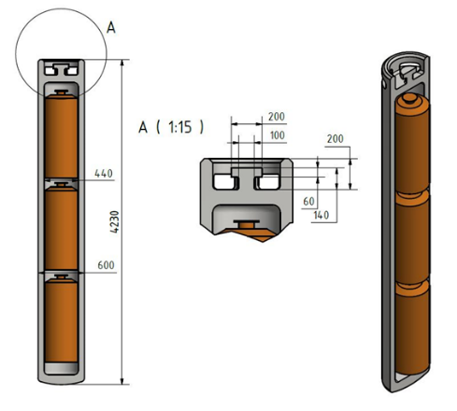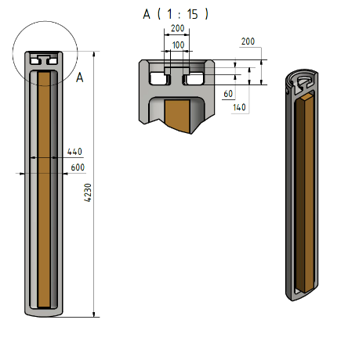

FIG.2. Canister with reprocessing waste (left), SF (NPP Krško, middle), and Danish waste (right) [27].

The respective national inventories fit with the concept in following way:

- Three containers of reprocessing waste (CSD-v or CSD-c), meaning that the Dutch reprocessing waste would require 359 canisters. ECN-canisters are incompatible with the DBD concept;
- One assembly of SF from NPP Krško, meaning that the SF from NPP Krško would require 2282 canisters. HLW from decommissioning is incompatible with DBD;
- Four stainless-steel cylinders of Danish type, meaning that the Danish waste would require 9 canisters;
- The different types of Norwegian SF would require different internal canister configurations. The entire inventory of SF could fit in 69 canisters [2].

The required lifetime of the canister is set to 1000 years under repository conditions. This is in order to comply with Requirement 8 in Specific Safety Requirements No. SSR-5 by the IAEA, which say that the engineered barriers must provide containment while the waste produces significant amounts of heat. For SF and reprocessing waste, that means approximately 1000 years [40, 41, 42]. Given a wall thickness of 80 mm, 1000 years corresponds to an annual corrosion rate of 80 µm. This is feasible with several materials such as austenitic steel, carbon steel, copper (applied as coating outside a more mechanically robust material), titanium, and nickel-chromium-molybdenum alloys [43, 44].

Borehole seals
After the waste has been emplaced, the borehole should be sealed in a way that restores the integrity of the geological barrier, by removing the preferred pathway that that an unsealed borehole otherwise produces. In soft rock types such as salt or clay, the rock can be relied upon to self-heal over time. Not so for crystalline rock, which is assumed to be the host rock in the reference design. Therefore, sealing materials must be emplaced in the hole. There must be no gaps between the seals and the host rock, nor must such gaps form over time. Therefore, any casing and cement used for holding the casing in place, must be removed before the borehole is sealed. Several types of materials can be used as seals. Cement, bentonite (and other clays), geopolymers, metal alloys, silicate gels, in-situ rock, and non-setting grouts are some examples [1]. The materials should be selected in part based on site-specific chemical conditions. In crystalline rock, perhaps the most challenging part of sealing is to minimize the permeability of the excavation damaged zone along the borehole annulus. This can be done by e.g:

- adapting the drilling techniques so that the damage is minimal to begin with [1];
- milling out parts of the annulus after the borehole has been drilled [45], and ;
- emplacing sealing materials that penetrate or compress the surrounding rock [8].

Cost estimates and strategic implications
The costs of a DBD-facility depend on the design, which in turn depends on the waste form, the size of the waste inventory, the geological conditions, and the safety requirements. All these factors could vary from country to country. At a site where a CRZ is relatively close to the surface, a small waste inventory could be disposed of in a single, relatively shallow borehole. If a deeper borehole is required, either because the CRZ is deeper down or because a larger inventory is to be disposed of, then a deeper borehole is needed. The radiotoxicity and physicochemical properties of the waste could also affect the required depth. Furthermore, it could be necessary to leave some space between the canisters, to enable heat dissipation and to support each canister with a buffer material. The greater the spacing, the lower waste capacity per unit borehole length. The cost of a borehole increases semi-exponentially with depth [14]. Therefore, there could be large variations in the costs of DBD for different sites, designs, and inventories.
These variations are illustrated by three generic designs with different depths and different emplacement zones, as shown in Table 1. In addition to the described conceptual costs, construction costs per borehole and operational costs per canister are uncertain. In the cost model, ranges for these costs have been used. A flat probability distribution has been used for the ranges. The ranges are based on a literature review [1, 12, 13, 14, 46, 47] and dialogue with the industry.

TABLE 1. COST MODEL FOR CONCEPTS A, B, AND C

 |  | A | B | C
Fixed parameters | Total borehole length (m) | 3500 | 2000 | 1000
Fixed parameters | Length of emplacement zone (m) | 2000 | 800 | 100
Fixed parameters | Length of seals and backfill (m) | 1500 | 1200 | 900
Variables | Cost of site investigation + construction + sealing (MEUR) | 60-120 | 40-80 | 12-30
Variables | Buffer distance between canisters in the disposal zone (m) | 0.4-4
Variables | Operational costs per canister (MEUR) | 0.03-0.3

The cost of using each reference concept for each national inventory described in Chapter 2 were calculated with a simple Monte-Carlo simulation. The results are shown in Fig. 3. They show that for the Dutch reprocessing waste and the SF from NPP Krško, concept A is the most cost efficient. This is due to economies of scale, whereby the larger repository is more cost efficient. The median number of type A boreholes required for the Netherlands and NNP Krško are 2 and 10, respectively. For Norway, Concept B is the most cost-efficient. One such borehole could take the entire Norwegian inventory, whereas around 6 borehole of type C would be required. The entire Danish inventory could fit in a single borehole of type C, making that the most cost efficient for the Danish HLW. The cost of a shared repository has also been estimated. For the combined inventory of all the nations, Concept A is the most cost-efficient (11 boreholes), with a cost of approximately 1500 MEUR. This is only 7 % lower than the total cost of separate optimal solutions for the respective waste inventories.

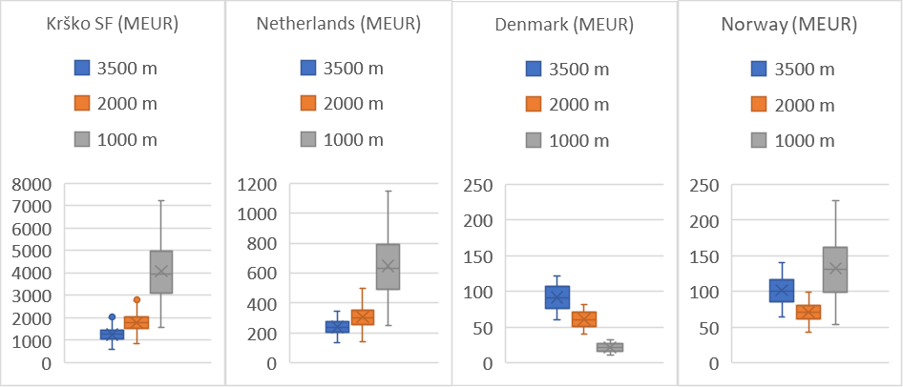
FIG. 3. Cost estimates for disposing of the respective national inventories in boreholes of different depth.

These results suggest that a multinational DBD repository may yield relatively small savings in costs for site selection, construction, and operation, compared to individual national repositories. The fixed costs per repository, and therefore the financial benefits from sharing, are greater for mined repositories [12, 21]. Although 7 % is equivalent to approximately 100 MEUR in absolute terms, these savings may not be large enough to make a multinational repository a more attractive option than national solutions, considering the inherent challenges of establishing a multinational repository (e.g. social license, site selection, transportation). However, that does not remove the need for international collaboration. Development, design, safety assessment, and encapsulation make up a significant portion of the life-cycle costs of any repository. Countries would benefit from sharing these costs, for example by developing a set of tools and components such as canister designs, borehole seals, drilling equipment, safety assessment methods, and encapsulation facilities. This kind of cost-sharing could take the form of a joint effort such as ERDO. A less direct form of cost-sharing could be facilitated by private enterprise. A commercial company that specializes in DBD could develop standardized solutions that could be applied in different nations. Through economies of scale, that would reduce the cost for all its customers, thus achieving the same goal as a conscious joint effort. No matter the form it takes, international collaboration and knowledge sharing is important, because it shows that many countries face the same challenges and that those challenges can be overcome by using variations of the same methods.
Some of the HLW from The Netherlands, Croatia, and Slovenia are packed, or are intended to be packed, in containers that are too large for DBD. Unless such wastes are repackaged, they would need to go to a mined repository. If a mined repository is constructed in any case, then DBD-compatible waste should perhaps also be routed to a mined repository. On the other hand, it is plausible that the radiotoxicity and heat generation of the DBD-compatible waste (SF from NPPs and reprocessing waste) is greater than that of the incompatible wastes (decommissioning waste and SF from research reactors). Therefore, the design of the mined repositories could be simpler if the DBD-compatible wastes were routed to DBD. Inclusion of both DBD in a national strategy could broaden the range of potentially suitable sites. A site that is suitable for DBD, might not be equally suitable for a mined repository (although it could be). The site-selection criteria for a mined repository may be broader if the higher-activity wastes are routed to DBD. In general, DBD may increase the number of options available for disposal of HLW.

Conclusion
Safe management of spent fuel and radioactive waste is a national responsibility. International collaboration can enable the implementation of technical solutions, both in the shape of shared facilities and through shared development processes and knowledge transfer. DBD is a technically feasible concept that could add to the range of technologies available for waste-management organizations. The lower fixed costs and greater adaptability to small inventories could allow internationally collaborative efforts to shift focus from the pursuit of a shared mined repository to the development of standardised development processes, designs, canisters, seals, equipment, and methods.

References

[1] | B. S. AADNØY and M. B. DUSSEAULT, “Deep Borehole Placement of Radioactive Wastes,” NND, 2020.
[2] | T. FISCHER, H.-J. ENGELHARDT and T. WANNE, “Deep Borehole Disposal Concept,” NND, 2020.
[3] | UNITED STATES ENERGY RESEARCH & DEVELOPMENT ADMINISTRATION (ERDA), "Alternatives for Managing Wastes from Reactors and Post-Fission Operations in the LWR Fuel Cycle," ERDA, 1976.
[4] | SKB, "Handling of Spent Nuclear Fuel and Final Storage of Vitrified High Level Reprocessing Waste," SKB, 1977.
[5] | OECD-NEA, "Management and Disposal of High-Level Radioactive Waste: Global Progress and Solutions," OECD-NEA, 2020.
[6] | ISRN, "International panorama of research on alternatives to geological disposal of high-level waste and long-lived intermediate-level waste; IRSN Report/2019-00318," ISRN, 2019.
[7] | SKB, "Project on Alternative Systems Study (Pass) Final Report," SKB, 1992.
[8] | A. BESWICK, F. F. GIBB and K. TRAVIS, “Deep Borehole Disposal Of Nuclear Waste: Engineering Challenges,” Proceedings of the Institution of Civil Engineers , 2014.
[9] | R. MULLER, S. FINSTERLE, J. GRIMSICH, R. BALTZER, E. MULLER, J. RECTOR, J. PAYER and J. APPS, "Disposal of High-Level Nuclear Waste in Deep Horizontal Drillholes," Energies, 2019.
[10] | G. BRACKE, F. CHARLIER, A. LIEBSCHER, F. SCHILLING and T. RÖCKEL, "About the Possibility of Disposal HLRW in Deep Boreholes in Germany," Geosciences, 2017.
[11] | M. RIGALI, S. PYE and E. HARDIN, “Large Diameter Deep Borehole (LDDB) Disposal Design Option for Vitrified High-Level Waste (HLW) and Granular Wastes,” Sandia National Laboratories, 2016.
[12] | T. SAANIO, T. FISCHER, A. GARDEMEISTER, A. IKONEN and T. WANNE, "Stand-alone repository DGR and Deep borehole - cost estimation," NND, 2020.
[13] | G. K. W. BRACKE and T. ROSENZWEIG, “Status of Deep Borehole Disposal of High-LevelRadioactive Waste in Germany,” Energies, 2019.
[14] | A. BATES, “Optimization of Deep Boreholes for Disposal of High-Level Nuclear Waste (PhD-Thesis),” MIT, 2015.
[15] | G. FREEZE, E. STEIN, L. PRICE, R. MACKINNON and J. TILLMANN, "Deep Borehole Disposal Safety Analysis," Sandia National Laboratories, 2016.
[16] | DEEP ISOLATION, "Spent Nuclear Fuel Disposal in a Deep Horizontal Drillhole Repository Sited in Shale: Numerical Simulations in Support of a Generic Post-Closure Safety Analysis," 2020.
[17] | G. FREEZE, E. STEIN, P. BRADY, C. LOPEZ, D. SASSANI, K. TRAVIS, F. GIBB and J. BESWICK, "Deep Borehole Disposal Safety Case," Sandia National Laboratories, 2019.
[18] | IAEA, "Joint Convention on the Safety of Spent Fuel Management and on the Safety of Radioactive Waste Management," 1997.
[19] | IAEA, "Framework and Challenges for Initiating Multinational Cooperation for the Development of a Radioactive Waste Repository," Vienna, 2016.
[20] | IAEA, "Underground Disposal Concepts for Small Inventories of Intermediate and High-Level Radioactive Waste, IAEA-TECDOC-1934," Vienna, 2020.
[21] | N. CHAPMAN, C. MCCOMBIE and P. RICHARDSON, "Strategic Action Plan for Implementation of European Regional Repositories (SAPIERR): Stage 3 Work Package 3 Economic Aspects of Regional Repositories (SAPIERR): Stage 3 WP 3 Economic Aspects of Regional Repositories," European Commission, 2008.
[22] | ARAO, "Inventory of SF and HLW for Possible Deep Borehole Disposal – Slovenia," 2020.
[23] | DANISH DECOMMISSIONING, "Det Særlige Affald – Indhold af Radioaktive Stoffer, Udbrænding og Varmeudvikling," 2013.
[24] | E. VERHOEF, E. NEEFT, G. DEISSMANN, A. FILBY, R. WIEGERS and D. KERS, "Waste families in OPERA," COVRA, 2016.
[25] | H. LOUKUSA, H. NORDMAN, S. KARVONEN and A. HAUTOJÄRVI, "Feasibility of KBS-3 Spent Fuel Disposal Concept For Norwegian Spent Fuel," NND, 2020.
[26] | T. FISCHER and J. ENGELHARDT, "Sealing Concept for Deep Borehole Disposal," NND, 2021 (in prep).
[27] | A. WUNDERLICH and D. H. P. SEIDEL, "Deep Borehole Disposal Canister," NND, 2021 (in prep).
[28] | A. HAGROS, J. ENGELHARDT, T. FISCHER, H. GHARBIEH, A. HAUTOJÄRVI, P. HELLÄ, I. HÄKKINEN, A. IKONEN, T. KARVONEN, P. KETO, V. RINTA-HIIRO, T. SCHATZ, T. WANNE and T. ÄRVÄS-TUOVINEN, "Host Rock Target Properties for Norwegian National Facility," NND, 2021.
[29] | A. HAGROS, T. KARVONEN and T. SAANIO, "Requirements Table Description Memorandum," NND, 2021 (in prep).
[30] | MINISTRY OF INFRASTRUCTURE AND THE ENVIRONMENT, "Joint Convention on the Safety of Spent Fuel Management and on the Safety of Radioactive Waste Management - National Report of the Kingdom of the Netherlands for the Sixth Review Meeting," The Hague, 2017.
[31] | SLOVENIAN NUCLEAR SAFETY ADMINISTRATION, "Seventh Slovenian Report Under the Joint Convention on the Safety of Spent Fuel Management and on the Safety of Radioactive Waste Management," Ljubljana, 2020.
[32] | CROATIAN STATE OFFICE FOR RADIOLOGICAL AND NUCLEAR SAFETY, "6th National Report on Implementation of the Obligations Under the Joint Convention on the Safety of Spent Fuel Management and on the Safety of Radioactive Waste Management," Zagreb, 2017.
[33] | IAEA, "Classification of radioactive waste: General Safefy Guide No. GSG-1," IAEA, 2009.
[34] | UDDANNELSES- OG FORSKNINGSMINISTERIET, "Forslag til folketingsbeslutning om en langsigtet løsning for Danmarks radioaktive affald," 2017.
[35] | DANISH HEALTH AUTHORITY, "Joint convention on the safety of spent fuel management and on the safety of radioactive waste management; National Report from the Unity of the Realm Denmark Greenland; 6th Review Meeting," 2017.
[36] | IAEA, "Return Of Research Reactor Spent Fuel To The Country Of Origin: Requirements For Technical And Administrative Preparations And National Experiences, TECDOC 1593," IAEA, Vienna, 2008.
[37] | P. BENNETT, B. OBERLANDER, P. ADELFANG and E. ERIKSSON, "Recommendations for the Conditioning f Spent Metallic Uranium Fuel and Aluminium Clad Fuel for Interim Storage and Disposal," Nærings- og handelsdepartementet, 2010.
[38] | NND, "Begrenset Konseptvalgutredning om Behandling av Norsk Brukt Reaktorbrensel," NND , 2020.
[39] | L. KRALL, T. MCCARTIN and A. MACFARLANE, “Siting Deep Boreholes for Disposal of Radioactive Waste: Consequences for Tight Coupling between Natural and Engineering Systems,” Environmental Sciences & Technology, 2020.
[40] | M. O'BRIEN, L. COHEN, T. NARASIMHAN, T. SIMKIN, H. WOLLENBERG, W. BRACE, S. GREEN and H. PRATT, "The Very Deep Hole Concep: Evaluation of an Alternative for Nuclear Waste Disposal," U.S. Department of Energy, 1979.
[41] | L. JOHNSON, M. NIEMEYER, G. KLUBERTANZ, P. SIEGEL and P. GRIBI, "Calculaions of the Temperature Evolution of a Repository for Spent Fuel, Vitrified High-Level Waste and Intermediate Level Waste in Opalinus Clay," NAGRA, 2002.
[42] | SKB, "Long-Term Safety for the Final Repository for Spent Nuclear Fuel at Forsmark," SKB, 2011.
[43] | R. PATEL, J. PUNSHON, J. NICHOLAS, P. BASTID, R. ZHOU, C. SCHNEIDER, N. BAGSHAW, D. HOWSE, E. HUTCHINSON, R. ASANO and F. KING, "Canister Design Concepts for Disposal of Spent Fuel and High Level Waste, Technical Report 12-06," NAGRA, 2012.
[44] | J. PAYER, S. FINSTERLE, J. APPS and R. MULLER, "Corrosion Performance of Engineered Barrier System in Deep Horizontal Drillholes," Energies, 2019.
[45] | T. VRÅLSTAD, A. SAASEN, E. FJÆR and T. Y. J. K. M. ØIA, "Plug & Abandonment of Offshore Wells: Ensuring Long-Term Well Integrity and Cost-Efficiency," Journal of Petroleum Science and Engineering, 2019.
[46] | B. ARNOLD, P. BRADY, S. BAUER, C. HERRICK, S. PYE and J. FINGER, "Reference Design and Operations for Deep Borehole Disposal of High-Level Radioactive Waste," Sandia National Laboratories, 2011.
[47] | R. CALVO, O. K.-B. DAVID, R. MACKINNON, G. FREEZE, F. PERRY, A. TARABAY and M. HOMEL, "Deep Borehole Disposal in Israel," SNL, 2018.
[48] | ANDRA, "National Inventory of Radioactive Materials and Waste," 2018.

