Overall optimization of radioactive waste processing

and disposal for problematic waste management

A. NAKAGAWA
Japan Atomic Energy Agency
Tokai-mura, Japan
Email: nakagawa.akinori@jaea.go.jp

T. SASAKI
Japan Atomic Energy Agency
Tokai-mura, Japan

Y. SAKAMOTO
Japan Atomic Energy Agency
Tokai-mura, Japan

Abstract

Japan Atomic Energy Agency (JAEA) has stored radioactive wastes generated from R&D activities related nuclear science and technology. A part of these wastes contains compressed waste without prior radiological, chemical or physical characterization assessed, as well as mixed waste containing lead and mercury with little information about its contents. Pre-treatment and radiological characterization efforts for such problematic wastes are very time consuming and costly. In order to optimize the processing and disposal of the problematic wastes, a method to balance the processing work and disposal facility robustness was studied. Work analysis of waste processing showed bottleneck processes, such as radiological characterization and segregation of hazardous materials and combustibles. Establishment of a conservative scaling factor method and non-destructive gamma-ray measurement enable easier radiological characterization. Hazardous materials will be identified using records and nondestructive inspection. The waste identified as hazardous will be unpacked and segregated. Based on preliminary survey of about 1,000 drums, only 10 % of stored drums contain hazardous materials and need segregation. Regarding the separation of combustibles, total volume of the combustibles will be evaluated using nondestructive inspection technique such as high-energy X-ray CT and the waste that does not comply with the waste acceptance criteria should be mixed with waste containing a small amount of combustibles in order to satisfy the waste acceptance criteria on a disposal facility average. It was estimated that segregation throughput of compressed waste should be increased about 5 times more than conventional method by applying the countermeasures.

INTRODUCTION
JAEA has stored much of waste generated from its R&D activities related to nuclear science and technology. A part of these wastes contains compressed waste without prior radiological, chemical or physical characterization assessed, as well as mixed waste containing lead and mercury with little information about its contents.
Such problematic wastes have been manually unpacked and segregated to separate combustibles and hazardous materials for final disposal and these pre-treatment efforts are very time consuming and costly. Additionally, since radionuclide composition of problematic wastes is complex and variable, the wastes are planned for homogenization through plasma melting and destructive radiological analysis is considered as a method for its radioactivity characterization. Such characterization efforts are also very time consuming and costly.
In order to optimize the processing and disposal of problematic wastes, a method to balance the processing work and disposal facility robustness was studied.

work analysis of problematic waste processing
Problematic wastes processing flow that is currently considered in JAEA is shown in Fig.1. These wastes will be segregated to metal/incombustible, hazardous material and combustible in pre-treatment stage. Since problematic wastes contain radionuclides that are difficult to measure by non-destructive method, the wastes are planned for homogenization through plasma melting and destructive radiological analysis will be applied. The molten wastes will be conditioned for disposal. Hazardous wastes that treatment method is not determined are stored in storage facility.
Separation work of problematic wastes consists unpacking of waste package, unwrapping of waste and manually segregation by material. Current situation of separation work is shown in Fig.2. Especially, separation work of compressed wastes that are needed to disassemble takes more than 5 hours per one package.
Separation work of metal and incombustible is required for safety of melting treatment. In order to prevent the sudden boiling of molten metal and the failure of gas treatment system, it is necessary to separate low-boiling-point metal and remove halogenated hydrocarbons. Such separation work is very time consuming and costly. In order to eliminated this separation work, radiological characterization without melting treatment was studied.
Hazardous materials such as lead, mercury, etc. are currently separated and stored. But, based on preliminary survey of about 1,000 drums generated in the past, only 10 % of stored drums contain hazardous materials. Since the hazardous materials in the drum cannot be identified before unpacking, unpacking and separation work is needed for all drums. If the number of drums that need to be separated is reduced, separation work volume will be reduced. Therefore, the method of reduction of separation work volume and increase of separation throughput was considered.
The reason why combustibles are separated is that the decomposed gas is generated and degradation products can increase radionuclide migration [1]. Since most of problematic wastes contains combustibles, manual separation of combustibles is very time consuming and costly. Therefore, a method of acceleration of separation throughput was studied.

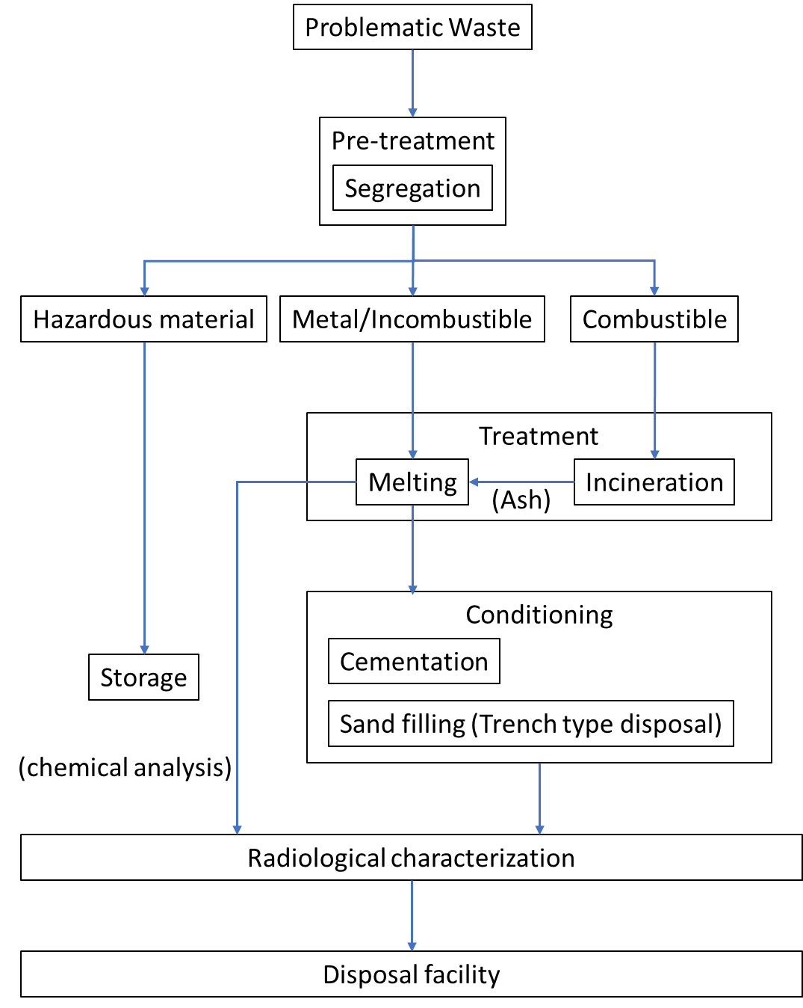
FIG. 1. Schematic flow of problematic waste processing
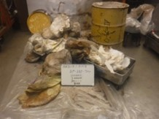 |  | 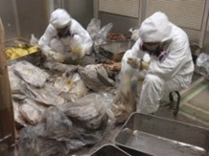
(i) Unpacking |  | (ii) Unwrapping
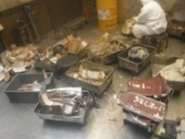 |  | 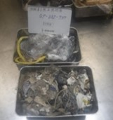
(iii) Segregation |  | (iv) Sorting
FIG. 2. Current situation of segregation work

RADIOLOGICAL CHARACTERIZATION

Conservative radionuclide composition ratio
The radiological characterization of the problematic waste will be conducted using plasma melting and destructive/radiochemical analysis. This work, however, is very time consuming and costly.
In order to solve this issue, a method using a conservative radionuclide composition ratio was studied. First, waste generation facilities are classified into some groups with similar nuclide composition ratio in the waste. Second, relative radionuclide concentration for key nuclide that can be detected by gamma-ray measurement is evaluated for each group. Finally, for each nuclide to be evaluated, the maximum relative concentration of the classified group is adopted. Even if wastes from different facilities is mixed, using this method, the upper limit of the radioactivity concentration can be shown without paying attention to the waste mixing ratio of each facility.
Since there is almost no measurement data at present, data collection will be conducted and countermeasures will be considered in the future.

Enhancement of disposal facility robustness
There are two measures to reduce the number of nuclides to be evaluated for radioactivity concentration. The following measures will be used to reduce the number of nuclides;

- Reduce the radionuclides migrating from the disposal facility by reducing the infiltration of rainwater into the disposal facility using artificial barrier
- Establish the disposal facility structure with a radionuclide migration suppression function using sorption barrier material

In order to enhance the robustness of the disposal facility as described above, the following methods were examined;

- Construct the water shield using impermeable sheet, clay layer, etc.
- Install the inorganic materials that can be expected to adhere to anionic substances such as C-14
- Establish the excavation resistance embankment using reinforced concrete
- Set the radionuclide elution rate based on the robustness of waste package

By constructing the disposal facility with the above functions, the safety of the disposal facility will be improved. Thus, the number of nuclides selected as important nuclides for safety assessment can be narrowed down.

THE SEPARATION OF HAZARDOUS MATERIALS FROM WASTE

Non-destructive inspection
According to a preliminary survey, about 10% of all drums need to be separated from hazardous materials. By using a non-destructive inspection method that can quickly identify drums containing hazardous materials, work volume of segregation from hazardous substances can be reduced.
At present time, the most promising non-destructive inspection method is the high-energy X-ray CT. High energy X-ray CT is expected to be used an inspection tool due to its high permeability and resolution. The example of X-ray CT image of simulated waste is shown in Fig.3. The advantage of introducing X-ray CT is that there are few development factors and it can be installed immediately. Since it is not possible to distinguish materials with almost the same density, it is necessary to develop an image identification technology for discriminating a slight density difference.

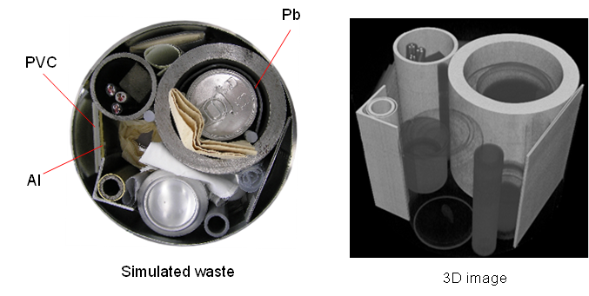
FIG. 3. Example of 3D image of high energy X-ray tomography

Enhancement of disposal facility robustness
The acceptance criteria of hazardous and gas generation materials for safety enhanced trench type disposal facility described in 3.2 were evaluated.

Acceptance criteria of hazardous materials
Regarding hazardous materials, the concentration of heavy metals such as lead, mercury, cadmium, chromium and arsenic migrated from waste to groundwater was evaluated. Then, the concentration contained in the waste that can comply with the environmental quality standards for water in Japan was estimated. The results are shown in Table.1.

TABLE 1. ESTIMATED ACCEPTANCE CRITERIA OF HAZARDOUS MATERIALS

Elements | Without impermeable sheet  and artificial barrier  (kg/200L drum) | Only artificial barrier  (kg/200L drum) | With impermeable sheet  and artificial barrier  (kg/200L drum)
Pb | 1.8×10⁻¹ | 3.4×10⁻¹ | 5.0×10⁰
Hg | 5.7×10⁻⁴ | 5.4×10⁻³ | 5.4×10⁻²
Cd | 5.3×10⁻² | 1.0×10⁻¹ | 1.5×10⁰
Cr | 4.0×10⁻² | 4.1×10⁰ | 4.1×10¹
As | 1.4×10⁻³ | 1.1×10⁻¹ | 1.1×10⁰

Acceptance criteria of gas generation materials
When aluminium metal is solidified with cement, hydrogen gas will be generated by reacting with waste in an alkaline environment. Hydrogen gas has the potential to explode and can cause human exposure when it is released into atmosphere with radioactive substances in the waste. Therefore, filters containing aluminium are currently segregated and removed. However, after confirming that it does not affect the safety of the disposal facility, disposal of waste package containing aluminium is considered to be a measure to accelerate segregation. Moreover, the impact of hydrogen gas generation from iron under the same condition was evaluated.
In the case of a disposal site where 50,000 drums can be disposed, it is confirmed that even if all the waste is a hydrogen gas generating materials, the influence of gas generation on the disposal facility and the exposure dose is small.

THE SEPARATION OF COMBUSTIBLES FROM WASTE
The main types of combustibles contained in waste are paper, cloth gloves, vinyl wrapping, etc. used for handling radioactive materials. When these combustibles are directly disposed, there are problems such as generation of flammable gas due to microbial decomposition and promotion of migration due to complex formation between cationic radionuclides and decomposition products of combustibles. In order to solve these problems, combustibles have been separated and removed from waste and incinerated. In this paper, however, by evaluating the impact of direct disposal of combustibles on the disposal facility, the acceptance criteria for disposal facility where combustibles can be disposed was examined. The points considered to evaluate the amount of combustibles that can be disposed in the disposal facility are as follows;

- The explosive potential if methane gas generated by the decomposition of combustibles
- The accumulated pressure in the impermeable sheet of the generated methane gas
- Exposure does from gas containing radioactive materials
- The impact of decomposition products on radionuclide migration behaviour
- The depression of disposal facility due to the increase in internal space by gas generation

Based on the above evaluations, the structure of disposal facility that could accept waste containing combustibles was considered. The trench type disposal facility was examined with the following measures taken so that waste containing combustibles would not affect the disposal facility. The image of combustibles acceptable disposal facility is shown in Fig.4.

- To construct embankment of the upper part of the disposal facility for surface depression in the future
- To install a gas collection pipes according to the amount of gas generation

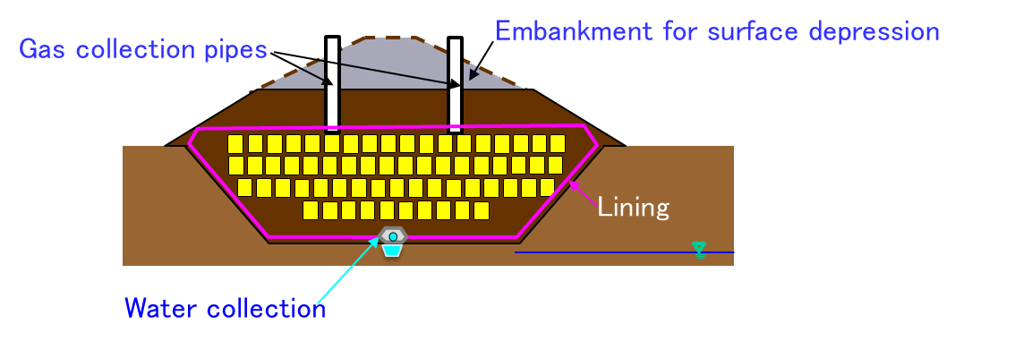
FIG. 4. Image of combustibles acceptable disposal facility
The acceptance criteria of the combustible amount in the disposal facility that takes the above measures was evaluated at 20 vol% of the volume of the disposal facility. The waste that does not comply with the waste acceptance criteria should be mixed with waste containing a small amount of combustibles in order to satisfy the waste acceptance criteria on a disposal facility average. If the combustible volume is under the waste acceptance criteria, they will not be separated. As a result, it is expected that segregation work can be eliminated by identification of combustible amount using non-destructive inspection and controlling combustible volume at the disposal facility to an average of 20 vol%.

Effect assessment of measures
The effect of accelerating segregation work of compressed waste package was evaluated by taking the measures described so far. The conditions of the evaluation are as follows;

- The quantity of waste to be treated is 23,000 drums.
- 6 workers will segregate 1 drum per day and 200 drums a year.
- The measurement time for identifying the object such as hazardous materials, combustibles, etc. to be segregated by non-destructive inspection is 70 minutes.
- Based on preliminary inspection of about 1,000 drums, only 10% of 23,000 drums may contain hazardous materials and need segregation.
- 1 worker will manage 10,000 drums a year in order to satisfy the waste acceptance criteria on a disposal facility average.

The work volume before taking the measures is 690 man-years (=23,000drums/(200drums /6 men/year)).
If measures are taken to segregate only hazardous materials by non-destructive inspection without separating unsuitable substances for melting and combustibles, the amount of waste to be separated will be 2,300 drums. Therefore, the amount of work volume before taking measures is 69 man-years.
About the measurement of non-destructive inspection, if the time required for one measurement is 70 minutes, the daily operating time is 7.5 hours. If it is possible to measure 1,500 hours a year, it is possible to measure about 1,200 drums a year. Thus, 2 workers are needed for non-destructive inspection, the work volume of non-destructive inspection is about 40 man-years (=23,000drums/(1,200drums/2men/year)).
Moreover, 3 workers will be needed to manage 23,000 drums in order to satisfy the waste acceptance criteria on a disposal facility average. Hence, the work volume of managing disposal facility is 3 man-years.
From the above, even considering the uncertainty of the identification rate of hazardous waste to be separated (i.e., even if 15% of 23,000 drums may contain hazardous materials), the required work volume is about 140 man-years. Thus, this result is shown to be about 5 times work volume before the measures are taken.

CONCLUSION
In order to optimize the processing and disposal of problematic wastes such as compressed wastes, a method to balance the processing work and disposal facility robustness was studied. Work analysis of waste processing showed bottleneck processes, such as radiological characterization and segregation of hazardous materials and combustibles after preliminary investigation of problematic wastes.
Regarding a radiological characterization, the evaluation of radioactivity concentration using conservative radionuclide composition ratio and non-destructive gamma-ray measurement are presented.
About the acceleration of segregation work, identification of hazardous materials and combustibles by non-destructive inspection and enhancement of the disposal facility robustness are to accelerate waste separation by 5 times compared to the conventional method.
JAEA will continue their radiological, physical and chemical characterization activities for problematic waste. Detailed safety assessments and design of the disposal facility will also be conducted. The application of non-destructive testing will be studied further.

References
- S. Bradshaw, S.C. Gaudie, B.F. Greenfield, S. Long, M.W. Spindler and J.D. Wilkins, UKAEA Report AERE-R 12806 (1987).

