# INTERNATIONAL COLLABORATION IN THE

# U.S. DISPOSAL RESEARCH PROGRAM:

# ADVANCES MADE IN TESTING AND PREDICTING

# COUPLED PROCESSES IN ENGINEERED AND

# NATURAL BARRIERS

Jens Birkholzer

Lawrence Berkeley National Laboratory, Berkeley, California, USA

Email: jtbirkholzer@lbl.gov

**Abstract**

The United States research program for geologic disposal of spent fuel and high-level waste is engaged in broad and active collaborations with several international geologic disposal programs. Such collaboration is a beneficial and cost-effective strategy for knowledge dissemination on different geologic disposal options; it also allows sharing international investment needs such as those for large-scale field experiments in underground research laboratories. To date, the U.S. program has established formal and informal cooperation partnerships with several international initiatives and institutions and has developed a number of collaborative R&D activities. This presentation gives on overview of these R&D activities, with specific focus on activities that improve our current understanding of the coupled thermal-hydrological-mechanical (THM) and chemical (THMC) processes occurring in engineered and natural barriers. We start with a brief review of selected international cooperation initiatives and then describe a few specific research projects featuring simulation of coupled processes during the early emplacement phase (e.g., heater tests). We focus specifically on such studies that use experimental data sets provided by international research cooperation for joint modeling work to increase the confidence in performance-relevant predictions of coupled processes.

## INTRODUCTION

About a decade ago, the United States geologic disposal research shifted away from the unsaturated fractured tuff formation at Yucca Mountain as the designated disposal site for spent fuel and high-level radioactive waste. At the same time, the U.S. Department of Energy (DOE) instituted a new Used Fuel Disposition (UFD), which later on became the Spent Fuel and Waste Disposition (SFWD) campaign. The UFD/SFWD campaign initiated a broad R&D program to provide a sound technical basis for multiple viable disposal options across clay, crystalline, and salt rocks. The goals of the campaign were (and still are) to (1) increase confidence in the robustness of generic disposal concepts, (2) develop the science and engineering tools needed to support disposal concept implementation, and (3) conduct R&D on the direct disposal of existing dual-purpose (storage and transportation) canisters. The campaign goals were further developed into a roadmap documents that provided guidelines for future R&D in repository sciences consistent with an integrated approach to developing safety cases for repositories in given geologic media [1-2]. In 2012, recognizing the benefits of international collaboration toward the common goal of safely and efficiently managing the back end of the nuclear fuel cycle, SFWD developed a strategic plan to emphasize international cooperation [3] and has since engaged in collaboration activities with several international geologic disposal programs in Europe and Asia, in an effort coordinated by Lawrence Berkeley National Laboratory [4]. International geologic disposal programs are at different maturation states, ranging from “early-stage research” in some countries to selected and characterized sites to pending license applications in others. The opportunity exists to collaborate at different levels, ranging from providing expertise to those countries “behind” the U.S. to sharing information and knowledge with those countries that have mature programs. Working with other countries optimizes limited resources and leads to a common set of best practices and lessons learned. Today, national lab scientists associated with SFWD are engaged in a balanced portfolio of international R&D activities in disposal science, addressing relevant R&D challenges in fields like near-field perturbation, engineered barrier integrity, radionuclide transport, integrated system behavior, and method development for characterization and monitoring [4-5]. Guiding principles for selection of specific collaboration activities have been as follows:

* Focus on activities that align with the strategic direction of the SFWD Campaign and complement ongoing disposal R&D.
* Select collaborative R&D activities based on technical merit, relevance to safety case, and cost/benefit, and strive for balance in terms of host rock focus and repository design.
* Emphasize collaboration that provides access to and/or allows for participation in field experiments conducted in operating underground research laboratories in host rocks not currently available in the U.S.
* Focus on collaboration opportunities for active R&D participation of U.S. researchers and close collaboration with international scientists on specific R&D projects relevant to both sides.

Section 2 to 4 below provide, respectively, a description of the international initiatives/institutions the U.S. has engaged with, an overview of the research activities conducted under the umbrella of international collaboration, and a more detailed description of two collaboration examples with focus on coupled processes testing and modelling.

## INTERNATIONAL COLLABORATION INITIATIVES

Since 2012, SFWD joined six multinational collaboration initiatives as a formal partner, and also engaged in multiple bilateral (formal and informal) collaborations with individual institutions. Here we give a quick overview of these multinational initiatives and their characteristics:

### Mont Terri Project (https://www.mont-terri.ch/): The Mont Terri Project is an international research partnership for the characterization and performance assessment of a clay/shale formation. The partnership provides open access to an existing underground research laboratory (URL) in Switzerland, the Mont Terri URL [6]. Partner organizations can conduct experiments in the URL, can participate in experiments conducted by others, and have access to all project results from past and ongoing efforts. DOE joined the Mont Terri Project as a formal partner in July 2012. Since then, SFWD researchers have engaged in several projects ranging from large-scale heater tests to damage zone, diffusion and fault slip experiments.

* DECOVALEX Project (https://decovalex.org/): The DECOVALEX Project (DEvelopment of COupled Models and their VALidation Against EXperiments) is an international research collaboration and model comparison activity for coupled processes simulations in geologic repository systems. The project, which has been active and running for almost 30 years, develops modeling test cases that involve experimental data sets from international underground research facilities [7]. Typically, these experimental test cases are proposed by one of the project partners, and are then collectively studied and modelled by all DECOVALEX participants. In recent years, DOE scientists participated in a broad range of relevant modelling tasks, with focus on topics like bentonite gas transport, fault slip, groundwater resaturation, upscaling of heater tests, and fluid inclusion modeling. SFWD scientists are currently serving as task leads for two new tasks, one focusing on coupled processes and brine migration in heated salt, and another one on performance assessment model comparison. More information on selected DECOVALEX tasks will be given in Section 4.1.
* SKB Task Forces: The SKB Task Forces are a forum for international collaboration in the area of conceptual and numerical modelling of performance-relevant processes in natural and engineered systems. One task force focuses on flow and radionuclide migration processes in naturally fractured crystalline rock (Groundwater Flow and Transport Task Force, Sweden (GWFTS) Task Force); another task force tackles remaining challenges in predicting the coupled behavior of the engineered barrier system (EBS Task Force). DOE joined both task forces in January 2014, and has been actively engaged since in collaboration tasks such as flow channelization in fractured crystalline rock or THMC simulation studies on bentonite behavior.
* CFM Project: The Colloid Formation and Migration (CFM) Project is an international research project for the investigation of colloid formation, bentonite erosion, colloid migration, and colloid-associated radionuclide transport. This collaborative project (currently nine partners) is one of several experimental R&D projects associated with the Grimsel Test Site (GTS) in the Swiss Alps, a URL situated in sparsely fractured crystalline host rock and one of few facilities underground that permits radionuclide studies. The CFM project conducts radionuclide migration experiments in a fracture shear zone complemented by laboratory and modeling studies. SFWD researchers are currently supplementing the field interpretation of CFM experiments with targeted laboratory studies on thermal alteration of bentonite colloids.
* FEBEX-DP: The Full-scale Engineered Barriers EXperiment (FEBEX) experiment at GTS consisted of an in situ full- scale heater test conducted in a crystalline host rock with bentonite backfill (currently 10 partners). Heating started in 1997, and since then a constant temperature of 100°C has been maintained, while the bentonite buffer has been slowly hydrating in a natural way. The heating phase of the experiment ended in spring 2015 after 18 years of operation. A related international collaboration project, referred to as FEBEX Dismantling Project (FEBEX-DP), was initiated in June 2014, with the objective of dismantling the test site, performing a post-mortem analysis of engineered and natural barrier components, and conducting joint analysis of the integrity of these barriers. DOE joined the FEBEX-DP as one of the initial partners. The project has now officially ended, but continues to provide a unique opportunity for better understanding of the performance of barrier components that underwent heating and natural resaturation for a significant period.
* HotBENT Project: This project addresses research needs related to the performance of clay buffers and near-field rock at temperatures ranging from 150oC to 200oC. Such temperatures may lead to potentially detrimental physicochemical changes of engineered and natural materials (pressure buildup and stress changes, secondary mineralization, cementation, illitization) and may induce complex moisture transport processes, including strong convection of vapor. Because the impact of such processes on the performance of a repository cannot be realistically reproduced and properly (non-conservatively) assessed at the smaller laboratory scale, the objective of HotBENT is to plan and conduct a large in-situ experiment at the GTS in Switzerland. The collaborative experiment is currently under construction; it is expected that the heaters will be turned on in the Summer/Fall of 2021. DOE is one of the founding partners of the HotBENT Project. More information on HotBENT preparations and predictive modelling studies will be given in Section 4.2.

Above listed collaborative initiatives all foster active research, provide access to field and laboratory data, and/or may allow for participation in field experiments in URLs. Complementing these activities, DOE or its national laboratories have also engaged in collaboration opportunities provided by the Nuclear Energy Agency (NEA) or by certain European Union research programs, where the nature of the engagement is less on active research collaboration rather than on the exchange of information or sharing of approaches. Examples include NEA’s Clay Club, Salt Club, Crystalline Club, Thermochemical Database Project, and RepMET Project. In addition to its extensive cooperation with multiple international organizations under the umbrella of the initiatives described above, the SFWD program has also explored multiple bilateral collaboration opportunities.

## Portfoloio of International Research activities

International collaboration activities form a considerable portion of SFWD’s disposal research portfolio and significant advances have been made over the past years across different host rock types and engineered barrier system (EBS) research challenges [4]. Figure 1 gives a visual overview of the major international experiments conducted in various countries that SFWD researchers have participated in since 2012, either as active members of the experimental team, or as researchers involved in the interpretative evaluation and model interpretation of the experimental data (see list of experiments in Table 1). Experiments in bold denote ongoing collaborations. The figure tries to graphically illustrate the balance and focus of SFWD’s international program over the past years. Going from the center outward, one can see that activities are well balanced between EBS focus, near-field focus and far-field emphasis. There are other observations: (1) Several experiments address at the same time EBS behavior and near-field processes, which comes as no surprise because in situ experiments in URL tunnels by design have near-field host rock impacts even if the main emphasis may be on the engineered barrier behavior. (2) SFWD’s international portfolio is well balanced between argillite and crystalline focus, whereas less international work has been conducted for salt host rock. This can be explained by the U.S. program having its own salt URL in the bedded salts at the Waste Isolation Pilot Plant (WIPP) in New Mexico, which complements other international work on Salt R&D. (3) Looking at the key research questions discussed earlier, the portfolio shows good balance topical such areas “Near-field Perturbation”, “Engineered Barrier Integrity”, and “Flow and Radionuclide Transport”, all of which are areas that can be well tackled in URL experiments. In contrast, only one experiment, the Full-Scale Emplacement Experiment (or FE Heater Test) at Mont Terri URL addresses, as a full-scale demonstration experiment, the topic of “Integrated System Behavior”. Given the current status of the U.S. disposal program where R&D is currently generic (i.e., not site-specific) it does make sense to place less emphasis on demonstration experiments.



*FIG. 1: High-level overview of the major international experiments conducted in various countries that SFWD researchers have participated in since 2012. Experiments in bold denote currently active collaborations. Status: April 2019. [4]*

*TABLE 1. High-level overview of the major international experiments conducted in various countries with SFWD participation. Experiments in bold denote currently active collaborations. Status: April 2019. [4]*



## Example activities in the DECOVALEX and hotbent Projects

### DECOVALEX Project

Since the project initiation in 1992, DECOVALEX has been organized in several four-year phases, each phase featuring a number of modeling tasks of importance to radioactive waste disposal and other geoscience applications. Seven project phases were successfully concluded between 1992 and 2019, results of which have been summarized in several overview publications [7]. To illustrate the working mode and value of the DECOVALEX Project, we provide below one example task from the most recent full project phase (referred to as DECOVALEX-2019) and then touch on the unique modeling challenges tackled in the currently ongoing DECOVALEX phase (referred to as DECOVALEX-2023). These examples illustrate that the insight and scientific knowledge gained would not have been possible if one group had studied these complex THMC modeling challenge alone rather than within a truly collaborative setting.

#### THM Upscaling Task in DECOVALEX-2019

The purpose of the THM Upscaling Task was to evaluate upscaling approaches for coupled thermal-hydrological-mechanical modeling, in order to be able to predict the complex response of the EBS and clay host rock heat emanating from emplaced waste canisters. The task evolves from the modelling small size heater experiments (some cubic meters) to real-scale emplacement cells (some ten cubic meters) all the way to scale of an entire waste repository (cubic kilometers). The hydrogeologic properties and emplacement design used in this task are closely aligned with the French repository program, which focuses on the Callovo-Oxfordian claystone (COx) formation near Bure in the east of France. The repository design developed by the French radioactive waste management agency Andra assumes that waste canisters will be placed horizontally in a series of parallel micro-tunnels drilled from access drifts, each microtunnel about 80 m long and 0.7 m in diameter. A comprehensive research program was conducted in the Meuse/Haute-Marne Underground Research Laboratory (URL) near Bure to investigate the THM response of the COx to thermal loading from parallel microtunnels, through laboratory and in situ experiments. The *in situ* experimental program ranged from small-scale heating boreholes (TED experiment) to a full-scale representation of one emplacement micro-tunnel (ALC experiment).

Like in most other DECOVALEX tasks, the modelling program developed by Andra was organized in sub-tasks, in this case including a benchmark test, an interpretive exercise, a blind prediction, and a large-scale application. In a first step, the models used were benchmarked in 3D to validate the correctness of code implementation considering THM processes. The second step consisted of an interpretative modelling of a small-scale *in situ* heating experiment (TED) realized in Andra’s URL. The TED experiment, which started in 2010 and ended in July 2013, involved three heaters in three boreholes parallel to each other at a distance of about 2.7 m. The third step involved the interpretation and modelling of a full-scale heating experiment (ALC experiment) based on model calibrations performed at the smaller scale. Lastly, as a final modelling step, the behavior of a single emplacement cell was extrapolated to the full-scale behavior at the repository scale. Figure 2 illustrates the stepwise modelling sequence with steps of increasing scale and complexity [8].

Five international modelling teams participated in the upscaling task, all of which deployed the same basic poro-elastic methodology. Pore pressures were linked with stresses via effective stress theory and using Biot coefficients. Some mechanical plasticity was examined in the context of gallery and borehole engineered damage zone (EDZ) formation and properties, but the teams all took different approaches in this regard. Therefore, the main differences between the results of the teams relate to different parameterization and modelling choices rather than fundamentally different mathematical models. The benchmarking from Step 1 showed that details of the formulations, such as the equation of state for water density as a function of pressure and temperature and water viscosity, could lead to non-trivial differences in the results obtained. For the TED experiment (Step 2), teams were able to obtain very similar results using similar thermal parameterization and were able to fit the data well (Figure 3). More variability was seen in the pressure response, mainly due to differing treatment of gallery construction and damage to the COx, but the overall parameterization and pressure response were consistent.

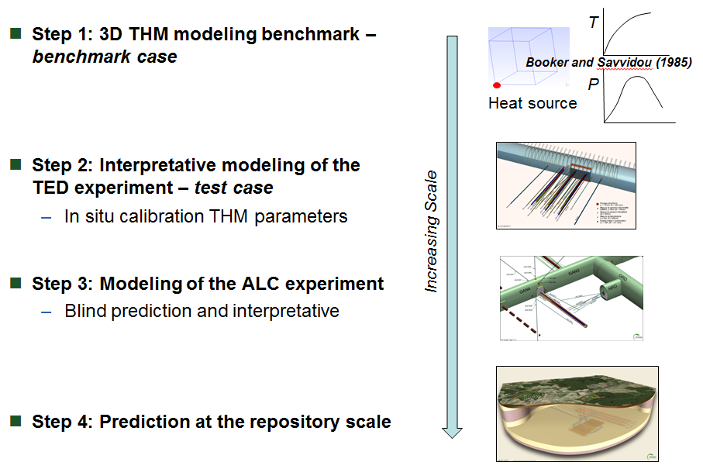

*FIG. 2. Overview of DECOVALEX-2019 Upscaling Task with steps of increasing scale.*

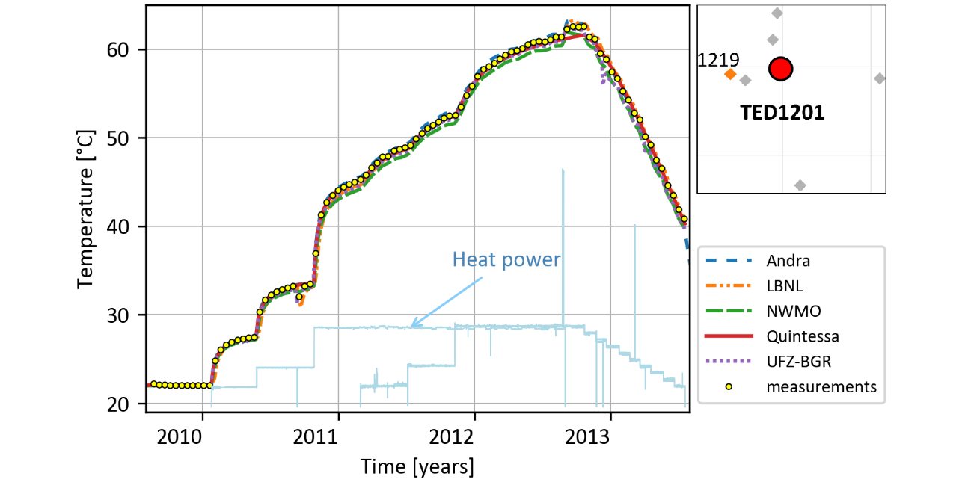

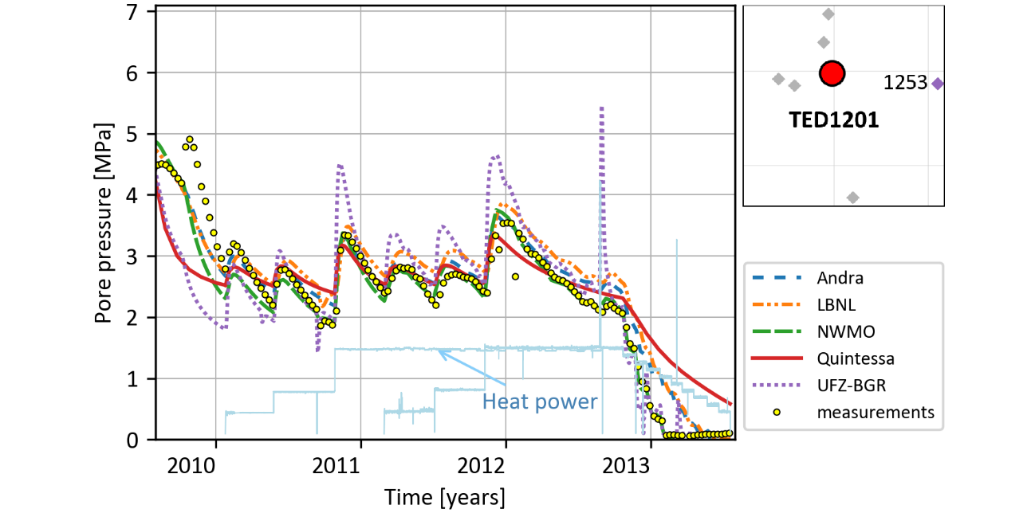

*FIG. 3. Temperature (top) and pressure (bottom) data at sensor TED1219 compared to modelling results.*

The blind predictions of the ALC experimental results showed a good overall representation of evolution of the experiment, while also revealing a non-trivial deviation from the measurements with pore pressures only being well-represented parallel to the direction of bedding. Recalibrations were able to obtain better fits, including adjusting the EDZ representation and increasing the permeability anisotropy. This result appears to illustrate the impact of heterogeneity in the COx even over relatively short distances. Step 4, which involved THM modelling of one quarter of an entire repository with multiple galleries and disposal tunnels (Figure 4) gave good and coherent results depending on the different geometrical assumptions made by the research teams. This builds confidence that large-scale repository models of this kind are tractable and robust, and can be used to predict temperatures and pore pressures.

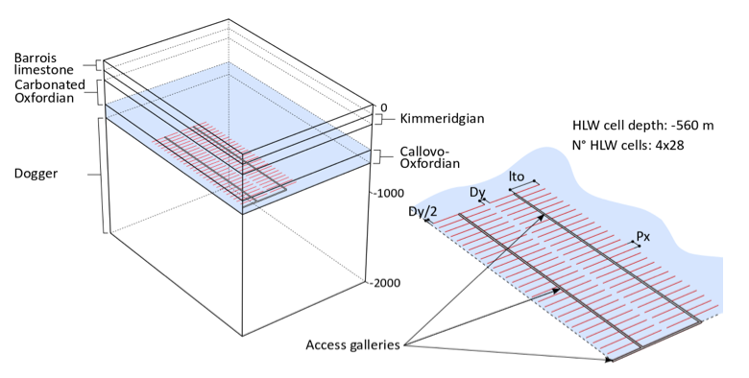

*FIG. 4. Model configuration of a quarter of HLW repository.*

Overall, the five international modelling teams (from the U.S., Canada, Germany, the United Kingdom, and from France) showed that the use of a thermo-poro-elastic model yielded satisfactory representations of the two in-situ heating experiments. A correct interpretation of the boundary conditions, equations of state for water, as well as finding permeability values keeping a anisotropy ratio consistent with respect to what is observed in the field, were essential for plausible and well-calibrated models. Numerical modelling of the whole waste repository was also performed. Modelling teams had more freedom in order to set their models for repository-scale simulations, which led to different and original approaches. The assumptions and hypothesis enacted in the different modelling approaches were verified by the inter-comparison of the numerical results. Step 4 thus provided a number of best practice guidelines for modelling large-scale deep geological repositories.

#### A Brief Snapshot of Tasks in DECOVALEX-2023

The current phase of the DECOVALEX Project started in early 2020 and will end in late 2023. Seventeen international partner organizations with approximately 50 research teams are participating in the collaborative analysis and modelling of seven tasks [9]. Research and modelling challenges range from fundamental process understanding (three tasks respectively focusing on micro-scale THMC lab experiments, advection of gas in bentonite, and heat- or gas driven fracturing) to full-scale THM demonstration experiments (two heater test tasks with focus on near-field behavior in the EBS and clay-rich host rock). The final two tasks, coordinated by SFWD scientists from Sandia National Laboratories in the U.S., are briefly described here:

* Brine Availability Test in Salt (BATS): The objectives of this task are to observe and predict the coupled processes governing the availability of water to heated excavations in geologic salt. Brine availability strongly impacts the long-term performance of salt repositories for heat-generating radioactive waste. The BATS task utilizes data from ongoing salt heater tests to (1) confirm the strengths and types of coupled THMC processes that govern preferential brine flow paths and canister corrosion, and (2) develop and validate numerical and constitutive models for coupled processes and salt migration in bedded salt. The field tests are conducted in short horizontal boreholes at the repository level (~650 m depth) in Waste Isolation Pilot Plant (WIPP) in the United States. A comprehensive monitoring campaign provides data on volumetric flowrate and composition of fluids (e.g., brine and steam) and tracers entering the boreholes through time. Geophysical data (i.e., electrical resistivity tomography, acoustic emissions, ultrasonic wave velocity, temperature, fiber-optic distributed temperature and strain) complement solid (i.e., cores around seals and heaters before and after testing), liquid (i.e., samples of brine with natural and added tracers), and gas (i.e., stable water isotopes and gas chemical composition) sampling. The seals and surrounding salt will be over-cored and removed after extended exposure to compare against complementary laboratory tests on seal materials. Several research teams from the U.S., Germany, the Netherlands, and the United Kingdom are participating in the task.
* Comparison of Performance Assessment Modelling Approaches: The ultimate objective of this task is to build confidence in the models, methods, and software used for performance assessment (PA), or safety assessment, of deep geologic repositories, and/or to bring to the fore additional research and development needed to improve PA methodologies. To achieve this objective, this task involves a staged comparison of models and methods used in different PA frameworks, including: (1) coupled-process submodels (e.g., waste package corrosion, spent fuel dissolution, radionuclide transport, etc.) comprising the full PA model, (2) deterministic simulation(s) of the entire PA model for defined reference scenario(s), (3) probabilistic simulations of the entire PA model, and (4) uncertainty quantification (UQ) and sensitivity analysis (SA) methods/results for probabilistic simulations of defined reference scenario(s). As opposed to most other DECOVALEX modelling tasks which are based on and closely aligned with laboratory or field experiments, this PA task is generic in nature. Two generic repository reference cases are considered in parallel, one with disposal in fractured crystalline host rock and a second with disposal in a bedded salt formation. More than ten teams from the U.S., Germany, Canada, the Netherlands, Republic of Korea, Sweden, Czech Republic, and Taiwan are participating in the task.

The seven modelling tasks defined for the current DECOVALEX-2023 phase closely mirror the current scientific interest within the international community and address recognized research gaps in radioactive waste disposal.

### HotBENT Project

Several international disposal programs have recently become interested in investigating whether clay-based barrier materials can withstand temperatures higher than the 100 °C threshold for bentonite performance usually assumed in advanced repository designs. For example, the SFWD campaign in the U.S. is exploring the feasibility of direct geological disposal of large spent nuclear fuel canisters (the so-called dual-purpose canisters) currently in dry storage, which would benefit from much higher emplacement temperatures. The performance of bentonite barriers in the <100-150 °C temperature range is underpinned by a broad knowledge base built on laboratory and large-scale in-situ experiments, whereas much less is known at temperature impacts above this threshold [10]. Some studies postulate a potentially detrimental temperature- driven physicochemical response of materials (cementation, illitization) at temperatures above 150-200 °C, the characteristics of which are highly dependent on, and coupled with, the complex moisture transport processes induced by strong thermal gradients. The impact of such complex processes on the performance of a repository cannot be realistically reproduced and properly (non-conservatively) assessed at the smaller laboratory scale. Such an assessment needs to be conducted by large in-situ experiments in underground research laboratories (URLs), where the most relevant features of future emplacement conditions can be adequately reproduced.

HotBENT is an ongoing international effort to jointly address this research need; i.e., to install and conduct a full-scale high-temperature heater test (with temperatures of up to 200° C at the canister/buffer interface) which allows evaluation of complex temperature effects under realistic conditions of strong thermal, hydraulic and density gradients in bentonite buffer materials. Such evaluation will lead to improved mechanistic models for the prediction of temperature-induced processes, including chemical alteration and mechanical changes, which can then be used for performance assessment (PA) analysis of high-temperature scenarios. Under the leadership of the Swiss radioactive waste management agency Nagra, the HotBENT Project officially formed in 2018 as an international consortium with four full partner institutions (U.S. DOE, Surao from Czech Republic, RWM from the United Kingdom, and NUMO from Japan) and four associated institutions (NWMO from Canada, BGR from Germany, ENRESA from Spain, and Obayashi from Japan). Much progress has been made since then. As shown in Figure 5, the full-scale experiment is constructed in aa horizontal tunnel in modular fashion, whereby a module represents a heater rested on a bentonite block pedestal and encapsulated by a granular bentonite backfill. Modules differ in their design temperature, bentonite type, experimental duration, and whether a liner is used or now. The two modules deepest in the drift are separated from the others by an insulation plug to enable excavation of part of the experiment with minimal perturbations to the remaining modules. The test installation in a gallery in the GTS in Switzerland is almost finished at the time of writing this paper in June 2021 (Figure 6). Meanwhile a detailed monitoring and instrumentation network has been planned and installation is nearly completed.

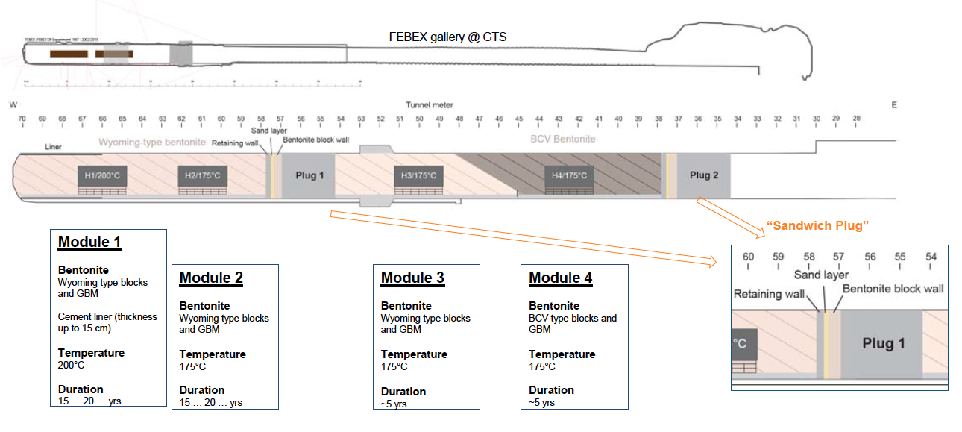

*FIG. 5. Final HotBENT design with individual modules [4].*

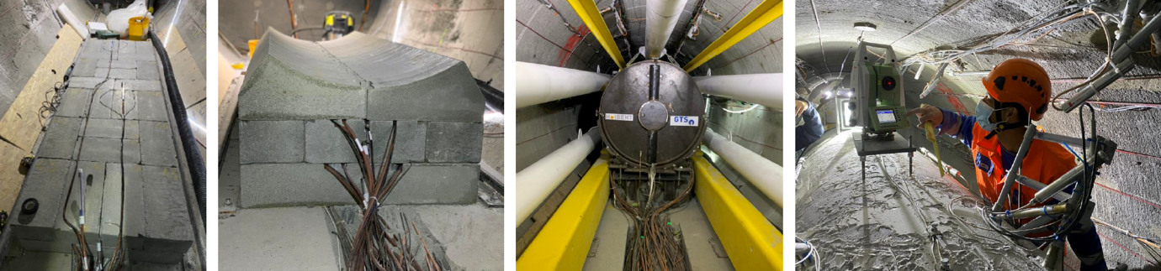

*FIG. 6. Select images from HotBENT installation (courtesy of Nagra). The pedestal for the canister heaters consists of three layers of bentonite blocks with sensors grinded into the blocks (two left images). Granular bentonite as backfill is emplaced with an auger machine (second image from right). Bentonite slope is surveyed after backfill (right image).*

HotBENT is a recent one of many examples where a shared technical challenge in waste disposal forged an international collaboration which now brings together much needed expertise and resources to conduct a very complex and expensive field experiment. Once complete, the HotBENT experiment will: (1) increase the data base (monitoring, sampling, lab-analysis) and understanding on buffer behaviour at high T conditions, (2) assess buffer performance at realistic scales and gradients compared to small scale laboratory tests and modelling, (3) evaluate effects and impacts of microbial activities / corrosion processes / gas evolution, and (4) integrate mechanistic THMC modelling and lab activities (e.g., mock-up experiments) to provide tested models for performance assessment (PA) analysis of high-temperature scenarios.

## Summary and outlook

The focus on international collaboration has allowed engagement of U.S. researchers with the international waste management R&D community in terms of best practices, new science advances, state of the art simulation tools, new monitoring and performance confirmation approaches, and lessons learned. The joint R&D with international researchers, the worldwide sharing of knowledge and experience, and the access to relevant data/experiments from a variety of URLs and host rocks has helped SFWD researchers significantly improve their understanding of the current technical basis for disposal in a range of potential host rock environments. Comparison with experimental data has contributed to testing and validating predictive computational models for evaluation of disposal system performance in a variety of generic disposal system concepts. Comparison of model results with other international modelling groups, using their own simulation tools and conceptual understanding, have enhanced our confidence in the robustness of predictive models used for performance assessment. The possibility of linking model differences to particular choices in conceptual model setup provides guidance into “best” modelling choices and understanding the effect of model uncertainty. International collaboration also provides ample opportunity of training/educating junior staff well suited to move the U.S. disposal research program forward into the next decades.

ACKNOWLEDGEMENTS

This work was supported by the Spent Fuel and Waste Science and Technology Campaign, Office of Nuclear Energy, of the U.S. Department of Energy under Contract Number DE-AC02-05CH11231 with Lawrence Berkeley National Laboratory. We also express our gratitude to Prasad Nair (DOE NE-81), Tim Gunter (DOE NE-81), Bill Boyle (DOE NE-81), and David Sassani (SNL) for helpful discussions and insights.

References

1. DOE (U.S. Department of Energy), Used Fuel Disposition Campaign Disposal Research and Development Roadmap, FCR&D-USED-2011-000065, Used Fuel Disposition Campaign, Washington, D.C. (2012).
2. Sevougian, S.D., Mariner, P.E., et al., DOE SFWST Campaign R&D Roadmap Update, M2SF-19SN010304042, DOE Spent Fuel and Waste Disposition Campaign, Sandia National Laboratories, SAND2019-9033R (2019).
3. UFD, Office of Used Nuclear Fuel Disposition International Program – Strategic Plan, April 2012, DOE (2012).
4. Birkholzer, J., Faybishenko, B., International Collaboration Activities in Different Geologic Environments, Spent Fuel Waste Science and Technology (SFWST) Milestone Report, M2SF-19LB010307012, LBNL-2001239, Lawrence Berkeley National Laboratory, Berkeley, CA USA (2019) 298 pp.
5. NWTRB (2020), Filling the Gaps: The Critical Role of Underground Research Laboratories in the U.S. Department of Energy Geologic Disposal Research and Development Program, A Report to the U.S. Congress and the Secretary of Energy, U.S. Nuclear Waste Technical Review Board, NWTRB (2020).
6. Bossart, P., Bernier, F, Birkholzer, J.T., Bruggeman, C., Connolli, P., Dewonck, S., Fukaya, M., Herfort, M., Jensen, M., Matray, J., Mayor. J, Moeri, A., Oyama, T., Schuster, K., Shigeta, N., Vietor, T., and Wieczorek, K., Mont Terri Rock Laboratory, 20 Years of Research: Introduction, Site Characteristics and Overview of Experiments, Swiss Journal of Geosciences, 110 1 (2017) 3-22.
7. Birkholzer, J.T., Tsang, C.-F., Bond, A.E., Hudson, J.A., Jing, L., and Stephansson, O., 25 Years of DECOVALEX - Scientific Advances and Lessons Learned from an International Research Collaboration in Coupled Subsurface Processes, International Journal and Rock Mechanics and Mining Sciences 122 (2019) 1-21.
8. Seyedi, D., Plua, C., Vitel, M., Armand, G., Rutqvist, J., Birkholzer, J., Xu, H., Guo, R., Thatcher, K., Bond, A., Wang, W., Nagel, T., Shao, H., Kolditz, O. Upscaling THM Modelling from Small-scale to Full-scale In-situ Experiments in the Callovo-Oxfordian Claystone. Int J Rock Mech Min Sci 144: 104582 (2021).
9. BIRKHOLZER, J.T., BOND, A., Coupled Processes Research in the DECOVALEX Project: An Overview of Past and Current Modelling Tasks, Invited Presentation, CouFrac 2020, International Conference on Coupled Processes in Fractured Geological Media, Seoul, Korea (2020).
10. Vomvoris, S., Birkholzer, J.T., Zheng, L., GaUs, I., Blechschmidt, I., THMC Behavior of Clay- Based Barriers Under High Temperature – from Laboratory to URL Scale, Proceedings, International High-Level Radioactive Waste Management Conference, Charleston, NC, USA (2015).