Control & Management of nuclear Waste Water with a Novel Nanotechnology Method

Mahdiar Haghi

AEOI

Tehran; Iran
Email: mhaghi@aeoi.org.ir

Sajjad Rashidi Dafeh

Department of Management, Nano Nokhbegan Fatehrvand (NNFA) Company

Tehran; Iran

Abstract

In this study, iron oxide super paramagnetic nanoparticles, Fe₃O₄@MnF₂O₄ and Fe₃O₄@SiO₂ core/shell nanocomposites synthesized via ultrasonic assisted chemical co-precipitating technique to remove heavy metals from wastewater, especially nuclear wastewater. Optimization method under controlled conditions was used to increase the adsorption of heavy metals by nanoparticles as adsorbent. Thus, the adsorption percentage of lead, nickel, chromium and mercury metals were determined 95.4%, 90%, 75% and 70.26% via Fe₃O₄ super paramagnetic nanoparticles, respectively, by atomic absorption spectroscopy. Finally, the absorbance of this nanocomposite for 4 solutions of lead, nickel, and chromium and mercury metals was 90.87%, 90.56%, 71.36% and 73%, respectively. At the end, the core/shell nanocomposite of the iron oxide/silica was also fabricated by reflux-assited chemical co-precipitation method and the absorption precentage of this nanocomposite for 4 pollution solution of lead, nickel, chromium and mercury contaminants were calculated 94.25%, 87%, 79.57% and 76.14%, respectively. At the end step, the zirconium wastewater was prepared and the iron oxide nanoparticles and their nanocomposites were tested according to the optimum conditions. The adsorption percentage of the zirconium ion source pollution was reported about 75.33% and 77.08%.

INTRODUCTION
Nanotechnology is the quickly growing area of researches all over the world. With the development of it, engineering applications of nanomaterials are rapidly developed in other fields such as food, electronics, medicine and etc [1]. Nowadays nuclear power field has the major subsequent chance based on the use of engineered nanomaterials. For example, nanoparticles such as Fe₃O₄ magnetic nanoparticles [2] and nanoporous materials [3] have been synthesized and investigated as absorbent for remove of heavy and nuclear waste water, respectively. Also, mesoporous silica nanoparticles (<100 nm) have been studied for the catalysis applications[4]. Furthermore, Fluorescent mesoporous manganese ferrite nanoparticles have been synthesized as a candidation for absorbent of pollution waste water [5, 6].
Magnetic nanocrystals such as Fe₃O₄ have engrossed much consideration due to their unique magnetic properties and nuclear power applications such as absorbent of pollution waste water, and it’s applications in fabricating of rad fuel [7-14].
The magnetic nanoparticles (MNPs) that illustrated super paramagnetic behavior are preferred for nuclear power applications; for example, remove of heavy and radioactive metal ions [15-18]. They should have essential features to their extensive use in the nuclear field.
However, the MNPs are unstable and quickly agglomerated after synthesis. Therefore, it is required to reduce their agglomeration and modify their surface with suitable functional groups for a specific application. The surface coatings and core/shell nanocomposites could effectively solve these problems [20-25].
The combination of MNPs with optical semiconductor materials in core/shell structures or other ferrites have engrossed remarkable attention because of these shells could protect the cores, introduce multiple functions and create new properties to the hybrid structures and provide a steric barrier to prevent magnetic nanoparticle agglomeration [26-30]. Superparamagnetic iron oxide nanoparticles (MNPs) as a core are a popular magnetic material of common use [31]; because of their low toxic and chemical stability [32]. Besides, semiconductor nanomaterials or nanoparticles (NPs) have been attracted considerable interest, ascribing to its promising potential applications including remove of radioactive metal ion, biosensors, light-emitting diodes (LEDs) and lasers [33-37].
Ethylenediaminetetraacetic acid (EDTA), have been used extensively in the applications such as in-vivo application like analysis of blood and other apps. It is an anticoagulant for blood samples [38]. EDTA prevents the agglomeration of nanoparticles. EDTA-treated nanoparticles made the particles highly water-dispersible. Furthermore, carboxylate groups of EDTA could attach to the surface of Fe₃O₄ nanoparticles through the strong coordinating ligands [39].
In this work, biocompatible Fe₃O₄ MNPs, Fe₃O₄@MnFe₂O₄ and Fe₃O₄@SiO₂ core/shell nanocomposites were fabricated by a facile refluxing assisted co-precipitation method using the EDTA as capping agent for remove of heavy metal ion like zirconium from nuclear waste water. Biocompatible EDTA was chosen because its carboxylate groups have a strong coordination affinity to the iron cations and biocompatible properties. The structure, morphology, magnetic and optical properties of nanoparticles were investigated and optimized.

2. Experimental Section
2.1 Materials
All chemicals were high purity and provided by Merck Company: FeCl₃·6H₂O, FeCl₂·4H₂O, MnCl₂, Ethylenediaminetetraacetic acid (EDTA), ammonia solution [NH₄OH], 2-methoxyethanol (for core/shell solvent), deionized water (D.I), absolute ethanol, Mercury(II) acetate, Lead(II) acetate, Nickel(II) acetate, Chromium(II) acetate, ZrCl_{4,} TEOS and PEG.

2.2 Synthesis of Fe₃O₄ MNPs
In this work, MNPs were synthesized by chemical co-precipitation method. At first, 1 mol of FeCl₃·6H₂O and 2 mol of FeCl₂·4H₂O was dissolved in 50 ml of D.I water, separately. This solution was sonicated and stirred at the different reaction temperature of (RT, 50, 75 and 98 ^{ᵒ}C) for several minutes until obtained a homogeneous solution. In the next step, NH₄OH was added drop by drop in this solution until pH reached to 9.00 under continues stirring or sonication. The solution turned to black color immediately due to the formation of Fe₃O₄. The sonication or stirring was incessant for diverse times (30, 60, 90 and 120 min) in order to complete of precipitation.
Finally, this black precipitation was isolated via magnetic and washed several times with absolute ethanol and D.I water to remove impurities. In order to the characterization of Fe₃O₄ MNPs and preparation of core/shell nanocomposites, these precipitations were dried at 100 ºC for 12 hours in an oven.

2.3 Synthesis of Fe₃O₄@MNFe₂O₄ and Fe₃O₄@SiO₂ core-shell nano-composites
In this work, refluxing assisted co-precipitation method were employed to synthesize and fabrication of Fe₃O₄@MNFe₂O₄ and Fe₃O₄@SiO₂ core/shell nano-composites. After synthesize of the Fe₃O₄ MNPs at optimum condition such as stirring times (30 min) and reaction temperature (50 ^{ᵒ}C), 1 mol of these MNPs dispersed in 50 ml of 2-methoxyethanol by bath ultrasonic for 12h. Then a)3, b)6, c)9 and d) 12 mol of Mncl₂/Fecl₂ and Fecl₃ were dispersed in 100 ml of 2-methoxyethanol by magnetic stirring and sonicator, separately. Then, the above solutions mixed and sonicated for 60 min. Also, amount of NH₄OH solution was dissolved in 25 ml of 2-methoxyethanol and added drop-wise to the above solution under continues stirring or sonication (PH=9). Immediately, the suspension is refluxed with vigorously stirring at the diverse reflux temperature (50 ^{ᵒ}C, 75 ^{ᵒ}C, 100 ^{ᵒ}C and 125 ^{ᵒ}C) for different times of (30, 60, 90 and 120 min). The color of the solution changed to dark gray, it indicates the formation of manganese ferrite shells. With the optimization of reflux time (30 min) and reflux temperature (75 ^{ᵒ}C), the Fe₃O₄@SiO₂ core/shell was synthesized.

2.4 Characterization
The Structural of Fe₃O₄ MNPs and their nano-composites were analyzed using X-ray diffraction (XRD, Philips MPD PW 3040) over the 2θ Ranges from 20º - 80º at the scan rate of 0.02º/sec. The surface morphology of the samples was taken by using a scanning electron microscope (SEM, Ultra plus-Zeiss SM). Fourier transforms infrared (FTIR) spectroscopy was used to identify chemical bonds of particles. A UV–Vis spectrophotometer (Perkin Elmer-Lambda 1050) was used. Also, the magnetic properties of the samples were accomplished via a vibrating sample magnetometer (VSM) Lake Shore 7304. Also the atomic absorption spectroscopy was employed for determination of metal ions.

3 Results and Discussion

3.1 Structure
Fig. 1 shows the XRD patterns of the (a) pure Fe₃O₄ and (b) Fe₃O₄@MNFe₂O₄ and Fe₃O₄@SiO₂ core-shell nano-composites., the major peaks are identified at 2θ equal to 30.17°, 35.63°, 43.20°, 53.80°, 57.42° and 62.90° which corresponds to the crystalline planes (220), (311), (400), (422), (511) and (440), respectively in cubic phase of Fe₃O₄. All of the peaks are attributed to the Face-center cubic (FCC) structure of Fe₃O₄ crystal according to (card no. JCPDS.65-3107). as can be seen, the peak broadening in the patterns of the Fe₃O₄ MNPs indicates that these MNPs are in nano-scale. The average crystallite size was examined using the Scherrer formula:
D=k λ / β Cos (θ) (1)

Where k, λ, β and θ denote to Scherrer constant, X-ray wavelength, the peak width at half maximum (FWHM) and the Bragg diffraction angle. Thus, the average crystallite size of the Fe₃O₄ was found to be about 10 nm. Fig.1b represents the XRD spectrum of Fe₃O₄@MnFe₂O₄ core/shell nano-composites with the weight ratio of (1:6), showing that the peaks of both Fe₃O₄ and MnFe₂O₄ appear. It is noteworthy that some enhanced peak intensity is caused by peak overlapping. This indicated that the coating process did not change the cubic phase of the Fe₃O₄ MNPs and MnFe₂O₄ nanoparticles.
Also, Fig. 2c depicts the XRD pattern of Fe₃O₄@SiO₂ core/shell nano-composites with the conﬁrms the presence structure of Fe₃O₄ and SiO₂.

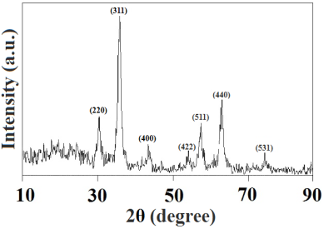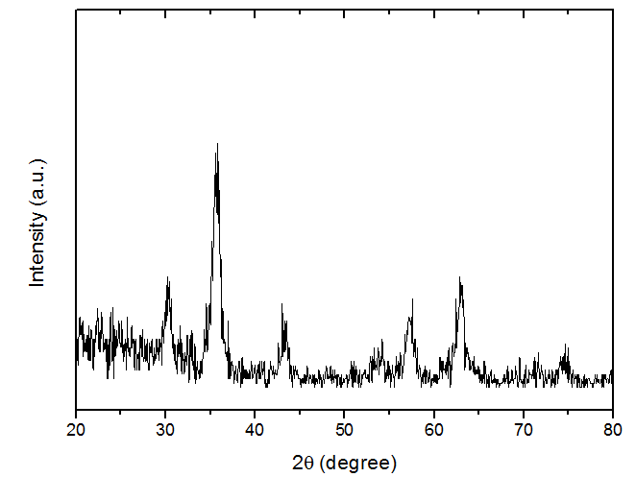
(A) (B)
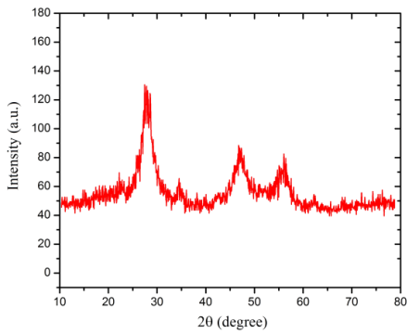
(C)

Fig. 1. The XRD pattern of (A) pure Fe₃O₄ and (B) Fe₃O₄@MnFe₂O₄ and (C) Fe₃O₄@SiO₂ core/shell nano-composites

3.2 Morphology and size
The morphology and particle size of the Fe₃O₄ MNPs and their nano-composites are investigated by SEM, are shown in Fig. 2, respectively. Fig. 2a shows SEM image of Fe₃O₄ MNPs. This image disclosed that Fe₃O₄ MNPs have a regular and homogeneous distribution. The average sizes of them were estimated at about 10 nm. Also, the SEM image of the Fe₃O₄@MnFe₂O₄ and Fe₃O₄@SiO₂ is shown in Fig. 2b and 2c. Comparing with them, it was found that the surface of Fe₃O₄ MNPs became irregular and rougher after growth of their shell. Also, the average size of Fe₃O₄@MnFe₂O₄ and Fe₃O₄@SiO₂ core/shells were determined about 30-35 nm, respectively. This is in close agreement with the results calculated from XRD data using the Scherrerʼs equation.

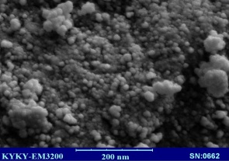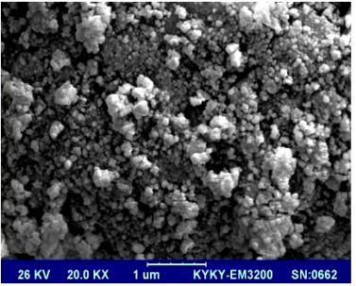
(A) (B)

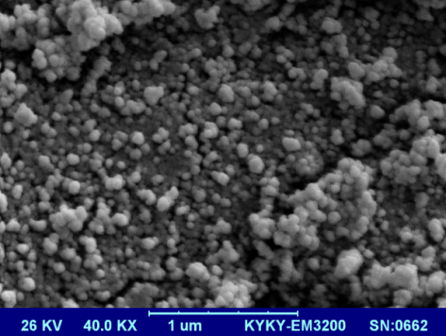
(C)

Fig.2. SEM images of (A) pure Fe₃O₄ and (B) Fe₃O₄@MnFe₂O₄ and (C) Fe₃O₄@SiO₂ core/shell nano-composites

3.3 Absorption measurements: optical properties
Optical properties of Fe₃O₄ MNPs were studied by Uv–Vis spectroscopy measurement. Fig. 3 depicted the UV-Vis spectrum of Fe₃O₄ MNPs, grown in diverse stirring times for (a) 30, (b) 60, (c) 90 and (d) 120 min. One can see that the Fe₃O₄ MNPs are of high optical absorption for all of the samples. Clearly, absorption edge shifts to the longer wavelength with the increases of the stirring time from 30 to 120 min, since Fe₃O₄ MNPs become denser with increasing the diameter and number of them. The band gap of very small nanostructure materials shifts that it corresponded to QSE and change of grain size. According to this effect, with the increase in grain size, the band gap is reduced. Thus, with the increase in growth time or change of other conditions, the nanoparticles were mostly grown and also the size of the nanoparticles increased and the band gap is reduced. The band gap of nanoscale materials is mainly associated with two factors: QSE and surface and interface effects. The QSE causes to the blue shift or increasing band gap while the surface and interface effects lead to the redshift or decreasing band gap by decreasing particle size.
The energy band gap of the Fe₃O₄ MNPs grown in diverse stirring times is determined using Tauc formula. The band gap values of the Fe₃O₄ MNPs grown in diverse stirring times have been found to be 3.301, 2.901, 2.558 and 2.146 eV, respectively. It is worth noting that the band gap decreases with increasing of the stirring times from 30 to 120 min. According to the quantum size effect (QSE), with increases in grain size, the energy band gap is reduced [47]. Thus, according to the above spectrums, the stirring time was optimized at 30 min, because of its suitable size and density of the MNPs. With the optimization of the stirring time, Fe₃O₄ MNPs were synthesized at the different reaction temperature of (a) RT, (b) 50, (c) 75 and (d) 98 ^{ᵒ}C. The UV-Vis spectrums of the Fe₃O₄ MNPs at various reaction temperatures are shown in Fig. 3C. Similar to the previous UV-Vis spectrums, all of the samples are transparent in the UV region. According to the Fig. 3C, there was an evident blue shift in absorption edge when reaction temperature increases from 25 ^{ᵒ}C to 50 ^{ᵒ}C compared with other temperature. Also, the band gap of the Fe₃O₄ MNPs with diverse reaction temperatures from 25 ^{ᵒ}C to 98 ^{ᵒ}C is determined using the Tauc relation. Thus, E_{g} was found to be 1.875, 3.311, 2.679 and 2.196 eV, respectively (Fig. 3D). It can be clearly seen that with increasing of reaction temperatures from 25 to 50 ^{ᵒ}C, the band gap is increased and it is decreased from 75 ^{ᵒ}C to 98 ^{ᵒ}C. Finally, according to the above results, the Fe₃O₄ MNPs were optimized at the reaction temperature of 50 ^{ᵒ}C for the growth time of 30 min.

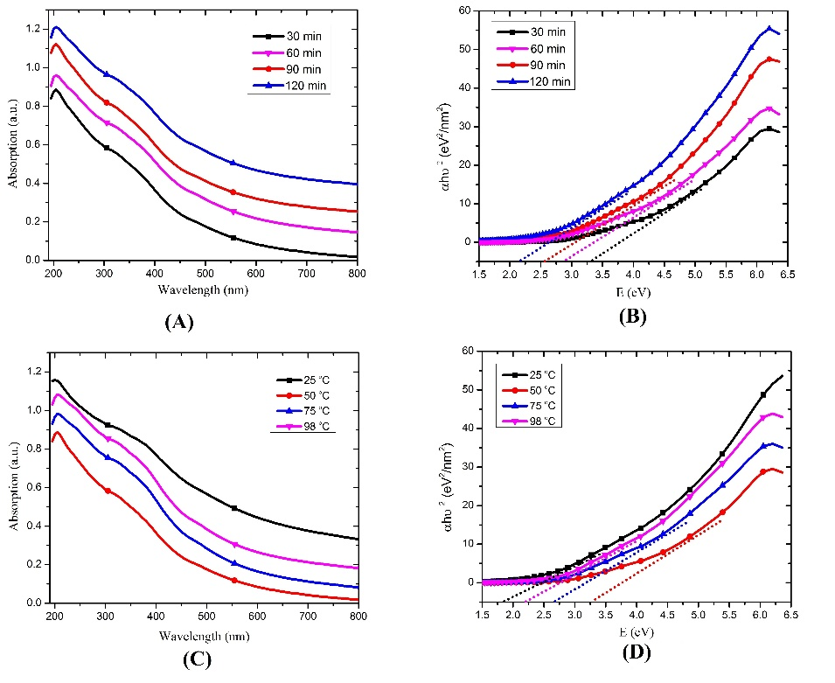
Fig. 3. UV-Vis spectrum and the optical band gap of the Fe₃O₄ MNPs grown in different stirring times (A, B) and various reaction temperatures (C, D).

3.4 FTIR
Fig. 4 represents the FTIR spectrum of (a) pure Fe₃O₄ and (b) Fe₃O₄@MnFe₂O₄ and (c) Fe₃O₄@SiO₂ core/shell MNPs. From the IR spectra of the pure Fe₃O₄ MNPs, the absorption band is attributed to the stretching vibrations of -OH and C-O, respectively. Also, the strong absorption peak of 634.40 cm⁻¹ is related to the stretching vibrations of the Fe-O bond, indicating that the structure of Fe₃O₄ is well formed. For their core/shell MNPs the peaks corresponding to the stretching vibrations of Fe-O, Mn-O and Si-O.

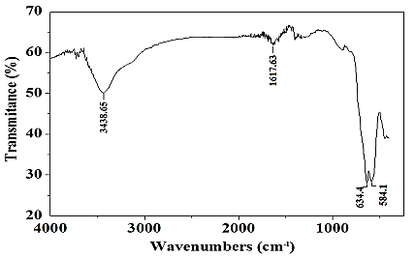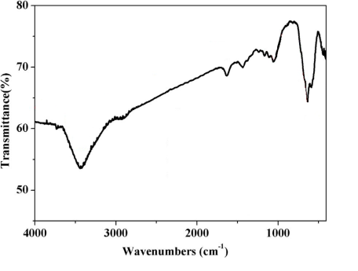
(A) (B)
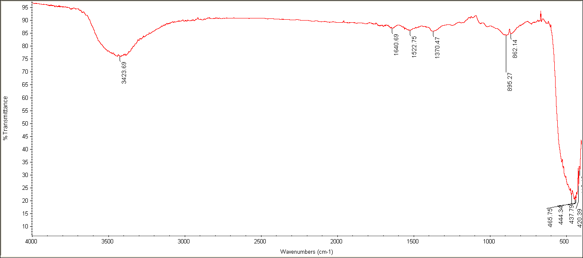
(C)
Fig. 4. The FTIR spectrum of (A) pure Fe₃O₄ and (B) Fe₃O₄@MnFe₂O₄ and (C) Fe₃O₄@SiO₂ core/shell nano-composites

4 absorption technique
4.1 optimization of absorption condition
By optimizing iron oxide nanoparticles, an optimization method under controlled conditions was used to increase the adsorption of heavy metals by adsorbent nanoparticles (iron oxide). Thus, the values ​​(a) 1 gr / Lit , (b) 5 gr / Lit and (c) 10 gr / Lit of EDTA-coated iron oxide nanoparticles and different values ​​of Aqueous solution of toxic metal contamination like lead concentrate with a concentration of (a) 25 (ppm), (b) 50 (ppm) and (c)75 (ppm) mixed with different material with various pH values ​​(a) 3, (b) 6 and (c) 9 was allowed with different contact times (a) 6 hr, (b) 12 hr and (c) 20 hr and at different contact temperatures (a)25 °C, (b)50 °C and (c)75 °C by the magnetic stirrer. For precise optimization, a variable parameter was first maintained and the rest of the parameters were kept constant, for example, to optimize the dose of nanoparticles iron oxide, doses of 1 to 10 grams per liter were taken, then the dosage parameters of soluble metal, PH, temperature, and contact time remained constant.
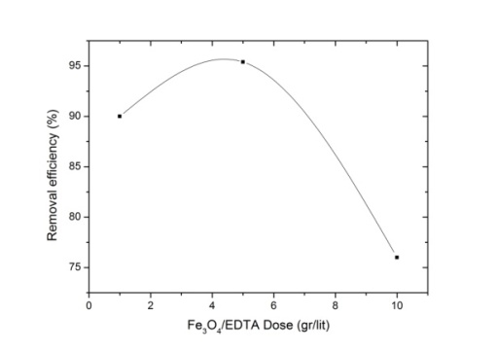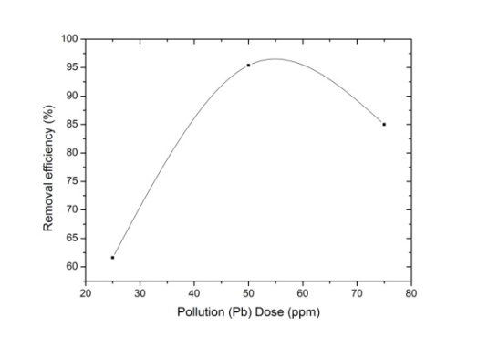
- (B)
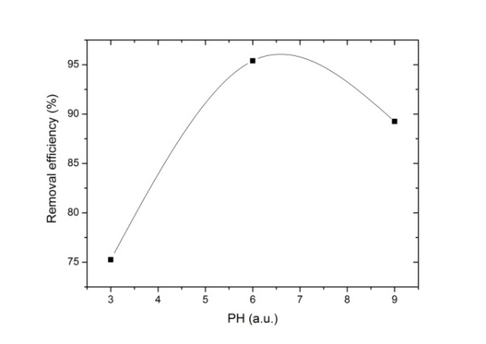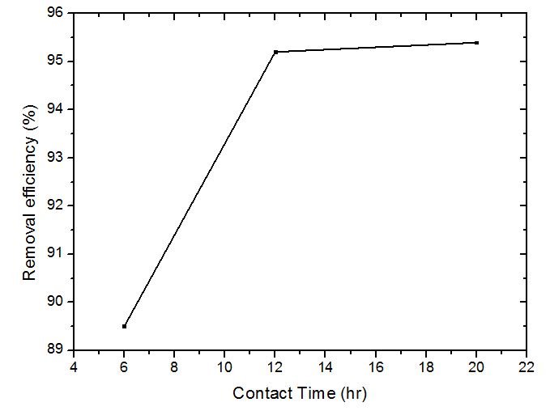
- (D)
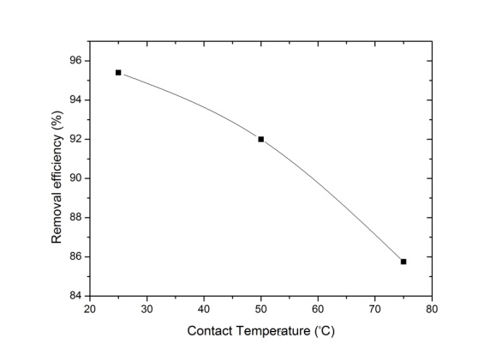
(E)
Fig. 5. Optimization of absorption condition (A) Dose of nano absorbent, (B) Dose of metal ion, (C) PH values, (D) Contact time and (E) Contact temperature

Thus, according to Fig.5, the optimal amount for the iron oxide nanoparticle dose (5 gr / Lit), the optimal amount for the solution of lead metal contamination (50 ppm), the optimal amount for the pH of the solution containing nano-adsorbent and lead metal, on the number 6, the optimal amount for the contact time, 20 hours and the optimum value for contact temperature, 25 °C, was read by atomic absorption spectroscopy (AAS).

4.2 absorption of metal ion by nanocomposites
By optimizing the Fe₃O₄/MnFe₂O₄ core/shell nano-composite, 4 contaminants (lead, nickel, chromium and mercury) were placed under pre-optimized conditions for absorption. Finally, the absorption rate of this nano-composite was 90.87%, 90.56%, 71.36% and 73.7%, respectively, according to atomic absorption spectrometry analysis. At the end, the absorption rate of Fe₃O₄/SiO₂ was 94.4%, 87.7%, 79.57% and 14.46%, respectively, according to atomic absorption spectrometry analysis for lead, nickel, chromium and mercury contamination.

4.3 Absorption of Zirconium wastewater by nanoparticles and their nanocomposites
At the end, zirconium wastewater was prepared and the iron oxide nanoparticles were adsorbed to the optimum conditions. First, the main zirconium wastewater was transferred to the atomic absorption unit under special laboratory conditions. In order to obtain better and more accurate data, the volume of hydrochloric acid 37% and 1% volume of ammonium fluoride was added to the above sample. Then, in order to construct zirconium standards for atomic absorption analysis, 7 samples with concentrations of 5 (ppm), 25 (ppm), 50 (ppm), 100 (ppm), 200 (ppm), 400 (ppm) and 800 (ppm) with precursor of (ZrCl4) was made at the laboratory and delivered to the atomic absorption device operator. Thus, the zirconium content of the main zirconium wastewater by the atomic absorption spectrophotometer (2000/974) (ppm) and the main zirconium content after applying the nanoparticles under (a) 50 ° C and (b) without temperature of 495/564(ppm) and 460/35 (ppm) was reported. With this description, the absorption of zirconium ion source pollution by iron oxide nanoparticles under temperature and without temperature was reported as 75.33% and 77.8%, respectively, indicating the fact that these nanoparticles would be better absorbed without applying the temperature.
Also, the nano-composites of Fe₃O₄@MnFe₂O₄ and Fe₃O₄@SiO₂ were synthesized as a zirconium effluent absorber that was synthesized from the previous phase. Therefore, the concentration of the initial solution after the absorption by Fe₃O₄@SiO₂ and Fe₃O₄@ MnFe₂O₄ nano-composite was reported to be 623.88 and ppm 838.18, respectively. In fact, the absorbance of these two nano-composites is 68.84% and 58.48%, respectively, which reflects the fact that the absorption rate decreased in the nanoparticles due to the increase in the size of the nanoparticles.

5 Conclusions
In this research work, Fe₃O₄ MNPs and their Nano-composites synthesized via ultrasonic assisted chemical co-precipitation technique to remove heavy metals from wastewater, especially nuclear wastewater. Optimization method under controlled conditions was used to increase the adsorption of heavy metals by nanoparticles as adsorbent. According to results, the adsorption percentage of lead, nickel, chromium and mercury metals were determined 95.4%, 90%, 75% and 70.26% via Fe₃O₄ MNPs. Finally, the absorbance of this nano-composite for 4 solutions of lead, nickel, chromium and mercury metals was 90.87%, 90.56%, 71.36% and 73%, respectively. At the end, the core/shell nano-composite of the iron oxide/silica was also fabricated by reflux-assisted chemical co-precipitation method and the absorption percentage of this nano-composite for 4 pollution solution of lead, nickel, chromium and mercury contaminants were calculated 94.25%, 87%, 79.57% and 76.14%, respectively. Thus, the zirconium wastewater was prepared and the iron oxide nanoparticles and their nano-composites were tested according to the optimum conditions. The adsorption percentage of the zirconium ion source pollution was reported about 75.33% and 77.08%, respectively.

References
[1] S. A. Kulkarni, P. S. Sawadh, K. K. Kokate, “Synthesis and Characterization of Fe₃O₄ Nanoparticles for Engineering Applications”, International Journal of Computer Apllications Proceedings on International Conference on Benchmarks in Engineering Science and Technology, October, (2012) 17-18.
[2] L. Chen et.al., “One-step fabrication of amino functionalized magnetic graphene oxide composite for uranium (VI) removal”, Journal of Colloid and Interface Science, 472 (2016) 99-107. L. Chen et.al., “One-step fabrication of amino functionalized magnetic graphene oxide composite for uranium (VI) removal”, Journal of Colloid and Interface Science, 472 (2016) 99-107.
[3] M. Liu et.al., “Programmed gradient descent biosorption of strontium ions by Saccaromyces cerevisiae and ashing analysis: a decrement solution for nuclide and heavy metal disposal”. J. Hazardous. Mater. 314 (2016) 295–303.
[4] Z. Chen et.al., “Synthesis of magnetic Fe₃O₄/CFA composites for the efficient removal of U(VI) from wastewater”, Chemical Engineering Journal, 320 (2017) 448-457.
[5] F. L. Fan et.al., “Rapid removal of uranium from aqueous solutions using magnetic Fe₃O₄@SiO₂ composite particles”, Journal of Enviromental Radioactivity, 106 (2012) 40-46.
[6]. US DOE, “Final supplemental environmental impact statement for a geologic repository for the disposal of spent nuclear fuel and high-level radioactive waste at Yucca Mountain”, DOE/EIS-250 F-S1F (2008) Office of Civilian Radioactive Waste Management.
[7] F. L. Fan et.al, “Rapid removal of uranium from aqueous solutions using magnetic Fe₃O₄@SiO₂ composite particles”, Journal of Environmental Radioactivity, 106 (2012) 40-46.
[8] D. yuan et.al, “Removal of uranium (VI) from aqueous solution by amidoxime functionalized superparamagnetic polymer microspheres prepared by a controlled radical polymerization in the presence of DPE”, Chemical Engineering Journal, 285 (2016) 358-367.
[9] N. Neyaz et.al., “Synthesis and characterisation of modified magnetite super paramagnetic nano composite for removal of toxic metals from ground water”, I.J.E.S, 5(2) (2014) 260-269.
[10] P. C. Panta and C. P. Bergmann, “Obtention by Coprecipitation and Magnetic Characterization of Fe₃O₄ Nanoparticles Coated with Surfactants”, Nano Research and Applications, 1(19) (2015) 1-4.
[11] D. W. Chen and J. L. Wang, “Removal of cesium from radioactive wastewater using magnetic chitosan beads cross-linked with glutaraldehyde”, NUCL. SCI. TECH, 27 (2016) 43-48.
[12] J. Wu and H. Yu, “Biosorption of 2, 4- dichlorophenol by immobilized white-rot fungus Phanerochaete chrysosporium from aqueous solutions”, Bioresource technol, 98(2) (2007) 253-259.
[13] C. Mehta, J. M. Abbas, G. S. S. Saini, S. K. Tripathi, “Preapration and Charactrization of Self-Assembled n-ZnS Thin Films”, Iraqi Journal of Applied Physics, 4 (2008) 31-34.
[14] F. Keyhanian, S. Shariati. Mohammad Faraji, M. Hesabi, “Magnetite nanoparticles with surface modification for removal of methyl violet from aqueous solutions”, Arabian Journal of Chemistry, 9(1) (2016) S348-S354.
[15] Y. Xing et.al., “Controllable synthesis and characterization of Fe₃O₄/Au composite Nanoparticles”, Journal of MMM, 380 (2015) 150-156.
[16] Y. Ren et.al., “Rapid removal of uranium from aqueous solutions using magnetic Fe₃O₄@SiO₂ composite particles”, Chemical Engineering Journal, 223 (2013) 300-311.
[17] M. Shekofteh and A. Habibi, “Facile preparation of Fe₃O₄@AgBr–ZnO nanocomposites as novel magnetically separable visible-light-driven photocatalysts”, Ceramics International, 41 (2015) 1467-1476.
[18] H. Xiaoyun et.al, “Core–shell structured Fe₃O₄/PANI microspheres and their Cr(VI) ion removal properties”, Synthetic Metals, 171 (2013) 1-6.
[19] Y. Wei et.al., “Synthesis of Fe₃O₄ Nano particles and their magnetic properties”, Procedia Engineering, 27 (2012) 632-637.
[20] P. Tang et.al., “High-Efficient Scavenging of U(VI) by Magnetic Fe₃O₄@Gelatin Composite”, Journal of Molecular Liquids, 221 (2016) 497-506.
[21] S. D. Obersick et.al., “Spin canting across core/shell Fe₃O₄/Mn_{x}Fe_{3−x}O₄ nanoparticles”, Scientific Reports, 8(1) (2018) 3425-3437.
[22] T. Lichao et.al, “Synthesis of Fe₃O₄@TiO₂ core–shell magnetic composites for highly efficient sorption of uranium (VI)”, Colloids and Surfaces A: Physicochemical and Engineering Aspects, 469 (2015) 279-285.
[23] W. Long, H. Liu, X. Yan and L. Fu, “Preparation of new nano magnetic material Fe₃O₄@g-C₃N₄ and good adsorption performance on uranium ion”, Materials Science and Engineering, 322 (2018) 1-6.
[24] S. D. Obersick et.al., “Spin canting across core/shell Fe₃O₄/Mn_{x}Fe_{3−x}O₄ nanoparticles”, Scientific Reports, 8(1) (2018) 3425-3437.
[25] J. Zhang et.al., “Effect of environmental conditions on the sorption of uranium on Fe₃O₄@MnO₂ hollow spheres”, Journal of Molecular Liquids, 223 (2016) 534-540.
[26] Y. SHI, “Superparamagnetic Nanoparticle for magnetic Resonance Imaging (MRI) Diagnosis”, School of Chemical Engineering, University of Adelaide, (2006).
[27] R. Davarnejad and P. Panhai, “Cu (II) removal from aqueous wastewaters by adsorption on the modified Henna with Fe₃O₄ nanoparticles using response surface methodology”, Separation and Purification Technology, 158 (2016) 286-292.
[28] S. D. Obersick et.al., “Spin canting across core/shell Fe₃O₄/Mn_{x}Fe_{3−x}O₄ nanoparticles”, Scientific Reports, 8(1) (2018) 3425-3437.
[29] Yoo D, Lee JH, Shin TH, Cheon J. Theranostic magnetic nanoparticles. Acc Chem Res 2011;44(10): 863-74.
[30] Y. Zhu et.al., “Removal of Co²⁺ from radioactive wastewater by polyvinyl alcohol (PVA)/chitosan magnetic compositet”, Progress in Nuclear Energy, 71 (2014) 172-178.
[31] J. S. Lee, E. J. Lee, H.J. Hwang, “Synthesis of Fe₃O₄-coated silica aerogel nanocomposites”, Trans. Nonferrous Met. Soc. China, 22 (2012) 702-706.
[32] A. H. Lu, E. L. Salabas, F. Schuth, “Magnetic nanoparticles: synthesis, protection, functionalization, and application”, Angew Chem Int Ed Engl, 1222 (2007) 44-46.
[33] M. Mahdavi et.al., “Synthesis, Surface Modification and Characterisation of Biocompatible Magnetic Iron Oxide Nanoparticles forBiomedical Applications”, molecules, 18 (2013) 7533-7548.
[34] S. D. Kulkarni et.al., “Novel Magnetically Separable Fe₃O₄@ZnO Core–Shell Nanocomposite for UV and Visible Light Photo-catalysis”, Advanced Science Letters, 23 (2017) 1724-1729.
[35] J. E. Kim, J. Y. Shin, M. H. Cho, “Magnetic nanoparticles: an update of application for drug delivery and possible toxic effects”, Archives of Toxicology, 86 (2012) 685-700.
[36] G. Bayramoglu, I. Gursel, Y. Tunali, M. Y. Arica, “Biosorption of phenol and 2-chlorophenol by Funalia trogii pellets”, Bioresource technol, 100(10) (2009) 2685-2691.
[37] I. A. Bakhteeva et.al., “Magnetic sedimentation and aggregation of Fe₃O₄@SiO₂ nanoparticles in water medium”, Separation and Purification Technology, 159 (2016) 35-42.
[38] Y. Li et.al., “Preparation of Functionalized Magnetic Fe₃O₄@Au@polydopamine Nanocomposites and Their Application for Copper (II) Removal”, Polymers, 10 (2018) 570-585.
[39] F. Chen, Sh. Xie, J. Zhang, R. Liu, “Synthesis of spherical Fe₃O₄ magnetic nanoparticles by co-precipitation in choline chloride/urea deep eutectic solvent”, J. Mater. Lett. 112 (2013) 177-179.

