Current Status of Solid Waste

Management on Fukushima Daiichi

Nuclear Power Station

Noriyuki Saito
Tokyo Electric Power Company Holdings
Futaba-gun, Fukushima, Japan
Email: saito.nori@tepco.co.jp

Abstract

There are many outdoor storage area for rubble, etc. on the premises of Fukushima Daiichi NPS. “Eliminating the temporary outdoor storage area within FY 2028” is the target process which Inter-Ministerial Council of Japan shows. Solid Waste Management Plan on Fukushima Daiichi NPP which has been developed by TEPCO is the plan to achieve this target. The main idea of this plan is to reduce the volume of waste as much as possible and then move it into the solid waste storage warehouse. To realize the idea, two miscellaneous solid waste incineration facilities, volume reduction equipment for metals and concrete, and additional solid waste storage warehouses have been planned to establish in the near future. By utilizing these facilities, it is evaluated that the targeted process can be achieved.

INTRODUCTION
Ten years have passed since the Fukushima accident occurred. Tokyo Electric Power Company Holdings (TEPCO) is undertaking decommissioning of Fukushima Daiichi Nuclear Power Station (NPS) steadily and safely, incorporating domestic and international expertise, to fulfil its responsibility for the March 11, 2011 accident.
Over the last decade, significant progress has been made in decommissioning work on Fukushima Daiichi NPS. For examples, the amount of contaminated water generated due to the intrusion of groundwater into the reactor building has been reduced. Removal of all fuel assemblies from Unit 4 was completed in December 2014 [1] and it was completed at Unit 3 in February 2021 [2]. Surveys inside the containment vessels using robots and other means have been also progressed. On 2018, deposits which probably included fuel debris were found at the bottom of the pedestal inside the Unit 2 PCV [1]. In February 2019, a contact investigation on the detected deposits inside the Unit 2 PCV was successfully conducted [1].
On the other hand, every decommissioning work generates waste. Because almost all the premises on Fukushima Daiichi NPS are still designated as controlled area, most of the waste generated from the decommissioning work must be treated as radioactive waste. It is impossible to take waste out of the premises at present. So, storage volume of solid waste on Fukushima Daiichi NPS has been increasing gradually. This paper shows the history, current status and future plan of solid waste management on Fukushima Daiichi NPS.

Waste Management Challenge after the Accident
Immediately after the accident, a large amount of rubbles were generated around Units 1 to 4 due to the tsunami and hydrogen explosions. These rubbles prevented us from approaching for emergency measures and building the necessary facilities. One of the first thing we did after the accident was to remove these rubbles. Because some of them were very high dose, remote control heavy equipment was used to remove them. Then, in order to install various facilities needed for decommissioning, it was necessary to clear the forest and prepare the ground on the site. As a result, a vast amount of contaminated soil and felled trees were generated.
Before the accident, 8 solid waste storage warehouses had been constructed and operated. The storage capacity of them was about 57,000m³ [3]. However, at the accident, there was not enough room to accommodate the waste into the existing storage buildings, because about 37,000m³ operating waste had been already stored [3]. As it was necessary to secure waste storage areas urgently, temporary solid waste storage areas had to be set up outdoor.
On Fukushima Daiichi NPS, we call solid waste “the rubble, etc.”. The rubble, etc. is classified into rubble, trimmed tree and used protective clothing. Caused by the lack of information about contents of radionuclides, especially long half-time nuclides, Rubble is further categorised by material type and surface dose rate level.
FIG.1 shows the storage management method for the rubble, etc. [4]. Rubble is stored in sectioned areas with storage systems for each dosage category in order to block and prevent dispersion. For examples, rubble with a surface dose rate of 0.1mSv/h to 1mSv/h should be covered with protection sheet and of 1mSv/h to 30mSv/h should be stored in container or ‘Covered-type’ temporary storage facility. FIG.2 shows photos of several examples of outdoor storage area [5]. FIG.3 shows a structure of ‘Covered-type’ temporary storage facility [6].
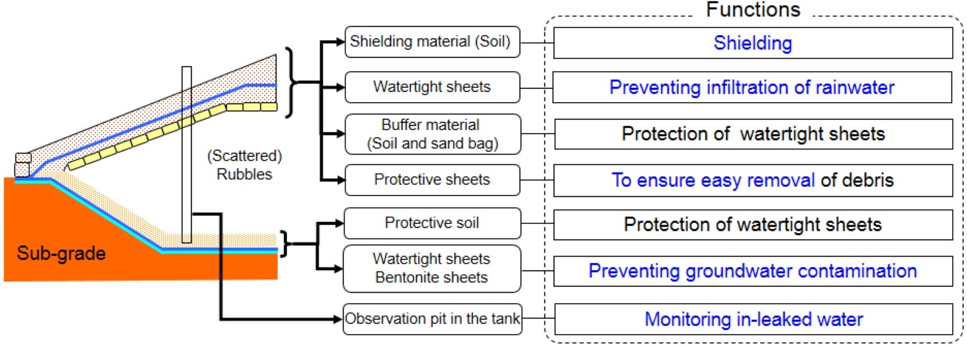
FIG. 3. Sectional view showing the structure of ‘Covered-type’ temporary storage facility
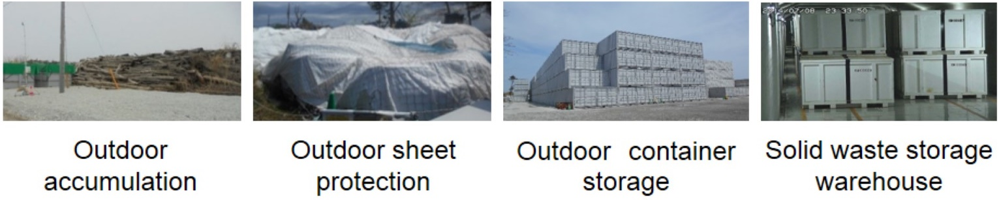
FIG. 2. Photos showing status of storage area
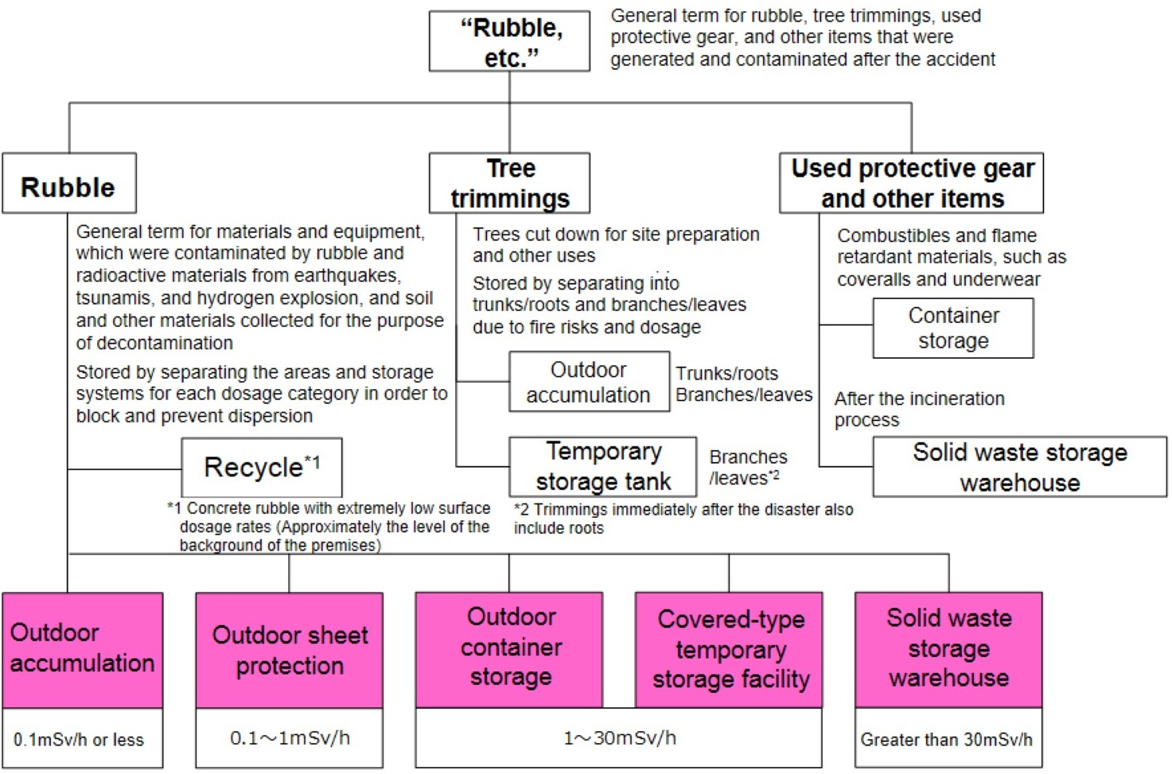
FIG. 1. Diagram showing storage management method for rubble etc.
As the decommissioning work has progressed, the amount of waste accumulated has been increasing. While the total storage volume of rubble at the end of FY2013 was 95,000m³ [7], the total volume of that at the end of 2020 was 311,000m³ [5]. FIG.4 shows the current status of waste storage area on the premises.
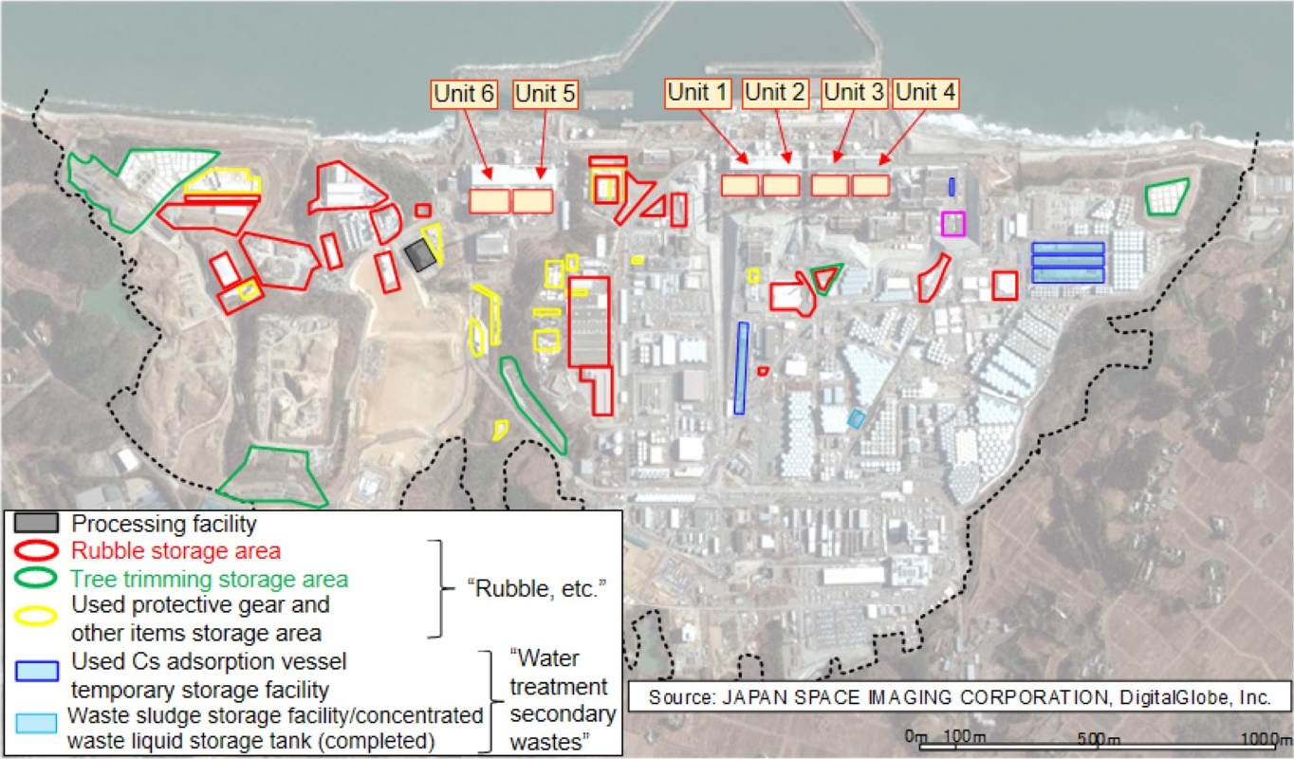
FIG. 4. Diagram showing the current status of waste storage area on the premises

We have continuously improved waste management manner. For example, a miscellaneous solid waste incineration facility for burnable waste was built and started operation in March 2016[4].
Solid Waste Management Plan on Fukushima Daiichi NPP was also developed in 2016[4]. The main objective of this plan is to reduce the volume of waste as much as possible and then move it into the storage warehouses. We forecasted the waste generation volume within the next 10 years in this plan. Based on this forecast, we formulated a construction plan for volume reduction facilities and solid waste storage warehouses. According to the plan, waste storage warehouse No.9 which can store the solid waste about 33,600 m³ was built and started operation in February 2018[4].
Solid Waste Management Plan on Fukushima Daiichi NPP is revised annually. The latest plan was published in July 2020[4].

Future Plan
“Mid-and-Long-Term Roadmap towards the Decommissioning of TEPCO’s Fukushima Daiichi Nuclear Power Station Units 1 to 4” which is published by Inter-Ministerial Council shows the milestone (main target process) for solid waste management on site [8]. The milestone is as follows:
FY2028, TEPCO will eliminate the outdoor temporary storage area for all solid waste (fallen tree, rubble and others, soil, used protective clothing and others) except for secondary waste from water treatment and waste to be used for reuse/recycle, in order to reduce the workers’ risk such as radiation dose risk from all of the decommissioning works, various types of solid waste have been generated.
The latest Waste Management Plan on 2020 shows the plan to achieve this targeted process.
FIG.5 shows the projected result of waste generation forecast in this plan. It is forecasted that by end of 2032FY, approximately 784,000 m³ of waste will be generated [4]. Out of this total volume, approximately 203,000m³ is estimated to be metals and concrete with surface dose rate of 5μSv/h or less [4]. We assume these can be reused or recycled. Except for these metals and concrete, approximately 581,000m³ of rubble, etc. should be stored as solid waste [4].

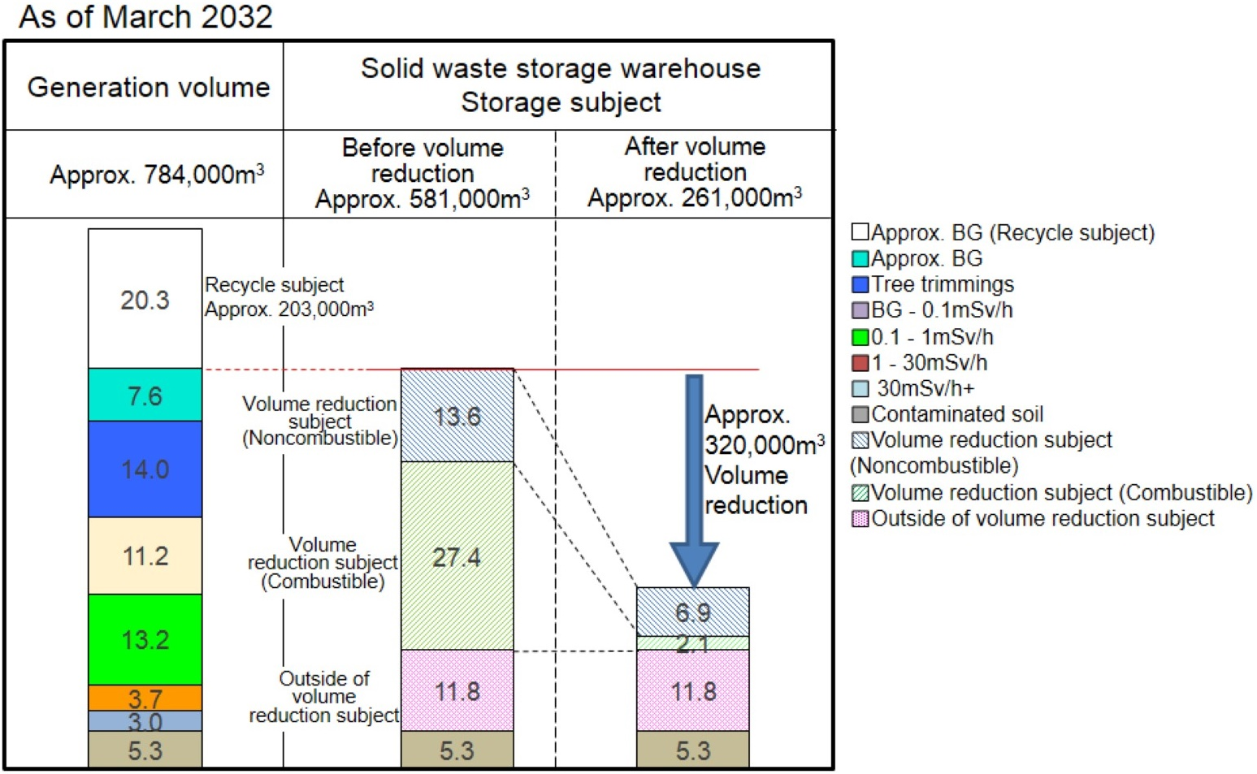
FIG. 5. Diagram showing the result of waste generation forecast at the end of FY2032
According to our plan, an additional incinerator called “Additional miscellaneous solid waste incineration facility” is under construction. This facility is scheduled to start operation within FY2021 [9]. And also we have a plan to install “Volume reduction equipment” for metals and concrete with surface dose rate of 1mSv/h or less. This facility is under foundation work and scheduled to start operation in FY2022 [4]. These facilities will enable significant volume reduction of combustible materials, metals and concrete. Consequently, it is estimated that approximately 261,000m³ should be stored in solid waste storage buildings at the end of FY2031 (FIG.5) [4]. So, we have been designing additional solid waste storage warehouses, No.10 and 11. These facilities are scheduled to open in FY2022 or later [4]. FIG.6 shows the schematic layout of planned solid waste management-related facilities [10].
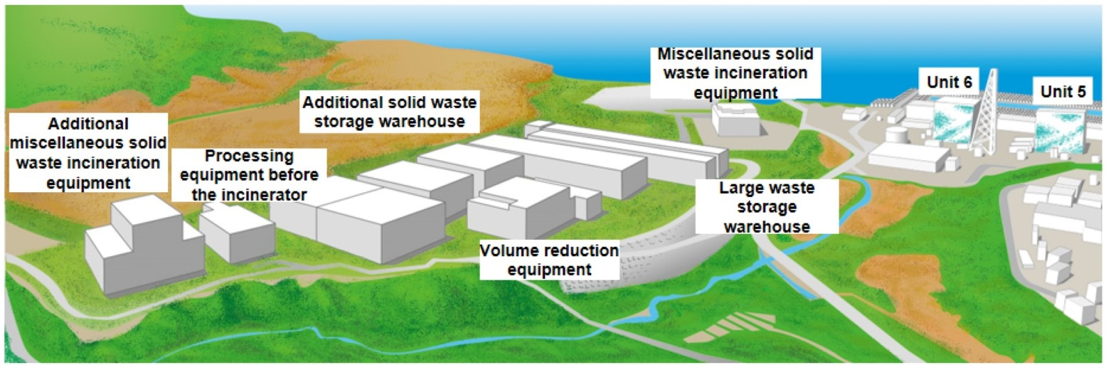
FIG. 6. Picture showing the schematic layout of planned solid waste management-related facilities
FIG.7 indicates the overview of our solid waste management plan in 10 years [4]. FIG.8 shows the future image of solid waste storage conditions on the premises. By implementing this plan, we believe the targeted process in the Mid-and-Long-Term Roadmap “eliminating the temporary outdoor storage area within FY 2028” is achievable [4].
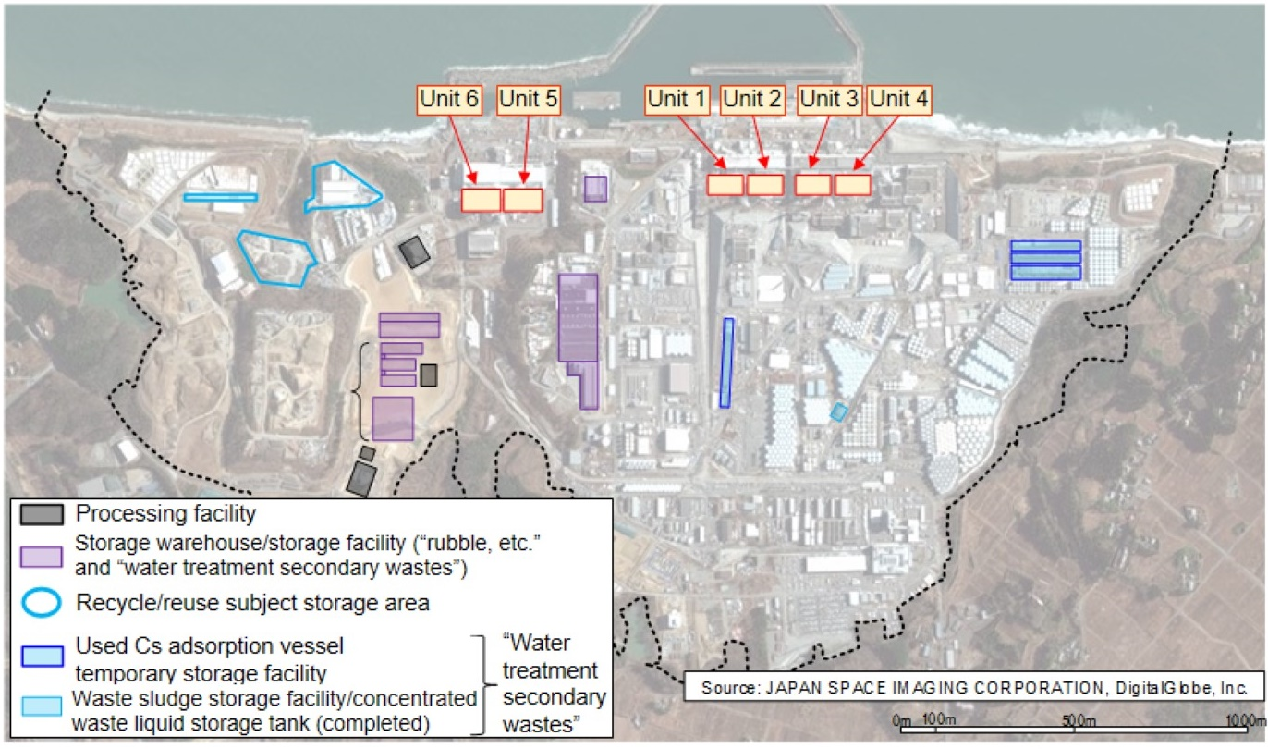
FIG. 8. Diagram showing the future image of solid waste storage conditions on the premises
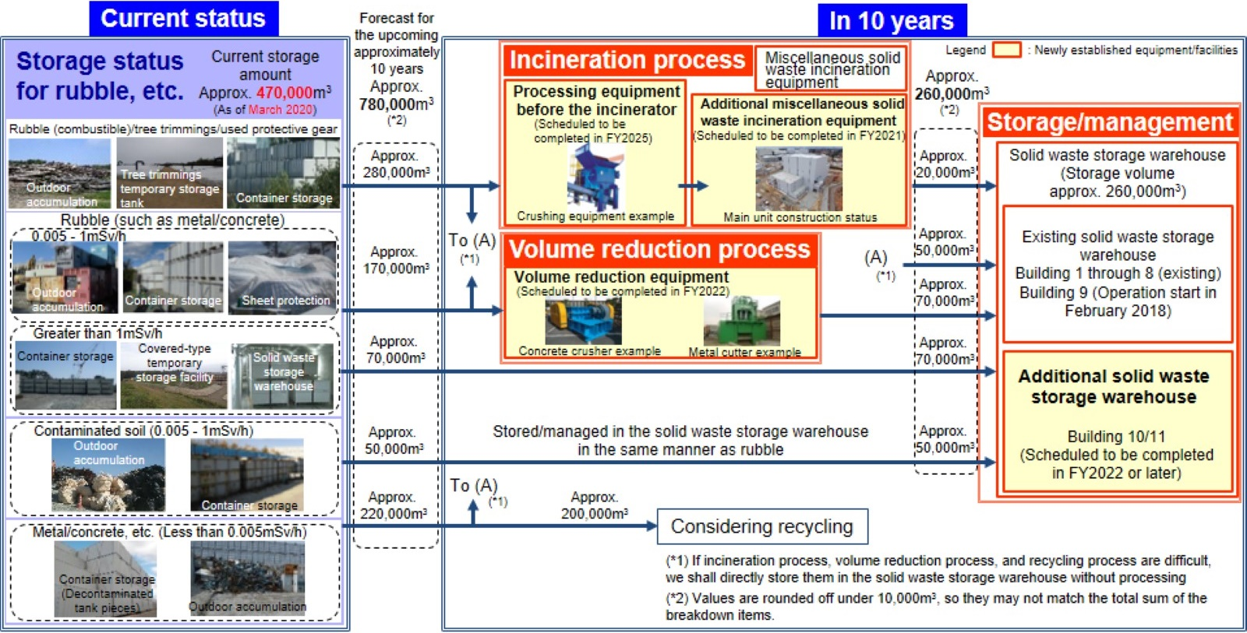
FIG. 7. Diagram showing the overview of Solid Waste Management Plan on Fukushima Daiichi NPP

REFERENCES
References
- THE GOVERNMENT OF JAPAN, Events and highlights on the progress related to recovery operations at TEPCO’s Fukushima Daiichi Nuclear Power Station, IAEA, February 2021
- SECRETARIAT OF THE TEAM FOR CUNTERMEASURES FOR DECCOMMISSIONING AND CONTAMINATED WATER TREATMENT, Monthly progress (May 27, 2021),
https://www.meti.go.jp/english/earthquake/nuclear/decommissioning/pdf/mp202105.pdf
- NUCLEAR REGULATORY AUTHORITY JAPAN, Report on Radiation Control, etc. regarding nuclear facilities FY2012 edition, 2013(Written in Japanese)
- TOKYO ELECTRIC POWER COMPANY HOLDINGS, Solid Waste Storage Management Plan on Fukushima Daiichi NPS, 2020 (Written in Japanese)
- TOKYO ELECTRIC POWER COMPANY HOLDINGS, Management Status of Rubble, Felled trees, Used Protective Clothing, etc. at March 2021, 89th Secretariat Meeting of the Team for Countermeasures for Decommissioning and Contaminated Water Treatment, 2021 (Written in Japanese)
- TOKYO ELECTRIC POWER COMPANY HOLDINGS, Fukushima Daiichi NPS Implementation Plan for Specific Nuclear Facilities, 2021 (Written in Japanese)
- TOKYO ELECTRIC POWER COMPANY HOLDINGS, Management Status of Rubble and Felled trees, at March 2014, 5th Secretariat Meeting of the Team for Countermeasures for Decommissioning and Contaminated Water Treatment, 2014 (Written in Japanese)
- THE INTER MINISTERIAL COUNCIL FOR CONTAMINATED WATER AND DECOMMISSIONING ISSUES, Mid-and-Long-Term Roadmap towards the Decommissioning of TEPCO’s Fukushima Daiichi Nuclear Power Station, 2019
https://www.meti.go.jp/english/earthquake/nuclear/decommissioning/pdf/20191227_3.pdf
- TOKYO ELECTRIC POWER COMPANY HOLDINGS, Current Status of Additional Miscellaneous Solid Waste Incineration Equipment, 88th Secretariat Meeting of the Team for Countermeasures for Decommissioning and Contaminated Water Treatment, 2021 (Written in Japanese)
- TOKYO ELECTRIC POWER COMPANY HOLDINGS, Measures to Deal with Waste Materials, 2021
https://www.tepco.co.jp/en/hd/decommission/progress/waste/index-e.html

